Original Research Article
Effects of Ethion (50% EC) on Acetylcholinesterase Activity in the Freshwater Fish Catla catla

.
ABSTRACT

The present study evaluated the toxic effects of the organophosphate (OP) pesticide Ethion (50% EC) on acetylcholinesterase (AChE) activity in the freshwater fish Catla catla and assessed its potential as a biomarker of pesticide induced neurotoxicity. An experimental laboratory based toxicological study was conducted at the Department of Zoology & Aquaculture, Acharya Nagarjuna University, Guntur, Andhra Pradesh, India, over a period of three months, involving both acute (lethal) and sublethal exposure trials. Fish were exposed to a lethal concentration of Ethion (2.8 µg/L for 24 hrs) and a sublethal concentration (0.28 µg/L) for 24 hrs, 4 days, and 8 days. AChE activity was measured in brain, muscle, gill, liver, and kidney tissues using standard biochemical assays, and behavioural alterations were also recorded. The results showed significant inhibition of AChE activity in all tissues, exhibiting a clear dose and time dependent pattern. Under lethal exposure (24 hrs), brain tissue exhibited the highest inhibition (44.59%) while the liver showed the lowest (31.83%). Sublethal exposure also resulted in consistent inhibition, with brain tissue (33.60%) being more affected than the liver (15.18%). Prolonged sublethal exposure further intensified enzyme suppression, indicating cumulative neurotoxic effects. In addition, behavioural abnormalities such as hyperactivity, erratic swimming, and impaired coordination were observed, correlating with the extent of AChE inhibition. These findings demonstrate that AChE activity serves as a sensitive and reliable biomarker of Ethion toxicity in C. catla, and they underscore the ecological risks posed by OP pesticide contamination in aquatic ecosystems. The study highlights the potential of integrating biochemical and behavioural endpoints to assess pesticide impacts and emphasizes the urgent need for stricter regulation and sustainable management of pesticide use in agriculture.

Keywords: Acetylcholinesterase, Catla catla, Ecotoxicology, Ethion (50% EC), Neurotoxicity, Organophosphate toxicity

- INTRODUCTION
The entry of agricultural pesticides into aquatic ecosystems has emerged as a significant environmental concern worldwide, particularly in regions where intensive farming practices rely heavily on chemical inputs. Modern agricultural production depends extensively on pesticides to sustain crop yields and meet the food demands of a growing global population. However, pesticides that are applied to crops rarely remain restricted to the fields where they are intended. Instead, they often reach adjacent aquatic ecosystems through multiple pathways, including irrigation return flows, surface runoff, leaching into groundwater, and atmospheric drift. This contamination results in chronic and acute exposure of nontarget aquatic organisms, thereby altering ecosystem functioning and biodiversity. Such consequences have been widely reported in developing nations, including India, where intensive agriculture is closely linked to the extensive use of pesticides and where pesticide residue monitoring in aquatic environments remains limited (Ore et al., 2023).
While effective in crop protection, organophosphate (OP) pesticides are particularly prone to entering surrounding water bodies, creating substantial ecological risks. These compounds are widely applied due to because of their low cost, high efficacy, and relatively rapid degradation in terrestrial environments. Nevertheless, their water solubility and mobility enable them to move from agricultural fields to rivers, lakes, reservoirs, and aquaculture ponds. The presence of OP residues in aquatic environments has been consistently reported in biological matrices, indicating the vulnerability of freshwater species to pesticide contamination (Ore et al., 2023). Continuous exposure to sublethal doses may not cause immediate mortality, but it often induces physiological stress, disrupts biochemical processes, and impairs reproductive and behavioural functions in aquatic organisms. Over time, this exposure contributes to biodiversity decline and threatens the sustainability of fisheries and aquaculture systems, which are crucial for food security.
Ethion, a nonsystemic OP insecticide, is commonly used in Indian agriculture to manage pests on fruits, vegetables, cereals, and plantation crops. Its toxicological mechanism is well established and is mediated primarily through the inhibition of acetylcholinesterase (AChE), a critical enzyme responsible for terminating synaptic transmission at cholinergic synapses. Under normal physiological conditions, AChE hydrolyses acetylcholine into acetate and choline, thereby halting nerve impulses and maintaining neural function. When AChE activity is inhibited by OP pesticides such as ethion, acetylcholine accumulates at nerve terminals, leading to continuous stimulation of postsynaptic receptors. This overstimulation causes hyperexcitation, impaired neuromuscular coordination, and, under severe conditions, paralysis and mortality (Aroniadou et al., 2023). The inhibition of AChE is a consistent and quantifiable endpoint of OP toxicity, which is why AChE activity has been widely adopted as a biomarker in ecotoxicological studies across multiple aquatic species (Costa, 2018).
Fish serve as important sentinel organisms for monitoring environmental contamination because of their ecological relevance, physiological sensitivity, and socioeconomic importance. The use of fish in ecotoxicological assessments is particularly valuable because they occupy different trophic levels and ecological niches, making them suitable for understanding contaminant transfer within aquatic food webs. A substantial body of research has demonstrated the inhibitory effects of OP pesticides on AChE activity in diverse fish taxa. For example, zebrafish have been employed as models for studying acute OP poisoning, revealing consistent reductions in AChE activity across exposure regimens (Faria et al., 2015; Koenig et al., 2020). Similar results were reported in rainbow trout exposed to imidacloprid, where neurotoxic responses included oxidative stress and significant AChE inhibition in brain tissues (Uçar et al., 2021). Organ-specific responses have also been documented in rohu (Labeo rohita) and silver barb (Barbonymus gonionotus), in which exposure to OP pesticides results in histopathological alterations and brain AChE inhibition (Reza et al., 2017). These studies demonstrate that OP pesticide exposure exerts neurotoxic effects on a wide range of fish species and reinforce the role of AChE inhibition as a reliable biomarker of exposure.
Carp species are of particular importance in South Asia, where they contribute substantially to aquaculture and inland fisheries. Among these, Catla catla is a major carp species that is widely cultivated in ponds and reservoirs and is simultaneously abundant in natural riverine systems. This species is ecologically significant as a component of freshwater ecosystems and is commercially important as a staple and economic resource. However, this dual role increases its vulnerability to anthropogenic contaminants. Aquaculture ponds are often situated in close proximity to agricultural lands, and shared water resources facilitate the transfer of pesticides into fish culture systems. This makes C. catla an appropriate model species for assessing pesticide induced neurotoxicity in ecotoxicological studies.
Several investigations have demonstrated that OP pesticide exposure in freshwater fish causes not only neural impairments but also broader physiological and biochemical disruptions. For example, Prasanna et al. (2020) reported that exposure of Labeo rohita to ethanol altered the activities of hepatic enzymes, including alanine aminotransferase (ALT) and aspartate aminotransferase (AST). These results indicate hepatic stress and metabolic imbalance, suggesting that OP toxicity extends beyond neurotransmission to include other vital physiological systems. Similarly, chlorpyrifos exposure in rainbow trout results in oxidative damage and histopathological changes, highlighting the broader implications of OP contamination for fish health (Ali et al., 2020). Moreover, mixtures of chlorpyrifos and cypermethrin have been shown to induce physiological alterations and suppress cholinesterase expression in Nile tilapia (Oreochromis niloticus), further emphasizing the potential for compound effects when multiple pesticides are present in aquatic environments (Thanomsit et al., 2020). These findings underscore the multifaceted toxicological profiles of OP pesticides and highlight the importance of comprehensive biomarker evaluations.
Research on the behavioural consequences of OP exposure has also provided important insights. Behavioural endpoints, such as swimming activity, feeding behaviour, and predator avoidance, are critical indicators of fish survival and ecological fitness. Sandoval et al. (2019) reported that exposure to low doses of OP pesticides reduced the ability of fish to escape predation, linking neurotoxic impairment to ecological consequences. Similarly, Ghosh et al. (2022) and Singh et al. (2017) documented the acute toxicity of triazophos and deltamethrin in Channa punctatus, with significant inhibitory effects on AChE activity and associated behavioural abnormalities. These studies demonstrate that behavioural assessments, when combined with biochemical endpoints such as AChE activity, provide a holistic framework for evaluating pesticide induced stress in fish populations.
Additional insights have been obtained from studies on other stressors and contaminants that influence AChE activity in aquatic organisms. For example, Olivares et al. (2021) reviewed AChE responses in fish exposed to hydrocarbons and reported that AChE inhibition is a general biomarker of chemical stress beyond OPs. Paduraru et al. (2021) reported that the oxidative stress and behavioural impairments induced by deltamethrin and lead toxicity in zebrafish could be mitigated by vitamin C supplementation, underscoring the interactive effects of pesticides and antioxidants. These findings collectively highlight the central role of AChE as a biomarker across chemical stressors, reinforcing its suitability for evaluating the neurotoxic potential of ethion in C. catla.
Recent studies have also focused on the benefits of adopting multibiomarker approaches to assess pesticide toxicity. Gopal et al. (2024) demonstrated that azoxystrobin exposure in grass carp (Ctenopharyngodon idella) led to significant toxicological and haematological alterations, illustrating the systemic impacts of pesticides on blood physiology and immune responses. In a complementary investigation, Gopal and Rathnamma (2025) reported oxidative stress and reduced oxygen consumption in grass carp under azoxystrobin exposure, providing evidence of the broad physiological stress that pesticides impose on aquatic organisms. These studies exemplify how integrating biochemical, haematological, and behavioural biomarkers yields a more comprehensive understanding of pesticide induced toxicity and provides a comparative framework for assessing similar impacts in C. catla.
The consequences of pesticide contamination extend beyond ecological health and into the realm of human wellbeing. Fish constitute an essential source of dietary protein and micronutrients for millions of people in South Asia. The accumulation of pesticide residues in edible tissues poses direct threats to food safety, while chronic exposure to pesticide contaminated fish may contribute to long term human health risks such as neurotoxicity, endocrine disruption, and carcinogenicity (Ore et al., 2023). These risks underscore the urgent need for stricter regulations on pesticide application, improved residue monitoring programs, and the adoption of sustainable pest management practices that minimize ecological and human health hazards.
Despite the growing body of research, there are significant gaps in the understanding of the tissue specific neurotoxic responses of C. catla to ethion exposure. While studies on other species have established AChE inhibition as a reliable biomarker of OP exposure, comprehensive assessments of both lethal and sublethal effects in C. catla remain scarce. Given its ecological significance and economic value, evaluating how different C. catla tissues respond to ethanol exposure under both acute and prolonged conditions is critical. Such investigations will strengthen risk assessment frameworks and provide scientific evidence for policymaking aimed at safeguarding freshwater ecosystems and associated livelihoods.
The present study was therefore conducted to evaluate the toxic impact of ethion (50% EC) on AChE activity in the brain, liver, kidney, gill, and muscle tissues of C. catla. Both lethal and sublethal concentrations were tested under controlled laboratory conditions to capture acute and chronic effects. In addition, behavioural alterations were documented to establish the functional consequences of enzymatic inhibition. By documenting tissue specific responses alongside behavioural manifestations, this study aims to provide a detailed account of the neurotoxic risks posed by ethion contamination in freshwater habitats. These findings are expected to reinforce the scientific basis for the use of AChE activity as a biomarker of OP pesticide stress and to inform sustainable management strategies for protecting aquatic biodiversity and food security in regions affected by agricultural intensification.
2. MATERIALS AND METHODS
2.1 Experimental animals
Fingerlings of Catla catla, measuring approximately 7-8 cm in length and weighing between 7.5 and 8.5 g, were procured from a local fish farm in Kuchipudi, Guntur District, Andhra Pradesh, India. The samples were acclimated to laboratory conditions at 28 ± 2 °C for a period of 15 days before experimentation. During acclimation, the fish were maintained in aerated, dechlorinated water and provided with a standard diet.
2.2 Experimental design and pesticide exposure
Following acclimatization, the fish were randomly divided into control and treatment groups. On the basis of preliminary LC₅₀ studies and previous literature (Prasanna et al., 2020), the treatment groups were exposed to sublethal and lethal concentrations of commercial grade ethanol (50% EC). The exposure durations were 24 hrs, 4 days, and 8 days. The control fish were maintained under identical conditions without pesticide exposure. The water conditions were maintained at 28 ± 2 °C, and the samples were continuously aerated, with a 12:12 hrs light–dark photoperiod. During exposure, the fish were monitored for behavioural changes, feeding activity, and mortality.
2.3 Tissue sampling
At the end of each exposure period, the fish were sacrificed, and the brain, liver, kidney, gill, and muscle tissues were carefully dissected for biochemical analysis. The samples were stored under appropriate conditions until the enzyme assays were performed.
2.4 AChE assay
AChE activity in the tissues was determined spectrophotometrically following the methods of Ellman (1961). Tissue homogenates were prepared, and the rate of hydrolysis of acetylthiocholine iodide was measured.
2.5 Protein estimation
The protein content of the tissue homogenates used for the enzyme assays was estimated via the Lowry method (1951), with bovine serum albumin (BSA) used as the standard.
2.6 Statistical analysis
All experiments were conducted in triplicate with 6-8 fish per group. The data are expressed as the means ± standard deviations (SDs). The statistical significance of differences between the control and treated groups was evaluated via appropriate statistical tests.
2.7 Safety and ethical considerations
All procedures involving experimental animals were performed in accordance with institutional guidelines for the care and use of laboratory animals. The handling and disposal of ethion (50% EC) followed standard safety protocols to minimize exposure risks to personnel and prevent environmental contamination.
3. RESULTS
3.1 Short term exposure (24 hrs)

tissues. The brain exhibited the greatest inhibition, with reductions of 33.60% at the sublethal concentration and 44.59% at the lethal concentration. In contrast, the liver showed the lowest inhibition (15.18% at sublethal concentrations and 31.83% at lethal concentrations). Gill, kidney, and muscle tissues showed intermediate decreases, ranging from 18.26% to 39.13% (Table 1, Figure 1).
3.2 Long term exposure (4 and 8 days)
Sustained exposure to sublethal concentrations resulted in progressive inhibition of AChE activity. After 4 days, brain and muscle tissues showed inhibition levels of 39.63% and 35.79%, respectively. By day 8, brain activity decreased further to 49.12%, whereas muscle activity declined to 37.37%. The liver was relatively less affected throughout the exposure duration, whereas gill and kidney tissues presented intermediate responses, which is consistent with their roles in pesticide uptake and detoxification (Table 2, Figure 2).
3.3 Tissue specific sensitivity
The results clearly demonstrated that the brain is the most sensitive tissue to ethion induced neurotoxicity, followed by the muscle, gill, and kidney, whereas the liver presented the lowest degree of inhibition. All changes were statistically significant (P < 0.05) across tissues and exposure durations.
Table 1. AChE activity and percent inhibition in Catla catla after 24 hrs of exposure to sublethal and lethal concentrations of ethion (50% EC).
Tissue | Control | Sublethal | % Inhibition | Lethal | % Inhibition
Gill | 6.87 ± 0.18 | 5.49 ± 0.19 | 20.08 | 4.26 ± 0.26 | 37.99
Liver | 7.34 ± 0.29 | 6.23 ± 0.23 | 15.18 | 5.01 ± 0.19 | 31.83
Brain | 6.10 ± 0.19 | 4.05 ± 0.14 | 33.60 | 3.38 ± 0.10 | 44.59
Kidney | 5.75 ± 0.09 | 4.62 ± 0.18 | 19.65 | 3.50 ± 0.03 | 39.13
Muscle | 4.90 ± 0.17 | 3.89 ± 0.09 | 18.26 | 3.11 ± 0.17 | 36.53
Note: Values represent the means of five observations (± standard deviation). Differences are statistically significant at P < 0.05. AChE activity is expressed as µmol acetylthiocholine iodide hydrolysed/g tissue/min.
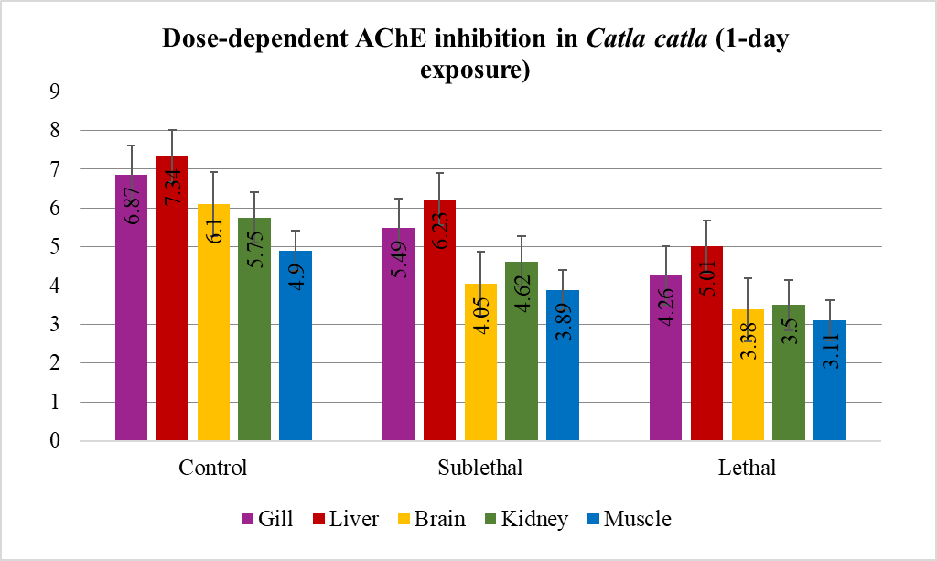
Figure 1. AChE activity (µmol acetylthiocholine iodide hydrolysed/g tissue/min) and percent inhibition relative to the control in the brain, gill, liver, kidney, and muscle tissues of Catla cats after 24 hrs of exposure to sublethal and lethal concentrations of ethion (50% EC).
Table 2. AChE activity and percent inhibition in Catla catla after 4 and 8 days of exposure to sublethal concentrations of ethion (50% EC).
Tissue | Control (4d) | Sublethal (4d) | % Inhibition | Control (8d) | Sublethal (8d) | % Inhibition
Liver | 6.53 ± 0.21 | 4.53 ± 0.01 | 30.62 | 6.10 ± 0.21 | 4.00 ± 0.13 | 34.42
Gill | 5.81 ± 0.10 | 3.99 ± 0.07 | 31.32 | 5.16 ± 0.10 | 3.15 ± 0.05 | 38.95
Kidney | 5.35 ± 0.15 | 4.01 ± 0.14 | 25.04 | 4.84 ± 0.15 | 3.57 ± 0.02 | 26.69
Brain | 6.03 ± 0.09 | 3.64 ± 0.05 | 39.63 | 5.70 ± 0.09 | 2.80 ± 0.09 | 49.12
Muscle | 4.61 ± 0.11 | 2.96 ± 0.05 | 35.79 | 3.05 ± 0.11 | 1.91 ± 0.07 | 37.37
Note: Values represent the means of five observations (± standard deviation). Differences are statistically significant at P < 0.05. AChE activity is expressed as µmol acetylthiocholine iodide hydrolysed/g tissue/min.
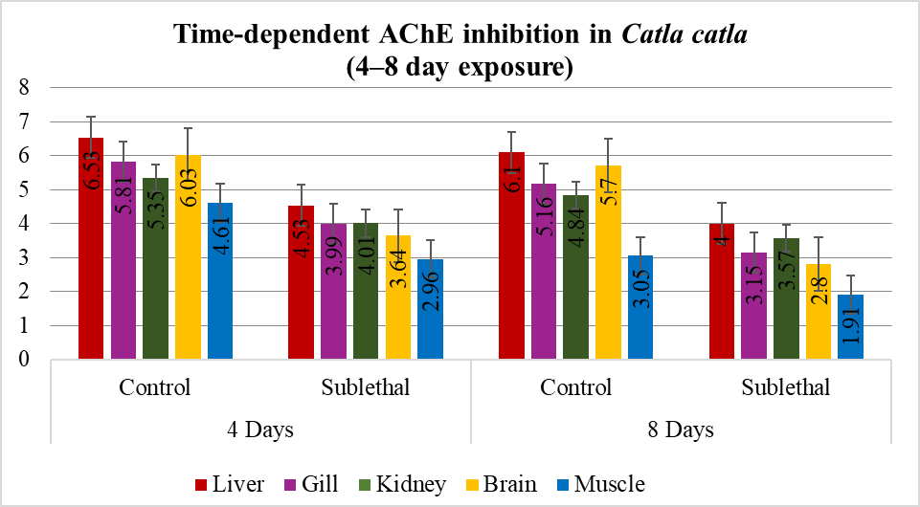
Figure 2. AChE activity (µmol acetylthiocholine iodide hydrolysed/g tissue/min) and percent inhibition relative to the control in the brain, gill, liver, kidney, and muscle tissues of Catla cats after 4 and 8 days of exposure to sublethal concentrations of ethion (50% EC).
4. DISCUSSION
AChE is an essential enzyme present at cholinergic synapses and neuromuscular junctions, where it hydrolyses acetylcholine into acetate and choline, thereby terminating neurotransmission (Anglister et al., 1995). OP pesticides, including ethion, exert their toxicity primarily by inhibiting AChE, leading to excessive accumulation of acetylcholine at synaptic junctions. This accumulation causes prolonged activation of cholinergic receptors, impaired neuromuscular function, and neurotoxic manifestations such as hyperexcitation, loss of coordination, and mortality (Olivares et al., 2021; Paduraru et al., 2021).
In the present study, exposure of Catla catla to ethanol resulted in significant, concentration and time dependent inhibition of AChE activity across multiple tissues. The brain tissue consistently presented the highest level of inhibition, followed by the muscle, whereas the liver presented the lowest reduction. The greater sensitivity of neural tissues is consistent with their direct reliance on AChE for neurotransmission, whereas the relatively lower inhibition observed in the liver can be attributed to its role in detoxification and metabolism. Behavioural impairments, including erratic swimming, hyperactivity, and reduced coordination, closely paralleled biochemical changes, indicating clear evidence of functional impairment.
These findings are consistent with earlier reports on other fish species. OPs such as chlorpyrifos, diazinon, and imidacloprid have been shown to significantly reduce AChE activity in species such as Oreochromis niloticus, Labeo rohita, and Oncorhynchus mykiss. The degree of inhibition is influenced by both the concentration and duration of exposure (Faria et al., 2015; Reza et al., 2017; Sandoval et al., 2019; Uçar et al., 2021). The consistency of these outcomes across taxa highlights AChE inhibition as a robust biomarker of OP pesticide exposure in aquatic organisms.
The tissue specific patterns observed in this study also provide biological insights. Neural tissues such as the brain and muscle, which are central to neuromotor activity, appear more vulnerable to pesticide induced inhibition because of their high energy requirements and greater susceptibility to oxidative stress. Suppression of AChE activity in these tissues disrupts synaptic signalling and metabolic regulation, leading to impaired feeding, locomotion, and predator escape responses (Ghosh et al., 2022; Sharma, 2019; Singh et al., 2017). In contrast, detoxification organs such as the liver and kidney exhibited comparatively lower inhibition, reflecting their functional role in biotransformation and xenobiotic clearance.
Collectively, these results confirm that ethion exerts neurotoxic effects on C. catla by disrupting cholinergic neurotransmission, with brain tissue identified as the most sensitive site. The strong association between AChE inhibition and behavioural alterations underscores the ecological value of AChE as a biomarker of pesticide stress. In addition to ecological risks, pesticide residues have the potential to accumulate in edible fish tissues and biomagnify through the food chain. This poses significant human health concerns, including risks of neurological disorders, oxidative stress, and systemic toxicity, thereby emphasizing the urgent need for stricter regulation and judicious use of OP pesticides in agriculture.
5. CONCLUSION
The findings of this study demonstrate that ethion (50% EC) induces marked, concentration and time dependent inhibition of AChE activity in Catla catla. Brain tissue emerged as the most sensitive site of inhibition, followed by muscle, whereas the liver showed comparatively lower suppression, reflecting tissue specific susceptibility. These biochemical alterations are closely associated with behavioural impairments, providing strong evidence of functional neurotoxicity.
These results affirm that AChE activity is a reliable biomarker for assessing OP pesticide exposure in freshwater fish. More importantly, the disruption of neural and behavioural functions highlights the ecological risks posed by ethion contamination, with potential consequences for fish survival, reproduction, and population stability. Given the importance of C. catla in aquaculture and food security, such risks extend beyond ecological health to human wellbeing through the food chain.
This study underscores the need for stricter regulation of OP pesticide usage and advocates for integrative biomonitoring approaches that combine biochemical and behavioural endpoints. Future research should expand on multibiomarker frameworks and long term ecological assessments to develop sustainable pesticide management strategies that protect aquatic biodiversity and safeguard human health.
6. DATA AVILABILITY
The data will be available upon request.
10. COMPLIANCE WITH ETHICAL STANDARDS
Conflict of interest: The authors declare that they have no conflicts of interest related to this study.
Ethical approval: This study was conducted in strict accordance with the ethical standards for animal research outlined by the Institutional Animal Ethics Committee (IAEC), Acharya Nagarjuna University. All experimental procedures involving fish handling, exposure, and sampling followed the National Guidelines for the Care and Use of Laboratory Animals and adhered to international ethical standards for animal welfare in scientific research. Efforts were made to minimize stress and discomfort to the experimental animals throughout the study.

Disclaimer (Artificial Intelligence)
The author(s) declare that NO generative AI technologies such as large language models (ChatGPT, COPILOT, etc.) and text to image generators have been used during the writing or editing of this manuscript.
11. REFERENCES
- Ali, M., Majid, M., Hussain, I., Kali, S., Naz, T., Niazi, M. B. K., Khan, M. R. A., & Zafar, M. I. (2020). Chlorpyrifos mediated oxidative damage and histopathological alterations in freshwater fish Oncorhynchus mykiss in Northern Pakistan. Aquaculture Research, 51(11), 4583–4594. https://doi.org/10.1111/are.14804
- Anglister, L., Stiles, J. R., Haesaert, B., Eichler, J., & Salpeter, M. M. (1995). Acetylcholinesterase at neuromuscular junctions. In D. M. Quinn, A. S. Balasubramanian, B. P. Doctor, & P. Taylor (Eds.), Enzymes of the cholinesterase family (pp. 451–460). Springer. https://doi.org/10.1007/978-1-4899-1051-6_55
- Aroniadou-Anderjaska, V., Figueiredo, T. H., de Araujo Furtado, M., Pidoplichko, V. I., & Braga, M. F. M. (2023). Mechanisms of Organophosphate Toxicity and the Role of Acetylcholinesterase Inhibition. Toxics, 11(10), 866. https://doi.org/10.3390/toxics11100866
- Costa L. G. (2006). Current issues in organophosphate toxicology. Clinica chimica acta; international journal of clinical chemistry, 366(1-2), 1–13. https://doi.org/10.1016/j.cca.2005.10.008
- Ellman, G. L., Courtney, K. D., Andres, V., & Featherstone, R. M. (1961). A new and rapid colorimetric determination of acetylcholinesterase activity. Biochemical Pharmacology, 7(2), 88–95. https://doi.org/10.1016/0006-2952(61)90145-9
- Faria, M., Garcia-Reyero, N., Padrós, F., Babin, P. J., Sebastián, D., Cachot, J., Prats, E., Arick Ii, M., Rial, E., Knoll-Gellida, A., Mathieu, G., Le Bihanic, F., Escalon, B. L., Zorzano, A., Soares, A. M., & Raldúa, D. (2015). Zebrafish Models for Human Acute Organophosphorus Poisoning. Scientific reports, 5, 15591. https://doi.org/10.1038/srep15591
- Ghosh, P.., Das, E.., & Ghosh, A. (2022). Evaluation of haematological and behavioural changes in Channa punctatus (Bloch) on short-term exposure to a commercial-grade synthetic pyrethroid pesticide. Journal of Experimental Biology and Agricultural Sciences, 10(1), 97–103. https://doi.org/10.18006/2022.10(1).97.103
- Gopal, A., & Rathnamma, V. (2025). Azoxystrobin-induced oxidative stress and reduced oxygen consumption in grass carp (Ctenopharyngodon idella): A multi-biomarker toxicity evaluation. Toxicology International. [Advance online publication].
- Gopal, A., Gurubilli, C. R., Mudunuru, S., & Rathnamma, V. (2024). Toxicological and hematological assessment of azoxystrobin in freshwater fish: A study on grass carp (Ctenopharyngodon idella). African Journal of Biomedical Research, 27(4S), 6996–7003. https://doi.org/10.53555/AJBR.v27i4S.4923
- Koenig, J. A., Acon Chen, C., & Shih, T.-M. (2020). Development of a Larval Zebrafish Model for Acute Organophosphorus Nerve Agent and Pesticide Exposure and Therapeutic Evaluation. Toxics, 8(4), 106. https://doi.org/10.3390/toxics8040106
- Lowry, O. H., Rosebrough, N. J., Farr, A. L., & Randall, R. J. (1951). Protein measurement with the Folin phenol reagent. Journal of Biological Chemistry, 193(1), 265–275. https://doi.org/10.1016/S0021-9258(19)52451-6
- Olivares-Rubio, H. F., & Espinosa-Aguirre, J. J. (2021). Acetylcholinesterase activity in fish species exposed to crude oil hydrocarbons: A review and new perspectives. Chemosphere, 264, 128401. https://doi.org/10.1016/j.chemosphere.2020.128401
- Ore, O. T., Adeola, A. O., Bayode, A. A., Adedipe, D. T., & Nomngongo, P. N. (2023). Organophosphate pesticide residues in environmental and biological matrices: Occurrence, distribution and potential remedial approaches. Environmental Chemistry and Ecotoxicology, 5, 9–23. https://doi.org/10.1016/j.enceco.2022.10.004
- Paduraru, E., Flocea, E. I., Lazado, C. C., Simionov, I. A., Nicoara, M., Ciobica, A., Faggio, C., & Jijie, R. (2021). Vitamin C Mitigates Oxidative Stress and Behavioral Impairments Induced by Deltamethrin and Lead Toxicity in Zebrafish. International journal of molecular sciences, 22(23), 12714. https://doi.org/10.3390/ijms222312714
- Prasanna, C., Anithasmruthi, C., & Rathnamma, V. V. (2020). Toxicity evaluation and behavioural changes of Labeo rohita exposed to ethion 50% EC. International Journal of Pharmaceutical Sciences and Research, 11(11), 5579–5586. https://doi.org/10.13040/IJPSR.0975-8232.11(11).5579-86
- Reza, A. H. M. M., Rakhi, S. F., Hossen, M. S., & Hossain, Z. (2017). Organ-specific histopathology and brain acetylcholinesterase inhibition in rohu, Labeo rohita, and silver barb, Barbonymus gonionotus: Effects of three widely used organophosphate pesticides. Turkish Journal of Fisheries and Aquatic Sciences, 17(4), 819–830. https://doi.org/10.4194/1303-2712-v17_4_18
- Sandoval-Herrera, N., Mena, F., Espinoza, M. et al. Neurotoxicity of organophosphate pesticides could reduce the ability of fish to escape predation under low doses of exposure. Sci Rep 9, 10530 (2019). https://doi.org/10.1038/s41598-019-46804-6
- Sharma, M. (2019). Behavioural responses in effect to chemical stress in fish: A review. International Journal of Fisheries and Aquatic Studies, 7(1), 1-5. https://www.fisheriesjournal.com/archives/2019/vol7issue1/PartA/6-6-33-208.pdf
- Singh, S., Tiwari, R. K., & Pandey, R. S. (2017). Evaluation of acute toxicity of triazophos and deltamethrin and their inhibitory effect on AChE activity in Channa punctatus. Toxicology reports, 5, 85–89. https://doi.org/10.1016/j.toxrep.2017.12.006
- Thanomsit, C., Nualkaw, C., Prasatkaew, W., Wattanakornsiri, A., Nanuam, J., Nanthanawat, P., & Kiatprasert, P. (2020). Adverse effects of chlorpyrifos and cypermethrin mixture on physiological alterations and cholinesterase expression in Nile tilapia (Oreochromis niloticus). Thai Journal of Agricultural Science, 53(3), 134–148. https://li01.tci-thaijo.org/index.php/TJAS/article/view/246540/168610
- Uçar, A., Özgeriş, F. B., Parlak, V., Yeltekin, A. Ç., Kocaman, E. M., Alak, G., & Atamanalp, M. (2021). Neurotoxic responses of rainbow trout (Oncorhynchus mykiss) exposed to fipronil: multi-biomarker approach to illuminate the mechanism in brain. Drug and Chemical Toxicology, 45(5), 2140–2145. https://doi.org/10.1080/01480545.2021.1908751

