Assessment of Productive and Reproductive Traits of Kamarupa Bird under field condition

Abstract
Krishi Vigyan Kendra, Chandel conducted demonstrations on rearing Kamrupa birds under intensive system of rearing conditions in KVK demonstration farm as well as at Farmers field. The birds performed well in farmers field condition undersemi intensive system of rearing, with an average body weight gain was found to be 2150 g at the end of 6 month of age in male bird whereas it was 1685g for female Kamrupa bird whereas body weight of local bird were recorded as to be 1492g and 1297g respectively in male and female bird respectively. Similarly, age at 1st laying egg for Kamrupa birds was 172 day where as it was 208 day for local poultry bird .Average egg production was found To
Be 148 eggs/bird /year for Kamrupa and only 78 eggs/bird /year for local poultry under intensive system. Evaluating the growth and reproductive efficiency of such birds is essential to determine their productivity potential under field conditions.

KeyWords: Backyard, Bird,growth , Kamarupa, Performance, Poultry

Introduction

Poultry plays a vital role in enhancing rural livelihoods, ensuring nutritional security, and generating additional income for small and marginal farmers. Backyard poultry rearing has been a traditional practice in villages where small numbers of native chickens are reared with minimum inputs under free-range scavenging system. The modern backyard poultry production came into practice with an objective to develop improved dual purpose breed of poultry birds due to low production performance of local birds. Among different poultry breeds, the Kamarupa bird developed at College of veterinary science, Khanapara, Gauhati, a dual-purpose variety developed for backyard farming, has gained significant importance due to its adaptability, hardiness, and suitability under low-input management conditions. Evaluating the growth and reproductive efficiency of such birds is essential to determine their productivity potential under field conditions. The Front Line Demonstration (FLD) serves as an effective tool to showcase improved technologies in real farming situations, thereby encouraging farmers to adopt better practices. Assessing the growth rate, body weight, egg production, hatchability, and survivability of Kamarupa birds under FLD provides valuable insights into their performance, sustainability, and contribution to rural farmers.
Materials and Methods
A total of 400 nos of one month old Kamarupa chicks were distributed for rearing under backyard system to 10 farm women from Liwa Chaning village and Chandel Christian village under Chandel district comprising of five nos of farm women each per village . Forty chicks each of one month old Kamarupa birds were distributed to each of the farmer. They kept their birds under semi intensive system. They fed their birds few grains, broken rice and water in the morning daily and then after 9 am all the birds were allow for scavenging till 4 pm. The birds were released for scavenging during the day time. They were offered a mixture of grains, broken rice and kitchen waste in the evening. The birds scavenged on insects, worms, grasses etc. Little amount of Mineral mixtures was supplemented with feed. Standard vaccination protocol was followed. Body weight gain were recorded at monthly interval . Egg production and age on first laying was also recorded. Standard vaccination Schedule for Ranikhet diseases was followed. Parameters like body weight, age at first egg laid and average egg production was recorded to see the production performance to compare with local birds..

Feeding Management
Scavenging-based feeding: These Kamarupa birds were largely depend on scavenging, where they consume household waste, spilled grains, kitchen waste, insects, snails, and green grasses. Farmers supplement scavenging with broken rice, rice bran, maize, oil cakes, and vegetable waste.

Health and Vaccination Schedule
Health care measures were strictly followed. The chicks were vaccinated against Newcastle Disease (Ranikhet Disease) following the standard vaccination schedule.
Deworming
Farmers regularly administer anthelmintics or use traditional remedies (papaya seeds, neem extracts) for deworming at intervals of 2–3 months.
Result and Discussion
The average body weight gain of Kamarupa male and female chickens exhibited significantly higher body weight gain up to 6 months of age compared to the local backyard poultry birds.. Both Kamarupa male and female chicken showed higher body weight gain till 6 month of age, viz. for male 2189$±11.58$ and 1712$±10.65$ g for female. On the other hand, local chicken under backyard system yielded lower body weight gain at the end of 6 m with 1492$±$10.58 g for male and 1297$±$10.63 g for female. The Average age at 1st lay and average egg production in Kamarupa and local poultry under backyard rearing system was recorded as 172.50±1.25 days for Kamarupa bird and 230.68±2.50 days in local bird as shown in (Table 2). Laying capacity bird bird per year for Kamarupa bird were recorded as 148±3.10 eggs and in case of local birds were recorded as78±1.58 eggs. The body weight of Kamarupa birds reared under semi intensive system were recorded as, day old 39.24a ±2.30, 8 weeks 525.42b±50.64 , 20 weeks 1400.45 b±95.36, 32 weeks 1670.49 b±132.56, 40 weeks 1800.57 b±136.45. (Kalita et al, 2016). In free range system age at sexual maturity was 185.37 b±4.61 for Kamarupa chicken (Kalitaet al2016).The reproductive performance also varied significantly between the two groups (Table 2). The mean age at first egg was recorded 172.50 ± 1.25 in Srinidhi birds and 178.65$±2.43$. Higher age at first egg was observed by Sarma et al (2018) in Srinidhi and Vanaraja birds under field condition.The average age at first egg lay was observed to be 170.85$±2.40 and 178.65±2.43 in Srinidhi bird reported by (A Ameeta Devi et. al 2025.$).The lower egg production (50.93±0.28) up to 40 wk of age was estimated by Sarma et al (2018) in traditional farming system Further, studies conducted under a semi-intensive system revealed that the body weight of Kamrupa birds increased steadily with age. At day-old, the chicks weighed 39.24 ± 2.30 g. By 8 weeks, the body weight increased to 525.42 ± 50.64 g, and at 20 weeks, it reached1400.45 ± 95.36 g. Growth continued up to 32 weeks (1670.49 ± 132.56 g) and 40 weeks (1800.57 ± 136.45 g) (Kalita et al., 2016). These values clearly indicate that Kamarupa birds possess strong growth potential even under semi-intensive rearing conditions. The average egg production in Kamrupa as well as local poultry under backyard system were found to be 127 and 60 respectively reported by Arindam Chakraborty (2023).A Ameeta Devi et al (2025) reported that growth performance in Srinidhi birds under semi intensive system was better than extensive condition. These results indicated that management provided at farm condition was better than traditional farming system of management.

Table 1.Average body weight gain in Kamrupa and local poultry under backyard rearing system.

Age | Kamrupa (Avg. Body wt. in gram) |  |  | Local Poultry (Avg. Body wt in gram)
Age | Male | Female | Pooled | Male | Female | Pooled
Day old | 40$±$1.73 | 38$±1.26$ | 39$±1.05$ | 34$±$0.98 | 30$±0.87$ | 32$±$0.92
1 month | 388$±10,23$ | 319$±9.14$ | 353.5$±9.56$ | 397$±$9.78 | 289$±$7.98 | 343$±$8.31
2 months | 742$±11.42$ | 517$±10.64$ | 629.5$±10.22$ | 578$±$9.64 | 460$±$10.32 | 519$±9.47$
3 months | 1266$±10.35$ | 1041$±8.97$ | 1153.5$±8.65$ | 795$±10.34$ | 618$±$9.76 | 706.5$±$8.97
4 months | 1750$±11.47$ | 1315$±10.28$ | 1532.5$±10.87$ | 961$±$11.25 | 812$±$11.06 | 886.5$±10.54$
5 months | 2050$±10.76$ | 1585$±8.90$ | 1817.5$±9.16$ | 1145$±$8.87 | 1023$±$9.65 | 1084$±10.36$
6 months | 2189$±11.58$ | 1712$±10.65$ | 1950.5$±11.35$ | 1492$±$10.58 | 1297$±$10.63 | 1394.5$±$11.28
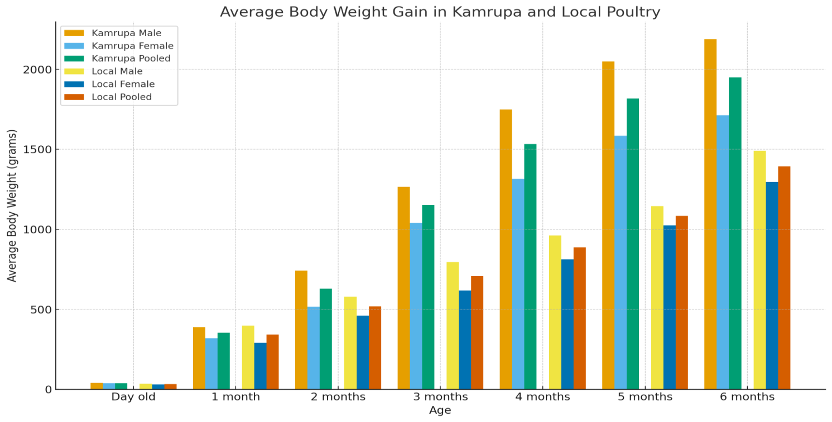
Fig 1 :Average body weight gain in Kamrupa and local poultry
Production performance
The present study was close with those reported by (Niranjan etal. Singh et al (2018) as annual egg production of 149.47± 4.46 numbers forVanaraja upto72 weeks of age and Deka et al (2016) in Srinidhi birds under farm and field conditions which closely matches the performance observed in Kamarupa birds. Similarly, Deka et al. (2016) reported comparable results in Srinidhi birds under both farm and field conditions, further supporting the present observations. In addition to egg production, Singh et al. (2018) also noted a higher average egg weigh tin Vanaraja birds, suggesting breed-specific differences in egg quality traits.However higher egg weight was recorded by Singh et al (2018) in Vanaraja birds.Sangma et.al (2022).studied macro anatomical studies on the female reproductive system of Kamarupa variety and Indigenous chicken of Assam.
The survivability percentage up to 40 weeks of age was another important performance indicator. The survivability percentage up to 40 wk of age was observed as 97.15 under farm condition. Comparable survivability rates and almost similar findings were reported by Kumaresan A et al (2008) under extensive system of management in Vanaraja birds under extensive management systems and by Singh et al. (2018) in Srinidhi birds under organized farm conditions and Singh et al (2018) in Srinidhi birds under farm condition. These results indicated that management provided at farm condition was better than traditional farming system of management. Parameters such as age at first egg, total egg production, egg weight, and survivability percentage were significantly improved under farm conditions as reported by Talukdar et.al (2020). Comparative study of various economic traits of Kamrupa and Indigenous. The mean age at sexual maturity was lower, and egg production up to 40 weeks was notably higher indicating that optimal nutrition, controlled environment, and proper health care management. Though there were no significant difference in age on first laying there was significant differences in egg production per bird per year. Saikia et .al (2023) reported that Kamarupa birds matured earlier (age at first egg ~163.06 days) and produced more eggs and heavier eggs at various ages, and Sarma, M. (2024) evaluate economic traits of Kamrupa in backyard systems matched others in survivability—highlighting its adaptability and efficiency under rural backyard management.
Table 2 : Economic traits

Parameters | Kamrupa bird | Local bird
Age at first egg laying (days) | 172.50±1.25ª | 230.68±2.50^{b}
Egg production (number /bird/ year) | 148±3.10ª | 78±1.58^{b}
32 week | 43.24±1.10ª | 34.12±1.12^{b}
40 week | 54.82±1.50ª | 39.54±1.60^{b}

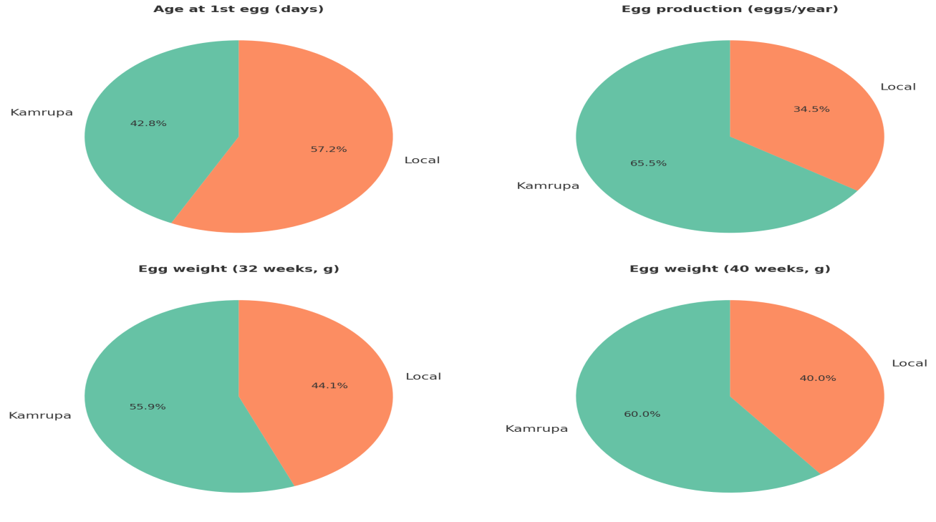
Fig 2 :Kamarupa outperforms Local in egg production, egg weight, and age at first egg
These consistent findings highlight that organized farm management ensures better survivability compared to traditional backyard farming. Overall, the results strongly suggest that scientific management practices play a pivotal role in influencing growth and reproductive performance of improved poultry varieties. Parameters such as age at first egg, total egg production, egg weight, and survivability percentage showed significant improvement under farm-based rearing systems compared to traditional backyard management. Birds reared under farm conditions
Conclusion
The comparative evaluation of Kamarupa birds with local indigenous birds clearly indicated that Kamarupa performed better in terms of body weight gain, growth rate, and survivability under farmer’s field conditions. Kamarupa birds attained higher body weight at different age intervals and exhibited faster growth compared to local non-descript birds, which generally showed slower growth and delayed maturity. The improved genetic makeup of Kamarupa, coupled with its adaptability to backyard and semi-scavenging systems, contributed to its superior performance. Although both Kamarupa and local birds were reared under similar low-input management conditions, the growth advantage of Kamarupa ensured better economic returns for farmers through higher meat yield within a shorter rearing period. Therefore, Kamarupa birds can be considered a suitable alternative to traditional local birds for enhancing livelihood, income, and nutritional security of rural households.
Disclaimer (Artificial intelligence)
Option 1:
Author(s) hereby declare that NO generative AI technologies such as Large Language Models (ChatGPT, COPILOT, etc.) and text-to-image generators have been used during the writing or editing of this manuscript.
Option 2:
Author(s) hereby declare that generative AI technologies such as Large Language Models, etc. have been used during the writing or editing of manuscripts. This explanation will include the name, version, model, and source of the generative AI technology and as well as all input prompts provided to the generative AI technology
Details of the AI usage are given below:
1.
2.
3.
References
A, AmeetaDevi ,KhumloLevish ,K ,Sonamani Singh (2025). Growth and reproductive performances of Srinidhi birds under semi intensive system of rearing. Journal of Applied lifesciences International.28 (5),26-31
Arindam Chakraborty et.al (2023) KAMRUPA Bird as Backyard Poultry: Performance EvaluationJournal of Krishi Vigyan Kendra 11 : 258-260

Kalita N, Pathak N, Ahmed M (2016) Kamrupa’- A new dual chicken variety for farmers of Assom and North-East India. Indian J Anim Sci 86 (6): 686-690.

Deka PJ, Sarma M, Nath PJ, Borgohain R, Mahanta and J, Deka B (2016) Production Performance of Vanaraja bird under traditional system of rearing in Assam. Int J Livestock Res 4(2):81-85.

Niranjan M, Sharma RP, Rajkumar U, Chatterjee RN, Reddy BL, Bhattacharya TK (2008) Comparative evaluation of production performance in improved chicken varieties for backyard farming. Int J Poul Sci 7:1128-1131.
Kumaresan A, Bujarbaruah KM, Pathak KA, Chettri B, Ahmed SK, Haunshi S. Analysis of a village chicken production system and performance of improved dual purpose chickens under a subtropical hill agro ecosystem in India. Tropical Animal Health Production. 2008; 40:395-402.
Singh,V.P.,and Pathak,V.2017.Contribution of carcass cuts in meat production of Kadaknath, Aseel and Vanraja breeds of chicken. J. Anim. Res., 7(1): 213-217.
Sangma, Mansil & Dev Choudhury, Kamal & Sarma, M. & Kalita, N. & Deka, A.. (2022). Comparative Macro Anatomical Studies on the Female Reproductive System of Kamrupa Variety and Indigenous Chicken (Gallus domesticus) of Assam during Different Stages of Laying. Indian Journal of Animal Research. 10.18805/IJAR.B-4850.
Sarma, M. (2024). Evaluating the varied economic traits of Kamrupa chickens in backyard rearing
systems of Assam. International Journal of Agriculture Extension and Social Development, 7(3), 110-112
Talukdar, R., and & Kalita, N. (2020). Comparative study of various economic traits of Kamarupa and Indigenous chicken under backyard system of rearing in Assam. Journal of Agri Search, 7(2), 106–110.

