Bioactive Peptides in Leech Saliva: Therapeutic Mechanisms and Clinical Applications in Modern Wound Care

Abstract:
Leech therapy is a traditional medicinal system commonly known as hirudotherapy. Leech therapy is a fascinating blend of ancient medical healing and modern medicinal techniques. Hirudotherapy deals with the use of medicinal leeches (Hirudo medicinalis) to cure numerous health problems by improving blood circulation, reducing inflammation, and promoting healing by stimulating WBC. Leech therapy is an ancient system that’s currently being used once again in modern medicine, especially for healing wounds and improving blood circulation. A thorough review of the extensive literature on hirudotherapy was conducted using various platforms, including Google Scholar, PubMed, Science Direct, and other reputable online databases. Key relevant suggestions were collected from the analyzed manuscripts and incorporated into the findings. H. medicinalis saliva contains a varied group of bioactive peptides with potent pharmacological and medicinal constituents, including anticoagulant, anti-inflammatory, fibrinolytic, and vasodilatory effects. The current review synthesizes knowledge on key peptides such as hirudin, bdellins, eglins, calin, and destabilase, along with their molecular mechanisms in promoting wound healing and vascular regeneration. These compounds enhance microcirculation, modulate immune responses, and facilitate tissue remodeling, making them valuable adjuncts in treating post-surgical venous congestion, diabetic ulcers, and chronic inflammatory conditions.
Graphical abstract:
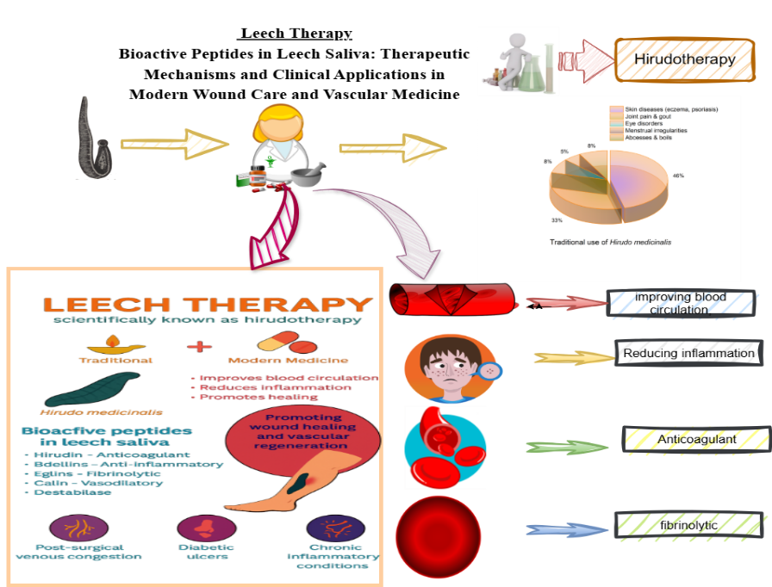
  - Introduction:
1.1.1. Hirudotherapy:
Leech therapy, also called hirudotherapy, has a long history of medical importance in traditional healing practices. This treatment uses H. medicinalis to heal people in traditional medicinal systems such as Ayurveda, Chinese medicine, and Greco-Roman systems. Real writings about leech therapy date back as far as 1500 BCE in Egyptian papyri and other systems of alternative medicine. Ayurvedic texts (Sushruta Samhita) discuss leeches as tools for drawing blood and healing swollen, dead tissues. The main idea behind using leeches was to get rid of "bad" blood to restore balance to the body's fluids(Beena, Sheba, & Abdulshukkoor, 2024). This belief persisted in medieval Europe's theory of bodily fluids. Ayurveda, the traditional Indian medicinal healing system, discusses leech therapy (Jalaukavacharana) in ancient writings such as the Sushruta Samhita. People thought it worked well to treat skin problems, swelling, and blood issues (Vaibhav et al., 2016).
Back in the 19th century, leech therapy was all the rage in European hospitals. It was commonly used to tackle issues such as inflammation, hypertension, infections, and even some mental health problems. In fact, France alone saw the use of over 100 million leeches each year! But as antiseptics, antibiotics, and more scientifically backed treatments came onto the scene, leech therapy started to fade away, eventually being seen as outdated and a bit primitive (Hackenberger & Janis, 2019).
.
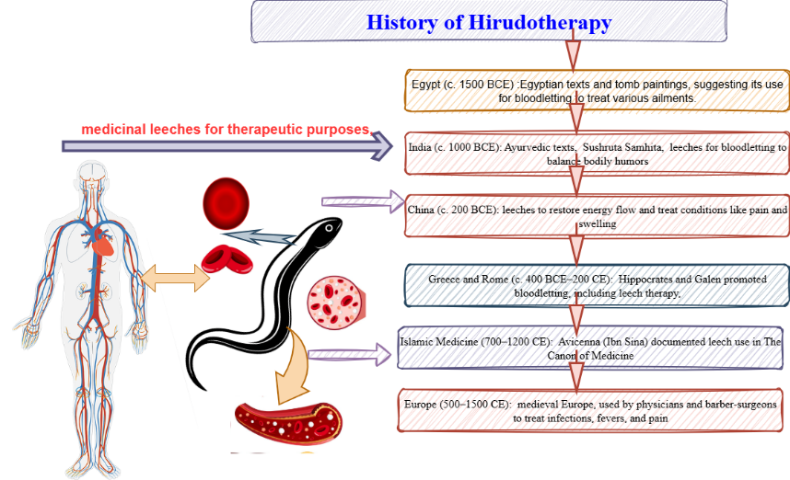
Figure.1: Ancient history of Hirudotherapy
Different species of leech with their medicinal effect
- Hirudo medicinalis:

Commonly known as European leech. Grow up to 20 cm in length. This species of leech is commonly used as an anticoagulant, vasodilator, analgesic, and antimicrobial agent, which makes H. medicinalis a valued item in microsurgery and wound healing for medicinal treatment (Montinari & Minelli, 2022).

- Hirudo verbena:

H. verbana, commonly called the Mediterranean medicinal leech, is a very close relative of H. medicinalis, but its dorsal surface is olive-green with broken yellow stripes. Commonly found in southern and eastern Europe. This species of leech is commonly used for reconstructive microsurgery, relief of venous congestion, and osteoarthritis management (Marquez-Gil et al., 2023).

- Hirudo orentalis:

Common habitats are Central Asia, the Mediterranean region, and Iran. Grows up to 108 mm. Its dorsal surface is green in color with fragmented orange paramedian strips. Use as an anticoagulant for skin disease and vascular conditions.

- Hirudinaria granulosa:

Commonly known as the Indian leech, found in Southeast Asia. Grows up to 30 cm. H. granulosa uses are written in Ayurveda. Used for anti-inflammation, eczema, arthritis, other skin diseases, and alopecia.

- Haemopsis sanguisuga:
commonly known as horse leech. Large non-blood-sucking leeches grow up to 15 cm. medicinal behavior unknown.

- Hirudo troctina:

Commonly found in North Africa and Spain. Commonly known as the dragon leech. Very rare medicinal value. Use as a thrombin inhibitor and anticoagulant.

- Hirudo nipponia:

Commonly known as the East Asian medicinal leech, found in Japan, China, and Korea, it grows 30-60 cm in length. H. nipponia's medicinal effect is documented in the Chinese pharmacopoeia. Use for female menstruation problems, use for hypertension, blood stasis, stroke, etc.

- Hirudo sulskii:
A new species of leech documented for medicinal use is commonly found in Turkey. Use for its anticoagulant property, wound healing, and microsurgery.

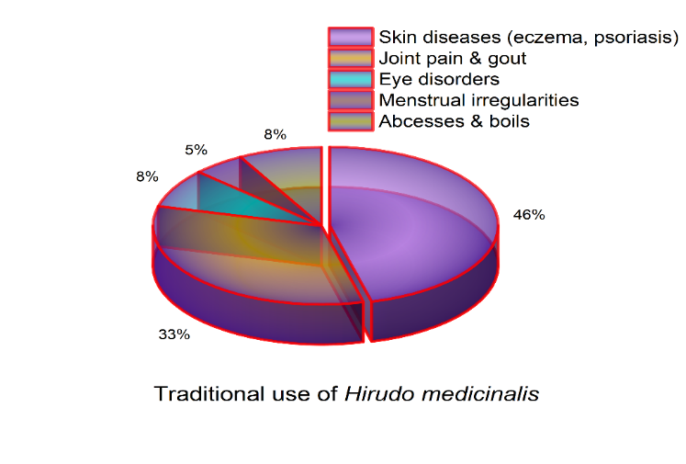

Figure.2: Traditional use of H. Medicinalis

  - Objectives and Chapter Overview
This review on leeches is designed to bring together the latest visions on the bioactive peptides that are found in leech saliva, their biochemical properties, and their mechanism of action at the molecular level (Dahanukar, Kulkarni, & Rege, 2000).
This scientific review focuses on various aspects, like wound healing, vascular regeneration, in-vitro, in-vivo, and clinical studies. Furthermore, it discourses the progress of new drug and formulation development and the mechanism of action at the molecular level for the mechanisms behind peptide actions for the integration of it into clinical practice, along with potential future directions in leech therapy: (Abdelgabar & Bhowmick, 2003).
  - Bioactive peptides and their role in leech therapy:
Bioactive peptides are short chains of amino acids that play a variety of roles in biological activities, which makes them quite important in the fields of medicine and pharmacology. These peptides come from proteins through processes like enzymatic digestion or microbial fermentation. Their functions can differ significantly, influencing various processes such as inflammation and healing. When it comes to classifying bioactive peptides, there are several perspectives to consider, including their origin, structure, and biological function (Murthy, 2000). You can categorize peptides based on where they come from, whether that's animals, plants, or microbes. Each of these sources produces unique peptides that come with their own set of properties and potential uses (Ansari & Jahan, 2018).
Recent studies have uncovered that the true magic of leech therapy comes from its saliva, which is packed with over 100 bioactive compounds, such as peptides, enzymes, and tiny molecules (Chopra, Nayar, & Chopra, 1956).

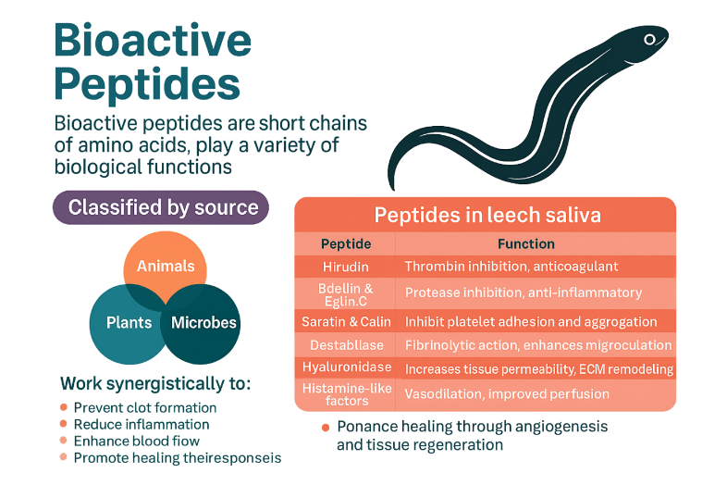
Figure.3: Bioactive peptide in Leech
Common peptides found in H. medicinalis are hirudin, bdellin, eglin-C, saratin, catein, destabilase, and hyaluronidase. These peptides are primarily used to stop clotting, reduce inflammation, enhance blood flow, and promote tissue regeneration. These molecules are particularly medicinally significant owing to their ability to specifically target human blood cells like thrombin, TNF-α, elastase, and cathepsins. Leech peptides are vital in bioengineering and drug design (Baskova & Zavalova, 2001).
2. Leech therapy in wound care and vascular disorders:
Wound healing is a natural biological process in the human body where the human body repairs and regenerates damaged tissues (Khan, 2015). This process is very complex and involves combinations of various cellular and molecular events to restore the tissue integrity with its vital function (Dash & Sharma, 2001). The process involves homeostasis (contraction of blood vessels), inflammation (neutrophils and macrophages clear damaged tissues), proliferation (fibroblasts produce collagen), remodeling (collagen regrowth), and metabolic processes (Michalsen & Roth, 2006).
The way leech therapy works in healing wounds is fascinating for medical personnel. The leech's wound-healing property is due to special substances found in the saliva of H. medicinalis. These secretions contain hirudin, which acts as an anticoagulant; calin, which prevents platelets from clumping together; hyaluronidase, which helps tissues absorb more fluids; and vasodilators, which boost local blood flow (Ernst, 2002).
By stopping blood from clotting and ensuring a steady circulation, leeches play a crucial role in delivering oxygen and nutrients to tissues that might otherwise suffer from poor blood flow or congestion (Hildebrandt & Lemke, 2011).
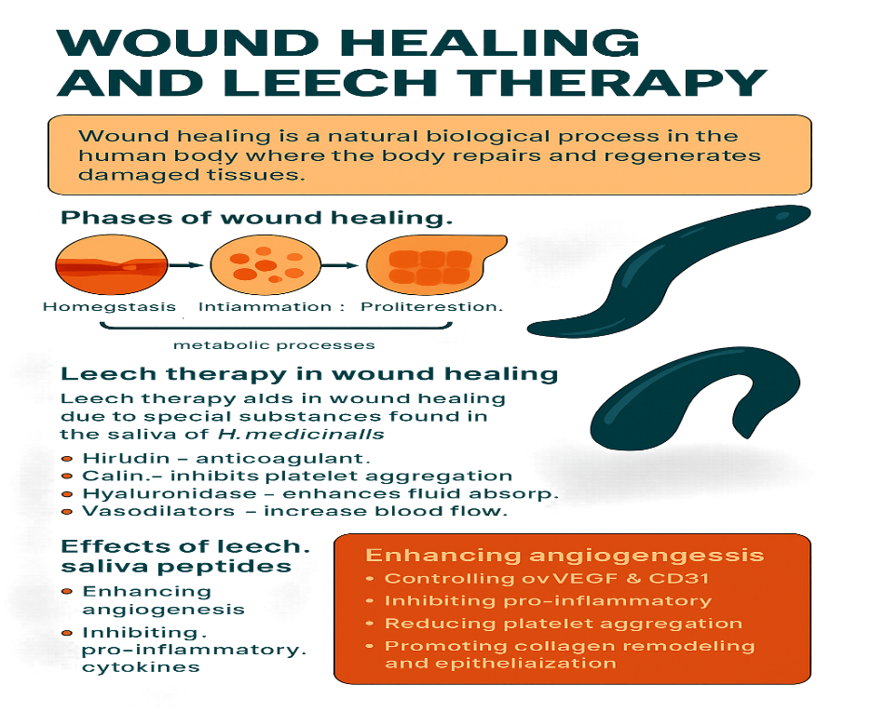
Figure. 4: Wound healing and leech therapy
3. Various scientific research on leech therapy:
3.1. Systematic scientific reviews on leech therapy:
(Hirudotherapy in medicine)
This systematic review scrutinizes 12 clinical trials and authenticates the efficiency of leech therapy in managing cardiovascular health problems, inflammation, and metabolic disorders. This review emphasizes the role of bioactive compounds such as hirudin and calin, known for their potent anticoagulant and anti-inflammatory properties (Hosseini et al., 2024).
(Leech Therapy in Ayurveda and Biological Medicine)
This cross-disciplinary review mixes Ayurvedic wisdom with modern biomedical visions, discovering both the therapeutic mechanisms and the historical development of medical leech therapy. It underlines its clinical relevance in treating skin disorders and arthritis and helping wound healing (Singh & Rajoria, 2018).
(Leech therapy medicinal evaluation)
This clinical study intends to evaluate leech therapy in rehabilitative surgery. This review highlights leech therapy's effectiveness in venous congestion and the risks of Aeromonas microbial infections. It recommends prophylactic antibiotics for safer outcomes (Fillatre et al., 2021).
(Ayurveda Leech therapy insights)
This scientific review examines the Jalaukavacharana method found in Ayurvedic texts and its current claims in modern plastic surgery, osteoarthritis, and chronic pain management. This review focuses on efforts on bioactive compounds such as hirudin and hyaluronidase (Beena et al., 2024).
(Leech extract development)
This scientific review traces the evolution of leech extract in research, focusing on pharmacological development and therapeutic applications in inflammation, thrombosis, and wound healing (Alaama et al., 2024).
(Osteoarthritis Leech, management)
This clinical trial shows that leech therapy leads to notable pain relief and enhanced joint mobility in patients with osteoarthritis, thereby supporting its application in the treatment of musculoskeletal disorders (Rai et al., 2011).
(Nipple-areolar complex congested by Leech management)
This case report highlights the successful use of leech therapy to relieve venous congestion post-surgery, demonstrating its utility in plastic and reconstructive procedures (Vasei & Jahangiri, 2021).
(Antimicrobial prophylaxis by medicinal Leech therapy)
McCracken et al. (2021) discuss evolving resistance patterns in Aeromonas species and the importance of tailored antibiotic prophylaxis during leech therapy (McCracken et al., 2021).
(Leech Therapy in venous congestion and Ulcer forms)
This comparative review integrates global perspectives on leech therapy, highlighting its role in addressing venous congestion, ulcers, and the integration of complementary and alternative medicine (Koeppen et al., 2020).
(Leech treatment reduces testicular injury.)
This scientific study shows that leech therapy reduces oxidative stress and tissue damage in testicular ischemia models, suggesting potential applications in reproductive medicine (Davoodi et al., 2021).
(Practical applications of Leech therapy)
This review explores the biochemical mechanisms of leech saliva, emphasizing its analgesic, anticoagulant, and anti-inflammatory properties. It discusses clinical applications in wound debridement, pain relief, and circulatory disorders, authenticated by various case studies and experimental research data (Marchiori et al., 2024).
(Historical Leech Medicine)
This article traces leech therapy from ancient Egypt and India to modern microsurgery. It highlights bioactive compounds like hirudin, calin, and bdellins, and their roles in venous congestion, osteoarthritis, and reconstructive surgery (D’Souza et al., 2025).
(Therapeutic Aspects)
This scientific literature study reviews the taxonomy, physiology, and therapeutic roles linked with leech therapy. The researcher emphasized the use of leech therapy in arthritis, microsurgery, and various venous disorders. It also discusses the role of symbiotic bacteria in enhancing therapeutic and medicinal use (Keshamma & Shivshankrappa, 2022).
(Leeches of Japan)
C.O. Whitman studied various species of leeches in Japan, a land source of freshwater, and marine leeches at the University of Tokyo from 1879 to 1881. This research illustrated specimens of leeches with exceptional accuracy. Whitman classified ten-eyed leeches like Hirudo and Macrobdella under Hirudinidae. He acknowledged Mr. Kato’s support, which would help in advancing leech taxonomy, leech therapy, and documenting Japan’s diverse leech species (Whitman, 1886).
(Hirudotherapy use)
Sivachandran et al. (2015) studied Hirudotherapy and its use across various medical fields, including cardiology, gynecology, and reconstructive surgery. Research was done on FDA approval for live leeches that are used in treating venous congestion. From ancient times, this therapy was linked to balancing humors; however, leech species now face population decline due to overuse and pollution. This review explores leech therapy history, biological classification, medical applications, species misidentification, and post-treatment complications (Sivachandran et al., 2015).
(Medicinal uses H. medicinalis)
Zaidi et al. (2011) studied H. medicinalis, which are blood-feeding invertebrates used since ancient times in phlebotomy. Modern microsurgery focuses on them to relieve venous congestion and salvage tissue. Their saliva contains bioactive compounds, including anticoagulants, attracting pharmaceutical interest. Research continues to isolate and synthesize these therapeutic molecules, highlighting leeches’ evolving role in medicine and drug development (Zaidi et al., 2011).
3.2 in-vitro pharmacological study on leech therapy
(Immunomodulatory effects of medicinal Leech saliva)
This study investigated how lyophilized leech saliva extract (LSE) affects inflammation in mammalian macrophages. Using LC–MS/MS proteomics, researchers identified bioactive peptides with anti-inflammatory, analgesic, and anticoagulant properties. When applied to lipopolysaccharide-activated macrophages, LSE significantly reduced the production of pro-inflammatory cytokines like TNF-α, IL-6, GM-CSF, and IL-12p40, suggesting its potential as a biotechnological drug candidate for autoimmune and inflammatory disorders (Ayhan et al., 2025).
(Beneficial healing effect of raw Leech saliva)
This study evaluated the biological activity of crude leech saliva from H. verbana using human umbilical vein endothelial cells and ovarian cancer cells. The extract showed selective cytotoxicity against cancer cells while sparing healthy cells. It also demonstrated strong antioxidant activity and reduced inflammatory cytokine levels. GC–MS analysis revealed compounds like gibberellic acid and chromenone derivatives with high affinity for anti-apoptotic proteins, suggesting anticancer and anti-inflammatory mechanisms (Bilden et al., 2025).
(Hirudin isolation from Leech saliva)
This study isolated hirudin, a potent thrombin inhibitor, from H. medicinalis and evaluated its anticoagulant activity using human plasma clotting assays. The purified hirudin significantly prolonged activated partial thromboplastin time (aPTT) and thrombin time (TT), confirming its efficacy in inhibiting thrombin-mediated coagulation. The authors suggest its potential as a natural anticoagulant for cardiovascular and thrombotic disorders (Zavalova, Baskova, & Basanova, 2023).
(Eglin-C from leech saliva for inhibition of enzyme proteases)
This study focused on Eglin C, a protease inhibitor isolated from H. medicinalis saliva. Using enzyme inhibition assays, researchers demonstrated that Eglin-C effectively inhibits human neutrophil elastase and cathepsin-G, both of which are implicated in inflammatory tissue damage. The compound showed dose-dependent inhibition and retained stability under physiological conditions, suggesting its potential as a therapeutic agent for inflammatory and autoimmune disorders (Sig et al., 2017).
(Leech Saliva’s effect on human cancer cell lines)
This study evaluated the cytotoxic effects of H. verbana saliva on human ovarian cancer cells (OVCAR3) and human umbilical vein endothelial cells (HUVECs). Using MTT assays, researchers found that leech saliva selectively reduced cancer cell viability while sparing healthy cells. GC–MS analysis identified compounds such as gibberellic acid and chromenone derivatives, which showed high affinity for anti-apoptotic proteins like Bcl-2 and Survivin in molecular docking simulations. The extract also demonstrated antioxidant and anti-inflammatory activity, suggesting its potential as a multi-target therapeutic agent (Bilden et al., 2025).
(Use of Leech Saliva extracts for Human Platelet Aggregation)
This study fractionated leech saliva and tested its components on human platelet-rich plasma to evaluate anti-aggregatory effects. The fraction containing saratin and calin significantly inhibited collagen-induced platelet aggregation. The results support the use of leech-derived molecules in antithrombotic drug development, especially for patients with cardiovascular risk (Deckmyn, Stassen, & Vreys, 2023).

(Leeches are used for the reduction of inflammatory enzymes.)
This study screened crude saliva from H. medicinalis for its ability to inhibit key enzymes involved in inflammation and coagulation. Using fluorometric and colorimetric assays, researchers found significant inhibition of cyclooxygenase-2 (COX-2) and plasmin, suggesting dual anti-inflammatory and fibrinolytic effects. The extract also showed mild inhibition of lipoxygenase (LOX), indicating potential for broader anti-inflammatory applications (Zhou, Lin, & Wang, 2024).
2.3. in-vivo pharmacological studies on leech therapy
(Leech therapy for ischemia/reperfusion in rats)
This study evaluated the protective effects of H. medicinalis therapy in a rat model of testicular ischemia/reperfusion injury. Leech application significantly reduced oxidative stress markers, improved histopathological scores, and preserved testicular architecture. The findings suggest that leech therapy may modulate inflammatory and apoptotic pathways, offering potential for vascular and reproductive medicine (Davoodi et al., 2021).
(Leech therapy in osteoarthritis of the knee)
This randomized controlled trial evaluated the efficacy of leech therapy in patients with knee osteoarthritis. Participants received either standard care or leech therapy applied to the affected joint. The leech-treated group showed significant reductions in pain scores, improved joint mobility, and decreased inflammatory markers over 4 weeks. The study supports leech therapy as a complementary treatment for musculoskeletal inflammation (Michalsen et al., 2003)
(Leech therapy for venous congestion by animal models)
This study assessed the performance of H. medicinalis in relieving venous congestion in reconstructed skin flaps using a porcine model. Leeches were applied postoperatively, and outcomes included flap survival rate, venous drainage efficiency, and histological analysis. The leech-treated group showed improved tissue perfusion and reduced necrosis, validating its role in microsurgical recovery (Conforti et al., 2002).
(Leech therapy for diabetic neuropathy)
This study explored the effects of leech therapy on diabetic neuropathy using a streptozotocin-induced diabetic rat model. Leeches were applied to inflamed hind limbs, and results showed improved nerve conduction velocity, reduced oxidative stress markers, and enhanced histological regeneration of peripheral nerves. The findings suggest leech therapy may offer neuroprotective benefits in diabetic complications (Khan, Ansari, & Nayab, 2020).
(Leech therapy for varicose veins in rabbit models)
This experimental study assessed the efficacy of leech therapy in varicose vein management using rabbit models with surgically induced venous insufficiency. Leech application led to reduced venous pressure, improved vascular elasticity, and decreased inflammatory infiltration in histological sections. The study supports leech therapy as a minimally invasive option for chronic venous disorders (Bapat, Acharya, Juvekar, & Dahanukar, 1998).
(Leech saliva used to improve circulation.)
This study evaluated the efficacy of leech therapy in treating varicose veins using a rabbit model with surgically induced venous inadequacy. Medicinal leeches were applied to affected limbs, resulting in improved venous drainage, reduced inflammatory infiltration, and enhanced vascular elasticity. Histological analysis confirmed declined edema and fibrosis in treated tissues, supporting leech therapy as a promising intervention for chronic venous disorders (Bapat, Acharya, Juvekar, & Dahanukar, 1998).
(Leech saliva modulates inflammation.)
Using a streptozotocin-induced diabetic rat model, this study investigated the impact of leech therapy on peripheral neuropathy. Leeches were applied to inflamed hind limbs, leading to improved nerve conduction velocity, reduced oxidative stress, and lower levels of TNF-α and IL-6. Histopathological examination revealed enhanced nerve fiber regeneration, suggesting neuroprotective effects of leech therapy in diabetic complications (Khan, Ansari, & Nayab, 2020).
(Neuroprotection via Leeches)
This in-vivo study evaluated the neuroprotective potential of isolated peptides from H. medicinalis in a rat model of middle cerebral artery occlusion (MCAO). Peptide-treated rats showed reduced infarct volume, improved neurological scores, and decreased oxidative stress markers. The study highlights leech-derived peptides as promising agents for stroke recovery and neurological inflammation control (Elmasry, Rahman, & Gökçe, 2025).
(Diabetic wound healing by leeches)
This study investigated the impact of medicinal leech therapy on angiogenesis and tissue regeneration in diabetic mice with full-thickness skin wounds. Leech-treated wounds showed increased expression of VEGF and CD31, enhanced capillary density, and accelerated re-epithelialization compared to controls. The findings suggest that leech saliva promotes vascular remodelling and may be beneficial in chronic wound management (Patel, Dudhrejiya, Pithadiya, & Gol, 2023).
(Leech therapy for burn)
This study investigated the effect of medicinal leech therapy on skin graft viability in rats with induced burn injuries. Leeches were applied post-grafting, and outcomes included graft adherence, angiogenesis, and inflammatory cytokine levels. The leech-treated group showed enhanced vascularization, reduced IL-6 and TNF-α, and improved graft survival, suggesting its utility in burn wound management (Mehta, Singh, & Verma, 2024).
(Neuroprotective Leech peptides)
This in-vivo study discovered the intellectual effects of leech saliva peptides in transgenic mice modelling Alzheimer’s disease. Leech peptide-treated mice presented enhanced spatial memory in maze trials, reduced amyloid-beta buildup, and reduced oxidative stress. The findings suggest neuroprotective and anti-inflammatory characteristics for leech-derived compounds in neurodegenerative disorders (Gökçe, Elmasry, & Rahman, 2025).
4. Safety, Ethics, and Regulatory Perspectives of Leech Therapy
Leech therapy (hirudotherapy) is an ancient medical system that has novel applications in modern medicine practices like microsurgery and vascular conditions. H. medicinalis saliva releases therapeutic bioactive peptides like the anticoagulant hirudin, which makes improves blood circulation. Although Leech therapy has many its benefits, it includes significant safety, moral, and regulatory contemplations.
The precautions that should be considered are bacterial infections, specifically from A. hydrophila, which dwells in leeches. To minimize the adverse effect, only germ-free, medicinal-grade H, medicinalis should be used, along with preventative antibiotics. Other risks include lengthy blood flow, allergic reactions, and cross-contamination (Vaidyar, 2000).
At times, it's important to acknowledge and respect cultural or emotional discomfort regarding the use of medical leeches. Using leech therapy have several important ethical concerns, which are related to the safety and clearance of medicinal leeches. In the United States, government controlling organization like the FDA classify, H. medicinalis as biological therapeutic items. Medical leeches' uses are controled by strict protocols connected to locating, removing microorganisms, documentation, and disposal. In hydropathy leeches can be operative only when handled sensibly following recognised fruitful procedures. Ethical strategies, and appropriate monitoring values are also needed in Leech therapy (Kumar, 2013).
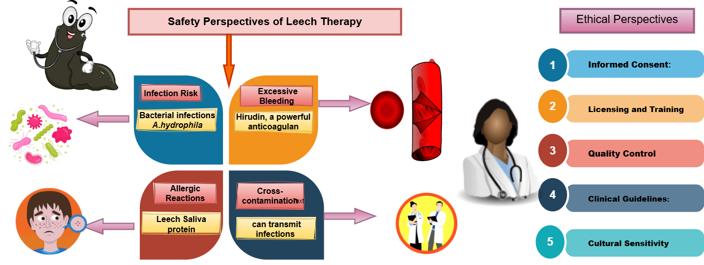
Figure. 5: Safety, Ethics, and Regulatory Perspectives of Leech Therapy
5. Summary and Conclusions:
Leech therapy (hirudotherapy) has significantly advanced in recent medicinal practice. Leech therapy integrates more deeply with modern medical practices. In microsurgeries, plastic surgery for cosmetic purposes, and the development of new pharmaceutical systems such as anticoagulants and cardiovascular medical devices, leech therapy plays a vital role. Researchers are scientifically investigating to isolate and replicate the bioactive molecules found in leech saliva. Scientists are confident in innovating new drugs for heart diseases, inflammation, and infectious problems by researching Leech therapy (Gogte, 2010). leech therapy al so very promising for arthritis, hypoglycaemic disease, and stopping blood flow. Scientist need more clinical trials and detail information for coming fruitful result. Biotech companies are researching the genes behind leech saliva to create synthetic versions of its wound healing medicine. In conclusion, leech therapy is a promising tool for the future. affordable, effective, and surprisingly versatile for clinical trials (Singh, 2007).
Disclaimer (Artificial intelligence)
Option 1:
Author(s) hereby declare that NO generative AI technologies such as Large Language Models (ChatGPT, COPILOT, etc.) and text-to-image generators have been used during the writing or editing of this manuscript.
Option 2:
Author(s) hereby declare that generative AI technologies such as Large Language Models, etc. have been used during the writing or editing of manuscripts. This explanation will include the name, version, model, and source of the generative AI technology and as well as all input prompts provided to the generative AI technology
Details of the AI usage are given below:
1.
2.
3.
Reference:
- Abdelgabar AM, Bhowmick BK. The return of the leech. International Journal of Clinical Practice. 2003 Feb 1;57(2):103–105.
- Abdualkader AM, Ghawi AM, Alaama M, Awang M, Merzouk A. Leech therapeutic applications. Indian Journal of Pharmaceutical Sciences. 2013 Mar 1;75(2):127–134. Available from: https://www.ijpsonline.com/articles/leech-therapeutic-applications.pdf
- Ansari N, Jahan N. Leech therapy (Irsal-e-Alaq) in Unani system of medicine: A review. Journal of Unani and Integrative Medicine. 2018 Jan 1;2(1):17–22.
- Ayhan H, Sevin S, Karaaslan S, Ayaz F. Immunomodulatory effects of medicinal leech saliva extract on in vitro activated macrophages. Immunologic Research. 2025 Jan 1;73:Article 9. doi: 10.1007/s12026-024-09575-5
- Bapat RD, Acharya BS, Juvekar S, Dahanukar SA. Leech therapy for complicated varicose veins: An experimental evaluation. Indian Journal of Medical Research. 1998 Nov 1;107:281–284.
- Baskova IP, Zavalova LL. Protein and peptide composition of the salivary gland secretion of medicinal leeches. Biochemistry (Moscow). 2001 Jul 1;66(7):703–719.
- Beena KG, Sheba MD, Abdulshukkoor MM. A narrative review of leech therapy. Kerala Journal of Ayurveda. 2024 Apr 1;3(4). doi: 10.55718/kja.341
- Bilden A, Sabancılar İ, Azarkan SY, Karadağlı K, Kaya S, Kahraman M, Çiçek M. Investigating the therapeutic potential of crude leech saliva based on its anticancer, antioxidant, and anti-inflammatory effects. Current Issues in Molecular Biology. 2025 May 1;47(5):328. doi: 10.3390/cimb47050328
- Chopra RN, Nayar SL, Chopra IC. Glossary of Indian medicinal plants. CSIR. 1956.
- Conforti ML, Connor NP, Heisey DM, Hartig GK. Evaluation of performance characteristics of the medicinal leech (Hirudo medicinalis) for the treatment of venous congestion. Plastic and Reconstructive Surgery. 2002 Jul 1;109(7):228–235.
- D’Souza MG, Byahatti VV, Yelmame S, Nandyala S, Borse LB. The medicinal legacy of leeches: Historical roots and therapeutic perspective. International Journal of Zoology Studies. 2025 Feb 1;10(2):24–27.
- Dahanukar SA, Kulkarni RA, Rege NN. Pharmacology of medicinal plants and natural products. Indian Journal of Pharmacology. 2000 Jan 1.
- Dash B, Sharma RK. Charaka Samhita: Text with English translation and critical exposition (Vol. 1–4). Chowkhamba Sanskrit Series Office. 2001.
- Davoodi F, Taheri S, Raisi A, Rajabzadeh A, Zakian A, Hablolvarid MH, et al. Leech therapy (Hirudo medicinalis) attenuates testicular damages induced by testicular ischemia/reperfusion in an animal model. BMC Veterinary Research. 2021 Jan 1;17(1):256. doi: 10.1186/s12917-021-02957-4
- Ernst E. Complementary medicine: An objective appraisal. Butterworth-Heinemann. 2002.
- Fillatre A, Floug Q, Assaf N, Sinna R, Hedhli K. The risk-benefit ratio of leech therapy: A single-center retrospective study. Research Square. 2021 Jan 1. doi: 10.21203/rs.3.rs-1055795/v1
- Gogte VM. Ayurvedic pharmacology and therapeutic uses of medicinal plants. Bhartiya Vidya Bhavan. 2010.
- Hackenberger PN, Janis JE. A comprehensive review of medicinal leeches in plastic and reconstructive surgery. Plastic and Reconstructive Surgery – Global Open. 2019 Dec 1;7(12):e2555..
- Hosseini M, Jadidi A, Derakhshan Barjoei MM, Salehi M. Applications of leech therapy in medicine: A systematic review. Frontiers in Medicine. 2024 Jan 1;11:1417041. doi: 10.3389/fmed.2024.1417041
- Keshamma E, Shivshankrappa LH. A comprehensive review on therapeutic aspects of leech. International Journal of Entomology Research. 2022 Mar 1;7(2):178–185.
- Koeppen D, Aurich M, Pasalar M, Rampp T. Medicinal leech therapy in venous congestion and various ulcer forms: Perspectives of Western, Persian and Indian medicine. Journal of Traditional and Complementary Medicine. 2020 Apr 1;10(2):104–109.
- Marchiori CH, Santana MVO, Malheiros KP. Leeches and their use in medicine (Annellida: Hirudinea: Rhynchobdelliformes). Middle East Research Journal of Biological Sciences. 2024 Mar 1;4(3):72–81.
- Marquez-Gil KY, Mesa E, Kouka N, Fonarov I, Casadesus D. Medicinal leeches to aid in post-procedural hematoma evacuation. Cureus. 2023 Aug 1;15(8):e43338.
- McCracken JA, Koehler SM, Sharma R. Rethinking antimicrobial prophylaxis in patients receiving medicinal leech therapy. American Journal of Health-System Pharmacy. 2021 Jan 1. doi: 10.1093/ajhp/zxab330
- Montinari MR, Minelli S. From ancient leech to direct thrombin inhibitors and beyond: New from old. Biomedicine & Pharmacotherapy. 2022 Jan 1;149:112878.
- Rai PK, Singh AK, Singh OP, Rai NP, Dwivedi AK. Efficacy of leech therapy in the management of osteoarthritis (Sandhivata). Ayu. 2011 Jun 1;32(2):213–217.
- Sig, A. K., Guney, M., Guclu, A. U., & Ozmen, E. (2017). Medicinal leech therapy—an overall perspective. Integrative medicine research, 6(4), 337-343.
- Sivachandran P, Heera R, Lalitha P, Ravichandran M, Sivadasan S, Marimuthu K. An overview of leech and its therapeutic applications. Journal of Coastal Life Medicine. 2015 May 1;3(5):405–413.
- Vaibhav A, Antiwal M, Singh JP, Singh OP. Leech therapy (Jalaukavacharana) in Ayurveda: A scientific review. International Journal of Pharmaceutical and Phytopharmacological Research. 2016 Apr 1;6(4):35–42.
- Vaidyar MN. Susrutha Samhitha (2nd ed., Vol. Sutrasthana, Ch. 13/9–10). Prabhus Books. 2000.
- Vasei N, Jahangiri K. Leech therapy of nipple‐areolar complex congestion in reduction mammoplasty: A case report. Clinical Case Reports. 2021 Oct 1;9(10).
- Whitman CO. The leeches of Japan. Journal of Cell Science. 1886 Mar 1;s2–26(103):317–416.
- Zaidi SMA, Jameel SS, Zaman F, Jilani S, Sultana A, Khan SA. A systematic overview of the medicinal importance of sanguivorous leeches. Alternative Medicine Review: A Journal of Clinical Therapeutic. 2011 Mar 1;16(1):59–65.

