From Nutritional Value to Safety: Sub-acute Toxicity Assessment of Gnetum gnemon L. Methanolic Leaf Extract in Swiss Albino Mice

ABSTRACT

Aim: The aim of the study was to estimate the nutrient content, bioactive compounds, and safety of Gnetum gnemon (GG) methanolic leaf extract to determine its usefulness as a functional food source and a therapeutic agent.
Study Design: The experiment consisted of proximate analysis, LC-MS profiling, and in vivo toxicity measurement of Swiss albino mice.
Place and Duration of the study: The present study is an experimental study conducted in a laboratory in the Department of Zoology, Cotton University, between February 2025 and June 2025
The Methodology: The methanolic leaf extract of GG was analysed for moisture, protein, fat, fiber, ash, and carbohydrate content.LC-MS was carried out to determine bioactive phytochemicals. To evaluate safety, three mice groups were used, Group I (Control), Group II (200mg/kg bw) and Group III (400mg/kg bw) dose of methanolic leaf extract, were assessed for haematological (WBC, RBC, Hb, HCT, MCV, MCH, MCHC, platelets, and PCV) and biochemical (ALT, AST, creatinine, and urea) parameters. Data are represented as mean ± SEM (n = 5) and analysed using one way ANOVA with Bonferroni test; p < .05 value was considered significant.

. Data are represented as mean ± SEM (n = 5), and a p < 0.05 value is considered significant.
Results: In this study, proximate analysis of the methanolic leaf extract showed that it has high carbohydrate (85.40 ± 0.50%) and protein levels (17.30 ± 0.30%) and but the extract has low fat (3.05 ± 0.10%) and moisture (65.20 ± 0.25%) contents. Bioactive compounds found in LC-MS analysis were stilbenoids such as resveratrol (m/z 227.13) and gnetin C (m/z 453.30). There were no changes in hematological and biochemical parameters, and no anaemia, immunotoxicity, hepatotoxicity, or nephrotoxicity was found in the mice bodies.
Conclusion: GG methanolic leaf extract is not only nutritionally useful, but it also contains strong biological phytochemicals, is haematologically and biochemically safe, and is useful in nutrition as a functional food and safe therapeutic agent.

Keywords: Gnetum gnemon; LC-MS; nutritional value; Swiss albino mice; toxicity

1. INTRODUCTION
Plants have been used since ancient times not only as food sources but also as an aid in the development of flavors and the treatment of disease(Salmerón-Manzano et al., 2020;Sun & Shahrajabian, 2023). Various parts of plants, such as seeds, leaves, flowers, fruit, stems, and roots, are rich in phytochemicals, and these parts are all related to the medicinal and nutritional properties of plants(Chanda & Ramachandra, 2019). Compounds including flavonoids, alkaloids, terpenoids, stilbenoids, and phenolic acids are particularly significant, as they have been shown to contribute to therapeutic benefits through their antioxidant, anti-inflammatory, antimicrobial, antibacterial, and anticancer activities(Dar et al., 2023). Due to these characteristics, the role of plants is increasingly becoming appreciated, contributing to health promotion and the prevention of diseases(Hossain et al., 2025).
Gnetum gnemon is a plant belonging to the genus Gnetum and family Gnetaceae, the only genus in this family consisting of tropical evergreen trees, shrubs, and climbers found in lowland areas in Northeast South America, tropical West Africa, China, and Asia(Yang et al., 2017;Jin et al., 2020). They have traditionally been used in foods like soups, stews, and salads, as well as having some medicinal purposes, in their leaves and seeds(Huong et al., 2025). These properties endow Gnetum species with nutritional as well as medical potential, especially as sources of functional foods (Tatefuji et al., 2014). In addition to these characteristics, the safety profile of G. gnemon analysis was also an important part of this study. Most plants possessing medicinal properties have negative effects when used at high doses or for a long period (Vonica et al., 2014). Thus, toxicological investigations should be conducted to ascertain the exact harmful impact of this extract. Only basic results can be obtained from acute toxicity studies, whereas data from sub-acute studies can be more specific as they study the effects of repeated dosing, which may produce cumulative and/or time-released toxicities.
The present study aimed to investigate the sub-acute toxicity of G. gnemon methanolic leaf extract to Swiss albino mice. This is an essential step for demonstrating its safety as a nutritional and medicinal plant.
2. materials and Methods

2.1 Extraction of plant material

Fresh leaves of Gnetum gnemon L. were collected from Chala village, Charaideo district, authenticated by a taxonomist from the Department of Botany, Guwahati University, with voucher specimen No. (No. GUBH20508), and washed thoroughly with distilled water. The leaves were shade-dried at room temperature, powdered using a mechanical grinder, and stored in airtight containers until use. 100 grams of powdered Gnetum gnemon L. leaves were ground and placed in an amber conical flask containing 500 mL of methanol, then macerated for three days(Abubakar & Haque, 2020). The extraction mixture was periodically filtered through muslin cloth at 24-hour intervals to maximize yield. After maceration, the extract was filtered using Whatman filter paper, and the solvent was removed using a rotary evaporator under reduced pressure. Residual methanol was further dried in an oven at a temperature not exceeding 45°C for at least 48 hours to ensure complete removal. The dried extract was stored in an amber glass bottle at 4°C until further use(Wado et al., 2022).

2.2 Nutritional composition analysis

The proximate composition of Gnetum gnemon leaves, including carbohydrate, protein, crude fiber, moisture, ash, and fat content, was determined as mentioned by (Abdulkadir et al., 2016) and (Habtamu et al., 2018). Moisture content was measured using the hot air oven method by drying the leaf samples until a constant weight was obtained at 105°C. Crude protein was determined by the Kjeldahl procedure. Total fat was quantified through acid hydrolysis, employing a Soxhlet extractor containing petroleum ether at 60°C until it reached a steady weight. The enzymatic-gravimetric procedure was used to estimate dietary fiber. Leaves were successively treated with 1alpha-amylase, protease, and amyl glucosidase at 60°C, precipitated by ethanol with fiber. Ash content was identified using the gravimetric technique by combustion of dried leaf samples in a muffle furnace at 550°C until a constant weight was obtained. The percentage of carbohydrates in methanolic leaf extract was calculated by difference according to, using the formula: % Carbohydrate=100− (% Moisture+% Protein+% Fat+% Crude Fiber+% Ash).

2.3 LC-MS analysis

Phytochemical profiling of Gnetum gnemon methanolic leaf extract was performed using an A 6410 Triple Quadrupole LC/MS system (Agilent Technologies, USA) with a liquid autosampler at Biotech Park, Guwahati, Assam, India. Chromatographic separation technique was carried out on a 1260 Infinity High-Performance Liquid Chromatography (HPLC) system, Agilent Technologies, USA. The HPLC was equipped using a liquid autosampler for analytical and preparative purposes. The LC–MS system allows simultaneous liquid chromatographic separation and mass spectrometric detection. It is suitable for the quantification of trace organic compounds, macromolecules, and bioactive metabolites. The mass spectrometer scanned a mass range of m/z 15–1650 amu using electrospray ionization (ESI) in positive and negative modes. Compounds were tentatively identified based on retention times, m/z values, and comparison with spectral databases.

2.4 Experimental animals

Mature Swiss albino male and female mice weighing 25-30g were acclimatized to laboratory conditions at least 2 weeks before the experiment. The mice were kept in groups of five in clean metal cages with a controlled temperature of 22 ± 20°C, relative humidity of 50-60 %, and a 12-hour light-dark cycle(Thummar et al., 2016;Elyasi et al., 2022). All experiments were carried out in the light phase according to the requirements of the Institutional Animal Ethics Committee. The mice were marked with identifiers on the tail and given standard rodent food and water ad libitum. This study was approved by the Animal Ethical Committee of Cotton University (Reg. No. 15/IAEC/CU/05/01/2021).

2.5 Sub-acute toxicity study

Methanolic leaf extract of Gnetum gnemon (GG) sub-acute oral toxicity was determined based on (OECD, 2008) guideline 407 in male and female Swiss albino mice. The mice were subjected to a 7-day acclimatization period followed by the grouping of the animals into two groups (n = 5). Group I was given vehicle control (PBS), and GG was administered to Group II and Group III at 200 mg/kg bw and 400mg/kg bw doses. Oral administration was done after an overnight fast in the mice. Animals were closely monitored within 1 hour of treatment, monitored at regular intervals up to 4 hours, and once a day for 28 days. At the end of the 28 days, the mice were sacrificed, and blood samples were obtained. Then, the blood and serum samples were used to examine hematological and biochemical parameters(Wahyuni et al., 2017).

2.5.1 Hematological and biochemical parameter analysis

Blood samples collected from mice were collected in EDTA-coated tubes and analyzed using a Mindray hematology analyzer. The parameters measured included white blood cells (WBC), red blood cells (RBC), hemoglobin (Hb), hematocrit (HCT), mean corpuscular volume (MCV), mean corpuscular hemoglobin (MCH), mean corpuscular hemoglobin concentration (MCHC), platelet count (PLT), and packed cell volume (PCV) (Abdou et al., 2019;Edem & Okokon, 2025).Biochemical analysis of serum samples was carried out using an automated chemistry analyzer (COBAS INTEGRA 800 Autoanalyzer (Roche Diagnostics, Germany). The parameters measured included alanine aminotransferase (ALT), aspartate aminotransferase (AST), creatinine, and urea (Loha et al., 2019;Obakiro et al., 2021) .

2.6 Statistical analysis

Statistical analysis was performed using GraphPad Prism 10. The sample size per group was calculated to achieve 80% power at a significance level of p = 0.05, using LaMotte’s power calculation method, resulting in n = 5 per group. Data were tested for normality using the Shapiro–Wilk test. Values are presented as mean ± SEM. Comparisons among experimental groups were calculated with one-way ANOVA, followed by Bonferroni post hoc test for multiple comparisons with significance set at p < 0.05.

3. results and discussion

3.1 Nutritional analysis

The details proximate analysis of the GG methanolic leaf extract was presented in Table 1. The high moisture content in GG. The moisture content was 65.20 ± 0.25%, crude protein 17.30 ± 0.30%, crude fat 3.05 ± 0.10%, crude fiber 15.10 ± 0.28%, and ash content 1.25 ± 0.06%. Carbohydrates constituted the highest amount at 85.40 ± 0.50% (Table.1). These findings indicate that GG leaves are high sources of carbohydrates and proteins, but the sources of fats and moisture are relatively low. The substantial carbohydrate percentage emphasizes their potential as an energy source, and the large amount of protein content indicates their nutritional use in animal growth and maintenance. Low-fat content is an advantage to the formulation of low-energy diets, and the fiber and ash fractions indicate digestive and mineral supplements. Moisture means the presence of water content, which is essential for life. These results agree with previous studies that describe GG as one of the functional foods with nutritional and therapeutic significance(Bhat & binti Yahya, 2014;Mollejon & Gabane, 2019).
Table 1. Proximate analysis of GG methanolic leaf extract
Parameters | Value (Mean ± SEM, n = 5)
Moisture content | 65.20 ± 0.25 %
Crude protein | 17.30 ± 0.30 %
Crude fat | 3.05 ± 0.10 %
Crude fiber | 15.10 ± 0.28%
Ash content | 1.25 ± 0.06 %
Carbohydrate content | 85.40 ± 0.50 %

3.2 LC-MS analysis
LC-MS analysis of GG methanolic leaf extract showed the presence of several key peaks with major ions found at m/z 132.95, 232.76, 289.94, 416.94, 487.20, 514.25, 585.17,713.33,104.16, 186.06, 227.13, 274.21, 340.27, 453.30, 491.24, 556.39, 679.46, 717.40, 871.50(Fig.1a and b). These prominent peaks were accompanied by other minor peaks that were found, which can possibly add to the total bioactivity of the extract. Interestingly, certain of the observed peaks m/z 453.30 and 227.13 were closely related to those previously reported in GG(Munim et al., 2017). As an example, m/z 227 was similar to resveratrol, and m/z 455.19 was similar to gnetin C, which are well-known stilbenoid derivatives with powerful antioxidant and pharmacologic properties(Hafidz et al., 2017). The availability of these bioactive components indicates the possible contribution of the extract to its therapeutic effects, thus indicating that GG is a potential source of functional phytochemicals.
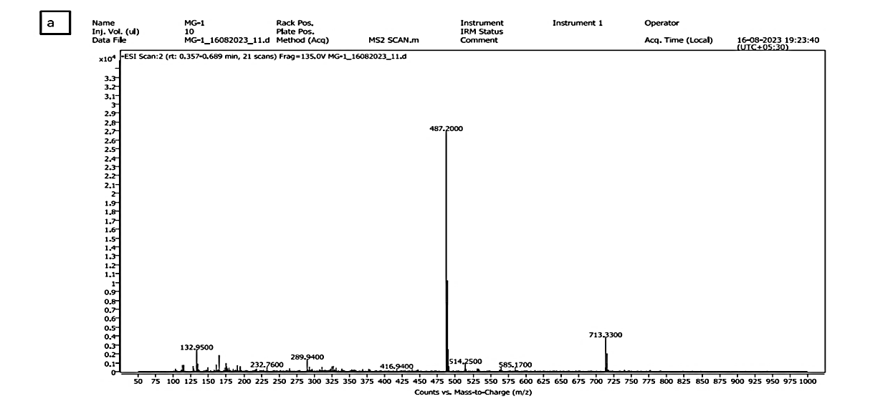
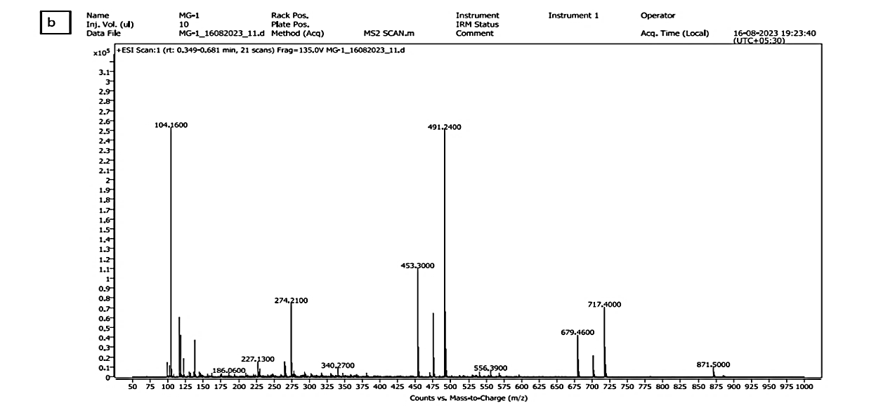
Fig 1.LC–MS chromatograms and mass spectra of GG methanolic leaf extract (Fig. a and Fig. b) showing the presence of several bioactive compounds.
3.4 Hematological parameter analysis
Hematological profile of the mice receiving GG methanolic leaf extract was shown in Fig.2. There were no statistically significant differences in the values of hematological parameters such as (WBC; Dose: F₂,₁₂ = 0.32, p = .732; Sex: F₁,₁₂ = 0.69, p = .423; Interaction: F₂,₁₂ = 1.08, p = .372), (MCV; Dose: F₂,₁₂ = 3.12, p = .081; Sex: F₁,₁₂ = 0.53, p = .480; Interaction: F₂,₁₂ = 0.44, p = .653), (MCH; Dose: F₂,₁₂ = 0.39, p = .688; Sex: F₁,₁₂ = 2.70, p = .126; Interaction: F₂,₁₂ = 0.44, p = .654), (MCHC; Dose: F₂,₁₂ = 2.36, p = .137; Sex: F₁,₁₂ = 2.14, p = .169; Interaction: F₂,₁₂ = 0.07, p = .932), (platelets; Dose: F₂,₁₂ = 0.83, p = .460; Sex: F₁,₁₂ = 3.82, p = .075; Interaction: F₂,₁₂ = 0.14, p = .869), and (PCV; Dose: F₂,₁₂ = 0.69, p = .520; Sex: F₁,₁₂ = 1.07, p = .321; Interaction: F₂,₁₂ = 0.14, p = .874) between the treated groups and the control group (p >.05), a slight increase in (RBC; Dose: F₂,₁₂ = 2.13, p = .161; Sex: F₁,₁₂ = 0.05, p = .826; Interaction: F₂,₁₂ = 1.21, p = .332), (Hb; Dose: F₂,₁₂ = 1.69, p = .226; Sex: F₁,₁₂ = 1.87, p = .196; Interaction: F₂,₁₂ = 2.91, p = .093)and (HCT; Dose: F₂,₁₂ = 1.20, p = .334; Sex: F₁,₁₂ = 2.17, p = .167; Interaction: F₂,₁₂ = 2.54, p = .120) was observed in the higher dose treated female mice group(p>.05) but still within the normal physiological range(Suksanga et al., 2023)(Fig. 2). The stable values of RBC, hemoglobin, and hematocrit levels show that the extract did not cause any anemia or any effect on erythropoiesis, and the unaltered WBC values show that the production of leukocytes and the immune process was not compromised. The count of platelets and the volume of mean platelets were also observed to be within the normal physiological range, indicating that the process of thrombopoiesis and the coagulation processes were not affected. The absence of marked changes in all the hematological indices indicates that GG methanolic leaf extract is hematologically safe and it does not cause toxic effects to the blood-forming organs, which is in agreement with previous study findings that the majority of plant-derived extracts do not affect hematological parameters in sub-acute toxicity studies(Ounjaijean & Somsak, 2024).
Fig 2. Hematological parameters of Swiss albino mice of control and Gnetum gnemon (GG) methanolic leaf extract-treated mice
Values are expressed as mean ± SEM (n = 5). No statistically significant differences (p > .05) were observed for MCV, MCH, MCHC, platelets, and MPV between the treated groups and the control group. A slight increase in RBC, Hb, and HCT was observed in the higher dose treated female group, but showed non-significant(p>.05).
3.5 Biochemical parameters analysis
The biochemical test results showed that the serum level of alanine aminotransferase (ALT; Dose: F (2,24) =2.511, p=.10; Sex: F (1,24) =0.115, p=.73; Interaction: F (2,24) =0.076, p=.92, Two-way ANOVA), aspartate aminotransferase (AST; Dose: F₂,₂₄ = 3.02, p = .07; Sex: F₁,₂₄ = 1.31, p = .26; Interaction: F₂,₂₄ = 0.79, p = .47), (creatinine; Dose: F₂,₁₂ = 1.08, p = .371; Sex: F₁,₁₂ = 0.12, p = .732; Interaction: F₂,₁₂ = 0.57, p = .581, Two-way Anova) and (urea; Dose: F₂,₁₂ = 1.37, p = .291; Sex: F₁,₁₂ = 0.81, p = .386; Interaction: F₂,₁₂ = 2.41, p = .132) in mice that were administered with GG methanolic leaf extract were of no significant difference, and were comparable with that of the control group (p > .05) (Fig.3). The consistency of ALT and AST levels implies that the extract did not trigger hepatocellular leakage or hepatocellular necrosis, corresponding to a lack of liver toxicity. Similarly, stable creatinine and urea values indicate that there are no abnormalities in the renal parameters, and this stability confirms that no glomerular damage occurs in the kidney. The results have significance as changes in ALT and AST are reported as the early signs of hepatotoxicity, whereas high levels of creatinine and urea are the indicators of kidney dysfunction. The lack of these changes in the treated groups suggests that GG methanolic leaf extract does not act or interfere with hepatic or renal functions during its repeated use. The same findings have been observed with other medicinal plants in toxicity studies, where liver and kidney markers were stable and indicating that the extract of the plants were safe to use(Suksanga et al., 2023). The present findings, therefore, underscore the biochemical safety profile of GG methanolic leaf extract and justify its potential as a nutritionally safe therapeutic candidate.

Fig 3. Effect of GG methanolic leaf extract on serum biochemical parameters of mice in the sub-acute toxicity study
Values are presented as mean ± SEM (n = 5). No significant differences (p > .05) were observed between control and treated groups.
4. Conclusion

The current study reveals that Gnetum gnemon (GG) methanolic leaf extract has potential nutritional and therapeutic potential. Proximate analysis showed the leaves to be high in carbohydrates and proteins and low in fat and intermediate in fiber, to show their potential as an energy source, and as a nutritional supplement for animal growth and maintenance, respectively. LC-MS analysis also revealed the presence of some of the bioactive compounds, e.g., stilbenoid derivatives (resveratrol and gnetin C), which could be attributed to the antioxidant and pharmacological activities of the extract. Notably, GG methanolic leaf extract treatment of the mice did not cause any noticeable change in hematological parameters, suggesting that the methanolic leaf extract is not hematologically toxic or has no adverse effect on the blood-forming organs. Likewise, important biochemical parameters of the liver and kidney (ALT, AST, creatinine, and urea) were maintained, indicating that there was no hepatotoxicity and nephrotoxicity.
Collectively, these data indicate that GG methanolic leaf extract is nutritionally rich, biochemically harmless, and comprises biologically active compounds that have possible beneficial health effects, which makes this compound a potential candidate as far as functional food and safe therapeutic agent are considered. Further studies are needed to explore its pharmacological properties and underlying mechanisms of GG methanolic leaf extract.

Competing interests

The authors state that there are no competing interests to disclose.

Ethical approval

All animal experiments carried out during this research were approved by the Institutional Animal Ethical Committee, Cotton University, Guwahati (Regn No. 15/IAEC/CU/05/01/2021). The experiments were carried out in accordance with the CPCSEA guidelines.

Disclaimer (Artificial intelligence)
Option 1:
Author(s) hereby declare that NO generative AI technologies such as Large Language Models (ChatGPT, manuscript.
Option 2:
Author(s) hereby declare that generative AI technologies such as Large Language Models, etc. have been used during the writing or editing of manuscripts. This explanation will include the name, version, model, and source of the generative AI technology and as well as all input prompts provided to the generative AI technology
Details of the AI usage are given below:
1.
2.
3.

References

Abdou, R. H., Basha, W. A., & Khalil, W. F. (2019). Subacute toxicity of Nerium oleander ethanolic extract in mice. Toxicological Research, 35(3), 233–239.
Abubakar, A. R., & Haque, M. (2020). Preparation of medicinal plants: Basic extraction and fractionation procedures for experimental purposes. Journal of Pharmacy and Bioallied Sciences, 12(1), 1–10.
Bhat, R., & binti Yahya, N. (2014). Evaluating belinjau (Gnetum gnemon L.) seed flour quality as a base for development of novel food products and food formulations. Food Chemistry, 156, 42–49.
Chanda, S., & Ramachandra, T. V. (2019). A review on some Therapeutic aspects of Phytochemicals present in Medicinal plants. International Journal of Pharmacy & Life Sciences, 10(1).
Dar, R. A., Shahnawaz, M., Ahanger, M. A., & Majid, I. ul. (2023). Exploring the diverse bioactive compounds from medicinal plants: a review The Journal of Phytopharmacology, 12(3), 189–195.
Edem, U. A., & Okokon, J. E. (2025). Subacute Toxicity Study of Leaf Extract of Saccharum officinarum. Biology, Medicine, & Natural Product Chemistry, 14(1), 91–100.
Elyasi, Z., Rajashekhar, U., Jha, D. K., & Khadka, J. (2022). Evaluation of in-vivo anticancer activity Choerospondias axillaris in Swiss albino mice models. Journal of Pharmaceutical Research International , 34, 26–50.
Habtamu, F. G., Haki, G. D., Fekadu, B., Rakshit, S. K., & Ashagrie, Z. W. (2018). Nutritional and antinutritional evaluation of indigenous Ethiopian Okra (Abelmoschus esculentus) seed accessions. African Journal of Food, Agriculture, Nutrition and Development, 18(1).
Hafidz, K. A., Puspitasari, N., Yanuar, A., Artha, Y., & Mun’im, A. (2017). HMG-CoA Reductase inhibitory activity of Gnetum gnemon seed extract and identification of potential inhibitors for lowering cholesterol level. Journal of Young Pharmacists, 9(4), 559.
Hossain, M. S., Wazed, M. A., Asha, S., Amin, M. R., & Shimul, I. M. (2025). Dietary phytochemicals in health and disease: Mechanisms, clinical evidence, and applications—a comprehensive review. Food Science & Nutrition, 13(3), e70101.
Huong, N. T., Hop, N. Q., Duy, D. A., & Son, N. T. (2025). The genus Gnetum: Traditional use, phytochemistry, nutritional value, biosynthesis, synthesis, pharmacology, toxicology, synthetic advance, and pharmacokinetics. Fitoterapia, 106461.
Jin, W.-Y., Liu, B., Zhang, S.-Z., Wan, T., Hou, C., & Yang, Y. (2020). Gnetum chinense, a new species of Gnetaceae from southwestern China. PhytoKeys, 148, 105.
Loha, M., Mulu, A., Abay, S. M., Ergete, W., & Geleta, B. (2019). Acute and subacute toxicity of methanol extract of Syzygium guineense leaves on the histology of the liver and kidney and biochemical compositions of blood in rats. Evidence‐Based Complementary and Alternative Medicine, 2019(1), 5702159.
Mollejon, C. V, & Gabane, L. E. O. S. (2019). Nutritional and nutraceutical content of Gnetum gnemon (bago) leaf extract.International Journal of Research Publications, 31(2), 75.
Mun’im, A., Munadhil, M. A., Puspitasari, N., & Yanuar, A. (2017). Angiotensin converting enzyme inhibitory activity of Melinjo (Gnetum gnemon L.) seed extracts and molecular docking of its stilbene constituents. Asian Journal of Pharmaceutical and Clinical Research, 148–243.
Obakiro, S. B., Kiprop, A., Kigondu, E., K’owino, I., Kiyimba, K., Drago Kato, C., & Gavamukulya, Y. (2021). Sub-acute toxicity effects of methanolic stem bark extract of Entada abyssinica on biochemical, haematological and histopathological parameters in wistar albino rats. Frontiers in Pharmacology, 12, 740305.
Ounjaijean, S., & Somsak, V. (2024). Exploring the Antimalarial Potential of Gnetum Gnemon Leaf Extract Against Plasmodium berghei in Mice. Journal of Tropical Medicine, 2024(1), 3471083.
Salmerón-Manzano, E., Garrido-Cardenas, J. A., & Manzano-Agugliaro, F. (2020). Worldwide research trends on medicinal plants. International Journal of Environmental Research and Public Health, 17(10), 3376.
Suksanga, A., Siripongvutikorn, S., Leelawattana, R., Yupanqui, C. T., & Idowu, A. O. (2023). Assessment of biological activities, acute and sub-chronic toxicity of Liang (Gnetum gnemon var. tenerum) leaves powder, a natural product. Biological and Pharmaceutical Bulletin, 46(12), 1666–1675.
Sun, W., & Shahrajabian, M. H. (2023). Therapeutic potential of phenolic compounds in medicinal plants—Natural health products for human health. Molecules, 28(4), 1845.
Tatefuji, T., Hashimoto, K., & Company, Y. B. (2014). Inhibitory Effect of Gnetin C , a Resveratrol Dimer from Melinjo ( Gnetum gnemon ), on Tyrosinase Activity and Melanin Biosynthesis. November. https://doi.org/10.1248/bpb.35.993
Thummar, V. R., Parasuraman, S., Basu, D., & Raveendran, R. (2016). Evaluation of in vivo antitumor activity of cleistanthin B in Swiss albino mice. Journal of Traditional and Complementary Medicine, 6(4), 383–388.
Vonica, M., Baričevič, D., & Brvar, M. (2014). Adverse effects and intoxications related to medicinal/harmful plants. Acta Agriculturae Slovenica, 103(2), 263–270.
Wado, T. E., Suleman, S., & Mohammed, T. (2022). Antimicrobial evaluation of sequentially extracted leaf of vernonia auriculifera hiern (Rejicho). BMC Complementary Medicine and Therapies, 22(1), 219.
Wahyuni, F. S., Arisanty, D., Hayaty, N. F., & Juwita, D. A. (2017). Sub-acute toxicity study of the ethyl acetate fraction of Asam Kandis Rinds (Garcinia cowa Roxb.) on the liver and renal function in mice. Pharmacognosy Journal, 9(3).
Yang, Y., Wang, Z., & Xu, X. (2017). Taxonomy and distribution of global gymnosperms. China Scientific Books.

