DIVERSITY AND DISTRIBUTION OF SPIDER FAUNA AT BABY JOHN MEMORIAL GOVERNMENT COLLEGE CAMPUS CHAVARA, KOLLAM DISTRICT , KERALA

ABSTRACT
The current study's objective was to examine the variety of spiders found in different areas of the Baby Journal Memorial Government College campus in Chavara, Kollam. an investigation into the spider fauna was conducted for six months, during January to June 2024. A total of 40 spider species belonging to 27 genera and 15 families were collected from the study site, totalling 286 individuals. Family Araneidae was the most prevalent (25 %), followed by Oxyopidae (12.5%), Salticidae and Pholcidae (10%) respectively. Less common species included spiders belonging to families Philodromidae and Pisauridae (7.5% ). Eight feeding guilds of spiders, i.e., Ambushers, ground dwellers, scattered line weavers, stalkers, orb-web weavers and space web builders were identified. Diversity indices were computed, including the Simpson, Shannon-Wiener, Pielou's evenness, and Margalef richness indices. The diversity calculated by Shannon Weiner’s index in different sites were 2.302 (Site 2), 2.244 (Site 3), 2.156 (Site 4) and 1.633 (Site 1). The evenness is higher in Site 1(0.8529) compared to other sites, 0.8325 (Site 2), 0.7855 (Site 4), 0.7703 (Site 3). The Simpson indices value was higher in Site 2 with 0.8848 value as compared to Site 3 with 0.8648 value, Site 4 with 0.8578 value and Site 1 with 0.778 value. Berger-Parker index revealed the relative dominance of the species. The value of Berger-DBP (0.333) showed dominance is less but diversity is more in Site 2 than Site 1 (0.1852), Site 3 (0.25) and Site 4 (0.2667).
KEYWORDS: Diversity indices, Ecosystem, feeding guild, Spider, fauna, diversity indices
1.INTRODUCTION

Spiders are essential components of ecosystems, playing vital roles in ecological balance by functioning as predators and prey (Riechert & Lockley 1984). Many spider families contain species capable of capturing vertebrate prey, which are termed ‘‘habitual vertebrate-eaters’’ and ‘‘occasional vertebrate-eaters”; some larger spider species occasionally feed on small mice, birds and lizards (Nyffeler & Gibbons 2022). Spiders play a significant ecological role as exclusive predators and regulate insect populations (Wise 1993). Being ectothermic organisms, the food, feeding behaviors, metabolic rate and activity levels of spiders vary with temperature (Barghusen et al. ,1997). Even though there are 51,900 identified spider species globally, there is limited knowledge regarding their ecology, diversity and distribution (World Spider Catalogue, 2025. Very little research has been conducted on the spider diversity in Kerala. Some of the studies that have been published on Kerala's spiders involve those by Sebastian et. al., 2023 studied the predatory spiders of Kuttanad (1994) and feeding potential of spiders. Biology of Cheiracanthium melanostoma (Thorell) (2002), biocontrol potential of Pardosa birmanica (2001) and Oxyopes chittrae (2004) were also studied by him. Sudhikumar et. al., studied about the web building spiders in Kuttanad (2005) and also re described the species like Argyrodes flagellum (2004) and Trigonobothrys martinae (2004) recently. Sebastian et al., (2005) documented the spider diversity in the high ranges associated with the Western Ghats of central Kerala. District wise local studies portraying the diversity of spiders deserve more importance in the current scenario of ecological destruction and other anthropogenic interventions. Sudhi Kumar et al., (2005), Sebastian et al., (2005), and Jose et al., (2005). The present work intends to study the diversity and predatory functional group of spider species and add information to the database of spider species on the Baby John Memorial Government College Campus Chavra Kollam
2.MATERIALS AND METHODS
2.1 Study Site
The present study explored the diversity of spiders in different locales of the Baby John Memorial Government college campus, Kollam, Kerala. The study was carried out during the period from January to June 2024. The selected study area is Baby John Memorial College Campus which is situated in Kollam r district of Kerala. It is located between 9° 4' N, 76° 29' E N and 8° 99' N, 76° 53' E. Total area is 10 acres. For the study the entire campus has been surveyed, by dividing the area into four sites. Site 1 is the Main block of the campus. Sites consist of buildings, new construction and roads that connect departments, and have the highest concentration of people and buildings. Site 2 is the Marshy area. These sites have wide variety of habitats in it, which include grasslands, wetland, ponds and good number of indigenous plants. Site 3 is the Botanical Garden. Botanical Garden of campus is enriched with various types of tresses. Medicinal, beneficial, ornamental, fruit plants are most available in this area. Site 4 is Open fields consists of mainly herbs, shrubs, trees and grasslands type. Survey was done three or four times a week in the morning and evening hours.
2.2 Sampling Method
Spider collection was done during the morning (7.00 am to 10.00 am) and evening (16.00 pm to 18.00 pm) time to maximize the species richness. Spiders were collected by adopting standard sampling techniques such as sweep netting, beating sheets, active searching, hand picking and Umbrella collection. Collected spiders were photographed in the field itself with the help of Redmi Pro 15 and then released to their natural habitat. A small number of spiders were studied under a microscope to identify and analyse certain morphological traits
2.3 Preservation and Identification
The specimens were preserved in 70% alcohol for later identification and kept in specimen tubes with labelling and the remaining live specimens after microscopic examination were freed into the wild. Detailed species identification was carried out under a stereo-zoom dissecting binocular microscope (Stemi 305 Zeiss ISH500) up to the generic and species levels. Microscopic photographs of the spider were captured using a Canon Power Shot A2300 HD Digital Camera and a Tucsen Camera (ISH500) mounted on the stereomicroscope. Taxonomic identification was performed using the following references: Tikader (1971, 1982), Tikader & Biswas (1981), Tikader & Malhotra (1980), Sethi & Tikader (1988), Majumder & Tikader (1991), Beatty et al. (2008), Gajbe (1999, 2008), Chen & Chen (2002), Shukla & Broome (2007), Han & Zhu (2010), Kim & Lee (2014), Pravalikha & Srinivasulu (2015), Hänggi & Sandrine (2016), Caleb et al., (2017), Caleb & Acharya (2020), Prajapati & Kamboj (2020), Sankaran et al. (2021), Caleb & Wijesinghe (2022) and other relevant literature from the World Spider Catalog (WSC 2023).
2.4 Diversity indices
Data was analysed statistically to determine species diversity, species richness, species abundance and evenness. Microsoft Excel was used to construct different graphs according to analysed data. The data analysis discussed in this study includes the abundance of the species n(n), the richness of the species (s), the diversity of the species (H) and the evenness of then species (E). The abundance of the species is the number of individual species found in each site of sampling while the richness of the species is based on the number of species appear in each location of the study. Shannon diversity – (H’), evenness – (e^H/S), Margalef’s species richness (d) and Fisher alpha diversity (α) were computed using PAST software (Hammer et al. 2001) and their interpretations followed Magurran (2004). Feeding habits were investigated through observational techniques, focusing on prey capture behaviors (Borkar & Seth, 2020). The diversity of the species is determined by the diversity index (H) of Shannon – Weaner, Marg alef’s, Menhinick’s Index, Berger-Parker’s Index and Simpson index, using the following formula:
1. Shannon’s diversity index, H’ = -  (pi In Pi)
where H’= Shannon Index, Pi = Proportion of individuals belonging to the ith species, ln = Natural logarithm (natural number)
2. Simpson’s value, D = ∑ ni (ni-1) /N (N-1)
Where ni = the number of individuals of a species N = Total number of all individuals
3. Margalef’s index (R) =S-1/In(N)
where R= Margalef’s richness index, S= total of species, N= total no of individual sample
4. Berger-Parker’s Index (d)=Nmax / N
where Nmax = the number of individuals in themost abundant species, N=total number of individuals in the sample.
The evenness of the species is determined bythe evenness index of Shannon (E) using the following formula:
E = H/ln(S);
Where E = evenness; S = the number of species.

3.RESULT
3.1 Species Composition of Spiders in BJM Govt College Campus
A total of 40 species of spiders belonging to 27 genera and 15 different families during the study period. Among 15 families the most dominant families were Araneidae consisting of 4 genera & 10 species followed by Oxyopidae (2 genera & 5 species), Salticidae and Pholcidae (4 species) respectively. Less common species included spiders belonging to families Philodromidae and Pisauridae (2 genera & 3 species). Only two species were recorded from each family viz. Cheiracanthidae and Lycosidae. Rest of the families like Scycotidae, Theridiidae, Tetragnathidae, Dictynidae, Thomisidae, Sparassidae, and Zodariidae were represented by single species (Table 1).
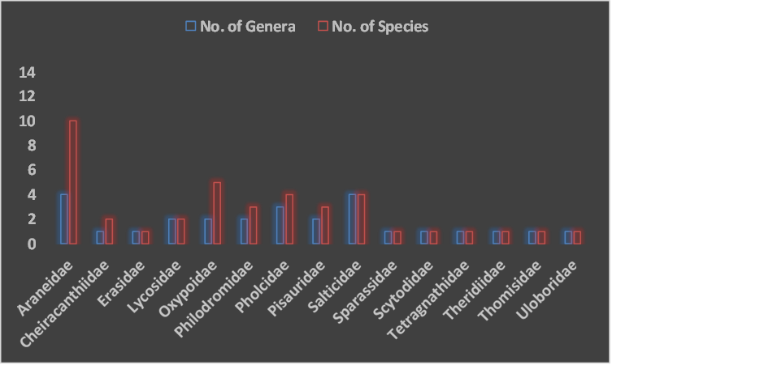
Fig 1. Representation of genera and species in different spider families of the entire spider assemblage recorded in the study area.
3.2 Distribution of Spider Species among the study sites
The distributions of spider species indicated a few differences across all of the sites surveyed. Open habitat has the highest number of species (30) among the sites studied. Buildings have the fewest records at both the species (12) and individual level (Fig 2).
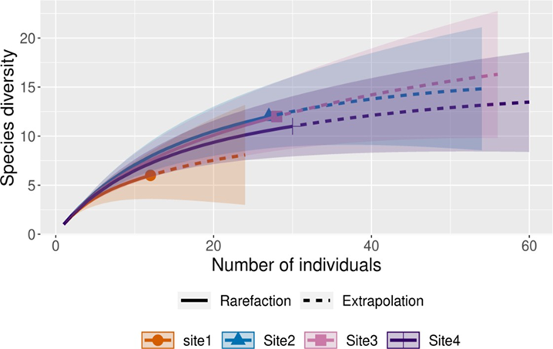
Fig 2: Species Accumulation Curve of spiders in different habitat
3.3 Diversity Indices of Spiders in each site of BJM College Campus
For analyzing the alpha diversity of the three zones, diversity indices like Shannon- Weiner diversity index, Margalef richness index, Simpson- dominance index and evenness index were calculated and presented in (Table 2). The richness value of spiders was 3.338 (Site 2), 3.301 (Site 3), 2.94 (Site 4) and 2.012 (Site A) respectively. The diversity calculated by Shannon Weiner’s index in different sites were 2.302 (Site 2), 2.244 (Site 3), 2.156 (Site 4) and 1.633 (Site 1). The evenness is higher in Site 1(0.8529) compared to other sites, 0.8325 (Site 2), 0.7855 (Site 4), 0.7703 (Site 3). The Simpson indices value was higher in Site 2 with 0.8848 value as compared to Site 3 with 0.8648 value, Site 4 with 0.8578 value and Site 1 with 0.778 value (Table 2). Berger-Parker index revealed the relative dominance of the species. The value of Berger-DBP (0.333) showed dominance is less but diversity is more in Site 2 than Site 1 (0.1852), Site 3 (0.25) and Site 4 (0.2667). A high H’ value would indicate an even distribution of species. It allows us to not only know the number of species but also the abundance of the community. Typical values of the Shannon-Weiner Index (H’) are generally between 1.5 and 3.5 in most ecological studies, and the index is rarely greater than 4. The Shannon index increases as both the richness and the evenness of the community increase. It can be concluded that the abundance of spider species at this study site is high. The evenness index (e) was high (e >0, 0.8529). As the evenness index increases with a decrease in stress (Pielou 1966), this indicates that the study areas have very minimal to no stress elements. Margalef’s species richness indicated a higher value (d = 3.31), and this minimizes the effect of sample size bias (Odum 1971). Species richness as a measure on its own takes no account of the number of individuals of each species present. It gives as much weight to those species that have very few individuals as compared to those that have many individuals (Magurran 2004). Fisher’s alpha diversity (α = 39 .73) is also significantly high. This may reflect comparatively less stress in their environment.
3.4 Guild Composition of Spiders in BJM Govt College
During survey and collection of spiders, the microhabitats used by them were noted and accordingly the detail observations of each spider collected are given in Table- 3. Categorically, three types of major microhabitats were noted, in the web, on the plant/branches and on the ground. Based on the foraging behaviour of spiders in the field they are divided into eight functional groups. In the result, the guild structure is represented in the form of percentage composition. Results of the present study have revealed that the most dominant group was of Orb web weaver (Fig 3) which consisted of 32% of spider species. Representative families of Orb web weaver included Araneidae, Tetragnathidae and Uloboridae. Stalkers (20%) was the second largest dominant guild in the study site which consists of families Oxyopidae,Salticidae. Ambushers which constitute 15% of guild composition belong to the family Philodromidae, Pisauridae, Thomisidae. Ground dwellers representing 10% of guild composition were found to be from the families Scytodidae, Philodromidae, Lycosidae. Foliage dwellers representing 7 % of guild composition were found to be from the families Cheiracanthiidae, Sparassidae. Sheet web weaver (3 %) is seen in the family Eresidaeare. Space- web builders (3%) consist of family Theridiidae.The feeding guild analysis represents 32% of orb-web weavers and 20% stalkers. This may be due to flourishing vegetation layers during monsoon, including trees, shrubs, grasses and herbs landscapes that provide a healthy environment and shelters to other faunal invertebrate and vertebrate organisms; vegetation stratifications reveal ideal substrate for orb-web weaver spiders such as araneids and uloborids. The web-spinning activities are usually influenced by physiological factors, i.e., temperatures, humidity and rainfall (Barghusen et al., 1997). Stalkers, including salticids and oxyopids, feed on similar prey. Web-weavers are almost strictly insectivorous, while stalkers and wandering spiders exhibit a mixed strategy of insectivorous and araneophagic foraging patterns (Nyffeler 1999). The presence of diverse spider species (Table 1) indicates healthy surroundings, availability of food resources, habitat structures, prey occurrence and feeding activities during the study period at BJM College campus.
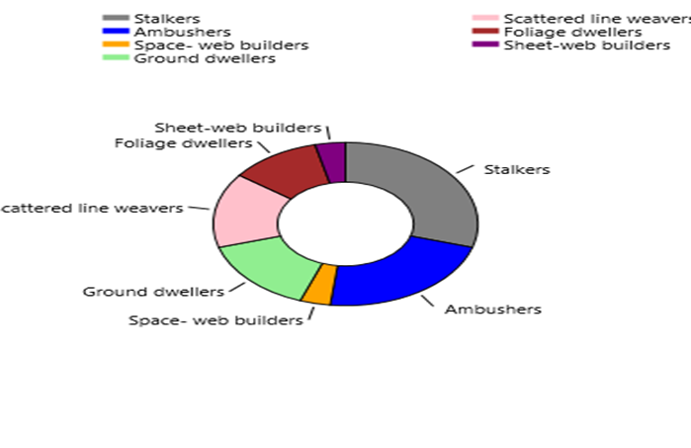

Fig 3: Predatory functional group of spiders with species

Table 1Checklist of spiders of BJM Government College Campus

No | Family | Scientific Name | Guild
1 | Araneidae | Argiope pulchella  (Thorell, 1881) | Orb web weaver
2 |  | Argiope aurantia  (Lucas, 1833) | Orb web weaver
3 |  | Argiope catenulate  (Doleschall, 1859) | Orb web weaver
4 |  | Araneus gemmoides  (Chamberlin & Ivie, 1935) | Orb web weaver
5 |  | Araneus diademstus  (Clerck, 1757) | Orb web weaver
6 |  | Araeus cavaticus  (Keyserling,1882) | Orb web weaver
7 |  | Cyraptophora citricola  (Forskål, 1775) | Orb web weaver
8 |  | Cytrophora cicatrosoa  (Stoliczka, 1869) | Orb web weaver

9 |  | Cyclosa bifida  (Doleschall, 1859) | Orb web weaver
10 |  | Eriovixia laglaisei  (Pocock, 1900) | Orb web weaver
11 | Cheiracanthiidae | Cheiracanthium danieli  (Tikader, 1975) | Foliage dwellers
12 |  | Cheiracanthium  melanostomum (Thorell , 1895) | Foliage dwellers
13 | Erasidae | Stegodyphussarasinorum (Karsch, 1892) | Sheet-web builders
14 | Lycosidae | Lycosa lambai  (Tikader & Malhotra, 1980) | Ground dwellers
15 |  | Hippasa sp  (Simon, 1885) | Ground dwellers
16 | Oxyopidae | Oxyopes salticus  (Hentz, 1845) | Stalkers
17 |  | Oxyopes sunandae  (Latreille, 1804) | Stalkers
18 |  | Oxyopes biramanicus  (Latreille, 1804) | Stalkers
19 |  | Peucetia viridians  (Hentz, 1832) | Stalkers
20 |  | Oxyopes variablis  (Thorell, 1869) | Stalkers
21 | Philodromidae | Tibellus macellus  (Simon, 1875) | Ambushers
22 |  | Tibellus elongates  (Tikader, 1960) | Ambushers
23 |  | Philodromus decoratus  (Tikader, 1962) | Ground dwellers
24 | Pholcidae | Pholcus phalangioides  (Füssli, 1775) | Scattered line weavers

25 |  | Pholcus fragillimus  (Strand, 1907) | Scattered line weavers
26 |  | Artema atlanta  (Walckenaer, 1837) | Scattered line weavers
27 |  | Crossopriza lyoni  (Blackwall, 1867) | Scattered line weavers
28 | Pisauridae | Dendrolycosa gitae  (Tikader, 1970) | Ambushers
29 |  | Dendrolycosa sp. | Ambushers
30 |  | Pisaura podilensis  ( Patel & Reddy, 1990) | Ambushers
31 | Salticidae | Plexippus paykuli  (Audouin, 1826) | Stalkers
32 |  | plexipuspetarassi  (Audouin, 1826) | Stalkers
33 |  | Adoxostoma forsteri  (Simon, 1909) | Stalkers
34 |  | Menemerus bivittatus  (Dufour,1831) | Stalkers
35 | Sparassidae | Heteropoda venatoria  (Linnaeus, 1767) | Foliage dwellers
36 | Scytodidae | Scytodes thoracica  (Latreille, 1802) | Ground dwellers
37 | Tetragnathidae | Tetragnatha mandibulata  (Walckenaer, 1841) | Orb- web Weavers
38 | Theridiidae | Argyrodes flavescens  ( O. Pickard-Cambridge, 1880) | Space- web builders
39 | Thomisidae | Synema parvulum  (Hentz, 1847) | Ambushers
40 | Uloboridae | Zosis geniculata  (Olivier, 1789) | Orb web weaver

.

Table 2. Alpha diversity indices of spiders in different sites of BJM college campus.

Alpha diversity indices | Habitat types
Alpha diversity indices | Buildings | Marshy area | Garden | Open field
Number of taxa | 6.00 | 12.00 | 12.00 | 11.00
Individuals | 12.00 | 27.00 | 28.00 | 30.00
Simpson_1-D | 0.77 | 0.88 | 0.86 | 0.85
Shannon_H | 1.63 | 2.30 | 2.24 | 2.15
Evenness_e^H/S | 0.85 | 0.83 | 0.77 | 0.78
Margalef | 2.01 | 3.33 | 3.30 | 2.94
Berger-Parker | 0.33 | 0.18 | 0.25 | 0.26

4.DISCUSSION

The present study revealed that diversity and ecology of spiders is closely related to the structural complexity of the environment. Hence the information on their diversity and ecological studies would be helpful in conserving the ecosystem. This study indicates that the spider fauna in the BJM College Campus is moderately rich. Spiders are ubiquitous in nature and their diversity depends on many factors like habitat structure, temperature, humidity and vegetation of the areas Uniyal et. al., (2011). Therefore, keeping these factors in mind the study site was divided into different habitats. Araneidae is regarded as one of the most cosmopolitan families, containing a high number of genera (Coddington & Levi, 1991; Dipner Schoeman & Jocqué, 1997; Romo & Flórez, 2008). In our study, also this family reached in first position. Thus, this family may be broadly adapted to the environmental conditions of the study area, facilitating easier establishment compared to other families that have specific habitat preferences. Interestingly, the abundance and richness of Araneidae and Salticidae families did not change between wet and dry seasons. Consequently, other conditions, such as food availability or vegetation structure may be critical parameters for establishment (Borges & Brown, 2001; Jiménez-Valverde & Lobo, 2007). In similar studies of other ecosystems at different altitude, there is no clear consensus whether the spider community is influenced by climatic conditions, because statistical tests corroborating this relationship for these variables are not available (Escorcia et al., 2012). Two limiting factors that are influencing the abundance of Araneidae are climatic conditions and differences in plants for web construction, yet, the orb weaver community did not show major changes in richness or abundance in relation to seasonal variation in precipitation. These results suggest a consistent guild classification can promote future comparison between different geographic regions and habitats. Also, suggest that different families may have similar ecological roles, with replacement of some taxa by other within the same guild according to the region. Guild structure may therefore be predictable and independent of taxonomic structure. This study also indicates that tropical regions may have higher redundancy of functional roles or finer resource partitioning than temperate regions. If the diversity-stability relation is confirmed, this may be an indication of higher resistance to disturbance in high diversity in sacred groves. Finally, functional diversity may correlate with habitat structure and vegetation complexity. Vegetation structure influences family level spider composition because similar families tend to associate within similar habitat type. The result also reveals the presence of similar species at specific time of the season. Thus, proving seasonal variation has a significant impact on spider diversity than vegetation structure. All the above observations definitely bring us to the conclusion that the spider fauna in the BJM College Campus is moderately rich. Hence, we can say that diversity and an ecology study always give an insight of an area, its health and richness and also help in conservation of a specific ecosystem
Implications and Future Directions
The objective of the present study was to investigate the diversity of spider fauna in the BJM Govt College Campus Kollam. It was also an attempt to elucidate some of the questions related to diversity patterns and ecological processes of spiders at spatial and temporal scales. Currently, the world is experiencing an unprecedented decline in biodiversity due to a variety of reasons, and the extent of the loss is unimaginable due to the lack of sufficient taxonomic and ecological knowledge about many extant fauna and flora. This is especially true for arthropods, which account for more than 80 % of all known living animal species. The following are the recommendations for future research and conservation
- Research on taxonomy and systematic of spiders and other invertebrates should be encouraged. The Western Ghats region is one of the biodiversity hotspots in the world and hosts many protected and unprotected areas. Moreover, many of the agricultural landscapes in the region are capable of harbouring greater biodiversity. Further surveys should be encouraged not only in the protected areas but also in the agricultural landscapes, including those surrounded by semi-urban areas.
- More intensive studies are required along with appropriate revisionary studies which would help ascertain the exact extent of species diversity in each family. The present study would provide a baseline data to further workers in this field.
- The habitat is constantly under threat and under strong pressure of urbanization. This study greatly emphasizes on the conservation and protection of these unique habitat structures.

5. CONCLUSION
This was the first attempt to document spider diversity in the Baby John Memorial Government College Campus. The study provides data on how a species responds to its surroundings and food availability in relation to its distribution within a specific habitat. The findings support previous studies indicating that habitat diversity significantly influences spider diversity. For example, jumping spiders like Plexippus paykulli and Phidippus regius were observed in varied environments, while Cheiracanthium inclusumwas primarily found in shrublands and woodlands,. Species like Tibellus elongates in wet, shaded environments further emphasize the ecological importance of micro habits. These findings provide foundational insights into spider diversity in Baby John Memorial Government College Campus and call for further research into their ecological roles and conservation needs. Habitat preservation is critical, as human activities and habitat loss may significantly impact spider populations. Future studies combining seasonal and functional analyses will deepen our understanding of the ecological services these arachnids provide

REFERENCES
Barghusen, L.E., D.L. Claussen, M.S. Anderson & A.J. Bailer (1997). The effects of temperature on the web-building behaviour of the common house spider, Achaearanae tepidariorum. British Ecological Society, Functional Ecology 11: 4 –10
Beatty, J.A., J.W. Berry & B.A. Huber (2008). The Pholcid spiders of Micronesia and Polynesia (Araneae, Pholcidae). The Journal of Arachnology 36: 1–25
Borkar, M., & Seth, M. (2020). Observations on Ecology and Behavioural Two Species of Theraphosid Spiders from the Western Ghats of Goa, India; with Notes on Their Conservation Concerns. Applied Ecology and Environmental Sciences, 8 (6), 544-555. https://doi.org/10.12691/AEES-8-6-29.
Caleb J. T. D. (2020) Spiders (Arachnida:Araneae) fromthe vicinity of Araabath Lake, Chennai, India,Journal of Threatened Taxa 12(1): 15186–15193.
Caleb, J. T. D. (2016) Taxonomic notes on some ant-mimicking jumping spiders (Araneae: Salticidae) from India. Arthropoda Selecta, 25: 403-420
Chen, S.H. & Y.T. Chen (2002). Note on a newly recorded spider,Perenethis venusta L. Koch 1878, from Taiwan (Araneae: Pisauridae). Bio Formosa37: 31–35.
Gajbe, U.A. (1999). Studies on some spiders of the family: Oxyopidae (Araneae: Arachnida) from India. Records of the Zoological Survey of India, Calcutta; Occasional Paper No. 97 (part 3): 31–79
Hammer, , D.A. Harper & P.D. Ryan (2001). PAST: Paleontological statistics software package for education and data analysis. Palaeontologia electronica 4(1): 1–9
Han, G.X. & M.S. Zhu (2010). Taxonomy and biogeography of the spider genus Eriovixia(Ar aneae: Araneidae) from Hainan Island, China.Journal of Natural History44: 2609–2635
Hänggi, A. & S. Sandrine (2016). Storage buildings and greenhouses as stepping stones for non-native potentially invasive spiders (Araneae) – a baseline study in Basel, Switzerland. Arachnologische Mitteilungen / Arachnology Letters 51: 1–8
Jose S. K., A. V. Sudhikumar, S. Davis, and P. A. Sebastian (2005). Preliminary studies on the spider fauna (Arachnida: Araneae) in Parambikulam wildlife sanctuary in Western Ghats, Kerala, India. Journalof Bombay Natural History Society, 102 (3): pp????
Kim, S.T. & S.Y. Lee (2014). Arthropoda: Arachnida: Araneae: Clubionidae, Corinnidae, Salticidae, Segestriidae. Spiders. Invertebrate Fauna of Korea 21(31): 1–18
Majumder S.C. (2007) Pictorial handbook on spiders Sundarbans: West Bengal. Zoological Survey ofIndia 20(2): 1-42
Mathew M.J., Sudhikumar A.V. and Jose K.S. (2009). Natural history and bioecology. In: Spiders of India (Eds. Sebastian P.A. and K.V. Peter), Universities Press (India) Pvt. Ltd. pp 40–63
Nyffeler, M. & J.W. Gibbons (2022). Spiders feeding on vertebrates is more common and widespread than previously thought, geographically and taxonomically. Journal of Arachnology 50(2): 121–134
.
Pravalikha, G.B. & C. Srinivasulu (2015). A new species of genusThomisus Walckenaer, 1805 (Araneae: Thomisidae) from Telangana, India and a detailed description of Thomisus projectus Tikader, 1960. Journal of Threatened Taxa 7(3): 7000–7006.https://doi.org/ 10.11609/jott.04076.7000-6
Riechert, S.E. & T. Lockley (1984). Spiders as biological control agents. Annals of Review of Entomology 29: 299–320
Sebastian, P.A., Mathew, M.J., Beevi, S.P., Joseph, J. and Biju, C.R. (2005a). The spider fauna of the irrigated rice ecosystem in central Kerala, India across different elevational ranges. The Journal of Arachnology, 33(2): 247-255.
Shukla, A. & V.G. Broome (2007). First report of the brown widow spider, Latrodectus geometricus C. L. Koch (Araneae: Theridiidae) from India. Current Science 93: 775–777.
Sudhikumar, A. V., Mathew, M. J., Sunish, E., Murugesan, S., and Sebastian, P. A. (2005) Preliminary studies on the spider fauna in Mannavan shola forest, Kerala, India (Araneae). European Arachnology Supplement, 1, 319-327.
Tikader B.K. (1987) Handbook of Indian Spiders,Calcutta. Zoological Survey of India. 251 pp
Tikader, B.K. & B. Biswas (1981). Spider fauna of Calcutta and vicinity Part 1. Records of Zoological Survey of India 30: 1–149.
Tikader, B.K. (1971). Descriptions of some little-known spiders from India of the genusMiagrammopesCambridge (Uloboridae).Journal of the Asiatic Society, Calcutta13: 172–177.
Tikader, B.K. (1982). The Fauna of India;Spiders: Araneae, 2 (1 & 2) (Araneidae & Gnaphosi dae), Zoological Survey of India, Calcutta, 533 pp.Threatened TaxaTikader, B.K. & M.S. Malhotra (1980). The Fauna of India – Araneae, Vol. I Part 2, Zoological Survey of India, Calcutta, 446 pp.
Uetz, G.W., J. Halaj & A.B. Cady (1999). Guild Structure of spiders in major crops. Journal of Arachnology 27: 270–280
Wise, D. H. (1993). Spiders in Ecological webs, Cambridge Univ.Press, London. pp: 342.
World Spider Catalog (2025). World spider catalog, Version 24. Natural History Museum Bern. http://wsc.nmbe.ch. doi: 10.24436/2.

