QUALITY RETENTION AND SHELF LIFE EXTENSION IN THE WHITE LEG SHRIMP LITOPENAEUS VANNAMEI (BOONE, 1931) USING ACALYPHA INDICA LEAF EXTRACT

ABSTRACT:

This study aimed to evaluate the efficacy of Acalypha indica leaf extract (AILE) on the quality retention and extend shelf- life of white leg shrimp Litopenaeus vannamei during ice storage for 15 days. Litopenaeus vannamei were subjected to Acalypha indica leaf extract (AILE) at a concentration of 10ml on the sample each day during the storage. They were stored at a shrimp to ice ratio of 1:3 until 15th day in an ice box. Evaluated parameters used to determine the shrimp quality include odour, texture and general appearance (inclusive of colour) were examined. The sensory evaluation survey of shrimp was conducted for 15 days in Guru Nanak College (Autonomous), Velachery, Chennai – 42, Tamil Nadu, India. Maceration method was followed for the extraction of Acalypha indica leaf extract (AILE). Sensory evaluation survey was conducted for quality evaluation of Litopenaeus vannamei. The difference in quality retention of both control and sample were observed by mean sensory scores. In comparison, the treatment with AILE natural additives prolonged the samples’ shelf life to 15 days during ice storage. The control recorded the lowest scores, while higher scores were obtained from the AILE treated sample. Therefore, it can be concluded that the extract of Acalypha indica leaf extract (AILE) can be used in quality retention and shelf- life extension of shrimp.

Keywords: White leg shrimp; Acalypha indica; shelf-life; quality retention.

1. INTRODUCTION
One of the most widely cultivated species in aquaculture worldwide is the white leg prawn (Litopenaeus vannamei). Freshness, which is primarily established by microbiological, physical, biochemical, and sensory factors, is fundamentally linked to the quality and acceptability of prawns for human consumption (Kuswandi et al., 2012). Shrimp spoiling is analysed sensory-wise in the current study as loss of texture, discolouration, and bad odour. Shrimp quality cannot be maintained by ice storage alone. Thus, including natural preservatives could improve shrimp's shelf life, delay spoiling, and lower the hazards associated with chemical preservatives.
Acalypha indica is a tiny herbaceous plant that is a member of the Euphorbiaceae family and is frequently referred to as "Kuppai meni" in Tamil. Acalypha indica is an upright annual herb that grows to a height of 30 to 100 cm. It is found as a weed in India's plains. It is also present in the hottest areas across the globe, the plant has a high moisture content of upto 90% and a total ashes value of 18% suitable for body hydration (Takle et al., 2011) The phytochemical components that are frequently found in Acalypha indica leaf extract (AILE) include cardiac glycosides, terpenoids, flavonoids, and saponins. According to Novo et al. (2000), terepenoids, a broad and varied class of AILE, have strong antibacterial qualities. To treat a variety of illnesses, including bronchitis, snake bites, rheumatism, pneumonia, and asthma, entire plant extracts, stems, leaves, roots, and flowers are utilized in medicine (Singh et al., 2006). Scabies, anti-parasiticides, eye infections, respiratory issues, and the reduction of blood sugar levels, along with the treatment of scabies and other dermatological conditions (Chopra et al., 1996).
Natural antioxidants derived from plant extracts have been researched recently to enhance the preservation of fish products. Extracts from pomegranate peels (Basiri et al., 2015); cashew leaves (Sae-leaw et al., 2019); guava leaves (Olatunde et al., 2021); and soursop leaves (Abubakar Saleh Ahmad et al., 2023). Essential oils' antimicrobial and antioxidant qualities have made them a natural substitute for artificial seafood preservatives (Pierozan et al., 2024).
This study investigates the quality rentention of shrimp during storage in crushed ice and treating them with AILE. To maintain fresh shrimp quality, it must be stored with a 1:3 ratio of shrimp to ice, depending on the conditions and the storage duration (Hendiy et al., 1983). The sensory changes in the shrimp were determined using a sensory scoring scale sheet as part of the survey method (Jeyasekaran et al., 2006). Consumers’ preferences are taken into consideration when evaluating the effects of AILE on Litopenaeus vannamei quality during ice storage.

2. materials and methods
2.1 Tools and materials used:
The tools used are like graduated cylinders, conical flasks, funnels, spatulas, and petri plates.
The ingredients and materials used are Acalypha indica leaves, a thermocol ice box, crushed ice, cotton, distilled water, and muslin cloth.
2.1.1 Instruments used:
Laboratory weighing balance, refrigerator, blender, and laboratory crushed ice maker machine.

2.2 Collection of samples:
Plants were gathered from Chennai's Velachery Lake's bunds. It was recognized and confirmed to be Acalypha indica. Fifty shrimp, weighing half a kilogram, were purchased from Chennai's Vanagaram fish market. The Department of Advanced Zoology and Biotechnology at Guru Nanak College in Chennai recognized and verified them as Litopenaeus vannamei Boone in 1931.

2.3 Preparation of Acalypha indica leaf extract:
The freshly collected leaves of Acalypha indica were washed under running tap water and were shade dried for 10 days at room temperature (24°C). A blender was used to grind the dried leaves into a fine powder. The dried leaves and powdered form of the Acalypha indica plant are depicted in Figures 1, 2, and 3. After weighing 60g of dried Acalypha indica leaf powder, 400ml of distilled water (15g/100ml) was added to dissolve it. After thoroughly stirring, the mixture was placed in an airtight glass container. The maceration procedure lasted seven days, during which time it was shaken ten times a day to avoid lumps. A muslin cloth was used to filter the mixture through eight layers. The filtering produced 200 ml of the extract. After being moved to the conical flask, the extract was covered with a cotton stopper and kept in the refrigerator.

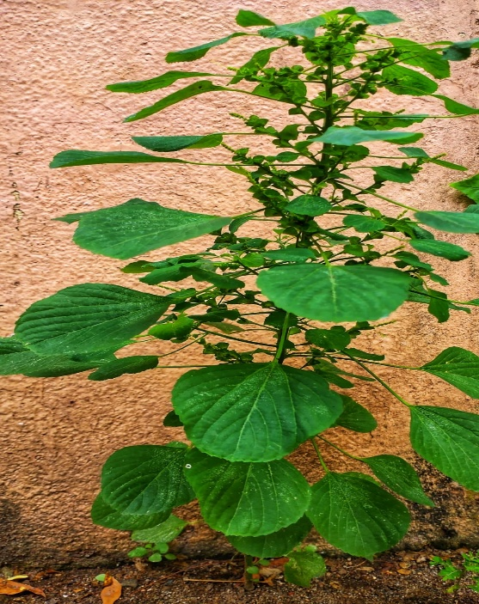
Figure.1. Acalypha indica Linn in natural habitat

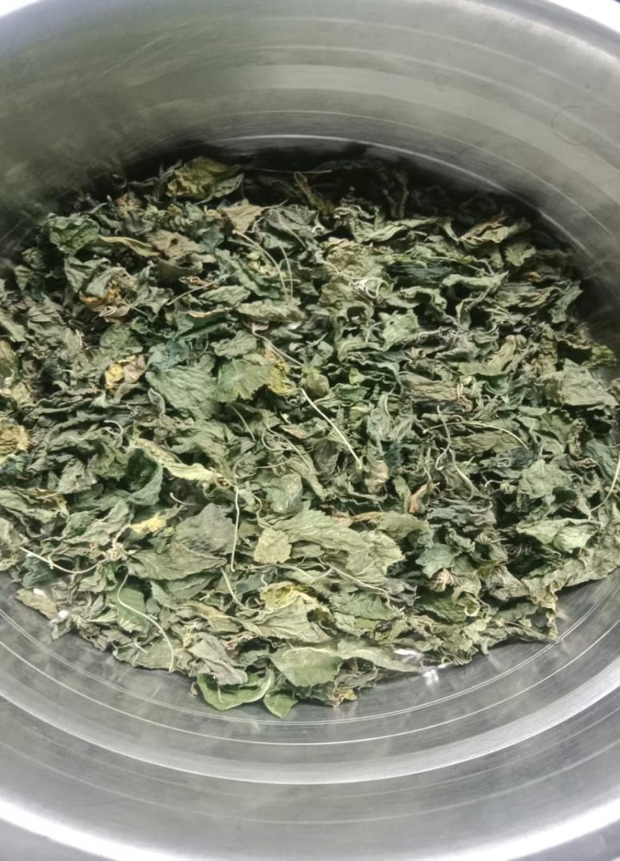

Figure. 2. Dried Acalypha indica leaves

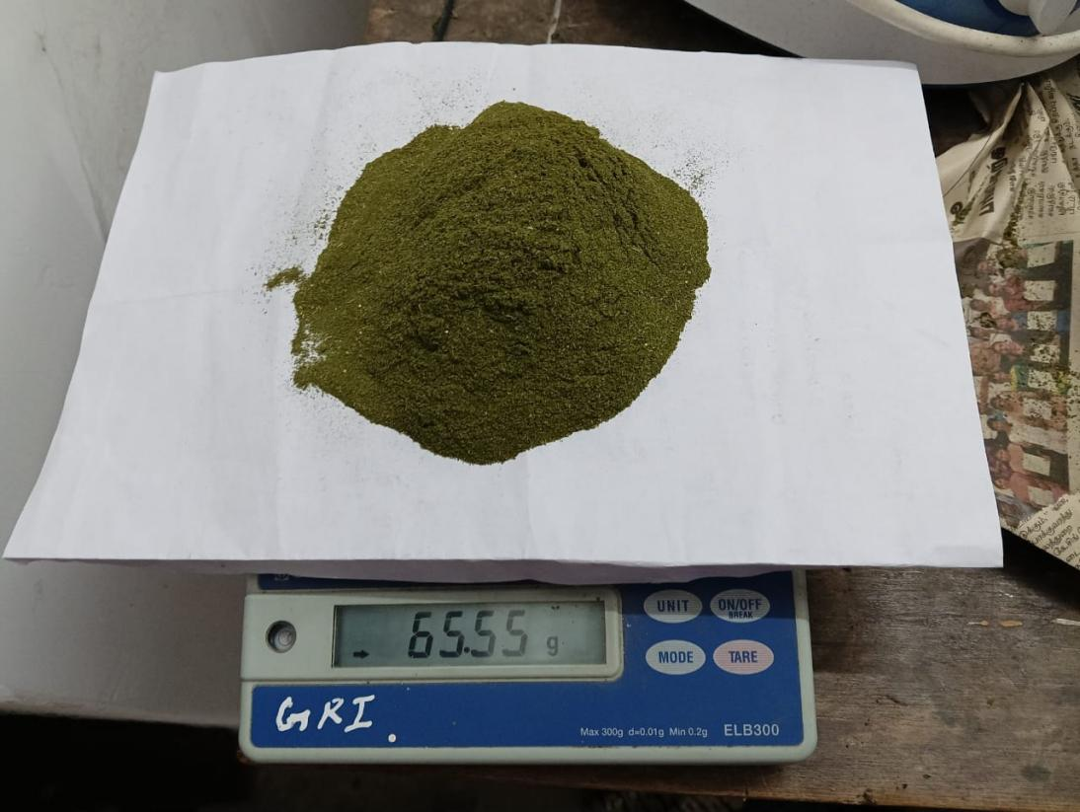

Figure. 3. Dried Acalypha indica leaves powder

2.4 Preparation of the sample:
Thirty fresh shrimp were divided into two groups (15 pieces as control and 15 pieces as sample). The control was left uncoated stored in ice box filled with crushed ice made from ice maker machine. The sample was coated with 5ml of Acalypha indica leaf extract (AILE) and 5ml of AILE mixed with crush ice. The ice box was filled with 1:3 ratio of shrimp and ice. First layer is filled with crushed ice and then AILE coated shrimps were placed in the second layer. Third and fourth layer of ice was placed over the shrimp. This procedure was repeated throughout the storage of 15 days.

2.5 Sensory evaluation:
The sensory properties of Litopenaeus vannamei (Figure 4) were evaluated by the public survey method, enabling them to detect the primary indicators of spoilage on the basis of 10-point scale scores. The sensory characteristics studied included the odor (smell), texture, and general appearance (inclusive of color). The scores were given on a decreasing order scale with 10-9 for excellent, 8-7 for good, and 6-5 for fair and acceptable. The score sheet in the survey table was used (Jeyasekaran et al., 2006). The mean of the scores given by the public represented the general sensory quality of the shrimp (Table 1). The quality of Litopenaeus vannamei of both the sample and control image was given in Figures 5 and 6 during 15 days of ice storage.
2.6 Stastistical analysis:
All measurement was reported as means and standard deviation (SD). The analysis of variance and significant differences were calculated using SPSS software.

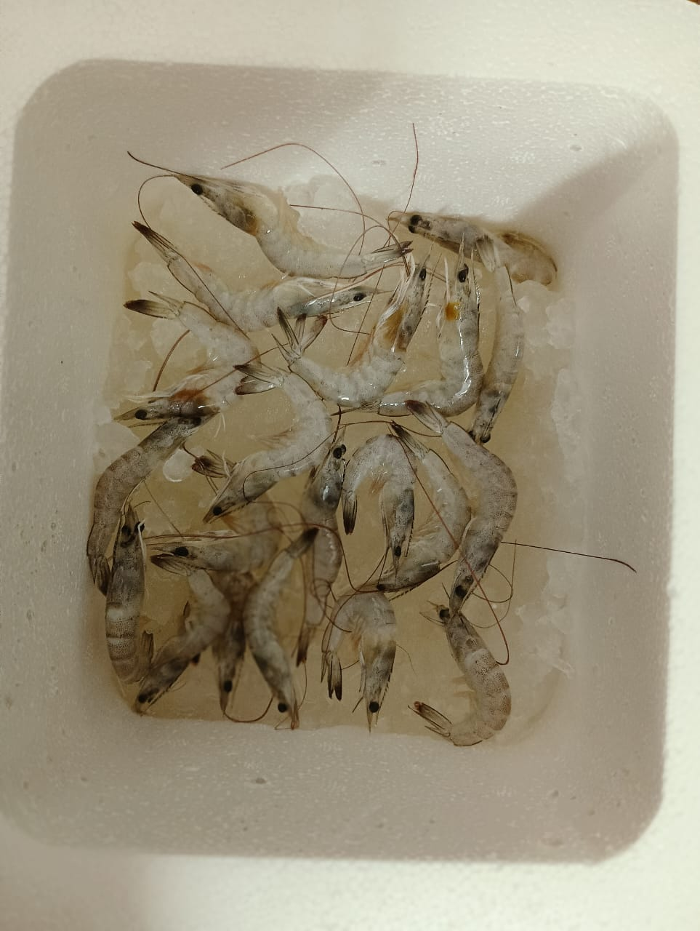

Figure.4. Litopenaeus vannamei

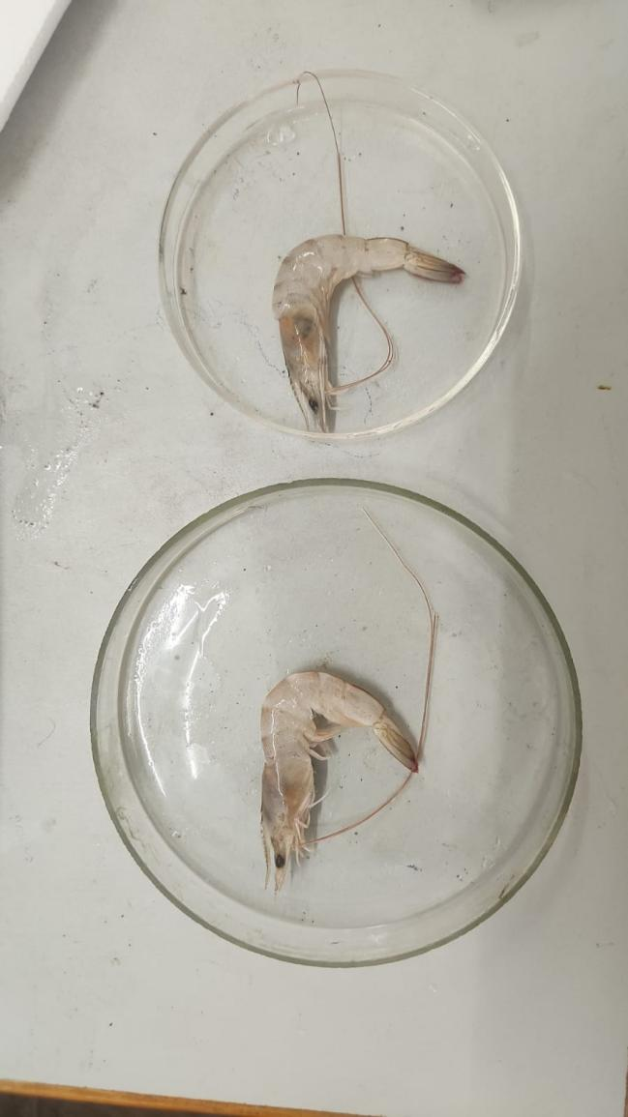

Figure 5. [Day 1 SAMPLE (LEFT), CONTROL (RIGHT)]

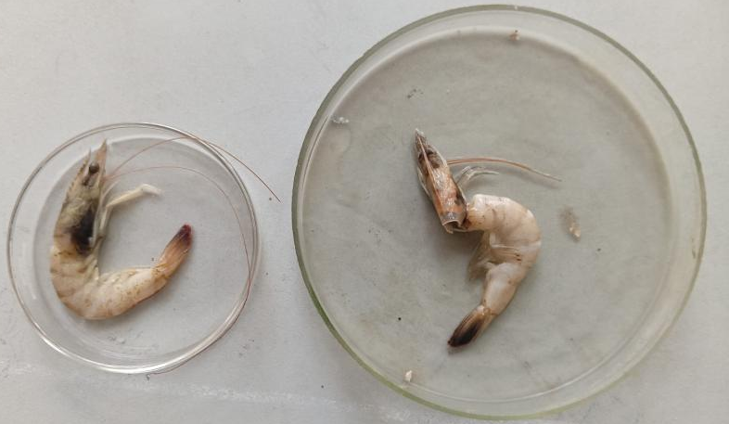
Figure 6. [Day 15 SAMPLE (LEFT) , CONTROL (RIGHT)]

Table 1. Score sheet employed for sensory evaluation of Litopenaeus vannamei
Score | Odor | General appearance | Texture
10 | Salty, briny scent | Head completely attached to body | Firm, Elastic, Hard shell / body
9 | Slightly Salty, briny scent | Head still attached to body | Fairly firm, Slightly elastic
8 | Slight Odor | Head, Body and tail slightly fade | Slightly soft body /shell
7 | Neutral to Bland | Head, Body and tail slightly fade | Slightly soft body /shell
6 | Slightly ammoniacal | Slightly loose carapace; head with slight discoloration; body and tail exhibiting light black spots | Slightly soft body /shell
5 | Slightly Fishy | Head slightly loose; head and tail discoloration | Soft Body and Shell
4 | Offensive, Sulfide | Head slightly detached from body; head, body and tail discoloration | Soft Body and Shell
3 | Ammoniacal, Sulfide | Head slightly detached from body; body and tail exhibiting dark discoloration | Sponge-like body
2 | Strongly Sulfide, Urea, Fecal | Head slightly detached from body; body and tail exhibiting dark discoloration | Body sponge-like
1 | Strongly ammoniacal | Head slightly to completely detached from body; body and tail exhibiting dark discoloration | Mushy, very soft, Papery shell

3. results and discussion
The Acalypha indica leaf extract contains antioxidant agents that are beneficial in keeping the quality of L. vannamei in chilled storage. A. indica leaf extract at 10 ml concentration for 15 days improved the sensory characteristics and extended the shelf life of L. vannamei. Odor is 3.9% higher in the sample compared to the control, and the texture of the sample is 9.9% better than the control. The general appearance of the sample is 20.1% better compared to the control. Acalypha indica leaf extract was proved to prolong the shelf life of L. vannamei in chilled storage. Since shrimp is a significant source of animal protein more research is required to reduce the over 25% worldwide food supply loss resulting from improper storage practices. The sensory score values obtained from the survey approach were used to compute the statistical summary score for odor, texture, and general appearance of Litopenaeus vannamei Boone on AILE (Table 2). According to the current study, we can increase the shrimp's shelf life by applying Acalypha indica leaf extract. The paired samples correlations are mentioned in Table 3. The frequency survey period of 15 days mean scores were represented in Figure 7.
3.1 Acalypha indica traditional medicine
Acalpha indica has great potential to treat a variety of diseases and ailments. The phytochemical constituents of the whole plant was reported to contain Acaindinin and Acetonylgeraniin (Ma et al., 1997). Acalypha indica leaf extract contained Corilagin (Ma et al., 1997) Ferulicacid (Rajsekhar and Azhar,2011) and Aurantiamide (Raj et al., 2000) while the root was reported to have Stigmasterol (Raj et al., 2003), 3,3’ Methylene bis (4-hydroxyl coumarin and Syringic acid (Rajsekhar and Azhar, 2011). Furthermore, in addition to boosting independence in terms of drug supply, employing this plant as a herbal remedy might boost the plant's value and the future economic growth of farmers (Ojediran et.al., 2024). It has a wide range of medicinal properties, including expectorant, anthelmintic, antibacterial, laxative,andanti-diabetic. The herb has antivenom qualities (Annie et al., 2004). Additionally, Acalypha indica has a diuretic effect (Das et al., 2005). Taking into consideration safety aspects and the isolation of active compounds and phytochemicals from Acalypha indica, further studies need to be carried out to unravel the search for bioactivity.

3.2 Litopenaeus vannamei Boone on AILE
The water content affects not only the shrimp’s physical and sensory properties but also the activity of spoilage bacteria and autolytic enzymes (Yang et al., 2017). Treatment of goat skins with A. indica formulation was able to preserve goat skins at ambient temperature (Vijayalakshmi et al.,2009). By providing a condition that is not conducive to bacterial growth, a 1:3 shrimp to ice ratio extends the shelf life. Freshness, which is primarily influenced by microbiological, physical, biochemical, and sensory factors, is fundamentally linked to the quality and acceptability of shrimp for human consumption. However, with this survey study the results can be concluded that extract of Acalypha indica leaf extract act as a natural preservative to extend the shelf-life of shrimp and in its quality retention. Further researches can be done on shelf-life extension of fishes and crustaceans using Acalypha indica leaf extract.

3.3 Shrimp Shelf-Life Extension During Storage
The application of an edible tragacanth gum (TG) coating, fortified with Persian lime peel (Citrus latifolia) extract (LPE), enhanced the quality and shelf life of cold-stored Pacific white shrimp (Litopenaeus vannamei), improving both physico-chemical and sensory attributes (Khaledian et al., 2021). Chitosan coating and ethanolic extracts of green tea leaves (GTE) and fenugreek seeds (FSE) extend the shelf life of Pacific white shrimp (PWS) (Litopenaeus vannamei) in cold storage (Hatab et al., 2018). The developed bioactive nanopackaging was derived from nanochitosan sourced from shrimp shells and the conversion of the white layer of orange peel into nanocellulose (Hasanin et al., 2025). The impact of lemon (Citrus limon) and pomelo (Citrus maxima) peel extracts on the quality and melanosis of Indian white prawns (Fenneropenaeus indicus) has been examined throughout a 15-day storage period, treated samples demonstrated a superior effect on shelf-life extension and quality preservation compared to untreated samples during refrigerated storage (Pandiyan et al., 2022). Active edible coatings from microalgal exopolysaccharides (EPS) supplemented with varied quantities of red seaweed extract resulted in improved quality and longer shelf life for chilled shrimp (Balti et al., 2020). Shrimps were better preserved by composite films made of blue crab chitosan (Cs) and bluefin tuna collagenous proteins (BTCP) Cs90-10BTCP film solution, which inhibited lipid peroxidation and slowed the growth of spoilage microbes (Azaza et al., 2023). As an edible coating (EC) for shrimp (Fenneropenaeus indicus), cloves (Syzygium aromaticum) buds extract (CLE) is used for biopreservation during refrigeration (Tayel et al., 2020). The impact of multi-targeted treatments, such as vacuum impregnation (VI), soursop leaf extract (SLE), pulsed electric field (PEF), and modified atmosphere packaging (MAP), with and without cold plasma (CP) treatment, on the shelf life and quality of Pacific white shrimp (Penaeus vannamei) over a 21-day period of refrigeration (Ahmad et al., 2025). For enhancing the storage stability of Pacific white shrimp, kiam wood extract (KWE) is a sustainable and natural preservative that presents a competitive alternative to artificial additives in the seafood sector (Amin et al., 2025). By acting as an antioxidant and antibacterial agent, corn zein and a garlic-based nanoemulsion extended Litopenaeus vannamei's shelf life at refrigeration (Rahnama et al., 2021). The cell-free supernatant (CFS) of L. plantarum used as a beneficial antibacterial ingredient or component in antimicrobial coatings in order to improve the quality of shrimp while they are refrigerated (Roshanzamir et al., 2025).

Table 2. Summary Score data observation of odor, texture and general appearance
Statistics performed using SPSS software
 |  | Odor Control | Odor Sample | Texture Control | Texture Sample | General Appearance Control | General Appearance Sample
N | Valid | 150 | 150 | 150 | 150 | 150 | 150
N | Missing | 0 | 0 | 0 | 0 | 0 | 0
Mean |  | 6.9800 | 7.3667 | 6.2867 | 7.4467 | 6.0733 | 8.1400
Std. Error of Mean |  | .17633 | .14012 | .18617 | .16096 | .21800 | .14533
Median |  | 7.0000 | 8.0000 | 7.0000 | 8.0000 | 6.0000 | 9.0000
Mode |  | 9.00 | 8.00 | 8.00 | 9.00 | 6.00ª | 10.00
Std. Deviation |  | 2.15964 | 1.71616 | 2.28016 | 1.97139 | 2.66998 | 1.77994
Variance |  | 4.664 | 2.945 | 5.199 | 3.886 | 7.129 | 3.168
Range |  | 8.00 | 9.00 | 8.00 | 8.00 | 9.00 | 8.00
Minimum |  | 2.00 | 1.00 | 2.00 | 2.00 | 1.00 | 2.00
Maximum |  | 10.00 | 10.00 | 10.00 | 10.00 | 10.00 | 10.00
Sum |  | 1047.00 | 1105.00 | 943.00 | 1117.00 | 911.00 | 1221.00
CV |  | 30.940 | 23.296 | 36.270 | 26.474 | 43.962 | 21.867
a. Multiple modes exist. The smallest value is shown

Table 3. Paired Samples Correlations

 |  | N | Correlation | Significance One-Sided p | Significance Two-Sided p
Pair 1 | Odor Control  and  Odor Sample | 150 | .205 | .006 | .012
Pair 2 | Texture Control  and  Texture Sample | 150 | .443 | <.001 | <.001
Pair 3 | General Appearance Control  and  General Appearance Sample | 150 | .547 | <.001 | <.001

Figure 7: Frequency_Mean scores during a 15-days survey period [Series 1 – Odor Control; Series 2 – Odor Sample; Series 3 – Texture Control; Series 4 – Texture Sample; Series 5 – General Appearance Control; Series 6 – General Appearance Sample]

4. Conclusion
Litopenaeus vannamei quality dropped in the control without treatment with AILE. Acalypha indica leaf extract had a significant effect on retaining the quality of Litopenaeus vannamei. Sensory evaluation scores for odor show control with 6.9800 and sample with 7.3667. Therefore there is a difference with odor 0.3867 higher in the sample compared to the control. The sensory evaluation score for texture shows control with 6.2867 and sample with 7.4467. Therefore there is a difference with texture 1.16 in the sample, which is higher compared to the control. The sensory evaluation score for general appearance (inclusive of color) control shows 6.0733 and the sample with 8.1400. Therefore, there is a difference observed with general appearance, 2.0667, better than compared to the control. The overall appearance is thus 2.0667 better than the control, indicating a difference. From this study, we need to further improve the shrimp’s storage method to mitigate the loss of world’s seafood supply using Acalypha indica. Incorporate fish natural preservation method to extend the shelf-life and quality retention of Shrimp.

Disclaimer (Artificial intelligence)
Author(s) hereby declare that NO generative AI technologies such as Large Language Models (ChatGPT, COPILOT, etc.) and text-to-image generators have been used during the writing or editing of this manuscript.
REFERENCES:
- Kuswandi, B., Jayus, Larasati, T. S., Abdullah, A., and Heng, L. Y. (2012). Real-time monitoring of shrimp spoilage using on-package sticker sensor based on natural dye of curcumin. Food Analytical Methods, 5(4), 881-889.
- Takle, V. V., Savad, R. V., Kandalkar, A. M., Akarte, A. M., and Patel, A. M. (2011). Pharmacognostic and Phytochemical investigations of aerial parts of Acalypha indica Linn. Pharmacognosy Journal, 3(21), 33-35.
- Nostro, A., Germanò, M. P., D’Angelo, V., Marino, A., and Cannatelli, M. A. (2000). Extraction methods and bioautography for evaluation of medicinal plant antimicrobial activity. Letters in applied microbiology, 30(5), 379-384.
- Singh, C. (2006). Ethnomedicinal uses of wild herbs in Bhagalpur district, Bihar.
- Chopra, R. N., and Nayar, S. L. (1956). Glossary of Indian medicinal plants. Council of scientific and Industrial Research.
- Basiri, S., Shekarforoush, S. S., Aminlari, M., and Akbari, S. (2015). The effect of pomegranate peel extract (PPE) on the polyphenol oxidase (PPO) and quality of Pacific white shrimp (Litopenaeus vannamei) during refrigerated storage. LWT-Food Science and Technology, 60(2), 1025-1033.
- Sae-Leaw, T., and Benjakul, S. (2019). Prevention of quality loss and melanosis of Pacific white shrimp by cashew leaf extracts. Food Control, 95, 257-266.
- Olatunde, O. O., Tan, S. L. D., and Benjakul, S. (2021). Ethanolic guava leaf extract with different chlorophyll removal processes: Antioxidant properties and its preventive effect on lipid oxidation in Pacific white shrimp. International Journal of Food Science & Technology, 56(4), 1671-1681.
- Ahmad, A. S., Sae-Leaw, T., Zhang, B., Singh, P., Kim, J. T., and Benjakul, S. (2023). Impact of ethanolic Thai indigenous leaf extracts on melanosis prevention and shelf-life extension of refrigerated Pacific white shrimp. Foods, 12(19), 3649.
- Pierozan, M. B., Oliveira Filho, J. G. D., Cappato, L. P., Costa, A. C., and Egea, M. B. (2024). Essential oils against spoilage in fish and seafood: Impact on product quality and future challenges. Foods, 13(23), 3903.
- Hendiy, M. J. (1983) Technology of fishery products. Translated into Arabic, University of Basra, Iraq.pp:853.
- Jeyasekaran, G., Ganesan, P., Anandaraj, R., Shakila, R. J., and Sukumar, D. (2006). Quantitative and qualitative studies on the bacteriological quality of Indian white shrimp (Penaeus indicus) stored in dry ice. Food microbiology, 23(6), 526-533.
- Ma, Y. T., Chuang, J. I., Lin, J. H., and Hsu, F. L. (1997). Phenolics from Acalypha indica. Journal of the Chinese Chemical Society, 44(5), 499-502.

- Rajsekhar Saha, R. S., and Azhar Ahmed, A. A. (2011). Phytochemical constituents and pharmacological activities of Acalyphus indica Linn: a review.

- Raj, J. and Singh, K. (2000). Pharmacological and phytochemical constituents, traditional uses on Acalphya indica Linn: A review. Journal of Cardiovasular Disease Research 22(21&22): 21-26

- Ojediran, G. O., Ojediran, O., Titilawo, O. Y., Shehu, Z., and Titilawo, M. A. (2024). Activities of Acalypha indica Linn (Euphorbiaceae): A Concise Review of its Phytochemical Components and Ethnomedicinal Uses. BIMA JOURNAL OF SCIENCE AND TECHNOLOGY (2536-6041), 8(1B), 23-30.

- Annie, S. (2004). Rajendran k, Ramgopal B, Denish Kumar C. Neutralization potential of vivper russelli (Russell’s viper) venom by ethnol leaf extract of Acalypha indica. J. Enthopharmaccol, 94, 267-73.

- Das, A. K., Ahmed, F., Biswas, N. N., Dev, S., and Masud, M. M. (2005). Diuretic activity of Acalypha indica. Dhaka University Journal of Pharmaceutical Sciences, 4(1).

- Yang, X., and Qian, K. (2017). Protein O-GlcNAcylation: emerging mechanisms and functions. Nature reviews Molecular cell biology, 18(7), 452-465.

- Vijayalakshmi, K., Judith, R., and Rajakumar, S. (2009). Novel plant based formulations for short term preservation of animal skins. Journal of Scientific and Industrial Research, 68(8), 699.

- Khaledian, S., Basiri, S., and Shekarforoush, S. S. (2021). Shelf-life extension of pacific white shrimp using tragacanth gum-based coatings containing Persian lime peel (Citrus latifolia) extract. Lwt, 141, 110937.

- Hatab, S., Lin, K., Miao, W., Chen, M., Lin, J., and Deng, S. (2018). Potential utilization of green tea leaves and fenugreek seeds extracts as natural preservatives for pacific white shrimp during refrigerated storage. Foodborne pathogens and disease, 15(8), 498-505.

- Hasanin, M. S., Emam, M., Ahmed, M. A., Rohim, F. M., Mohamed, M. A. A., El Saied, H., and Abdelkhalek, A. (2025). Bioactive preservative nano-packaging films based on food wastes of orange peels and Shrimp for apple (Malus domestica var. Anna) fruit quality and storage. Bioresources and Bioprocessing, 12(1), 54.

- Pandiyan, P., Soni, A., and Elumalai, P. (2022). Effects of lemon and pomelo peel extracts on quality and melanosis of Indian white prawn during chilled storage. J. Food Process. Preserv, 46, e15952.

- Balti, R., Mansour, M. B., Zayoud, N., Le Balc'h, R., Brodu, N., Arhaliass, A., and Masse, A. (2020). Active exopolysaccharides based edible coatings enriched with red seaweed (Gracilaria gracilis) extract to improve shrimp preservation during refrigerated storage. Food Bioscience, 34, 100522.

- Azaza, Y. B., Hamdi, M., Charmette, C., van Der Lee, A., Jridi, M., Li, S., and Nasri, R. (2023). Development and characterization of composite films based on chitosan and collagenous proteins from bluefin tuna: application for peeled shrimp preservation. Cellulose, 30(1), 373-395.

- Tayel, A. A., Elzahy, A. F., Moussa, S. H., Al-Saggaf, M. S., and Diab, A. M. (2020). Biopreservation of shrimps using composed edible coatings from chitosan nanoparticles and cloves extract. Journal of Food Quality, 2020(1), 8878452.

- Ahmad, A. S., Sae-Leaw, T., Zhao, Y., Ma, L., Zhang, B., Hong, H., and Benjakul, S. (2025). Synergistic Effects of Selected Nonthermal Technologies Combined with Soursop Leaf Extract on the Quality and Shelf Life of Refrigerated Pacific White Shrimp. Foods, 14(8), 1388.

- Amin, M., Buatong, J., Temdee, W., Kurnia, K. A., Unsunnidhal, L., Odeyemi, O. A., and Benjakul, S. (2025). Kiam Wood (Cotylelobium lanceotatum) Extract as a Potential Bio‐Preservative for Mitigating Spoilage and Quality Degradation of Refrigerated Shrimp. Journal of Food Science, 90(7), e70417.

- Rahnama, M., Anvar, S. A., Ahari, H., & Kazempoor, R. (2021). Antibacterial effects of extracted corn zein with garlic extract‐based nanoemulsion on the shelf life of Vannamei prawn (Litopenaeus vannamei) at refrigerated temperature. Journal of food science, 86(11), 4969-4990.

- Roshanzamir, T., Basiri, S., Shekarforoush, S. S., and Gholamhosseini, A. (2025). Bio preservation Strategies: Evaluating the Efficacy of Lactic Acid cell-free Supernatants in Extending the Refrigerated Shelf Life of Shrimp. Applied Food Research, 101047.

