Effective Control and Eradication of Mycoptes musculinus in Research Mice Colonies

Abstract
Aims: To develop and evaluate an effective eradication program for Mycoptes musculinus in a research facility by implementing a combination of animal isolation, environmental control, and chemical treatments.
Study Design: Observational case study documenting the identification, control, and eradication phases of a mite infestation in a laboratory setting.
Place and Duration of Study: Animal research facility, [Institution Name], conducted over three months (e.g., August 2024 to October 2024).
Methodology: Clinical signs of infestation, such as excessive grooming, hair loss, and scaling, prompted diagnostic tests including cellophane tape tests, skin scrapings, and PCR for confirmation. Microscopic examination identified mite sexual dimorphism, aiding in understanding population dynamics. Control measures included isolating and euthanizing affected mice, sealing wild rodent access points with plaster of Paris, and disinfecting facility areas with ivermectin (1:50 dilution) and Butox solution (1.5ml/L).
Aims: To develop and evaluate an effective eradication program for Mycoptes musculinus in a research facility by implementing a combination of animal isolation, environmental control, and chemical treatments.
Study Design: Observational case study documenting the identification, control, and eradication phases of a mite infestation in a laboratory setting.
Place and Duration of Study: Institute Animal facility,IISER Bhopal, conducted over three months (e.g., August 2024 to October 2024).
Methodology: Clinical signs of infestation, such as excessive grooming, hair loss, and scaling, prompted diagnostic tests including cellophane tape tests, skin scrapings, and PCR for confirmation. Microscopic examination identified mite sexual dimorphism, aiding in understanding population dynamics. Control measures included isolating and euthanizing affected mice, sealing wild rodent access points with plaster of Paris, and disinfecting facility areas with ivermectin (1:50 dilution) and Butox solution (5 ml/L). Weekly follow-ups and environmental inspections ensured the effectiveness of the intervention.
Results: The intervention and butox therapy successfully eradicated Mycoptes musculinus from the facility. Post-treatment follow-ups showed no evidence of reinfestation over a three-month period. Environmental sealing, combined with strategic disinfection protocols, proved effective in breaking the infestation cycle.
Conclusion: A swift and integrated response, including animal containment, environmental controls, and chemical disinfection, can eradicate Mycoptes musculinus in laboratory facilities. This case underscores the importance of early detection, comprehensive mitigation strategies, and continuous monitoring in maintaining biosecurity in research animal facilities. Future research should focus on alternative and sustainable approaches to prevent mite outbreaks.
Keywords:
Mycoptes musculinus ,Mite infestation control, Parasite management, Mite prevention methods

Introduction
Mycoptes musculinus is the fur mite of mice and is very dangerous because of the possible effects on animal health, welfare, and experimental outcomes. In fact, it imposes severe stress on mice, altering the immune responsiveness and thus perhaps affecting the experimental outcome, particularly those that pertain to immunology or behavioral studies. Such sudden appearance of clinical signs like itching, excessive grooming, and hair loss in our facility against this background was a clarion call for the confirmation and subsequent control of such an infestation (Sundar et al. 2016).
Given the limitation in resources, especially in a small isolation area that could not accommodate the affected mice outside the healthy population, we could not take the usual containment procedure. Thus, we devised a special procedure which worked around these limitations by integrating strategic euthanasia of heavily infested animals, symptomatic containment procedures, and environmental disinfection throughout the facility (Fox et al., 2002). The immediate control and long-term prevention, of course, dealt with modifications in standard practices to the specific layout and operational demands at our facility.
We describe herein the details of our diagnostic procedures, including microscopic and molecular confirmation, as well as customized control measures adopted like environmental disinfection, sealing potential sources of re-infestation, and routine monitoring (Lindstrom et al., 2011; Lee et al., 2019). Our experience underlines the flexibility in laboratory management for the effective eradication of pests and safeguarding the research environment for continued high-quality experimental work.
Materials and Methods
1.Clinical Observation
Clinical symptoms in the mice were the basis for the initial identification of Mycoptes musculinus. Clinical signs among the afflicted mice include itching, undue self-grooming, scratching more frequently, loss of hair, scaly skin in chronic conditions, and a change of the general coat condition to a rough or unkempt appearance. This contrasts the normal appearance of the mice coat, which is characteristically glossy and smooth (Fox et al., 2002; Percy & Barthold, 2007).

2.Cellophane Tape Test
To ensure that Mycoptes musculinus was indeed present on the surface of the skin, a small piece of clear tape was lightly pressed onto the lesion area of mouse skin and fur to pick up mites. Later on, the mites were examined under the light microscope at 40x and 100x (Baker, 2007). Mites are identified by their typical oval bodies, with eggs as small translucent structures attached to fur or skin debris.

3.Skin Scraping and Processing
Skin scrapings from the affected areas were taken for further confirmation of the infestation and collection of more material for analysis. The samples were dissolved in the KOH solution, and the isolated mites were observed under a microscope to confirm the infestation. (Bino Sundar et al., 2017)

4.Direct PCR Analysis
The methodology used for molecular confirmation was informed by approaches for microbiota and health monitoring in mouse colonies as outlined by Scavizzi et al.(2021). TTGATGGGTACCCTCGATTAT and GAATGA ATCACATCAACAGAAG were used for amplification. The reaction mix included template DNA (extracted sample), forward and reverse primers, fusion polymerase, dNTPs and 10x fusion buffer with reaction condition as initial denaturation at 95°C for 5 minutes ,35 cycles of denaturation at 95°C for 30 seconds, annealing at the optimized temperature 55°c for 30 seconds, and extension at 72°C for 1 minute followed by a final extension at 72°C for 5 minutes. The PCR products on an agarose gel (2%) stained with ethidium bromide were viewed under a chemidoc system The PCR products on an agarose gel (2%) stained with ethidium bromide were viewed under a chemidoc system. It was expected to show bands at 100 kb corresponding to Mycoptes musculinus.

Results
The clinical examination was performed based on general symptoms of Mycoptes musculinus infection. Confirmation was by microscopic examination of the cellophane tape test and skin scraping, together with the PCR confirmation using mites-specific primers, confirming the above-mentioned infestation, where the expected 100-bp band of PCR products was found. The female was identified as bearing chitinous claw terminally on the 3rd and the 4th pair of legs and the male were having 4th appendages modified to as claspers

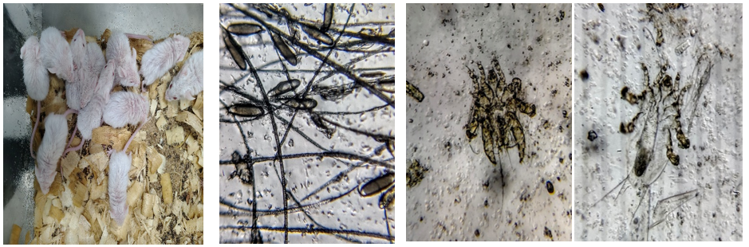
Fig 1 : Mouse pups exhibiting signs of Mycoptes musculinus
Fig 2 : Mycoptes musculinus eggs adhered to hair shafts.
Fig 3 (a) Adult male Mycoptes musculinus
(b) Adult female Mycoptes musculinus

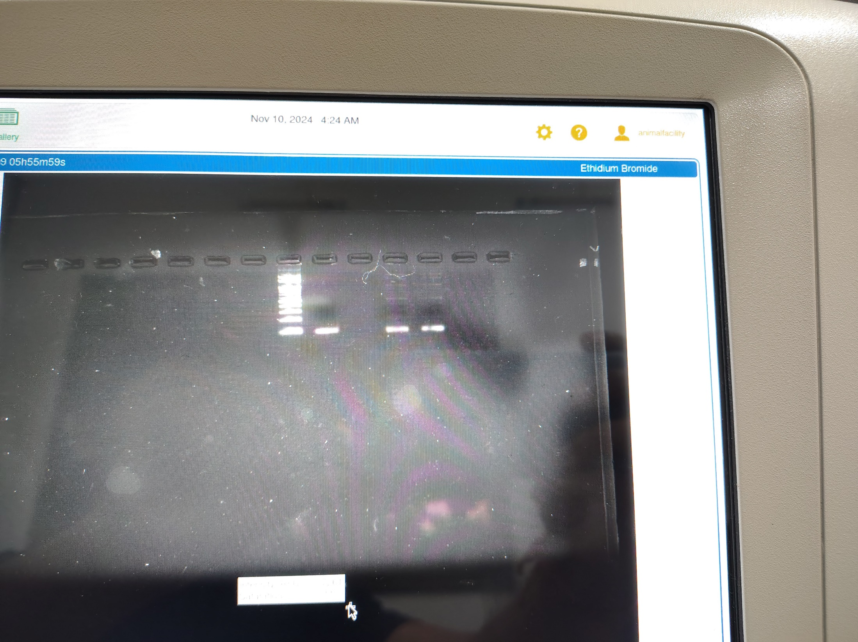
With only limited isolation space, the strategy had to be the isolation of as many affected animals as possible, paralleled by the euthanizing of heavily infested mice to prevent further spread within the colony. While small isolation capacity may pose some logistical challenge, we have ensured source control and disinfection. Entry points for wild rodents were located and sealed with plaster of Paris, removing any potential sources of reinfestation from outside the facility. Facility-wide disinfection practices consisted of an ivermectin 1:50 dilution for treating cages. Cage fumigation was conducted concurrently with a weekly facility-wide mopping practice utilizing Butox until the colony was free of remaining residual populations of mites along with dipping in 1.5ml commercially available butox in 1 litre of water weekly for four weeks (Percy & Barthold, 2007).
Positive
sample
100 kb
ladder
Positive
sample
Positive
sample
Positive
sample
Negative
sample
Fig 4 : PCR product of Mycoptes musculinus showing a distinct 100 bp band after gel electrophoresis

Monthly monitoring demonstrated no recolonization at the end of the third month and confirmed the efficacy and efficiency of our strategy for the elimination of Mycoptes musculinus both in the facility and throughout the colony.

Discussion
Eradication of Mycoptes musculinus thus points to the efficacy of combining target diagnostic techniques with customized control measures. Clinical observations of itching, excessive grooming, and visible hair loss initially pointed toward a probable mite infestation; confirmation to accuracy, however, was obtained with diagnostic steps such as the cellophane tape test, skin scraping, and PCR analysis. The characterstics feature of male and female was constant with the findings of Sundar et al. (2016). This suggests a multi-layered approach and hence a need for thorough diagnostic protocols in laboratory settings.
These facility-specific constraints, such as the limitation of isolation space, required a flexible response. The euthanization of heavily infested cases while isolating the remaining affected animals helped manage containment risks. Our experience emphasizes the need for ample, well-ventilated areas of isolation for biosecurity in laboratory facilities (Fox et al., 2002; Percy & Barthold, 2007).
Beyond isolation, environmental control focused on sealing entry points for wild rodents and using targeted disinfection protocols with ivermectin and Butox to eliminate mites in cage environments, emphasizing how regular disinfection is crucial for sustaining a mite-free colony (Ricart Arbona et al., 2010; Mehlhorn et al., 2010). Follow-up inspections performed on a periodic basis confirmed success with our disinfection protocols, preventing recurrence by underscoring the need for routine monitoring.
Conclusion
Our study demonstrates that a structured, targeted approach integrating diagnostics, customized isolation protocols, and rigorous environmental control effectively mitigates Mycoptes musculinus infestations in laboratory mouse colonies. Adapted strategies of selective euthanasia, barrier reinforcement, and stringent disinfection protocols controlled the parasite infestation despite challenges posed by limited isolation space without compromising the health of unaffected animals. Sustained elimination of the mites shows that proactive management and complete disinfection are required for protecting research integrity against such issues.
Declaration
Author(s) hereby declare that NO generative AI technologies such as Large Language Models (ChatGPT, COPILOT, etc.) and text-to-image generators have been used during the writing or editing of this manuscript.
Acknowledgement
The authors are grateful to acknowledge the Institue Animal Facility , IISER Bhopal .

Funding
No funding

Ethical consent
All authors hereby declare that "Principles of laboratory animal care" (NIH publication No. 85-23, revised 1985) were followed, as well as specific national laws where applicable. All experiments have been examined and approved by the appropriate ethics committee”

Competing interests
Authors have declared that no competing interests exist.

References

- Baker DG (2007) Flynn’s parasites of laboratory animals, 2nd edn. American College of Laboratory Animal Medicine, Blackwell Publishing, Iowa, USA, pp 361–363, pp 438–440.
- Bino Sundar ST, Harikrishnan TJ, Latha BR, Gomathinayagam S, Srinivasan MR, Ramesh S (2017) Incidence of fur mite infestation in laboratory rodents. J Parasit Dis 41(2):383–386. DOI: 10.1007/s12639-016-0811-4.
- Fox JG, Anderson LC, Loew FM, Quimby FW (2002) Laboratory animal medicine. 2nd edn. Academic Press, New York.
- Lee MA, Shen Z, Holcombe HR, Ge Z, Franklin EG, Ricart Arbona RJ, Lipman NS, Fox JG, Sheh A (2019) Detection of Myocoptes musculinus in Fur Swab and Fecal Samples by Using PCR Analysis. J Am Assoc Lab Anim Sci 58(6):796–801. DOI: 10.30802/AALAS-JAALAS-19-000046.
- Lee, M. A., Shen, Z., Holcombe, H. R., Ge, Z., Franklin, E. G., Ricart Arbona, R. J., Lipman, N. S., Fox, J. G., & Sheh, A. (2019). Detection of Myocoptes musculinus in fur swab and fecal samples by using PCR analysis. Journal of the American Association for Laboratory Animal Science: JAALAS, 58(6), 796–801. https://doi.org/10.30802/AALAS-JAALAS-19-000046
- Lindstrom KE, Carbone LG, Kellar DE, Mayorga MS, Wilkerson JD (2011) Soiled bedding sentinels for detection of fur mites in mice. J Am Assoc Lab Anim Sci 50:54–60.
- Mehlhorn, H., Schumacher, B., Jatzlau, A., Abdel-Ghaffar, F., AL-Rasheid, K., Klimpel, S., & Pohle, H. (2010). Efficacy of deltamethrin (Butox® 7.5 pour-on) against nymphs and adults of ticks (Ixodes ricinus, Rhipicephalus sanguineus) in treated hair of cattle and sheep. Parasitology Research, 108(4), 963–971. https://doi.org/10.1007/s00436-010-2141-2
- Percy DH, Barthold SW (2007) Pathology of laboratory rodents and rabbits. Iowa State University Press, Ames.
- Ricart Arbona, R. J., Lipman, N. S., & Wolf, F. R. (2010). Treatment and eradication of murine fur mites: III. Treatment of a large mouse colony with ivermectin-compounded feed. Journal of the American Association for Laboratory Animal Science: JAALAS, 49(5), 633–637.
- Sahinduran S, Ozmen O, Haligur M, Yukari BA (2010) Severe Myocoptes musculinus infestation and treatment in laboratory mice. Ankara Üniv Vet Fak Derg 57:73-75.
- Scavizzi, F., Bassi, C., Lupini, L., Guerriero, P., Raspa, M., & Sabbioni, S. (2021). A comprehensive approach for microbiota and health monitoring in mouse colonies using metagenomic shotgun sequencing. Animal Microbiome, 3(1), 13. https://doi.org/10.1186/s42523-021-00113-4
- Sundar, S., Harikrishnan, T., Bhaskaran Ravi, L., Sankaralingam, G., Srinivasan, M., & Ramesh, S. (2016). Incidence of fur mite infestation in laboratory rodents. Journal of Parasitic Diseases, 41(2), 334–337. https://doi.org/10.1007/s12639-016-0811-4

