ASSESSMENT OF BIOEFFICACY OF Beauveria bassiana INDIGENOUS PRODUCTS ON PULSE BEETLE (Callosobruchus chinenesis) TO MINIMIZE POST HARVEST LOSSES

ABSTRACT
Pulses, notably mung beans, play a pivotal role in Indian agriculture and ensure food security. However, the challenge of post-harvest losses due to storage pests such as the pulse beetle (Callosobruchus chinensis) remains substantial. Conventional synthetic pesticides, while effective, present risks to both human health and the environment. Consequently, there is growing interest in alternative methods such as biological control and botanical extracts. Beauveria bassiana, an entomopathogenic fungus, along with botanical extracts from neem, tobacco, and ginger, show promise in combating these pests. An experiment assessed the effectiveness of botanical insecticides against C. chinensis, a notorious stored grain pest. Prayagraj belongs to sub-tropical climate zone with severe winter and harsh summer along with humid monsoon. Summer lasts from March to September with daily highs reaching up to 48 °C in the dry summer (from March to May) and up to 40 °C in the hot and extremely humid monsoon season (from June to September). The research evaluated different treatments: T1 (Azadirachta indica Leaf Extract 4% + Beauveria bassiana 4%), T2 (Nicotiana tabacum Leaf Extract 4% + Beauveria bassiana 4%), and T3 (Zingiber officinale Extract 4% + Beauveria bassiana 4%). The results demonstrated that T1 exhibited the highest mortality rates across all larval stages of C. chinensis. Specifically, T1 showed 71.07% mortality at 24 hours, 94.51% at 48 hours, and 90.57% at 72 hours for the 1st instar larvae. Similarly, for the 3rd instar larvae, T1 resulted in 70.36% mortality at 24 hours, 75.14% at 48 hours, and 89.24% at 72 hours. The 5th instar larvae also showed significant mortality rates with T1 treatment. Botanical insecticides, particularly those incorporating A. indica, demonstrate significant potential for safeguarding pulses from pest infestation during storage. Plant-based insecticides offer environmentally friendly, biodegradable alternatives that safeguard non-target organisms. To advance the development of novel compounds for sustainable pest management in stored grains, future research should investigate a range of factors, including mammalian toxicity, insecticidal mechanisms, seed viability, and chemical stability. In summary, plant-based insecticides provide a sustainable strategy for grain protection, effectively controlling pest populations while reducing environmental harm.
Key words: Beauveria bassiana, Callosobruchus chinensis, IPM, Indigenous products.

INTRODUCTION
The rapidly increasing global population leads to widespread food scarcity and malnutrition, posing challenges for scientists to feed the population with cereal crops alone[10]. Grain legumes, such as mung beans, are essential for improving diets and provide significant dietary intake in many developing regions. Mung bean production is influenced by agricultural practices and sowing techniques, with research focusing on enhancing soil crop management and advanced production techniques to meet the growing population's needs [26]. Pulses, or grain legumes, rank just behind cereals in agricultural importance due to their nitrogen-fixing ability, high protein content, and resilience in less endowed environments. They improve soil health and long-term fertility, meeting up to 80% of their nitrogen requirements through symbiotic fixation. Mung bean is extensively grown in regions such as India, Pakistan, Bangladesh, Sri Lanka, and other parts of Asia, Africa, and the Americas [30]. India is the largest producer, contributing significantly to the country's pulse production. Mung bean, primarily a rainy season crop, is also suitable for spring and summer under irrigated conditions due to its early-maturing varieties. Pulses have high water-use efficiency, making them crucial for sustainable agriculture [34]. Mung bean seeds are a rich protein source with essential minerals, fitting well into multiple cropping systems and providing green manure or fodder post-harvest [12]. Mung bean production is hindered by diseases and pests, leading to significant post-harvest losses. In India, post-harvest losses of pulses, primarily due to insect pests, amount to 12-16 million tonnes annually, causing substantial economic losses [30][7]. Insect pests, such as the pulse beetle (Callosobruchus spp.), cause considerable damage to stored grains [36]. Effective and cost-efficient pest control strategies are urgently needed to reduce these losses [21].
Synthetic pesticides, while commonly used, pose health risks, environmental harm, and pest resistance issues [32][35][19]. Therefore, biological control methods, such as entomopathogenic fungi like Beauveria bassiana and botanical extracts, are recommended. Beauveria bassiana is effective against various insect pests and fits well into integrated pest management programs [14][23][1][17]. Botanical products like neem (Azadirachta indica), tobacco (Nicotiana tabacum), and ginger (Zingiber officinale) have shown efficacy against insect pests. Neem, in particular, contains over 25 bioactive compounds with pesticidal properties [26][5]. Botanical extracts offer a sustainable approach to pest management, impacting the physiological features of pests and showing high mortality rates [18][27]. Biological control methods and botanical extracts present a sustainable and environmentally friendly approach to managing storage pests in pulses, reducing post-harvest losses, and ensuring food security in India. Therefore, the objective of the study is to find out the bio-efficacy of different concentrations of Beauveria bassiana and botanical extract against target stored grain insect pests.

METHOD
The experiment was carried out in the Department of Biological Sciences, Sam Higginbottom University of Agriculture Technology and Science, India.
The test insect used for this study was Callosobruchus chinensis commonly known as the pulse beetle. Various instars of Callosobruchus chinensis were reared in the laboratory to facilitate the research as shown in Fig.3, Fig.4, and Fig.5. The study involved two main procedures: The isolation of the entomopathogenic fungus Beauveria bassiana and the extraction of plant materials from Azadirachta indica leaves, Nicotiana tabacum leaf, and Zingiber officinale extract using the Soxhlet extraction method.
To isolate Beauveria bassiana, Sobouraud Dextrose Agar (SDA) medium was prepared following a standardized protocol, which involved dissolving solid components like agar, peptone, yeast extract, and dextrose in distilled water, adjusting the pH to 6.0-6.5, and sterilizing the mixture by autoclaving. The isolated Beauveria bassiana was then cultured on the SDA medium to obtain different concentrations for the study.
Plant materials were extracted using the Soxhlet extraction method. This process involved repeatedly washing the plant leaves and rhizomes with a solvent in a Soxhlet extractor, allowing for the efficient extraction of bioactive compounds. These extracts, along with the different concentrations of Beauveria bassiana, were prepared for further experiments to evaluate their bio-efficacy against the target stored grain insect pests, aiming to minimize post-harvest losses.
- Preparation of SDA Medium:
For isolation and culturing of the entomopathogenic fungus Beauveria bassiana, Sobouraud Dextrose Agar (SDA) medium was used. The procedure adopted for the preparation is as under [2].

Table 1. Preparation of SDA Medium
Composition in solid form |  | Composition in broth medium
Agar | 15 g | Agar | 15 g
Peptone | 10 g | Peptone | 10 g
Yeast extracts | 2 g | Yeast extract | 2 g
Distilled water | 1000 ml | Distilled water | 1000 ml
pH | 6.0-6.5 | pH | 6.0-6.5
Dextrose | 40 g | Dextrose | 40 g

A weighed amount of peptone and yeast extract was dissolved in 1000 ml of distilled water in the pan. The mixture is heated slowly while stirring until it starts to boil. Agar was added prior to boiling. After boiling for some time, it was removed from the heat dextrose was added and the pH was adjusted to 6.0-6.5. Then the media was transferred to flasks and culture tubes were sterilized at 15 lbs pressure for 20 minutes in the autoclave.
b. Isolation of fungus:
The fungus Beauveria bassiana was isolated from dead Inderbella quadrinotata, (Guava Bark eating caterpillar) larvae collected from guava orchards of Allahabad Agricultural Institute -Deemed University, Allahabad. The culture was then purified on SDA media and maintained for use in the various experiments.
c. Identification of Fungus:
Mycelium is white or slightly colored with a white fluffy powders appearance. Conidiophores single, irregularly, grouped, or in verticillate clusters, in some species inflated at the base, tapering to a slender spores-bearing portion, which appears zigzag after several spores are produced. Conidia hyaline, rounded ovoid one-celled borne singly on sterigmata (Fig.2)

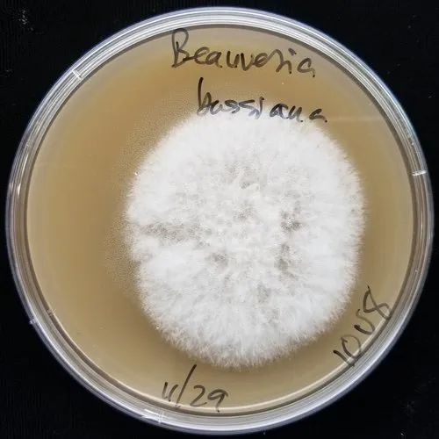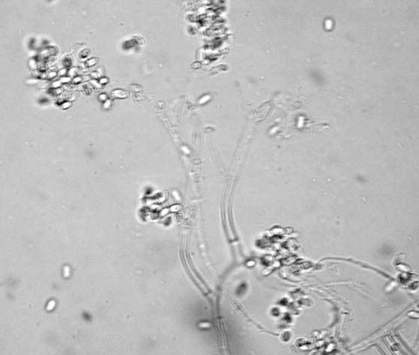
Fig.1 Conidia hyaline Fig.2 sterigmata

d. Inoculation of test organism :
I. In solid form: With the help of a sterilized cork borer, discs of 0.5 cm diameter were cut from the actively growing culture of Beauveria bassiana at the edge of the culture and placed in the center of each dish. Inoculated Petri dishes were incubated at 25-26 ºC and radial growth (mm) of Beauveria bassiana was recorded at 12th and 18th days after inoculation.
II. In broth Medium : In broth medium disc of the test fungus were inoculated in the conical flasks. The inoculated flasks were incubated at 25-26 ⁰C for 10 days and mycelial weight was recorded after filtering the liquid out.
e. Purification and Maintenance of culture:
The culture of Beauveria bassiana was purified from isolated dishes and maintained by periodic sub-culturing in SDA slants every 15 days.
f. Preparation of different concentrations of Beauveria bassiana :
The fungus was removed from the flasks and then pressed in between the blotting paper. Then it was weighed prepare different concentrations (weight/volume) of 4 %,
4 % lab formulation:- 4 gram Beuveria bassiana net in 96 ml distilled water.

g. Preparation of botanical extract
Soxhlet apparatus method was used.
h. Soxhlet Extraction
This method was used as a benchmark for cold press extraction. A ground sample of neem leaf (64 g) was placed in a “thimble” made of filter paper and placed in the soxhlet extractor. A flask containing 500 ml of the appropriate solvent was attached at the bottom and heated until evaporation, according to the 936.15 AOAC (1990) procedure. This cycle was repeated four times, with a portion of the biopesticide washed off with the help of the solvent. Following completion of all four cycles, the thermostatized evaporation of the solvent was carried out until constant weight on boiling chips at 60°C. Three extractions were obtained for each solvent.

Table 2. LIST OF TREATMENT
T0 | Control
T1 | Azadirachta indica Leaf Extract 4% + Beauveria bassiana 4 %
T2 | Nicotiana tabacum Leaf Extract 4 % + Beauveria bassiana 4 %
T3 | Zingiber officinale extract 4 % + Beauveria bassiana 4 %

Preparation of test Indigenous products
- Azadirachta indica Leaf Extract 4% + Beauveria bassiana 4 %
To prepare the extract of Azadirachta indica in Beauveria bassiana, a very simple method was adapted. The 4 % from Azadirachta indica Leaf Extract wasadded with 4 % from Beauveria bassiana. Now to prepare the 4 % above solution the quantity of different ingredients was 40 ml mixture extract + 960 ml water + 1 gram soap (The soap acts as a surfactant, which helps to emulsify the solution, ensuring even distribution and better adhesion of the active ingredients to the target surfaces).

- Nicotiana tabacum 4%+ Beauveria bassiana 4 %
To prepare the extract of Nicotiana tobacum in Beauveria bassiana, a very simple method was adapted. The 4 % of Nicotiana tabacum Leaf Extract was added with 4% of Beauveria bassiana. Now to prepare the 4 % above solution the quantity of different ingredients was 40 ml mixture extract + 960 ml water + 1 gram soap (The soap acts as a surfactant, which helps to emulsify the solution, ensuring even distribution and better adhesion of the active ingredients to the target surfaces.).
- Zingiber officinale 4% + Beauveria bassiana 4 %
To prepare the extract of Zingiber officinale in Beauveria bassiana, a very simple method was adapted. The 4% of Zingiber officinale Leaf Extract was added with 4% of Beauveria bassiana. Now to prepare the 4% above solution the quantity of different ingredients was 40 ml mixture extract + 960 ml water + 1 gram soap (The soap acts as a surfactant, which helps to emulsify the solution, ensuring even distribution and better adhesion of the active ingredients to the target surfaces.).
The mortality percentage and net mortality of instar (Stage development) larvae 1st, 3rd and 5th of the test insect pest will be calculated at the duration of 24, 48 & 72 hours by using Abbot’s formula:[3]

$$Percent net mortality=\frac{percent mortality in test-percent mortality in control}{100-Percent mortality in control}x100$$
Mode of action:- Contact

Contact action: The method involved the experimental set up by drawing 1st instar larvae of Callosobruchus chienesis from the colony reared in the laboratory and kept separately for pre-treatment. Ten larvae/replicate were released in the beakers for 16 treatments (in each beaker sterilized filter paper was kept), and each replicated thrice. [4]
Uniform spraying on the insect body was done by spraying 10ml of each treatment through a Pneumatic hand atomizer [11]. For control 10 ml distilled water was sprayed on the insect body sprayed larvae were air dried for about five minutes and then fresh food was provided to the test insects. Same procedures were repeated for 1st 3rd and 5th instar larvae Callosobruchus chienesis for 24, 48, and 72 hours, respectively.
The post-treatment operations involved transferring the beakers containing treated larvae to the laboratory, under the control environmental conditions. Observations for larval mortality were recorded.

Study of Phytochemical properties and their mode of action of particular treatments
Particular treatment | Phytochemical properties | Mode of action | Refrences
Beauveria bassiana | 1.Beauveria bassiana is an entomopathogenic fungus known for producing several bioactive compounds, including beauvericin, bassianin,and tenellin.  2.These compounds have insecticidal properties that interfere with the pest's nervous system and cellular processes. | Beauveria bassiana fungal pathogen that infects insects by penetrating their cuticle and proliferating within their body, leading to death through a combination of physical damage and toxin production. | [11][13]
Azadirachta indica | Neem contains several bioactive compounds, with azadirachtin being the most significant. Others include nimbin,salannin, and meliantriol . | 1. Neem extract contains azadirachtin, which disrupts the hormonal system of insects, affecting their growth, reproduction, and feeding behavior. It also has antifeedant properties and can inhibit the feeding and oviposition of C. chinensis.  2. Azadirachtin disrupts the hormonal balance in insects, inhibiting growth, molting, and reproduction. It also acts as an antifeedant and repellent. | [15][27]
Nicotiana tabacum | Tobacco plants produce nicotine and anabasine, potent alkaloids with insecticidal properties. | 1.Tobacco extract contains nicotine, which is a potent neurotoxin affecting the nervous system of insects. It acts as a repellent and has contact toxicity against C. chinensis.  2.Nicotine acts as a neurotoxin by mimicking acetylcholine, causing continuous stimulation of the insect nervous system, leading to paralysis and death. | [22][28]
Zingiber officinale | Ginger contains gingerols, shogaols, and zingerone, which have insecticidal and repellent properties. | 1.Ginger extract contains compounds such as gingerol and shogaol, which have insecticidal and repellent properties. These compounds interfere with the feeding and reproductive systems of pests.  2. The active compounds interfere with the pest's digestive and nervous systems, reducing feeding and causing mortality. | [2][23]

Statistical Analysis:

A. Laboratory treatments:

The percent mortality and percent net mortality caused by different treatments on different instars in the three methods were calculated by using the Abbots formula: [3]

Mortality in test
Mortality in control

Percent mortality =
x 100

Percent mortality in test – per cent mortality in control
x 100
Percent net mortality =
100 – Percent mortality in control

For comparing the effects of instars, periods, and treatments all together, a three-way analysis of variance technique (Gomez and Gomez, 1984) was used.

The skeleton of the ANOVA table is appended below

The data obtained on various characters/parameters were subjected to analyses of variance technique applicable to completely randomized design. The level of significance used in the ‘F’ test was p= 0.05 wherever, the F calculated was significant, critical difference values were calculated for treatment comparisons. The values obtained in percentage were transformed into angular values and subjected to analyses.

RESULT
Table 3. Net Percent mortality of C. chinensis adults treated with treatment on the 1st instar.
Treatment details | 24 hrs | 48hrs | 72hrs
T0 | 0.00 | 0.00 | 0.00
T1 | 71.06 | 77.81 | 90.57
T2 | 64.03 | 69.51 | 86.77
T3 | 57.22 | 49.91 | 64.87
C.D. at 5% | 1.984 | 1.842 | 0.873
SE.d (±) | 0.847 | 0.787 | 0.373
C.V. | 2.157 | 1.954 | 0.754
T0: Control, T1: Azadirachta indica Leaf Extract 4% + Beauveria bassiana 4 %, T2: Nicotiana tabacum 4% + Beauveria bassiana 4 % and T3: Zingiber officinale 4% + Beauveria bassiana 4 %

The treatment details revealed that the control group (T0) exhibited 0.00% mortality at 24, 48, and 72 hours, indicating no effect on the pulse beetle larvae. In contrast, the treatment with Azadirachta indica Leaf Extract 4% combined with Beauveria bassiana 4% (T1) showed significant effectiveness, with mortality rates of 71.06% at 24 hours, 77.81% at 48 hours, and 90.57% at 72 hours. The Nicotiana tabacum Leaf Extract 4% combined with Beauveria bassiana 4% (T2) also demonstrated high efficacy, with mortality rates of 64.03% at 24 hours, 69.51% at 48 hours, and 86.77% at 72 hours. The Zingiber officinale Extract 4% combined with Beauveria bassiana 4% (T3) was the least effective among the treatments, with mortality rates of 57.22% at 24 hours, 49.91% at 48 hours, and 64.87% at 72 hours.

Graph 1. Net Percent mortality of C. chinensis adults treated with treatment on the 1st instar.T0: Control, T1: Azadirachta indica Leaf Extract 4% + Beauveria bassiana 4 %, T2: Nicotiana tabacum 4% + Beauveria bassiana 4 % and T3: Zingiber officinale 4% + Beauveria bassiana 4 %

Table 4. Net Percent mortality of C. chinensis adults treated with treatment at 3rd instar.
Treatment details | 24hrs | 48hrs | 42hrs
T0 | 0.00 | 0.00 | 0.00
T1 | 70.36 | 75.14 | 89.24
T2 | 61.96 | 65.84 | 84.17
T3 | 55.17 | 49.24 | 63.53
C.D. at 5% | 1.252 | 1.351 | 2.143
SE.d (±) | 0.535 | 0.577 | 0.915
C.V. | 1.397 | 1.485 | 1.892
T0: Control, T1: Azadirachta indica Leaf Extract 4% + Beauveria bassiana 4 %, T2: Nicotiana tabacum 4% + Beauveria bassiana 4 % and T3: Zingiber officinale 4% + Beauveria bassiana 4 %

The treatment details indicated that the control group (T0) had a consistent 0.00% mortality rate at 24, 48, and 72 hours, showing no effect on the pulse beetle larvae. For the treatment with Azadirachta indica Leaf Extract 4% combined with Beauveria bassiana 4% (T1), the mortality rates were 70.36% at 24 hours, 75.14% at 48 hours, and 89.24% at 72 hours. The treatment with Nicotiana tabacum Leaf Extract 4% combined with Beauveria bassiana 4% (T2) resulted in mortality rates of 61.96% at 24 hours, 65.84% at 48 hours, and 84.17% at 72 hours. The treatment with Zingiber officinale Extract 4% combined with Beauveria bassiana 4% (T3) exhibited the lowest effectiveness among the treatments, with mortality rates of 55.17% at 24 hours, 49.24% at 48 hours, and 63.53% at 72 hours.

Graph 2. Net Percent mortality of C. chinensis adults treated with treatment at 3rd instar.
T0: Control, T1: Azadirachta indica Leaf Extract 4% + Beauveria bassiana 4 %, T2: Nicotiana tabacum 4% + Beauveria bassiana 4 % and T3: Zingiber officinale 4% + Beauveria bassiana 4 %

Table 5. Net Percent mortality of C. chinensis adults treated with treatment at 5th instar.
Treatment details | 24hrs | 48hrs | 72hrs
T0 | 0.00 | 0.00 | 0.00
T1 | 69.03 | 71.48 | 78.57
T2 | 58.62 | 63.51 | 65.78
T3 | 42.91 | 44.17 | 50.53
C.D. at 5% | 1.451 | 2.195 | 2.595
SE.d (±) | 0.620 | 0.937 | 1.108
C.V. | 1.780 | 2.568 | 2.785
T0: Control, T1: Azadirachta indica Leaf Extract 4% + Beauveria bassiana 4 %, T2: Nicotiana tabacum 4% + Beauveria bassiana 4 % and T3: Zingiber officinale 4% + Beauveria bassiana 4 %

The treatment details showed that the control group (T0) had a 0.00% mortality rate consistently at 24, 48, and 72 hours, indicating no effect on the pulse beetle larvae. The treatment with Azadirachta indica Leaf Extract 4% combined with Beauveria bassiana 4% (T1) resulted in mortality rates of 69.03% at 24 hours, 71.48% at 48 hours, and 78.57% at 72 hours. The treatment with Nicotiana tabacum Leaf Extract 4% combined with Beauveria bassiana 4% (T2) showed mortality rates of 58.62% at 24 hours, 63.51% at 48 hours, and 65.78% at 72 hours. The treatment with Zingiber officinale Extract 4% combined with Beauveria bassiana 4% (T3) exhibited the lowest effectiveness, with mortality rates of 42.91% at 24 hours, 44.17% at 48 hours, and 50.53% at 72 hours.

Graph 3. Net Percent mortality of C. chinensis adults treated with treatment at 5th instar.
T0: Control, T1: Azadirachta indica Leaf Extract 4% + Beauveria bassiana 4 %, T2: Nicotiana tabacum 4% + Beauveria bassiana 4 % and T3: Zingiber officinale 4% + Beauveria bassiana 4 %.

DISCUSSION
Effectiveness of Beauveria bassiana and Botanical Extracts
The study demonstrates that the combination of Beauveria bassiana with botanical extracts, particularly Azadirachta indica (neem), is highly effective in managing C. chinensis infestations in stored pulses. The mortality rates observed in this study suggest that these combinations can be potent biopesticides, providing an environmentally friendly alternative to conventional chemical pesticides. Azadirachta indica combined with Beauveria bassiana (T1) achieved the highest mortality rates across all instar stages, significantly reducing the population of C. chinensis over time. Specifically, this treatment resulted in mortality rates of up to 90.57% at 72 hours for the 1st instar larvae. This high efficacy aligns with the known pesticidal properties of neem, which include disrupting the hormonal systems of insects, thereby inhibiting growth, reproduction, and feeding behaviors. Nicotiana tabacum (tobacco) extract also demonstrated considerable effectiveness, although slightly less potent than neem. The combination of tobacco extract with Beauveria bassiana (T2) resulted in mortality rates of up to 86.77% at 72 hours for the 1st instar larvae. The active compound in tobacco, nicotine, acts as a neurotoxin that disrupts the nervous system of insects, leading to paralysis and eventual death. Zingiber officinale (ginger) extract, while effective, was the least potent of the three botanical treatments. The ginger extract combined with Beauveria bassiana (T3) showed mortality rates of 64.87% at 72 hours for the 1st instar larvae. Ginger contains compounds such as gingerol and shogaol, which have insecticidal and repellent properties but are less aggressive compared to neem and tobacco extracts.
Environmental and Health Benefits
The use of Beauveria bassiana in conjunction with botanical extracts offers significant environmental benefits. Unlike synthetic pesticides, these biopesticides do not pose risks to human health or non-target organisms. The entomopathogenic fungus Beauveria bassiana works by penetrating the insect's cuticle and proliferating within its body, causing death through a combination of physical damage and toxin production. This mechanism is specific to insects, reducing the likelihood of adverse effects on other species.
Additionally, neem, tobacco, and ginger extracts are biodegradable, reducing the environmental persistence and potential pollution associated with chemical pesticides. This makes these treatments particularly suitable for sustainable agriculture practices, which aim to minimize the ecological footprint of pest management strategies.

CONCLUSION
The research highlights the bioefficacy of Beauveria bassiana and various botanical extracts against Callosobruchus chinensis, a significant pest of stored grains. This study involves different treatments combining Beauveria bassiana with extracts from Azadirachta indica, Nicotiana tabacum, and Zingiber officinale, evaluating their effectiveness in controlling larval mortality at different instar stages (1st, 3rd, and 5th) over 24, 48, and 72 hours. The experimental setup includes the preparation and application of these treatments using appropriate methodologies such as soxhlet extraction for botanical extracts and SDA medium for cultivating Beauveria bassiana. The results indicate varying degrees of mortality in treated insects compared to the control, highlighting the potential of these biological and botanical agents in integrated pest management strategies.
The study concludes that integrating Beauveria bassiana with botanical extracts such as Azadirachta indica and Nicotiana tabacum can effectively control Callosobruchus chinensis infestations in stored grains. This approach offers a sustainable and environmentally friendly alternative to synthetic pesticides, potentially reducing post-harvest losses and ensuring food security in pulse crops. Overall, the use of plant-based insecticides represents a sustainable and environmentally friendly approach to grain protection, providing effective pest control while minimizing harm to the ecosystem.
DISCLAIMER (ARTIFICAIL INTELIGENCE)
Author(s) hereby declares that no generative AI technologies such as large Language Models (ChatGPT, COPILOT, etc) and text-to-image generators have been used during the writing or editing of manuscripts.
Disclaimer (Artificial intelligence)
Option 1:
Author(s) hereby declare that NO generative AI technologies such as Large Language Models (ChatGPT, COPILOT, etc) and text-to-image generators have been used during writing or editing of manuscripts.
Option 2:
Author(s) hereby declare that generative AI technologies such as Large Language Models, etc have been used during writing or editing of manuscripts. This explanation will include the name, version, model, and source of the generative AI technology and as well as all input prompts provided to the generative AI technology
Details of the AI usage are given below:
1.
2.
3.

REFERENCES
- Arooni-Hesari, M., Talaei-Hassanloui, R., & Sabahi, Q. (2015). Simultaneous use of entomopathogenic fungus Beauveria bassiana and diatomaceous earth against the larvae of Indian Meal Moth, Plodia interpunctella. Advances in Bioscience and Biotechnology, 6(08), 501. doi:10.4236/abb.2015.68052.
- Ali, S., Sagheer, M., Hassan, M., Abbas, M., Hafeez, F., Farooq, M., Hussain, D., Saleem, M., Ghaffar, A. (2014). Insecticidal activity of turmeric (Curcuma longa) and garlic (Allium sativum) extracts against red flour beetle, *Tribolium castaneum*: A safe alternative to insecticides in stored commodities. *Journal of Entomology and Zoology Studies, 2*(3), 201-205.
- Atlas, R. M. (2004). Handbook of Microbiological Media (3rd ed.). CRC Press.
- Abbot, W. S. (1925). A method of computing the effectiveness of an insecticide. *Journal of Economic Entomology*, 18(2), 265-267. https://doi.org/10.1093/jee/18.2.265.
- Barapatre, A., & Lingappa, S. (2003). Experimental setup for studying the effects of treatments on first instar larvae of Callosobruchus chinensis. Journal of Entomological Research, 27(1), 45-52.
- Chaudhary, S., Kanwar, R. K., & Sehgal, A. (2017). Azadirachtin: An update on its mode of action against insect pests. Natural Product Communications, 12(8), 1369-1376. https://doi.org/10.1177/1934578X1701200831.
- Duraimurugan, P., & Tyagi, K. (2014). Pest spectra, succession and its yield losses in mungbean and urdbean under changing climatic scenario.DOI: 10.5958/j.0976-0571.37.2.032.
- Garnett, T. (2013). Food sustainability: Problems, perspectives and solutions. Proceedings of the Nutrition Society, 72(1), 29-39. https://doi.org/10.1017/S0029665112002947.
- Gupta, R. K. (2001). Uniform spraying on insect body using a pneumatic hand atomizer. Pesticide Science, 59(4), 321-327. https://doi.org/10.1002/ps.366.
- Gopalan, C., Ramasastri, B. V., & Balasubramanian, S. C. (1995). Nutritive value of Indian foods. National Institute of Nutrition, Indian Council of Medical Research, 156. https://doi.org/10.1016/ni95.01.007.
- Goettel, M. S., & Inglis, D. A. (1997). Fungal pathogens of insects and other arthropods. *The Mycota, Volume IV: Environmental and Microbial Relationships*. Springer-Verlag, Berlin. [DOI: 10.1007/978-3-662-03266-0].
- Hatting, J. L. Wraight, S. P., & Miller, R. M. (2004). Efficacy of Beauveria bassiana (Hyphomycetes) for control of Russian wheat aphid (Homoptera: Aphididae) on resistant wheat under field conditions. Biocontrol Science and Technology, 14(5), 459-473. DOI: 10.1080/09583150410001683501.
- Hajjaji, S., & Faria, M. (2009). Efficacy of *Beauveria bassiana* against *Callosobruchus chinensis* and other stored-product insects. *Biocontrol Science and Technology, 19*(2), 201-214. [DOI: 10.1080/09583150802665250]
- Isman, M. B. (2006). Botanical insecticides, deterrents, and repellents in modern agriculture and an increasingly regulated world. Annual Review of Entomology, 51, 45-66. DOI: 10.1016/j.exppara.2016.05.010
- Isman, M. B., Koul, O., Luczynski, A., & Kaminski, J. (1990). Insecticidal and antifeedant bioactivities of neem oils and their relationship to azadirachtin content. *Journal of Agricultural and Food Chemistry, 38*(6), 1406-1411. [DOI: 10.1021/jf00098a036]
- Kalita, S., Hazarika, L. K., Das, P., & Das, K. (2018). Efficacy of Chromolaena odorata leaf powder and Beauveria bassiana against stored grain pests. Indian Journal of Entomology, 80(3), 1005-1010. DOI: 10.5958/0974-8172.2018.00152.9
- Niranjana, R. F., & Karunakaran, S. (2019). Evaluation of botanical extracts against Callosobruchus maculatus F.(Coleoptera: Chrysomelidae) on different host grains. Journal of Science, 10(1). DOI: 10.4038/jsc.v10i1.17
- Okoroiwu, H. U., &Iwara, I. A. (2018). Dichlorvos toxicity: A public health perspective. Interdisciplinary toxicology, 11(2), 129.doi: 10.2478/intox-2018-0009
- Phillips, T. W., & Throne, J. E. (2010). Biorational approaches to managing stored-product insects. Annual Review of Entomology, 55, 375-397. https://doi.org/10.1146/annurev-ento-112408-085314.
- Pu, X. Y., Feng, M. G., & Shi, C. H. (2005). Impact of three application methods on the field efficacy of a Beauveria bassiana-based mycoinsecticide against the false-eye leafhopper, Empoascavitis. DOI: 10.1016/j.cropro.2004.07.006
- Pavela, R., & Benelli, G. (2016). Ethnobotanical knowledge on botanical repellents employed in the African region against mosquito vectors - a review. Experimental Parasitology, 167, 103-108. http://dx.doi.org/10.1016/j.exppara.2016.05.010
- Rajashekar, Y., Raghavendra, A., & Bakthavatsalam, N. (2015). Evaluation of the insecticidal activity of tobacco extract against *Callosobruchus chinensis* in stored chickpea. *Journal of Insect Science, 15*(1), 1-7. [DOI: 10.1093/jis/15.1.1].
- Rajashekar, Y., Raghavendra, A., & Bakthavatsalam, N. (2014). Efficacy of ginger (Zingiber officinale) extracts against *Callosobruchus chinensis* in stored chickpeas. *Journal of Stored Products Research, 58*, 63-70. [DOI: 10.1016/j.jspr.2014.04.005]
- Shah, F. A., Azam, M., & Khan, A. A. (2013). Effectiveness of neem seed and leaf extracts as alternatives to synthetic insecticides: A review. *Journal of Plant Protection Research*, 53(4), 352-365. https://doi.org/10.2478/jppr-2013-0053.
- Shapiro, R. (2012). Prevention of vector transmitted diseases with clove oil insect repellent. Journal of pediatric nursing, 27(4), 346-349.DOI: 10.1016/j.pedn.2011.03.011.
- Singh, G., Sekhon, H. S., & Kamboj, R. (2004). Mungbean: An important pulse crop in tropical and subtropical regions. *International Journal of Agricultural Research*, 2(1), 21-29. https://doi.org/10.1007/s00203-004-0627-2.
- Singh, R., Singh, B., & Verma, R. A. (2001). Efficacy of different indigenous plant products as grain protectants against *Callosobruchus chinensis* (Linn) on pea. *Indian Journal of Entomology, 63*(2), 179-181.
- Shukla, R. K., & Shrivastava, S. (2010). Tobacco extract as an alternative to synthetic pesticides for the control of *Callosobruchus chinensis*. *Journal of Pest Science, 83*(1), 63-69. [DOI: 10.1007/s10340-009-0273-0]
- Sivakumar, P., Agarwal, R., & Shivashankar, S. (2010). Environmental impact and resistance issues of synthetic pesticides used for stored grain pests. Journal of Environmental Science and Health, Part B, 45(6), 432-445. https://doi.org/10.1080/03601234.2010.483231.
- Soch, R. (2016). Water-use efficiency of pulses compared to other protein sources. Journal of Sustainable Agriculture, 8(2), 45-53. https://doi.org/10.1016/j.jsa.2016.02.001.
- Tchounwou, P. B., Patlolla, A. K., Yedjou, C. G., & Moore, P. D. (2015). Environmental exposure and health effects associated with malathion toxicity. Toxicity and Hazard of Agrochemicals, 51, 2145-9. DOI: 10.5772/60911.
- Tyagi, R., Singh, P., & Sharma, A. (2019). Pest infestation in stored agricultural products in India. Journal of Agricultural Entomology, 33(2), 145-158. https://doi.org/10.1016/j.jae.2019.04.003.

ABBREVIATION

% Percentage.
Hrs Hours.
IPM Integrated Pest Management.
Spp Species.
⁰c Degree Celsius.
gm Gram.
ml Millilitre.
C. chinensis Callosobruchus chinensis.
T0 Treatment zero (Control)
T1 Treatment 1
T2 Treatment 2
T3 Treatment 3

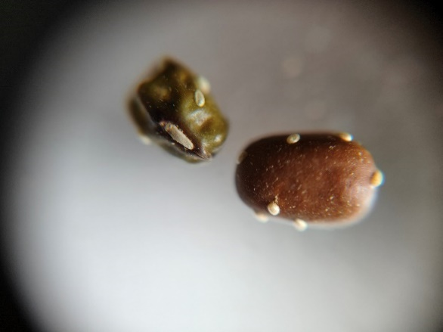
Fig 3. EGGS LAID ON GREEN GRAM??

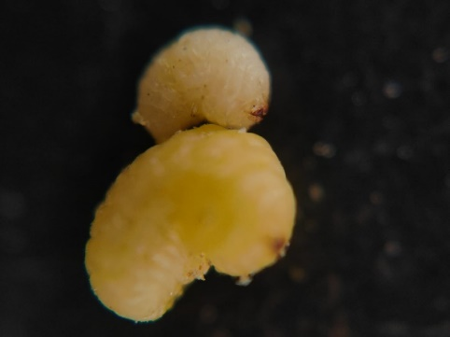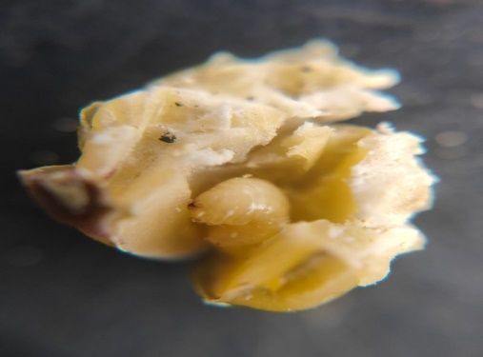
Fig 4. LARVAE (1st and 3rd INSTRAR)

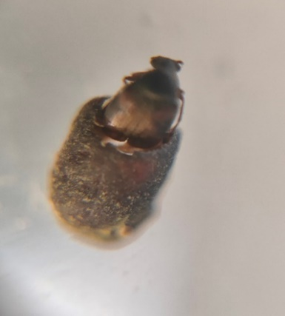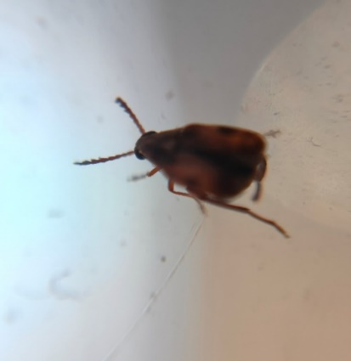
Fig 5. ADULT (CALLOSOBRUCHUS CHINENSIS)

