“Health Impacts of Shift Work among IT Professionals: A Cross-sectional Study from Karnataka, India.”

ABSTRACT
The present study investigates the health impacts of shift work among Information Technology (IT) professionals, with a focus on differences between day and night shift employees. A cross-sectional survey was conducted among 150 IT workers in Bangalore and Mysuru, Karnataka using a structured online questionnaire. The survey assessed sleep quality, dietary patterns, stress levels, musculoskeletal health, menstrual health (in female respondents), and coping behaviours such as alcohol, caffeine, and smoking use. Results indicated that night shift workers reported significantly higher prevalence of sleep disturbances (64.5%), headaches (64.5%), cardiovascular risk factors (31%), and menstrual irregularities (50.1% of female respondents) compared to day shift workers. Lifestyle modifications such as increased caffeine intake (36.2%) and reliance on sleep-inducing substances (24.4%) were also more common among night shift employees. These findings highlight the occupational health risks associated with night shift work and underline the need for workplace interventions aimed at circadian health, stress reduction, and ergonomic well-being.
KEYWORDS: Circadian rhythm, shift work, sleep disturbances, occupational health, IT professionals, stress, metabolic health

INTRODUCTION
The main service providers in the information technology sector are divided into three categories: internet and e-commerce, IT software industry, and IT enabled services. According to Chowdhury et al. (2013), there are roughly 916 IT providers registered with the National Association of Software and Service Companies throughout India. This set of contemporary occupational disorders is gradually spreading among information technology (IT) personnel, with India being a leader in the cyber world in terms of computer-related occupational health issues (Pukur et al., 2024).
A new generation of occupational health issues has also been brought about by this. Employees frequently feel "burnout" as a result of their daily grind of demanding, repetitive, and unpleasant job. Sedentary behavior and bad lifestyle choices, such as smoking and drinking alcohol, increase the chance of developing non-communicable diseases like hypertension. There is a wealth of Western literature on this issue, along with a small number in Indian settings.
According to Pejtersen et al .(2010), work insecurity is the inability to preserve desired continuity in a circumstance when one's job is at danger. According to earlier research, firms and employees sign a psychological contract that clearly outlines what each side will provide and anticipate receiving (Laine et al., 2009).
Employees have a sense of control and the capacity to forecast their own life based on these contracts. Changes that jeopardize employee perceptions of control elicit powerful reactions, including feelings of insecurity, given the significance of this empowerment in people's life (Rao and Chandraiah, 2012).
The negative physical and mental reactions that might occur when an employee's job demands and their level of control over fulfilling those needs clash are referred to as "workplace stress." Generally speaking, stress can result from a job's high demands combined with little control over the circumstances. Workplace stress can originate from a variety of sources or from a single incident. Employers and workers may be affected(Shropshire and Kadlec, 2012).
The response-based perspective, stimulus-based perspective, and cognitive transactional process perspective are the three general viewpoints that can be used when researching stress, according to Therefore, Occupational stress has been identified as a mental and physical condition that adversely affects a person's efficacy, output, well-being, and caliber of work (Comish and Swindle, 1994).
The shift workers in IT companies are constantly facing numerous health problems due to their shift system. Most research has proven that the night shift workers are mostly having high number of health risks. To work irregular hours, so called shift work, involves a greater risk to develop bad health compared to work daytime (Ohida et al., 2001). In today’s society the demand for 24-hour availability neccessitates shift work . It has been found that shift work can disrupt human circadian rhythms which are normally acclimated to daytime wakefulness and nighttime rest (Horwitz and McCall, 2004).
At the physiological level, medical investigations have demonstrated that circadian de-synchronization can lead to changes in hormonal levels, increase the risk of cardiovascular disease, produce sleep-cycle disturbances and result in significant fatigue (Lunde et al,2020) In turn, these outcomes may result in decreased levels of cognitive functioning, inferior job performance increased feelings of stress and a greater number of work-related accidents (Costa,1997).
When industrial activity necessitated 24-hour production or services, the employer mandated that workers work in three shifts. Each company may have a different night shift start and end time, as well as a different lengthy time allotment for each shift (Wyatt and Marriott, 1953). The majority of industries usually allotted the same amount of time for each shift—eight hours. Nonetheless, several businesses also had extended night shifts with intervals of relaxation (Lady and Ansor Firdas, 2018).
Circadian rhythms are the patterns of biological activity that build up and down a 24-hour cycle, such as free running cycles, which include cell division, hormone production, respiration rate, body temperature, and urine excretion (Shaker et al,2018). The circadian system responded slowly to sudden changes in time cues, thus when the 24-hour work-rest cycle was changed from a diurnal to a nocturnal one, as in night shift work, circadian rhythms were upset (Gibbs et al.,2007). A person's circadian rhythms can be disrupted by a shift in schedule, such as working night shifts, because physiological and psychological phases have rhythms that are distinct to each hour of the day. Other rhythms, such those related to waking and sleeping, blood pressure, body temperature, hormone production, and patterns, are set by circadian rhythms. The environment has a big impact on circadian rhythms, especially light stimulation (Schmidt, et al.,2012). The health and well-being of Information Technology (IT) employees have become a growing concern in recent years. Research has shown that IT professionals are prone to various physical and mental health issues due to the sedentary nature of their work, long working hours, and high stress levels (Anna and Basel, 2007).
Carpel tunnel syndrome is the maximum common problem in work related musculoskeletal disorder in information technology professionals. It involves the compression or irritation of the median nerve within the carpal tunnel at the base of the hand.When the median nerve develops irritation in this region due to pressure, swelling, and/or stretching, indications will occur (Singh and Borkar ,2020).
It has been noted that the amount of hours spent staring at a screen is more closely associated with the emergence of visual problems than the number of years. However, musculoskeletal complaints have an accumulation impact on the individuals; initially minor and transient, the symptoms gradually assume a more acute and permanent nature as the subjects age. In the current study, stress is more prevalent in the early years. The nature and scope of the work also had an impact (Sharma and Khandekar, 2006)

METHODS

The survey was conducted among IT professionals in online mode. The questionnaires were created with careful consideration and in fields that highlight their physical health and mental health related problems that are prevalent among the youngsters these days.
Around 20 questions were carefully crafted as it included their age, experience, type of shift and other health hazard related questions.

TOOL: - The survey was conducted in online mode. Since IT companies have night shift and day shift [rotational work], it is hard to get track of employees in each shift. Hence the survey was decided to be done online through google platform.
‘Google forms’ was used to create questions. Various questions along with choices for each question was provided. A link was generated and circulated to the IT employees through WhatsApp.
The questionnaire was developed under the supervision of a faculty guide, who reviewed it for content validity and appropriateness.
SURVEY AREA: - The survey questions were circulated to all IT employees through WhatsApp. The IT employees in our contacts were selected as initial participants. They were asked to take up the survey and the data was collected. Further the link was circulated to their teammates and colleagues and thus the data was recorded. A total of 150 IT workers participated in the poll. The majority of these IT workers are located in Bangalore and Mysuru.
RESULT
The result obtained showed that the day shift and night shift workers face a lot of health issues because of the prolonged shift hours. Total of 150 responses were collected and recorded. The respondents include both Males and Females. According to the survey night shift workers seem to face more problems and has higher risks of Cardio Vascular Disease and mental health problems.

Participant Characteristics
The poll was completed by 150 IT experts in total. There were somewhat more men than women among the responders, who were about 28 years old on average. The majority of participants said they worked nine to ten hours per day. While the remainder worked day or rotating shifts, nearly half worked night shifts.

General Profile of Respondents (N = 150)

Table 1: Displays the respondents' basic demographic information.

Variable | Value
Average Age (years) | 28.4 (±4.6)
Gender (Male/Female) | 84 (56%) / 66 (44%)
Work Experience (years) | 4.2 (±2.1)
Shift Type | Night: 73 (48.7%) / Day: 63 (42.0%) / Rotational: 14 (9.3%)
Average Work Hours | 9.3 (±1.2)

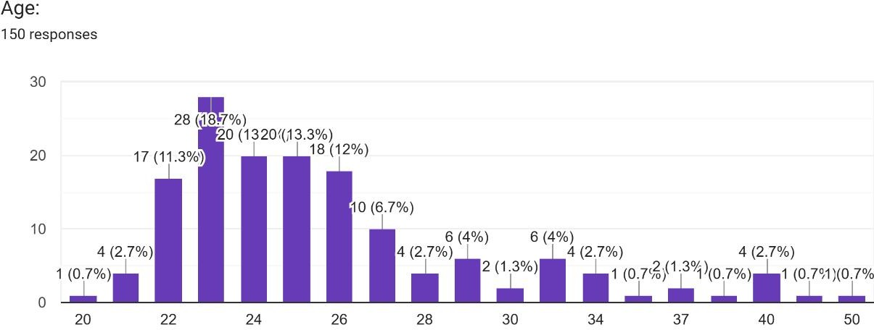
Fig 1: Age Distribution of 150 respondents
In the graph above, X-axis indicates different age groups and Y-axis indicates number of respondents in the particular age group.

These results indicate that the sample represents a relatively young workforce with a considerable
share working in night shifts. The respondents belong to all age groups from 20 to 40. They come from different educational backgrounds and have different work experience. They all work in different domains in IT.
Table 2: Coping Strategies Used by respondents

Behaviour | Night Shift (%) | Day Shift (%) | Chi-square test | p-value
Caffeine use | 36.2 | 21.4 | χ² = 5.9 | 0.015 *
Alcohol for sleep | 14.5 | 6.2 | χ² = 4.4 | 0.036 *
Sleeping pill use | 9.9 | 2.5 | χ² = 5.2 | 0.022 *
Smoking | 15.8 | 5.3 | χ² = 6.1 | 0.013 *
Yoga/Meditation | 18.4 | 27.8 | χ² = 2.7 | 0.099 (NS)

Table 2 highlights the strategies used by workers to stay awake or manage stress. Use of caffeine, alcohol, and smoking was more common among night shift workers. Healthier practices like yoga and meditation were reported more often by day shift workers.

Table 3: Health Complaints in Day vs. Night Shift Workers
Health Issue | Night Shift (%) | Day Shift (%) | Chi-square test | p-value
Sleep problems | 64.5 | 38.2 | χ² = 12.4 | 0.001 **
Headaches/Migraines | 64.5 | 41.0 | χ² = 9.6 | 0.002 **
Cardiovascular risks | 31.0 | 14.5 | χ² = 6.8 | 0.009 **
Menstrual issues in females | 50.1 | 21.3 | χ² = 10.2 | 0.001 **
Digestive issues | 30.0 | 18.5 | χ² = 4.2 | 0.041 *
Stress/Anxiety/Depression | 43.4 | 28.1 | χ² = 5.6 | 0.018 *
(*p < 0.05, **p < 0.01)
Table 3 shows that compared to day shift workers, night shift workers experienced greater health issues. The night shift group experienced significantly greater levels of stress, headaches, and sleep problems. Menstrual abnormalities were also more common among female respondents who worked nights.
According to the survey's findings, workers on the night shift reported noticeably greater health issues than those on the day shift, particularly with regard to headaches, sleep difficulties, cardiovascular risks, and mental health issues.

Responses provided by the participants to the Queries
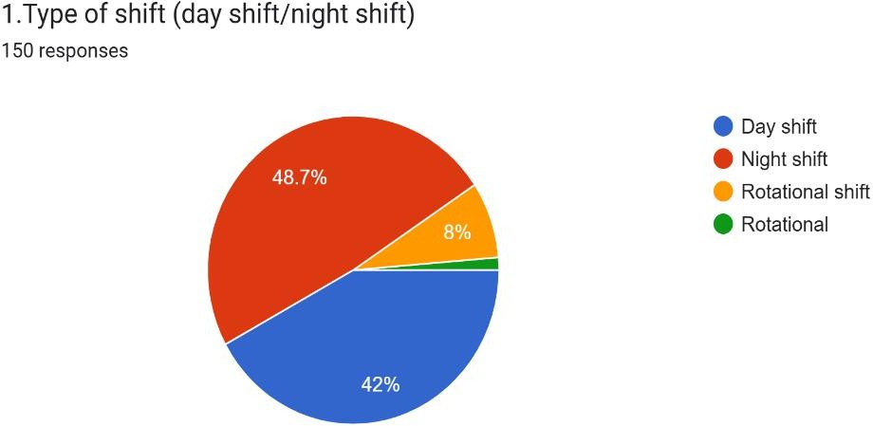

Fig .2 : Shift Preferences among 150 respondents

According to the graph 48.7% of the respondents are working in night shift and 42% respondents are working in day shift.

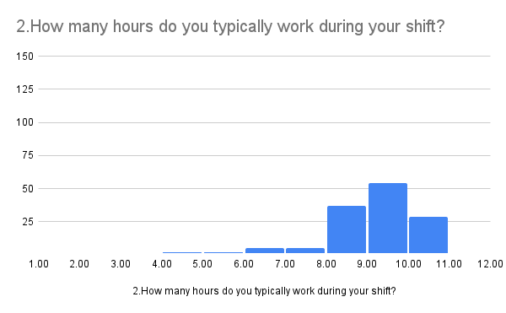
Working hours
No .of responds
Fig .3: Working hours during the shift

The X-axis indicates the working hours and Y-axis represents the number of respondents.
According to the graph, most of the respondents work for 9-10 hours. 54 respondents have said that they work for 9-10 hours. All these respondents are IT employees and they are bound to sit In-front of the system for 10 hours. Due to the prolonged exposure to the systems and laptops, the respondents face multiple problems like vision loss, bad body posture, irritation, stress and many more.

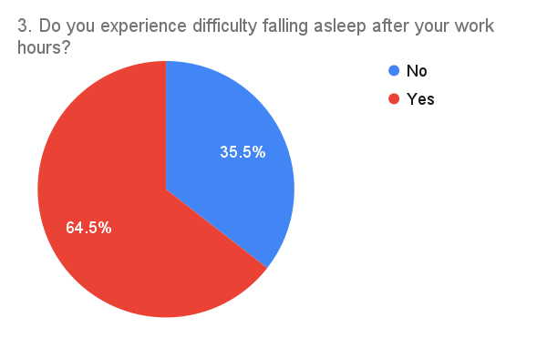

Fig. 4: Difficulty falling asleep after the work hours

According to the above data 64.5% of the employee’s face difficulties in falling asleep. As they are subjected to prolonged use age of electronic devices, it affects their melatonin production cycle and hence affects their sleep.

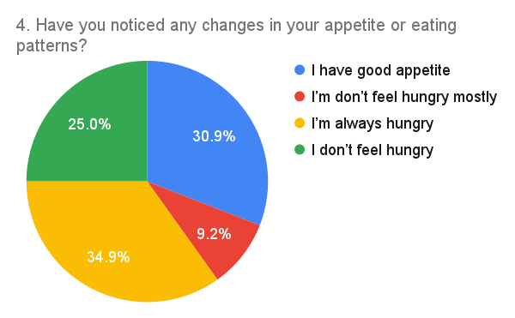
Fig. 5: Changes in appetite or eating patterns

According to the graph above 34.9% of the respondents are always hungry. This is because they eat a lot during their night shift to keep themselves active. As the rhythm of their cycle gets affected it results in loss of appetite or excessive hunger during their shift hour.

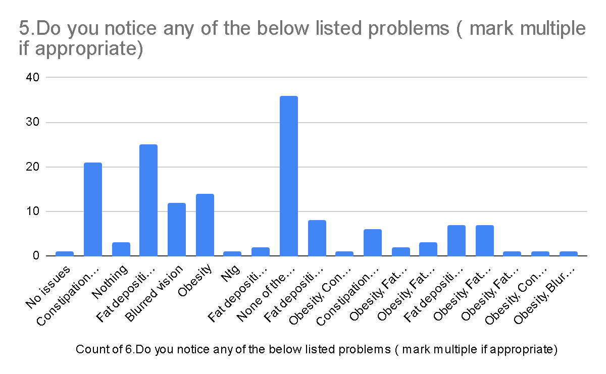
No. 0f responds
Health problems
Fig .6: Respondents experienced various health problems
In the above graph the Y axis indicates number of respondents and X axis indicates the various health problems seen in the respondents.
According to the graph above, 36% of people have fat deposition around hips, 19.3% of people are obese, 30% of people suffer from constipation and other digestion related problems, 24.7% people have blurred vision. All these problems are seen in youngsters because they are seated throughout the day In-front of laptops and computers. They do not move a lot during work hours, and hence face all the above problems.

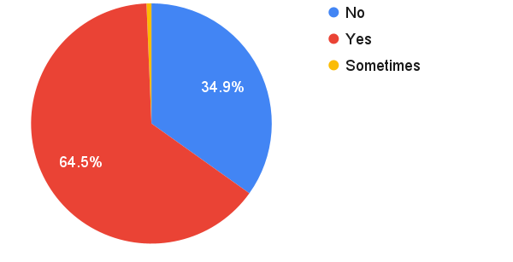

Fig .7 : Experience of migraines or headaches during or after work hours

From the graph above we see that 64.5% of the respondents suffer from migraines or headaches during or after their work hours. This is also due to constantly being exposed to the rays of the system. They also experience headaches due to the stress and workload during their shift hours.

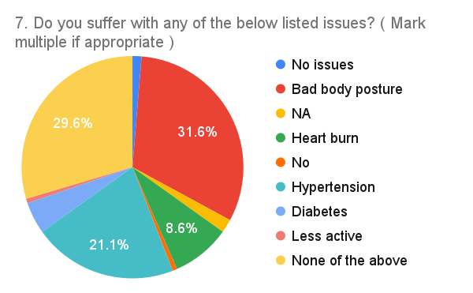
Fig. 8: Issues experienced by the respondents

According to the data from the above graph, 31.6% of the people’s body posture is affected. They sit all day and work and hence their spinal cord or back bone becomes bent and does not align properly and hence affect their personality. 31% of the people suffer from hypertension, 8.6% of people have heart burn/acidity and 4.6% of people have diabetes. All these are due to the fluctuations in their sleep and wake up cycle.

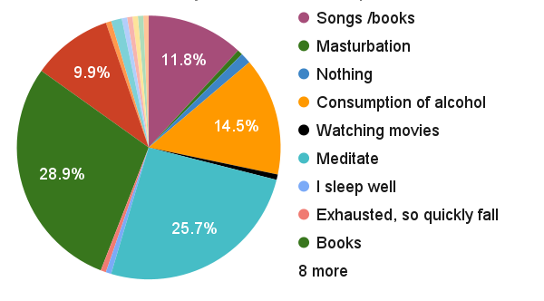
Fig. 9: Measures taken to fall asleep

From the graph above we see that 14.5% of the respondents consume alcohol to fall asleep, 9.9% of the people use sleeping pills to fall asleep. We see that people at the very young age is addicted to alcohols and drugs because of the disturbance in the sleeping habits and stress. we also see that 28.9% of people are reading books and listen to Music to help fall asleep.

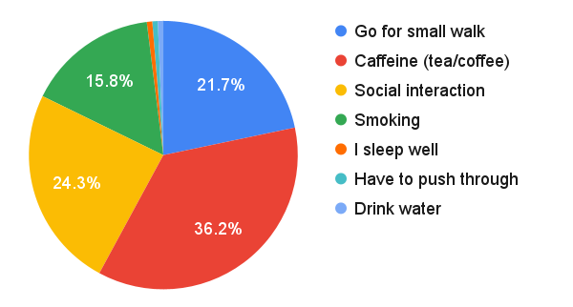
Fig .10 : Managing to stay awake during work hours

According to the graph above 36.2% of the respondents are addicted to the consumption of caffeine to not to fall asleep during their work-hours. The caffeine addiction leads to digestion problems and metabolic challenges. 15.8% of the respondents are addicted to smoking to not fall asleep during the work-hours. Due to this habit their lungs are damaged at young age which leads to ill health.

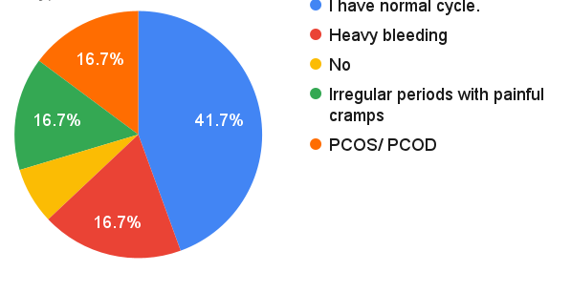
Fig. 11: Menstrual cycle problems in female

From the graph above we see that 50.1% of the female respondents suffer from irregular periods (16.7%), heavy bleeding (16.7%), PCOD/PCOS (16.7%). Because of the disturbance in the circadian rhythm, the hormones are imbalanced and that in turn affects the menstrual cycle. Also, the stress during the work hours might lead to increased production of cortisol and that leads to imbalanced hormone cycle and alters the menstrual cycle. The cortisol hormone is peaked during day and low at night, due to the disturbance in the circadian rhythm like night shift, the hormone is peaked during night and hence affects menstrual cycle and causes, irregular periods, absence of periods etc.

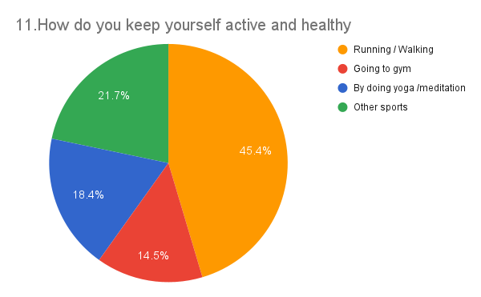

Fig .12: Ways to keep oneself active and healthy

From the graph we observe that 45.4% of the respondents go for running /walking to keep themselves active. Also, 14.5% of the respondent's workout in the gym and 18.4% of the people practice Yoga and Meditation to keep themselves healthy and active. Keeping our body healthy and active is a very important task in today’s world because people at a very young age are becoming more susceptible to disease.

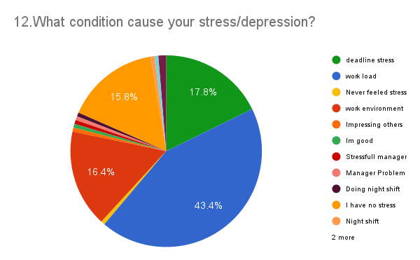

Fig .13: Conditions that cause stress/depression

As we see from the graph above, 43.4% of the respondents are suffering from anxiety, stress/depression because of workload.16.7% of the respondents feel stressed due to the work environment and 16.7% of the respondents are stressed due the deadlines. The IT employees are the most depressed people with bad life style and food style says a study published in the journal of occupational and environmental medicines.

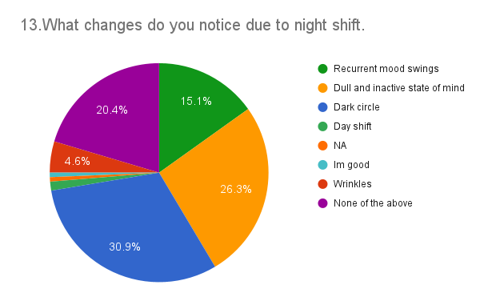
Fig. 14: Changes observed due to night shift.

From the above graph it is known that 30.9% of the respondents have dark circles, 4.6% of the people have wrinkles, 26.3% of the people suffer from dull and inactive state of mind and 15.1% of the respondents have recurrent mood swings. All these changes are seen in night shift workers due to the stress and disturbed circadian rhythm.

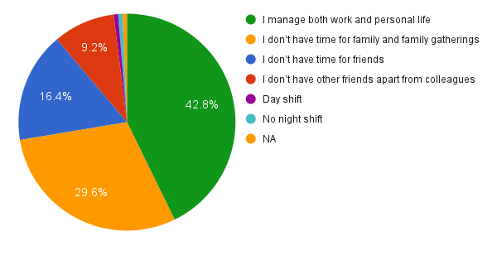
Fig .15: Night shift affects personal life

The above graph shows that 46% (16.4% + 29.36%) of the respondents do not have any time for friends and family gatherings. 9.3% of the respondents do not have any friends other than colleagues. The night shift workers face all these problems because, they work all night and take rest / sleep during the day and hence they do not have time for their family.

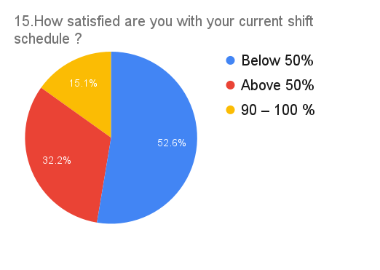

Fig. 16: Percentage of employees satisfied with the current shift schedule

Above graph shows that 52.6% of the below are not satisfied with their work, 32.2% are satisfied with their work and 15.1% of the people are highly satisfied with their work. Most of the night shift workers are not happy with their shift because of the stress and workload that comes along with mental and physical health risks.

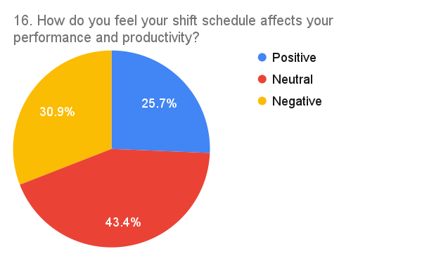

Fig .17: Shift schedule affects performance and productivity

From the above graph we see that 30.9% of the respondents feel that night shift affects negatively on their performance and productivity. Since the circadian rhythm, metabolic cycle, hormone cycle are all disturbed, it in turn affects the work performance and productivity. The quality sleep is more important to maintain one’s body and mind. When it is disturbed, it affects the work quality, efficiency.

DISCUSSION

The results of this survey show that both day and night shift IT employees face several health issues, but the risks are more pronounced among night shift workers. Sleep disturbances were reported by almost two-thirds of night shift employees, which is consistent with earlier studies that link irregular working hours to circadian rhythm disruption (Ohida et al., 2001; Schmidt et al., 2012). Even though some workers try to compensate by sleeping during the day, this does not restore the same quality of rest because natural body rhythms are still misaligned.

Another key finding was the high rate of digestive issues and irregular eating patterns among night shift employees. Many reported feelings hungry more often during their shifts, which could be linked to changes in metabolism. Previous studies have also noted that eating at night can disrupt digestive cycles and contribute to obesity and related disorders (Shaker et al., 2018).

Mental health concerns were also more common in night shift workers. Stress, anxiety, and depression were reported at higher rates, and some respondents admitted to using alcohol, sleeping pills, or smoking as coping strategies. The reliance on these methods shows how the pressure of irregular working hours can lead to unhealthy behaviours. On the other hand, some employees attempted healthier approaches like exercise, yoga, or meditation, though these were more commonly reported by day shift workers.

A particularly concerning finding was among female respondents, where nearly half reported menstrual irregularities. This highlights how night shift work and circadian rhythm disruption can contribute to hormonal imbalances, echoing earlier evidence in medical literature.

Finally, the study also shows that night shift employees feel their productivity and personal lives are negatively affected. Many reported having less time for family and friends, which further adds to stress and reduces work satisfaction. These results suggest that shift work is not only a physical health risk but also has strong social and psychological consequences.

LIMITATIONS AND FUTURE RESEARCH

This study is not without its limitations. First, the survey was shared mostly through online links and professional contacts, so the sample was not randomly selected. This means the results may not fully represent all IT professionals, and some bias could be present.

Second, all the information was self-reported by the employees, which may affect accuracy since people can understate or overstate habits like alcohol, caffeine, or smoking. Third, the study was limited to IT employees from Bangalore and Mysuru, so the findings cannot automatically be generalized to other regions or countries.

Finally, although the questionnaire was developed with guidance from a faculty supervisor and checked for relevance, it was not tested statistically for reliability.

For future studies, it would be useful to collect data from a larger and more diverse sample across different cities or even different countries. Using random or stratified sampling methods would also make the results stronger. A long-term follow-up study would be helpful to see how health issues develop over time, instead of just capturing a single point. More advanced statistical techniques, such as regression analysis, could also be applied to understand whether night shift work itself is the main factor or if other factors (like age, gender, or lifestyle) play a role. Finally, future research could look at interventions — for example, testing how wellness programs, flexible schedules, or ergonomic improvements might reduce the health problems faced by IT employees.

CONCLUSION

As man was created, the natural order has always been to work during the day and sleep or relax at night.But as the times flew and competition increased, the rule of nature is changed. As the advancements in technology and cost of living increased, humans have found millions of ways to survive in this world against all competition. The shift system in all multinational companies, IT companies provide employment to large scale of people. It also provides constant service to people across the world and hence, the shift work system is essential.
Shift work is associated with lot of health risks. The shift workers are constantly under lot of pressures. According to the survey the night shift workers face more problems compared to day shift workers. most of the workers are facing difficulties in falling asleep because their circadian rhythm is disturbed. Once the circadian rhythm is disturbed it alters the entire body functions and activities. The night shift workers have seen developing cardiovascular diseases, hypertension, reduced metabolic rate, significant fatigue, sleep cycle disturbances, bad body posture, and it leads to hormonal imbalances and results in ill health.
Even though the shit works affect the sleep quality and health of the workers/employees, it is inevitable for the company because of the requirements of the foreign clients. But also, the dysfunction in the circadian rhythm leads to poor job performance in the work as it interferes the sleeping quality of the individual.
Preventive measures like ergonomic treatments, workplace wellness initiatives, flexible scheduling, and routine health screenings should be given top priority by organizations. Larger, multi-site samples and longitudinal designs should be used in future studies to determine causal linkages and evaluate the efficacy of workplace interventions.

CONSENT
It is not applicable

DISCLAIMER (ARTIFICIAL INTELLIGENCE)
No generative AI technologies such as Large Language Models (ChatGPT, COPILOT, etc) and text-to-image generators have been used during writing or editing of this manuscript.

COMPETING INTERESTS
Authors have declared that no competing interests exist.

REFFERENCES

- Anna, W. I. R. Z., & Basel, S. (2007). How to measure circadian rhythms in humans. Medicographia, 29(1), 84–90.
- Chowdhury, R., Adhikary, M., Mukherjee, A., Roy, H., & Lahiri, S. (2013). Asymptomatic hypertension among it professionals and its association with known risk factors in Kolkata: a cross-sectional study. International Journal of Medical Science and Public Health, 2(2), 382-386.
- Comish, R., Swindle, B., & Daboval, J. (1994). Managing stress in the workplace. The National Public Accountant, 39(9), 24-30.
- Costa, G. (1997). The problem: Shiftwork. Chronobiology International, 14(2), 89–98. https://doi.org/10.3109/07420529709001147
- Gibbs, M., Hampton, S., Morgan, L., & Arendt, J. (2007). Predicting circadian response to abrupt phase shift: 6-sulphatoxymelatonin rhythms in rotating shift workers offshore. Journal of Biological Rhythms, 22(4), 368–370. https://doi.org/10.1177/0748730407301985
- Horwitz, I. B., & McCall, B. P. (2004). The impact of shift work on the risk and severity of injuries for hospital employees: An analysis using Oregon workers’ compensation data. Occupational Medicine, 54(8), 556–563. https://doi.org/10.1093/occmed/kqh110
- Lady, L., & Firdaus, A. (2018, April). Analyzing circadian rhythms for breaktime scheduling on night shift work. In 2018 5th International Conference on Industrial Engineering and Applications (ICIEA) (pp. 321–325). IEEE. https://doi.org/10.1109/IEA.2018.8387109
- Laine, M., van der Heijden, B. I., Wickström, G., Hasselhorn, H. M., & Tackenberg, P. (2009). Job insecurity and intent to leave the nursing profession in Europe. The International Journal of Human Resource Management, 20(2), 420-438.
- Lunde, L. K., Skare, Ø., Mamen, A., Sirnes, P. A., Aass, H. C., Øvstebø, R., … & Skogstad, M. (2020). Cardiovascular health effects of shift work with long working hours and night shifts: Study protocol for a three-year prospective follow-up study on industrial workers. International Journal of Environmental Research and Public Health, 17(2), 589. https://doi.org/10.3390/ijerph17020589
- Ohida, T., Kamal, A. M. M., Sone, T., Ishii, T., Uchiyama, M., Minowa, M., & Nozaki, S. (2001). Night-shift work related problems in young female nurses in Japan. Journal of Occupational Health, 43(3), 150–156. https://doi.org/10.1539/joh.43.150
- Pejtersen, J. H., Kristensen, T. S., Borg, V., & Bjorner, J. B. (2010). The second version of the Copenhagen Psychosocial Questionnaire. Scandinavian journal of public health, 38(3_suppl), 8-24.
- Pukur, T. K., Pravinbhai, P. J., & Jayprakashkumar, M. (2024). Role of Ergonomics in Occupational Health Problems of Information Technology Professional of Ahmedabad City. Indian Journal of Public Health Research & Development, 15(4).
- Rao, J. V., & Chandraiah, K. (2012). Occupational stress, mental health and coping among information technology professionals. Indian journal of occupational and environmental medicine, 16(1), 22-26.
- Schmidt, C., Peigneux, P., & Cajochen, C. (2012). Age-related changes in sleep and circadian rhythms: Impact on cognitive performance and underlying neuroanatomical networks. Frontiers in Neurology, 3, 118. https://doi.org/10.3389/fneur.2012.00118
- Shaker, D., Samir, A., Zyada, F., El-Sharkawy, M., & Ekladious, S. M. (2018). Impact of shift work on sleep problems, hormonal changes, and features of metabolic syndrome in a sample of Egyptian industrial workers: A cross-sectional study. Middle East Current Psychiatry, 25(2), 91–97. https://doi.org/10.1097/01.XME.0000534678.95667.59
- Sharma, A. K., Khera, S., & Khandekar, J. (2006). Computer-related health problems among information technology professionals in Delhi. Indian Journal of Community Medicine, 31(1), 36–38. https://doi.org/10.4103/0970-0218.54934
- Shropshire, J., & Kadlec, C. (2012). I’m leaving the IT field: The impact of stress, job insecurity, and burnout on IT professionals. International Journal of Information and Communication Technology Research, 2(1).
- Singh, R. M., & Borkar, P. (2020). Prevalence of work-related musculoskeletal disorders among IT professionals in India: A literature review. International Journal of Research in Medical Sciences, 8(10), 3765–3770. https://doi.org/10.18203/2320-6012.ijrms20204357
- Wyatt, S., & Marriott, R. (1953). Night work and shift changes. British Journal of Industrial Medicine, 10(3), 164–174. https://doi.org/10.1136/oem.10.3.164

s

