Original Research Article
ROLE OF SOIL ARTHROPODS UNDER TREE COVER IN ENHANCING SOIL FERTILITY AND SUSTAINABILITY: A STUDY FROM SIKAR, RAJASTHAN

ABSTRACT
Soil arthropods are groups of backbone less animals that spend part or all of their life cycle (eggs, larvae, pupae, and adults) under the soil. These animals include isopods, spiders, scorpions, ticks, mites, centipedes, millipedes, springtails, ants, beetles, and their relatives. Especially in arid and semi-arid areas, soil arthropods play an important role in maintaining soil fertility and fostering ecosystem sustainability. The variety and functional role of soil arthropods under tree cover, and their impact on soil health metrics, are examined in this study. Using common collecting techniques, including the quadrat, Berlese funnel, and pitfall traps, was carried out in open fields and under native tree species. When compared to open fields, the results showed a significantly higher diversity and abundance of arthropods under tree cover, which was positively correlated with better soil structure and nutrient availability (NPK). By stabilizing microhabitats, retaining moisture, and adding organic litter, trees help to create an environment that is conducive to soil arthropod activity. These organisms enhance nitrogen cycling, decomposition, and overall soil production. In order to maintain soil fertility and biodiversity, this study emphasizes the ecological significance of maintaining tree cover in agricultural environments.

Keywords: Arthropod; Fertility; Organic matter; Pitfall Trap; Soil Biodiversity; Sustainability

1. INTRODUCTION
Ecosystem services and agricultural output are influenced by soil, which is extremely diverse. At the Earth's surface, there is a mixture of organic and mineral matter. Microorganisms are essential to the cycling of nutrients and their availability to crops. The rhizosphere and bulk soil have different levels of soil biodiversity. (Beed et al.,2017).
The ability of a soil to meet plant needs for nutrients (including water) and a physical matrix sufficient for healthy root development is referred to as "soil fertility," and it is greatly impacted by biological activities. (Culliney and T.W., 2013).
With more than 1.5 million species known to science, the Arthropoda is the biggest animal phylum and makes up almost 80% of all species in the animal kingdom (Zhang and Z.Q., 2011).
With 84% of all Arthropoda and almost 69% of all documented Animalia kingdom species, Hexapoda is the largest subphylum under the phylum Arthropoda (Chandra et al., 2021).
Soil arthropods are crucial to the upkeep of soil health and quality as well as the provision of ecosystem services. It is commonly known that soil arthropods have a role in a variety of processes, including the breaking down and decomposition of organic matter, the development of soil structure, and the cycling of nutrients. (Menta and Remelli, 2020).
Trees in general provide a number of environmental benefits and play an important role in ecosystem services.. Inclusion of tree species in agricultural systems can also optimize nutrient recycling and have positive effects on soil physical and chemical properties.. Because of their drought tolerance, ability to withstand harsh climates, tree species such as Prosopis cineraria, Acacia Senegal, and Tecomella undulata are regarded as ideal for desert land circumstances. These tree species can be grown on soil with poor fertility, moisture deficit, and high soil temperature. (Kumar et al., 2017).
In the dry regions of India, the most significant timber tree is the "Rohida," also known as the Marwar teak or desert teak (Tecomella undulata). September marks the beginning of foliar development and flowering, which lasts until February or March. Numerous foliar pests and insect visits are noted on the flowers during this time (Verma and Vir, 1995).
Because tree roots are deeper and more extensive than those of herbaceous species, tree-based agriculture systems are thought to be more effective at cycling nutrients than many herbaceous systems (Sundaramoorthy et al., 2009).
Soil is the foundation of both natural plant communities and agriculture. For the majority of land-based species, the thin layer of soil that covers the earth’s surface thus signifies the difference between survival and extinction. (Doran and Zeiss, 2000).
Indicators of soil health or quality should meet the following requirements: (1) sensitivity to changes in soil management; (2) strong correlation with the beneficial functions of soil; (3) ease of understanding and usefulness for land managers; and (4) affordability and ease of measurement. (Parisi et al., 2005).
The two most prevalent mesofaunal groups are Acari and Collembola. Collembola in soils can affect soil structure in certain systems and are significant consumers of microbial films, fungal hyphae, and larger plant debris. Mesostigmata and Oribatida are significant suborders of Acari. In the majority of undisturbed soils, oribatids are the most abundant and varied group. (George et al., 2017).
By tearing up dead plant parts and digging into coarse woody waste, soil microarthropods aid microbial development and chemical degradation while capturing energy and nutrients from rapidly decaying litter. (Tripathi et al., 2009)
Numerous interactions exist between soil organisms, and the soil in which they may be introduced greatly influences their behaviour. Microorganisms are important in agriculture. (Singh et al., 2017)
The importance of interactions between soil animals and microbial decomposers has been emphasised in the majority of studies. Isopods aid in the spread of microbiota involved in decomposition processes by excreting faecal pellets containing bacterial propagules and fungal spores (Zimmer, 2002).
Supporting a variety of active soil organisms that are in charge of carbon turnover, nutrient cycling, residue breakdown, and other processes like disease and pest control. The wide variety of organisms present in soils drives several ecological processes that are vital to the functioning of terrestrial ecosystems.. A complex and interconnected food web is made up of a large number of invertebrates, up to one billion bacterial cells, and up to 200 m of fungal hyphae per gram of soil. (Sofo et al., 2020).
Soil invertebrates are generally divided into four categories based on their size: (1)Microfauna: 20 μm to 200μm(protozons, nematodes, crustaceans, rotifers,etc.)(2)Mesofauna:200μmto2mm(mites, springtails, pseudoscorpion,insectlarvae,etc.)(3)macrofauna:2to2mm(insects,worms,isopods)(4)megafauna:>20mm(vertebrates like rodents, reptiles) (Raza et al., 2019).
The environment in which plants live is complex and multitrophic. Most multitrophic studies have focused on above-ground interactions, generally neglecting the fact that above- and below-ground organisms interact in complex ways. (Altieri et al., 2012).
The 'top-down' consequences of human activity typically have a negative impact on biodiversity and soil faunal activity. The world's food production is mostly caused by intensive agricultural practices that involve significant external energy inputs (such as tillage) and agrochemicals. These practices also diminish the diversity of soil fauna and microbes and override biological controls of soil processes. (Devi et al., 2019).
2. MATERIAL AND METHODS
2.1 Study area-
The study was conducted in the Sikar district of Rajasthan, characterized by a semi-arid climate with sparse vegetation. Selected study sites included areas with native tree species(e.g., Prosopis cineraria, Azadirachta indica, Tecomella undulata)and adjacent agricultural fields with no tree cover.
2.2 Fauna extraction
2.2.1 Quadrat method –
Dividing the study area into smaller, manageable sections called quadrats or plots. Physically mark the corner of each selected quadrat with stakes, flags, or other markers. Collect soil samples within each marked quadrat. Soil samples were collected from 5–15cm soil layers using a shovel. Collections were conducted from July 2024 to June 2025. Label the Ziplog bag with the site name, Sampler name, date, and time of sample collection.
2.2.2 Pitfall Traps:
Place small containers (like cups or jars) in the ground with the rim level with the soil surface. Fill the containers with a preservative liquid (e.g., ethanol, propylene glycol). Leave traps for a specific period (e.g., 24 hours to several days) to capture ground-dwelling arthropods.
2.2.3 Tullgren funnels:
Smaller soil fauna were extracted using Tullgren funnels. The animals were collected in vials with 70% ethyl alcohol after being left to descend in the funnel for 24 hours. Following the extraction, a stereoscopic microscope was used to segregate the various groups of arthropods. The specimens were then picked up with a bristle and stored in 70% alcohol in distinct jars for identification and grouping. To prepare the slides, the smaller soil fauna were processed. For observation, soil fauna were dehydrated in a succession of graded alcohols, stained with eosin, and then mounted in DPX. Arthropod groups were distinguished using various taxonomic groups.
2.2.4 Physical Properties Analysis methods-
Soil texture analysis -Analysis by the Manson jar soil test.
Collect the soil using the quadrat method. Spread the soil out on some paper and remove any pebbles, and as much of the bits of roots and fluffy organic matter. Also, use a spatula to crush the lumpy aggregates of soil. Breaking down aggregates is important to properly analyze the soil texture. Fill the soil about a quarter full. Adding one teaspoon of Borax helps the clay settle out of the sample. Shake the jar very well for 3-4 minutes to ensure that the aggregates break down into their components. Measure the total depth of the soil column and the thickness of the individual layers. Calculate the percentages of sand, silt, and clay. Use the USDA soil texture triangle to determine soil texture type.
2.2.5 Chemical Properties Analysis Methods-
Analyze soil PH, organic matter content, nutrient levels(N, P, K).
PH-By PH meter.
Phosphorus Analysis-Use the Olsen, Bray, and Mehlich-3 Extraction method according to soil phosphorus.
Potassium Analysis- By Flame Photometry .
2.2.6 .Data Analysis-
Diversity Indices-Calculate biodiversity indices (e.g., Shannon-Wiener, Simpson’s to assess the impact on soil biodiversity
In accordance with studying the ecological community richness of arthropod abundance, the diversity indexes of Simpson diversity index (1-D), Shannon (H′), and the evenness index of Pielou (J) were calculated.
Simpson's diversity index($D)=1-[ \sum{n(n-1)/N(N-1)}$]
Where, D=Index, n= number of individuals of a single species, N= number of individuals in the total population
Shannon diversity index ( H)=-$\sum_{i=1}^{N}{P_{i}\log_{2 }}P_{i}$
where H is the diversity index, and Pi is the proportion of a particular species out of the total N species during a particular period of observation.
The species richness index of Margalef (DMg) was also calculated to estimate the proportion of individuals recorded by the most rich site.
Margalef species richness index(DMg)=(S-1)/In(N)
Where S is the number of species in the assemblage; N max is the number of individuals in the numerically dominant species in each locality, and ln, the natural logarithm.
3. RESULTS AND DISCUSSION
Soil fertility indicators such as organic carbon, phosphorus, and moisture content were positively correlated with arthropod abundance and diversity. The presence of litter and root biomass under tree cover provided favorable microclimatic conditions, which supported nutrient cycling through the activity of detritivores and predators. Soil mesofauna, including Acari, Collembola, and macrofauna such as Hymenoptera, Orthoptera, Diptera, and Coleoptera, are the major biotic components present in soil. They perform several vital activities and play an important role in biological processes in the rhizosphere and within the environment by decomposing organic matter.
Table 1. Physico-Chemical Properties of experimental soil (5-15 cm)
Physico-chemical properties | Prosopis cineraria | Azadirachta indica | Tecomella undulata | Open agricultural field
Texture | Sandy loam | Sandy loam | Sandy loam | Sandy loam
pH | 8.2±0.12 | 8.1±0.10 | 8.1±0.11 | 8.2±0.11
EC(ds/m) | 0.15±0.009 | 0.16±0.009 | 0.14±0.006 | 0.14±0.006
Organic Carbon(%) | 0.29±0.01 | 0.38±0.01 | 0.36±0.01 | 0.26±0.01
Phosphorus(kg/ha.) | 35±0.37 | 41±0.22 | 30±0.20 | 34±0.33
Photas(kg/ha.) | 310±1.71 | 410±1.80 | 360±1.45 | 260±1.35
Zinc(ppm) | 0.90±0.02 | 0.84±0.03 | 0.80±0.01 | 0.81±0.01
Iron(ppm) | 4.90±0.03 | 4.96±0.01 | 4.91±0.02 | 4.00±0.01
Copper(ppm) | 0.40±0.02 | 0.44±0.01 | 0.49±0.01 | 0.35±0.02
Manganese(ppm) | 3.11±0.01 | 3.98±0.03 | 3.18±0.02 | 3.91±0.01
Sulpur(ppm) | 14±0.40 | 19±0.45 | 16±0.40 | 18±0.40

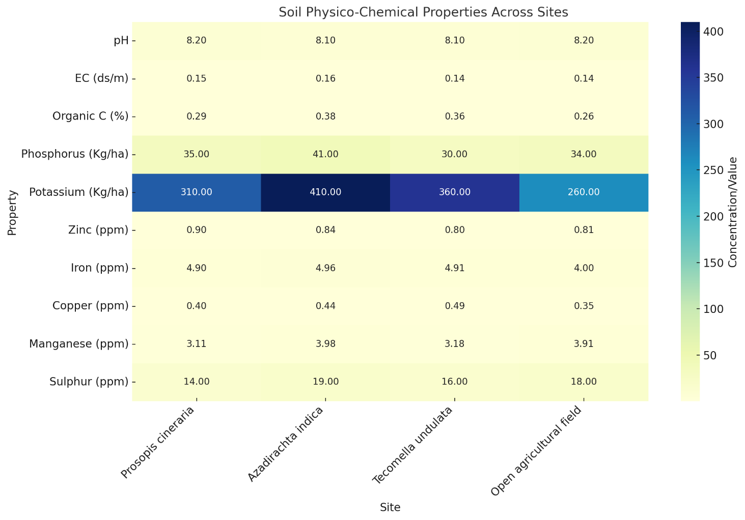

Fig 1 : Soil Physico-Chemical Properties Across Sites

Table 2. Arthropod diversity under Prosopis cineraria:
CLASS | ORDER | FAMILY | INDIVIDUALAS | % OVER TOTAL COUNT
Insecta | 1.Diptera | Cecidomycidae,Calliphoridae,Muscidae,Psychodidae,Drosophilidae,Anthomyiidae | 39 | 17.64%
 | 2. Hymenoptera | Apidae,Torymidae,Ormyridae,  Stephenidae,Eulophidae,,Formicidae | 20 | 9.04%
 | 3.Hemiptera | Miridae,Coreidae,Cieadellidae | 17 | 7.69%
 | 4.Coleoptera | Anthicidae ,Burprestidae,Dermistedae | 16 | 7.23%
 | 5.Lepidoptera | Noctuidae,Hesperiidae,Lasiocampidae,Lycaenidae | 15 | 6.78%
 | 6.Blattodae | Blattidae | 12 | 5.4%
Arachnida | 1. Parasitiforms | Macrochelidae | 34 | 15.38%
 | 2. Mesostigmata |  | 22 | 9.95%
 | 3.Araneae | Scytodidae,Oxyopidae,Philodromidae | 15 | 6.78%
Collembola | 1.Entomobryomorpha | Isomidae | 31 | 14.07%
TOTAL |  |  | 221

Table 3. Arthropod diversity under Azadirachta indica
CLASS | ORDER | FAMILY | INDIVIDUALS | % OVER TOTAL COUNT
Insecta | 1.Diptera | Culicidae,Cecidomyiidae,  Sciaridae,Psychodidae | 32 | 13.91%
 | 2. Hymenoptera | Formicidae | 22 | 9.56%
 | 3. Blattodae | Blattidae | 15 | 6.52%
 | 4.Hemiptera | Miridae,Coreidae,cleadellidae | 12 | 5.21%
 | 5.Coleoptera | Leiodidae,Ptillidae | 11 | 4.78%
Arachnida | 1. Mesostigmata |  | 40 | 17.39%
 | 2.Araneae | Lycocidae,scytodidae,Oxyopidae | 28 | 12.17%
 | 3. Parasidiform | Macrochelidae | 25 | 10.86%
 | 4.Opiliones | Sclerosomatidae | 10 | 4.34%
Collembola | 1.Entomobryomorpha | Isotomidae | 35 | 15.21%
Total |  |  | 230

Table 4. Arthropod diversity under Tecomella undulata
CLASS | ORDER | FAMILY | INDIVIDUALS | % OVER TOTAL COUNT
Insecta | 1.Hemiptera | Pantatomidae,Alydidae,  Rhyparochromidae | 24 | 15.09%
 | 2. Diptera | Psychodidae,Musidae,Drosophilidae | 22 | 13.83%
 | 3. Hymenoptera | Formicida | 20 | 12.57%
 | 4.Orthoptera | Acrididae,Gryllidae | 16 | 10.06%
 | 5.Blattodae | Blattidae,Termitidae | 12 | 7.54%
 | 6. Coleoptera | Scarabaeidae | 8 | 5.03%
Aracnida | 1. parasitiforms | Macrochelidae | 25 | 15.75%
 | 2. Mesostigmata |  | 17 | 10.69%
Collembola | 1.Entomobryomorpha | Isotomidae | 15 | 9.43%
Total |  |  | 159

Table 5. Arthropod diversity in an open agricultural field
CLASS | ORDER | FAMILY | INDIVIDUALS | % OVER TOTAL COUNT
Insecta | 1.Hemiptera | Lygaeinae,Pyrrhocoridae,Pentatomidae,Dinidoridae | 16 | 15.84%
 | 2. Diptera | Culicidae,Psychodidae | 15 | 14.85%
 | 3.Orthoptera | Gryllidae,Acrididae | 13 | 12.87%
 | 4.Coleoptera | Tenebrionidae | 7 | 6.93%
Arachnida | 1. Araneae | Scytodidae, Oxyopidae, philodromidae, | 20 | 19.80%
 | 2. Parasitiforms | Macrochelidae | 10 | 9.90%
 | 3.Opiliones | Sclerosomatidae | 9 | 8.91%
Collembola | 1.Entamobryomorpha | Isotimidae | 11 | 10.89%
Total |  |  | 101
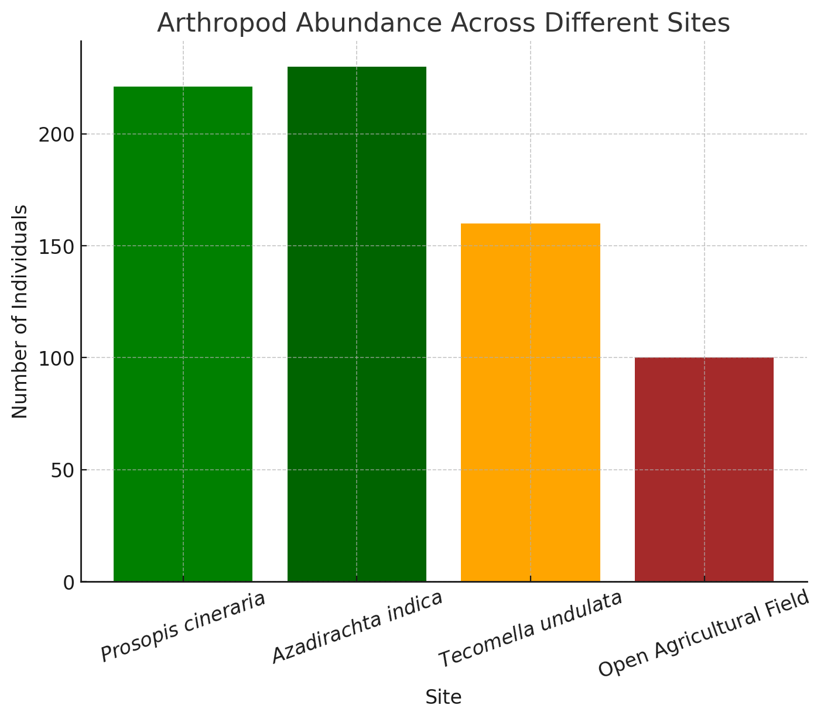

Fig 2 : Arthropod Abundance Across Different Sites

Table 6. Species diversity and species richness indices
Indices | Shanon H’ | Pielo’s evenness | Simpson1-D | Margalef DMg
Prosopis cineraria | 2.23 | 0.97 | 0.884 | 1.67
Azadirachta indica | 2.19 | 0.96 | 0.886 | 1.66
Tecomella undulata | 2.14 | 0.97 | 0.879 | 1.57
Open agricultural field | 2.02 | 0.97 | 0.885 | 1.52

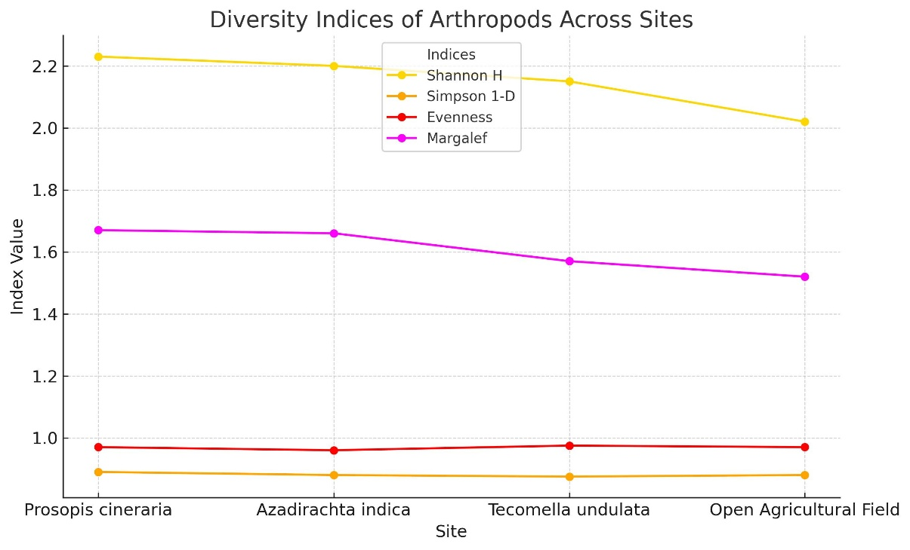

Fig 3 : Diversity Indices of Arthropods Across Sites
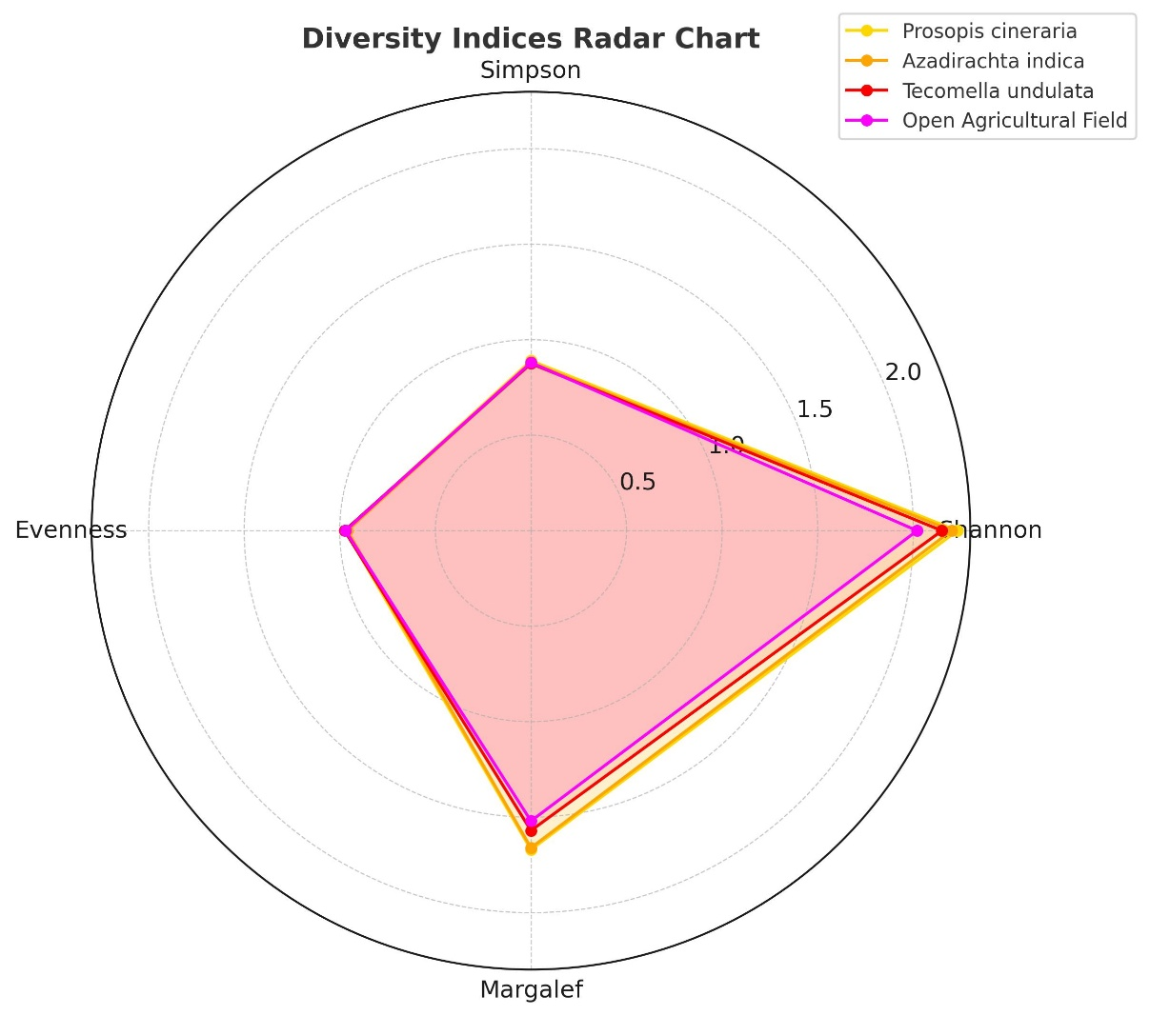

Fig 4 : Diversity Indices Rader Chart
In our study, we anticipated that more arthropods would be present under tree cover compared to an open agricultural field. We recorded three different classes of arthropod communities: Insecta, Arachnida, and Collembola. The most dominant class recorded was Insecta, which comprised 53.84% under Prosopis cineraria, 40% under Azadirachta indica, 64.15% under Tecomella undulata, and 50.49% in an open agricultural field. Among the insecta class, the highest number of individuals were identified under the orders Diptera and Hymenoptera.
Other classes, Arachnida and Collembola, share 32.12% and 14.02% respectively, in Prosopis cineraria. Classes Arachnida and Collembola share 44.78% and 15.28% respectively, in Azadirachta indica. Classes Arachnida and Collembola share 18.26% and 9.43% respectively, in Tecomella undulata. Classes Arachnida and Collembola share 38.61% and 10.89 % respectively, in the Open Agriculture field.
Different species diversity and richness indices were calculated. Shannon index (H’), the diversity measurement that combines species and their relative abundance, was calculated to be 2.23 for Prosopis cineraria,2.19 for Azadirachta indica, 2.14 for Tecomella undulata, and 2.02 for the open agricultural field. Highest in Prosopis cineraria, indicating greater species diversity, and lowest in the open agricultural field, suggesting lower diversity.
Pielo’s evenness, a measure of the relative abundance of the different species, was calculated as 0.97 for Prosopis cineraria, 0.96 for Azadirachta indica,0.97 for Tecomella undulata, and 0.97 for the open agriculture field. Fairly uniform across all environments, indicating balanced species diversity.
Simpson (1-D)index was calculated as 0.884 for Prosopis cineraris, 0.886 for Azadirachta indica,0.879 for Tecomella undulata, and 0.885 for the open agricultural field, indicating higher diversity.
Margalef DMg (Species Richness Index) was calculated as 1.67 for Prosopis cineraria,1.66 for Azadirachta indica,1.57 for Tecomella undulata, and 1.52 for the open agricultural field. Prosopis cineraria supports more individuals. The open agricultural field has the lowest richness, possibly due to limited microhabitats or frequent human disturbance.
Increasing tree cover in agricultural landscapes can support arthropod diversity and significantly improve ecosystem function. Tree cover creates a stable microclimate with moderate temperature and high input of organic matter through litter fall. These conditions favor the proliferation of soil arthropods, which in turn accelerate the breakdown of organic material and enhance nutrient cycling. The interaction between trees and soil arthropods contributes to long-term soil sustainability in a fragile ecosystem like the Thar Desert.

4. CONCLUSION
The current study highlights the crucial role of tree cover in enhancing soil arthropod diversity and abundance. A rich community of soil arthropods is supported by tree-covered areas because they offer favourable microclimate conditions, organic matter inputs, and habitat heterogeneity. By improving soil structure, decomposing litter, and cycling nutrients, these organisms have a major positive impact on soil health. On the other hand, because of the harsher soil conditions and lack of organic input, arthropods are generally less common in open or sparsely vegetated environments. The results highlight how important it is to preserve and increase tree cover to support ecological processes and soil biodiversity. Thus, incorporating agroforestry and tree-based land use practices can significantly improve soil health and sustainability in an agricultural landscape.

REFERENCES
Altieri, M. A., Ponti, L., & Nicholls, C. I. (2012). Soil fertility, biodiversity and pest management. Biodiversity and insect pests: key issues for sustainable management, 72-84
Beed, F., Dubois, T., Coyne, D., Lesueur, D., & Ramasamy, S. (2017). Soil biodiversity. In Routledge handbook of agricultural biodiversity (pp. 127-144). Routledge.
Chandra, K., Gupta, D., Saini, J., Singh, L. R. K., Ahmed, I., Kazmi, S., ... & Bhunia, D. (2021). Arthropoda: Hexapoda. Faunal Diversity of Biogeographic Zones of India: Desert, 85-127.
Culliney, T. W. (2013). Role of arthropods in maintaining soil fertility. Agriculture, 3(4), 629-659.
Devi, N. U., Pavan, S., & Rao, K. S. (2019). Chapter-5 Soil Faunal diversity and their functional roles in enhancing the soil fertility. Current Research In Soil Fertility, 19, 77.
Doran, J. W., & Zeiss, M. R. (2000). Soil health and sustainability: managing the biotic component of soil quality. Applied soil ecology, 15(1), 3-11.
George, P. B., Keith, A. M., Creer, S., Barrett, G. L., Lebron, I., Emmett, B. A., ... & Jones, D. L. (2017). Evaluation of mesofauna communities as soil quality indicators in a national-level monitoring programme. Soil Biology and Biochemistry, 115, 537-546.
Kumar, M., Kumar, P., Tewari, J. C., & Pandey, C. B. (2017). Changes in soil fertility under multipurpose tree species in Thar Desert of Rajasthan. Range Management and Agroforestry, 38(2), 274-279.
Menta, C., & Remelli, S. (2020). Soil health and arthropods: From complex system to worthwhile investigation. Insects, 11(1), 54.
Parisi, V., Menta, C., Gardi, C., Jacomini, C., & Mozzanica, E. (2005). Microarthropod communities as a tool to assess soil quality and biodiversity: a new approach in Italy. Agriculture, ecosystems & environment, 105(1-2), 323-333.
Raza, M. B., Bhoi, T. K., & Samal, I. (2019). Soil arthropods as a nutrient enhancer. Int. J. Chem. Stud, 7, 1687-1692.
Singh, S., Singh, V., & Pal, K. (2017). Importance of microorganisms in agriculture. Climate and environmental changes: impact, challenges and solutions, 1, 93-117.
Sofo, A., Mininni, A. N., & Ricciuti, P. (2020). Soil macrofauna: A key factor for increasing soil fertility and promoting sustainable soil use in fruit orchard agrosystems. Agronomy, 10(4), 456.
Sundaramoorthy, S., Mehar, S. K., & Suthar, M. S. (2009). Soil biology in traditional agroforestry systems of the Indian Desert. In Desert Plants: Biology and Biotechnology (pp. 91-120). Berlin, Heidelberg: Springer Berlin Heidelberg.(5)
Tripathi, G., Ram, S., Sharma, B. M., & Singh, G. (2009). Fauna-associated changes in soil biochemical properties beneath isolated trees in a desert pastureland of India and their importance in soil restoration. The Environmentalist, 29(3), 318-329.
Verma, S. K., & Vir, S. (1995). Field insect pests of Rohida (Tecomella undulata) in Arid Zones of Rajasthan. Annals of Arid Zone, 34, 51-51.
Zhang, Z. Q. (2011). Animal biodiversity: An outline of higher-level classification and survey of taxonomic richness. Magnolia press
Zimmer, M. (2002). Nutrition in terrestrial isopods (Isopoda: Oniscidea): an evolutionary-ecological approach. Biological Reviews, 77(4), 455-493.

