Review Article

Impact of climate change on prevalence of waterborne Vibrio sp. in fisherfolk health of the Indian Sundarbans.

Abstract:
Sundarbans, a region in West Bengal (India) and Bangladesh, is home to 188 fishing coastal villages and 76,981 fisherperson families (fisherfolk). The region is also a diarrhea-endemic zone, with yearly high incidences, primarily during the monsoons and summer, affecting nearly 380,138 fisherpersons. The Global Climate Risk Report shows that climate change has short-term and long-term impacts on the physicochemical parameters of waterbodies and vibrios growth due to alterations in salinity, temperature, pH, DO etc. 12 Vibrio sp. (out of 20) cause zoonotic infection in human and are found in free form in estuarine and coastal water bodies or associated with fish and shellfish. Fisherpersons’ health and livelihood are at the highest risk, being first in human contact with pathogenic Vibrio species, including Vibrio cholerae, V. vulnificus, and V. parahaemolyticus, which are associated with coastal flooding and the invasion of seawater deeper inland. These vibrios invade as opportunistic pathogens directly or are transmitted through zoonotic transmission from fish and shellfish to fisherpersons, resulting in massive gastrointestinal infections, including gastric ulcer, vibriosis, and septicemia. Sunderbans is the largest coastline for capture and culture fisheries in India, and Climate change, rising salinity, and temperature fluctuations are significantly impacting aquatic environments, and the prevalence of water-borne diseases (mainly gastrointestinal) among fisherpersons. More study is required to estimate the long-term effects of climate change on the economic sustainability of aquaculture, disease susceptibility, and antibiotic resistance arising due to microbial dysbiosis and the quality of life of Sundarban’s fisherpersons.

Keywords: climate change, Vibrio sp. diversity, fisherfolk health, Indian Sundarbans.
- Introduction:
The Indian Sundarbans, the world's largest mangrove ecosystem, is home to a rich biodiversity and supports the livelihoods of millions of people, including fisherpersons who depend on its aquatic resources (fish and shellfish). Sundarbans biosphere reserves of India support a wide diversity of shellfish crabs (57 species), including mudcrabs [1]. The Sundarbans mangrove ecosystem is a dynamic, productive, and diversified ecosystem facing several environmental stresses of anthropogenic activities, primarily excessive fossil fuel combustion, causing increased CO₂ in nature, which alters the global carbon cycle and climate pattern, and natural origin [2]. Deforestation, over-exploitation of natural resources, soil erosion, deposition of heavy metals and metalloids, pesticides, extension of population, discharge of untreated sewage, and oil spillage from vessels are identified as major threats affecting biodiversity [3]. However, this region is also highly vulnerable to climate change, with rising temperatures, altered precipitation patterns, and increased frequency of extreme weather events. One of the lesser-known consequences of climate change in this region is the potential increase in waterborne Vibrio sp., a group of bacteria that can cause a range of illnesses in humans, including cholera, vibriosis, and septicemia [4 & 5]. Over the past few decades, India's climate has changed dramatically (Figure 1). It may change considerably more—possibly faster—with potentially fatal effects, especially for coastal areas. Sometimes natural catastrophes can be so deadly and devastating that they kill thousands of people, cause enormous amounts of damage, and steal valuable goods [6]. People like Sundarbans fisherpersons are closer to coastal regions and face an increased risk of natural disasters along with waterborne diseases, including zoonotic bacterial diseases due to increasing anomalies of climate [7]. One of the lesser-known consequences of climate change in this region is the potential increase in waterborne Vibrio sp., a group of bacteria that can cause a range of illnesses in humans, including cholera, vibriosis, and septicemia. Vibrio parahaemolyticus causes gastroenteritis by horizontal transfer of genetic materials, ultimately creating a genetic deletion [8]. As climate change alters the environmental conditions in the Sundarbans, the prevalence and distribution of Vibrio sp. are likely to shift, increasing the risk of zoonotic transmission to fisherpersons and other communities. The association between cholera and climatic variables like rainfall, temperature, sea surface temperature, El Niño, etc. has been investigated by a variety of data analysis methods such as time series analysis, generalized linear model, regression analysis, and statial / GIS [9]. This is particularly concerning, given the limited access to healthcare and sanitation facilities in this region. This study aims to investigate the impact of climate change on the prevalence of waterborne Vibrio sp. in the Indian Sundarbans and assess the risk of zoonotic transmission to fisherpersons, with a focus on identifying strategies for mitigation and adaptation. India came in seventh place globally, behind Afghanistan, out of the ten most affected countries, according to the Global Climate Risk Index (2019) (GLOBAL CLIMATE RISK INDEX 2021). Between 1901 to 2018, the average temperature increase in India is around 0.70C leading to extreme climatic disasters and sea level rise [10].

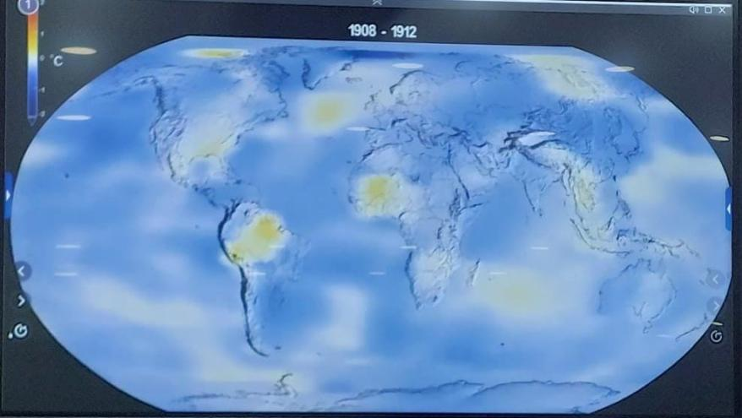
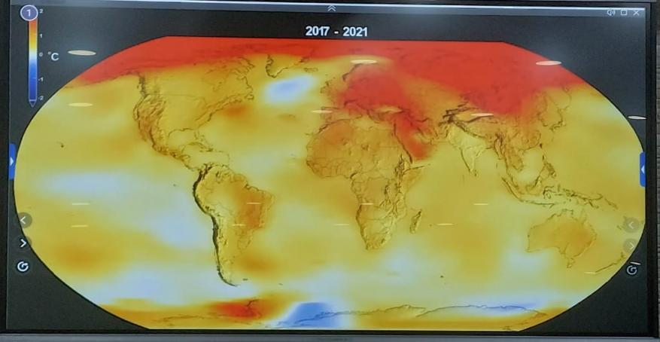
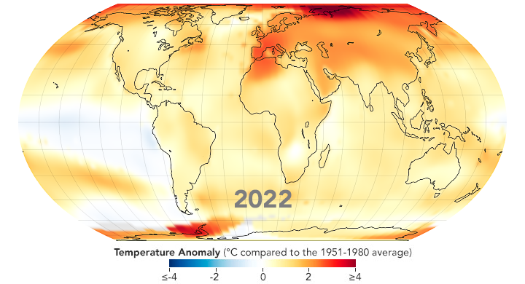

Figure 1. Increasing the global temperature, according to NASA information
(India 7th rank out of 10 most affected countries)
2. CONCEPT OF CLIMATE AND ITS CHANGE:
A region's long-term average atmospheric characteristics, such as its temperature, humidity, precipitation, wind patterns, and other meteorological elements, are referred to as its climate. A complex and dynamic system, the climate is impacted by a multitude of natural and man-made variables. The first version climate classification scheme was published in 1918 and continued to be modified; the last version was published in 1936. The modified Koppen system finally describes five major climate groups (groups A, B, C, D, and E) subdivided into 14 individual climate types, along with the special category of highland (H) climate, as shown in Table 1.
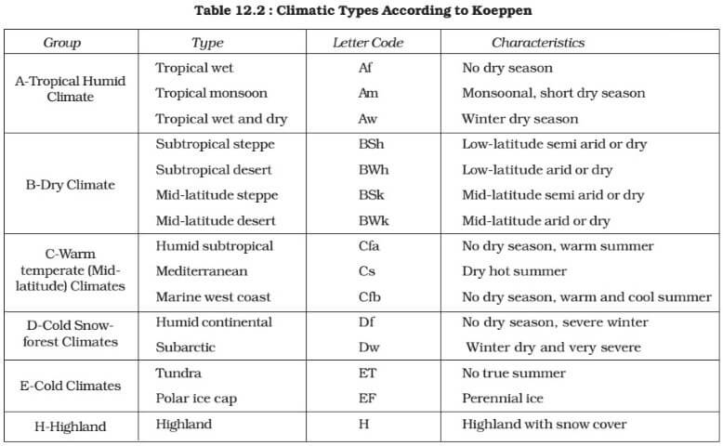
Table 1: Climate classification according to the Koppen system

Climate change refers to significant, long-term alterations in global or regional climate patterns [11]. This change can be caused by Natural Factors (Volcanic eruptions, Changes in Earth's orbit, Solar radiation, and Human-Induced / Anthropogenic Factors (Greenhouse gas emissions, Deforestation, Burning fossil fuels, Land use changes, Industrial processes) [12]. Based on documented evidence, climate change is typically divided into two categories: predictable and unpredictable (primary and secondary data). In this paper, climate change and weather conditions that could occur in the future and could be predicted in advance are referred to as predictable climate changes (cyclones, for example), and unpredictable climate changes (changing water current, for example) cannot be predicted in advance [13]. Climate change affects the natural environment's water parameters, such as turbidity, salinity, pH, DO, and temperature, as well as environmental issues pertaining to water quality and other stressors (temperature, salinity, DO, TDS, pH, etc.) (Figure 1). 3.6 billion people currently reside in regions that are extremely vulnerable to climate change, according to the WHO. Climate change is predicted to result in an additional 2,50, 000 fatalities year between 2030 and 2050, just from heat stress, malaria, diarrhea, and undernourishment. Climate change enhances the transmission season and expands the geographical distribution of vector-borne diseases due to increased temperature and salinity (Figure 1 and 2). Increased average temperatures can result in extended warm seasons, earlier springtime, milder and shorter winters, and hotter summers (Figure 2). As a result, many vector-borne disease carriers may find that their living conditions are more favorable. Moreover, climate change in the long run can also lead to the deadliest disease, cancer. A rise in the frequency of extreme weather events, such as storms, floods, droughts, and cyclones, has an immediate impact on human health in terms of deaths and injuries (physical trauma and PTSD). It also has an indirect impact through housing loss, population displacement, contaminated water supplies, decreased food production, an increased risk of infectious disease epidemics, and damage to infrastructure necessary for the delivery of healthcare services.
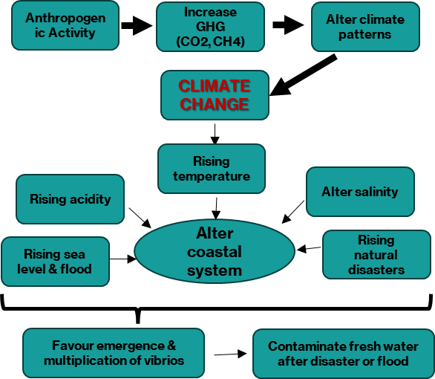

Figure 2: Climate change and its cause and effect
3. CLIMATE CHANGE AND EVIDENCE OF DISEASE:
Both urban and natural habitats can be severely harmed by natural disasters, which may create opportunities for fungal exposure or favorable conditions for fungal growth. The Intergovernmental Panel on Climate Change (IPCC) predicts that climate change will significantly increase health risks globally. Natural disasters raise the risk of traumatic injuries, such as cuts, abrasions, and wounds that compromise the skin's protective layer and let fungi in. Eight patients injured in a Colombian volcano eruption in 1985 contracted soft-tissue infections brought on by Rhizopus arrhizus, marking the first known fungal epidemics connected to natural disasters. Globally, the frequency of these epidemics has been increasing ever since [14]. Due to long-term sea surface warming, there have been indications of increased seasonal duration, concentration, and geographic expansion of Vibrio infections in the Pacific Northwest of the United States, Israel, and coastal Chile. The Centers for Disease Control and Prevention (CDC) reported that there was a 41% increase in Vibrio vulnificus infection cases between 1996 and 2005 in the United States. In Korea, V. vulnificus reaches its peak in September and June. In November, it is prevalent every year because of an increase in sea water temperature. After an exceptionally warm summer in 1994, reports of Vibrio vulnificus were made throughout the German coast. There is evidence linking the Baltic Sea's long-term warming and temperature anomalies to an increase in Vibrio vulnificus infections (Table 2). Climate modeling techniques indicate that the frequency of Vibrio infections from the Baltic region may nearly double for every degree Celsius increase in the annual maximum water temperature [15]. Given the virus's potential importance and the fact that it had spread to 69 countries and territories, causing thousands of instances of microcephaly, the World Health Organization (WHO) declared a public health emergency in February 2016 [16]. The pH values of soil are changed by the ash that is left over from volcanic eruptions and wildfires. It raises nutrient contents, which may have an effect on microbial communities and produce completely new conditions for the colonization of fungi with advantageous traits that enable them to withstand harsh situations and become dangerous to people. Fungal spores can travel long distances in a fire stream and impact populations that are far away and unexposed. There have also been reports of significant fungal contamination in the immediate aftermath of flood disasters. This is because biological fragments (such as mycotoxins) and fungal spores can be released into the air and spread over large distances due to high humidity and moisture levels, which are further aided by strong winds [14]. Following storms, wildfires, or structural damage, fungus-related infections may gradually spread. Fungal spores that are small enough to enter the lungs and cause respiratory fungal infections, asthma, or chronic inflammation can be inhaled. In addition to causing notable increases in humidity and damage to buildings in the affected areas, heavy rains, floods, and tsunamis can also foster a climate that is conducive to the germination and proliferation of fungi. Ultimately, a situation in which the land has been contaminated with harmful watery microorganisms could be brought about by tsunamis. This intriguing hypothesis could help explain why the subtropical fungus Cryptococcus gattii arrived in the Pacific Northwest 35 years after the 1964 Great Alaskan Earthquake and the ensuing tsunami [14]. Scientists looked at how climate anomalies can broaden the temporal and geographic range of Vibrio parahaemolyticus and Vibrio vulnificus-caused seafood-borne infections [17]. Satellite imaging and in situ monitoring equipment were among the sources of historical climate data from regions where the seafood industry was concerned. Climate anomalies like El Niño, which delivered enormous amounts of abnormally warm water into these regions, are closely correlated with the geographic expansion of V. parahaemolyticus outbreaks into Peru and Alaska. Warmer water temperatures (>20 °C) observed throughout April and November since 1998 are correlated with a seasonal extension of V. vulnificus infections linked to oysters harvested from the Gulf of Mexico during these months. Many of the marine bacteria known as Vibrio species, which are found in estuaries all over the world, are highly resistant to antibiotics and can cause virulent human diseases. Between 1996 and 2005, the average yearly incidence of all Vibrio infections rose by 41%. The shellfish species V. vulnificus (Vv), which is found in the Southeast United States, depends on temperature ranges of 16–33 °C and salinity levels of 5–20 ppt for optimum growth. Concerns about how climate change may affect the geographic distribution of Vv and the possibility of increased exposure risk are raised by rising sea levels and warmer water temperatures brought on by atmospheric warming [18, 19].
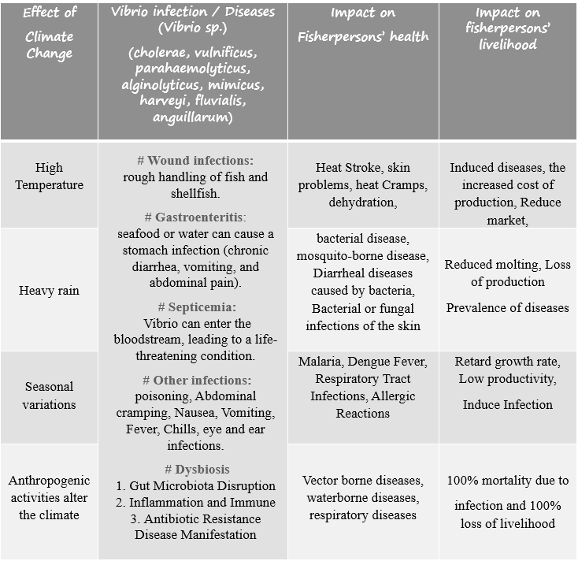
Table 2: Climate change impacts on fisherfolk's health and livelihood

Waterborne diseases (WBDs) impact human health and the environment, and their spread has been greatly impacted by climate change. Developing nations are most affected by climate change, particularly those that are members of the Association of Southeast Asian Nations (ASEAN). Vibrio cholerae is a watery disease that is most common and vulnerable during extreme weather events. Due to its position, the Philippines is frequently hit by tropical storms, such as Bopha in 2012 and Haiyan in 2013, while Cyclone Nargis in 2008 was responsible for more than 95% of the damage and fatalities in Myanmar during the previous 20 years. Therefore, it is crucial that ASEAN nations put policies in place to adapt to these climate changes and protect their citizens from the effects of WBDs [20, 21].
4. CLIMATE CHANGE AND ZOONOTIC DISEASES:
German pathologist and physician Rudolf Virchow coined the word "zoonosis" toward the end of the 1800s to refer to illnesses that humans and animals contracted from one another. "Zoon" (animals) and "noson" (sickness) are the ancient Greek terms from which "zoonosis" was derived. "Diseases and infections that are naturally transmitted between vertebrate animals and man" is how the Expert Committee on Zoonosis characterized zoonotic diseases. So far, approximately 200 different forms of zoonotic diseases have been identified [21]. The risk factors for zoonoses include climate change, antimicrobial resistance, land include climate change, antimicrobial resistanece, law use changes, and animal production practices [22]. These diseases account for a sizable portion of newly diagnosed and developing human ailments. Furthermore, it is estimated that approximately 60% of all human pathogens and 75% of newly emerging infectious diseases originate from animals [23]. More than 60% of new infectious diseases that affected humans between 1940 and 2004 were zoonotic diseases, meaning they originated in animals. Both the global economy and public health are greatly impacted by this. Of them, arthropods were responsible for 22.8% of the causes, and animals for 71.8% of the origins. The world's thirteen most common zoonoses caused 2.4 billion illness cases and 2.7 million human fatalities annually, which significantly affected low- and middle-class livestock workers in these nations. Experts state that zoonoses may endanger human health in several ways (Figure 3, Table 3):
i. Every year, epidemic zoonoses cause millions of deaths and billions of illnesses in impoverished populations. Foodborne zoonoses, leptospirosis, brucellosis, bovine tuberculosis, and cysticercosis are a few examples of endemic zoonoses.
ii. Epidemic zoonoses, of which leishmaniasis, rabies, anthrax, and Rift Valley disease are a few examples, typically happen infrequently. On the other hand, they can appear among populations that are already at risk because of famine, disease, low immunity, flooding, or climate change. A significant amount of temporal and spatial variability is evident in outbreaks.
iii. Emerging zoonoses may reappear in a population or may have happened previously, but at the moment, their incidence and geographic range are rapidly growing. Zoonoses account for two-thirds of all newly discovered infectious diseases.
iv. Although originally zoonotic, zoonoses are now primarily or only transmitted from person to person. Included are illnesses, including dengue fever, pneumonia, malaria, measles, and HIV/AIDS. Currently, they are about as severe as endemic zoonoses.
On March 11, 2019, the World Health Organization (WHO), the Food and Agriculture Organization of the UN (FAO), and the World Organization for Animal Health (OIE) published a roadmap for countries that employ a One Health approach to address the risks of zoonotic diseases. As highlighted in the book, the increasing trend seems commensurate with the growing threat that zoonotic infections represent to public health. Interestingly, the WHO identified the Eastern Mediterranean Region as a hotspot for newly emergent zoonoses at the beginning of the twenty-first century. Additionally, live bacteria have been isolated from ice samples dating back 25,000 years and from 20–40-million-year-old Dominican amber. The Virola virus was found in a 300-year-old frozen mummy in Siberia in 2012. In 2005, NASA scientists discovered bacteria that were 8 million years old in Antarctic ice samples. In 2016, scientists discovered bacteria frozen in Alaska for 32,000 years. Climate change is affecting the spread of zoonotic diseases in many ways, including changing disease patterns (Diseases are becoming more widespread and changing with the seasons due to climate change. For instance, diseases carried by vectors that were once exclusive to tropical regions are increasingly expanding to colder climates, creating more opportunities for transmission. Climate change may improve the living circumstances for disease-carrying animals, increasing the likelihood that the illness may infect people. Making diseases more resistant to treatment (Pathogens and vectors may evolve adaptation mechanisms in response to climate change, increasing the resistance of diseases to traditional therapies).
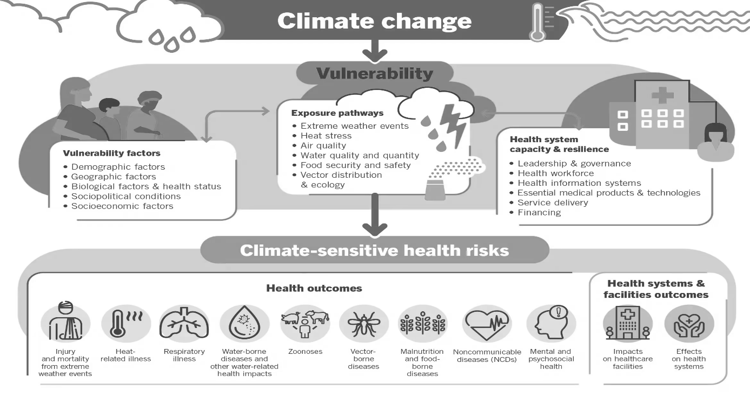

Figure 3. Climate change and Diseases (adapted from the WHO picture)

Table. 3: Climate change and Zoonotic Vibrio sp. infections
Pathogenic  Vibrio sp. | Diseases in Shellfish (crab and shrimp) | Vibrio Zoonotic Diseases
Vibrio  alginolyticus | Septicemia, Bacteremia (adult), Shell disease (Juvenile and Adult), wound infection. | Out of 1400 micro-organisms 200 infections are zoonotic in nature. 12 vibrios in no.  - Gastroenteritis  - Infection in wound skin  - Food poisoning  - Watery diarrhea  - Abdominal cramping  - Nausea  - Vomiting  - Fever  - Chills  # V. vulnificus may cause severe effect & life-threatening infections.  # V. mimicus cause eye and ear infections
Vibrio  anguillarum | Vibriosis, Shell disease  (Juvenile and Adult)
Vibrio  vulnificus | Bacteremia (adult), Shell disease (Juvenile and Adult), wound infection, cutaneous lesions.
Vibrio  harveyi | Luminescent Vibriosis (eggs and larvae), Shell disease (Juvenile and Adult), high mortality.
Vibrio  fluvialis | Shell disease  (Juvenile and Adult)
Vibrio  mimicus | Shell disease  (Juvenile and Adult)
Vibrio  cholerae | Vibriosis, Bacteremia  (adult)

5. Climate change and its impact on the Vibrio population:
Due to long-term sea surface warming, there have been indications of increased seasonal duration, concentration, and geographic expansion of Vibrio infections in the Pacific Northwest of the United States, Israel, and coastal Chile. After an exceptionally warm summer in 1994, reports of Vibrio vulnificus were made throughout the German coast. There is evidence linking the Baltic Sea's long-term warming and temperature anomalies to an increase in Vibrio vulnificus infections. Climate modeling techniques indicate that the frequency of Vibrio infections from the Baltic region may nearly double for every degree Celsius increase in the annual maximum water temperature [15, 24]. Climate change enhances the transmission season and expands the geographical distribution of vector-borne diseases (like dengue and malaria), as warmer temperatures and humidity favours the breeding of insect vectors and also alter the geographic distribution of existing vectors [25]. Warmer average temperatures can mean longer warm seasons, earlier spring seasons, shorter and milder winters, and hotter summers. Conditions might become more favourable for many carriers of vector-borne diseases [26] . Climate generally refers to the mean weather at a specific location on Earth. A climate's anticipated temperature, precipitation, and wind speed are typically stated in terms of past measurements. Any long-lasting alteration to the average environment or climate variability is known as climate change. So, climate change is a large-scale, long-term shift in the planet's weather patterns and average temperatures (Figure 1). Among the halophilic vibrios, V. parahaemolyticus and V. vulnificus are the major leading seafood-associated human gastrointestinal damage bacteria present in almost all saline water [27, 28]. Temperature and salinity are the two main suitable environmental factors or conditions that may help to multiply the growth of vibrios. On the other hand, the main impact of climate anomalies or alterations is global warming. Therefore, the increased temperature can increase the population of vibrios that easily contaminate the salt water as well as the surrounding freshwater during natural calamities or disasters. So, anomalies in saltwater temperature may also explain the sudden emergence of vibrios outbreaks in new areas [17] (Table 2 and 3). Rising temperatures, altered precipitation patterns, and a rise in the frequency of extreme weather events are creating the perfect environment for Vibrio growth. Important elements affecting Vibrio populations are as follows [6] (Table 4):
1. Temperature: Because Vibrio sp. growth rates rise exponentially with temperature, warmer waters are better for the survival and spread of these organisms. This expansion of their habitat range is leading to increased Vibrio-related illnesses.
2. Salinity: Variations in precipitation and evaporation patterns affect salinity levels, which can promote the growth of some Vibrio species.
3. Nutrient availability: Vibrio gets the nutrients it needs to flourish thanks to altered ocean upwelling patterns and increased nutrient runoff from land.
4. Ocean acidification: As the ocean absorbs more CO₂, its pH levels decrease, becoming more acidic. This change in chemistry can enhance the growth and virulence of Vibrio bacteria. Vibrio can more easily infect marine life when pH levels drop.
5. Coastal erosion and sea level rise: As sea levels rise, coastal erosion and flooding can contaminate water sources with Vibrio bacteria, increasing the risk of waterborne illnesses. Vibrio can spread from freshwater to marine ecosystems due to increased flooding and sediment resuspension.
6. Shifts in phytoplankton communities: Climate change is altering the composition of phytoplankton, which can impact the food web and potentially lead to an increase in Vibrio populations.

Table 4. Climate change and its impact on the Vibrio population and the human population
Key climate drivers | Key climate hazards | Climate-sensitive pathways | vibrio-borne diseases
- Fossil fuels  - Deforestation  - Land use | - Increased temperature  - Extreme precipitation and floods  - Increased drought | - Contamination,  - Pathogen replication, survival, and virulence,  - Low water availability and elevated pathogen conc. | Vibrio population increases in a  suitable environment
- Fossil fuels  - Deforestation  - Land use |  | - Contact with flood water and sewage,  - Ingestion of contaminated & food,  - Lack of clean water for hygiene | Contaminated  Water for use
- Fossil fuels  - Deforestation  - Land use |  | - Disrupted public health surveillance, emergency response & prevention  - Disrupted access to health care  - Food insecurity, malnutrition & diseases susceptibility. | Diseases in humans  (disease burden)

Based on documented evidence, climate change is typically divided into predictable and unpredictable (primary and secondary data). In this paper, climate change or weather conditions that could occur in the future but could be predicted in advance are referred to as predictable climate changes (cyclones, for example), and those that could not be predicted in advance are referred to as unpredictable climate changes (changing water current, for example). Climate change affects the natural environment's water parameters, such as turbidity, salinity, pH, DO, and temperature. Environmental issues of water quality or other stressors, such as temperature, salinity, DO, TDS, pH, and so forth, frequently increase the risk of disease outbreaks in aquatic animals [5, 29].
6. Climate change and Vibrio sp. infections:
Certain diseases that are especially vulnerable to ecological shifts are seeing changes in their patterns of infection due to climate change. Given the expansion of the disease vector's distribution range and the local prolongation of the transmission season, this circumstance is particularly relevant to vector-borne diseases [30]. The naturally rapid-growing Vibrios are found in water in more than 100 species in marine habitats with warm waters and low to moderate salinities. There are 12 Vibrio species known to cause infections in people who are directly exposed to that water, especially fishers [13, 6]. These Vibrio species can cause diseases typically acquired as wound infections from exposure to seawater or gastrointestinal illnesses linked to the intake of raw or undercooked seafood. Numerous clinical indications can result from vibriosis, which is caused by these non-cholera Vibrio species, mainly Vibrio parahaemolyticus, Vibrio alginolyticus, and Vibrio vulnificus [32, 5]. Although mild and self-limiting gastroenteritis is the most prevalent symptom, exposure of an open wound to seawater can also result in skin infections in fisherpersons directly or through zoonotic transmission. In many cases, it was found in isolated areas where there had been no previous cases of the disease and where the environmental circumstances were thought to be unfavorable for pathogenic Vibrios (Table 3).
So, waterborne Vibrio sp. infections can significantly impact fisherpersons, who are at increased risk of exposure due to their occupation (occupational risks or hazards). Climate change is increasing the risk of waterborne Vibrio sp. infections in fishers at the following points (Table 4 and 5):
1. Occupational exposure: Fishermen are frequently exposed to contaminated water, seafood, and marine environments, making them more susceptible to Vibrio infections.
2. Wound infections: Open wounds or cuts on the skin can become infected with Vibrio bacteria, leading to serious infections, amputations, or even death.
3. Gastroenteritis: Consuming contaminated seafood or water can cause Vibrio gastroenteritis, leading to diarrhea, vomiting, and abdominal pain.
4. Cholera: In rare cases, fisherpersons may be exposed to Vibrio cholerae, which can cause severe diarrhea and dehydration.
5. Septicemia: In severe cases, Vibrio bacteria can enter the bloodstream, leading to septicemia, a life-threatening condition.
6. Economic impact: Vibrio infections can lead to lost productivity, medical expenses, and decreased livelihoods for fisherpersons and their communities.
7. Prevention: Fisherpersons can reduce their risk by wearing protective gear, ensuring proper wound care, and practicing good hygiene when handling seafood and equipment.
8. Vaccination: Vaccines are available for some Vibrio species, such as Vibrio cholerae, and may be recommended for high-risk individuals like fishers.
9. Monitoring and reporting: Regular monitoring of water quality and reporting of Vibrio cases can help prevent outbreaks and protect fisherpersons' health.
10. Education and awareness: Educating fisherpersons about the risks and prevention strategies can help mitigate the impact of waterborne Vibrio sp. infections.
Most Common Vibrio sp. in S. serrata aquacultural farm [33] (Table 3)–

a) Vibrio Cholerae:
Cholera is a severe waterborne diarrheal disease frequently occurring in developing countries. It is caused by Vibrio cholerae, a gram-negative curved bacillus bacterium, transmitted almost exclusively via contaminated water, food, etc. V. cholerae multiply in the small intestine and produce the enterotoxin called choleragen, which binds irreversibly to epithelial cells of the small intestine and stimulates cyclic AMP within the mucosa cells. The activation of cyclic AMP initiates excessive secretion of water and electrolytes (chlorine ions) into the intestine and inhibits absorption of sodium ions. The symptoms of the disease include nausea, vomiting, abdominal pain, diarrhea with ‘rice water stools, and severe dehydration. The rapid loss of fluid or dehydration produces shock, and if the infection is untreated, can cause the death of the patient. For centuries, cholera has been endemic in Asia, mainly in the Ganges delta of the Bay of Bengal15, Bangladesh, and India16. Asiatic cholera has exploded at several different times, spread rapidly, and resulted in waves of global pandemics.

b) Vibrio parahaemolyticus =
Vibrio parahaemolyticus is a ubiquitous inhabitant of temperate and tropical coastal areas around the world. The epidemiology of V. parahaemolyticus is characterized by sporadic cases of infection along coastal areas, mostly associated with the consumption of raw or undercooked contaminated seafood over the warmer months, although wound exposure to contaminated water can also cause infection. The ingestion of raw or improperly cooked contaminated food was the most probable source of the V. parahaemolyticus infections, although cross-contamination of cooked food (for example, with contaminated water) might have been a secondary vehicle. Its sporadic cases and outbreaks were reported in Europe, Africa, New Zealand, and most Asian countries, thereby turning V. parahaemolyticus into a major seafood-borne pathogen and a global public health concern. Infections were associated with heterogeneous groups of diverse strains, although some groups prevailed in each geographical area. A sudden increment of gastroenteritis cases was detected in Calcutta, India. In contrast to most of the previous outbreaks, all the isolates from these cases clustered in a single homogeneous group, a variant of the serotype containing the same virulence traits. V. parahaemolyticus is the leading cause of bacterial infectious diarrhea.

c) Vibrio vulnificus:
Vibrio vulnificus is common in estuarine waters and has been isolated from a range of different environmental sources, including seawater, sediment, and seafood products. Unlike V. cholerae and V. parahaemolyticus, V. vulnificus is an opportunistic pathogen, with virtually all cases occurring in those with an underlying disease. The most common risk factors are liver diseases (such as cirrhosis or hepatitis), diabetes mellitus, and malignancies. Previous studies have indicated that individuals with chronic liver disease, such as cirrhosis, are up to 80–fold more likely than healthy individuals to develop V. vulnificus-associated primary septicemia.
d) Vibrio alginolyticus =
Like other vibrios, V. alginolyticus is becoming more widely acknowledged as a new human disease, and summertime is when infection rates rise the most. Seawater is home to V. alginolyticus, which typically causes ear infections and superficial wounds. The majority of V. alginolyticus wound infection reports are caused by cuts or abrasions that are exposed to tainted saltwater. With 131 cases—nearly 20% of all vibriosis infections—V. alginolyticus was found to be a substantial cause of infection in a vibriosis investigation. Furthermore, new epidemiological data point to a sharp rise in the incidence of V. alginolyticus infections in the USA.
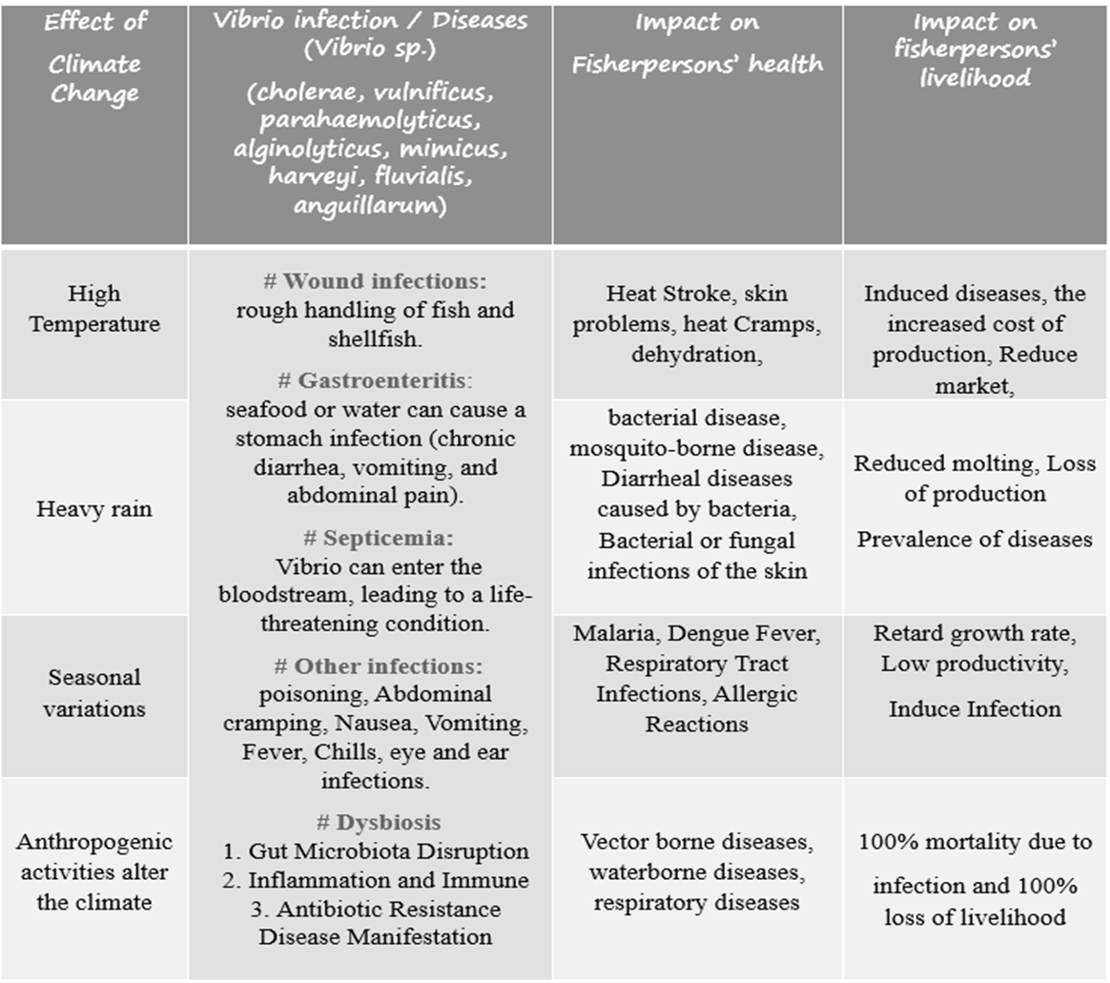
Table 5. Climate change and Vibrio sp. infections

Similar to V. parahaemolyticus, infections associated with V. vulnificus originate from two distinct sources: consumption of contaminated seafood, in particular molluscan shellfish, resulting in gastroenteritis or primary septicemia which is often associated with consumption of oysters, where this bacterium can occur in large numbers (≥10⁵ per gram); or exposure of wounds to seawater or seafood products, resulting in wound infections and secondary septicemia. However, unlike V. parahaemolyticus, V. vulnificus is a highly fatal human pathogen and it is responsible for >95% of seafood-related deaths in the United States [34].
7. Effect of climate change on the Sundarbans and fisherpersons:
There are many contributing variables, including human activity, and the tale of climate change is not confined to a particular day or event. Increased global temperatures, erratic weather patterns, natural disasters, the appearance of new disease-causing pathogen species, disturbances to ecological equilibrium states, a reduction in environmental tolerance, and more are some of the most important effects of climate change [6] (Saha et al., 2024). Fishery resource availability in West Bengal is impacted by climate anomalies, as are fishermen [35]. Fish and shellfish are examples of fishery animals whose physiological activity is increased by higher temperatures; this increase in activity raises the biological oxygen demand (BOD). On the other hand, water's ability to occupy oxygen is diminished when its temperature rises. As a result, fisheries creatures' capacity to grow, develop, and reproduce will eventually be hampered by the water's declining oxygen availability. In addition to decreasing dissolved oxygen, climate change-induced salinity increases also contribute to the growth of disease-prone halophilic pathogens (Shigella, Clostridium, Vibrios, etc.). Fishermen and the availability of fishery resources in West Bengal are both impacted by climate anomalies (Figure 4; Table 6). Furthermore, fish and shellfish are more physiologically active when the temperature rises, and this increased activity raises the biological oxygen demand (BOD). Conversely, a rise in water temperature decreases the water's ability to hold onto oxygen. Therefore, decreasing oxygen supply in water will eventually hinder fisheries creatures' capacity to grow, develop, and reproduce. Climate change-induced salinity increases also lower dissolved oxygen levels and contribute to the growth of disease-prone halophilic pathogens (Shigella, Clostridium, Vibrios, etc.) [36]. Sea level rise, saline incursion reducing freshwater supply, and an increase in storm frequency are the primary effects of climate change on West Bengal's coastal region [6]. Fishermen in the coastal region of the Sundarbans, which is extremely vulnerable to sea level rise and destroys the marine fish nursery ground, frequently capture over 120 species of fish [37]. The Bay of Bengal's marine environment has changed from the pre-industrial era by lowering the pH to 0.5 and raising the dissolved CO₂ from 380 ppm to 800 ppm, which is sensitive to fish eggs, embryos, larvae, and other organisms. Fishing is West Bengal's third-largest export sector, and the state's economy is vulnerable to the effects of climate change, which could affect our level of food security and poverty by putting more strain on fisheries production. The loss of the marine ecosystem and the destruction of the nutrient ground for aquatic and semi-aquatic organisms are the results of a continuous increase in water temperature (0.050C/yr) in the coastal environment, which also has a significant effect on other physical parameters such as salinity, evaporation, free CO₂, precipitation, fresh water mixed with seawater, and decreased pH. The growth of aquatic species is impacted by intensive trawling during fish and shellfish breeding seasons, and dragging trawl nets may reduce dissolved oxygen. Sediment clouds that build on the ocean floor have the potential to disrupt the ocean's natural equilibrium of physicochemical characteristics and reduce the amount of oxygen available to aquatic life. Marine water can get contaminated by the usage of crude oil and oil spills from trawlers. The availability of natural marine fisheries resources in West Bengal is hampered by such circumstances [38].
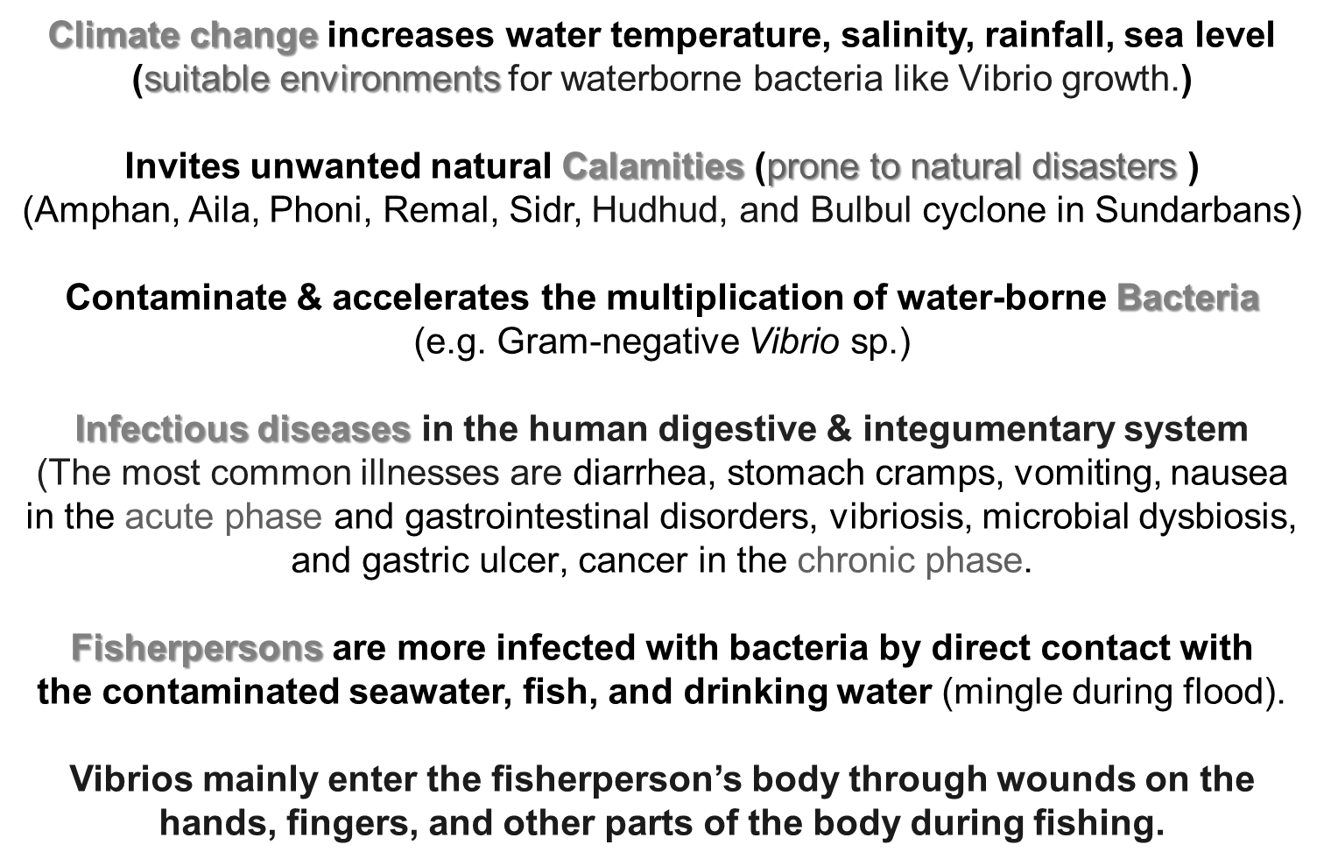

Figure 4. Effect of climate change on the Sundarbans and fisherpersons

Table 6. Climate Change and Potential Impacts on Fisherpersons of West Bengal
Stressors of climate change | Pathway | Potential impacts
- Warmer water  - Water level rise  - Stronger Strome  - Unpredictable sea conditions  - Change to ocean currents  - Extreme weather  - Ocean acidification  - Scarcity of freshwater for drinking  - Coastal flooding  - Increase of cyclonic storms | Biological productivity | Disruption of the marine ecosystem
 | Biological productivity | Reduced growth, the productivity of fish stocks
 | Biological productivity | Fish kills from low oxygen
 | Biological productivity | Damage to critical habitats
 | Capture  fisheries | Waterborne diseases
 | Capture  fisheries | Lower yield
 | Capture  fisheries | Change in species caught
 | Capture  fisheries | Reduce safety at sea
 | Capture  fisheries | Damage infrastructure, net and gear
 | Capture  fisheries | Sink boat
 | Capture  fisheries | Increased operational costs
 | Occupation / Livelihood | Increased Occupation hazards
 | Occupation / Livelihood | Low income
 | Occupation / Livelihood | Reduce health safety
 | Occupation / Livelihood | Damage sanitation structure by sinking latrine, tube well, pond.
 | Occupation / Livelihood | Threat to cultural identity
 | Occupation / Livelihood | Reduce wellbeing
 | Occupation / Livelihood | Reduction of physical fitness and increase injury
Main problems in fisherfolk livelihood (table 4) –
• Overfishing and Declining Fish Stocks: The sustainability of fish resources is at risk due to indiscriminate fish seed harvesting and declining tiger prawn populations.
• Climate Change and Natural catastrophes: Fishing activities and the lives of fishermen are impacted by cyclonic storms, low pressure in the Bay of Bengal, and other natural disasters.
• Lack of Infrastructure: The expansion of the fishing industry is hampered by a lack of post-harvest infrastructure and other services.
8. Health Status of fisherpersons and fisherfolk in indian sundarbans:
FAO 2015 reported that small-scale fishers directly contributed nearly 90 % of the 120 million people engaged in capture fisheries globally, and 97% of the world's Fisherpeople reside near coastal areas with coastal fishery dependency. 2/3 of the global fish have been caught by small-scale fisheries for direct human consumption, which has increased daily. These communities make a critical contribution to food security, local livelihoods, and national economies, especially in developing countries like India. The Indian Sundarbans is the largest continuous mangrove forest, which is famous for its marine and estuarine fish resources due to the presence of rivers Ganges, Brahmaputra, and Meghna. Several people are involved in fishing activities, as the capture of natural resources. But nowadays, fisheries livelihoods are the major alarming because of anthropogenic activities (deforestation, oil spills from motorized vessels, fossil fuel, tourism development, water pollution, indiscriminate and unscientific collection of capture fisheries) and natural activities (recurrent storms, erosion, flooding, sea level rise, increase pH and salinity, temperature etc.) (table 6). The health status of Sundarbans fisherpersons and fisherfolk is affected by various factors, including their occupation, environmental conditions, and water quality. Water pollution directly affected their health as they are close to the saline water. Increased temperature and salinity induce favourable environmental conditions for opportunistic growth bacteria, including Vibrios. These vibrios cause dysbiosis of their gut microbiome, and long-term conditions such cause gut diseases, which may accelerate stomach ulcers (Figure 5). Dysbiosis refers to an imbalance in the microbiota, which can lead to various diseases, including gastric cancer. Vibrio species, including Vibrio vulnificus, Vibrio parahaemolyticus, and Vibrio cholerae, can cause dysbiosis in humans and animals in 3 ways –
- Loss of beneficial bacteria,
- Overgrowth of potentially pathogenic bacteria,
- Loss of overall bacterial diversity.
Vibrio-induced Dysbiosis in fisherfolk -
1. Gut Microbiota Disruption: Vibrio species can disrupt the balance of the gut microbiota, leading to changes in the composition and function of the microbiome.
2. Inflammation and Immune Response: Vibrio infections can trigger an inflammatory response, which can further disrupt the microbiota and lead to dysbiosis.
3. Antibiotic Resistance: The overuse of antibiotics can contribute to the development of antibiotic-resistant Vibrio strains, making treatment more challenging.
4. Disease Manifestation: Vibrio-induced dysbiosis can manifest as various diseases, including gastroenteritis, septicemia, and wound infections.
Climate Change
Temperature / salinity/pH
GI Dysbiosis
Growth of Vibrio sp.
GI infections
GI ulcer
GI disease

Figure 5. The annual occurrence of over 2.78 million deaths worldwide and about 20%-50 % of
worldwide, fishermen face dangers including gastrointestinal disease problems
9. Plan of action and mitigation:
The Sundarbans are the world's largest mangrove forest. It is located on the border of West Bengal between Bangladesh and India and covers an area of 9,630 km². The Ganges, Brahmaputra, and Meghna rivers run through this system to produce the largest delta in the world. Significant sections of the Indian side have been designated as Ramsar Sites, wetlands of international significance, even though the Indian side has been a UNESCO World Heritage Site since 1987. Of the 102 islands in the Sundarbans Delta, 48 are inhabited by people who work as fishermen. The project's main goal was to identify or examine the connections between health problems, work dangers, and climate change that had an immediate impact on the socioeconomic well-being of WB's fishermen. Data for the survey will be gathered from Asha employees, residents, block offices, fishing agents, fisher extension offices, and fishermen, among others. Human samples (water, stomach juice, blood, seminal fluid, etc.) from Sundarban fishermen must be gathered and examined to discover the effect. The habitat of Sundarban fisherfolk is typically found along West Bengal's coast. There are roughly 3,80,138 fishermen who work directly or indirectly in the marine fishery industry in West Bengal, which includes 188 fishing villages and 76,981 fisherman families [6] (Marine Fisheries Census 2010 Part II. 1, West Bengal, CMFRI). The current information state of the coastal settlements in the Sundarbans, where 53,927 fishermen reside, is examined in our review study. In the Indian Sundarbans, this will be the first assessment project and future work plan to link climate change-affected waterbodies and fishermen with increased cancer risks and occupational health concerns. State and federal governments, as well as non-governmental organizations operating in the Sunderbans, will be made aware of this to implement these changes:
a) In addition to post-disaster rehabilitation, health risks will be the primary criteria to evaluate, and significant actions are anticipated in the Sunderbans in this regard, given the frequency of cyclones and climate change there.
b) Our study will offer a framework for changing national policy for climate change-affected individuals who have received rehabilitation.
c) social shifts, occupational skewing, and the effects of COVID-19 will be crucial factors to take into account further in impacted groups.
d) Raising awareness of the effects of catastrophic occurrences among all pertinent stakeholders, such as the general public, vulnerable populations, healthcare professionals, and policymakers, is part of the program.
e) Through information, education, and communication activities, the districts hope to raise awareness by creating messages that are more acceptable in their local and cultural contexts through posters, audio, and video, hosting public health events, and issuing disaster management advisories. The State health division will supply the content for disaster management. Utilizing these resources, translating the necessary content, and distributing it at all levels are the districts' responsibilities.
f) Educating communities and health professionals about new diseases and health effects related to climate change.

10. Conclusion:
According to the review, heat waves, storms, floods, wildfires, air pollution, and vector-borne diseases are among the environmental hazards and disasters that climate change makes worse. These events pose serious dangers to the health and safety of workers. Additionally, it has been shown that because of institutional injustices, limited access to resources, and exposure to dangerous working conditions, some groups, such as low-income workers, migrants, indigenous communities, and disadvantaged populations, are disproportionately impacted by climate change. The fishermen encountered several significant cyclones, including Amphan, Bulbul, Mora, Komen, and Aila, that were destructive but predicted. Death from infectious and deadly diseases is another extremely unpredictable form of devastation [39]. Infections with bacteria and parasites, some zoonotic (bacteria that spread from animal to human), account for a significant portion of fish mortality in both wild and farmed fish. The most prevalent zoonotic bacteria and parasites that are detrimental to fish and humans (public health) are gram-positive (Mycobacteria, Streptococcus, etc.) and gram-negative (Aeromonas, Vibrio, etc.) [40]. Because of the knowledge gap, they are unaware of safeguarding themselves against various dangers or calamities. Fishermen's income also correlates with their degree of education, kind of home, work, health, and overall social standing. Therefore, the most crucial indicator for preserving socioeconomic standing is having enough money for a fisherman's family. However, revenue is dependent on the availability of fisheries resources, which are impeded by anomalies or changes in the climate [41] Anomalies in the climate alter the physicochemical characteristics of the water (temperature, salinity, pH, DO, BOD, TDS, N-contents, etc.), which eventually destroys the marine environment and kills fish and shellfish eggs, larvae, juveniles, and adults [42]. Additionally, their expensive fishing gear, craft, and raft are destroyed by natural disasters. Therefore, the health and economic standing of fishermen are also negatively impacted by the dangers and hazards associated with the fishing profession. The productivity of the sea and its environs (coastal regions, estuaries) as well as the health of fishermen were therefore progressively deteriorated by climate change [43]. In this article, we attempt to identify research gaps and the extent of research about the effects of climate change on occupational health and the rise or change of waterborne pathogens that cause illnesses in fishermen in the Indian Sundarbans [44]. The effects of either predictable or unanticipated climatic change on the occupational health of fishermen in the coastal region of West Bengal can also be evaluated [45]. Fisherpersons should increase their knowledge, abilities, and understanding of climate-related hazards, emergency procedures, and preventive measures [46-50]. This can be achieved through capacity building, training, and awareness-raising programs, implementing successful climate resilience strategies, exchanging best practices, and promoting a culture of safety etc [51-53].

11. DISCLAIMER (ARTIFICIAL INTELLIGENCE):
We hereby declare that NO generative AI technologies such as Large Language Models (ChatGPT, COPILOT, etc.) and text-to-image generators have been used during the writing or editing of this manuscript.
13. CONFLICT OF INTEREST
The authors have no conflict of interest.
14. REFERENCES:
- Saha, S. and Ray, S. 2014. Sublethal effect of arsenic on oxidative stress and antioxidant status in the edible crab, Scylla serrata in India. Clean-soil, air, water, 42(9): 1216 – 1222.
- Baag,S. and Mandal,S. 2023. The influence of ocean acidification and warming on responses of Scylla serrata to oil pollution: An integrated biomarker approach. Comparative biochemistry and physiology Part B. Biochemistry and molecular biology, 266.110847.
- Ray, S. and Saha, S. 2011. Arsenic toxicity of estuarine mudcrab. LAP LAMBERT Academic Publishing GmbH & Co. KG., Germany. ISBN: 978-3-8443-3035-9.
- Saha, S. and Dash, G. 2021. Climatic Stress on Cultured Scylla sp.: Impact on livelihood and Public Health in West Bengal. International Journal of Researches in Biosciences, Agriculture & Technology, S17: 331 – 344.
- Saha, S. and Dash, G. 2021. Zoonotic Vibrio diversity and diseases in mudcrab fishery: impacts on public health in India. Uttar Pradesh Journal of Zoology, 42(19): 48-58.
- Saha, S., Basu, B., Dash, G. 2024. Studies on climate change and its impact on the occupation and health of fisherpersons in West Bengal. Indian Journal Environmental Protection, 44(7): 637 – 648.
- Saha, S. and Basu, B. 2024. The impact of climate change on waterborne microbial diversity and Dysbiosis in carcinogenesis of Indian Sundarbans fisherpersons: A review. In Prof. Aysun Turmen (Ed.) Research Advances in Environment, Geography and Earth Science. B P International, Vol.2. pp. 150 -170.ISBN: 978-81-972756-7-8. DOI: 10.9734/bpi/raeges/v2.
- Ariadi, H., Musa, M., Mahmudi, M., Hertika, A.M.S. 2025. Organic Material Solubility and Dynamic Modelling Analysis of Intensive Shrimp Farming Activities in the Coastal Area of Pekalongan, Indonesia. Croatian Journal of Fisheries, 83 (2):71-85.
- Mardiana, T.Y., Ariadi, H., Linayati, L., Wijianto, W., Fahrurrozi, A., Maghfiroh. 2023. Estimation of water carrying capacity for floating net cage cultivation activities in Pekalongan Coastal Waters. Jurnal Perikanan Universitas Gadjah Mada, 25 (1): 19-24.
- Ariadi, H., Musa, M., Mahmudi, M., Hertika, A.M.S. 2025. The waste load and carrying capacity on intensive shrimp farming: A mini review. Ecological Engineering & Environmental Technology, 26 (4): 323-333.
- Maharani, K., Ulfa, S., Ariadi, H. 2024. An estimation of dissolved oxygen production model by paddle aerator in whiteleg shrimp (Litopenaeus vannamei) culture. BIO Web of Conferences, 136: 01004.
- Firdausa, D.I., Sulistiana, A., Ariadi, H. 2024. Plankton community profile in silvofishery ponds. BIO Web of Conferences, 136: 0100.
- Ariadi, H., Wijaya, M.C., Elyah, F., Mardiana, T.Y. 2021. Financial Analysis Of Tilapia (O. niloticus) Fry Business Activity At The Klemunan Fish Fry Center, Blitar District. Journal of Aquaculture Development and Environment, 4 (1): 227-232.
- Ariadi, H., Fadjar, M., Mahmudi, M. 2019. The relationships between water quality parameters and the growth rate of white shrimp (Litopenaeus vannamei) in intensive ponds. Aquaculture, Aquarium, Conservation & Legislatio, 12 (6): 2103-2116.
- Mardiana, T.Y., Ariadi, H., Rattanavichai, W., Soedibya, P.H.T., Linayati, L. 2024. Feasibility Study Area and Dissolved Oxygen Carrying Capacity of Silvofishery Pond on the Coastal Area. ILMU KELAUTAN: Indonesian Journal of Marine Sciences, 29 (2): 1-10.
- Linayati, L., Nhi, N.N., Ariadi, H., Mardiana, T.Y., Fahrurrozi, A., Syakirin, M.B. 2024. Relationship Between Abundance Of Clamydomonas spp And Chlorella spp On Clinical Performance Of Red Tilapia (Oreochromis niloticus) In Silvofishery Ponds. Croatian Journal of Fisheries, 82 (1): 33-42.
- Ariadi, H., Madusari, B.D., Mardhiyana, D. 2024. Dynamic modelling analysis on the effectiveness of coastal land resources for aquaculture activities utilization. Journal of Natural Resources and Environmental Management, 14(1): 174-174.
- Ariadi, H., Azril, M., Mujtahidah, T. 2023. Water Quality Fluctuations in Shrimp Ponds During Dry and Rainy Seasons. Croatian Journal of Fisheries, 81 (3):127-137.
- Mardiana, T.Y., Ariadi, H., Al Ramadhani, F.M., Syakirin, M.B., Linayati, L. 2024. Dynamic modeling system of Cholorophyceae abundance in pen-culture ponds during the dry season. Ecological Engineering & Environmental Technology, 25: 47-56.
- Chimalapati, S., De Souza Santos, M., Servage, K., De Nisco, N. J., Dalia, A.B. and Orth, K. 2018. Natural transformation in Vibrio parahaemolyticus: a rapid method to create genetic deletions. J Bacteriol 200: e00032-18.
- Asadgol, Z., Badirzadeh, A., Niazi, S., Mokhayeri, Y., Kermani, M., Mohammadi, H. and Gholami, M. 2020. How can climate change affect cholera incidence and prevalence? A systematic review. Environ Sci Pollut Res Int., 27(28): 34906-34926. doi: 10.1007/s11356-020-09992-7. Epub 2020 Jul 14. PMID: 32661979.
- Beri, D., Elkington, J., Moola, S., Bhaumik, S. and Jagnoor, J. 2024. Impact of climate change on water-related physical events, consequent human migration, and burden of drowning in India: An evidence synthesis. J Family Med Prim Care, 13 (9):3552 - 3563.
- IPCC. 2019. Special Report on Climate Change and Land. [online] Ipcc. Available at: https://www.ipcc.ch/srccl/.
- IPCC. 2018. Global Warming of 1.5 ⁰C. [online] IPCC. Available at: https://www.ipcc.ch/sr15/.
- 13. Saha, S. Pradhan, D. and Dash, G. 2023. Studies on diversity of bacterial diseases and occupational risks through mudcrab aquaculture in West Bengal. Journal of Pure and Applied Microbiology. 17(2):722-731. doi- https://doi.org/10.22207/JPAM.17.2.23.
- Seidel, D., Wurster, S., Jenks, J. D., Sati, H., Gangneux, J., Egger, M., Alastruey-Izquierdo, A., Ford, N. P., Chowdhary, A., Sprute, R., Cornely, O., Thompson, G. R., Hoenigl, M., &Kontoyiannis, D. P. (2024). Impact of climate change and natural disasters on fungal infections. The Lancet Microbe, 5(6), e594–e605. https://doi.org/10.1016/s2666-5247(24)00039-9.
- Baker-Austin, C., Trinanes, J. A., Taylor, N. G. H., Hartnell, R., Siitonen, A., & Martinez-Urtaza, J. 2012. Emerging Vibrio risk at high latitudes in response to ocean warming. Nature Climate Change, 3(1), 73–77. https://doi.org/10.1038/nclimate1628.
- World Health Organization. 2016. WHO Director-General summarizes the outcome of the emergency Committee regarding clusters of microcephaly and Guillain-Barré Syndrome. Who.
- Martinez-Urtaza, J., Bowers, J.C., Trinanes, J., DePaola, A., 2010. Climate anomalies and the increasing risk of Vibrio parahaemolyticus and Vibrio vulnificus illnesses. Food Research International 43: 1780–1790.
- Deeb, R., Tufford, D., Scott, G.I., Moore, J. G. and Dow, K. 2018. Impact of Climate Change on Vibrio vulnificus Abundance and Exposure Risk. Estuaries Coast. 41(8): 2289–2303. doi:10.1007/s12237-018-0424-5.
- Jung, Y.-J.; Khant, N.A.; Kim, H.; Namkoong, S. 2023. Impact of Climate Change on Waterborne Diseases: Directions towards Sustainability. Water, 15, 1298. https://doi.org/10.3390/w15071298.
- Weins, K. E., Lyer, A. S.., Bhuiyan, J. R. Lu, L. L., Cizmeci, D., Goraman, M. J., Yuan, D., Becker, R.L., Ryan, E. J., Calcewood, S. B., La Rocgue, R. C., Chowdhury, F., Khan, A.I., Levine, M. M., Chen, W. H., Charles, R. C., Azman, A.S., Qadri, F., Alter, G. and Harris, J. B. 2023. Predictive Vibrio cholerae infection and symptomatic disease: A systems serology study. The Landet. Microbe, 4(4): 228 – 235.
- Filho, W. L., Ternova, L., Parasnis, S. A., Kovaleva, M., & Nagy, G. J. 2022. Climate Change and Zoonoses: A review of Concepts, Definitions, and bibliometrics. International Journal of Environmental Research and Public Health, 19(2): 893. https://doi.org/10.3390/ijerph19020893.
- Wannous C. 2020. Climate change and other risk drivers of animal health and zoonotic disease emergencies: the need for a multidisciplinary and multisectoral approach to disaster risk management. Rev Sci Tech., 39(2): 461-470. doi: 10.20506/rst.39.2.3097. PMID: 33046929.
- Chomel, B. 2009. Zoonoses. In Elsevier eBooks (pp. 820–829). https://doi.org/10.1016/b978-012373944-5.00213-3.
- Jayakumar, J.M., Martinez-Urtaza, J., Brumfield, K. D., Jutla, A. S., Colwell, R.R., Cordero, O.X. and Almagro-Morno, S. 2024. Climate change and Vibrio vulnificus dynamics: A blueprint for infectious diseases. PLoS Pathog 20(12): e1012767. https://doi.org/10.1371/journal.ppat.1012767.
- Gubler, D. J., and Reiter, P. 1998. Climate change and vector-borne diseases. Emerging Infectious Diseases, 4(3): 429–436.
- Vezzulli, L., Colwell, R.R., Pruzzo, C. 2013. Ocean warming and spread of pathogenic vibrios in the aquatic environment. Micro Ecol, 65(4): 817-825, 10.1007/s00248-012-0163-2.
- FAO and WHO. 2020. Risk assessment tools for Vibrio parahaemolyticus and Vibrio vulnificus associated with seafood. Microbiological Risk Assessment Series No. 20. Rome.
- Dietrich, J., Hammerl, J.A., Johne, A., Kappenstein, O., Loeffler, C., Nöckler, K., Rosner, B., Spielmeyer, A., Szabo, I., Richter, M.H. 2023. Impact of climate change on foodborne infections and intoxications. J Health Monit. 8(Suppl 3):78-92. doi: 10.25646/11403. PMID: 37342431; PMCID: PMC10278375.
- Saha, S., Pradhan, D., Dash, D. 2022. Studies on Bio-resource, Threats and Conservation of Aquacultural Scylla serrata. In Shashi, P and Sashi, A. (Ed.) Management of natural resources and sustainable regional development. Akinik Publications, New Delhi, India, Chapter 10: pp. 111 – 141. DOI: https://doi.org/10.22271/ed.book.2032
- Semenza, J. C. and Menne, B. 2009. Climate change and infectious diseases in Europe. The Lancet Infectious Diseases, 9(6): 365–375.
- Austin, A. 2010. Vibrios as causal agents of zoonoses. Vet Microbiol., 140 (3-4): 310 – 317
- Elhadi, 2013. Occurrence of potentially human pathogenic Vibrio sp. in the coastal water of the Eastern province of Soudi Arabia. Research J. Microbiology, 8(1): 1-12.
- Saha, S. 2024. Bacterial Diseases in Aquacultural Shellfish and Public Health. In Dr. D. S. Rathod and Dr. S. S. Pedge (Ed.) Current Research in Fisheries and Aquatic Science (Vol. - 1) pp. 43-64. Weser Books, Germany.
- Ghosh U, Bose S, Bramhachari R. 2018. Living on the Edge: Climate Change and Uncertainty in the Indian Sundarbans, STEPS Working Paper 101, Brighton: STEPS Centre.
- Batabyal, P., Mookerjee, S., Einsporn, M.H., Lara, R.J., Palit, A. 2014. High prevalence of toxin producing enteropathogenic Vibrios among estuarine crab in Ganges delta of West Bengal, India. Infect Genet Evol., 26: 359 – 361.
- Chatterjee, T. 2017. Climate change and its collision on fisheries resource in Sundarbans region of South24pgns. West Bengal. Suresh Gyan Vihar University International J. Environment, Science and Technology, 3(2): 10 – 13.
- Ahmed, Z.M., Dosoki, M.I., Nasr, S.A.A. 2012. Occupational Hazards in Fish Industry. World Journal of Fish and Marine Sciences. 4(2): 201-210.
- Heck, N., Beck, M. W., Reguero, B., Pfliegner, K., Ricker, M., & Prütz, R. 2023. Global climate change risk to fisheries – A multi-risk assessment. Marine Policy, 148, 105404. https://doi.org/10.1016/j.marpol.2022.105404.
- George, P. R. and Harini, E. 2019. Fish-borne Zoonotic Diseases Are Risk to Public Health. Present Status of Fish Disease Management Programmes in India. Our Heritage, 67(2): 118 – 123.
- Thomson, M.C. and Stanberry, L.R. 2022. Climate Change and Vector-borne Diseases. N. Engl. J. Med. 2022;387: 1969-78. DOI: 10.1056/NEJMra2200092.
- Mandal, S., Hasan, I., Hawlader, N. H., Sultana, I. Rahman, M. M., Majumder, M. S. I. 2017. Occupational Health Hazard and Safety Assessment of Fishermen Community in Coastal Zone of Bangladesh. International Journal of Health Economics and Policy, 2(2): 63-71.

