A Comparative Morphometric Study of Indian Major Carps

Abstract
Amid growing demands for sustainable aquaculture, understanding species-specific growth patterns is essential for maximizing productivity. The findings revealed that Catla exhibited the highest weight gain, Mrigal showed superior linear growth, and Rohu demonstrated moderate overall performance. A significant positive correlation was observed between total length and other morphometric traits. These results highlight the value of species-specific selection for polyculture systems and emphasize the role of morphometric analysis in broodstock selection and aquaculture enhancement.
Keywords: Morphometric analysis, growth performance, polyculture, broodstock selection.
Introduction
In recent years, aquaculture has emerged as one of the fastest-growing sectors in the fisheries industry and is widely acknowledged for its crucial role in ensuring global food security and nutrition in the 21st century. India ranks as the world’s second-largest fish-producing nation, contributing approximately 8.92% to global fish output. In the fiscal year 2022–23, the country's total fish production is estimated at 17.54 million metric tons (MMT), with the inland sector accounting for 13.11 MMT and the marine sector contributing 4.43 MMT. India is also a leading aquaculture producer, holding the second position globally after China. Inland fisheries represent around 75% of the nation’s overall fish production.
Indian Major Carps (IMCs), including Catla catla, Labeo rohita, and Cirrhinus mrigala, are pivotal to India's freshwater aquaculture, contributing significantly to food security and economic livelihoods. These species are primarily cultivated through polyculture systems, optimizing resource use and enhancing production efficiency. Indian Major Carps (IMCs) contribute approximately 70–75% of the country’s total freshwater fish production (Chandra et al., 2024). India holds the second position globally in carp production, supported by strong domestic demand and a growing export market for value-added products (Murthy, 2002). The aquaculture sector is expanding at an annual rate of over 7%, with freshwater aquaculture making up 95% of the total output. Advances such as induced breeding and composite carp culture have significantly boosted productivity, with yields ranging from 3 to 6 tons per hectare per year (Jayasankar, 2018).
Morphometric analysis of Indian Major Carps such as Labeo rohita, Catla catla and Cirrhinus mrigala provides valuable information about their growth trends and adaptations to environmental conditions. Commonly measured parameters include total length, standard length, head length, snout length, body depth and eye diameter (Yadav & Paul, 2023). Landmark-based morphometric techniques have revealed considerable variation among species, helping to distinguish unique body shapes at different stages of development (K., n.d.)
Materials and Methods
Location/ Place of Work
The study was conducted at the College of Fishery Science, under Nanaji Deshmukh Veterinary Science University, located in Jabalpur, Madhya Pradesh, India.
1.1 Morphometric measurements
Morphometric parameters including total length, standard length, fork length, head length, snout length, eye diameter, pre-dorsal length, pre-pectoral length, pre-pelvic length, pre-anal length, body depth, caudal depth, post-orbital length, anal fin base length, pelvic fin base length and caudal length (Table 1) were recorded in centimeters, while total body weight was measured in grams. Data collection took place from June 28 to July 28, 2025.These morphometric measurements were taken using a divider, measuring board, measuring tape and single-pan balance, following the method described by Lowe McConnell (RH, L. M.1978).
Fig: 1 Typical morphological parameter of Indian major carp (Ng et al.,2017)
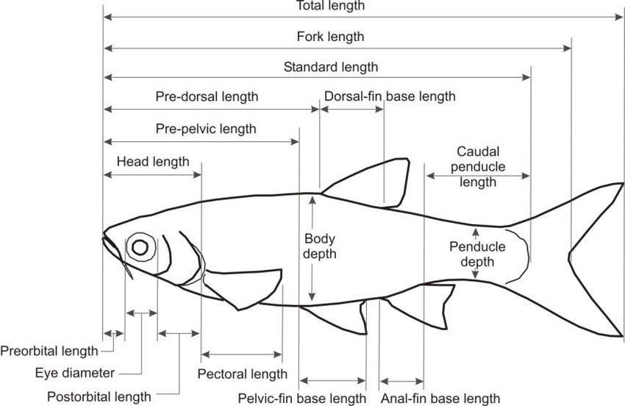

Table 1: Measured morphometric parameters of Indian major carps

Sl. No. | Morphometric Parameter | Abbreviation | Description of measured parameters
1 | Total Length | TL | It is a measurement of body length from tip of largest jaw (snout) to the largest part of caudal fin.
2 | Standard length | SL | Length from snout to the origin of caudal fin.
3 | Fork Length | FL | Length from snout to the point of bifurcation of caudal fin.
4 | Head Length | HL | Length from snout to the posterior most part of operculum.
5 | Pre Dorsal Length | PDL | Length from snout to the origin of the dorsal fin.
6 | Pre Pelvic Length | PPvL | Length from snout to the origin of pelvic fin.
7 | Dorsal Fin base Length | DFL | The distance between the anterior (front) and posterior (rear) ends of the base of the dorsal fin
8 | Caudal Peduncle Length | CPL | Total length – Standard length
9 | Body Depth | BD | Maximum vertical length of body (deepest part of the body).
10 | Eye Diameter | ED | Maximum length of eye orbit from one margin to other.
11 | Pre Orbital Length | PrOL | The distance from the tip of the snout to the anterior (front) margin of the eye.
12 | Post Orbital Length | POL | The distance from the posterior (rear) margin of the eye to the end of the operculum (gill cover)
13 | Pectoral Length | PL | The distance from the point where the pectoral fin is attached to the body (its base) to the tip of the fin.
14 | Pelvic Fin base Length | PFL | Pelvic fin base length is the distance from the front to the rear end of the pelvic fin’s attachment to the body.
15 | Anal Fin base Length | AFL | Anal Fin Base Length is the distance between the front and rear ends of the base where the anal fin is attached to the body.
16 | Peduncle Depth | PD | Peduncle depth refers to the vertical thickness

Result & Discussion
1.1 Morphometric measurements
Table 2: Morphometric observations of Catla
Sr. no. | Parameters | Day 1 | Day 15 | Day 30 | Mean | SE
1 | Weight of the Fish(gm) | 0.572 | 0.691 | 0.857 | 0.71 | 0.07
2 | Total Length(cm) | 36.5 | 36.8 | 36.9 | 36.7 | 0.1
3 | Fork length(cm) | 31.5 | 31.9 | 32 | 31.8 | 0.12
4 | Standard length(cm) | 28 | 28.3 | 28.5 | 28.3 | 0.12
5 | Head Length(cm) | 7.5 | 7.6 | 7.7 | 7.6 | 0.05
6 | Pre dorsal length(cm) | 13 | 13.3 | 13.5 | 13.3 | 0.12
7 | Pre pelvic length(cm) | 15 | 15.1 | 15.2 | 15.1 | 0.05
8 | Dorsal fin base length(cm) | 8 | 8.2 | 8.4 | 8.2 | 0.09
1 | caudal peduncle length (cm) | 7 | 7.1 | 7.2 | 7.1 | 0.05
9 | Body depth(cm) | 9.5 | 10.3 | 10.5 | 10.1 | 0.25
10 | Eye diameter(cm) | 2.2 | 2.3 | 2.5 | 2.33 | 0.07
11 | Preorbital Length(cm) | 3.3 | 3.4 | 3.6 | 3.43 | 0.07
12 | Postorbital length(cm) | 4 | 4.1 | 4.3 | 4.13 | 0.07
13 | Pectoral Length(cm) | 6.1 | 6.3 | 6.4 | 6.27 | 0.07
14 | Pelvic fin base Length(cm) | 1.5 | 1.6 | 1.8 | 1.63 | 0.07
15 | Anal fin base Length(cm) | 2.5 | 2.7 | 2.9 | 2.7 | 0.09
16 | Peduncle Length(cm) | 4 | 4.3 | 4.5 | 4.27 | 0.12

Table 3: Morphometric observations of Rohu
Sr.no | Parameters | Day1 | Day15 | Day30 | Mean | SE
1 | Weight of the Fish(gm) | 0.322 | 0.498 | 0.627 | 0.482 | 0.088
2 | Total Length(cm) | 29.5 | 29.9 | 30.1 | 29.83 | 0.176
3 | Fork length(cm) | 24.8 | 25 | 25.2 | 25 | 0.115
4 | Standard length(cm) | 23.5 | 23.8 | 24 | 23.77 | 0.145
5 | Head Length(cm) | 6 | 6.1 | 6.2 | 6.1 | 0.058
6 | Pre dorsal length(cm) | 11 | 11.2 | 11.4 | 11.2 | 0.115
7 | Pre pelvic length(cm) | 13.5 | 13.7 | 13.9 | 13.7 | 0.115
8 | Dorsal fin base length(cm) | 6 | 6.2 | 6.4 | 6.2 | 0.115
9 | caudal peduncle length (cm) | 5.5 | 5.7 | 5.9 | 5.7 | 0.115
10 | Body depth(cm) | 7 | 7.2 | 7.3 | 7.167 | 0.088
11 | Eye diameter(cm) | 1.3 | 1.5 | 1.6 | 1.467 | 0.088
12 | Preorbital Length(cm) | 2.3 | 2.5 | 2.6 | 2.467 | 0.088
13 | Postorbital length(cm) | 3.2 | 3.3 | 3.4 | 3.3 | 0.058
14 | Pectoral Length(cm) | 5 | 5.1 | 5.2 | 5.1 | 0.058
15 | Pelvic fin base Length(cm) | 1.1 | 1.2 | 1.3 | 1.2 | 0.058
16 | Anal fin base Length(cm) | 2 | 2.1 | 2.2 | 2.1 | 0.058
17 | Peduncle Length(cm) | 3.2 | 3.3 | 3.4 | 3.3 | 0.058

Table 4: Morphometric observations of Mrigal
Sr.no | Parameter | Day1 | Day15 | Day30 | Mean | SE
1 | Weight of the Fish(gm) | 0.612 | 0.746 | 0.978 | 0.77867 | 0.1069079
2 | Total Length(cm) | 37 | 37.3 | 37.5 | 37.2667 | 0.14531
3 | Fork length(cm) | 33.2 | 33.4 | 33.7 | 33.4333 | 0.14531
4 | Standard length(cm) | 31.2 | 31.5 | 31.8 | 31.5 | 0.17321
5 | Head Length(cm) | 7 | 7.1 | 7.2 | 7.1 | 0.05774
6 | Pre dorsal length(cm) | 14 | 14.2 | 14.5 | 14.2333 | 0.14531
7 | Pre pelvic length(cm) | 15 | 15.3 | 15.7 | 15.3333 | 0.20284
8 | Dorsal fin base length(cm) | 7 | 7.2 | 7.5 | 7.23333 | 0.14531
9 | caudal peduncle length (cm) | 7.1 | 7.3 | 7.4 | 7.26667 | 0.08821
10 | Body depth(cm) | 8 | 8.1 | 8.2 | 8.1 | 0.05774
11 | Eye diameter(cm) | 1.5 | 1.6 | 1.7 | 1.6 | 0.05774
12 | Preorbital Length(cm) | 2.5 | 2.6 | 2.7 | 2.6 | 0.05774
13 | Postorbital length(cm) | 3.5 | 3.7 | 3.8 | 3.66667 | 0.08821
14 | Pectoral Length(cm) | 5.1 | 5.3 | 5.5 | 5.3 | 0.11547
15 | Pelvic fin base Length(cm) | 1.8 | 1.9 | 2 | 1.9 | 0.05774
16 | Anal fin base Length(cm) | 2 | 2.1 | 2.2 | 2.1 | 0.05774
17 | Peduncle Length(cm) | 4.2 | 4.3 | 4.4 | 4.3 | 0.05774

The present study aimed to assess the morphometric and growth performance of Indian Major Carps Catla (Catla catla), Rohu (Labeo rohita), and Mrigal (Cirrhinus mrigala) under controlled conditions over 30-days period. The primary focus was on evaluating species-specific differences in body weight, total length, standard length, fork length, and other morphometric characteristics to better understand their growth dynamics, which are essential for broodstock selection and optimizing aquaculture practices. Catla, known for its robust growth, demonstrated the highest weight gain among the three species. Over the 30-day experimental period, its body weight increased from 0.572 g to 0.857 g, with a mean of 0.706 g and a standard error (SE) of 0.067. Mrigal followed closely with a mean weight of 0.779 g (SE = 0.107), while Rohu showed the least growth in terms of body weight, recording a mean of 0.482 g (SE = 0.088). These findings align closely with the study conducted by (Aasia Karim et al.,2021) which reported similar growth trends, noting that Catla performs better in polyculture systems due to its higher feed conversion efficiency and faster growth rate under standardized environmental and nutritional conditions. In terms of linear growth, Mrigal consistently exhibited superior length parameters. It recorded the highest total length with a mean of 37.27 cm, followed by Catla at 36.73 cm, and Rohu at 29.83 cm. Standard length measurements showed a similar pattern, with Mrigal averaging 31.5 cm, Catla at 28.27 cm, and Rohu at 23.77 cm. Fork length also reflected these differences, with Mrigal measuring 33.43 cm, Catla 31.8 cm, and Rohu 25.0 cm. These results highlight Mrigal's naturally elongated body structure, which facilitates faster linear growth, a trend previously documented by (Jhingran, 1991). The differences in body morphology among the species play a significant role in their adaptability and suitability for different aquaculture systems. For example, Mrigal's streamlined body makes it efficient for bottom feeding and sustained linear growth, while Catla's deeper body allows for better feed intake and weight accumulation in the upper and middle water columns.
The analysis of other morphometric traits further reinforced the distinct growth patterns of the species. Catla and Mrigal generally recorded higher values in head length, body depth, and eye diameter when compared to Rohu. Specifically, Catla showed the greatest body depth at 10.1 cm, which supports its classification as a deep-bodied fish with a high growth rate. Mrigal followed with slightly lower body depth but longer head and body proportions. Head length for Catla and Mrigal averaged 7.6 cm and 7.1 cm, respectively, whereas Rohu measured only 6.1 cm. These measurements are crucial indicators of feed intake capacity and overall health status. As per (Khan et al., 2020), body depth and head size are often positively correlated with growth rate and feed utilization efficiency, which explains the superior performance of Catla and Mrigal in this study.
Furthermore, eye diameter and orbital length were proportionally higher in Catla and Mrigal, which may contribute to enhanced visual capacity and better responsiveness to feeding, ultimately impacting growth. The variations observed among the species confirm their ecological adaptations and niche preferences, which must be considered when designing polyculture systems. Catla, being a surface and column feeder, benefits from its larger body mass and broader head profile, while Mrigal, a bottom feeder, leverages its slender structure for efficient grazing along pond substrates. Rohu, typically a mid-water feeder, exhibited moderate values in most traits, suggesting its role as a complementary species in mixed culture systems. The standard errors observed across the measurements were relatively low, indicating consistency in the data and validating the reliability of the experimental outcomes. This consistency underscores the importance of controlled experimental conditions in morphometric studies, allowing for precise comparisons and interpretations. Moreover, the positive and significant correlation between total length and various morphometric parameters observed in this study suggests that these traits increase proportionally. This finding is critical for broodstock selection, as fish with well-proportioned bodies are often preferred for breeding purposes due to their better reproductive and growth potential.
Comparative studies with existing literature further support the findings of the present research. (Das et al.,2019) highlighted that Rohu, while exhibiting moderate growth under monoculture conditions, performs well in polyculture setups due to its compatibility with both Catla and Mrigal. This observation was consistent with the current results, where Rohu showed relatively lower individual growth but remains an essential species for maintaining balance in multi-species systems. Additionally, (khan and Jhingran,1963) emphasized the utility of morphometric and meristic studies in identifying high-quality broodstock, which remains relevant in current aquaculture practices.
Overall, the study successfully demonstrated the species-specific morphometric and growth characteristics of Indian Major Carps, with Catla excelling in weight gain, Mrigal in linear dimensions, and Rohu maintaining balanced growth. These differences are not only important from a biological perspective but also have practical implications in aquaculture management. Selecting the right combination of species based on their growth traits can enhance overall productivity and sustainability in freshwater fish farming. The results also underscore the need for continued research on genetic and environmental influences on carp growth to further refine breeding and culture strategies.
Conclusion
The study concluded that morphometric parameters of Indian Major Carps showed a significant and positive correlation with total length, indicating that as the total length increased, the morphometric traits also increased proportionally. Catla demonstrated the highest weight gain, indicating its strong growth potential. In contrast, Mrigal exhibited superior length measurements, reflecting its elongated body form. Rohu showed steady and moderate growth in both weight and length, positioning it as a stable performer in composite culture systems. The results emphasize the value of incorporating species with complementary traits in polyculture setups to optimize overall productivity. Recognizing these interspecies differences is vital for effective broodstock selection, refining culture strategies, and boosting efficiency in freshwater aquaculture.
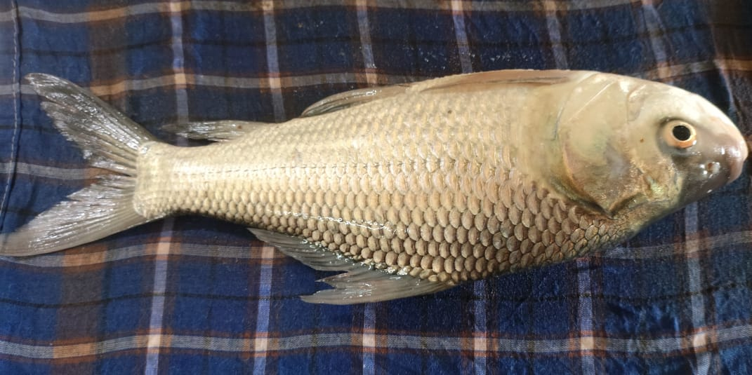  Fig: 2 Catla catla | 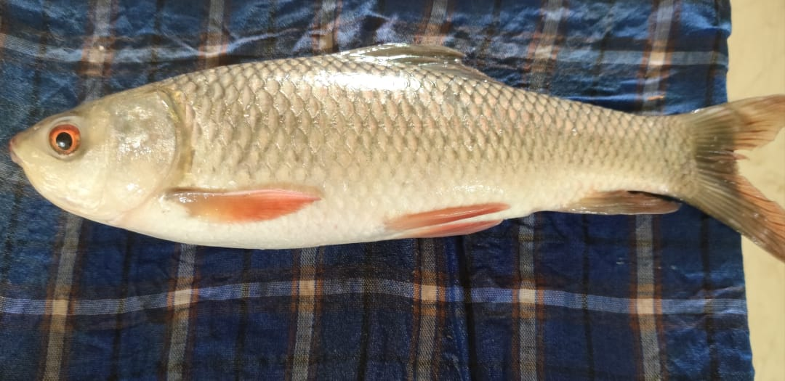  Fig: 3 Labeo rohita
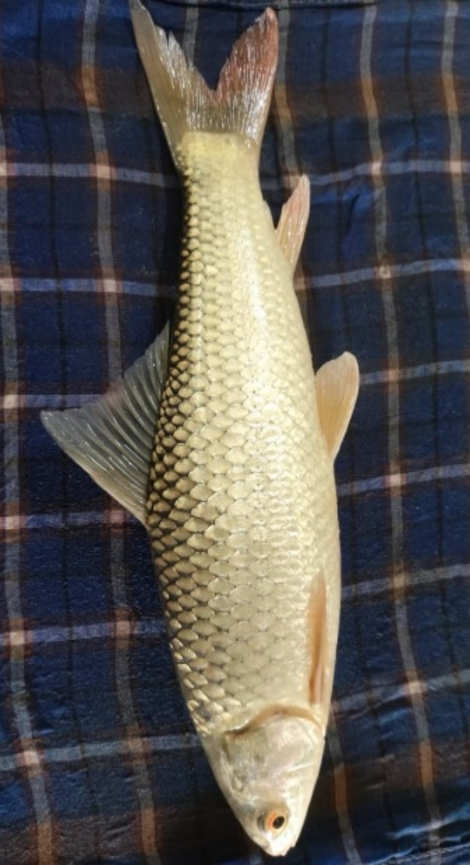  Fig: 4 Cirrhinus mrigala | 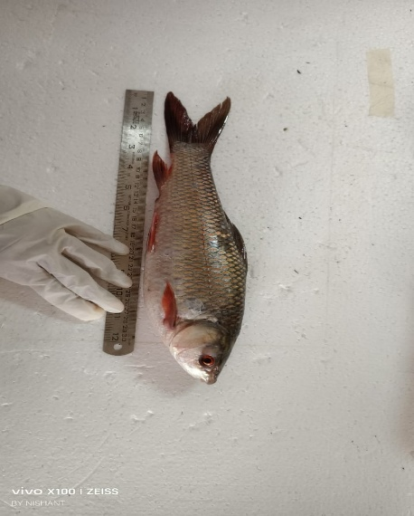  Fig:5 Total Length Measurement
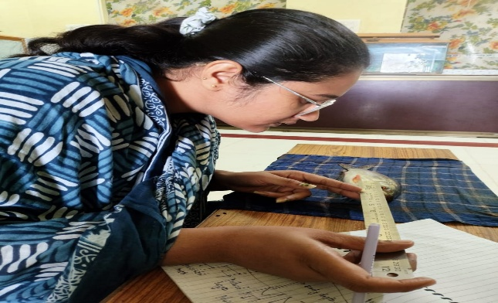  Fig:6 Eye Diameter Measurement | 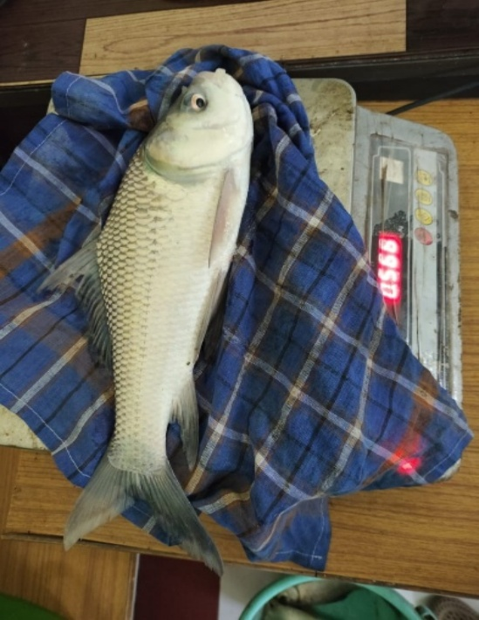  Fig 7: Weighing

References
DoF.gov.Annualreport;2023-24
Available: https://dof.gov.in/sites/default/files/2025-02/Final_Annual_Report.

Chandra, G., Samanta, R., Pushp, A., & Keer, N. R. (2024). Understanding the biology of Indian major carps: key insights for sustainable aquaculture and conservation (pp. 1–10).
Murthy, H. S. (2002). Indian Major Carps (pp. 262–272). CABI Publishing.
Jayasankar, P. (2018). Present status of freshwater aquaculture in India - A review. Indian Journal of Fisheries, 65(4).
Yadav, A. ur, & Paul, N. (2023). Morphometric analysis of fish, Labeo rohita in Lucknow, Uttar Pradesh, India. World Journal of Biology Pharmacy and Health Sciences, 14(3), 122–128.
Dwivedi, A. K. (n.d.). Landmark Based Morphometric Variations among Indian Major Carps.
RH, L. M. (1978). Identification of freshwater fishes. IBP Handbook (IBP). no. 3.
Ng, Casey & Ooi, Peter & Wong, Wey-Lim & Khoo, Gideon. (2017). A Review of Fish Taxonomy Conventions and Species Identification Techniques. Journal of Survey in Fisheries Sciences. 4. 54-93. 10.18331/SFS2017.4.1.6.
Karim, A., Shoaib, M. A., Khwaja, S., Yawar, N. A., Raza, A., & Bibi, S. (2024). Variations in growth performance of Catla (Catla catla), Rohu (Labeo rohita) and Mrigal (Cirrhinus mrigala) fed with varying levels of fishmeal-based diets in intensive farming. Brazilian Journal of Biology, 84, e267950. https://doi.org/10.1590/1519-6984.267950
Das, P. C., Mishra, B. K., & Swain, S. K. (2019). Comparative growth performance of Indian major carps under semi-intensive culture system. Journal of Fisheries, 7(2), 45–52. https://doi.org/10.17017/jfish.v7i2.2019.45
Jhingran, V. G. (1991). Fish and fisheries of India (3rd ed.). Hindustan Publishing Corporation.
Khan, M. A., Khan, S., & Saini, P. (2020). Morphometric and meristic characterization of Indian major carps from different river systems. Journal of Applied Ichthyology, 36(4), 540–547.
Natarajan, A. V., & Jhingran, A. G. (1963). On the biology of Catla catla (Hamilton) from the River Yamuna. Indian Journal of Fisheries, 10A (1), 43–95.

