Evaluation of Six Biorational Pesticides Against Third Instar Larvae of Spodoptera frugiperda or Which Biorational Pesticides Are Most Effective Against Fall Armyworm?

.
ABSTRACT

Aims: Evaluate the impact of six biorational pesticides (viz., neem leaf extract, neem seed kernal extract, neem oil, Bacillus thuringiensis, novaluron 10 % EC and diflubenzuron 25 % WP) on S. frugiperda third instar larvae under laboratory conditions.
Study design: The experiment was designed with a completely randomised design, featuring seven treatments replicated three times.
Place and Duration of Study: The experiment was conducted in the Department of Plant Protection, Shri Vishnav Institute of Agriculture, Shri Vaishnav Vidyapeeth, Indore, Madhya Pradesh.
Methodology: In the experiment, third-instar larvae of S. frugiperda were treated with six biorational pesticides via ingestion methods.
Results: Among the biorationals, novaluron 10% EC and diflubenzuron 25% WP were found to be most effective, as they recorded 100.00% and 90.00% larval mortality of third instar larvae. However, larval mortality in all treatments increased over time.
Conclusion: The study demonstrates that biorational pesticides are effective against Spodoptera frugiperda, with novaluron 10% EC being the most effective. It emphasizes the need for integrated pest management (IPM) and recommends rotating control methods to prevent over-reliance on a single strategy for sustainable pest control.

Keywords: efficacy, biocide, insecticide, larvicide, ingestion, mortality.

1. INTRODUCTION

The fall armyworm (Spodoptera frugiperda), native to tropical and subtropical regions of the Americas, has recently invaded several Asian countries, including India. It was first detected in India on 18th May 2018 in maize fields at the College of Agriculture, Shivamogga, Karnataka (Sharanabasappa et al., 2018), and later in Madhya Pradesh in March 2019 (Vishwakarma et al., 2020). Since then, it has rapidly spread across all maize-growing states (Suby et al., 2020). Known for its high reproductive rate, strong migratory ability, short life cycle, and wide host range, FAW is considered a serious pest (Wang et al., 2020). It feeds on over 353 plant species, mainly grasses, with a preference for maize, rice, sorghum, sugarcane, and also attacks vegetable crops and cotton (Russianzi et al., 2021). In maize, it causes damage during both vegetative and reproductive stages.
Maize is most vulnerable to pest damage during the late whorl stage, with susceptibility increasing from early to late growth stages (Kumar et al., 2022). Infestation levels range from 26.4% to 55.9%, causing an average yield loss of 11.57%. Damage to leaves, silks, and tassels can reach 25–50%, potentially reducing grain yield by up to 58%. In severe cases, larvae may feed on kernels, resulting in complete yield loss (Naganna et al., 2020).
After the invasion of Spodoptera frugiperda in India, initial control efforts focused heavily on chemical insecticides. However, the repeated use of broad-spectrum chemicals poses several concerns, including higher production costs, increased chances of the pest developing resistance, potential health hazards to farmers and consumers, and negative effects on biodiversity and the environment (Carvalho et al., 2022).

Furthermore, bio-rational pesticides have been long regarded as attractive alternatives to synthetic chemical insecticides for effective pest management, as they are eco-friendly, economical, target-specific, and biodegradable. However, empirical information on these approaches remains scant in India. The aim of the present study is to study the potentiality of bio-rational pesticides on the mortality of FAW under in vitro conditions.

2. Materials and methods

2.1. Multiplication of S. frugiperda
The effect of six biorational pesticides against S. frugiperda third instar larvae was studied under laboratory conditions at the Department of Plant Protection, Shri Vishnav Institute of Agriculture, Shri Vaishnav Vidyapeeth Vishwavidyalaya, Indore, Madhya Pradesh, India. Initially, the S. frugiperda sixth instar larvae were collected from the unsprayed maize fields of SVIAg and SVVV and kept in petri dishes with tender maize leaves until pupation. Seven pairs of emerged moths were released in a plastic container supplied with a cotton swab dipped in a 50% honey solution, and three such containers were maintained for each host plant. Five plants of each host plant were placed in a 250 mL conical flask containing water as the ovipositional substrate (Firake and Behere, 2020).
2.2. Methodology
Six biorational pesticides were replicated three times, and stored at room temperature (Table 1). Fresh maize leaves (20 days old) were dipped in a desired concentration of all bio-rational pesticides for 10 minutes and air-dried before releasing third-instar larvae of S. frugiperda for feeding on them. Simultaneously, control larvae were provided with water-treated maize leaves. The larvae were allowed to feed on treated leaves for 48 hrs. and thereafter they fed on untreated maize leaves as suggested by Helen et al., (2021).
Table 1: Different biorational pesticides
Neem leaf extract | 5 ml
Neem seed kernel extract (NSKE) | 5 ml
Neem oil | 5 ml*
Bacillus thuringiensis | 2 ml
Novaluron 10 % EC | 1.5 ml
Diflubenzuron 25 % WP | 0.7 mg
Control | -
*Surfactants 2 ml/l

2.3. Observation to be recorded:
Observations on larval mortality were recorded at 1, 3, 5, 7, and 10 days after treatment.
2.4. Statistical analysis:
The data of various experiments were suitably transformed wherever required and statistically analysed in CRD according to the method described by Gomez and Gomez (1984).
3. results and discussion

Perusal of data in Table 2 revealed that at 1 Day after treatment (DAT), the differences in the mean larval mortality of S. frugiperda among different bio-rational pesticides were non-significant (), and it ranged from 5.00% (neem oil, neem leaf extract and control) to 10.00% (novaluron 10% EC and diflubenzuron 25%WP).
The data in Table 2 revealed that at 3 DAT, differences in the mean larval mortality of S. frugiperda between treatments were significant (). Among the bio-rational pesticides, the highest mortality was recorded on novaluron (27.50 %) followed by diflubenzuron 25% WP (22.50 %) and neem oil (20.00%), but the latter two did not differ significantly from each other. These were followed by B. thuringiensis (15.00 %), and neem seed kernel extract and neem leaf extract (both of which recorded 12.50 %), but were statistically on a par with each other (). The lowest mortality was recorded in the control (5.00 %).
At 5 DAT, significant differences were observed in the larval mortality among different bio-rational pesticides (Table 2). Significantly highest mortality was recorded on novaluron 10% EC (47.50%) followed by diflubenzuron 25%WP (42.50%) and neem oil (40.00%), but were statistically on par with each other (). These were followed by B. thuringiensis (32.50%), and then neem seed kernal extract and neem leaf extract (both of which recorded 25.00%). Significantly lowest mortality was found in the control (7.50%).
At 7 DAT, the differences in the mean larval mortality of S. frugiperda among different bio-rational pesticides were significant (Table 2). Among the bio-rational pesticides, the highest mortality of S. frugiperda was observed in novaluron 10% EC (72.50%) followed by diflubenzuron 25%WP (65.00%) and neem oil (62.50%), but both the latter bio-rational pesticides were statistically on par with each other. B. thuringiensis (indicate %) followed the series and significantly differed from neem seed kernel extract (50.00%) and neem leaf extracts (47.50%). The lowest mortality was recorded in control (10.00%).
At 10 DAT, the differences in the mean larval mortality of S. frugiperda among different bio-rational treatments were significant (Table 2 and Plate 1). Among the bio-rational pesticides, novaluron 10% EC was found to be the most toxic with the highest larval mortality (100%) and exhibited significant difference from diflubenzuron 25 % WP (90.00%). These were followed by neem oil (87.50%), B. thuringiensis (82.50%), neem seed kernal extract and neem leaf extract (both of which registered 75.00%), but both were earlier and later statistically on a par with each other. On the other hand, the lowest mortality was observed in the control (12.50%). The present findings are in accordance with the findings of Mohanta (2022), who observed that the statistically significant larval mortality of S. frugiperda with novaluron occurred from 3, 5, 7 to 10 days after treatment. The corresponding larval mortality in all the treatments increased with time. Similarly, Helen et al. (2021), and Vishwakarma et al., (2023), also found that the toxicity of the insect growth regulators was time dependent. The present findings clearly indicate that the synthetic chitin inhibitors (i.e., novaluron and diflubenzuron) were more effective as compared to all other bio-rational pesticides.

Table 2. Impact of different bio-rational pesticides on S. frugiperda third instar larval mortality
Bio-rational Pesticides | 1st DAT | 3rd DAT | 5th DAT | 7th DAT | 10th DAT
Novaluron  10% EC | 10.00  (18.42) a | 27.50  (31.60) a | 47.50  (43.54) a | 72.50  (58.43) a | 100.00  (90.00) a
Diflubenzuron  25 % WP | 10.00  (18.41) a | 22.50  (28.28) b | 42.50  (40.59) a | 65.00  (53.72) b | 90.00  (71.54) b
Neem oil | 5.00  (12.85) c | 20.00  (26.50) b | 40.00  (39.15) ab | 62.50  (52.24) b | 87.50  (69.51) bc
Bacillus  Thuringiensis | 7.50  (15.85) b | 15.00  (22.73) c | 32.50  (34.70) bc | 55.00  (47.85) | 82.50  (65.44) c
Neem Seed Kernel Extract (NSKE) | 7.50  (15.85) b | 12.50  (20.62) c | 25.00  (29.97) c | 50.00  (44.98) cd | 75.00  (60.09) d
Neem Leaf Extract | 5.00  (12.88) c | 12.50  (20.62) c | 25.00  (29.97) c | 47.50  (43.55) d | 75.00  (60.09) d
Control | 5.00  (12.88) c | 5.00  (12.88) d | 7.50  (15.86) d | 10.00  (18.43) e | 12.50  (20.46) e
SEm± | 0.61 | 0.96 | 1.68 | 1.06 | 1.58
CD at 5% | 1.81 | 2.83 | 4.96 | 3.14 | 4.68
The mean followed by the same letters in each column are non-significant (P<0.05, DMRT)
#= Figures in parentheses are arcsine transformed value
DAT= Day After Treatment

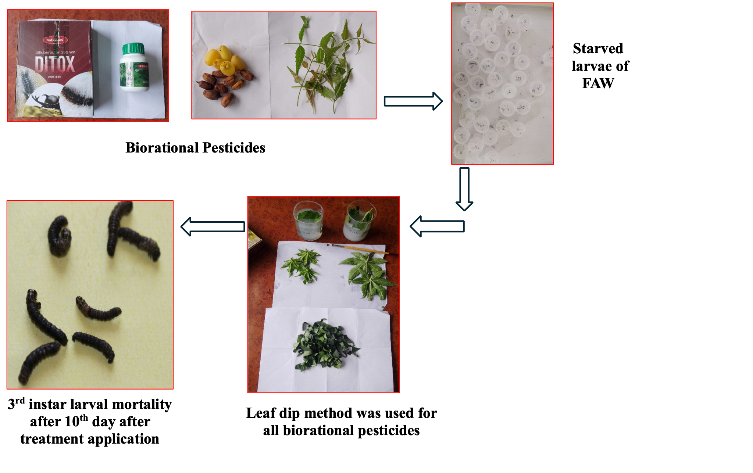
Plate 1. Efficacy of different biorational on S. frugiperda third instar larvae

4. Conclusion

This study highlights the effectiveness of biorational pesticides in controlling Spodoptera frugiperda infestations. Among the tested biorational pesticides, novaluron 10% EC proved to be the most potent. The results underscore the importance of adopting an integrated pest management (IPM) strategy. To ensure sustainable pest control, it is essential to rotate different management methods and avoid over-reliance on a single approach.

COMPETING INTERESTS DISCLAIMER:
Authors have declared that they have no known competing financial interests nor non-financial interests nor personal relationships that could have influenced the work reported in this paper.

References

Carvalho, I. F., Machado, L. L., Neitzke, C. G., Erdmann, L. L., Oliveira, L. T. and Bernardi, D. (2022). Biological parameters and fertility life table of Spodoptera frugiperda in different host plants. Journal of Agricultural Science, 14 (10), 48-56.
Firake, D.M., and Behere, G.T. (2020). Bioecological Attributes and Physiological Indices of Invasive Fall Armyworm, Spodoptera frugiperda (J. E. Smith) Infesting Ginger (Zingiber officinale Roscoe) Plants in India. Crop Protection, 137(1), 1-41.
Gomez, K. A., and Gomez, A.A., (1984) Statistical Procedures for Agricultural Research. 2 ^{nd} Edition, John Wiley and Sons Inc., New York, USA, p 198.
Helen, P. A., Tamboli, N. D., More, S. A. and Kulkarni, S. R. (2021). Bio-efficacy of biocontrol agents against Spodoptera frugiperda (J. E. Smith) under laboratory conditions. Journal of Entomology and Zoology Studies, 9 (4), 277-280.
Kumar, R.M., Gadratagi, B.G., Paramesh, V., Kumar, P., Madivalar, Y., Narayanappa, N., and Ullah, F., (2022) Sustainable Management of Invasive Fall Armyworm, Spodoptera frugiperda. Agronomy, 12 (1), 3-17.
Mohanta, S., (2021) Biology and morphometry of Spodoptera frugiperda on fodder maize genotypes and its management with insect growth regulators. M.Sc. Thesis, College of Agriculture, Jawaharlal Nehru Krishi Viswa Vidyalaya, Jabalpur, 109 p.
Naganna, R., Jethva, D.M., Bhut, J.B., Wadaskar, P.S., and Kachot, A., (2020) Present status of new invasive pest fall armyworm, Spodoptera frugiperda in India: A review. Journal of Entomology and Zoology Studies, 8(2), 150-156.
Russianzi, W., Anwar, R. and Triwidodo, H. (2021). Biostatistics of fall armyworm, Spodoptera frugiperda in maize plants in Bogor, West Java, Indonesia. Biodiversitas, 22 (6), 3463-3469.
Sharanabasappa, Kalleshwaraswamy, C. M., Maruthi, M. S. and Pavithra, H. B. (2018). Biology of invasive fall army worm, Spodoptera frugiperda (J.E. Smith) (Lepidoptera: Noctuidae) on maize. Indian Journal of Entomology, 80(3), 540-543.
Suby, S.B., Soujanya, P.L., Yadava, P., Patil, J., Subaharan, K., Prasad, G.S., et. al., (2020) Invasion of fall armyworm (Spodoptera frugiperda) in India: nature, distribution, management and potential impact. Current Science, 119 (1), 44-51.
Vishwakarma, R., (2023). Bionomics of fall army worm, S. frugiperda on maize genotypes and its management with bio-rational pesticides under in vitro conditions. Ph. D. Thesis, College of Agriculture, Jawaharlal Nehru Krishi Vishwa Vidyalaya, Jabalpur, 284p.
Vishwakarma, R., Kumari, P., Patidar, S., Das, S. B. and Nema, A. (2020). First report of fall army worm, Spodoptera frugiperda (J. E. Smith) (Lepidoptera: Noctuidae) on maize (Zea mays) from Madhya Pradesh, India. Journal of Entomology and Zoology Studies, 8(6), 819-823.
Wang, W., He P., Zhang Y., Liu T., Jing X. and Zhang S. (2020). The population growth of Spodoptera frugiperda on six cash crop species and implications for its occurrence and damage potential in China. Insects, 11(9), 1-15.

