Biomechanical Strength and Anatomical Characteristics of Decellularized Bone from Goat as Bone Xenograft Candidate

.

2. experimental details

2.1. Sample collection and preparation
Goat humerus bones were obtained from a local public market in Malang, Indonesia, and were frozen for not more than 8 hours. All residual soft tissues and muscles were carefully removed, and the bones were cut longitudinally into standardized segments measuring approximately 0.5 × 0.5 × 25 cm using a bone saw.

Figure 1. Preparation of goat bone segments into dog-bone models before and after decellularization, with both ends embedded in resin to prevent slippage during tensile testing.

2.5. Histological Characterization

Poly-L-lysine slides were stained by immunohistochemistry (IHC) for bone morphogenetic protein-2 (BMP-2) using the UltraTek HRP Anti-Polyvalent (DAB) Staining System (Scytek, USA). After deparaffinization and rehydration, endogenous peroxidase activity was blocked with 3% H₂O₂ for 10 min, followed by antigen retrieval in citrate buffer (pH 6.0). Non-specific binding was blocked with casein for 30 min. Sections were incubated overnight at 4 °C with rabbit anti-BMP-2 polyclonal antibody (5 µg/mL, ab5285, Abcam, USA). After washing, slides were incubated with a universal biotinylated secondary antibody, followed by streptavidin-HRP. Visualization was performed with DAB and counterstaining with hematoxylin. Finally, slides were dehydrated, cleared in xylene, and mounted with Entellan. This protocol aligns with recent studies evaluating osteogenic protein expression in decellularized xenograft scaffolds (Amirazad et al., 2022).

3.1.1. Macroscopic character

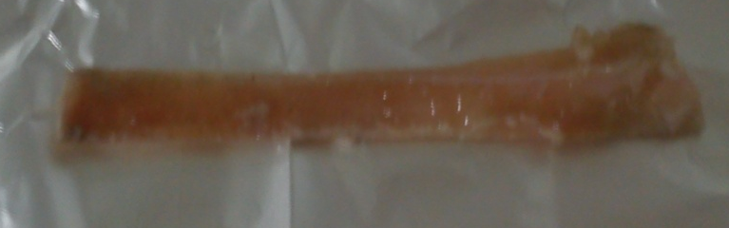
Figure 2. Fresh goat bone sample before the decellularization process, showing reddish and opaque appearance with visible marrow and soft tissue residues..

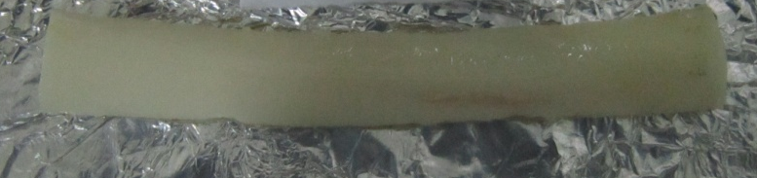
Figure 3. Goat bone sample after the decellularization process, appearing whitish and slightly translucent, indicating removal of marrow and cellular components while preserving cortical morphology.

3.1.2. Biomechanical strength character
The ultimate tensile stress (MPa) of goat bone samples was measured to evaluate the effect of decellularization on the biomechanical properties. Table 2 summarizes the tensile strength data for fresh and decellularized bone samples after 7, 14, and 25 days of immersion in SDS.

The ultimate tensile stress of decellularized bone samples increased slightly compared to fresh bone, with the highest value observed in the 14-day decellularized group (112.26 ± 30.98 MPa) (Table 2). The fresh bone group had a tensile stress of 83.14 ± 7.89 MPa, while the 7-day and 25-day decellularized groups had values of 90.26 ± 15.94 MPa and 98.65 ± 4.31 MPa, respectively. However, statistical analysis revealed no significant differences in tensile stress among the groups (P = 0.154), suggesting that decellularization did not significantly affect the ultimate tensile stress within the tested time points.

Table 2. Ultimate tensile stress (MPa) of goat bone samples in each group (mean ± SD)
 | Fresh | Immersion 7 days | Immersion 14 days | Immersion 25 days | p-value
Ultimate tensile stress (MPa) | 83.14±7.89 | 90.26±15.94 | 112.26±30,98 | 98.65±4.31 | 0.154
No significant differences were observed among groups (p > 0.05).

Figure 6. BMP-2 expression in fresh goat bone stained using IHC. A. Fresh bone showing intense brown staining, indicating BMP-2 expression in the surrounding matrix., B. Bone after 7 days of decellularization, showing moderate BMP-2 expression with slightly reduced. Intensity, C. Bone after 14 days of decellularization, with reduced BMP-2 expression and lighter brown staining, D. Bone after 25 days of decellularization, showing minimal BMP-2 expression, with very faint staining indicating a significant reduction in BMP-2 production.

the intensity of BMP-2 expression in the bone samples, with an insignificant decrease (P≥0.05) in BMP-2 intensity after 7, 14, and 25 days of decellularization, compared to fresh bone.

3.2. Discussion
Bone defects resulting from trauma, degenerative diseases, or infections often require bone substitutes for successful healing. The body's intrinsic regenerative capacity is limited for significant bone defects. While autografts remain the gold standard in clinical practice due to their high integration potential, their use is constrained by donor-site morbidity and the limited availability of grafts. As a result, alternative materials, such as xenografts, have gained attention. Among these alternatives, goat bone is a promising candidate due to its structural similarity to human bone, availability, and suitable size for specific anatomical sites. This study investigated the potential of goat bone as a xenograft material by examining its macroscopic morphology, biomechanical properties, preservation of extracellular matrix (ECM), and expression of osteogenic markers following decellularization. Our results indicate that decellularized goat bone preserves ECM integrity, maintains biomechanical properties, and retains some osteogenic potential, making it a suitable candidate for bone graft applications.

The BMP-2 expression, a key marker for osteogenesis, was also assessed using immunohistochemistry (IHC). BMP-2 plays a critical role in osteoblast differentiation and bone regeneration. Figure 6 and Figure 7 show that BMP-2 expression was significantly reduced in decellularized bone samples, particularly after 25 days of decellularization. Fresh bone showed strong BMP-2 expression, especially in osteoblasts and surrounding areas (Figure 6A), which is consistent with the high osteogenic potential of native bone. After decellularization, however, the intensity of BMP-2 staining decreased, particularly in the 25-day decellularized group (Figure 6D). These findings are in agreement with studies by Gomes et al. (, who reported a reduction in BMP-2 expression in decellularized bone matrices, potentially due to the loss of osteoblasts, which are the primary producers of BMP-2. Despite the reduction in BMP-2 expression, faint BMP-2 staining was still observed in decellularized samples, suggesting that the preserved ECM may still support some osteogenic activity, even in the absence of high BMP-2 levels.

