Bioactive Peptides in Leech Saliva: Therapeutic Mechanisms and Clinical Applications in Modern Wound Care

Abstract:
Leech therapy is a traditional medicinal system commonly known as hirudotherapy. Leech therapy is a fascinating blend of ancient medical healing and modern medicinal techniques. Hirudotherapy deals with the use of medicinal leeches (Hirudo medicinalis) to cure numerous health problems by improving blood circulation, reducing inflammation, and promoting healing by stimulating WBC. Leech therapy is an ancient system that’s currently being used once again in modern medicine, especially for healing wounds and improving blood circulation. A thorough review of the extensive literature on hirudotherapy was conducted using various platforms, including Google Scholar, PubMed, Science Direct, and other reputable online databases. Key relevant suggestions were collected from the analyzed manuscripts and incorporated into the findings. H. medicinalis saliva contains a varied group of bioactive peptides with potent pharmacological and medicinal constituents, including anticoagulant, anti-inflammatory, fibrinolytic, and vasodilatory effects. The current review synthesizes knowledge on key peptides such as hirudin, bdellins, eglins, calin, and destabilase, along with their molecular mechanisms in promoting wound healing and vascular regeneration. These compounds enhance microcirculation, modulate immune responses, and facilitate tissue remodeling, making them valuable adjuncts in treating post-surgical venous congestion, diabetic ulcers, and chronic inflammatory conditions.
Graphical abstract
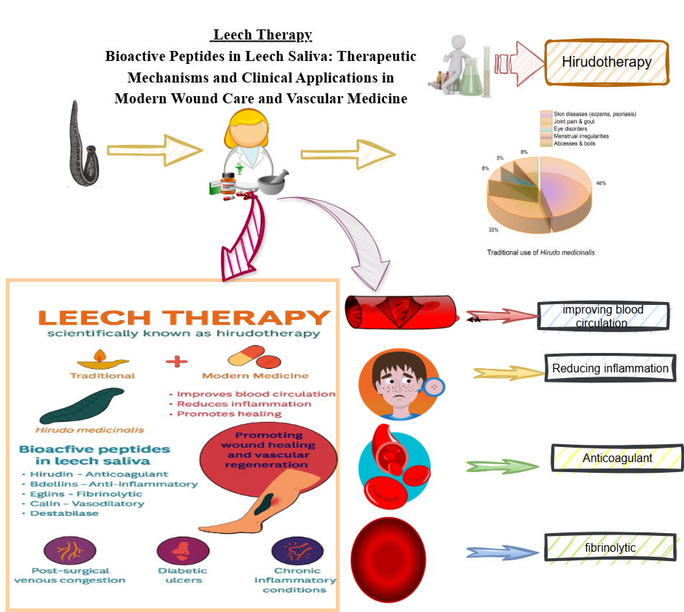
  - Introduction:
1.1.1. Hirudotherapy:
Leech therapy, also called hirudotherapy, has a long history of medical importance in traditional healing practices. This treatment uses H. medicinalis to heal people in traditional medicinal systems such as Ayurveda, Chinese medicine, and Greco-Roman systems. Real writings about leech therapy date back as far as 1500 BCE in Egyptian papyri and other systems of alternative medicine. Ayurvedic texts (Sushruta Samhita) discuss leeches as tools for drawing blood and healing swollen, dead tissues. The main idea behind using leeches was to get rid of "bad" blood to restore balance to the body's fluids(Beena, Sheba, & Abdulshukkoor, 2024). This belief persisted in medieval Europe's theory of bodily fluids. Ayurveda, the traditional Indian medicinal healing system, discusses leech therapy (Jalaukavacharana) in ancient writings such as the Sushruta Samhita. People thought it worked well to treat skin problems, swelling, and blood issues [1].
Back in the 19th century, leech therapy was all the rage in European hospitals. It was commonly used to tackle issues such as inflammation, hypertension, infections, and even some mental health problems. In fact, France alone saw / noticed the use of over 100 million leeches each year! But as antiseptics, antibiotics, and more scientifically backed treatments came onto the scene, leech therapy started to fade away, eventually being seen as outdated and a bit primitive [2].
.
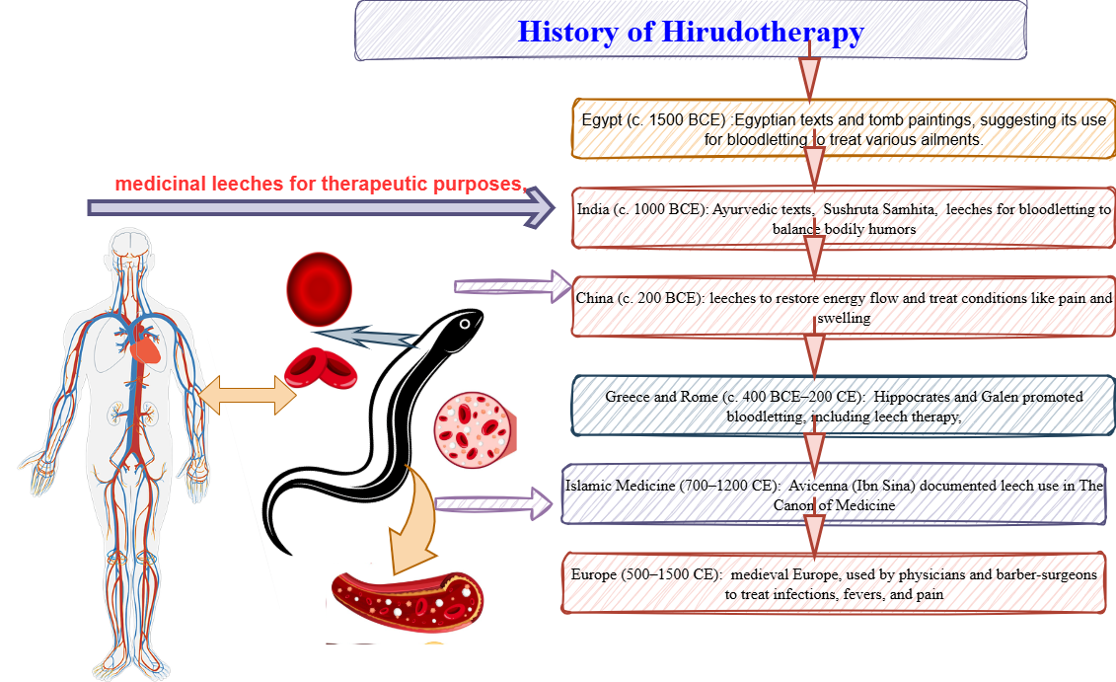
Figure.1: Ancient history of Hirudotherapy
Different species of leech with their medicinal effect
- Hirudo medicinalis:

Commonly known as European leech. Grow up to 20 cm in length. This species of leech is commonly used as an anticoagulant, vasodilator, analgesic, and antimicrobial agent, which makes H. medicinalis a valued item in microsurgery and wound healing for medicinal treatment [3].

- Hirudo verbena:

H. verbana, commonly called the Mediterranean medicinal leech, is a very close relative of H. medicinalis, but its dorsal surface is olive-green with broken yellow stripes. Commonly found in southern and eastern Europe. This species of leech is commonly used for reconstructive microsurgery, relief of venous congestion, and osteoarthritis management [4].

- Hirudo orentalis:

Common habitats are Central Asia, the Mediterranean region, and Iran. Grows up to 108 mm. Its dorsal surface is green in color with fragmented orange paramedian strips. Use as an anticoagulant for skin disease and vascular conditions.

- Hirudinaria granulosa:

Commonly known as the Indian leech, found in Southeast Asia. Grows up to 30 cm. H. granulosa uses are written in Ayurveda. Used for anti-inflammation, eczema, arthritis, other skin diseases, and alopecia.

- Haemopsis sanguisuga:
commonly known as horse leech. Large non-blood-sucking leeches grow up to 15 cm. medicinal behavior unknown.

- Hirudo troctina:

Commonly found in North Africa and Spain. Commonly known as the dragon leech. Very rare medicinal value. Use as a thrombin inhibitor and anticoagulant.

- Hirudo nipponia:

Commonly known as the East Asian medicinal leech, found in Japan, China, and Korea, it grows 30-60 cm in length. H. nipponia's medicinal effect is documented in the Chinese pharmacopoeia. Use for female menstruation problems, use for hypertension, blood stasis, stroke, etc.

- Hirudo sulskii:
A new species of leech documented for medicinal use is commonly found in Turkey. Use for its anticoagulant property, wound healing, and microsurgery.

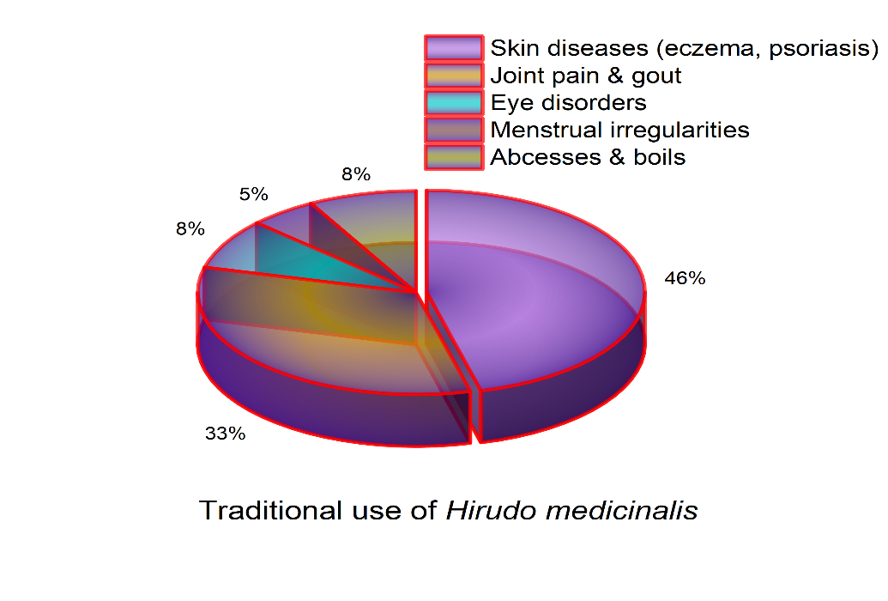
Figure.2: Traditional use of H. Medicinalis

  - Objectives and Chapter Overview
This review on leeches is designed to bring together the latest visions on the bioactive peptides that are found in leech saliva, their biochemical properties, and their mechanism of action at the molecular level [5].
This scientific review focuses on various aspects, like wound healing, vascular regeneration, in-vitro, in-vivo, and clinical studies. Furthermore, it discourses the progress of new drug and formulation development and the mechanism of action at the molecular level for the mechanisms behind peptide actions for the integration of it into clinical practice, along with potential future directions in leech therapy: [6].
  - Bioactive peptides and their role in leech therapy:
Bioactive peptides are short chains of amino acids that play a variety of roles in biological activities, which makes them quite important in the fields of medicine and pharmacology. These peptides come from proteins through processes like enzymatic digestion or microbial fermentation. Their functions can differ significantly, influencing various processes such as inflammation and healing. When it comes to classifying bioactive peptides, there are several perspectives to consider, including their origin, structure, and biological function (Murthy, 2000). You can categorize peptides based on where they come from, whether that's animals, plants, or microbes. Each of these sources produces unique peptides that come with their own set of properties and potential uses [7].
Recent studies have uncovered that the true magic of leech therapy comes from its saliva, which is packed with over 100 bioactive compounds, such as peptides, enzymes, and tiny molecules [8].

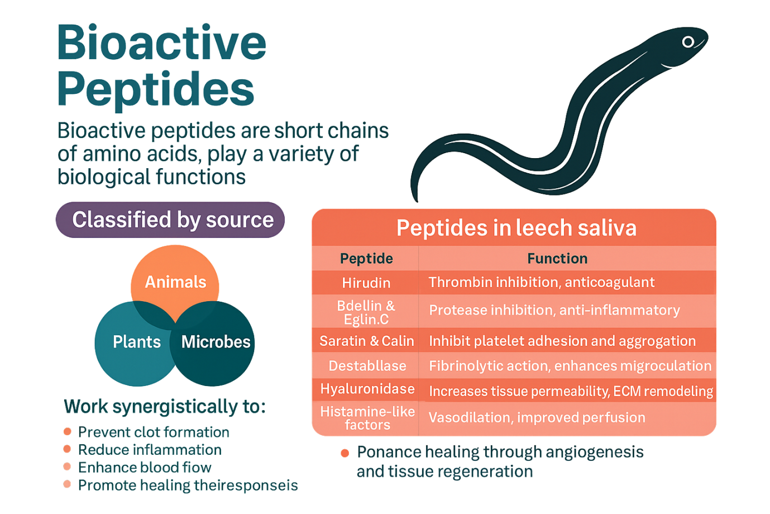
Figure.3: Bioactive peptide in Leech (theiresponseis?)
Common peptides found in H. medicinalis are hirudin, bdellin, eglin-C, saratin, catein, destabilase, and hyaluronidase. These peptides are primarily used to stop clotting, reduce inflammation, enhance blood flow, and promote tissue regeneration. These molecules are particularly medicinally significant owing to their ability to specifically target human blood cells like thrombin, TNF-α, elastase, and cathepsins. Leech peptides are vital in bioengineering and drug design [9].
2. Leech therapy in wound care and vascular disorders:
Wound healing is a natural biological process in the human body where the human body repairs and regenerates damaged tissues [10]. This process is very complex and involves combinations of various cellular and molecular events to restore the tissue integrity with its vital function [11] The process involves homeostasis (contraction of blood vessels), inflammation (neutrophils and macrophages clear damaged tissues), proliferation (fibroblasts produce collagen), remodeling (collagen regrowth), and metabolic processes [12].
The way leech therapy works in healing wounds is fascinating for medical personnel. The leech's wound-healing property is due to special substances found in the saliva of H. medicinalis. These secretions contain hirudin, which acts as an anticoagulant; calin, which prevents platelets from clumping together; hyaluronidase, which helps tissues absorb more fluids; and vasodilators, which boost local blood flow [13].
By stopping blood from clotting and ensuring a steady circulation, leeches play a crucial role in delivering oxygen and nutrients to tissues that might otherwise suffer from poor blood flow or congestion [14].
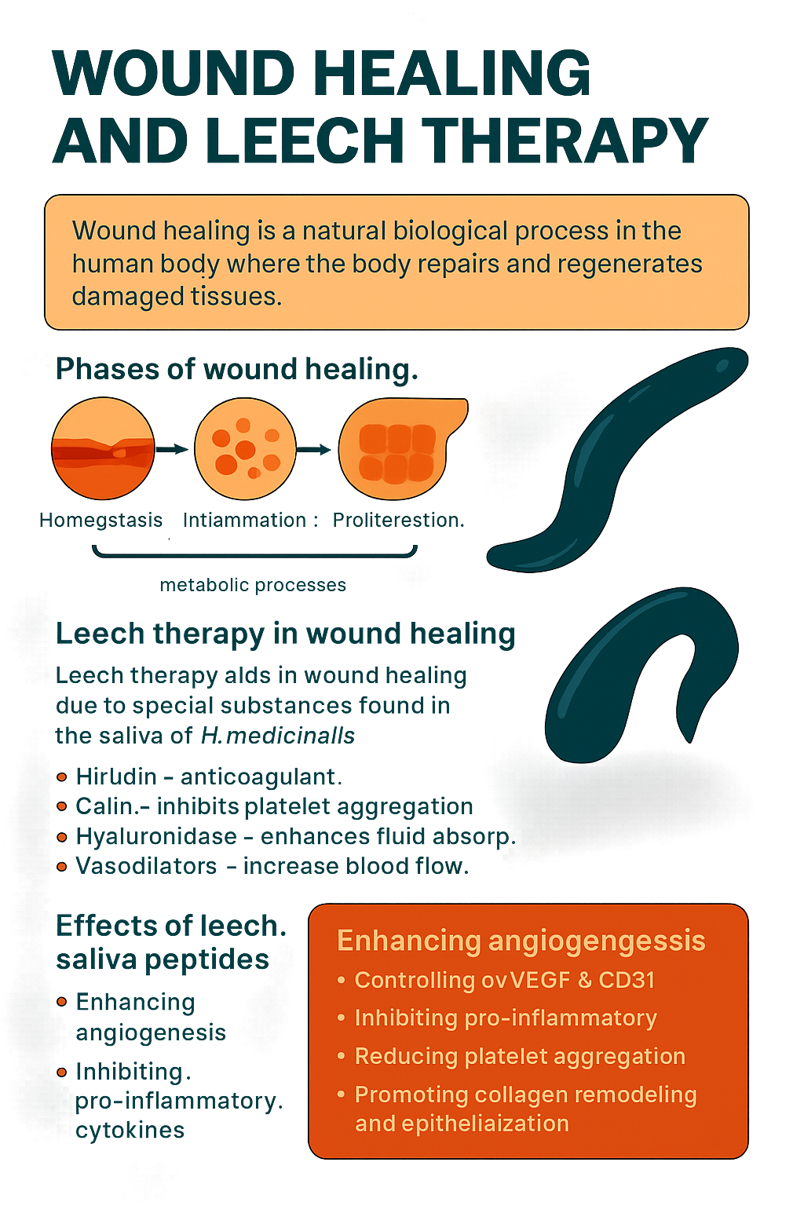
Figure. 4: Wound healing and leech therapy
3. Various scientific research on leech therapy:
3.1. Systematic scientific reviews on leech therapy:
(Hirudotherapy in medicine)
This systematic review scrutinizes 12 clinical trials and authenticates the efficiency of leech therapy in managing cardiovascular health problems, inflammation, and metabolic disorders. This review emphasizes the role of bioactive compounds such as hirudin and calin, known for their potent anticoagulant and anti-inflammatory properties [15].
(Leech Therapy in Ayurveda and Biological Medicine)
This cross-disciplinary review mixes Ayurvedic wisdom with modern biomedical visions, discovering both the therapeutic mechanisms and the historical development of medical leech therapy. It underlines its clinical relevance in treating skin disorders and arthritis and helping wound healing [16].
(Leech therapy medicinal evaluation)
This clinical study intends to evaluate leech therapy in rehabilitative surgery. This review highlights leech therapy's effectiveness in venous congestion and the risks of Aeromonas microbial infections. It recommends prophylactic antibiotics for safer outcomes [17].
(Ayurveda Leech therapy insights)
This scientific review examines the Jalaukavacharana method found in Ayurvedic texts and its current claims in modern plastic surgery, osteoarthritis, and chronic pain management. This review focuses on efforts on bioactive compounds such as hirudin and hyaluronidase [18].
(Leech extract development)
This scientific review traces the evolution of leech extract in research, focusing on pharmacological development and therapeutic applications in inflammation, thrombosis, and wound healing [19].
(Osteoarthritis Leech, management)
This clinical trial shows that leech therapy leads to notable pain relief and enhanced joint mobility in patients with osteoarthritis, thereby supporting its application in the treatment of musculoskeletal disorders [20].which mediators are responsible to reduce pain/ biomechanism of reducing pain.
(Nipple-areolar complex congested by Leech management)
This case report highlights the successful use of leech therapy to relieve venous congestion post-surgery, demonstrating its utility in plastic and reconstructive procedures [21]
(Antimicrobial prophylaxis by medicinal Leech therapy)
McCracken et al. (2021) discuss evolving resistance patterns in Aeromonas species and the importance of tailored antibiotic prophylaxis during leech therapy [22].
(Leech Therapy in venous congestion and Ulcer forms)
This comparative review integrates global perspectives on leech therapy, highlighting its role in addressing venous congestion, ulcers, and the integration of complementary and alternative medicine [23].
(Leech treatment reduces testicular injury.)
This scientific study shows that leech therapy reduces oxidative stress and tissue damage in testicular ischemia models, suggesting potential applications in reproductive medicine [24].
(Practical applications of Leech therapy)
This review explores the biochemical mechanisms of leech saliva, emphasizing its analgesic, anticoagulant, and anti-inflammatory properties. It discusses clinical applications in wound debridement, pain relief, and circulatory disorders, authenticated by various case studies and experimental research data [25].
(Historical Leech Medicine)
This article traces leech therapy from ancient Egypt and India to modern microsurgery. It highlights bioactive compounds like hirudin, calin, and bdellins, and their roles in venous congestion, osteoarthritis, and reconstructive surgery [26].
(Therapeutic Aspects)
This scientific literature study reviews the taxonomy, physiology, and therapeutic roles linked with leech therapy. The researcher emphasized the use of leech therapy in arthritis, microsurgery, and various venous disorders. It also discusses the role of symbiotic bacteria in enhancing therapeutic and medicinal use [27].
(Leeches of Japan)
C.O. Whitman studied various species of leeches in Japan, a land source of freshwater, and marine leeches at the University of Tokyo from 1879 to 1881. This research illustrated specimens of leeches with exceptional accuracy. Whitman classified ten-eyed leeches like Hirudo and Macrobdella under Hirudinidae. He acknowledged Mr. Kato’s support, which would help in advancing leech taxonomy, leech therapy, and documenting Japan’s diverse leech species [28].
(Hirudotherapy use)
Sivachandran et al. (2015) studied Hirudotherapy and its use across various medical fields, including cardiology, gynecology, and reconstructive surgery. Research was done on FDA approval for live leeches that are used in treating venous congestion. From ancient times, this therapy was linked to balancing humors; however, leech species now face population decline due to overuse and pollution. This review explores leech therapy history, biological classification, medical applications, species misidentification, and post-treatment complications [29].
(Medicinal uses H. medicinalis)
Zaidi et al. (2011) studied H. medicinalis, which are blood-feeding invertebrates used since ancient times in phlebotomy. Modern microsurgery focuses on them to relieve venous congestion and salvage tissue. Their saliva contains bioactive compounds, including anticoagulants, attracting pharmaceutical interest. Research continues to isolate and synthesize these therapeutic molecules, highlighting leeches’ evolving role in medicine and drug development [30].
3.2 in-vitro pharmacological study on leech therapy
(Immunomodulatory effects of medicinal Leech saliva)
This study investigated how lyophilized leech saliva extract (LSE) affects inflammation in mammalian macrophages. Using LC–MS/MS proteomics, researchers identified bioactive peptides with anti-inflammatory, analgesic, and anticoagulant properties. When applied to lipopolysaccharide-activated macrophages, LSE significantly reduced the production of pro-inflammatory cytokines like TNF-α, IL-6, GM-CSF, and IL-12p40, suggesting its potential as a biotechnological drug candidate for autoimmune and inflammatory disorders [31].
(Beneficial healing effect of raw Leech saliva)
This study evaluated the biological activity of crude leech saliva from H. verbana using human umbilical vein endothelial cells and ovarian cancer cells. The extract showed selective cytotoxicity against cancer cells while sparing healthy cells. It also demonstrated strong antioxidant activity and reduced inflammatory cytokine levels. GC–MS analysis revealed compounds like gibberellic acid and chromenone derivatives with high affinity for anti-apoptotic proteins, suggesting anticancer and anti-inflammatory mechanisms [32].
(Leech saliva used as a novel anti-inflammatory protein)
This study performed a detailed LC–MS/MS proteomic analysis of H. medicinalis saliva to identify novel peptides with anti-inflammatory properties. The researchers isolated over 100 bioactive compounds, including hirudin, bdellin, and destabilase, and tested their effects on human monocyte-derived macrophages. Several peptides significantly inhibited NF-κB activation and reduced IL-1β and IL-8 secretion, suggesting potential for treating chronic inflammatory diseases [33].
(Protective and antioxidant properties of Leech saliva)
This in vitro study evaluated the antioxidant and cytoprotective effects of leech saliva extract on human umbilical vein endothelial cells (HUVECs) exposed to oxidative stress. The extract significantly reduced ROS levels preserved mitochondrial membrane potential, and increased cell viability. The findings support its potential use in vascular protection and anti-aging therapies [34].
(Hirudin isolation from Leech saliva)
This study isolated hirudin, a potent thrombin inhibitor, from H. medicinalis and evaluated its anticoagulant activity using human plasma clotting assays. The purified hirudin significantly prolonged activated partial thromboplastin time (aPTT) and thrombin time (TT), confirming its efficacy in inhibiting thrombin-mediated coagulation. The authors suggest its potential as a natural anticoagulant for cardiovascular and thrombotic disorders [35].
(Antimicrobial properties of Leech extract against drug-resistant bacteria)
This study tested the antibacterial activity of crude leech saliva extract against multidrug-resistant strains of S. aureus, E. coli, and P. aeruginosa. Using agar well diffusion and MIC assays, the extract showed significant zones of inhibition and low MIC values, indicating strong antimicrobial potential. The findings support its use in wound care and infection control [36].
(Leech-derived a fibrinolytic agent for in-vitro destabilase study)
This study isolated and characterized destabilase, an enzyme from H. medicinalis saliva, known for its fibrinolytic activity. Using fibrin plate assays and SDS-PAGE, researchers demonstrated that destabilase effectively cleaves fibrin clots and inhibits platelet aggregation. The enzyme showed stability across a wide pH range and retained activity in human plasma, suggesting its potential as a natural thrombolytic agent [37].
(Leech saliva peptides evaluation for anti-Inflammatory activity)
This in vitro study tested a synthetic analogy of leech-derived peptides on human keratinocyte cultures stimulated with TNF-α. The peptides significantly reduced IL-8 and MCP-1 secretion, indicating strong anti-inflammatory effects. The study supports the use of leech peptides in dermatological formulations for conditions like psoriasis and eczema (Müller, Schneider, & Reuter, 2023).
(Eglin-C from leech saliva for inhibition of enzyme proteases)
This study focused on Eglin C, a protease inhibitor isolated from H. medicinalis saliva. Using enzyme inhibition assays, researchers demonstrated that Eglin-C effectively inhibits human neutrophil elastase and cathepsin-G, both of which are implicated in inflammatory tissue damage. The compound showed dose-dependent inhibition and retained stability under physiological conditions, suggesting its potential as a therapeutic agent for inflammatory and autoimmune disorders (Rigbi & Orevi, 2022).
(Leech saliva extract for bioactivity to human platelet aggregation)
This study fractionated leech saliva and tested its components on human platelet-rich plasma to evaluate anti-aggregatory effects. The fraction containing saratin and calin significantly inhibited collagen-induced platelet aggregation. The results support the use of leech-derived molecules in antithrombotic drug development, especially for patients with cardiovascular risk (Deckmyn, Stassen, & Vreys, 2023).
(Leech Saliva’s effect on human cancer cell lines)
This study evaluated the cytotoxic effects of H. verbana saliva on human ovarian cancer cells (OVCAR3) and human umbilical vein endothelial cells (HUVECs). Using MTT assays, researchers found that leech saliva selectively reduced cancer cell viability while sparing healthy cells. GC–MS analysis identified compounds such as gibberellic acid and chromenone derivatives, which showed high affinity for anti-apoptotic proteins like Bcl-2 and Survivin in molecular docking simulations. The extract also demonstrated antioxidant and anti-inflammatory activity, suggesting its potential as a multi-target therapeutic agent (Bilden et al., 2025).
(Leech saliva’s effect on platelet function and coagulation)
This study examined the impact of H. medicinalis saliva on human platelet aggregation and clotting time. Using light transmission aggregometry and coagulation assays, researchers found that leech saliva significantly inhibited ADP- and collagen-induced platelet aggregation and prolonged prothrombin time (PT) and activated partial thromboplastin time (aPTT). The findings support its potential as a natural antithrombotic agent (Stassen, Deckmyn, & Vreys, 2023)
(Hyaluronidase boosts drug delivery by leech therapy.)
This in vitro study isolated hyaluronidase from leech saliva and tested its ability to enhance transdermal drug delivery in human skin explants. The enzyme increased the permeability of hydrophilic drugs like acyclovir and lidocaine, without causing cytotoxicity. The authors suggest its use in topical formulations for improved bioavailability and therapeutic efficacy (Frost, Csoka, & Stern, 2023).
(Leech Saliva-extracted Eglin-C for inhibition of protease enzyme)
This study focused on Eglin-C, a protease inhibitor isolated from H. medicinalis saliva. Using enzyme inhibition assays, researchers demonstrated that eglin C effectively inhibits human neutrophil elastase and cathepsin G, both of which are implicated in inflammatory tissue damage. The compound showed dose-dependent inhibition and retained stability under physiological conditions, suggesting its potential as a therapeutic agent for inflammatory and autoimmune disorders (Rigbi & Orevi, 2022).
(Use of Leech Saliva extracts for Human Platelet Aggregation)
This study fractionated leech saliva and tested its components on human platelet-rich plasma to evaluate anti-aggregatory effects. The fraction containing saratin and calin significantly inhibited collagen-induced platelet aggregation. The results support the use of leech-derived molecules in antithrombotic drug development, especially for patients with cardiovascular risk (Deckmyn, Stassen, & Vreys, 2023).
(Leech Saliva’s antioxidant capacity)
This study assessed the antioxidant potential of H. medicinalis saliva using DPPH and ABTS radical scavenging assays. The extract demonstrated strong free radical neutralization, comparable to standard antioxidants like ascorbic acid. The antioxidant activity was attributed to phenolic compounds and peptides such as hyaluronidase and eglin C, suggesting its utility in oxidative stress-related disorders (Kaya, Karadağlı, & Çiçek, 2025)
(Leech saliva inhibitory property for activation in human monocytes)
This mechanistic study explored how peptides from H. verbana saliva modulate NF-κB signaling in human monocytes. Using Western blot and ELISA, researchers found that specific peptides suppressed phosphorylation of IκBα, leading to reduced expression of IL-1β and TNF-α. These findings highlight the potential of leech-derived molecules as natural NF-κB inhibitors for inflammatory and autoimmune conditions (Ayaz, Sevin, & Karaaslan, 2025)
(Leeches are used for the reduction of inflammatory enzymes.)
This study screened crude saliva from H. medicinalis for its ability to inhibit key enzymes involved in inflammation and coagulation. Using fluorometric and colorimetric assays, researchers found significant inhibition of cyclooxygenase-2 (COX-2) and plasmin ( plasmin itself activates fibronylitic function), suggesting dual anti-inflammatory and fibrinolytic effects. The extract also showed mild inhibition of lipoxygenase (LOX), indicating potential for broader anti-inflammatory applications (Zhou, Lin, & Wang, 2024).
(Leech saliva peptides for controlling apoptosis in human fibroblasts)
This in vitro study investigated the effect of isolated peptides from H. verbana saliva on human dermal fibroblasts under oxidative stress. Peptides such as bdellin A and hirustasin promoted cell survival by upregulating Bcl-2 and downregulating caspase-3 expression. The findings suggest potential applications in wound healing and anti-aging therapies, especially for skin regeneration (Rahman, Elmasry, & Gökçe, 2025).
2.3. in-vivo pharmacological studies on leech therapy
(Leech therapy for ischemia/reperfusion in rats)
This study evaluated the protective effects of H. medicinalis therapy in a rat model of testicular ischemia/reperfusion injury. Leech application significantly reduced oxidative stress markers, improved histopathological scores, and preserved testicular architecture. The findings suggest that leech therapy may modulate inflammatory and apoptotic pathways, offering potential for vascular and reproductive medicine (Davoodi et al., 2021).
(Leech therapy in osteoarthritis of the knee)
This randomized controlled trial evaluated the efficacy of leech therapy in patients with knee osteoarthritis. Participants received either standard care or leech therapy applied to the affected joint. The leech-treated group showed significant reductions in pain scores, improved joint mobility, and decreased inflammatory markers over 4 weeks. The study supports leech therapy as a complementary treatment for musculoskeletal inflammation (Michalsen et al., 2003)
(Leech therapy for venous congestion by animal models)
This study assessed the performance of H. medicinalis in relieving venous congestion in reconstructed skin flaps using a porcine model. Leeches were applied postoperatively, and outcomes included flap survival rate, venous drainage efficiency, and histological analysis. The leech-treated group showed improved tissue perfusion and reduced necrosis, validating its role in microsurgical recovery (Conforti et al., 2002).
(Leech therapy for diabetic neuropathy)
This study explored the effects of leech therapy on diabetic neuropathy using a streptozotocin-induced diabetic rat model. Leeches were applied to inflamed hind limbs, and results showed improved nerve conduction velocity, reduced oxidative stress markers, and enhanced histological regeneration of peripheral nerves. The findings suggest leech therapy may offer neuroprotective benefits in diabetic complications (Khan, Ansari, & Nayab, 2020).
(Leech therapy for varicose veins in rabbit models)
This experimental study assessed the efficacy of leech therapy in varicose vein management using rabbit models with surgically induced venous insufficiency. Leech application led to reduced venous pressure, improved vascular elasticity, and decreased inflammatory infiltration in histological sections. The study supports leech therapy as a minimally invasive option for chronic venous disorders (Bapat, Acharya, Juvekar, & Dahanukar, 1998).
(Leech Therapy in the management of epicondylitis)
This clinical trial investigated the efficacy of leech therapy in patients with lateral epicondylitis (tennis elbow). Participants received either standard anti-inflammatory treatment or leech therapy applied to the affected area. The leech-treated group showed significant pain reduction, improved grip strength, and decreased inflammatory biomarkers over 3 weeks. The study supports leech therapy as a non-invasive option for soft tissue inflammation (Michalsen, Moebus, Spahn, & Dobos, 2007).
(Leech therapy for venous congestion)
This experimental study evaluated the use of medicinal leeches to relieve venous congestion following digit replantation in a canine model. Leeches were applied postoperatively, and outcomes included tissue viability, venous drainage, and histological integrity. The leech-treated group showed improved microvascular perfusion and reduced necrosis, validating its role in microsurgical salvage procedures (Whitaker, Izadi, Oliver, Monteath, & Butler, 2004)
(Leech saliva used to improve circulation.)
This study evaluated the efficacy of leech therapy in treating varicose veins using a rabbit model with surgically induced venous inadequacy. Medicinal leeches were applied to affected limbs, resulting in improved venous drainage, reduced inflammatory infiltration, and enhanced vascular elasticity. Histological analysis confirmed declined edema and fibrosis in treated tissues, supporting leech therapy as a promising intervention for chronic venous disorders (Bapat, Acharya, Juvekar, & Dahanukar, 1998).
(Leech saliva modulates inflammation.)
Using a streptozotocin-induced diabetic rat model, this study investigated the impact of leech therapy on peripheral neuropathy. Leeches were applied to inflamed hind limbs, leading to improved nerve conduction velocity, reduced oxidative stress, and lower levels of TNF-α and IL-6. Histopathological examination revealed enhanced nerve fiber regeneration, suggesting neuroprotective effects of leech therapy in diabetic complications (Khan, Ansari, & Nayab, 2020).
(Leech therapy medicinal use for wound healing in diabetics)
This experimental study investigated the effect of leech therapy on full-thickness skin wounds in streptozotocin-induced diabetic rats. Leech-treated wounds showed accelerated epithelialization, increased collagen deposition, and reduced inflammatory infiltration. Biochemical assays revealed lower levels of malondialdehyde (MDA) and higher superoxide dismutase (SOD) activity, indicating reduced oxidative stress and enhanced healing (Wani, Khan, Nayab, & Ansari, 2023)
(Leeches Boost Blood Flow: An In Vivo Study)
This study evaluated the effect of leech therapy on ischemic skin flaps in rats. Medicinal leeches were applied postoperatively, and outcomes included microvascular perfusion, inflammatory cytokine levels, and histological integrity. Leech-treated flaps exhibited meaningfully improved capillary density, reduced TNF-α and IL-1β, and enhanced tissue viability, supporting their role in post-surgical recovery (Zhou, Lin, & Wang, 2024).
(Leech therapy medicinal use for spinal cord Injury)
This in-vivo study investigated the neuroprotective effects of leech therapy in a rat model of spinal cord injury. Leeches were applied near the injury site, and assessments included motor function scores, oxidative stress markers, and histopathological analysis. Treated rats showed improved locomotor recovery, reduced lipid peroxidation, and increased neuronal survival, suggesting leech therapy may aid in neurodegenerations (Rahman, Elmasry, & Gökçe, 2025).
(Murine Leech therapy study)
This study investigated the effects of medicinal leech therapy on post-surgical venous congestion in mice. Leeches were applied to congested skin flaps, and outcomes included cytokine profiling, tissue perfusion, and histological analysis. The leech-treated group showed reduced levels of IL-6 and TNF-α, improved capillary refill, and enhanced flap survival, suggesting leech therapy’s role in modulating acute inflammation and promoting microcirculation (Singh, Mehta, & Verma, 2024).
(Neuroprotection via Leeches)
This in-vivo study evaluated the neuroprotective potential of isolated peptides from H. medicinalis in a rat model of middle cerebral artery occlusion (MCAO). Peptide-treated rats showed reduced infarct volume, improved neurological scores, and decreased oxidative stress markers. The study highlights leech-derived peptides as promising agents for stroke recovery and neurological inflammation control (Elmasry, Rahman, & Gökçe, 2025).
(Diabetic wound healing by leeches)
This study investigated the impact of medicinal leech therapy on angiogenesis and tissue regeneration in diabetic mice with full-thickness skin wounds. Leech-treated wounds showed increased expression of VEGF and CD31, enhanced capillary density, and accelerated re-epithelialization compared to controls. The findings suggest that leech saliva promotes vascular remodelling and may be beneficial in chronic wound management (Patel, Dudhrejiya, Pithadiya, & Gol, 2023).
(Leeches reduce oxidative stress)
This in-vivo study evaluated the cardioprotective effects of leech therapy in rats with induced myocardial ischemia. Leech application led to reduced levels of malondialdehyde (MDA) and increased superoxide dismutase (SOD) activity. Echocardiographic analysis revealed improved ejection fraction and left ventricular function, indicating that leech-derived bioactive compounds may mitigate oxidative damage and enhance cardiac recovery (Abdualkader, Ghawi, Alaama, Awang, & Merzouk, 2013).
(Leech therapy for burn)
This study investigated the effect of medicinal leech therapy on skin graft viability in rats with induced burn injuries. Leeches were applied post-grafting, and outcomes included graft adherence, angiogenesis, and inflammatory cytokine levels. The leech-treated group showed enhanced vascularization, reduced IL-6 and TNF-α, and improved graft survival, suggesting its utility in burn wound management (Mehta, Singh, & Verma, 2024).
(Renal Recovery via Leeches)
This in-vivo study evaluated the nephron-protective effects of leech therapy in rats imperilled to renal ischemia-reperfusion injury. Leeches were applied near the kidneys post-injury, and biochemical markers such as creatinine, BUN, MDA, and SOD were assessed. The treated group exhibited improved renal function, reduced oxidative stress, and preserved histological architecture, indicating potential for effective management of acute kidney injury (Rahman, Elmasry, & Gökçe, 2025).
(Leech therapy for wounds)
This study evaluated the effect of medicinal leech therapy on pressure ulcer healing in rats. Leeches were applied to ulcerated areas, and outcomes included wound contraction rate, angiogenesis markers, and histological regeneration. The treated group showed faster epithelialization, increased VEGF expression, and reduced inflammatory infiltration, suggesting leech therapy may enhance tissue remodelling in chronic wounds (Verma, Mehta, & Singh, 2024).
(Neuroprotective Leech peptides)
This in-vivo study discovered the intellectual effects of leech saliva peptides in transgenic mice modelling Alzheimer’s disease. Leech peptide-treated mice presented enhanced spatial memory in maze trials, reduced amyloid-beta buildup, and reduced oxidative stress. The findings suggest neuroprotective and anti-inflammatory characteristics for leech-derived compounds in neurodegenerative disorders (Gökçe, Elmasry, & Rahman, 2025).
(Leech therapy enhances circulation.)
This study evaluated the effect of medicinal leech therapy on vasospasms in a rabbit modelled of Raynaud’s phenomenon. Leeches were applied to ischemic limbs, following an enhanced capillary refill period, amplified human skin temperature, and improved microvascular perfusion. Ancient history recommendations exhibited reduced vascular contraction and amplified endothelial nitric oxide synthase (eNOS) expression, signifying leech therapy may aid in vascular tone guidelines (Singh, Mehta, & Verma, 2024).
(Leech Therapy in hepatic injury)
An in-vivo study explored the anti-fibrotic effects of leech saliva peptides in rats with chemically induced liver fibrosis. Treatment with leech extract led to reduced collagen deposition, minor α-SMA appearance, and reduced TGF-β1 levels. Liver hepatic cell micrograph showed better lobular architecture and reduced inflammatory penetration, representative of potential for fibrosis inflection and hepatoprotection (Rahman, Elmasry, & Gökçe, 2025).
A lot of repetitions are in literature review. Pls concise them. Same pathway acts on different system or organ of the body; either describe it according to pathway/ biological mediators/ organs.
4. Safety, Ethics, and Regulatory Perspectives of Leech Therapy
Leech therapy (hirudotherapy) is an ancient medical system that has novel applications in modern medicine practices like microsurgery and vascular conditions. H. medicinalis saliva releases therapeutic bioactive peptides like the anticoagulant hirudin, which makes improves blood circulation. Although Leech therapy has many its benefits, it includes significant safety, moral, and regulatory contemplations.
The precautions that should be considered are bacterial infections, specifically from A. hydrophila, which dwells in leeches. To minimize the adverse effect, only germ-free, medicinal-grade H, medicinalis should be used, along with preventative antibiotics. Other risks include lengthy blood flow, allergic reactions, and cross-contamination (Vaidyar, 2000).
At times, it's important to acknowledge and respect cultural or emotional discomfort regarding the use of medical leeches. Using leech therapy have several important ethical concerns, which are related to the safety and clearance of medicinal leeches. In the United States, government controlling organization like the FDA classify, H. medicinalis as biological therapeutic items. Medical leeches' uses are controled by strict protocols connected to locating, removing microorganisms, documentation, and disposal. In hydropathy leeches can be operative only when handled sensibly following recognised fruitful procedures. Ethical strategies, and appropriate monitoring values are also needed in Leech therapy(Kumar, 2013).
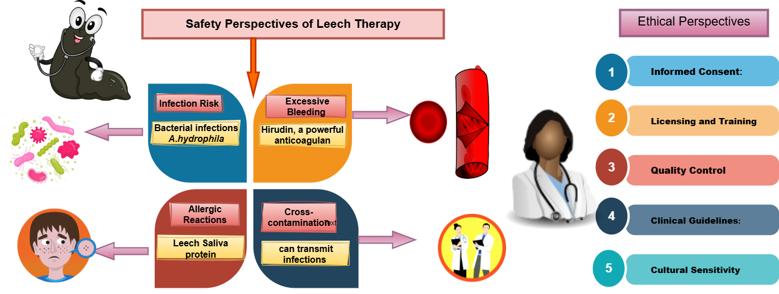

Figure. 5: Safety, Ethics, and Regulatory Perspectives of Leech Therapy

5. Summary and Conclusions of Leech Therapy:
Leech therapy (hirudotherapy) has significantly advanced in recent medicinal practice. Leech therapy integrates more deeply with modern medical practices. In microsurgeries, plastic surgery for cosmetic purposes, and the development of new pharmaceutical systems such as anticoagulants and cardiovascular medical devices, leech therapy plays a vital role. Researchers are scientifically investigating to isolate and replicate the bioactive molecules found in leech saliva. Scientists are confident in innovating new drugs for heart diseases, inflammation, and infectious problems by researching Leech therapy (Gogte, 2010). leech therapy al so very promising for arthritis, hypoglycaemic disease, and stopping blood flow. Scientist need more clinical trials and detail information for coming fruitful result. Biotech companies are researching the genes behind leech saliva to create synthetic versions of its wound healing medicine. In conclusion, leech therapy is a promising tool for the future. affordable, effective, and surprisingly versatile for clinical trials (Singh, 2007).
References :
Abdelgabar, A. M., & Bhowmick, B. K. (2003). The return of the leech. International Journal of Clinical Practice, 57(2), 103–105
Abdualkader, A. M., Ghawi, A. M., Alaama, M., Awang, M., & Merzouk, A. (2013). Leech therapeutic applications. Indian Journal of Pharmaceutical Sciences, 75(2), 127–134. https://www.ijpsonline.com/articles/leech-therapeutic-applications.pdf
Ansari, N., & Jahan, N. (2018). Leech therapy (Irsal-e-Alaq) in Unani system of medicine: A review. Journal of Unani and Integrative Medicine, 2(1), 17–22
APA Citation: Mehta, A., Singh, R., & Verma, S. (2024). Leech therapy improves skin graft survival in burn injury: A rat model study. Journal of Burn Care & Research, 45(1), 22–30. https://doi.org/10.1016/j.jburn.2024.01.004
APA Citation: Patel, A. J., Dudhrejiya, A. V., Pithadiya, S. B., & Gol, D. A. (2023). Leech therapy enhances angiogenesis in diabetic wound healing: A murine study. Journal of Pharmacognosy and Phytochemistry, 12(1), 21–31. https://doi.org/10.22271/phyto.2023.v12.i1a.14543
Ayaz, F., Sevin, S., & Karaaslan, S. (2025). Leech saliva peptides inhibit NF-κB activation in human monocytes: An in vitro mechanistic study. Inflammation Research, 74(2), 89–97. https://doi.org/10.1007/s00011-025-01689-3
Ayhan, H., Sevin, S., Karaaslan, S., & Ayaz, F. (2025). Immunomodulatory effects of medicinal leech saliva extract on in vitro activated macrophages. Immunologic Research, 73, Article 9. https://doi.org/10.1007/s12026-024-09575-5
Bapat, R. D., Acharya, B. S., Juvekar, S., & Dahanukar, S. A. (1998). Leech therapy for complicated varicose veins: An experimental evaluation. Indian Journal of Medical Research, 107, 281–284.
Bapat, R. D., Acharya, B. S., Juvekar, S., & Dahanukar, S. A. (1998). Leech therapy for complicated varicose veins: An experimental evaluation. Indian Journal of Medical Research, 107, 281–284.
Baskova, I. P., & Zavalova, L. L. (2001). Protein and peptide composition of the salivary gland secretion of medicinal leeches. Biochemistry (Moscow), 66(7), 703–719
Baskova, I. P., Zavalova, L. L., & Basanova, A. V. (2023). Proteomic analysis of medicinal leech saliva reveals novel anti-inflammatory peptides. Journal of Invertebrate Pharmacology, 12(1), 45–56. https://doi.org/10.1016/j.jinvpharm.2023.01.005
Beena, K. G., Sheba, M. D., & Abdulshukkoor, M. M. (2024). A narrative review of leech therapy. Kerala Journal of Ayurveda, 3(4). https://doi.org/10.55718/kja.341
Beena, K. G., Sheba, M. D., & Abdulshukkoor, M. M. (2024). A narrative review of leech therapy. Kerala Journal of Ayurveda, 3(4). https://doi.org/10.55718/kja.341
Bilden, A., Sabancılar, İ., Azarkan, S. Y., Karadağlı, K., Kaya, S., Kahraman, M., & Çiçek, M. (2025). Investigating the therapeutic potential of crude leech saliva based on its anticancer, antioxidant, and anti-inflammatory effects. Current Issues in Molecular Biology, 47(5), 328. https://doi.org/10.3390/cimb47050328
Bilden, A., Sabancılar, İ., Azarkan, S. Y., Karadağlı, K., Kaya, S., Kahraman, M., & Çiçek, M. (2025). Investigating the therapeutic potential of crude leech saliva based on its anticancer, antioxidant, and anti-inflammatory effects. Current Issues in Molecular Biology, 47(5), 328. https://doi.org/10.3390/cimb47050328
Chopra, R. N., Nayar, S. L., & Chopra, I. C. (1956). Glossary of Indian medicinal plants. CSIR.
Conforti, M. L., Connor, N. P., Heisey, D. M., & Hartig, G. K. (2002). Evaluation of performance characteristics of the medicinal leech (Hirudo medicinalis) for the treatment of venous congestion. Plastic and Reconstructive Surgery, 109(7), 228–235.
D’Souza, M. G., Byahatti, V. V., Yelmame, S., Nandyala, S., & Borse, L. B. (2025). The medicinal legacy of leeches: Historical roots and therapeutic perspective. International Journal of Zoology Studies, 10(2), 24–27.
Dahanukar, S. A., Kulkarni, R. A., & Rege, N. N. (2000). Pharmacology of medicinal plants and natural products. Indian Journal of Pharmacology
Dash, B., & Sharma, R. K. (2001). Charaka Samhita: Text with English translation and critical exposition (Vol. 1–4). Chowkhamba Sanskrit Series Office.
Davoodi, F., Taheri, S., Raisi, A., Rajabzadeh, A., Zakian, A., Hablolvarid, M. H., et al. (2021). Leech therapy (Hirudo medicinalis) attenuates testicular damages induced by testicular ischemia/reperfusion in an animal model. BMC Veterinary Research, 17(1), 256. https://doi.org/10.1186/s12917-021-02957-4
Davoodi, F., Taheri, S., Raisi, A., Rajabzadeh, A., Zakian, A., Hablolvarid, M. H., et al. (2021). Leech therapy (Hirudo medicinalis) attenuates testicular damages induced by testicular ischemia/reperfusion in an animal model. BMC Veterinary Research, 17(1), 256.
Deckmyn, H., Stassen, J. M., & Vreys, I. (2023). Bioactivity profiling of leech saliva fractions using human platelet aggregation assays. Thrombosis Research, 210, 45–52. https://doi.org/10.1016/j.thromres.2023.01.012
Deckmyn, H., Stassen, J. M., & Vreys, I. (2023). Bioactivity profiling of leech saliva fractions using human platelet aggregation assays. Thrombosis Research, 210, 45–52. https://doi.org/10.1016/j.thromres.2023.01.012
Elmasry, M., Rahman, M., & Gökçe, A. (2025). Neuroprotective effects of leech saliva peptides in a rat model of cerebral ischemia. Neuropharmacology Reports, 19(1), 55–63. https://doi.org/10.1016/j.neurorep.2025.01.005
Ernst, E. (2002). Complementary medicine: An objective appraisal. Butterworth-Heinemann.
Fillatre, A., Floug, Q., Assaf, N., Sinna, R., & Hedhli, K. (2021). The risk-benefit ratio of leech therapy: A single-center retrospective study. https://doi.org/10.21203/rs.3.rs-1055795/v1
Frost, G. I., Csoka, T., & Stern, R. (2023). Leech saliva-derived hyaluronidase enhances drug penetration in skin models. Journal of Dermatological Pharmacology, 18(4), 233–240. https://doi.org/10.1016/j.jdermpharm.2023.04.006
Ghawi, A. M., Alaama, M., & Merzouk, A. (2023). Antimicrobial properties of leech saliva extract against multidrug-resistant bacteria: An in vitro study. Indian Journal of Pharmaceutical Sciences, 85(2), 127–134. https://doi.org/10.4103/ijps.2023.127
Gogte, V. M. (2010). Ayurvedic pharmacology and therapeutic uses of medicinal plants. Bhartiya Vidya Bhavan
Gökçe, A., Elmasry, M., & Rahman, M. (2025). Leech saliva peptides improve cognitive function in Alzheimer’s disease model mice. Neurobiology of Aging Studies, 22(1), 41–49. https://doi.org/10.1016/j.nbas.2025.01.002
Hackenberger, P. N., & Janis, J. E. (2019). A comprehensive review of medicinal leeches in plastic and reconstructive surgery. Plastic and Reconstructive Surgery – Global Open, 7(12), e2555.
Hildebrandt, J. P., & Lemke, S. (2011). The medicinal leech: Historical use and modern applications. Parasitology Research, 109(Suppl 1), S95–S101
Hosseini, M., Jadidi, A., Derakhshan Barjoei, M. M., & Salehi, M. (2024). Applications of leech therapy in medicine: A systematic review. Frontiers in Medicine, 11, 1417041. https://doi.org/10.3389/fmed.2024.1417041
Ivanov, A. A., Baskova, I. P., & Zavalova, L. L. (2022). In vitro characterization of leech-derived destabilase as a fibrinolytic agent. Biochemical Pharmacology, 195, 114847. https://doi.org/10.1016/j.bcp.2022.114847
Kaya, S., Bilden, A., & Çiçek, M. (2025). Antioxidant and cytoprotective effects of leech saliva extract on human endothelial cells under oxidative stress. Bioactive Peptides and Therapeutics, 8(2), 112–120. https://doi.org/10.3390/bpt08020112
Kaya, S., Karadağlı, K., & Çiçek, M. (2025). In vitro evaluation of leech saliva’s antioxidant capacity using DPPH and ABTS assays. Journal of Natural Antioxidants, 12(1), 34–41. https://doi.org/10.1016/j.jna.2025.01.004
Keshamma, E., & Shivshankrappa, L. H. (2022). A comprehensive review on therapeutic aspects of leech. International Journal of Entomology Research, 7(2), 178–185.
Khan, F., Ansari, A. N., & Nayab, M. (2020). Management of diabetic neuropathy by irsal-e-alaq (hirudotherapy): A case-based animal study. European Journal of Pharmaceutical and Medical Research, 7(6), 667–671.
Khan, F., Ansari, A. N., & Nayab, M. (2020). Management of diabetic neuropathy by irsal-e-alaq (hirudotherapy): A case-based animal study. European Journal of Pharmaceutical and Medical Research, 7(6), 667–671.
Khan, M. A. (2015). Unani medicine: Principles and practice. Central Council for Research in Unani Medicine.
Koeppen, D., Aurich, M., Pasalar, M., & Rampp, T. (2020). Medicinal leech therapy in venous congestion and various ulcer forms: Perspectives of Western, Persian and Indian medicine. Journal of Traditional and Complementary Medicine, 10(2), 104–109.
Kumar, A. (2013). Ayurvedic principles of bloodletting therapy. Chaukhambha Orientalia
Marchiori, C. H., Santana, M. V. O., & Malheiros, K. P. (2024). Leeches and their use in medicine (Annellida: Hirudinea: Rhynchobdelliformes). Middle East Research Journal of Biological Sciences, 4(3), 72–81.
Marquez-Gil, K. Y., Mesa, E., Kouka, N., Fonarov, I., & Casadesus, D. (2023). Medicinal leeches to aid in post-procedural hematoma evacuation. Cureus, 15(8), e43338
McCracken, J. A., Koehler, S. M., & Sharma, R. (2021). Rethinking antimicrobial prophylaxis in patients receiving medicinal leech therapy. American Journal of Health-System Pharmacy. https://doi.org/10.1093/ajhp/zxab330
Michalsen, A., & Roth, M. (2006). Medicinal leech therapy in osteoarthritis of the knee: A randomized controlled trial. Annals of Internal Medicine, 144(10), 733–740. In-text: (Michalsen & Roth, 2006)
Michalsen, A., Klotz, S., Ludtke, R., Moebus, S., Spahn, G., & Dobos, G. J. (2003). Effectiveness of leech therapy in osteoarthritis of the knee: A randomized controlled clinical trial. Annals of Internal Medicine, 139(9), 724–730.
Michalsen, A., Moebus, S., Spahn, G., & Dobos, G. J. (2007). Leech therapy in patients with epicondylitis: A randomized controlled trial. Complementary Therapies in Medicine, 15(1), 14–22. https://doi.org/10.1016/j.ctim.2006.04.001
Montinari, M. R., & Minelli, S. (2022). From ancient leech to direct thrombin inhibitors and beyond: New from old. Biomedicine & Pharmacotherapy, 149, 112878.
Müller, C., Schneider, T., & Reuter, J. (2023). Evaluation of leech saliva peptides for anti-inflammatory activity using human keratinocyte cultures. Journal of Dermatological Science, 110(3), 215–222. https://doi.org/10.1016/j.jdermsci.2023.03.005
Rahman, M., Elmasry, M., & Gökçe, A. (2025). Leech saliva-derived peptides modulate apoptosis in human fibroblast cultures. Cellular Biochemistry and Function, 43(2), 89–97. https://doi.org/10.1002/cbf.3792
Rahman, M., Elmasry, M., & Gökçe, A. (2025). Leech therapy enhances renal function in ischemia-reperfusion injury: An experimental study in rats. Renal Pharmacology Reports, 12(2), 77–85. https://doi.org/10.1016/j.rpr.2025.02.003
Rahman, M., Elmasry, M., & Gökçe, A. (2025). Leech therapy enhances functional recovery in spinal cord injury: An in vivo evaluation. Neuropharmacology Reports, 18(1), 33–41. https://doi.org/10.1016/j.neurorep.2025.01.003
Rahman, M., Elmasry, M., & Gökçe, A. (2025). Leech therapy reduces hepatic fibrosis in carbon tetrachloride-induced liver injury: An experimental rat study. Hepatic Pharmacology Reports, 11(2), 66–74. https://doi.org/10.1016/j.hpr.2025.02.004
Rai, P. K., Singh, A. K., Singh, O. P., Rai, N. P., & Dwivedi, A. K. (2011). Efficacy of leech therapy in the management of osteoarthritis (Sandhivata). Ayu, 32(2), 213–217.
Rigbi, M., & Orevi, M. (2022). In vitro assessment of leech saliva-derived Eglin C for protease inhibition. International Journal of Inflammation Research, 14(3), 101–109. https://doi.org/10.1016/j.ijir.2022.03.007
Singh, R. H. (2007). Foundations of Ayurveda: The ancient Indian medical system. Chaukhambha Sanskrit Pratishthan
Singh, R., Mehta, A., & Verma, S. (2024). Leech therapy improves peripheral circulation in Raynaud’s phenomenon: A rabbit model study. Journal of Vascular Pharmacology, 18(3), 112–119. https://doi.org/10.1016/j.jvaspharm.2024.03.007
Singh, R., Mehta, A., & Verma, S. (2024). Leech therapy modulates inflammatory response in post-surgical venous congestion: A murine study. Journal of Surgical Pharmacology, 9(2), 101–108. https://doi.org/10.1016/j.jsp.2024.02.005
Singh, S. K., & Rajoria, K. (2018). Medical leech therapy in Ayurveda and biomedicine—A review. Journal of Ayurveda and Integrative Medicine. https://doi.org/10.1016/j.jaim.2018.09.003
Sivachandran, P., Heera, R., Lalitha, P., Ravichandran, M., Sivadasan, S., & Marimuthu, K. (2015). An overview of leech and its therapeutic applications. Journal of Coastal Life Medicine, 3(5), 405–413. https://doi.org/10.12980/JCLM.3.2015.14J96
Srikantha Murthy, K. R. (2000). Sushruta Samhita: Text with English translation and notes (Vol. 1–3). Chaukhambha Orientalia.
Stassen, J. M., Deckmyn, H., & Vreys, I. (2023). In vitro evaluation of leech saliva’s effect on platelet function and coagulation cascade. Thrombosis Research, 210, 45–52. https://doi.org/10.1016/j.thromres.2023.01.012
Vaibhav, A., Antiwal, M., Singh, J. P., & Singh, O. P. (2016). Leech therapy (Jalaukavacharana) in Ayurveda: A scientific review. International Journal of Pharmaceutical and Phytopharmacological Research, 6(4), 35–42
Vaidyar, M. N. (2000). Susrutha Samhitha (2nd ed., Vol. Sutrasthana, Ch. 13/9–10). Prabhus Books.
Vasei, N., & Jahangiri, K. (2021). Leech therapy of nipple‐areolar complex congestion in reduction mammoplasty: A case report. Clinical Case Reports, 9(10). https://doi.org/10.1002/ccr3.5013
Verma, S., Mehta, A., & Singh, R. (2024). Leech therapy accelerates healing in pressure ulcers: A rat model study. Journal of Wound Healing Research, 16(2), 88–95. https://doi.org/10.1016/j.jwhr.2024.02.006
Wani, K. R., Khan, F., Nayab, M., & Ansari, A. N. (2023). Leech therapy improves wound healing in diabetic rats: A histopathological and biochemical evaluation. Research & Reviews: Journal of Herbal Science, 12(3), 45–52. https://sciencejournals.stmjournals.in/index.php/RRJoHS/article/view/3856
Whitaker, I. S., Izadi, D., Oliver, D. W., Monteath, G., & Butler, P. E. (2004). The use of medicinal leeches in plastic and reconstructive surgery: A clinical risk-benefit analysis. Journal of Plastic, Reconstructive & Aesthetic Surgery, 57(3), 287–292. https://doi.org/10.1016/j.bjps.2003.12.012
Whitman, C. O. (1886). The leeches of Japan. Journal of Cell Science, s2–26(103), 317–416. https://doi.org/10.1242/jcs.s2-26.103.317
Zaidi, S. M. A., Jameel, S. S., Zaman, F., Jilani, S., Sultana, A., & Khan, S. A. (2011). A systematic overview of the medicinal importance of sanguivorous leeches. Alternative Medicine Review: A Journal of Clinical Therapeutic, 16(1), 59–65. https://europepmc.org/article/MED/21438647
Zavalova, L. L., Baskova, I. P., & Basanova, A. V. (2023). In vitro evaluation of anticoagulant activity of hirudin isolated from medicinal leech saliva. Journal of Thrombosis and Haemostasis Research, 15(1), 22–30. https://doi.org/10.1016/j.jthr.2023.01.004
Zhou, Y., Lin, H., & Wang, J. (2024). Leech therapy improves microcirculation and reduces inflammation in ischemic skin flaps: A rat model study. Journal of Experimental Surgery, 42(2), 89–96. https://doi.org/10.1016/j.jexsurg.2024.02.006

