Nutrient Profile and Phytochemical Analysis of Commercially Cultivated Oyster Mushroom (Pleurotus florida) in Madurai, Tamil Nadu, India

ABSTRACT
A study was conducted to investigate the nutrient profile and phytochemical analysis of commercially cultivated oyster mushrooms in Madurai. The study revealed the presence of all the biomolecules. The oyster mushroom Pleurotus florida was made of 90.00% moisture, and this was the highest, followed by protein and carbohydrate with 55% and 40%, respectively. Mineral analysis showed that Phosphorus was the most abundant mineral, followed by potassium, with values of 2000mg/100g and 400mg/100g, respectively. Vitamin analysis revealed the presence of vitamins B, C, and E, with B being the most abundant, while the least abundant vitamin was C. Phytochemical screening of ethanolic and aqueous extracts showed the presence of secondary metabolites such as alkaloids, glycosides, flavonoids, and polyphenols. The polyphenol content was much higher than the rest of the base, with a value of 4-13%.
KEYWORDS: Pleurotus florida, Phyto compound analysis, HS-GCMS, Madurai
INTRODUCTION
The strategy being investigated to raise nutrition security and feed the world sustainably by 2050 are maximizing production and leveraging local biodiversity to safeguard the long-term viability of food systems. The "Future Smart Food," or promoting underutilized foods, was known as a sustainable approach (Durst & Bayasgalanbat, 2014). Wild mushrooms are recognized by the Food and Agriculture Organization (FAO) as a source of nourishment and a means of subsistence for marginalized groups (Hanko 2023). Mushrooms are one commodity that can help preserve the foundation of our failing food systems (Pilling & Bélanger, 2019). The fleshy, spore-bearing fruiting body that is typically developed above ground, on soil, decaying wood, or an organic moist substrate is known as a mushroom. It is a member of the family Boletaceae and order Boletales (Zoberi 1985). A total of 50,000 to 100,000 species of mushroom were documented worldwide, of them over 2100 species have been known to be edible. The greatest numbers of wild edible mushroom species are documented from Asia (Patel et al., 2012; Paloi et al., 2023; Singh et al., 2025). Globally, the button, shiitake, and oyster mushrooms are the three most commonly, commercially grown species. Pleurotus species are members of the phylum Basidiomycota, which produces oyster-shaped mushrooms known as basidiocarps that can be either colored or white (Deeppalaksshmi and Sankaran 2014). They can be readily cultivated on agriculture waste. Oyster mushrooms are compatible for the new world. In addition to high nutrients, edible mushrooms are known to have several remarkable qualities, including antimicrobial, antiviral (including HIV), antitumor, antineoplastic, hepatoprotective, and immunomodulatory (Patel et al., 2012; Deeppalaksshmi & Sankara, 2014). They can be used as food and medicine; these have traditionally been given substantial monetary and cultural significance (Opige et al. 2006). People transmit traditional ecological knowledge (TEK) about mushroom from one generation to the next (Singh et al., 2025). Research specifies that there are considerable differences between commercially farmed mushrooms and various wild edible mushroom species, particularly in terms of nutrient makeup. A recent study by Ziarati & Ghasemynezhad-Shanderman (2014) confirmed that cooking conditions have an insightful and significant impact on nutrient composition. Numerous studies have revealed that nutrient composition is dependent on the type of substrate used and the growing conditions (Shah et al., 2004; Jonathan et al., 2006; Ezeibekwe et al., 2009). In recent years, 1000 tons of mushrooms are consumed in India. Consumers’ tastes and preferences have changed due to a rise in expenditure power, which supports the growth of the mushroom market (Wakchaure et al., 2011). Mushrooms are consumed for their medicinal qualities in addition to their nutritional and commercial value (Shah et al., 2004). There is a severe lack of knowledge about the nutritional facts of oyster mushrooms that are sold commercially, despite the fact that the nutritive and non-nutritive values of edible mushrooms have increased over the past few decades, with research examining their potential to satisfy nutritional needs and medicinal value nationwide (Pérez-Moreno et al., 2020). The nutritional value of the commercially grown oyster mushroom (Pleurotus florida) in Madurai is stated in this study.
MATERIALS AND METHODS
Study Area
The present study was carried out in the Mushroom culture Laboratory (9°56'13"N 78°02'35"E), Department of Zoology, Nadar Mahajana Sangam S. Vellaichamy Nadar College, Nagamalai, Madurai, Tamil Nadu, India.
Source of Sample and Identification
The oyster mushroom used in this study was obtained from Shiro Spawn Laboratory15 D, 1st Street, Tanjore Road, Old Paal Pannai, Lakshmipuram, Tiruchirappalli-620010, Tamil Nadu, India. The Mushroom used in this study was identified as Pleurotus florida using Taxonomical identification keys provided by Anshu Priyadarshini, 2018 (Fig. 1).
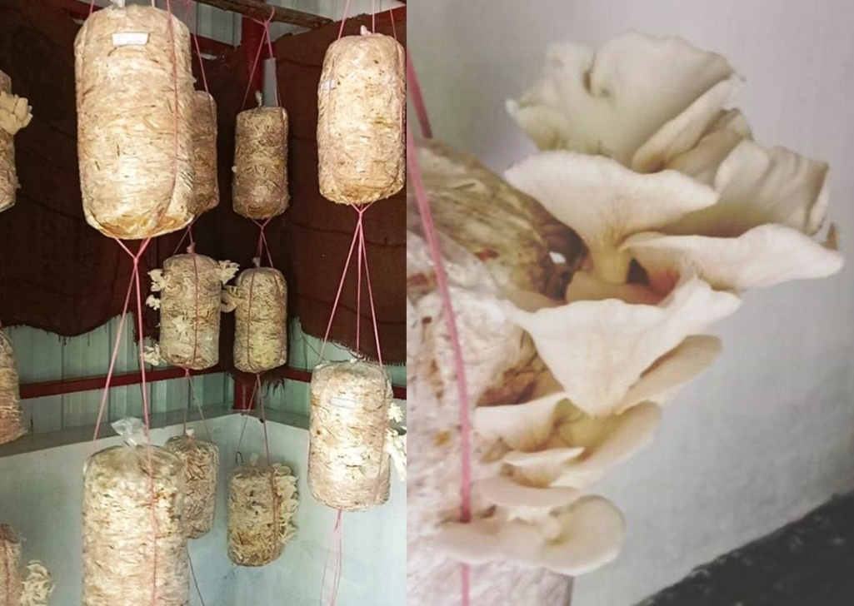
Figure 1. A portion of commercially cultivated oyster mushroom (Pleurotus florida)
Preparation of ethanolic Extract
The ethanolic extracts used in this study were prepared as previously described by Ebana et al. (2015).
Phytochemical Screening
The extracts were screened for the presence of phytochemicals as previously described by Ebana et al. (2014; 2015) and Preveena et al. (2014) but with some little modifications.
Test for Flavonoids
About 1 ml of 2 N sodium hydroxide was added to 2 mls of the extracts. The formation of a yellow colour was regarded as positive (Edet et al. 2016).
Test for Alkaloids
About 2 ml of each extracts were stirred with 5 ml of 1% aqueous hydrochloric acid on a steam bath and 1 ml of the filtrates then treated with a few drops of Mayer’s reagent and a second 1 ml portion was treated similarly with Dragendorff’s reagent. The presence of a precipitate with either of these reagents was taken as positive (Edet et al. 2016).
Test for Glycosides
Exactly 2 ml of chloroform with 10% ammonia solution was added to 2 ml of extract. Formation of a pink colour was regarded as positive for glycosides (Edet et al. 2016).
Test for Polyphenols
About 5 ml of each extracts were heated with 10 ml of distilled water for 30 minutes. Then 1 ml mixture of 10% ferric chloride and 1% potassium ferricyanide added to it. The formation of a green blue colour was regarded as positive (Edet et al. 2016).
Proximate composition analysis
The mushroom sample was analyzed for food composition according to the Association of Analysis Official Analytical Chemists (AOAC 1995). These included moisture, crude fiber, ash, crude protein, crude fat, and carbohydrate. (Edet et al. 2016).
Determination of vitamins
Vitamins B, E and C were determined according to methods previously described by Bessey et al. (1944), Bessey et al. (1946), Bender (1993), Bender (2003) and Ball (1998) (Edet et al. 2016).
Determination of mineral elements
The mineral elements were determined by the dry ash extraction method of AOAC (1995) as previously analysed by Edet et al. (2016).
Determination of volatile compounds using HS-GCMS
Two grams of air dried mushroom were added with 50 to 100 ml of methanol: Acetone (1:1) in SPME (Solid Phase Micro Extraction) holder and shaken vigorously for five minutes. The sample (2 µl) was injected to thermal desorption chamber and was allowed to run for 1.5 min. Analyses of volatile compounds were carried out using a QP-2010-Gas Chromatograph mass Spectrometer (Shimadzu GC/MS) attached with headspace. The headspace sample was then injected into a gas chromatograph using a 30 m x 0.25 mm DB-5 capillary column containing a 0.25 µm. The temperature of the oven was started at 50°C (1 min), then it reached to 240°C (3 min) and then it rose again to reach 300°C. Area of percentage of the individual component was calculated and interpreted. The components were identified by comparison of mass spectra and retention time data complemented with Wiley, Flavour and NIST GC/MS libraries (Lina Smolskaite 2016).
Statistical analysis ??????
RESULT AND DISCUSSION
The result of the proximate composition of the studied mushroom Pleurotus florida is presented in Table 1. The results indicate that the mushroom was very rich in moisture (90%). Ether extract (crude lipid) was not detected in the sample. Protein was 40%, nitrogen free extract (carbohydrate) 55%, fibre 32%, ash 10% and Fat 8%. Similarly, the composition of the oyster mushroom Pleurotus ostreatus revealed the similar source of food nutrients viz., moisture 91.00 %, carbohydrate 35.07%, protein 31.93%, fiber 25.00, ash 8.00%. According to the study by Edet et al. (2016) fat or ether extract was absent in the Oyster mushroom Pleurotus ostreatus.
Table 1. Proximate composition Pleurtus florida
S. No. | Name of the component | Composition (%)
 | Moisture | 90
 | Carbohydrate | 55
 | fiber | 32
 | protein | 40
 | Ash | 10
 | Fat | 8
The result for the mineral composition of the mushroom is presented in Table 2. The minerals examined were potassium, phosphorus, magnesium, zinc, calcium, sodium, iron and copper. The most abundant mineral was phosphorus with a composition of 2000mg/100g followed by potassium with 400mg/100g and magnesium 250mg/100g. The least abundant mineral examined was copper with 9.5mg/100g. Jonathan et al. (2006) also reported slightly lower values with P. ostreatus grown on different substrates for protein, fiber and carbohydrate. In their study, they found fat with values ranging from 3.93 to 8.72%. Our findings for proximate analysis were more agreeable to that obtained by Ahmed et al. (2009) and Edet et al. (2016). In addition to the basic classes of food, P. florida have been found to contain about eighteen different amino acids and it was proven by the researchers. The recently studied oyster mushroom was analyzed for nitrogen, potassium, calcium, phosphorus and magnesium (Edet et al. 2016).
Table 2. Mineral composition Pleurotus florida
S. No. | Mineral | Composition (mg/100g)
 | K |  | 400
 | P |  | 2000
 | Mg |  | 250
 | Zn |  | 15.8
 | Ca |  | 59.0
 | Na |  | 92.0
 | Fe |  | 83.5
 | Cu |  | 9.5
The result of the vitamins analysis is presented in Table 3. Vitamins B, C and E were analysed from the extract. From the results, the most abundant vitamin was B followed by E. The least abundant vitamin was vitamin C. Similar results were obtained for another species of Pleurotus. According to Edet et al. (2016), the examined vitamins were A, B, C and E with vitamin B being the most abundant (57.15 mg/dl) followed by C and E with 6.28 and 1.92 mg/100 g. The least abundant was vitamin C. Jonathan et al. (2006) found that P. ostreatus grown on different substrates contained vitamins B1, B2, B3 B5, C, D but not on vitamin A.
Table 3. Vitamins composition of Pleurotus florida
S.No | Name of the Vitamin | Composition (%)
 | Vitamin B1 (Thiamin) | 2-5
 | Vitamin B3 (Niacin) | 4-19
 | Vitamin B6 (Pyridoxine) | 1-6
 | Vitamin B2 (Riboflavin) | 2-17
 | Vitamin B5 (Pantothenic acid) | 3-26
 | Vitamin B9 (Folate) | 1-4
 | Vitamin E (Tocopherols) | 3-11
 | Vitamin C (Ascorbic acid) | Least level
The results of the phytochemical screening using ethanolic extracts were presented in Table 4. The screening reveals that the Pleurotus florida is very rich in a variety of phytochemicals such as alkaloids, glycosides, flavonoids and polyphenols. However, phlobatannins, anthraquinones and hydroxymethyl anthraquinones were absent. The most abundant phytochemical was polyphenol.
Table 4. Phytochemical screening of Pleurotus florida
S.No | Phytochemicals | Composition (%)
 | polyphenol | 4-13
 | Flavanoids | 1-6
 | B-Carotene | 8
 | Lycopene | 92
 | Ergosterol | 8mg
 | Alkaloids | 0.04-0.14
 | Sesquiterpene | Least level
 | Glycosides | Least level
 | Cythioformine A | Least level
 | Diatretol | Least level
 | Illudin C2 and C3 | Least level
 | Strobilurin | Least level
 | Favolon | Least level
 | Ganoderon | Least level
 | Pilatin | Least level
 | Lentinan | Least level
 | Oudemansin | Least level
 | Lanostane | Least level
Quantitative estimate of the volatile phytochemicals are presented in Table 5. According to the results alcohol, Esters, Acid, Aldehyde, ketone, terpene and phenol were analysed.
Table 5. Quantification of Volatile phytocompounds of Pleurotus florida
using Hs-GCMS
S.No. | Volatile compounds | Composition  (Unit : Area %)
Alcohol
1. | Ethanol | 0.189
2. | 1-Octane - 3 – ol | 16.214
3. | 1-Octadecanol | 0.146
4. | Cyclooctylalcohol | 1.895
5. | 3-methyl-1-propanol | 1.345
6. | 2-Methylaminoethanol | 0.139
7. | Trans-2-Undecen-1-ol | 0.091
Esters
8. | Butanoic acid, butyl ester (CAS) | 0.584
9. | Carbamic acid, methyl ester | ND
10. | L-Alanine, ethyl ester | 0.419
11. | 2-Ethylhexyl-2-ethylhexonate | 0.645
12. | Phthalic acid, decyl isobutyl ester | 0.090
13. | 2,2,4-Trimethyl-1,3-pentanediol diisobutyrate | 0.040
14. | Carbonic acid, dodecyl isobutyl ester | 0.785
Acid
15. | Propanoic acid | 3.512
16. | Acetic acid | 2.851
17. | Butanoic acid | 0.092
Aldehyde
18. | Benzaldehyde | 0.040
19. | Anisaldehyde | 0.084
Ketone
20. | 7,9-Di-tert-butryl-1-oxaspiro(4,5)deca-6,9-diene-2,8-dione | 1.214
21. | 2,5-Cyclohexadiene-1,4-dione, 2,6-bis (1,1- dimethylethyl) | 1.214
22. | 2,6-Di-T-butyl-4-methylene-2,5-cyclohexadiene-1-one | 0.098
23. | 2,3,4 H – Pyran – 4- one | 2.580
24. | 5,9-Undecadiene-2-one | 0.214
25. | Cyclooctene | 1.234
26. | 2-Cyclopenten-1-one | 2.145
Terpene
27. | Trans – alpha-bisabolene | 0.035
Phenol
28. | Phenol, 2,6 – bis (1,1-dimethylethyl)-4- methyl | 48.745
29. | 1-propanamine | 3.142
30. | Geranyl linalool | 0.642
*ND- Not Detected
CONCLUSION
Based on the findings in this study, the Oyster mushroom Pleurotus florida is rich in essential minerals and vitamins. Phytochemical screening revealed that it is also abundant with secondary metabolites or phytochemical bases that could be exploited for bioactive compounds. Further studies are recommended to ascertain the bio-potentiality of these secondary metabolites.

DISCLAIMER (ARTIFICIAL INTELLIGENCE)
Authors hereby declare that NO generative AI technologies such as Large Language Models (ChatGPT, COPILOT, etc.) and text-to-image generators have been used during the writing or editing of this manuscript.

REFERENCES
AOAC. (1995). Official Methods of Analysis. 13th Edition. Association of Official Analytical Chemist, Washington, D.C.
Ball, G. F. M. (1998). Bioavailability and analysis of vitamins in foods. London: Chapman and Hall.
Bender, A. D. (1993). An introduction to nutrition and metabolism. University College, London Press Limited, London, 182–182.
Bender, A. D. (2003). Nutritional biochemistry of vitamins. Cambridge University Press, London.
Bessy, O. A. (1944). Determination of ascorbic acid by titrimetric method. Journal Association Office Agricultural Chemists, 27, 537.
Bessy, O. A., Lowry, O. H., Brocke, M. S., & Lopper, J. A. (1946). Determiantion of vitamin A in small quantities of blood stream. Journal of Biological Chemistry, 166, 177.
Deeppalaksshmi, K., & Sankaran, M. (2014). Pleurotus ostreatus: An oyster mushroom with nutritional and medicinal properties. Journal of Biochemical Technology, 5(2), 718–726.
Durst, P., & Bayasgalanbat, N. (2014). Promotion of Underutilized Indigenous Food Resources for Food Security and Nutrition in Asia and the Pacific. Food and Agriculture Organization of the United Nations Regional Office for Asia and the Pacific.
Ebana, R. U. B., Etok, C. A., & Edet, U.O. (2015). Phytochemical screening and antimicrobial activity of Nypa fruticans harvested from Oporo River in the Niger Delta Region of Nigeria. International Journal of Applied Studies, 10, 1120–1125.
Ebana, R.U. B., Etok, C. A., & Edet, U.O. (2014). Nutritional and microbial analysis of melon (Citrullus colocynthis Linn) cake and its components- a traditional snack in South South Nigeria. International Journal of Applied Studies, 8(4) 1612–1617.
Ezeibekwe, I. O., Ogbonnaya, C. I., Unamba, C.I.N., & Osuala, O. M. (2009). Proximate analysis and mineral composition of edible mushrooms in parts of South Eastern Nigeria. Report and Opinion, 1(4), 32–36.
Hanko, J. (2023). Mushroom Cultivation for People with Disabilities . A Training Manual. Food and Agricultural Organization (FAO) of the United Nations. https://coin.fao.org/coin-static/cms/media/9/13171841512190/2001_12_high.pdf
Jonathan, G., Ayaji, A., Oku, I., & Donbebe, W. (2006). Nutritive value of common wild edible mushrooms from Southern Nigeria. Global Journal of Biotechnology & Biochemistry, 1(1), 16–21.
Lina Smolskaite. (2016). Rare forest and coastal-dune mushrooms : evaluation of antioxidant and biological properties. Agricultural sciences. Institut National Polytechnique de Toulouse - INPT; Kauno technologijos universitetas (Kaunas, Lituanie), English.
Opige, M., Kateyo, E., & Olila, D. (2006). Indigenous Knowledge and Usage of Indigenous Edible and Medicinal Mushrooms Among the Teso People of Eastern Uganda. Journal of Food Technology, 4(4), 325–330.
Paloi, S., Kumla, J., Paloi, B. P., Srinuanpan, S., Hoijang, S., Karunarathna, S. C., Acharya, K., Suwannarach, N., & Lumyong, S. (2023). Termite Mushrooms (Termitomyces), a Potential Source of Nutrients and Bioactive Compounds Exhibiting Human Health Benefits: A Review. Journal of Fungi, 9(1), 112. doi:10.3390/jof9010112
Patel, Y., Ram, N., & Singh, V. K. (2012). Medicinal properties of Pleurotus species (Oyster Mushroom): A review. World Journal of Fungal Plant Biology, 3(1), 1–12.
Pérez-Moreno, J., Guerin-Laguette, A., Arzú, R. F., & Yu, F. Q. (2020). Mushrooms, Humans and Nature in a Changing World: Perspectives from Ecological, Agricultural and Social Sciences. Springer Nature, 3–28.
Pilling, D., & Bélanger, J. (2019). The State of the World’s Biodiversity for Food and Agriculture. FAO Commission on Genetic Resources for Food and Agriculture.
Praveena, J., & Estherlydia, D. (2014). Comparative Study of phytochemical screening and Edet et al.; AIR, 7(3): 1-6, 2016; Article no.AIR.26196 antioxidant capacities of vinegar made from peel and fruit of pineapple (Ananas comosus L.). International Journal of Pharma and Bio Science, 5(4), 394–403.
Shah, Z. A., Ashray, M., & Ishtiod, M. (2004). Comparative study on cultivation and yield performance of oyster mushroom (Pleurotus ostreatus) on different substrates. Pakistan Journal of Nutrition, 3, 158–160.
Singh, A., Singh, G., Kapoor, R., Dhasmana, A., & Jerath, S. G. (2025). Wild Edible Mushrooms of Jharkhand: Nutrient-Dense Seasonal Foods to Improve Dietary Diversity Among Indigenous Communities. Nutrition and Food Science, 13(1). doi : http://dx.doi.org/10.12944/CRNFSJ.13.1.4
Wakchaure, G. C. (2011). Postharvest Handling of Fresh Mushrooms. In: Mushrooms: Cultivation, Marketing, and Consumption, Directorate of Mushroom Research, Indian Council of Agricultural Research, Solan, India, pp. 197–206.
Yu, S., Weaver, V., Martin, K., & Cantorna, M. T. (2009). The Effects of Whole Mushrooms during Inflammation. BMC Immunology, 10(1), 12.
Ziarati, P., & Ghasemynezhad-Shanderman, S. S. (2014). Safety and nutritional comparism of fresh, cooked and frozen mushroom (Agaricus bisporus). International Journal of Farming and Allied Sciences, 2(24), 1141–1147.
Zoberi, M. H. (1985), Some edible mushroom from Nigeria. The Nigeria Field, 38,81–89.

