First time report of butterfly species and diversity of Rabo Dam, Chhattisgarh in India

.
ABSTRACT

We conducted the specific butterfly survey in Rabo dam on the Kurket River, Tamnar Tehsil, Raigarh District, Chhattisgarh State in India, and documented 41 species of butterflies belonging to five families and 12 subfamilies. We photographed butterflies while walking at random from 7:00 a.m. to 10:00 a.m. and 3:00 p.m. to 5:00 pm. For this survey butterflies were photographed with digital cameras. A photographic documentation was completed, and compared the earlier studies and prepared the first specific checklist of butterflies for Raigarh as 58 species, with 17 new records for the districts Raigarh.

Keywords: Lepidoptera, Faunal survey, Habitat ecology, Wetland ecosystem, Pollinators.

1. INTRODUCTION

Butterflies are essential indicators of ecosystem health as they pollinate plants and assist to maintain biodiversity (Bouyer et al., 2007; Abrol & Abrol, 2012; Ghazanfar et al., 2016, Vijayan & Anbalagan, 2023). Research suggests that plants and pollinators evolve together (Morgan, 2000; Mitchell et al., 2009, Vijayan, 2025). The butterflies, which are herbivorous creatures, developed alongside plants (Ehrlich, 1984). Butterflies, classified as Lepidoptera, have a global presence, with around 19,238 identified species (Heppner, 1998). A new species, Amathusia travancorica and a new subspecies, Athyma inara sahyadriensis, are recently reported from the Western Ghats biodiversity hotspot in India (Kunte, & Basu, 2024). Nearly 1300 butterfly species have been identified in India (Varshney and Smetacek, 2015), and the Indian subcontinent has over 1500 species (Kehimkar, 2016). The study on Butterflies of Chhattisgarh were made incidentally by naturalist such as Forsayeth (1984), Swinhoe (1886) Betham (1890, 1891) and Witt (1909) etc. were documented the Butterflies of Central Indian region including Chhattisgarh.
In 19th and 20th centuries, the documentation of butterflies in Central India as combined state Madhya Pradesh including Chhattisgarh were made by many researchers like D'Abreau, (1920); Evans, (1932); Talbot, (1947); Wynter-Blyth, (1957); Singh, (1977); Gupta & Shukla, (1987) who laid the groundwork for regional lepidopteron records. After Chhattisgarh established as new state after Madhya Pradesh in 2000 the studies on butterflies documentation were started and after some joint reports with Madhya Pradesh Chandra (2006), Varshney (2006), Siddiqui and Singh (2004), Singh and Chandra (2002) the first checklist of state fauna of butterflies was published by Chandra et al. (2007) including 113 species of butterflies from Chhattisgarh. Subsequently Sharma & Chandra (2009), Chandra et al. (2014), Dubey et al. (2015), Sisodia, 2019, have contributed to document the butterflies fauna of Chhattisgarh. The state of Chhattisgarh, known for its rich biodiversity and unusual terrain, continues to produce fresh information about its lepidopteron fauna (Tandan et al., 2020, 2021, 2023, 2024a & b; Kamal et al., 2023). With the latest additions of Common Tinsel - Catapaecilma major and Erionota thrax, the state of Chhattisgarh now possesses significant butterfly variety, with 182 species documented (Tandan et al., 2024a; Tandan & Vishwanathan, 2024c).
The Butterflies diversity of the study area has been documented with the state fauna of Chhattisgarh. However, a specific report on the butterfly fauna for Raigarh district has not yet been documented. Chandra et al. (2014), have documented only 16 species of butterflies from Raigarh district. This was updated with addition of 25 new records (Sisodia, 2019).

2. material and methods

2.1 STUDY AREA:

Rabo dam (Figure 1), built on the Kurket River, Located in Tehsil Tamnar in Raigarh District of Chhattisgarh State. Catchment area of the reservoir is about 783 sq km and 681 ha submergence area. It is limited by latitude 22.09389∘N to 22.11222∘N and longitude 83.43944∘E to 83.46028∘E. The altitude of the site varies between 246 and 620 m above mean sea level. State Highway 1 (Raigarh– Gharghoda) is located about 10 km from study site in east direction. The site is approachable from this highway through a metaled road going up to the Gare Mines. Surrounding of the dam is covered with sub-tropical dry deciduous forest. The site is approachable from Raigarh by the State Highway which branches off at Punjipathra, about 15 km from the site and 25 km from the Raigarh town.

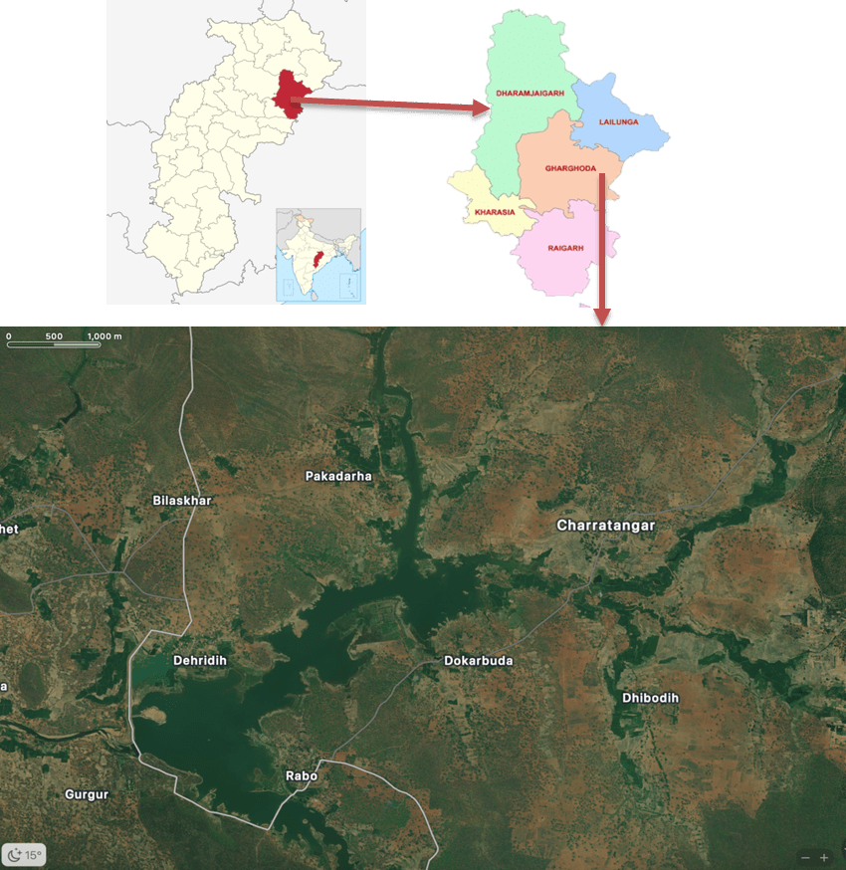
Figure 1: Study area, Rabo dam, Kurket River, Tehsil Tamnar in Raigarh District of Chhattisgarh State, India
2.2 Data Collection:
The study sites were visited between 7:00 am and 10:00 am, and 3:00 pm to 5:00 pm and Butterflies were photographed using DSLR/Coolpix cameras. Kehimkar (2016), a BNHS field guide, assisted with the identification, as did Smetacek (2016), Evans (1932), Blyth (1957), and Haribal (1992). Butterflies were photographed, and a checklist was prepared, including a comparison to prior surveys undertaken by Chandra et al. (2014) and Sisodia (2019) (Table 1).
Table 1. Updated checklist of Butterflies of Raigarh district
S. N. |  | Common Name | Scientific Name | Chandra et al., 2014 | Sisodia, 2019 | Present survey
Order : Lepidoptera
Super Family: Papilionoidea
Family: Papilionoidae
Sub family: Papilioninae
 | Lime Swallowtail |  | Papilio demoleus (Linnaeus, 1758) | + | + | +
 | Common Mormon |  | Papilio polytes (Linnaeus, 1758) | + | + | +
- # | Common Banded Peacock |  | Papilio crino Fabricius, 1793 | - | - | +
- # | Common Mime |  | Papilio clytia Linnaeus, 1758 | - | - | +
- # | Common Jay |  | Graphium doson (C. & R. Felder, 1864) | - | - | +
 | Blue Mormon |  | Papilio polymnestor Cramer, 1775 | + | + | +
 | Common Rose |  | Pachliopta aristolochiae(Fabricius,1775) | - | + | -
Family: Pieridae
Sub Family: Coliadinae
 | Common Emigrant |  | Catopsilia pomona (Fabricius, 1775) | + | + | +
 | Mottled Emigrant |  | Catopsilia pyranthe (Linnaeus, 1758) | - | + | +
 | Common Grass Yellow |  | Eurema hecabe (Linnaeus, 1758) | - | + | +
 | Small Grass Yellow |  | Eurema brigitta (Stoll, [1780]) | - | + | +
 | Spotless GrassYellow |  | Eurema laeta (Boisduval,1836) | - | + | -
Sub Family: Pierinae
 | Psyche |  | Leptosia nina (Fabricius,1793) | - | + | -
 | Common Jezabel |  | Deliaseucharis (Drury, 1773) | + | + | -
Family: Lycaenidae
Sub Family: Polyommatinae
 | Common Pierrot |  | Castalius rosimon (Fabricius, 1775) | - | + | +
- # | Lesser Grass Blue |  | Zizina otis (Fabricius, 1787) | - | - | +
- # | Dark Grass Blue |  | Zizeeria karsandra (Moore, 1865) | - | - | +
 | Pale Grass Blue |  | Pseudozizeeria maha (Kollar,[1884]) | - | + | -
 | Common Line blue |  | Prosotas nora (C. Felder, 1860) | - | + | +
 | Tailless Lineblue |  | Prosotas dubiosa (Semper, [1879]) | - | + | +
- # | Common Hedge Blue |  | Acytolepis puspa (Horsfield, [1828]) | - | - | +
- # | Gram Blue |  | Euchrysops cnejus (Fabricius, 1798) | - | - | +
 | Lime Blue |  | Chilades lajus (Stoll, [1780]) | - | + | +
 | Common Cerulean |  | Jamides celeno (Cramer,[1775]) | - | + | -
 | Zebra Blue |  | Syntarucus plinius (Fabricius,1793) | + | + | -
 | Bright BabulBlue |  | Azanusu baldus (Stoll, [1782]) | - | + | -
Sub Family: Theclinae
- # | Common Shot Silverline |  | Spindasis ictis (Hewitson, 1865) | - | - | +
- # | Peacock Royal﻿ |  | Tajuria cippus (Fabricius, 1798) | - | - | +
- # | Large Oakblue |  | Arhopala amantes (Hewitson, 1862) | - | - | +
- # | Purple Leaf Blue |  | Amblypodia anita Hewitson, 1862 | - | - | +
Family: Hesperiidae
Sub family : Coeliadnae
 | Common Banded Awl |  | Hasora chromus (Cramer, [1780]) | + | + | +
 | Brown Awl |  | Badamia exclamationis (Fabricius,1775) | + | + | -
Family: Nymphalidae
Sub Family: Danainae
 | Plain Tiger |  | Danaus chrysippus (Linnaeus, 1758) | + | + | +
 | Common Tiger |  | Danaus genutia (Cramer,[1779]) | + | + | +
 | Blue Tiger |  | Tirumala limniace (Cramer,[1775) | + | + | +
 | Common Crow |  | Euploea core (Cramer, [1780]) | + | + | +
Subfamily: Charaxinae
 | Plain Tawny Rajah |  | Charaxes psaphon Westwood,1874 | - | + | -
Sub Family: Satyrinae
- # | Common Evening Brown |  | Melanitis leda (Linnaeus, 1758) | - | - | +
 | Common Palmfly |  | Elymnias hypermnestra (Linnaeus, 1763) | - | + | +
- # | Common Bushbrown |  | Mycalesis perseus (Fabricius, 1775) | - | - | +
- # | Bamboo Treebrown |  | Lethe europa (Fabricius, 1775) | - | - | +
- # | Dark Evening Brown |  | Melanitis phedima (Cramer, [1780]) | - | - | +
Sub family: Heliconiinae
- # | Common Leopard |  | Phalanta phalantha (Drury, [1773]) | - | - | +
Sub Family: Limenitidinae
 | Common Sailer |  | Neptis hylas (Linnaeus, 1758) | - | + | +
 | Short-bandedSailer |  | Phaedyma columella (Cramer,1780) | - | + | -
 | Baronet |  | Euthalia nais (Forster, 1771) | - | + | +
 | Commander |  | Moduza procris (Cramer,[1777]) | - | + | -
 | Common Castor |  | Ariadne merione (Cramer,[1777]) | + | + | -
- # | Grey Count |  | Tanaecia lepidea (Butler, 1868) | - | - | +
Sub Family: Nymphalinae
 | Peacock Pansy |  | Junonia almana (Linnaeus,1758) | + | + | +
 | Gray Pansy |  | Junonia atlites (Linnaeus, 1763) | + | + | +
 | Lemon Pansy |  | Junonia lemonias (Linnaeus, 1758)) | - | + | +
 | Chocolate Pansy |  | Junonia iphita (Cramer, [1779]) | - | + | +
 | Yellow Pansy |  | Junonia hierta (Fabricius,1798) | - | + | -
 | Blue Pansy |  | Junonia orithya (Linnaeus, 1758) | + | + | +
 | Great Eggfly |  | Hypolimnas bolina (Linnaeus, 1758) | - | + | +
 | Danaid Eggfly |  | Hypolimnas misippus (Linnaeus,1764) | - | + | -
Sub Family: Acraeinae
 | Tawny Coster |  | Acraea violae (Fabricius, 1793) | - | + | +
S. N. with # denotes that the species has been recorded in the present survey for the Raigarh District.

3. results and discussion

The present study deals the first comprehensive checklist of butterflies in Raigarh district observed at Rabo Dam which resulted with 58 species of butterflies. Out of 58 species of documented butteflies, 41 species were recorded during present survey including 17 new records for the district butterflies of Raigarh. The study area Rabo Dam shows a good microhabitat quality which includes aquatic, riparian and terrestrial habitats are well known to inhabited by lepidopteron diversity due to availability of nectar and larval host plant (Kunte, 2000). The species composition and diversity shows significant variation while comparing with earlier survey.
Present survey shows the dominance of family Nymphalidae with 47 percent closely followed by Family Lycaenidae with 28 percent species (Figure 2 & 3) richness in the study area which is aligned with previous studies in Central India (Smetacek, 2015; Singh & Pandey, 2017) which suggesting that the survey area has varied habitat conditions and ecological advantages. Family Lycaenidae showes less diversity n this report due to most of the Lycaenidae butterflies prefers semi-urban wetland environment where they have their specialized host plants (Sharma et al., 2020).

Figure 2: Family wise Species Dominance in Percentage

Figure 3: Family wise Species Dominance in Percentage
We found that out of the 58 species documented, 12 species were reported across all three surveys, Chandra et al. (2014), Sisodia (2019) and present survey. Chandra et al. (2014), documented only 16 species from Raigarh and Sisodia (2019), have updated it with addition of 25 species. A significant addition of 17 new records in this survey indicates that the area specific study may increase many more species from the study area. The increase in species diversity may be due to seasonal variations, habitat changes, or enhanced survey techniques.

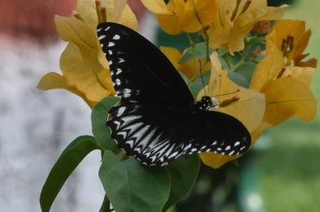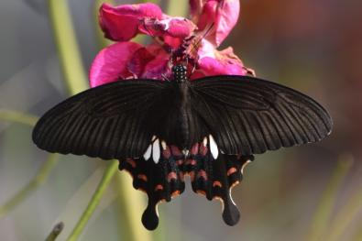
Image 1: Common Mime ©S K Patel Image 2: Common Mormon ©S K Patel
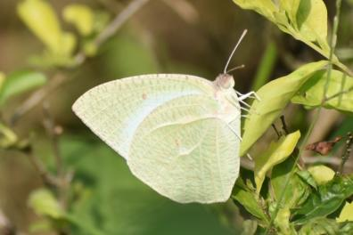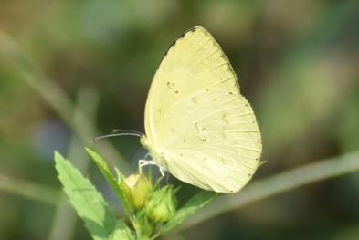
Image 3:Mottled Emigrant ©S K Patel Image 4: Common Grass Yellow©S K Patel
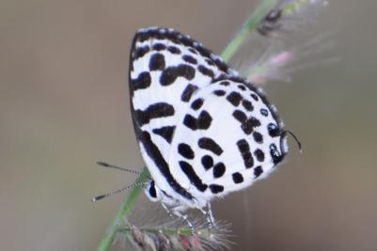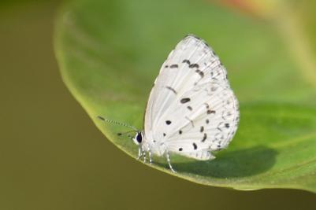
Image 5: Common Pierrot ©S K Patel Image 6: Common Hedge Blue ©S K Patel
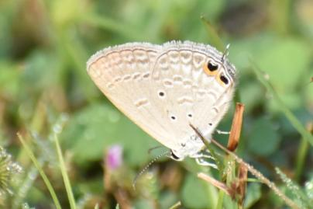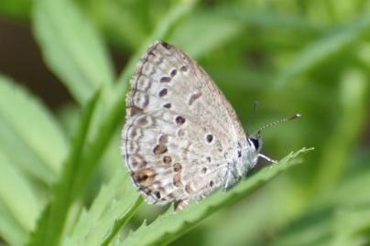
Image 7: Gram Blue ©S K Patel Image 8: Lime Blue ©S K Patel
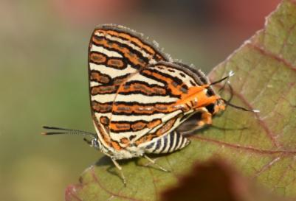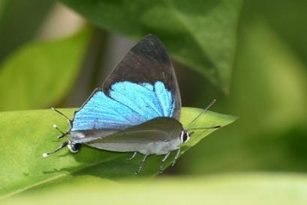
Image 9: Commmon shot Silverline ©S K Patel Image 10: Peacock Royal ©S K Patel
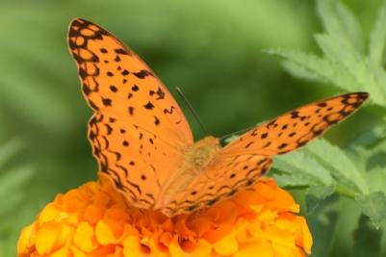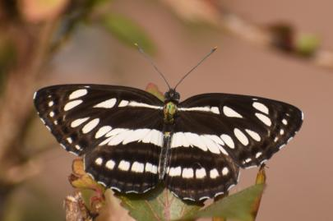
Image 11: Common Leopard ©S K Patel Image 12: Common Sailer ©S K Patel
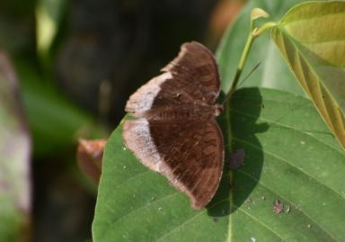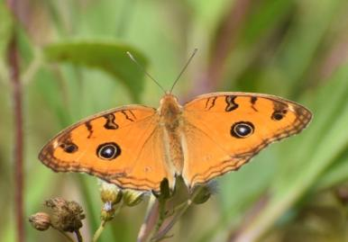
Image 13: Grey Count ©S K Patel Image 14: Peacock Pansy ©S K Patel
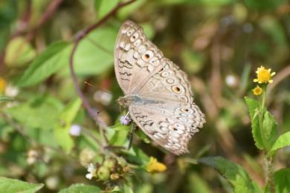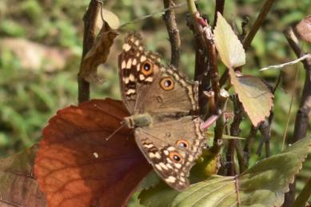
Image 15: Grey pansy ©S K Patel Image 16: Lemon Pansy ©S K Patel
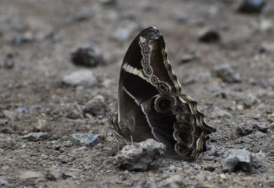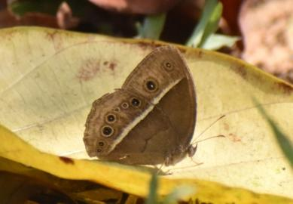
Image 17: Bamboo Tree brown ©S K Patel Image 18: Common Bushbrown ©S K Patel

4. Conclusion

The present study documents 58 species of butterflies from Raigarh District, with 41 species recorded in the present survey in which 17 species were first time documented for Raigarh district. This significant addition highlights the rich diversity of butterflies and it also emphasizes the importance of site specific survey. The variation in species composition compared to previous studies by Chandra et al. (2014) and Sisodia (2019) suggests that seasonal changes and improved survey efforts may key role to assess the local biodiversity in specific habitats.

Consent (where ever applicable)

NA

Ethical approval (where ever applicable)

NA

References

Abrol, D. P., & Abrol, D. P. (2012). Pollinators as bioindicators of ecosystem functioning. Pollination biology: Biodiversity conservation and agricultural production, 509-544.
Betham J.A. (1890). The butterflies of the Central Provinces. Journal of the Bombay Natural History Society, 5: 19–28; 151–161; 279–286.
Bouyer, J., Sana, Y., Samandoulgou, Y., Cesar, J., Guerrini, L., Kabore-Zoungrana, C., & Dulieu, D. (2007). Identification of ecological indicators for monitoring ecosystem health in the trans-boundary W Regional park: A pilot study. Biological conservation, 138(1-2), 73-88.
Chandra K., Raha A., Majumder A., Gupta R. (2014). New records and updated list of butterflies (Lepidoptera: Rhopalocera) from Chhattisgarh, Central India. Records of the Zoological Survey of India, 114: 233–250.
Chandra K. (2006). The butterflies (Lepidoptera: Rhopalocera) of Kangerghati National Park (Chhattisgarh). Advancement in Indian Entomology: Productivity and Health, 11: 83–88.
Chandra K., Sharma R.M., Singh A., Singh R.K. (2007). A checklist of butterflies of Madhya Pradesh and Chhattisgarh states, India. Zoos’ Print Journal, 22(8): 2790–2798.
d'Abreu E.A. (1920). Some insect prey of birds in the Central Provinces.
Dubey S., Agarwal R.K., Mondal S. (2015). New records of butterflies (Lepidoptera: Hesperiidae) in Bastar District (C.G.), India. Biolife, 3(2): 528–532.
Ehrlich, P. R. (1984). The structure and dynamics of butterfly populations. The biology of butterflies, 25-40.
Evans W.H. (1932). The Identification of Indian Butterflies. 2nd ed. Bombay Natural History Society, Bombay; 455 pp., 32 plates.
Forsayeth R.W. (1884). Life history of sixty species of Lepidoptera observed in Mhow, Central India. Transactions of the Entomological Society of London, 3: 377–419.
Ghazanfar, M., Malik, M. F., Hussain, M., Iqbal, R., & Younas, M. (2016). Butterflies and their contribution in ecosystem: A review. Journal of Entomology and Zoology Studies, 4(2), 115-118.
Gupta I.J., Shukla J.P.N. (1987). Butterflies from Bastar District, Madhya Pradesh, India.
Haribal M. (1992). The Butterflies of the Sikkim Himalaya and Their Natural History. Sikkim Nature Conservation Foundation, Gangtok; 217 pp.
Heppner J.B. (1998). Classification of Lepidoptera. In: Holarctic Lepidoptera, 5(Suppl. 1): 1–148.
Jangde, K. K., Kumar, A., Tandan, H. N., & Prasad, S. K. (2023). Biodiversity of butterflies (Lepidoptera) in Janjgir-Champa, with one addition to the state fauna of butterflies of Chhattisgarh. Journal of Experimental Zoology India, 26(1), 1279–1284. https://doi.org/10.51470/jez.2023.26.1.1279
Kehimkar, I. (2016). Butterflies of India. Bombay Natural History Society & Oxford University Press
Kunte, K., & Basu, D. N. (2024). Two new taxa of brush-footed butterflies (Lepidoptera: Nymphalidae) from the Western Ghats biodiversity hotspot, southern India. Zootaxa, 5543(3), 343-367.
Major (Druce, 1895)]: A New Record for Butterflies in Chhattisgarh, India”. Annual Research & Review in Biology 39 (9):178-83. https://doi.org/10.9734/arrb/2024/v39i92132.
Morgan, M. T. (2000). Evolution of interactions between plants and their pollinators. Plant Species Biology, 15(3), 249-259.Mitchell, R. J., Irwin, R. E., Flanagan, R. J., & Karron, J. D. (2009). Ecology and evolution of plant–pollinator interactions. Annals of botany, 103(9), 1355-1363.
Sharma R.M., Chandra K. (2009). First report of the occurrence of some rare butterflies (Lepidoptera: Rhopalocera) from Chhattisgarh, Central India. Records of the Zoological Survey of India: 33–36.
Siddiqui A., Singh S.P. (2004). A checklist of the butterfly diversity of Panna Forest (M.P.). National Journal of Life Sciences, 1(2): 403–406.
Sisodia A. (2019). Butterflies (Lepidoptera: Papilionoidea) of Chhattisgarh, India. Bionotes, 21(4): 116–141.
Smetacek, P. (2016). A naturalist's guide to the butterflies of India, Pakistan, Nepal, Bhutan, Bangladesh and Sri Lanka (176 pp.). John Beaufoy Publishing Ltd.Tandan, H. N., Chand, G., Naidu, R., & Tandan, S. (2020). Butterflies of Government Nursery, Bhatagaon, Chhattisgarh, with two additions to the state fauna. Bionotes, 22(3), 195–201.
Swinhoe C. (1885). On the Lepidoptera of Bombay and the Deccan. Part I–IV. Proceedings of the Zoological Society of London, 1885: 124–148.
Talbot G. (1947). The Fauna of British India, Including Ceylon and Burma. Butterflies, Vol. II. London: Taylor and Francis Ltd.
Tandan, H. N., Naidu, R., Chand, G., & Sampat, G. D. (2021). Butterflies of Tatamari Eco Centre, Chhattisgarh, India. Zoo’s Print, 36(9), 1–6.
Tandan, H. N., P. Vishwanathan, C. Shrimali, R. Sultana, G. Chand, R. Naidu, S. K. Patel, S. D. Bervanshi, P. K. Bhardwaj, L. B. Lama, and V. Rajan. (2024a). “Common Tinsel [Catapaecilma
Tandan, H., Naidu, R., Chand, G., Patel, S., Nag, G., Kumar, S., Jain, V., Bhoi, A., Agrawal, R., Lama, L., & Biswas, J. (2024b). Butterfly species diversity in Udanti Wildlife Sanctuary, Gariaband: An addition of two species to state faunal records of Chhattisgarh, India. Ambient Science, 11(1), 10–19. https://doi.org/10.21276/ambi.2024.11.1.aa03
Tandan, H. N., & Vishwanathan, P. (2024c). Addition of Erionota thrax (Linnaeus, 1767) to the butterfly (Lepidoptera: Rhopalocera) fauna of Chhattisgarh State. African Journal of Biological Sciences, 6(14), 8042–8049. https://doi.org/10.48047/AFJBS.6.14.2024.8042-8049
Varshney R.K. (2006). An estimate of the numbers of butterfly species in the Indian Region. Bionotes, 8(3): 61–63.
Varshney, R. K., & Smetacek, P. (Eds.). (2015). A synoptic catalogue of the butterflies of India (p. 54). Butterfly Research Centre, Bhimtal & Indinov Publishing. https://doi.org/10.13140/RG.2.1.3966.2164.
Witt D.O. (1909). The butterflies (Rhopalocera) of the Nimar district, Central Provinces. Journal of the Bombay Natural History Society, 19(3): 564–571.
Wynter-Blyth M.A. (1957). Butterflies of the Indian Region. Bombay Natural History Society, Bombay.

