Effective Control and Eradication of Mycoptes musculinus in Research Mice Colonies


Abstract

Infestations of Mycoptes musculinus are significant pests of laboratory mouse colonies, compromising both animal welfare and research outcomes. This study reports an eradication program developed for identifying, controlling, and eradicating Mycoptes musculinus within a research facility. The first onset of clinical signs, excessive grooming, hair loss, and scaling, prompted testing including cellophane tape tests, skin scrapings, and PCR for quick and accurate confirmation of infestation. In addition to microscopic examination that allowed differentiation of sexual dimorphism in mites, such precise identification further enhanced understanding of population dynamics concerning this outbreak .

To combat the infestation, we implemented an integrated eradication strategy: affected mice were isolated and humanely euthanized, potential wild rodent access points were sealed with plaster of Paris, and environmental disinfection protocols were initiated. Cages were treated with an ivermectin injection Hitek (1:50 dilution), and contaminated facility areas were mopped with Butox solution (5 ml/L). Regular follow-up inspections over three months demonstrated effective control, with no reoccurrence of mites.

The outcomes highlight that a rapid response, combined with environmental control and strategic use of disinfectants, can achieve lasting eradication of Mycoptes musculinus in laboratory settings. This approach underscores the importance of early detection, meticulous containment, and continuous monitoring to prevent future outbreaks. Insights from this case provide a framework for refining mite management protocols, exploring alternative treatments, and advancing biosecurity practices in research animal facilities.

Keywords:

Mycoptes musculinus ,Mite infestation control, Parasite management, Mite prevention methods

Introduction

Mycoptes musculinus is the fur mite of mice and is very dangerous because of the possible effects on animal health, welfare, and experimental outcomes. In fact, it imposes severe stress on mice, altering the immune responsiveness and thus perhaps affecting the experimental outcome, particularly those that pertain to immunology or behavioral studies. Such sudden appearance of clinical signs like itching, excessive grooming, and hair loss in our facility against this background was a clarion call for the confirmation and subsequent control of such an infestation.
Given the limitation in resources, especially in a small isolation area that could not accommodate the affected mice outside the healthy population, we could not take the usual containment procedure. Thus, we devised a special procedure which worked around these limitations by integrating strategic euthanasia of heavily infested animals, symptomatic containment procedures, and environmental disinfection throughout the facility (Fox et al., 2002). The immediate control and long-term prevention, of course, dealt with modifications in standard practices to the specific layout and operational demands at our facility.
We describe herein the details of our diagnostic procedures, including microscopic and molecular confirmation, as well as customized control measures adopted like environmental disinfection, sealing potential sources of re-infestation, and routine monitoring (Lindstrom et al., 2011; Lee et al., 2019). Our experience underlines the flexibility in laboratory management for the effective eradication of pests and safeguarding the research environment for continued high-quality experimental work.

Materials and Methods

- Clinical Observation
Clinical symptoms in the mice were the basis for the initial identification of Mycoptes musculinus. Clinical signs among the afflicted mice include itching, undue self-grooming, scratching more frequently, loss of hair, scaly skin in chronic conditions, and a change of the general coat condition to a rough or unkempt appearance. This contrasts the normal appearance of the mice coat, which is characteristically glossy and smooth (Fox et al., 2002; Percy & Barthold, 2007).

Cellophane Tape Test
To ensure that Mycoptes musculinus was indeed present on the surface of the skin, a small piece of clear tape was lightly pressed onto the lesion area of mouse skin and fur to pick up mites. Later on, the mites were examined under the light microscope at 40x and 100x (Baker, 2007). Mites are identified by their typical oval bodies, with eggs as small translucent structures attached to fur or skin debris.

Skin Scraping and Processing
Skin scrapings from the affected areas were taken for further confirmation of the infestation and collection of more material for analysis. The samples were dissolved in the KOH solution, and the isolated mites were observed under a microscope to confirm the infestation. (Bino Sundar et al., 2017)

Direct PCR Analysis
Molecular confirmation for a portion of the dissolved sample from KOH treatment was done using specific primers for Mycoptes musculinus according to Lee et al. 2019. The PCR products on an agarose gel (2%) stained with ethidium bromide were viewed under a chemidoc system. It was expected to show bands at 100 kb corresponding to Mycoptes musculinus.

Results

The clinical examination was performed based on general symptoms of Mycoptes musculinus infection. Confirmation was by microscopic examination of the cellophane tape test and skin scraping, together with the PCR confirmation using mites-specific primers, confirming the above-mentioned infestation, where the expected 100-bp band of PCR products was found according to Lee et al., 2019.

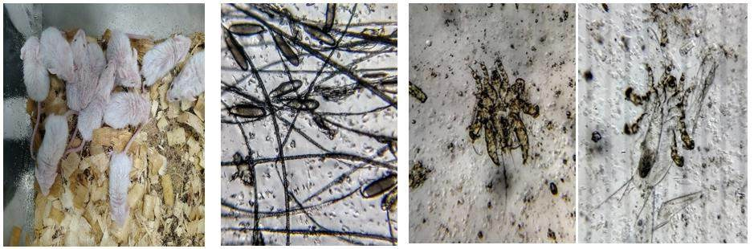

Fig 1 : Mouse pups exhibiting signs of Mycoptes musculinus
Fig 2 : Mycoptes musculinus eggs adhered to hair shafts.
Fig 3 (a) Adult male Mycoptes musculinus
(b) Adult female Mycoptes musculinus

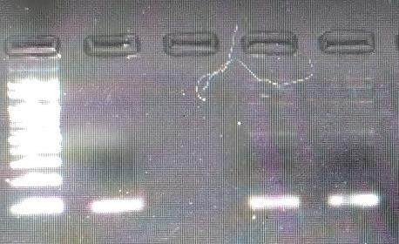
With only limited isolation space, the strategy had to be the isolation of as many affected animals as possible, paralleled by the euthanizing of heavily infested mice to prevent further spread within the colony. While small isolation capacity may pose some logistical challenge, we have ensured source control and disinfection. Entry points for wild rodents were located and sealed with plaster of Paris, removing any potential sources
100 kb
ladder
Positive
sample
Negative
sample
Positive
sample
of reinfestation from outside the facility. Facility-wide disinfection practices consisted of an ivermectin 1 : 50 dilution for treating cages. Cage fumigation was conducted concurrently with a weekly facility-wide mopping practice utilizing Butox until the colony was free of remaining residual populations of mites (Percy & Barthold, 2007).
Fig 4 : PCR product of Mycoptes musculinus showing a distinct 100 bp band after gel electrophoresis

Monthly monitoring demonstrated no recolonization at the end of the third month and confirmed the efficacy and efficiency of our strategy for the elimination of Mycoptes musculinus both in the facility and throughout the colony.

Discussion
Eradication of Mycoptes musculinus thus points to the efficacy of combining target diagnostic techniques with customized control measures. Clinical observations of itching, excessive grooming, and visible hair loss initially pointed toward a probable mite infestation; confirmation to accuracy, however, was obtained

with diagnostic steps such as the cellophane tape test, skin scraping, and PCR analysis. This suggests a multi-layered approach and hence a need for thorough diagnostic protocols in laboratory settings.
These facility-specific constraints, such as the limitation of isolation space, required a flexible response. The euthanization of heavily infested cases while isolating the remaining affected animals helped manage containment risks. Our experience emphasizes the need for ample, well-ventilated areas of isolation for biosecurity in laboratory facilities (Fox et al., 2002; Percy & Barthold, 2007).
Beyond isolation, environmental control focused on sealing entry points for wild rodents and using targeted disinfection protocols with ivermectin and Butox to eliminate mites in cage environments, emphasizing how regular disinfection is crucial for sustaining a mite-free colony. Follow-up inspections performed on a periodic basis confirmed success with our disinfection protocols, preventing recurrence by underscoring the need for routine monitoring.

Conclusion

Our study demonstrates that a structured, targeted approach integrating diagnostics, customized isolation protocols, and rigorous environmental control effectively mitigates Mycoptes musculinus infestations in laboratory mouse colonies. Adapted strategies of selective euthanasia, barrier reinforcement, and stringent disinfection protocols controlled the parasite infestation despite challenges posed by limited isolation space without compromising the health of unaffected animals. Sustained elimination of the mites shows that proactive management and complete disinfection are required for protecting research integrity against such issues.

References

  - Baker DG (2007) Flynn’s parasites of laboratory animals, 2nd edn. American College of
Laboratory Animal Medicine, Blackwell Publishing, Iowa, USA, pp 361–363, pp 438–440.
  - Bino Sundar ST, Harikrishnan TJ, Latha BR, Gomathinayagam S, Srinivasan MR, Ramesh S (2017) Incidence of fur mite infestation in laboratory rodents. J Parasit Dis 41(2):383–386. DOI: 10.1007/s12639-016-0811-4.
  - Fox JG, Anderson LC, Loew FM, Quimby FW (2002) Laboratory animal medicine. 2nd edn. Academic Press, New York.
  - Lee MA, Shen Z, Holcombe HR, Ge Z, Franklin EG, Ricart Arbona RJ, Lipman NS, Fox JG, Sheh A (2019) Detection of Myocoptes musculinus in Fur Swab and Fecal Samples by Using PCR Analysis. J Am Assoc Lab Anim Sci 58(6):796–801. DOI: 10.30802/AALAS-JAALAS-19- 000046.

  - Lindstrom KE, Carbone LG, Kellar DE, Mayorga MS, Wilkerson JD (2011) Soiled bedding sentinels for detection of fur mites in mice. J Am Assoc Lab Anim Sci 50:54–60.
  - Percy DH, Barthold SW (2007) Pathology of laboratory rodents and rabbits. Iowa State University Press, Ames.
  - Sahinduran S, Ozmen O, Haligur M, Yukari BA (2010) Severe Myocoptes musculinus infestation and treatment in laboratory mice. Ankara Üniv Vet Fak Derg 57:73-75.

