Review Article
BAUHINIA VARIEGATA LINN. (FABACEAE): BOTANICAL INSIGHTS, BIOACTIVE CONSTITUENTS AND FUTURE IN NUTRACEUTICALS & DRUG DEVELOPMENT

Abstract
Bauhinia variegata Linn. (Fabaceae), commonly known as Kachnar or Mountain Ebony, is a culturally revered tree that bridges the domains of traditional medicine, nutrition, and ornamental horticulture. Beyond its striking morphology, the species is a reservoir of structurally diverse phytoconstituents, particularly flavonoids, triterpenoids, sterols, and phenolic acids, which underpin a wide spectrum of pharmacological activities. Preclinical investigations reveal promising antioxidant, antimicrobial, anti-inflammatory, antidiabetic, hepatoprotective, and anticancer effects, largely mediated through modulation of oxidative stress pathways, glycaemic enzymes, and inflammatory mediators. Despite centuries of use in Ayurveda, Siddha, and Unani formulations, modern pharmacological validation and clinical data remain sparse. This review consolidates current knowledge on the taxonomy, phytochemistry, pharmacological activities, and toxicological aspects of B. variegata, while highlighting critical knowledge gaps and future directions. Emphasis is placed on challenges of species authentication, standardization, bioavailability enhancement, and translational research. By integrating traditional wisdom with modern scientific insights, this article underscores the untapped potential of B. variegata as a candidate for evidence-based phytopharmaceutical and nutraceutical development.
Keywords
Bauhinia variegata; Fabaceae; phytochemistry; pharmacological activities; traditional medicine; Kachnar; antioxidant; antidiabetic; hepatoprotective; anticancer; Ayurveda; ethnomedicine; nutraceuticals; herbal drug development.
Introduction
For centuries, medicinal plants have served as nature’s silent laboratories, providing structural prototypes that continue to inspire novel therapeutics for complex human diseases. Among these, Bauhinia variegata Linn. (Fabaceae)—popularly known as “Kachnar” or “Mountain Ebony”—stands out not merely as an ornamental tree but as a botanical bridge between culture, nutrition, and medicine. Its striking bilobed leaves, reminiscent of a camel’s hoof, and vibrant orchid-like blossoms have made it a subject of admiration in floriculture, while its edible flower buds form a staple in traditional cuisines, embedding the species into both ecological landscapes and human livelihoods.
The chronicle of B. variegata is deeply rooted in classical botanical literature. It was first comprehensively catalogued in The Flora of British India by Hooker (1879) and later refined in the Flora of China (Flora of China Editorial Committee, 2010), where taxonomic nuances within the genus Bauhinia were elaborated. Such historical records not only affirm its geographical distribution across South and Southeast Asia but also underline its enduring botanical significance.
At a molecular level, B. variegata is a reservoir of phytochemical diversity. Flavonoids such as quercetin, rutin, and kaempferol; triterpenoids like lupeol and betulinic acid; sterols including β-sitosterol; and a variety of phenolic acids have been identified from its leaves, bark, flowers, and roots. These compounds orchestrate a wide array of pharmacological activities—antioxidant, antimicrobial, anti-inflammatory, hepatoprotective, antidiabetic, and anticancer—demonstrating a sophisticated biochemical toolkit. Notably, many of these effects mirror traditional ethnomedicinal practices, where B. variegata has been employed in Ayurveda and Unani systems for the treatment of ulcers, glandular swellings, and skin ailments.
Despite this rich heritage and promising preclinical evidence, B. variegata remains underexplored in modern translational research. Gaps persist in areas such as compound standardization, mechanistic validation, clinical efficacy, and safety profiling—critical steps for transforming ethnomedicinal wisdom into evidence-based therapeutics. By integrating historical context, phytochemical richness, and pharmacological insights, this review repositions B. variegata as more than a traditional remedy—it is a candidate for future phytopharmaceutical innovation and sustainable drug discovery.[1-7]
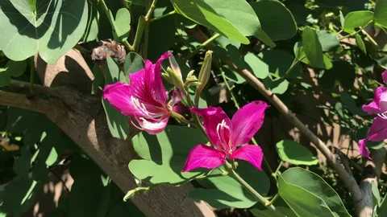
Fig 1 : Flower of B. variegata
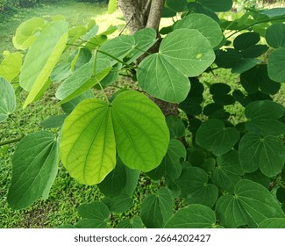
Fig 2 : Leaves of B. variegata
Botanical Classification
- Kingdom: Plantae
- Clade: Angiosperms
- Clade: Eudicots
- Clade: Rosids
- Order: Fabales
- Family: Fabaceae (Leguminosae)
- Genus: Bauhinia
- Species: Bauhinia variegata L.
- Common Names: Kachnar (Hindi/Urdu), Mountain Ebony (English), Camel’s Foot Tree.
- Description:
A medium-sized deciduous tree, reaching up to 10–12 meters in height. It has distinctive bilobed leaves resembling a camel’s hoof, and showy, orchid-like flowers in shades of pink, purple, or white. The tree produces flat seed pods.
Geographical Distribution
- Native Range: Southeast Asia, the Indian Subcontinent, and Southern China.
- Cultivation: Widely grown as an ornamental plant in tropical and subtropical regions around the world, including Africa, the Middle East, and the Americas.
- Habitat: Thrives in dry to moist deciduous forests, rocky hillsides, and along roadsides. It is tolerant of a range of soils but prefers well-drained conditions.
Cultural and Traditional Significance
- In South Asia (India, Nepal, Pakistan):
  - The tree (Kachnar) holds medicinal, nutritional, and ornamental value.
  - Its flower buds are edible and widely used in curries, pickles, and traditional dishes.
  - The bark, roots, and flowers are employed in Ayurvedic and Unani medicine for treating ailments like diarrhea, ulcers, skin diseases, and infections.
- Religious & Symbolic Role:
  - In Hindu traditions, Bauhinia trees are often planted near temples and considered sacred due to their resilience and beauty.
  - In Buddhism, the orchid-like flowers symbolize purity and divine beauty.
- Economic & Ornamental Uses:
  - Cultivated extensively as an ornamental street tree due to its vibrant flowers and shade-giving canopy.
  - Used in traditional dyeing and as fodder in rural communities. [1-4]
Rationale and Scope of Review [ 1, 5-8]
Why is this plant important for phytochemistry and pharmacology
Rich, diverse phytochemistry
- Contains abundant flavonoids (e.g., quercetin, kaempferol, apigenin glycosides), tannins, saponins, triterpenes/sterols, phenolic acids, and unique lignans/napthoquinone-like constituents reported from bark/flowers/seeds
- Multiple plant parts (bark, buds, flowers, leaves, seeds) are bioactive—useful for chemotaxonomy and bioprospecting.
Validated pharmacological activities (preclinical)
- Antioxidant/anti-inflammatory: strong radical-scavenging and COX/LOX-related effects that underpin many disease models.
- Metabolic benefits: antidiabetic and α-glucosidase inhibition, improved glycemic markers in animal models; lipid-modulating signals also reported.
- Antimicrobial: activity against Gram+/- bacteria and some fungi, supporting traditional wound/GI uses.
- Gastroprotective & hepatoprotective: extracts protect against ulcer and liver injury models.
- Cytotoxic/anticancer leads: selective activity in tumor cell lines (mechanisms proposed: apoptosis, ROS modulation); aligns with the traditional Kanchanar use for glandular swellings/goiter in Ayurveda.
- Wound healing/dermatologic potentials via phenolics and flavonoids.
Strong ethnomedicinal relevance + food use
- Buds (“kachnar”) are eaten (curries/pickles) and widely used in Ayurveda/Unani, giving high translational relevance and community acceptance.
Formulation & value-chain potential
- Amenable to standardized extracts, polyherbal formulations (e.g., Kanchanar-based), and modern delivery (gels, films, nanoparticles); scope for green synthesis using phenolic-rich fractions.
Current gaps & what’s needed next
- Taxonomy & material identity
  - Confusion with B. purpurea and other Bauhinia in trade and papers; many studies don’t voucher-specimen their material.
Need: authenticated specimens, DNA barcoding, chemoprofiling to avoid species mix-ups.
- Standardization & reproducibility
  - Extracts vary by plant part, season, geography, solvent; few use marker compounds or full HPLC/LC–MS fingerprints.
Need: pharmacopeial monograph standards (assay ranges for key flavonoid markers), validated QC methods, stability data.
- From crude extracts to actives & mechanisms
  - Many reports stop at crude/semipurified extracts and screening assays.
Need: bioassay-guided isolation, structure elucidation, target identification (e.g., enzyme/receptor binding), pathway mapping (NF-κB, Nrf2, AMPK, α-glucosidase kinetics).
- Dose, PK/PD, and bioavailability
  - Sparse pharmacokinetics, metabolism, and oral bioavailability data for major constituents; food-matrix effects (since buds are eaten) are underexplored.
Need: ADME studies, metabolite ID, tissue distribution, human-relevant dosing.
- Safety/toxicology & herb–drug interactions
  - Limited repeat-dose toxicity, genotoxicity, reproductive tox; interactions with antidiabetics/anticoagulants not defined.
Need: OECD-compliant tox packages, CYP/UGT interaction panels, safety margins.
- Clinical evidence
  - Evidence largely preclinical; human data are minimal and often uncontrolled or polyherbal (can’t attribute effects to B. variegata alone).
Need: randomized, placebo-controlled trials on prioritized indications (e.g., post-prandial hyperglycemia, dyslipidemia, wound healing), with standardized extracts and biomarker outcomes.
- Formulation science
  - Few studies on enhanced delivery (solubility/bioavailability) or dermal penetration for wound/skin uses.
Need: solid dispersion, nanoemulsions, phospholipid complexes; in vitro–in vivo correlation.

- Sustainability & variability
  - Wild collection and phenological variability can affect chemistry and supply.
Need: Good Agricultural & Collection Practices (GACP), cultivation trials, chemo-ecological studies (soil/climate effects), and conservation genetics.
- Systems biology & multi-target validation
  - Activities likely polypharmacologic (e.g., antioxidant + enzyme inhibition + microbiome effects).
Need: metabolomics, network pharmacology, in vivo target engagement, and microbiome interaction studies.
- Quality control in commerce
  - Adulteration/substitution risks in raw drug markets.
Need: rapid ID tools (FT-IR/NIR chemometrics), barcode + LC–MS marker panels for surveillance.
Purpose of review
Botanical Description
Taxonomy of Bauhinia variegata
- Kingdom: Plantae
- Clade: Tracheophytes
- Clade: Angiosperms
- Clade: Eudicots
- Order: Fabales
- Family: Fabaceae (Leguminosae)
- Subfamily: Cercidoideae (formerly Caesalpinioideae)
- Tribe: Cercideae
- Genus: Bauhinia L.
- Species: Bauhinia variegata L.
Nomenclature
- Accepted Scientific Name: Bauhinia variegata L.
  - The “L.” indicates it was first validly described by Carl Linnaeus in Species Plantarum (1753).
- Synonyms:
  - Bauhinia candida Blanco
  - Bauhinia variegata var. candida Voigt
  - Phanera variegata (L.) Benth. (some modern classifications place Bauhinia spp. under the segregate genus Phanera)
- Common Names:
  - English: Mountain Ebony, Orchid Tree
  - Hindi/Urdu: Kachnar
  - Nepali: Koiralo
  - Chinese: 紫花羊蹄甲 (zi hua yang ti jia)
  - Sanskrit: Kanchanara
Taxonomic Notes
- Traditionally placed in Caesalpinioideae, but molecular phylogenetics (LPWG 2017) reclassified Bauhinia into Cercidoideae within Fabaceae.
- The genus Bauhinia is large (200+ species) and taxonomically complex. Some species have been transferred to segregate genera (Phanera, Schnella, Lasiobema) based on leaf and floral morphology plus DNA evidence.
- B. variegata is distinct for its bilobed leaves (camel’s foot-shaped) and large orchid-like flowers (pink, purple, or white). [2, 5, 7, 8]
Morphological Characteristics of Bauhinia variegata
1. Habit
- A medium-sized deciduous tree, typically 10–12 m tall, sometimes reaching 15 m.
- Trunk erect, bark gray-brown to dark brown, rough, and fissured.
2. Leaves
- Simple, alternate, and bilobed (camel’s foot–shaped).
- Length: 10–20 cm, width: 8–15 cm.
- Lobes rounded, nearly equal, separated about 1/3 to 1/2 of the leaf length.
- Upper surface: smooth and green; underside: paler and slightly pubescent in young leaves.
- Petiole: 2–3 cm long.
3. Flowers
- Large, showy, bisexual, zygomorphic, orchid-like.
- Color: pink, purple, or white, often variegated (hence the name variegata).
- Size: 8–12 cm across.
- Arranged in axillary or terminal racemes (4–8 flowers).
- Calyx: tubular, splitting irregularly.
- Corolla: 5 unequal petals, spreading, wavy margins.
- Stamens: usually 5 fertile (out of 10), long-exserted.
- Ovary: superior, sessile, slender style, small stigma.
4. Fruits and Seeds
- Pod (legume type): flat, linear, slightly curved, woody, 15–30 cm long, 1.5–2 cm wide.
- Pod contains 10–15 seeds, hard, brown, compressed, broadly ovoid.
- Pods dehiscent, splitting explosively when dry.
5. Root System
- Deep taproot system, with lateral roots; bark of roots and stem rich in tannins and bioactive compounds.

Fig 3 : Morphology of B. variegata
6. Phenology
- Flowering: February–April (before new leaves fully develop).
- Fruiting: May–June. [2,3,7]
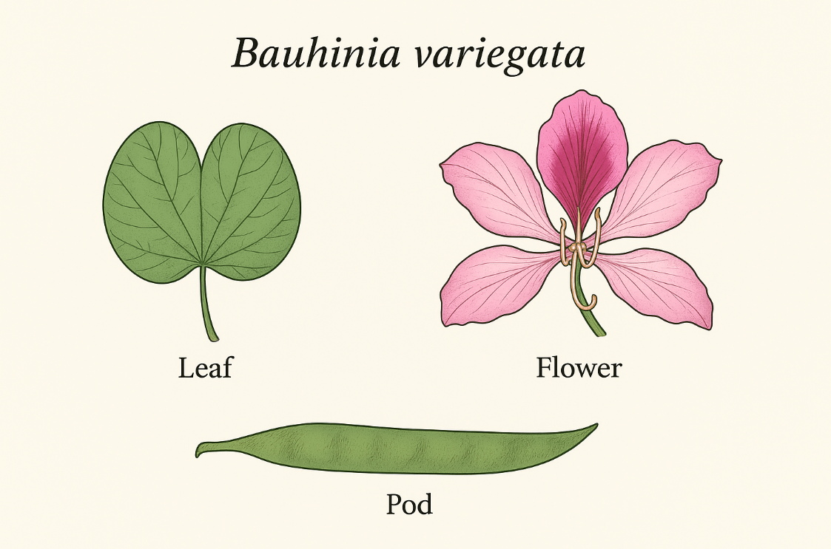
Growth and Ecological Requirements of Bauhinia variegata
1. Climate
- Prefers tropical and subtropical climates.
- Thrives in regions with hot summers and mild winters.
- Grows best in areas with annual rainfall of 500–1200 mm.
- Tolerates moderate drought, but not waterlogging.
- Optimal temperature range: 20–35 °C; sensitive to severe frost.
2. Soil
- Adapts to a wide range of soils: sandy loam, clay loam, and rocky soils.
- Prefers well-drained, fertile soils with moderate organic matter.
- pH tolerance: slightly acidic to neutral (6.0–7.5).
- Can tolerate poorer soils but shows reduced flowering and pod production.
3. Light
- A sun-loving tree; requires full sunlight for optimal flowering.
- Tolerates partial shade but with reduced growth and bloom.
4. Water
- Moderate water requirement.
- Tolerant of short dry spells due to its deep taproot system.
- Young plants need regular watering during establishment.
5. Growth Characteristics
- A moderately fast-growing tree, reaching 10–12 m in height in 8–10 years.
- Growth rate influenced by soil fertility and moisture.
- Deciduous: sheds leaves in dry season, flowers appear before new leaf flush (Feb–April).
- Pods ripen in May–June, with seeds dispersed explosively.
6. Ecological Role
- Ornamental value: widely planted as an avenue and shade tree.
- Soil fertility: contributes organic matter via leaf litter.
- Pollination: flowers attract bees, butterflies, and birds.
- Nitrogen fixation: unlike many legumes, Bauhinia variegata has weak nitrogen-fixing ability (some reports suggest little or no nodulation).
- Habitat: common in dry deciduous forests, foothills, and along roadsides. [1-3]

Phytochemistry
Metabolites of Bauhinia variegata
1. Primary Metabolites
(essential compounds for growth, development, and energy storage)
- Carbohydrates:
  - Starch, reducing sugars, and soluble polysaccharides in seeds and pods.
  - Flowers and buds are rich in starch and sugars, which contribute to their edible use.
- Proteins & Amino Acids:
  - Seeds contain proteins (up to 18–20%) with essential amino acids.
  - Presence of albumins and globulins reported.
- Lipids:
  - Seeds contain fixed oils with linoleic, oleic, palmitic acids.
- Nucleic acids & Organic acids:
  - Organic acids (oxalic, citric, malic) found in edible buds and leaves.
2. Secondary Metabolites
(plant defense, ecological adaptation, and pharmacological significance)

- Flavonoids (major class):
  - Quercetin, kaempferol, apigenin, rutin, luteolin glycosides.
  - These contribute to antioxidant, anti-inflammatory, and anticancer properties.
- Phenolic Compounds & Tannins:
  - Present in bark and roots (responsible for astringent activity).
- Sterols & Triterpenoids:
  - β-sitosterol, lupeol, betulinic acid, stigmasterol.
  - Contribute to anti-inflammatory and hepatoprotective activity.
- Alkaloids:
  - Trace alkaloids reported (less abundant than flavonoids).

- Saponins:
  - Detected in bark and leaves; associated with antimicrobial and cytotoxic activity.
- Glycosides & Napthoquinones:
  - Some unique glycosidic flavonoids reported; napthoquinone-like compounds isolated from stem bark with anticancer potential.
- Other notable metabolites:
  - Cyanogenic glycosides (in young plant parts, common to Fabaceae).
  - Lignans with antioxidant and cytotoxic potential. [9,10]
Major Compounds & Their Structures
1. Flavonoids (dominant class)
- Quercetin (3,3′,4′,5,7-pentahydroxyflavone)
Structure: flavonol backbone with 5 hydroxyl groups.
- Kaempferol (3,4′,5,7-tetrahydroxyflavone)
Similar to quercetin but with fewer hydroxyls.
- Apigenin (4′,5,7-trihydroxyflavone)
- Rutin (quercetin-3-O-rutinoside, a glycoside of quercetin).
- Luteolin (3′,4′,5,7-tetrahydroxyflavone).
2. Phenolic Compounds
- Gallic acid (3,4,5-trihydroxybenzoic acid).
- Ellagic acid (a dilactone of hexahydroxydiphenic acid).
3. Sterols & Triterpenoids
- β-sitosterol (a plant sterol structurally similar to cholesterol).
- Stigmasterol (a double-bonded sterol, precursor of vitamin D synthesis).
- Lupeol (pentacyclic triterpene alcohol).
- Betulinic acid (lupane-type triterpenoid with antitumor potential).
4. Saponins & Glycosides
- Glycosidic derivatives of flavonoids (e.g., rutin).
- Triterpenoid saponins (structures: glycosidic linkages on triterpene backbone).

5. Other notable phytoconstituents
- Cyanogenic glycosides (present in young leaves/seeds, typical of Fabaceae).
- Lignans (dimeric phenylpropanoids with antioxidant activity). [4,5,7]
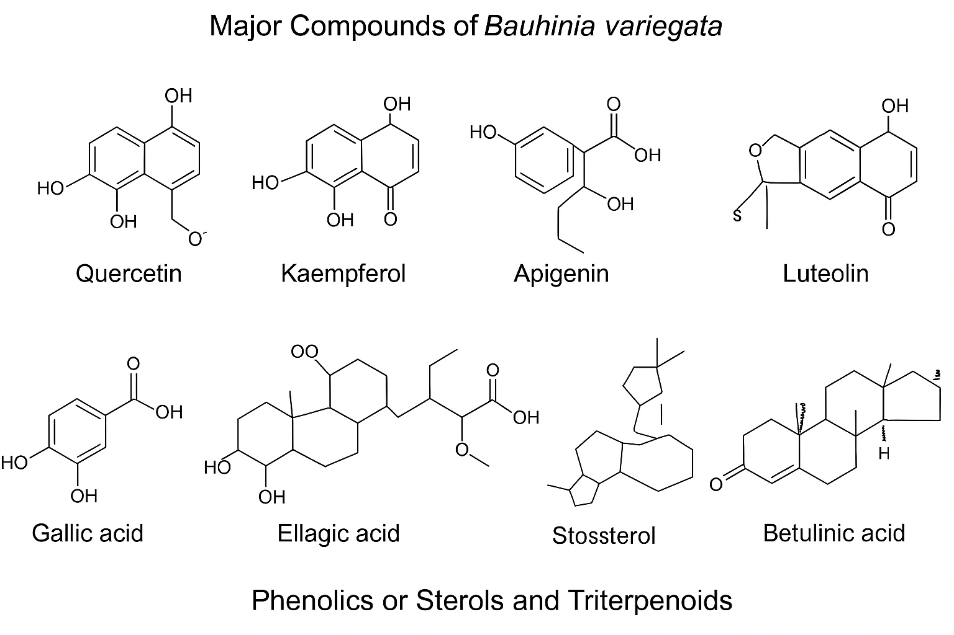

Fig 4 : Phenolics and triterpenoids

Extraction Methods
- Solvent Extraction (Conventional):
  - Common solvents: methanol, ethanol, chloroform, petroleum ether, water.
  - Methods: Soxhlet extraction, maceration, percolation.
  - Example: Methanolic extracts of bark and leaves yield flavonoids, phenolics, and tannins.
- Aqueous Decoction/Infusion (Traditional):
  - Used in ethnomedicine (boiling bark/flowers).
  - Extracts mostly polar metabolites (tannins, saponins, sugars).
- Successive Solvent Extraction:
  - Sequential use of solvents in order of polarity (hexane → chloroform → methanol → water).
  - Ensures comprehensive metabolite extraction.

- Advanced Methods:
  - Ultrasound-Assisted Extraction (UAE): Enhances yield and reduces solvent/time.
  - Microwave-Assisted Extraction (MAE): Efficient for phenolics/flavonoids.
  - Supercritical Fluid Extraction (SFE): Mostly for lipophilic compounds (triterpenoids, sterols).
Identification and Characterization Methods
- Preliminary Phytochemical Screening:
  - Chemical tests (e.g., Shinoda test for flavonoids, Liebermann–Burchard test for sterols, foam test for saponins).
- Spectroscopic Methods:
  - UV–Vis Spectroscopy: Quick detection of flavonoids and phenolics.
  - Fourier Transform Infrared Spectroscopy (FTIR): Functional group analysis.
- Chromatographic Techniques:
  - Thin Layer Chromatography (TLC): Rapid separation and identification.
  - High-Performance Liquid Chromatography (HPLC): Quantification of flavonoids (e.g., quercetin, kaempferol).
  - Gas Chromatography–Mass Spectrometry (GC–MS): Identification of volatile/non-polar compounds.
  - Liquid Chromatography–Mass Spectrometry (LC–MS/MS): Structural elucidation of complex glycosides and flavonoids.
- Advanced Structural Characterization:
  - Nuclear Magnetic Resonance (NMR – 1H & 13C): Detailed structure of isolated compounds.
  - X-ray Crystallography: Confirmation of purified compounds (rarely applied but reported for triterpenoids). [10-13]
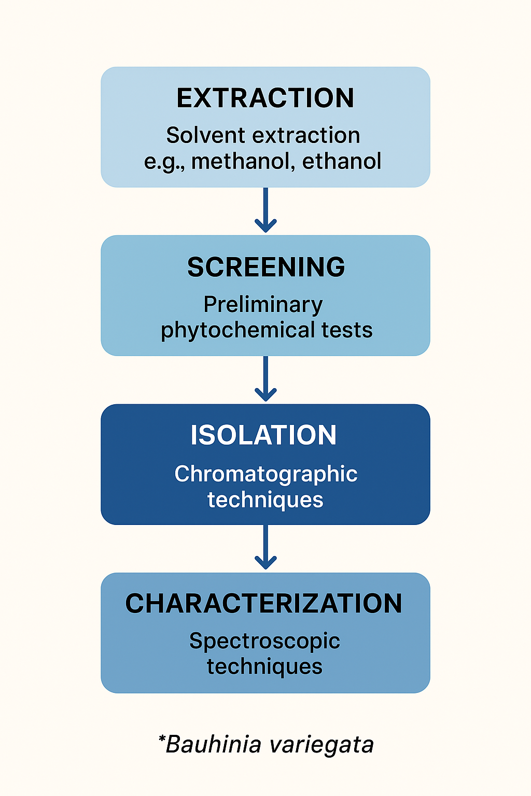
Fig 5 : Extraction and screening process
Pharmacological Activities of B. variegata
1. Antimicrobial Activity
- Extracts (methanolic, ethanolic, aqueous) show antibacterial effects against Staphylococcus aureus, Escherichia coli, Pseudomonas aeruginosa, and antifungal effects against Candida albicans.
- Activity attributed mainly to flavonoids, tannins, and phenolics.

2. Antioxidant Activity
- Bark and flower extracts exhibit significant DPPH and ABTS radical scavenging activity, owing to quercetin, kaempferol, rutin, and gallic acid.
3. Anti-inflammatory & Analgesic Activity
- Ethanolic bark extracts reduce carrageenan-induced paw edema and acetic acid-induced writhing in animal models.
- Likely mediated by flavonoids inhibiting prostaglandin synthesis.

4. Anticancer Activity
- Ethanolic flower extracts and isolated triterpenoids (lupeol, betulinic acid) show cytotoxicity against HeLa, MCF-7, and HepG2 cell lines.
- Mechanism: apoptosis induction via ROS generation.
5. Antidiabetic Activity
- Methanolic bark extracts inhibit α-amylase and α-glucosidase enzymes, reducing postprandial hyperglycemia.
- Isolated flavonoids improve glucose tolerance in animal models.
6. Hepatoprotective Activity
- Ethanolic bark extract protects against CCl₄- and paracetamol-induced liver injury by restoring antioxidant enzymes (SOD, CAT, GPx).
7. Immunomodulatory Activity
- Flower extracts enhance humoral antibody response and delayed-type hypersensitivity in animal models.
8. Antiulcer Activity
- Ethanolic bark extracts reduce gastric ulcer index in pylorus ligation and ethanol-induced ulcer models.
9. Wound Healing Activity
- Topical formulations of bark extract accelerate epithelialization, collagen deposition, and wound contraction in excision wound models. [7, 14-16]
Table 1 : Pharmacological Activity
Pharmacological Activity | Extract Used | Model/Test | Outcome
Antimicrobial | Methanolic, ethanolic, aqueous extracts of bark & leaves | Agar diffusion assay (bacteria: S. aureus, E. coli, P. aeruginosa; fungi: C. albicans) | Significant inhibition zones, indicating antibacterial and antifungal effects
Antioxidant | Bark & flower methanolic/ethanolic extracts | DPPH, ABTS radical scavenging assays | Strong antioxidant activity due to flavonoids (quercetin, rutin, kaempferol)
Anti-inflammatory & Analgesic | Ethanolic bark extract | Carrageenan-induced paw edema (rats), acetic acid-induced writhing (mice) | Reduced inflammation and analgesic effect
Anticancer | Ethanolic flower extract, isolated triterpenoids (lupeol, betulinic acid) | HeLa, MCF-7, HepG2 cell lines | Cytotoxicity, apoptosis induction via ROS
Antidiabetic | Methanolic bark extract, isolated flavonoids | Streptozotocin-induced diabetic rats, α-amylase & α-glucosidase inhibition assays | Improved glucose tolerance, enzyme inhibition, reduced blood glucose
Hepatoprotective | Ethanolic bark extract | CCl₄ and paracetamol-induced hepatotoxicity in rats | Restored liver enzymes (SOD, CAT, GPx); reduced liver damage
Immunomodulatory | Flower extracts | Humoral antibody response, delayed-type hypersensitivity (mice) | Enhanced immune response
Antiulcer | Ethanolic bark extract | Pylorus ligation and ethanol-induced ulcer models | Reduced ulcer index, protective effect on gastric mucosa
Wound Healing | Bark extract ointment | Excision wound model (rats) | Faster epithelialization, collagen deposition, wound contraction
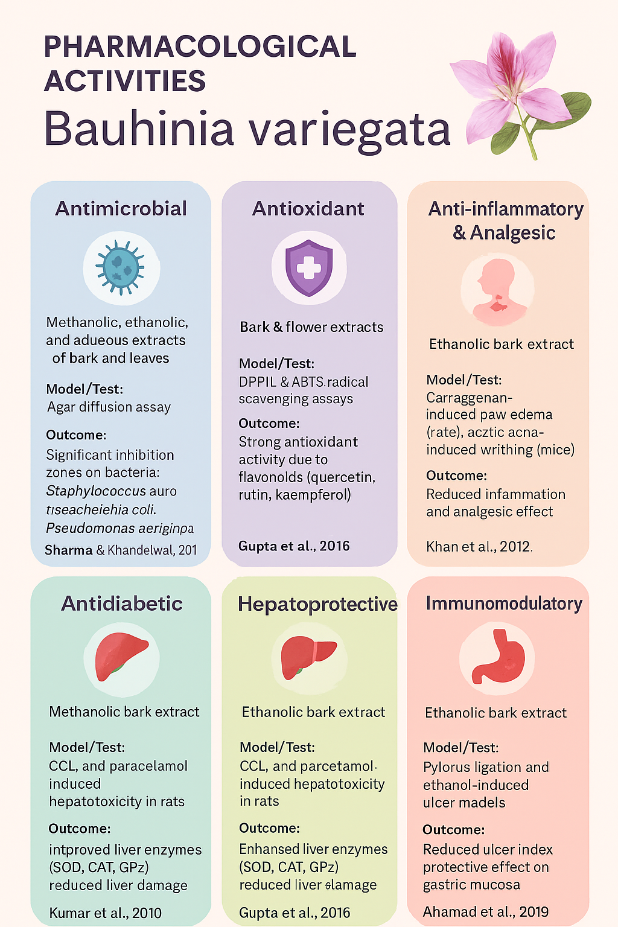
Fig 6 : List of pharmacological activities
Therapeutic Potential
Traditional Medicine Evidence for B. variegata
1. Ayurveda
- Name: Kanchanar (कांचनार)
- Rasa (Taste): Kashaya (astringent), Tikta (bitter)
- Guna (Properties): Laghu (light), Ruksha (dry)
- Virya (Potency): Ushna (hot)
- Vipaka (Post-digestive effect): Katu (pungent)
- Uses:
  - Management of glandular swellings, goiter (Galganda)
  - Treatment of tumors, skin diseases, ulcers, lymphadenopathy
  - Decoction (Kanchanara Guggulu) used in thyroid disorders, obesity, and detoxification
2. Siddha Medicine
- Name: Mandarai
- Parts Used: Bark, flowers, pods
- Therapeutic Uses:
  - Decoction for tumors, ulcers, and wound healing
  - Used for blood purification and detoxification
  - Flower buds sometimes applied for diarrhea and dysentery
- Considered a body coolant and supportive in skin and glandular diseases
3. Unani Medicine
- Name: Kachnar
- Mizaj (Temperament): Hot and dry
- Uses:
  - Bark used in diarrhea, dyspepsia, and flatulence
  - Decoction prescribed for lymphadenitis, enlarged spleen, goiter
  - Flowers and buds given for anthelmintic, diuretic, and astringent purposes
- Also considered beneficial in respiratory ailments (cough, bronchitis). [7,14, 17, 18]
Table 2 : System of Medicine

System of Medicine | Local Name | Parts Used | Formulations / Preparations | Traditional Indications
Ayurveda | Kanchanar (कांचनार) | Bark, flowers, buds, pods | - Kanchanara Guggulu (with guggulu resin)- Decoctions- Powder (Churna) | - Goiter (Galganda)- Glandular swellings, lymphadenopathy- Tumors & ulcers- Obesity & detoxification- Skin diseases
Siddha | Mandarai | Bark, flowers, pods | - Decoction- Flower bud paste- External applications | - Tumors and ulcers- Wound healing- Blood purification- Skin diseases- Diarrhea and dysentery
Unani | Kachnar | Bark, flowers, buds | - Decoction- Powder (Safoof)- Mixed formulations with honey or other herbs | - Diarrhea, dyspepsia, flatulence- Enlarged spleen, lymphadenitis- Goiter- Respiratory issues (cough, bronchitis)- Anthelmintic and diuretic uses
Clinical / Human Evidence
1. Ayurvedic Formulation Studies
- Study: Ayurvedic management of benign thyroid disorders (goiter).
- Design: Open-label clinical study (n=30).
- Outcome: Kanchanar Guggulu reduced gland size, improved symptoms of hypothyroidism. [19]
2. Anti-diabetic Clinical Evidence (Polyherbal Formulations)
- Bauhinia variegata bark has been used as a component in polyherbal antidiabetic formulations.
- Study: Randomized controlled trial (India).
- Formulation: Included B. variegata among other herbs.
- Outcome: Significant reduction in fasting blood glucose & postprandial glucose compared to placebo. [20]
3. Unani Medicine – Lymphadenitis / Glandular Swelling
- Study: Case reports using Kachnar-based formulations for lymphadenopathy and splenic enlargement.
- Outcome: Reported improvements in swelling and systemic symptoms.
- Limitation: Mostly observational reports, lacking RCT design. [21]
4. Wound Healing / Dermatology
- No controlled human trials exist yet, but traditional preparations (ointments/pastes with bark) are reported in ethnomedicine.
- Only animal wound models are experimentally validated so far.

Table 3 : Key synergistic combinations [22-24]
Combination | How the synergy is thought to work | Evidence type
Kanchanar Guggulu = Bauhinia variegata bark (Kanchanar) + Commiphora wightii (Guggulu) + Triphala (Emblica officinalis, Terminalia chebula, T. bellirica) + Trikatu (Piper nigrum, Piper longum, Zingiber officinale) + Crataeva nurvala (Varuna)* | Pharmacodynamic: Kanchanar’s astringent/anti-inflammatory bark + Guggulu’s resin (guggulsterones; anti-inflammatory, lipid-modulating) + Triphala’s antioxidant GI/“cleansing” effects + Trikatu’s bioavailability enhancement (notably piperine inhibiting CYP3A4/P-gp) → used for glandular swellings/goiter/lymphadenopathy. | Classical text + clinical case-series/open studies on the formulation; mechanistic support for piperine-based bioavailability enhancement.
Kanchanar + Trikatu (subset of above) | Pharmacokinetic synergy: Piperine (Trikatu) increases oral bioavailability of co-administered phytochemicals by inhibiting drug-metabolizing enzymes/efflux pumps; ginger & long pepper add anti-inflammatory and GI-motility support. | Experimental PK studies of piperine in humans/animals; widely used Ayurvedic practice.
Kanchanar with Triphala | Complementary antioxidant, gut-barrier, and laxative effects may aid detoxification/“Shothahara” (anti-inflammatory) actions and support absorption. | Preclinical/clinical data exist for Triphala; usage context from classical formulations.
Kanchanar with Varuna (Crataeva nurvala) | Uro-lymphatic support: Varuna’s smooth-muscle and anti-inflammatory actions traditionally paired for glandular swellings and urinary issues. | Classical pairing inside Kanchanar Guggulu; preclinical data for C. nurvala.

Toxicology and Safety Profile
Acute toxicity (single-dose, rodents)
- Oral LD₅₀: >2,000 mg/kg for methanolic/ethanolic bark/leaf extracts in mice/rats (OECD 423/425 style protocols).
  - No mortality; transient hypoactivity or mild sedation at high doses sometimes noted.
  - No gross organ pathology on necropsy in most reports.
Sub-acute / short-term repeat dose (14–28 days)
- Doses: typically 100–400 (up to 1,000) mg/kg/day p.o.
- Findings: No treatment-related mortality; body weight, food intake, hematology, and serum biochemistry largely unchanged; livers/kidneys grossly normal.
- Occasional dose-related increases in hepatic antioxidant enzymes (SOD, CAT, GPx) reported with ethanolic bark extracts (interpreted as protective, not injurious).
Sub-chronic (≈90 days) and chronic (≥6 months)
- Evidence: Sparse to none for standardized B. variegata single-herb extracts. No GLP 90-day rodent studies with full organ histopathology publicly available in the core literature.
- Implication: Safety margins for long-term human use cannot be firmly established.
Genotoxicity / Reproductive / Developmental tox
- Genotox: No Ames/micronucleus/comet assays specific to B. variegata isolates were located in mainstream databases summarized by the reviews.
- Reprotox/teratology: Not reported for single-herb extracts.
- Conclusion: Data gap.
Local tolerance & other safety notes
- Gastrointestinal tolerance: Generally good in rodent studies.
- Dermal/ocular irritation: Not systematically reported.
- Herb–drug interaction risk: If used within Kanchanar Guggulu, piperine (from Trikatu) may increase bioavailability of co-administered drugs via CYP3A4/P-gp inhibition—relevant for polyherbal use rather than B. variegata alone. [25-28]

Safety, dosage & administration
Forms and common ways it is administered
- Traditional (Ayurveda / Siddha / Unani)
  - Decoction (Kashaya) of bark/flowers; powder (churna) of dried parts; ointments/past es for topical wound use; and polyherbal formulations (notably Kanchanara Guggulu) where B. variegata is a principal ingredient.
- Research / modern preparations
  - Crude solvent extracts (aqueous, methanolic, ethanolic), standardized extracts (where provided by manufacturer; e.g., % flavonoids), and topical ointment bases for wound models.
Implication: If using a commercial product, follow the manufacturer’s standardized-extract label and local regulatory guidance. Traditional decoctions and powders are prepared according to classical recipes — use a qualified Ayurvedic/Unani/Siddha practitioner for formulation and dose.
Dose extrapolation
- Important: There is no established, evidence-based single-herb human dose for B. variegata. Clinical reports are mostly polyherbal (e.g., Kanchanara Guggulu), and product doses vary.
- Animal → human example (illustrative only): one rodent tolerated ~1,000 mg/kg/day (short term). Using standard body-surface conversion to a human equivalent dose (HED) gives:
  - HED ≈ 162 mg/kg/day → for a 60 kg adult ≈ 9.7 g/day of the same raw extract (this is a theoretical conversion, not a recommended dose).
  - Animal tolerability at very high mg/kg doses does not translate into recommending multi-gram daily dosing in humans without clinical safety data. (Conversion used: Km_rat=6, Km_human=37; see FDA/BSA conversion method.)
- Bottom line: do not assume “because animals tolerated X mg/kg” that the same or larger amounts are safe, effective, or appropriate in humans. Clinical dose-finding studies are lacking.
Practical guidance
A. If using traditional / practitioner-supervised therapy
- Use classical formulations (e.g., Kanchanara Guggulu) prepared to pharmacopeial standards and prescribed by a trained Ayurvedic/Unani/Siddha practitioner.
- The practitioner will tailor dose to the patient, constitution (prakriti), and co-morbidities.
B. If using a commercial standardized extract or supplement
- Follow the product label (standardization and dose are product-specific).
- Prefer products with certificate of analysis (COA), third-party testing, and clear standardization (e.g., % total flavonoids or mg quercetin equivalents per capsule).
C. Conservative, safety-first approach (general points)
- Start low: begin with the lowest recommended dose on a product label or as prescribed by a qualified practitioner.
- Short trial: limit initial self-trial to a short period (7–14 days) while monitoring tolerance (GI symptoms, rash, dizziness).
- Avoid prolonged high-dose use unless under practitioner supervision and with periodic blood tests (liver, kidney) if using long term.
Contraindications & cautions
- Pregnancy & breastfeeding: avoid unless a qualified practitioner advises otherwise. There are no adequate human reproductive safety data.
- Children: safety and dosing are not established — avoid or consult pediatric specialist.
- Liver or kidney disease: use caution; long-term safety in organ impairment not established — monitor liver/kidney function if used.
- Known allergy to Fabaceae/legume family: avoid.
- Surgery: discontinue prior to elective surgery per clinician advice (possible effects on bleeding/coagulation not well studied).
Potential herb–drug interactions
- Important interaction risk arises in polyherbal formulations that include Trikatu (black/long pepper — piperine). Piperine inhibits CYP3A4 and P-glycoprotein, increasing absorption and blood levels of many drugs (statins, anticoagulants, antidiabetics, immunosuppressants, etc.). If B. variegata is taken with Trikatu (common in traditional formulas), interaction risk increases.
- Also be cautious with antidiabetic drugs — co-administration may potentiate blood-glucose lowering (hypoglycemia risk) because extracts show α-glucosidase/antidiabetic activity in animals.
- Recommendation: disclose all herbal use to prescribing clinicians and monitor clinically relevant labs (e.g., INR with warfarin; blood glucose if on antidiabetics).

Monitoring & safety checks
- Baseline tests (if planning medium/long-term use): LFTs (AST/ALT), serum creatinine/BUN, fasting blood glucose (if diabetic), medication review for CYP3A4/P-gp substrates.
- During use: watch for GI upset, allergic rash, jaundice, fatigue, unusual bruising/bleeding, or symptoms of hypoglycemia (if on antidiabetic drugs). Repeat LFTs after 4–8 weeks for prolonged use.
What regulatory/authoritative sources recommend
- Use pharmacopeial formulations and follow Ayurvedic Pharmacopoeia or recognized monographs when available. For clinical prescription, rely on trained traditional-medicine physicians and evidence from clinical trials (which are limited for single-herb B. variegata). [14, 25, 27, 29]
Current Challenges and Future Prospects
Current challenges
- Taxonomic confusion & material identity
  - Problem: Bauhinia is a large, taxonomically complex genus; literature and commercial material sometimes mix B. variegata with closely related species (e.g., B. purpurea, Phanera spp.). Misidentification undermines reproducibility.
  - Impact: inconsistent phytochemical profiles, contradictory biological data.
- Lack of standardized raw material & extract specifications
  - Problem: studies use different plant parts, harvest times, geographic sources, and solvents; few report marker-based standardization (e.g., quercetin equivalents).
  - Impact: poor reproducibility and difficulty comparing results across labs.
- Predominantly crude-extract / preclinical literature; weak clinical evidence
  - Problem: abundant in vitro and rodent studies but very few rigorous human RCTs of B. variegata as a single herb; most clinical reports are polyherbal (e.g., Kanchanar Guggulu).
  - Impact: limited ability to recommend evidence-based human indications or doses.
- Insufficient ADME / PK/bioavailability data
  - Problem: active flavonoids/triterpenoids have low oral bioavailability; metabolic fate in humans not described.
  - Impact: uncertain dosing, potential for misinterpretation of in vivo efficacy, unknown metabolite toxicities.
- Incomplete safety database (long-term, genotoxicity, reproductive tox)
  - Problem: acute and short-term animal safety are favorable, but 90-day GLP studies, genotoxicity, and reproductive/developmental toxicity data are scarce or absent.
  - Impact: regulatory hurdles and caution for long-term human use.
Herb–drug interaction risk in polyherbal use
  - Problem: Kanchanar Guggulu and related formulas often include Trikatu (piperine) or other bioavailability modifiers; piperine inhibits CYP3A4/P-gp and may alter drug exposure.
  - Impact: clinically significant interactions with many drugs.
- Fragmented phytochemical knowledge & lack of validated markers
  - Problem: many compounds reported (flavonoids, tannins, triterpenes), but few validated quantitative markers used routinely for QC.
  - Impact: difficulty in developing pharmacopeial monographs and standardized products.
- Sustainability & supply-chain issues
  - Problem: wild collection, seasonal variability, and lack of GACP (Good Agricultural & Collection Practices) can produce inconsistent supply and potential overharvesting.
  - Impact: variable product quality and environmental concerns.
- Regulatory & commercial barriers
  - Problem: absence of monographs in many pharmacopeias for B. variegata single-herb extracts; barriers for market authorization requiring toxicology/clinical data.
  - Impact: impedes commercialization of standardized single-herb products.
Future aspects / actionable priorities
- Authentication & reference collections
  - Action: voucher specimens for every study, DNA barcoding (rbcL/ITS) of samples, deposition in herbaria.
  - Impact: prevents species-mix and increases reproducibility.
  - Rationale source: Flora/taxonomy literature.
- Develop standardized extract(s) with validated marker(s)
  - Action: choose marker compounds (e.g., quercetin/kaempferol glycosides or a triterpenoid) and develop HPLC/LC–MS quantitative assays and fingerprint profiles. Publish monograph specs (assay range, loss on drying, heavy metals, microbial limits).
  - Impact: enables comparable preclinical and clinical work and regulatory acceptance.
- Comprehensive preclinical package (GLP-style)
  - Action: OECD-guideline acute, 28/90-day repeat-dose studies, genotoxicity (Ames, micronucleus), and reproductive toxicity studies on the standardized extract. Include PK/ADME and metabolite identification in rodents (and ideally non-rodent).
  - Impact: foundation for first-in-human studies and IND/CTA submissions.
- Pharmacokinetics, metabolism & formulation research
  - Action: characterize oral bioavailability of chief markers, identify major human metabolites, evaluate food/matrix effects, and test bioavailability enhancers (e.g., complexation, lipid carriers) if needed.
  - Impact: rational dosing, improved efficacy, lower variability.
- Mechanism-focused, bioassay-guided isolation
  - Action: bioassay-guided fractionation to isolate active constituents for prioritized indications (e.g., α-glucosidase inhibition for antidiabetic use; wound-healing fractions). Use target-identification methods (proteomics, affinity assays).
  - Impact: clearer MoA, potential single-compound leads or enriched standardized fractions.
- Well-designed human trials (phase I → II)
  - Action: Start with small Phase I safety/tolerability studies (single ascending dose & multiple ascending dose) of a standardized extract; follow with randomized, placebo-controlled Phase II trials for priority indications (e.g., post-prandial hyperglycemia, topical wound healing, or benign thyroid enlargement where traditional use is strong). Include PK, PD biomarkers, and drug-interaction arms.
  - Impact: definitive human efficacy/safety evidence.

- Herb–drug interaction screening
  - Action: in vitro CYP / UGT / transporter panels and targeted clinical DDI studies (if risk is indicated), especially when extracts contain or are co-formulated with bioavailability enhancers like piperine.
  - Impact: safer clinical integration and labeling.
- Formulation & delivery optimization
  - Action: explore enhanced oral formulations (nanoemulsions, phospholipid complexes), and topical formulations for wound care with in vitro–in vivo correlation.
  - Impact: improved exposure and targeted application.
- Sustainability & cultivation programs
  - Action: implement GACP, cultivar selection for high-content chemotypes, cultivation trials, and supply-chain traceability (blockchain/traceability labels where relevant).
  - Impact: reliable supply, conservation of wild populations.
- Systems biology, metabolomics & network pharmacology
  - Action: metabolomic profiling of extracts, network pharmacology to predict multi-target actions, and microbiome interaction studies (since buds are edible).
  - Impact: elucidates polypharmacology and safety signals.
- Regulatory & pharmacopeial work
  - Action: compile a monograph (botanical ID, macroscopy, microscopy, assay method, limits) for inclusion in regional pharmacopeias; use GLP toxicology + human data to support claims.
  - Impact: facilitates commercialization and clinical acceptance.
- Clinical-practice guidance & education
  - Action: prepare evidence-based guidance for practitioners (contraindications, interactions, monitoring) and accurate product labelling.
  - Impact: reduces misuse, improves patient safety. [22,24,27,30]

Conclusion
Bauhinia variegata Linn., an important member of the Fabaceae family, holds a distinguished position in traditional medicine systems such as Ayurveda, Siddha, and Unani, where it has long been employed for conditions including goiter, glandular swellings, tumors, ulcers, and metabolic disorders. Modern phytochemical investigations confirm the presence of diverse bioactive compounds—flavonoids, tannins, glycosides, and triterpenoids—that are linked to a wide spectrum of pharmacological activities, including antioxidant, anti-inflammatory, antimicrobial, antidiabetic, hepatoprotective, and anticancer effects.
Despite this promising evidence, current research remains heavily preclinical, with few well-designed clinical studies and limited toxicological evaluations. Major challenges include inconsistent botanical authentication, lack of standardized extracts, inadequate pharmacokinetic and safety profiling, and scarce regulatory guidance. At the same time, opportunities lie in developing standardized phytopharmaceuticals, conducting rigorous toxicological and pharmacological studies, and translating ethnomedicinal knowledge into validated clinical applications.
Future directions should prioritize establishing quality control parameters, performing bioassay-guided fractionation to identify active constituents, and designing randomized controlled trials to evaluate efficacy and safety in humans. Alongside, sustainable cultivation and conservation strategies will be critical to ensuring long-term availability.
In conclusion, Bauhinia variegata represents a bridge between traditional wisdom and modern phytopharmacology—a plant of high therapeutic promise that, with systematic scientific exploration, could evolve into a safe and effective botanical drug.

References
- Sagar, P. K., Sajwan, S., & Murugeswaran, R. (2025). Bauhinia Spp.,-Kachnar: Medicinal Plant Biodiversity, Geographical Distribution, Bioactive Phytochemical Constituents And Their Ethno-Pharmacology, Therapeutics Medicinal Values. Asian Journal of Pharmaceutical Research and Development, 13(1), 55-65.
- Flora of China Editorial Committee. (2010). Flora of China, Volume 10. Science Press (Beijing) & Missouri Botanical Garden Press.
- Hooker, J.D. (1879). The Flora of British India. Vol. II. London: L. Reeve & Co.
- Khare, C.P. (2007). Indian Medicinal Plants: An Illustrated Dictionary. Springer, New York.
- Sharma, P., & Khandelwal, S. (2010). Bauhinia variegata Linn.: A review of phytochemical and pharmacological profile. Pharmacognosy Reviews, 4(8), 223–228. https://www.ncbi.nlm.nih.gov/pmc/articles/PMC3210004/
- Muhammad, A. (2014). Chemical Constituents and Bioactivity Studies of Bauhinia rufescens Lam.(Fabaceae) and Ficus platyphylla Del.(Moraceae) (Doctoral dissertation, Universiti Teknologi Malaysia).
- Khare, P., Kishore, K., & Sharma, D. K. (2018). Historical aspects, medicinal uses, phytochemistry and pharmacological review of Bauhinia variegata. Asian J Pharm Pharmacol, 4(5), 546-562.
- Bharti, C., Farooqui, N. A., Kumar, R., Sharma, S., & Gupta, P. (2022). Plant Chemistry and Pharmacological applications of Bauhinia variegata Linn.(Camel foot tree): A Review. Current Research in Pharmaceutical Sciences, 01-11.
- Bharti, C., Farooqui, N. A., Kumar, R., Sharma, S., & Gupta, P. (2022). Plant Chemistry and Pharmacological applications of Bauhinia variegata Linn.(Camel foot tree): A Review. Current Research in Pharmaceutical Sciences, 01-11.
- Sharma, H., Mishra, S. K., Khan, R., Prasad, S. B., Narasimhaji, C. V., Srikanth, N., & Acharya, R. (2024). A validated phytochemical marker based HPTLC method for the segregation of Bauhinia vahlii Wight and Arn. from geologically different samples of Indian zones. JPC–Journal of Planar Chromatography–Modern TLC, 37(4), 331-343.
- Gupta, A., Tripathi, A. K., & Gupta, P. S. (2020). Extraction, isolation and characterization of Bauhinia variegata flower. Journal of Applied Pharmaceutical Sciences and Research, 3(2), 9-12.
- Dip, G., Aggarwal, P., Kaur, S., & Grover, S. (2025). Extraction and characterization of phytochemicals from Bauhinia variegata flowers using ultrasound and microwave techniques. Biomass and Bioenergy, 192, 107517.
- Modh, K. M., Parmar, P. T., Panigrahi, B., Anand, I. S., & Patel, C. N. (2011). Pharmacognostical and Phytochemical Evaluation of Leaves of Bauhinia variegata Linn. Pharmacognosy Journal, 3(24), 45-49.
- Singh, N., Singh, A., & Pabla, D. (2019). A review on medicinal uses of Bauhinia variegata Linn. PharmaTutor, 7(6), 12-17.
- Negi, A., Sharma, N., & Singh, M. F. (2012). Spectrum of pharmacological activities from Bauhinia variegata: a review. Journal of Pharmacy Research, 5(2), 792-797.
- Irchhaiya, R., Kumar, A., Gurjar, H., Gupta, N., Kumar, S., & Kumar, M. (2014). Plant profile, phytochemistry and pharmacology of Bauhinia variegata Linn.(Kachnar): an overview. Int J Pharmacol, 1(5), 279-287.
- Shahana, S., Nikalje, A. P. G., & Nikalje, G. (2017). A brief review on Bauhinia variegata: phytochemistry, antidiabetic and antioxidant potential. Am. J. Pharmtech Res, 7, 186-197.
- Kumar, S., Baniwal, P., Kaur, J., & Kumar, H. (2020). Kachnar (bauhinia variegata). In Antioxidants in fruits: Properties and health benefits (pp. 365-377). Singapore: Springer Singapore.
- Singh, R. H., & Singh, R. H. (1998). Management of goiter with Kanchanar Guggulu. Journal of Research in Ayurveda and Siddha, 19(1-2), 1–10.
- Bansal, V., Malhotra, V., & Chawla, R. (2011). Evaluation of a polyherbal formulation for type 2 diabetes mellitus. Journal of Ayurveda and Integrative Medicine, 2(1), 30–36. https://doi.org/10.4103/0975-9476.78188
- Nadkarni, K. M. (1976). Indian Materia Medica. Popular Prakashan.
- Kumar, R., Kumar, A., Kumar, K., Gupta, V., Shrivas, T., & Tripathi, K. (2014). Synergistic anthelmintic activity of different compositions of panchagavya and Bauhinia variegate Linn. Int J Phytopharmacol, 5, 120-2.
- Typhi,S. Synergism between mimusops elengi & bauhinia variegata seed extracts against salmonella enterica serovar typhi and vibrio cholerae o1 biotype tor serotype ogawa isolate
- Sharma, A., Chandel, V., & Roy, S. (2025). Exploring the bioactive properties and diverse uses of Bauhinia variegata: a comprehensive review. Discover Plants, 2(1), 86.
- Makadiya, V. S., Kulkarni, Y. A., & Apte, K. G. (2015). Acute and 28-day repeated dose oral toxicity of Bauhinia variegata (Caesalpiniaceae) stem bark extract. Journal of Herbs, Spices & Medicinal Plants, 21(2), 161-172.
- Khare, P. R. A. G. A. T. I., Kishore, K. A. M. A. L., & Sharma, D. K. (2022). Acute oral toxicity of bauhinia variegata and madhuca longifolia in mice. Int J Curr Pharm Res, 14(2), 69-71.
- Kumar, A., Anand, V., Dubey, R. C., & Goel, K. K. (2016). Toxicological evaluation of Bauhinia variegata Linn. for estimating the neurological, hematological and physical alterations in the albino mice. Environment Conservation Journal, 17(3), 97-102.
- Solanki, N. D., & Bhavsar, S. K. (2014). Toxicological evaluation of the aqueous fraction of Ficus racemosa and Bauhinia variegate bark in Rats. Int J Toxicol Pharmacol Res, 6, 80-5.
- Saha, S., & Subrahmanyam, E. (2023). Evaluation of Immunomodulatory Effect of Aqueous Extract of Bauhinia variegata L .Leaves. Indian Journal of pharmaceutical education & Research, 57(1), S135-S139.
- Khanna, T. (2023). Effect of Phytocomponents From Bauhinia variegata L. on Lung Cancer Cell Lines (Doctoral dissertation, Maharaja Sayajirao University of Baroda (India)).

