Genetic Differentiation and Phylogenetic Analysis of Belenois ButterflySpecies (Belenois aurota and Belenois java) (Pieridae) Using DNA Barcoding of the COI Gene from A.P. - India

Abstract:
This study focuses on the molecular identification and genetic differentiation of two widely distributed 2 distinct Belenois butterfly species, Belenois aurota (Fabricius 1973) and Belenois java (Sparman 1968), through DNA barcoding of the mitochondrial COI gene from Seshachalam Bio reserve, A.P. Eggs were collected from Capparis zeylanica host plants and specimens were identified morphologically before DNA extraction. PCR amplification and sequencing of the COI gene revealed clear genetic distinctions between the two species, with sequence lengths of approximately 701 bp and 703 bp. Phylogenetic analysis and BLAST searches confirmed species identity and highlighted the utility of DNA barcoding in resolving species and assessing biodiversity. The results underscore the importance of molecular techniques in butterfly taxonomy, conservation, and ecological studies, providing a valuable reference for future biodiversity monitoring efforts in the region.
Key words: DNA barcoding, Belenois aurota, Belenois java, Molecular identification, Genetic differentiation, Species taxonomy, Phylogenetic analysis, Butterfly ecology
Introduction:
Butterflies are the best natural indicators of the ecosystem, even though they belong to the lowest taxa and are the least researched group (Brown, 1991). Their long-distance movement allows them to perform a wide range of ecosystem services, including pollen sharing between plants that are far apart (Andersson and Dobson, 2003). Such pollen migration gives plants greater tolerance to many illnesses and is the cause of genetic variety in plant species (Ghazanfar et al., 2016).The Pieridae family of butterflies includes the intriguing species Belenois Javaand Belenois aurota. The Caper White, or Belenois java, is a species that is extensively found over portions of Asia and Australia and is distinguished by its primarily white wings with black patterns. Belenois aurota, also known as the Pioneer White or widespread White, is a widespread bird in Asia and Africa that is distinguished by its black-spotted white wings(Si-Xun Ge et al., 2021). In addition to being valued for their remarkable looks and migratory patterns, both species are crucial pollinators in their respective ecosystems. As they appear similar, we want to go through the molecular studies.
The identification of butterflies is a challenging undertaking since they are a dominant group with close morphological similarities and an adaptable character. There is also a major lack of knowledge regarding species composition and regional morphometric diversity. High-tech methods are therefore urgently needed to identify these species and solve this issue before they change their variety or disappear. Numerous organisms, including beetles (Monaghan et al., 2006) and butterflies (Hebert et al., 2004; Hajibabaei et al., 2006), have been demonstrated to employ the COI gene. To identify every animal species on the planet, taxonomists, molecular biologists, governments, and non-governmental organizations have widely used the DNA barcoding method. Studies on ecology, biodiversity, conservation biology, and the cataloguing of butterflies are accelerated by this technique. As a reference for quick and efficient species identification, a significant number of sequences of well-identified organisms from public databases have emerged as an emerging utility (Blaxter, 2004). Additionally, when samples from wide geographic areas are evaluated, DNA barcoding may aid in the discovery of new or unknown species of butterflies (Hebert et al., 2008).
A primary goal has already been identified to accomplish this: the creation of reference records of sequences from known species (Ratnasingham and Hebert, 2007). DNA barcoding is intended to be a highly effective method for characterizing such huge genetic diversity at the regional level when combined with traditional taxonomy. DNA barcoding is a molecular technique that uses a short, standardized segment of DNA—typically the mitochondrial gene cytochrome c oxidase I (COI)—to identify and differentiate species(Hajibabaei et al., 2005). Traditional identification based on morphology can be challenging due to similar appearances among species, sexual dimorphism, or variations across developmental stages. DNA barcoding provides precise identification, especially for immature stages like caterpillars or in damaged specimens. Many butterfly species appear morphologically similar but are genetically distinct. Barcoding helps reveal these species, contributing to a more accurate understanding of biodiversity. Accurate species identification is critical for conservation planning. DNA barcoding helps assess species distributions, detect endangered or invasive species, and monitor population health more effectively(Vinaya Kumar Singh et., al 2021). Barcoding aids in rapid biodiversity assessments, especially in regions with high butterfly diversity, thus informing conservation strategies and ecological studies. It enables researchers to study patterns of speciation, migration, and evolutionary relationships among butterfly species.
Therefore, the current work focuses on verifying nucleotide differencebetween 2 Belenois species in widely distributed species.
Methodology:
The eggs of Belenois species were collected from Capparis zeylanica host plantsfrom Seshachalam Bio reserve, A.P.2 species of Belenois eggs were collected where possible to allow for the comparison of sequences. The eggs were collected and developed into adult forms in the Insect lab of Zoology department of Yogi Vemana university. Specimens were dissected the same day they attained the adult form, with the body preserved in 95% ethanol and frozen. Tissue from the wings, legs or thorax were used for extraction.
DNA Extraction:
1 ml of Xploregen gDNA Extraction Buffer™ 1 was added to the beaded vial and the vail is subjected to Horizontal vortex at maximum speed for 10 minutes. 300 μl of Xploregen gDNA Extraction Buffer™ 2 was added to the beaded vial containing solution and subjected to the horizontal vortex the vial at maximum speed for 7 minutes. The tube was centrifuged at 10,000 rpm for 3 minutes at room temperature (RT) and transferred 800 μl of supernatant to a sterile 2 ml vial. Added 200 μl of Xploregen gDNA Extraction Buffer™ 3 solution and vortex for 5 seconds and centrifuged at 10,000 rpm for 2 minutes and transferred 800 μl Supernatant to a clean sterile 2ml vial. Added 1 ml of Xploregen gDNA Extraction Buffer™ 4 solutions to the supernatant and vortex for 5 seconds. Transferred 700 μl of Lysate to the spin column (Do not discard the residual lysate) and centrifuged at 10,000 rpm for 2 minutes. Discarded the flow through. Repeated the above (10&11) steps and collected all the Lysate. (Ensure the entire lysate is processed via the spin column). Added 600 μl of XPLOREGEN gDNA EXTRACTION BUFFER™5 to the spin column and centrifuged at 10,000 rpm for 2 minutes. Discarded the flow through. Added 600 μl of Xploregen gDNA Extraction Buffer™ 6 to the spin column and centrifuged at 10,000 rpm for 2 minutes. Discarded the flow through. Centrifuged the empty spin column for 5 minutes at 10,000 rpm. Placed the spin column into a sterile 1.5 ml vial. Added 30 μl of Xploregen gDNA Extraction Buffer™ 7 (Elution 1) to the centre area of spin column and centrifuged for 5 minutes at 10,000 rpm. Placed the spin column to a new sterile 1.5ml vial. Discarded the spin column and stored both elution tubes for further processing.
DNA Quantification:
DNA sample of 164ng/μl was quantified.
PCR Amplification of COI Gene:
List 1 : 164 ng of Extracted DNA is used for amplification along with 10pM of each primer
LCO Forward primer | GGTCAACAAATCATAAAGATATTGG
HCO Reverse primer | TAAACTTCAGGGTGACCAAAAAATCA
The sequencing reaction is composed of a total volume of 10μl, which includes 4μl of Big Dye Terminator Ready Reaction Mix, 1μl of template DNA (at a concentration of 100ng/μl), 2μl of primer (at 10pmol/μl), and 3μl of Milli Q water. The PCR conditions involve an initial denaturation step at 96°C for 5 minutes, followed by 25 cycles of denaturation at 96°C for 30 seconds, hybridization at 50°C for 30 seconds, and elongation at 60°C for 1.5 minutes. The sequencing is conducted using an ABI 3130 Genetic Analyzer equipped with the Big Dye Terminator version 3.1 chemistry, utilizing a POP-7 polymer and capillary array. Data analysis is performed using SeqScape version 5.2, and the reactions are set up in an Applied Biosystems Micro Amp optical 96-well reaction plate, following the analysis protocol BDTv3-KB-Denovo version 5.2.
Results:
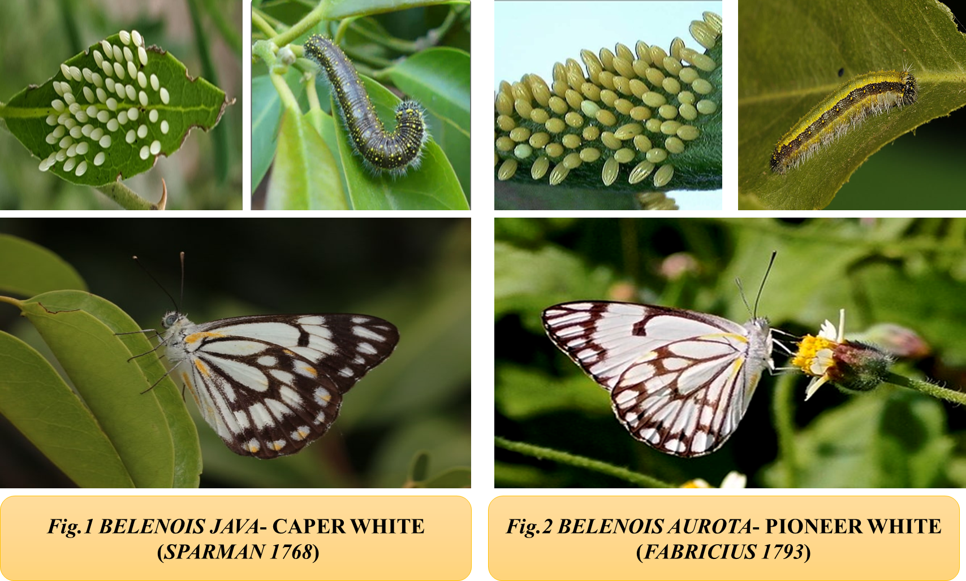
Fig.1 indicates the eggs, larva and adult form of the Belenois java.Fig.2 indicates the eggs, larva and adult form of the Belenois aurota.
COI Divergences. ~701bp (Belenois aurota) and ~703bp (Belenois java) portion of the mitochondrial gene cytochrome oxidase subunit I containing the DNA barcode region were sequenced using the primers LCO, HCO primers. The COIsequences were easily aligned, as no insertions or deletions weredetected.Adults with twodifferent COI sequences came from caterpillars grown from the eggs collected onCapparis zeylanica. Because of the strong associations betweencaterpillar food plants and COI sequences in other individuals,it was possible to ascertain the likely genotypic characteristics ofthese ‘‘heterozygotes.’’
Phylogenetic analysis:
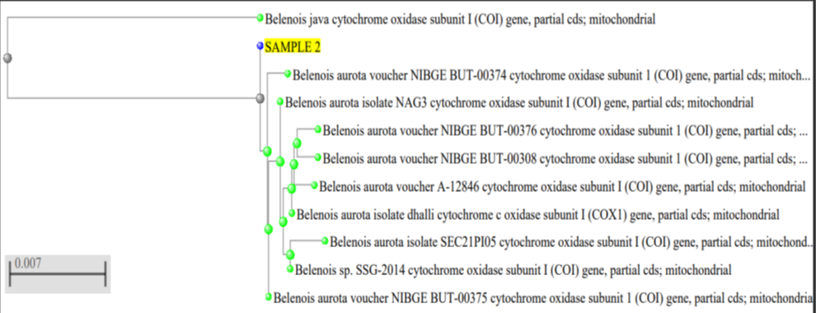
Fig.3 The above phylogenetic analysis explains the phylogenetic tree of the sample 2 Belenois java.
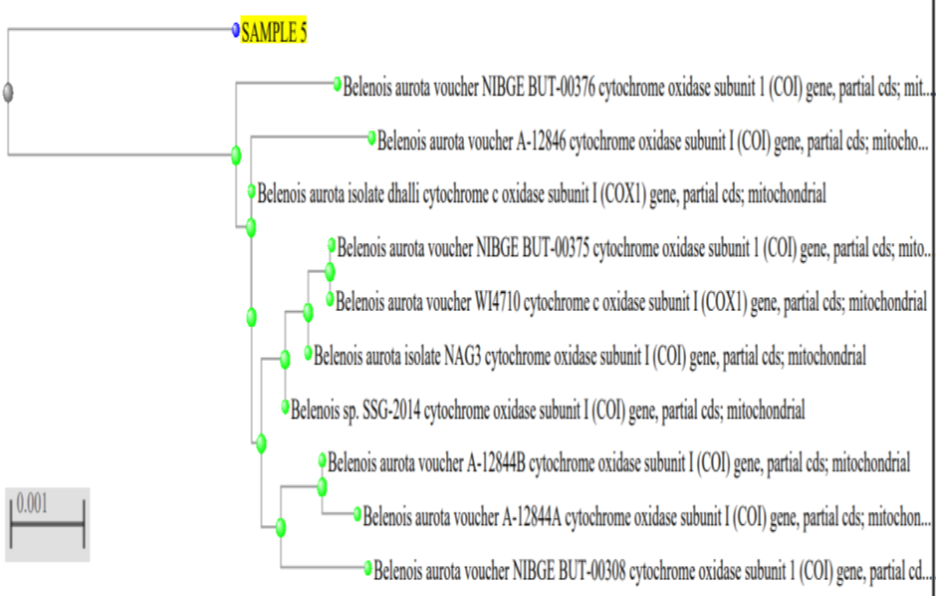
Fig.4 The above phylogenetic analysis explains the phylogenetic tree of the sample 5 Belenois aurota.
The above phylogenetic trees indicate that the sample 2 is the Belenois java and the sample 5 is the Belenois aurota.
Blast analysis:
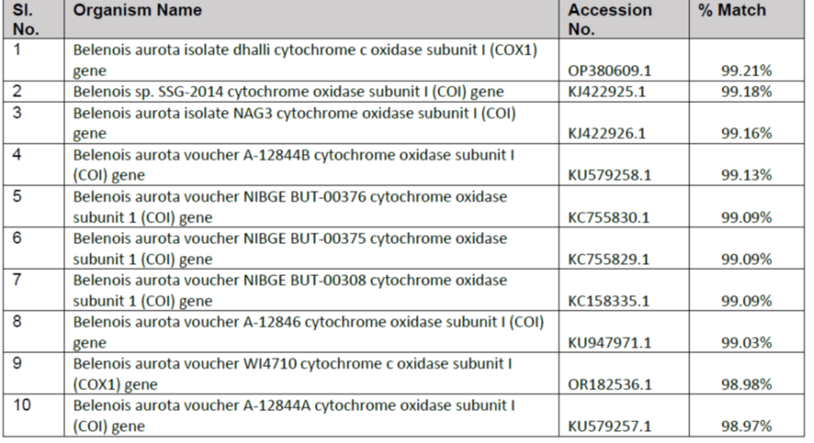
Table .1 explains the BLAST data of the Belenois java.
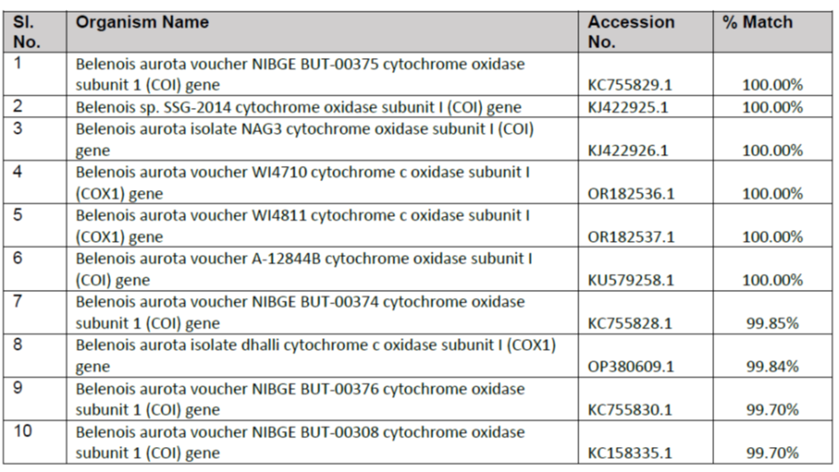
Table 2 : explains the BLAST data of the Belenois aurota.
Barcoding data:
Sequence analysis:
After removing unclear base calls and primer sequences, the sequences were put together. The Barcode of Life Database (BOLD, www.barcodinglife.org) was updated with the sequence information, picture, and supporting documentation for every voucher specimen. sequencing-Systematics of certain tropical Butterflies in and around Southern Andhra Pradesh [KSVGP] is the project file that contains the BOLD's detailed specimen records and sequencing information, including trace files.
Discussion
The current study effectively illustrates how DNA barcoding may be used to differentiate between Belenois aurota and Belenois java, two species of Belenois butterflies that are extensively spread (Fig. 1 And Fig. 2). By employing mitochondrial COI gene sequences, which are roughly 701–703 base pairs long, the study highlights the effectiveness of molecular methods for accurate species identification, especially when dealing with visually similar species. There were no insertions or deletions found in the COI sequence alignment, suggesting that the regions under investigation had good sequence conservation. Nonetheless, there was sufficient nucleotide difference between the two species to verify their genetic uniqueness. The phylogenetic analysis (Figs. 3 and 4) and the observed sequence variants lend credence to the use of COI barcodes as trustworthy indicators for species discrimination in Belenois butterflies.Inferred from mixed genotypic signals, the identification of heterozygous individuals emphasizes the possibility of gene flow or hybridization events, which calls for more research with bigger sample sizes. In accordance with current taxonomic frameworks, the phylogenetic analysis placed the sequences inside well-supported clades that corresponded to their respective species. High similarity scores from BLAST searches (Table 1 and Table 2 ) against the BOLD database supported morphological identifications and validated the usefulness of the barcode reference library. Sequence data incorporation into the BOLD platform improves the region's butterfly barcode repository and makes future comparative research easier.
Conclusion:
The efficacy of DNA barcoding as a method for precise species identification within the genus is demonstrated by the successful amplification and sequencing of the COI gene for Belenois aurota and Belenois java. The found genetic divergence emphasizes these closely related species' unique evolutionary lineages and validates their distinction. Particularly in areas where habitat loss and human pressures are present, this genetic approach provides a quick, accurate, and non-invasive way to monitor butterfly biodiversity. Future ecological, taxonomic, and conservation studies will be made easier by the generated barcode data, which is added to the global DNA barcode database. All things considered, DNA barcoding is a vital method for deepening our knowledge of butterfly variety and directing conservation efforts.
Reference:
- Andersson, S., Dobson, H.E., 2003. Antennal responses to floral scents in the butterfly Heliconius melpomene. J. Chem. Ecol. 29 (10), 2319–2330.
- Blaxter, M.L., 2004. The promise of DNA taxonomy. Philos. Trans. R. Soc. Lond. Biol. Sci. 359, 669–679.
- Brown, Jr, K.S., 1991. Conservation of neotropical environments: insects as indicators. Conserv. Insects Habit. 349, 404.
- Ghazanfar, M., Malik, M.F., Hussain, M., Iqbal, R., Younas, M., 2016. Butterflies and their contribution in ecosystem: A review. J. Ent. Zoo. Studies. 115 (42), 115–118.
- Hebert, P.D.N., deWaard, J.R., Landry, J.F., 2008. DNA barcodes for1/1000 of the animal kingdom. Biol Lett. https://doi.org/10.1098/rsl20090848.
- Hebert, P.D.N., Penton, E.H., Burns, J.M., Janzen, D.H., Hallwachs, W., 2004. Ten species in one: DNA barcoding reveals cryptic species in the neotropical skipper butterfly Astraptes fulgerator. Proc. Natl. Acad. Sci. USA 101 (41), 14812–14817.
- Monaghan, M.T., Balke, M., Pons, J., Vogler, A.P., 2006. Beyond barcodes: complex DNA taxonomy of a South pacific island radiation. Proc. R. Soc. Lond. B Biol. Sci. 273, 887–893.
- Mehrdad Hajibabaei, Daniel, H., Janzen, John, M., Burns, Winnie Hallwachs, and Paul ,D. N. Hebert 2004. DNA barcodes distinguish species of tropical Lepidoptera.January 24, 2006 - vol. 103 - no. 4.
- Ratnasingham, S., Hebert, P.D.N., 2007. The barcode of life data system (www. barcodinglife.org). Mol. Ecol. Notes. 7, 355–364.
- Si-Xun Ge, Shao-Ji Hu, Hong-Liang Shi, Feng-Ying Han, Ming-Jun Li, Li-Li Ren. The first record of the genus Belenois (Lepidoptera: Pieridae) from China.Biodiversity Data Journal, January 2021, 9(1).
- Vinaya Kumar Singh, Prakash Chandra Joshi , Sandeep Kumar Gupta Evaluating the DNA barcodes for identification of butterflies from Western Himalayas, Uttarakhand, India. Journal of Asia-Pacific Entomology 24 (2021) 118–124.

