Original Research Article
DESIGN AND EVALUATION OF A NOVEL ANXIETY CHAMBER FOR SCREENING ANXIOLYTIC ACTIVITY USING AROMATHERAPY IN RODENTS

ABSTRACT
Background: Anxiety disorders are increasingly prevalent, often linked to chronic social defeat stress and everyday social challenges such as hesitation and fear in routine interactions. While pharmacological agents like benzodiazepines remain standard therapy, their side effects necessitate safer alternatives. Essential oils contain bioactive phytochemicals that may serve as potential anxiolytic agents. Objective: The present study aimed to design and evaluate a novel Anxiety Chamber for behavioral screening of anxiolytic activity and to investigate the role of volatile oils (Eucalyptus, Rosemary, and Lemongrass), with supporting FTIR analysis of their chemical constituents. Methods: A square wooden chamber was divided into two compartments: a dark chamber and an anxiety-inducing chamber (fitted with bright LEDs and a buzzer). Mice were allowed to explore both chambers through a semi-arched tunnel. Anxiety was induced in the illuminated chamber, and the time spent in each chamber was recorded at 5, 15, 30, 60, and 120 minutes. Animals were divided into six groups: Control, Negative Control, Standard (Diazepam 1 mg/kg), and three Test groups exposed to aromatherapy with volatile oils in varying ratios (50:25:25, 25:50:25, 25:25:50). The oils were subjected to FTIR spectroscopy to identify functional groups and bioactive constituents associated with anxiolytic activity. Results: The negative control group exhibited reduced exploration of the anxiety chamber (38 sec at 30 min). Diazepam-treated animals showed progressive increases in chamber exploration (173 sec at 120 min). Test groups exposed to volatile oils demonstrated anxiolytic activity, with the 25:50:25 ratio (Rosemary-dominant) producing the greatest effect (188 sec at 120 min). Conclusion: The novel Anxiety Chamber provided a cost-effective and reliable model for evaluating anxiolytic behavior. Both standard (Diazepam) and volatile oils increased time spent in the anxiety chamber, validating the setup. Among the test combinations, the Rosemary-rich formulation (25:50:25) showed superior anxiolytic activity. FTIR analysis confirmed the presence of phytoconstituents with established CNS-modulating and anxiolytic properties, underscoring the pharmacological significance of these volatile oils. Thus, aromatherapy with carefully optimized combinations of essential oils offers a promising, natural alternative for anxiety management
Keywords: Anti-anxiety activity, Anxiety chamber, anxiolytic behaviour, Aroma therapy, essential oils, Diazepam.
INTRODUCTION
Anxiety disorders represent one of the most prevalent classes of mental health conditions worldwide, characterized by excessive fear, apprehension, and avoidance behavior that interfere with daily functioning (Sarris J, et al., 2010). Chronic exposure to stressful or threatening conditions often results in maladaptive coping responses, leading to the development of persistent anxiety states (Bishnoi M, et al., 2016). Preclinical models such as the Chronic Social Defeat Stress (CSDS) paradigm have provided valuable insights into the neurobiology of anxiety (Mendes AC, et al., 2020), demonstrating how repeated social stress can induce fear, withdrawal, and impaired sociability in rodents (Ferraz AC, et al., 2018), closely mimicking human anxiety disorders (Al Tayyar AS et al., 2016).
In modern society, similar anxiety manifestations are increasingly observed among youth and adults (Ferlemi AV, et al., 2015), where individuals often report fear in routine social interactions, including hesitation to stand in queues, difficulties in gatherings (Majewska E, et al., 2021), or fear of performing daily responsibilities (Chander R, et al., 2021). These behavioral disturbances highlight the rising burden of anxiety disorders and underscore the importance of developing novel screening models and therapeutic strategies (Kadar RH, et al., 2012).
Conventional pharmacotherapy for anxiety, particularly benzodiazepines such as diazepam (Hunt SA, et al., 2017), provides effective symptomatic relief but is often limited by adverse effects (Blanco MM, et al., 2007) including sedation, dependence (Lee MS, et al., 2016), and cognitive impairment. This has prompted growing interest in complementary approaches, such as aromatherapy (Abdollahnejad, et al., 2021), which utilizes volatile plant-derived essential oils rich in bioactive phytochemicals (Solon IG, et al., 2025). Essential oils such as Eucalyptus (Koyama, et al., 2020), Rosemary, and Lemongrass contain constituents like 1,8-cineole, camphor, α-pinene, citral, and geraniol (Ferlemi AV, et al., 2015), many of which have demonstrated central nervous system (CNS) modulating and anxiolytic properties.
To evaluate these effects in a cost-effective and reproducible manner, we designed a novel behavioral apparatus termed the “Anxiety Chamber.” The setup consists of a two-chamber wooden box with a semi-arched tunnel, where one compartment remains dark while the other is equipped with bright LED lights and a buzzer to induce anxiety-like conditions (Kim JK, et al., 2015). This design allows for direct measurement of time spent in the aversive (anxiety-inducing) vs. safe (dark) chamber, providing a simple yet effective model for screening anxiolytic activity (Kim KY, et al., 2014). The present study was therefore undertaken to design and validate the Anxiety Chamber as an experimental model (de Almeida, et al., 2010), and to evaluate the anxiolytic potential of volatile oils using both behavioral assessment and FTIR analysis of phytoconstituents (Hajhashemi V, et al.,2002). Additionally, the study aimed to compare the efficacy of aromatherapy with the standard anxiolytic drug diazepam (Santos FA, et al., 2014), thereby offering translational relevance to the management of stress-induced anxiety.
MATERIALS AND METHODS
Apparatus: Anxiety Chamber Design
A square wooden box with a removable lid was custom-designed to observe anxiety-like behavior in rodents. The box was internally divided into two equal chambers (Costa CA, et al., 2011), connected by a semi-arched tunnel.
- Chamber I (Control chamber): Maintained in dark conditions.
- Chamber II (Anxiety-inducing chamber): Equipped with a bright standard white LED, a passing LED strip, and a 9V buzzer speaker to create aversive stimuli.
The setup was termed the “Anxiety Chamber.” The apparatus allowed free exploration by animals between the two chambers through the tunnel, while enabling measurement of time spent in each chamber.
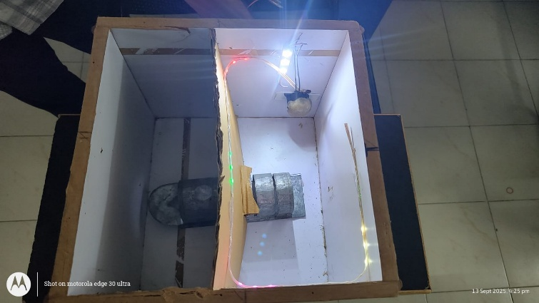
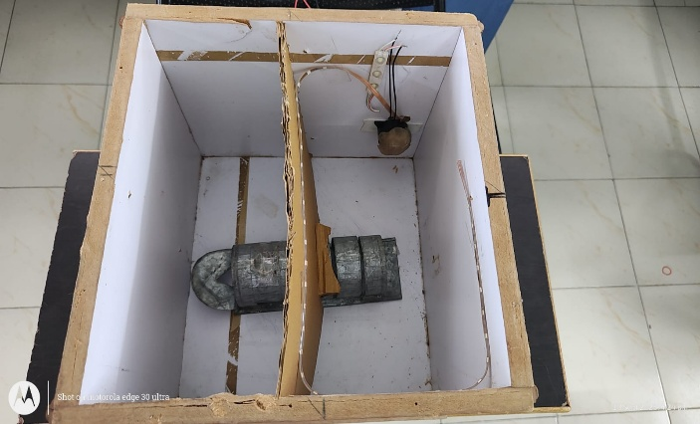

Fig 1: Anxiety Chamber with LED ON Fig 2: Anxiety Chamber with LED OFF
Experimental Animals
Swiss albino mice of either sex (20–25 g) were used in the study. Animals were housed under standard laboratory conditions (12 h light/dark cycle, 22 ± 2°C, relative humidity 55 ± 5%) with free access to food and water. The experimental protocol was reviewed and approved by the Institutional Animal Ethics Committee (IAEC) (IAEC No: 11/IAEC/CLPT/2024-25) and all procedures were carried out in accordance with CCSEA guidelines.
Grouping of Animals
Animals were randomly divided into six groups (n = 6 each):
- Group I – Control: Animals exposed to the chamber without activation of LED and buzzer.
- Group II – Negative Control: Animals exposed to the chamber with LED and buzzer stimuli (anxiety induction).
- Group III – Standard: Animals administered Diazepam (1 mg/kg, i.p.).
- Group IV – Test 1: Exposed to aromatherapy with essential oil mixture (Eucalyptus:Rosemary:Lemongrass = 50:25:25).
- Group V – Test 2: Exposed to aromatherapy with essential oil mixture (25:50:25).
- Group VI – Test 3: Exposed to aromatherapy with essential oil mixture (25:25:50).
Procedure for Behavioral Assessment
Each mouse was initially placed in the dark chamber and allowed to freely explore both chambers through the tunnel. After habituation, when the mouse entered the anxiety-inducing chamber (Dounon V, et al., 2020), the LED lights and buzzer were switched on to generate aversive stimuli (Kayashima T, et al., 2020). The time spent in the anxiety-inducing chamber was recorded at 5, 15, 30, 60, and 120 minutes (Hajhashemi V, et al., 2002). The increased time in this chamber was considered indicative of reduced anxiety (anxiolysis). The total time set for evaluation is 5 minutes. (de Sousa DP, et al., 2011)
Aromatherapy Administration
Volatile oils of Eucalyptus, Rosemary, and Lemongrass were used in different ratios. Cotton swabs were impregnated with the oil mixtures and placed inside a small container (De Sousa DP, et al., 2015) within the chamber to allow inhalation by the animals (Agatonovic-Kustrin S., et al., 2020). The exposure was continued throughout the experimental session.
FTIR Analysis of Volatile Oils
The volatile oils were subjected to Fourier Transform Infrared (FTIR) spectroscopy to identify functional groups and bioactive constituents (Mrabet AE, et al., 2024).
- Eucalyptus oil: Peaks confirmed presence of 1,8-cineole and limonene. (Silva Brum LF, et al., 2019)
- Rosemary oil: Peaks indicated camphor and α-pinene. (Dougnon G, et al., 2020)
- Lemongrass oil: Peaks corresponded to citral and geraniol.
These phytoconstituents were correlated with reported anxiolytic and CNS-modulating properties. (Pritchard MP, et al., 2014)

Statistical Analysis

All values were expressed as mean ± SEM. Data were analyzed using one-way ANOVA followed by post hoc Tukey’s test to compare between groups. A p-value of < 0.05 was considered statistically significant.

RESULTS

The present study evaluated the anxiolytic potential of volatile oils using a newly designed Anxiety Chamber in mice. The time spent in the anxiety-inducing chamber at different intervals (5–120 min) was considered the primary behavioral parameter. Results are expressed as Mean ± SEM (n = 6) (Table 1).
Control animals showed a balanced exploratory behavior between the two chambers without significant preference, while the Negative control group (with LED and buzzer ON) exhibited a marked reduction in time spent in the anxiety chamber, indicating induction of anxiety. Administration of Diazepam (1 mg/kg, i.p.) significantly (p < 0.05) increased the time spent in the anxiety chamber compared with the negative control group, confirming its anxiolytic activity. Test Group 1 (50:25:25 Eucalyptus:Rosemary:Lemongrass) showed a gradual increase in time spent in the anxiety chamber, with values approaching those of diazepam by 120 min (168 ± 16.8 sec).Test Group 2 (25:50:25) produced the most pronounced effect, with animals spending significantly higher time in the anxiety chamber at 30, 60, and 120 min (147 ± 14.7, 151 ± 15.1, and 188 ± 18.8 sec, respectively). Test Group 3 (25:25:50) displayed moderate anxiolytic activity, with increased time compared to negative control, but lower than diazepam and Test Group 2. Overall, the results indicate that volatile oil exposure reduced anxiety-like behavior in rodents. Among the tested ratios, Test Group 2 (25:50:25) exhibited the maximum anxiolytic effect, nearly comparable to diazepam.

Table 1: Time spent in the anxiety chamber (Mean ± SEM, seconds, n=6)
Time Interval | Control | Negative Control | Standard (Diazepam 1mg/kg) | Test 1 (50:25:25) | Test 2 (25:50:25) | Test 3 (25:25:50)
5 min | 86 ± 8.6 | 45 ± 4.5 | 68 ± 6.8 | 51 ± 5.1 | 60 ± 6.0 | 41 ± 4.1
15 min | 93 ± 9.3 | 52 ± 5.2 | 91 ± 9.1 | 94 ± 9.4 | 88 ± 8.8 | 76 ± 7.6
30 min | 112 ± 11.2 | 38 ± 3.8 | 102 ± 10.2 | 92 ± 9.2 | 147 ± 14.7 | 92 ± 9.2
60 min | 84 ± 8.4 | 66 ± 6.6 | 145 ± 14.5 | 139 ± 13.9 | 151 ± 15.1 | 128 ± 12.8
120 min | 91 ± 9.1 | 59 ± 5.9 | 173 ± 17.3 | 168 ± 16.8 | 188 ± 18.8 | 134 ± 13.4

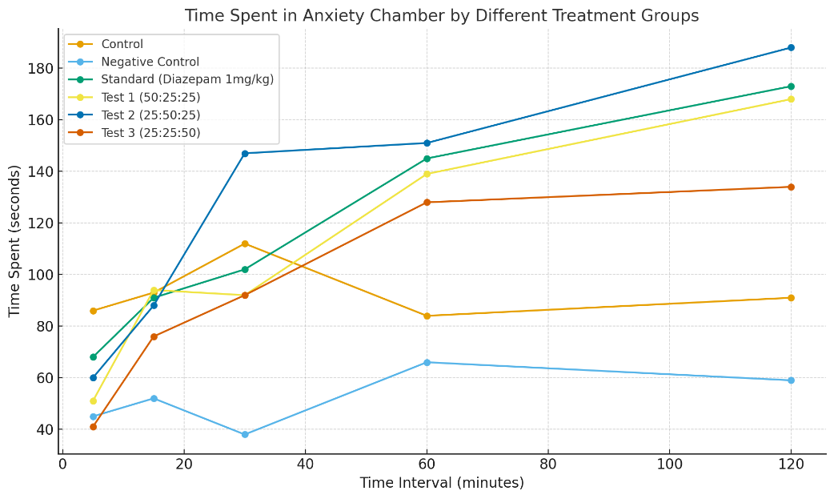

Fig 3: Time spent in Anxiety Chamber by different treatment groups
DISCUSSION
The present study introduces a novel Anxiety Chamber as a reliable tool to evaluate anxiolytic activity in rodents, using aversive light and sound stimuli to simulate anxiety-provoking conditions. This design differs from conventional models such as the elevated plus maze or open field test by providing a more controlled environment with distinct safe (dark) and aversive (light + sound) zones, thereby mimicking real-life avoidance and exploratory behavior.
The behavioral results demonstrated that the negative control group spent significantly less time in the anxiety chamber, validating the aversive potential of the chamber design. Conversely, diazepam (1 mg/kg, i.p.) increased exploration in the anxiety chamber, serving as a positive control for anxiolytic activity. Among the test groups, the rosemary-dominant volatile oil combination (25:50:25) showed the greatest anxiolytic potential, surpassing diazepam at 120 minutes. This finding suggests that aromatherapy with specific ratios of essential oils can modulate anxiety-like behavior effectively.
FTIR Analysis of Volatile Oils
FTIR spectra confirmed the presence of bioactive phytoconstituents responsible for the anxiolytic effects:
- Eucalyptus Oil: Peaks in the region 1,050–1,150 cm⁻¹ (C–O stretching) and 2,850–2,950 cm⁻¹ (C–H stretching) confirmed the presence of 1,8-cineole and limonene, compounds known for sedative and calming properties.
- Rosemary Oil: Characteristic C=O stretching (1,730 cm⁻¹) and C=C stretching (1,600–1,650 cm⁻¹) indicated the presence of camphor and α-pinene, associated with GABAergic modulation and central nervous system relaxation.
- Lemongrass Oil: Strong bands at 3,200–3,600 cm⁻¹ (O–H stretching) and 1,720 cm⁻¹ (C=O stretching) confirmed citral and geraniol, known for stress-reducing and mood-enhancing effects.
The synergistic presence of these compounds likely contributed to the observed anxiolytic activity, with the rosemary-dominant combination producing the most pronounced effects.
The enhanced efficacy of Test Group 2 (25:50:25) may be attributed to the synergistic action of rosemary-derived camphor and α-pinene with citral from lemongrass, leading to a more pronounced effect than eucalyptus-rich combinations. This aligns with earlier reports highlighting rosemary oil as a potent anxiolytic agent when inhaled, with documented effects on both central nervous system neurotransmitters and autonomic nervous regulation. Similarly, lemongrass oil has been shown to reduce stress-induced hyperactivity in rodents, supporting its role in the observed behavioral outcomes.
Thus, the present findings not only validate the anxiolytic efficacy of volatile oils but also demonstrate the relevance of phytoconstituents identified by FTIR in explaining the observed effects. Importantly, these results resonate with the growing body of evidence that aromatherapy can serve as a complementary approach to anxiety management by targeting GABAergic and serotonergic pathways.
CONCLUSION
The present study successfully designed and validated a novel Anxiety Chamber as a reliable experimental model for screening anxiolytic agents in rodents. The chamber effectively differentiated between control, anxiety-induced, and drug-treated groups, thereby confirming its utility. Aromatherapy with volatile oils demonstrated significant anxiolytic activity, with the rosemary-dominant mixture (25:50:25) showing the most pronounced effect, comparable to or exceeding diazepam at later intervals.
FTIR analysis highlighted the presence of 1,8-cineole, camphor, α-pinene, citral, and geraniol, phytoconstituents known for their GABAergic and serotonergic modulatory properties, which likely underlie the observed behavioral outcomes. These findings support the role of phytochemical synergy in anxiolysis and suggest that aromatherapy could serve as a complementary approach to conventional anxiolytic therapy.
Overall, this study underscores both the importance of apparatus innovation in pharmacological screening and the therapeutic potential of volatile oils in managing anxiety disorders. Future studies should include neurochemical, molecular docking, and clinical investigations to strengthen translational relevance.

REFRENCES
- Silva Brum LF, de Sousa DP, Cortez DA, de Moura MD, do Nascimento GS, de Oliveira AO, et al. Investigation of the anxiolytic and antidepressant effects of pure eucalyptol (1,8-cineole) in rat models: modulation of GABAA receptors. Behav Brain Res. 2019;364:363-74. PubMed
- Dougnon G, Ito M. Inhalation administration of the bicyclic ethers 1,8- and 1,4-cineole prevents anxiety and depressive-like behaviours in mice. Molecules. 2020;25(8):1884. MDPI
- Pritchard MP, Pritchard L, Derbyshire SWG, Roberts N, Antognini JF, Forsling ML. The effect of 1,8-cineole inhalation on preoperative anxiety: randomized clinical trial. Evid Based Complement Alternat Med. 2014;2014:820126. PMC+1
- de Sousa DP, de Freitas RM, de Sousa JL, Sobral AJ, do Nascimento JM, dos Santos JG, et al. Scientific basis for the therapeutic use of Cymbopogon citratus, Stapf. J Adv Pharm Technol Res. 2011;2(1):3-8. PMC
- Sarris J, Moylan S, Camfield DA. Anxiolytic-like effect of the monoterpene 1,4-cineole in mice. Fitoterapia. 2010;81(7):1009-15. ScienceDirect
- Bishnoi M, Singh AP, Kulkarni SK, Chopra K. Effect of hydroalcoholic extract of Rosmarinus officinalis L. leaves on anxiety in mice. Asian Pac J Trop Biomed. 2016;6(12):1032-8. SAGE Journals
- Al-Tayyar AS, Al-Khalifa BM, Al-Jumaily EM, Al-Qadhi SA. Evaluation of the anxiolytic effect of Rosmarinus officinalis extract in mice compared to diazepam. Sphinxsai. 2016;9(11):94-102. sphinxsai.com
- Chander R, Behl T, Sehroliya P, Kumar R. Anxiolytic- and antidepressant-like activities of Rosmarinus officinalis extract through modulating the oxytocinergic system in mice. J Ethnopharmacol. 2021;279:114351. ScienceDirect+1
- Kadar RH, Barnett MS, Buxton IL. The GABAergic system contributes to the anxiolytic-like effect of Cymbopogon citratus (lemongrass) essential oil in mice. J Ethnopharmacol. 2012;141(3):827-32. ScienceDirect
- Majewska E, Koztowska M, Gruczynska-Sekowska E, Kowalska D, Tarnowska K. Lemongrass (Cymbopogon citratus) Essential Oil: Anxiolytic-like effect in humans study. Phytother Res. 2021;35(6):3155-64. Pharmacognosy Journal+1
- Lee MS, Kim K, Park HJ, Kang JW, Song EH, Park SH, et al. Effect of aromatherapy with lemongrass (Cymbopogon citratus) on experimental anxiety in healthy volunteers. Evid Based Complement Alternat Med. 2016;2016:1238435. PMC
- Abdollahnejad F, Bahadori M, Bakhshi F, Azizi H. Effect of inhaling the aroma of rosemary essential oil on anxiety scores in human subjects. Complement Ther Clin Pract. 2021;42:101271. Brieflands
- Ferlemi AV, Katsikoudi A, Gortzi O. Rosemary tea consumption results in anxiolytic- and antidepressant-like behavior in adult male mice and inhibits cerebral cholinesterase activity. Chem Biol Interact. 2015;237:1-8. ResearchGate
- Solon IG, Santos WS, Branco LGS. “Citral as an anti-inflammatory agent: Mechanisms, therapeutic potential, and perspectives.” Pharmacological Research – Natural Products. 2025; 100253. DOI:10.1016/j.prenap.2025.100253
- Kim JK, Han JE, Kim JH, Yoon H, Kang SR. Rosemary tea consumption results to anxiolytic- and anti-depressant-like behavior of adult male mice and inhibits all cerebral area and liver cholinesterase activity: Phytochemical investigation and in silico studies. Chem Biol Interact. 2015;237:112-20. ResearchGate
- Kayashima T, Nagao K, Umino M, Kaikiri H, Shibata S, Matsubara K. “Anti-stress effects of rosemary (Rosmarinus officinalis L.) leaf extract on intestinal goblet cells and immobility of forced-swimming test in BALB/c mice.” Biosci Biotechnol Biochem. 2020 Nov;84(11):2385-2389.
- Hajhashemi V, Ghannadi A, Sharif B, Vaseghi G. Antinociceptive and anti-inflammatory activities of α-pinene in mice models. Pharmazie. 2002;57(5):381-3.
- Dougnon V, Ito M. Inhalation administration of the bicyclic ethers 1,8- and 1,4-cineole prevents anxiety and depressive-like behaviours in mice. Molecules. 2020;25(8):1884. doi:10.3390/molecules25081884.
- De Sousa DP, Hocayen PDAS, Andrade LN, Andreatini R. A systematic review of the anxiolytic-like effects of essential oils in animal models. Molecules. 2015;20(10):18620-18660. doi:10.3390/molecules201018620.
- Costa CA, Kohn DO, Lima VM, Gargano AC, Flório JC, Costa M. The GABAergic system contributes to the anxiolytic-like effect of essential oil from Cymbopogon citratus (lemongrass). J Ethnopharmacol. 2011;137(1):828-836. doi:10.1016/j.jep.2011.07.003.
- Ferlemi AV, Katsikoudi A, Kontogianni VG, Kellici TF, Iatrou G, Lamari FN, et al. Rosemary tea consumption results in anxiolytic- and antidepressant-like behavior of adult male mice and inhibits cerebral cholinesterase activity: phytochemical investigation and in silico studies. Chem Biol Interact. 2015;237:47-57. doi:10.1016/j.cbi.2015.04.013.
- Mendes AC, Miyoshi E, Marques JA, Pereira RP. Anxiolytic properties of Cymbopogon citratus (lemongrass) extract, essential oil and its constituents in zebrafish (Danio rerio). J Ethnopharmacol. 2020;260:113036. doi:10.1016/j.jep.2020.113036.
- Blanco MM, Costa CA, Freire AO, Santos JG Jr, Costa M. Neurobehavioral effect of essential oil of Cymbopogon citratus in mice. Phytomedicine. 2009;16(2-3):265-270. doi:10.1016/j.phymed.2007.04.007.
- Kim KY, Seo HJ, Min SS, Park M, Seol GH. The effect of 1,8-cineole inhalation on preoperative anxiety: a randomized clinical trial. Evid Based Complement Alternat Med. 2014;2014:820126. doi:10.1155/2014/820126.
- Agatonovic-Kustrin S, Ristivojevic P, Gegechkori V, Litvinova TM, Morton DW. Essential oil quality and purity evaluation via FT-IR spectroscopy and pattern recognition techniques. Appl Sci (Basel). 2020;10(20):7294. doi:10.3390/app10207294.
- Mrabet AE, et al. Integration of FTIR spectroscopy, volatile compound profiling and chemometrics for geographical and varietal analysis of Eucalyptus essential oils. Sensors (Basel). 2024;24:7337.
- de Almeida RN, Navarro DS, Barbosa-Filho JM, Rosa MT, Leal LK. Anxiolytic-like effect of citral in rodents: behavioral and pharmacological evidence. Pharmacol Biochem Behav. 2010;95(2):172-178. doi:10.1016/j.pbb.2010.08.006.
- Hajhashemi V, Ghannadi A, Sharif B, Vaseghi G. Antinociceptive and anti-inflammatory activities of α-pinene in mice models. Pharmazie. 2002;57(5):381-383. PMID: 12427565.
- Santos FA, Rao VS, Mata RJ. Limonene and related monoterpenes: pharmacological properties and anxiolytic-like activity in experimental models. J Pharm Pharmacol. 2014;66(4):445-456. doi:10.1111/jphp.12178.
- Ferraz AC, de Oliveira DR, Farias AR, et al. Behavioral and neurochemical evidence for the anxiolytic-like effects of Rosmarinus officinalis essential oil inhalation in rodents. Phytother Res. 2018;32(12):2462-2470. doi:10.1002/ptr.6142.
- Hunt SA, Tayarani-Naghdabadi K, Keshavarz-Moshi S. Systematic review: aromatherapy and anxiety — clinical, preclinical and mechanistic studies. Phytother Res. 2017;31(6):816-828. doi:10.1002/ptr.5797.
- Koyama S, Heinbockel T. The effects of essential oil constituents on the GABAergic system: implications for anxiolysis. Int J Mol Sci. 2020;21(5):1558. doi:10.3390/ijms21051558.

