Seasonal Gut Content Analysis of Oil Sardine (Sardinella longiceps) at Dabhol, Harnai and Mirkarwada, Ratnagiri Coast, Maharashtra.

Abstract
The oil sardine (Sardinella longiceps) is one of the most commercially important pelagic fish species along the Ratnagiri coast of Maharashtra. Understanding the dietary spectrum of oil sardine provides critical insights into trophic dynamics and resource availability in Potential Fishing Zones (PFZs). In this study, 270 specimens of S. longiceps were collected between January–May (pre-monsoon) and September–December (post-monsoon) from fish catched from PFZs of Dabhol, Harnai, and Mirkarwada, Ratnagiri district, Maharashtra. This study examines the qualitative and quantitative composition of gut contents during pre-monsoon (January to May) and post-monsoon (September to December) seasons of year 2024 at three major fish landing centres: Dabhol, Harnai and Mirkarwada. A total of 270 specimens (10 fish per month per site for 9 months) were analyzed using the Occurrence Method. The gut content analysis was not performed during monsoon months i.e. June to August due to fishing ban and PFZs advisory not available during this monsoon months. Planktonic organisms such as diatoms (Fragilaria oceanica, Chaetoceros sp., Thalassiosira sp., Coscinodiscus sp., Biddulphia spp., Rhizosolenia sp.), dinoflagellates (Ceratium sp., Peridinium sp.), copepods (Acartia sp., Paracalanus sp., Copepod nauplii.), fish eggs, Ostracods, polychaete larvae, tintinnids, larvaceans, organic matter, sand particles and detritus were identified. The results revealed marked seasonal variations, with diatom dominance in the post-monsoon period and higher copepod abundance in pre-monsoon months. The findings highlight the influence of coastal productivity and upwelling events on oil sardine feeding ecology.

Keywords: Sardinella longiceps, gut content, PFZ, Dabhol, Harnai, Mirkarwada, plankton, occurrence method

Introduction
The oil sardine (Sardinella longiceps) constitutes a major fishery resource along the west coast of India, contributing significantly to marine landings in Maharashtra (CMFRI, 2023). As a planktivorous fish, its feeding behavior directly reflects seasonal variations in planktonic availability, which in turn are influenced by coastal hydrodynamics, nutrient influx, and monsoonal cycles (Nair et al., 1983; Bhargava et al., 2016). The Indian oil sardine Sardinella longiceps is one of the most important small pelagic clupeids of the Indian subcontinent, contributing significantly to total marine fish production and the livelihood of coastal fishing communities (Nair & Subrahmanyam, 1955). Along the Maharashtra coast, particularly at Dabhol, Harnai and Mirkarwada landing centres in Ratnagiri district, the species forms a dominant component of the pelagic catch and supports both artisanal and mechanized fisheries (Shah et al., 2025). The feeding ecology of S. longiceps is predominantly planktivorous, with stomach content studies revealing that diatoms form the bulk of the diet, followed by dinoflagellates and zooplankton (Nair, 1960; Bhargava et al., 2021). Specific phytoplankton taxa such as Fragilaria spp. and Chaetoceros spp. are consistently reported as principal dietary items of oil sardine, closely linked to coastal phytoplankton blooms (Nair & Subrahmanyam, 1955; CMFRI, 2012). Seasonal upwelling along the eastern Arabian Sea enhances nutrient concentrations, stimulates phytoplankton growth, and strongly influences the feeding intensity and catch fluctuations of oil sardine (Amrutha et al., 2021). To assist fishers, Potential Fishing Zone (PFZ) advisories are generated by ESSO-INCOIS using remote sensing data on chlorophyll-a and sea surface temperature, highlighting zones of high productivity and fish aggregation (Shenoi, 2012; INCOIS, 2025). Studies have shown that PFZ-based fishing significantly improves catch per unit effort (CPUE) while reducing search time and operational costs, thus serving as an effective management tool for pelagic fisheries (Chavda et al., 2019; Pillai & Nair, 2010). However, despite existing reports on sardine diet from other parts of the Indian coast, detailed species-level and site-specific gut content analysis from PFZ-caught oil sardine in Dabhol, Harnai and Mirkarwada remains limited (Shah et al., 2025). Understanding the feeding composition of oil sardine in these PFZ-guided fisheries will provide valuable insights into trophic dynamics, validate the ecological relevance of PFZ advisories, and contribute to ecosystem-based fisheries management. Understanding gut content composition provides insights into the trophic role of the species, feeding preferences, and potential impacts of environmental changes on fishery productivity. The present study compares pre- and post-monsoon of year 2024 gut content composition of oil sardine across three important fish landing centers: Dabhol, Harnai, and Mirkarwada.

Materials and Methods

Study Area
Sampling was conducted at Dabhol (17°36′N, 73°11′E), Harnai (17°48′N, 73°06′E), and Mirkarwada (16°59′N, 73°18′E), all located along the Ratnagiri coast, Maharashtra.

Sample Collection
- Total fish examined: 270 oil sardines, 10 per month per site, January to December (2024). Excluding June, July and August (Monsoon Months)
- Seasons classified as:
  - Pre-monsoon: January–May
  - Post-monsoon: September–December
- Fish were preserved in ice and dissected within 6 hours of landing.
- Sampling frequency: 10 fish per month per site (total 270 fish; 140 pre-monsoon, 130 post-monsoon)

Gut content Analysis
- Fish were dissected, and the stomachs were carefully removed and preserved in 5% formalin.
- Gut contents were diluted in distilled water and examined under a compound microscope (Magnus MLX Plus) at 10X and 40X magnification.
- Planktonic components were identified using following keys (Desikachary1959, Newell & Newell (1977) and Subrahmanyan (1959).

Occurrence Method Calculation
The Occurrence Method (Hynes, 1950; Pillay, 1952) was used:
The occurrence (%) of each food item was calculated using:
Percentage of Occurrence=Number of stomachs containing a food item /Total stomachs examined ×100

Results and Discussion

Table 1: Seasonal and site-wise occurrence (%) of gut content items in Indian oil sardine (Sardinella longiceps) from PFZ zones of Dabhol, Harnai and Mirkarwada (Ratnagiri district). Pre-monsoon - January to May. (n=50 fishes per site); Post-monsoon -September to December. (n= 40 fishes per site)
Plankton Species | Dabhol Pre-Monsoon(n=50) | Dabhol Post-Monsoon(n=40) | Harnai Pre-Monsoon(n=50 | Harnai Post-Monsoon(n=40) | Mirkarwada Pre-Monsoon(n=50) | Mirkarwada Post-Monsoon(n=40)
Phytoplankton’s
Fragilaria oceanica | 22 | 20 | 24 | 21 | 23 | 22
Chaetoceros spp. | 19 | 17 | 21 | 19 | 20 | 18
Thalassiosira spp. | 15 | 14 | 16 | 15 | 14 | 17
Coscinodiscus spp. | 14 | 12 | 11 | 10 | 9 | 11
Biddulphia spp. | 5 | 6 | 5 | 6 | 4 | 5
Rhizosolenia spp. | 3 | 4 | 2 | 3 | 2 | 3
Ceratium spp. | 4 | 5 | 3 | 4 | 3 | 4
Peridinium spp. | 1 | 2 | 0 | 2 | 2 | 0
Zooplanktons
Acartia spp. | 9 | 11 | 7 | 10 | 10 | 12
Paracalanus spp. | 6 | 11 | 8 | 9 | 10 | 12
Copepod nauplii | 6 | 8 | 7 | 10 | 7 | 9
Fish eggs | 3 | 2 | 2 | 5 | 3 | 2
Ostracods | 1 | 1 | 0 | 1 | 0 | 1
Polychaete larvae | 1 | 0 | 0 | 1 | 1 | 0
Tintinnids | 1 | 3 | 2 | 3 | 2 | 3
Larvaceans | 1 | 2 | 1 | 2 | 1 | 0
Non-Living Organic Matter
Organic matter | 6 | 5 | 3 | 4 | 4 | 5
Sand particles | 3 | 4 | 2 | 4 | 6 | 8
Detritus | 2 | 4 | 5 | 4 | 7 | 9

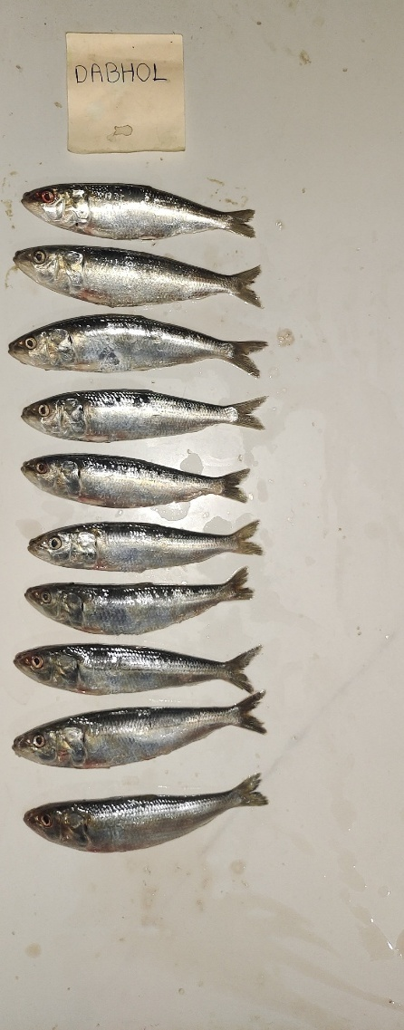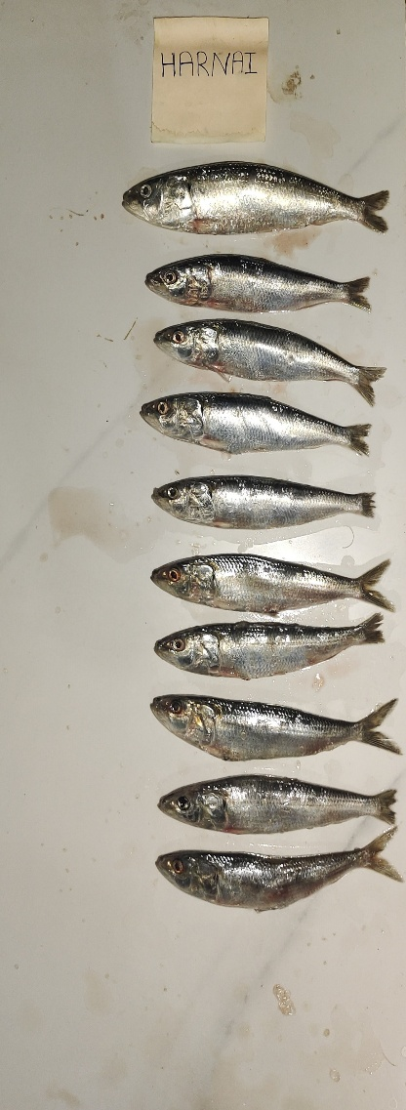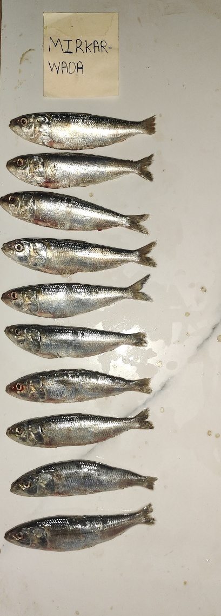

Fig 1 : Sardinella longiceps from Dabhol, Harnai and Mirkarwada arranged on tile

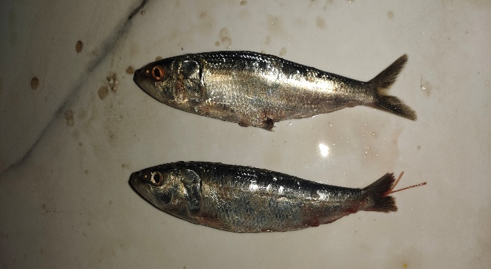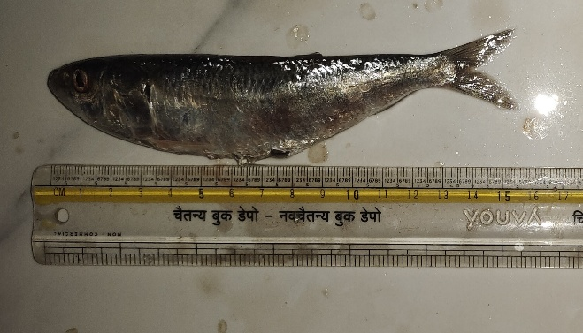

Fig 2 : Closer look of Sardinella longiceps.

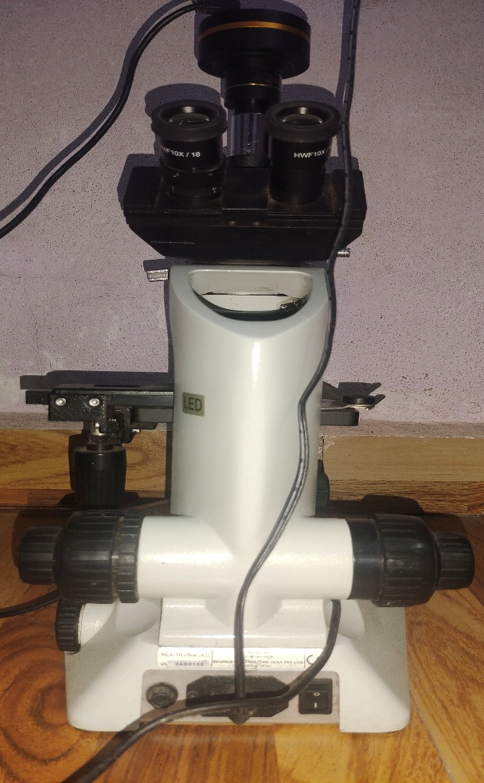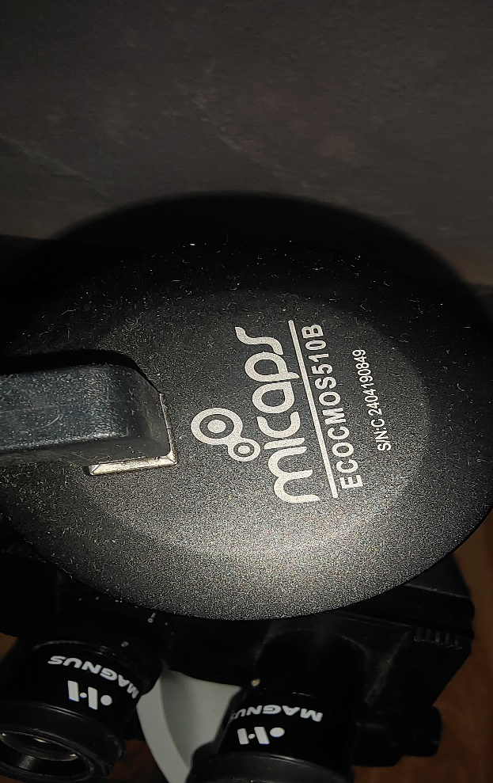
Fig 3 : Microscope (Magnus MLX Plus) & Camera (Micaps ECOMOS510B)

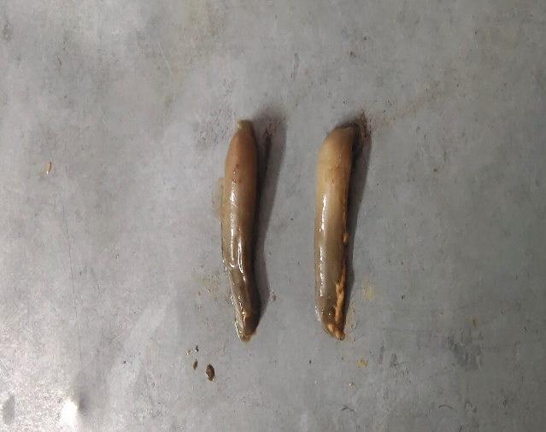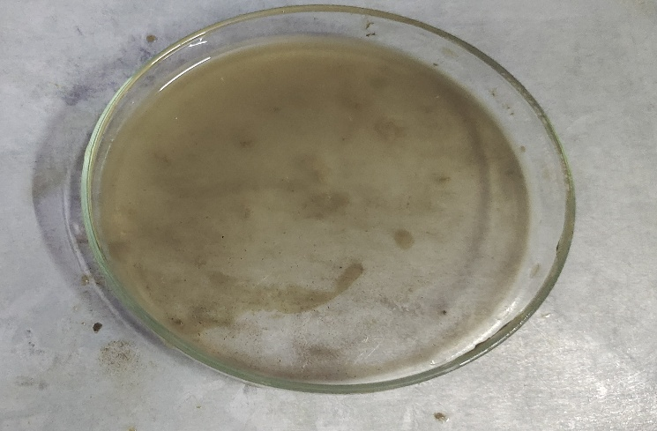
Fig 4 : Gut of Sardinella longiceps and slurry made of gut content for gut content analysis.
Planktons
Phytoplanktons

Fig 5 : Diatoms

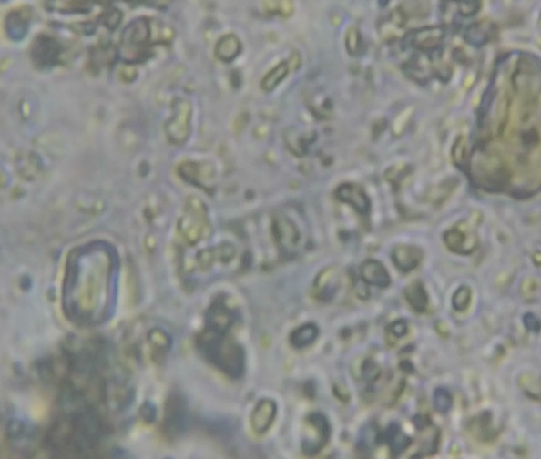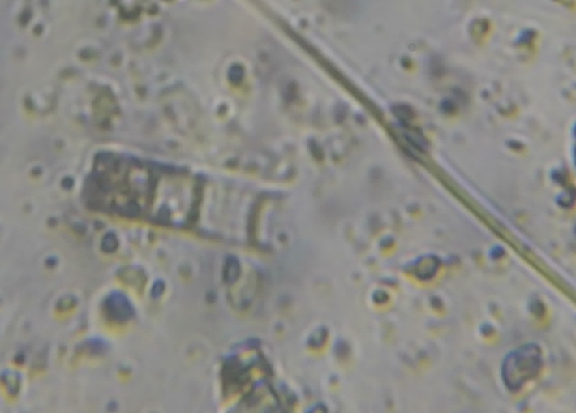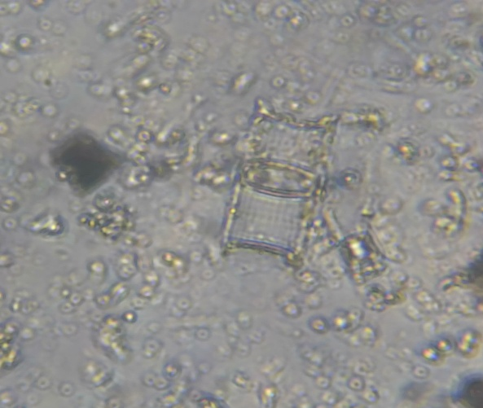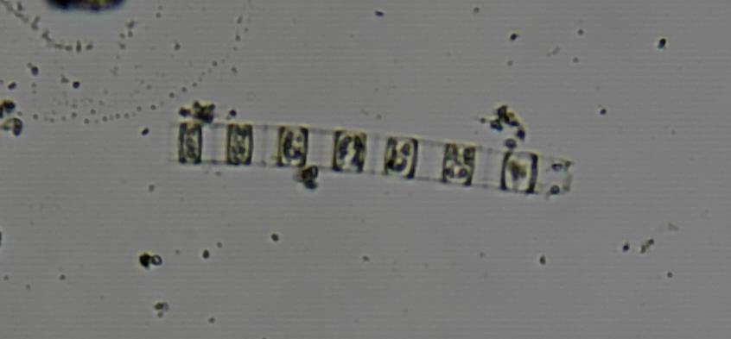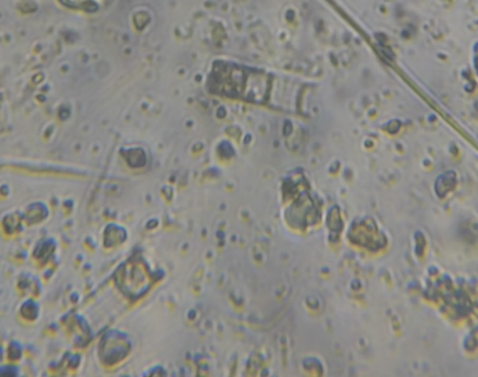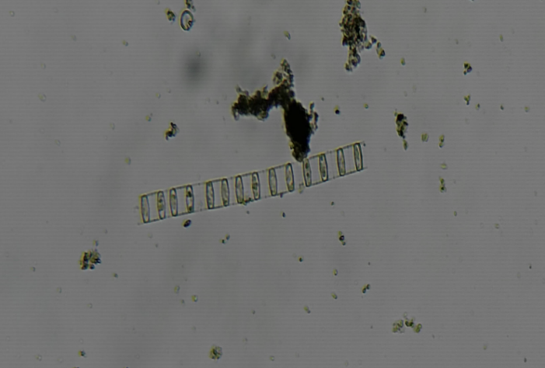
Fig 6 : Fragilaria oceanica

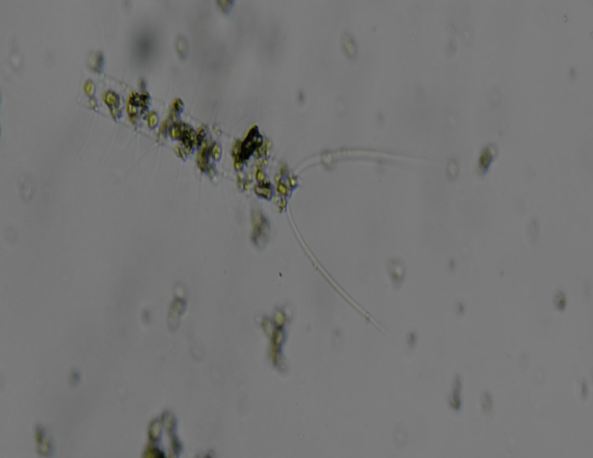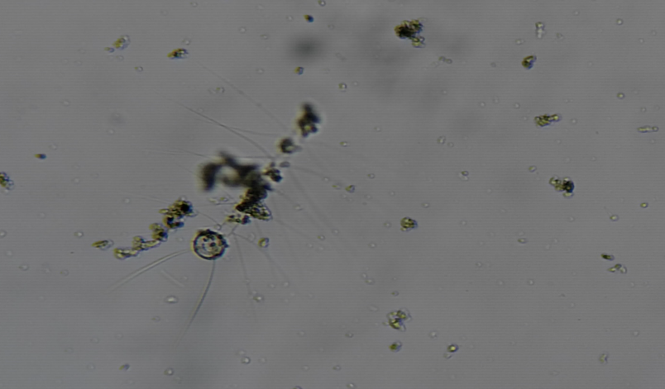

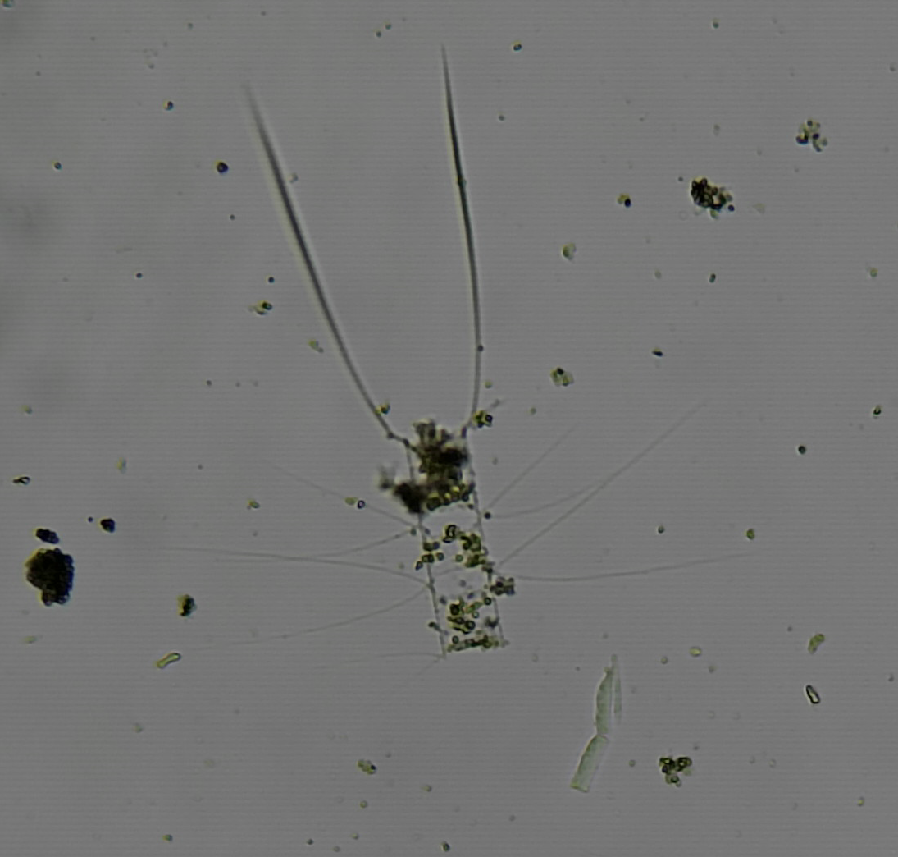

Fig 7 : Chaetoceros spp

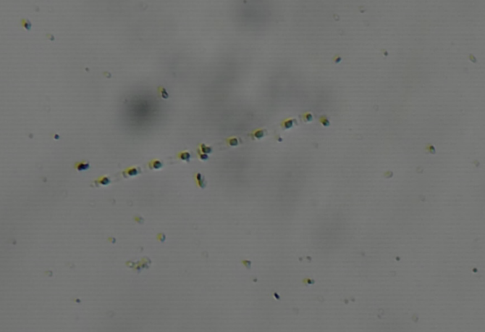

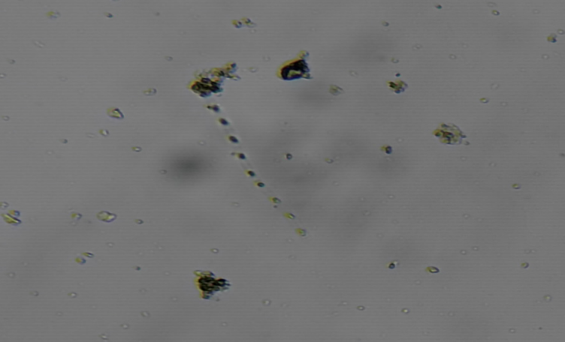

Fig 8 : Thalassiosira spp

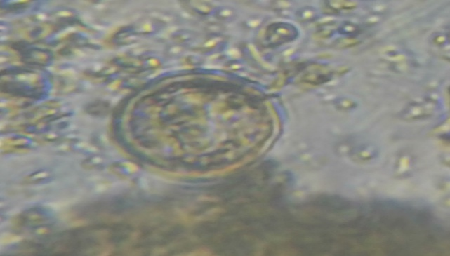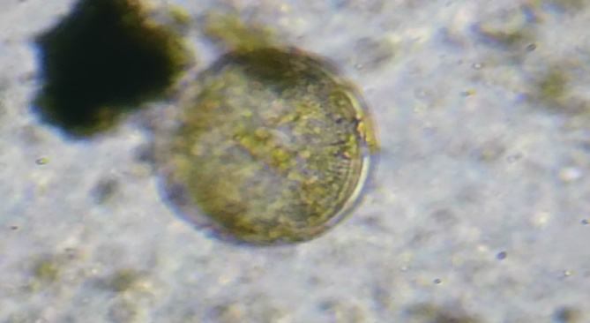
Fig 9 : Coscinodiscus spp.

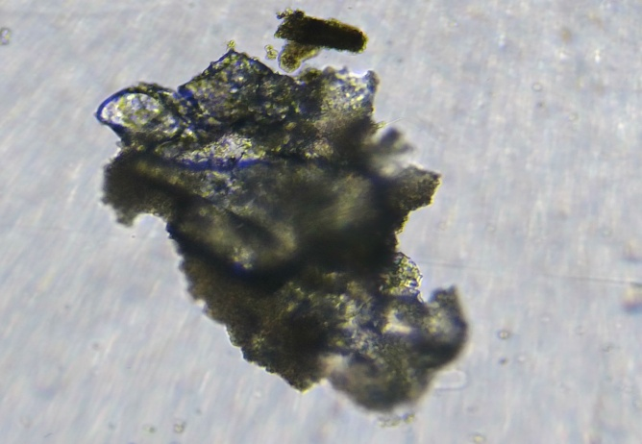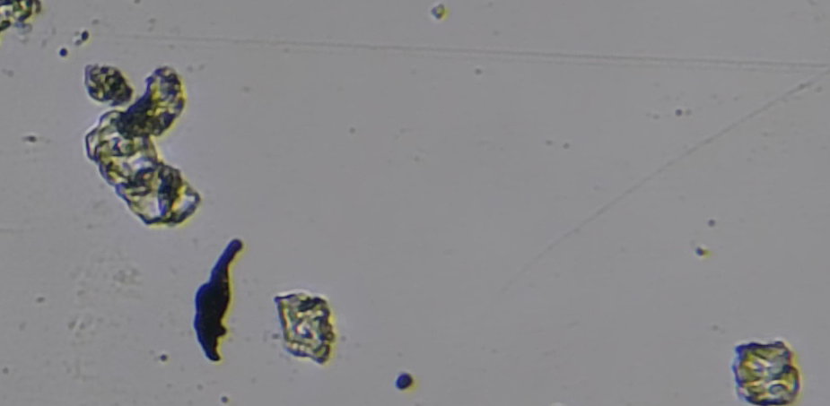
Fig 10 : Biddulphia sp.

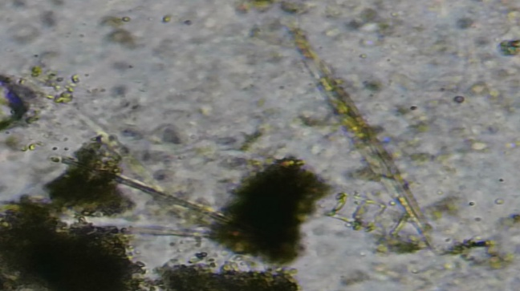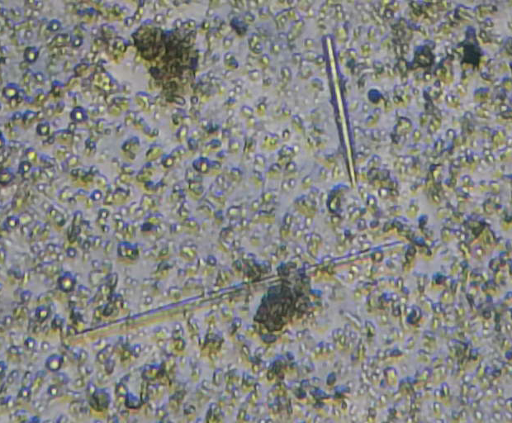
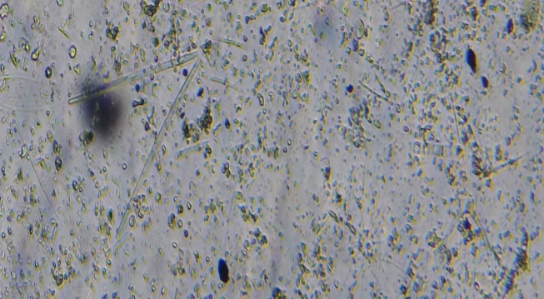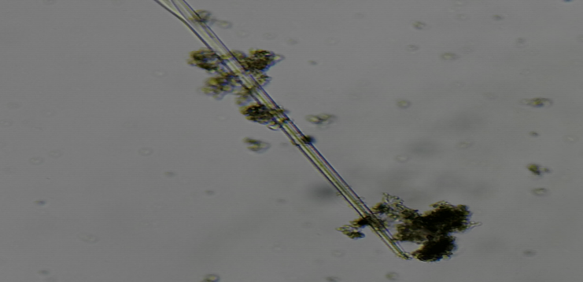
Fig 11 : Rhizosolenia sp.

Fig 12 : Dinoflagellates

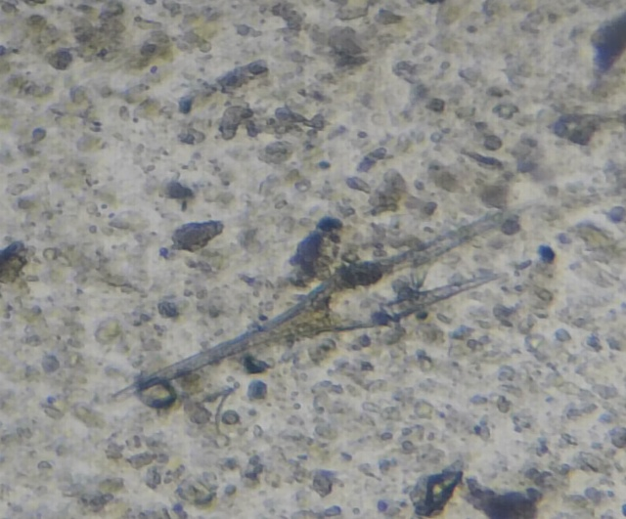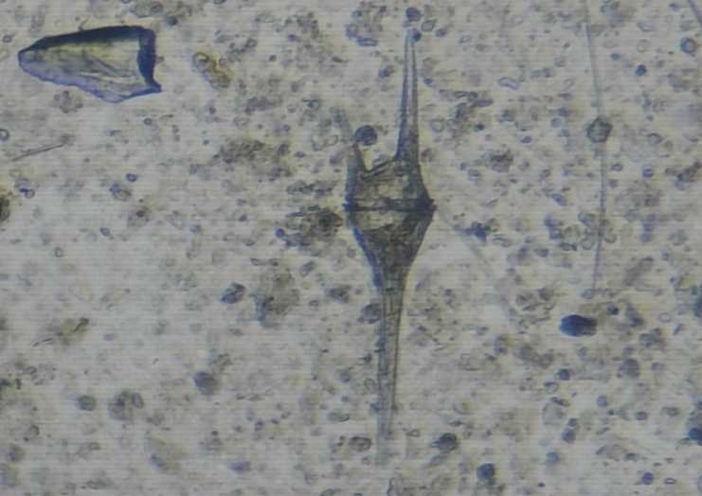
Fig 13 : Ceratium species

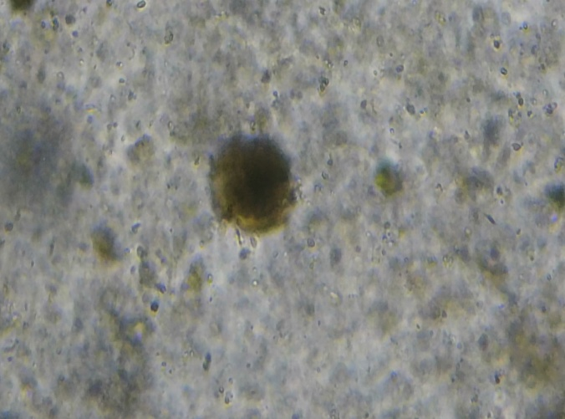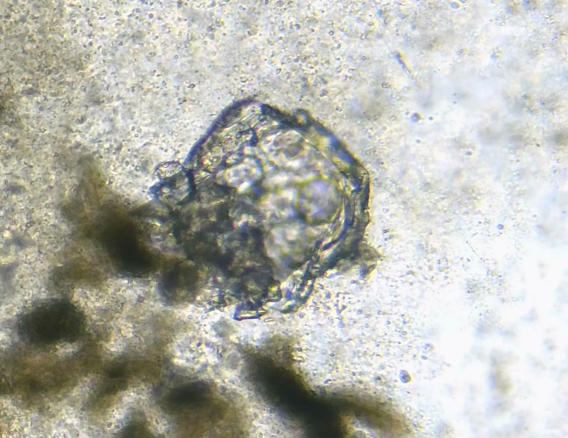
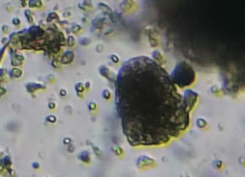
Fig 14 : Peridinium sp.
ZOOPLANKTONS

Fig 15 : Copepod

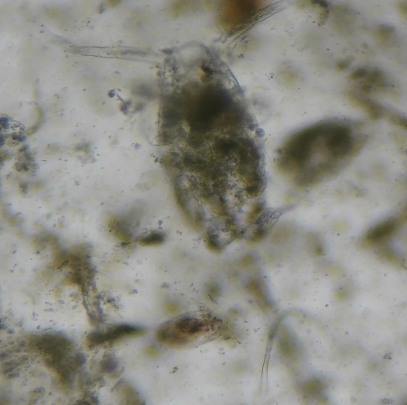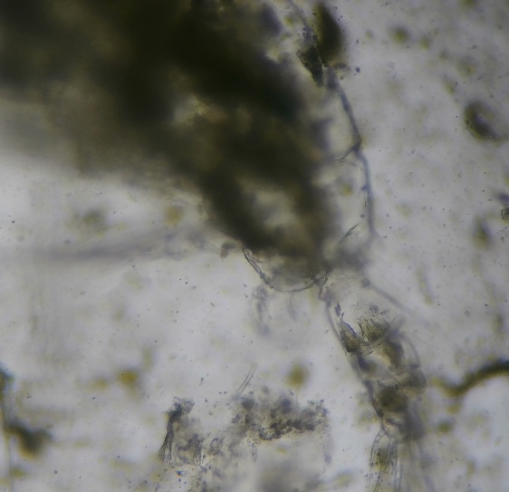
Fig 16 : Acartia sp

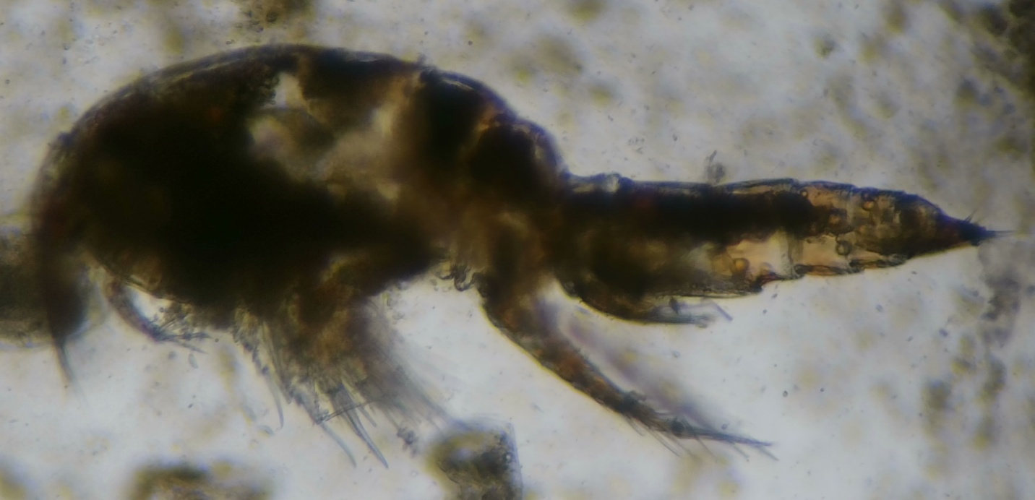
Fig 17 : Parancus sp

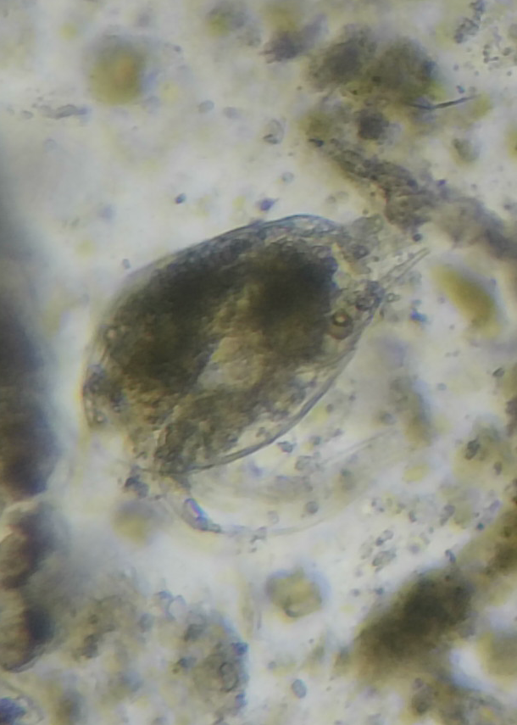
Fig 18 : Copepod nauplii

Other zooplanktons

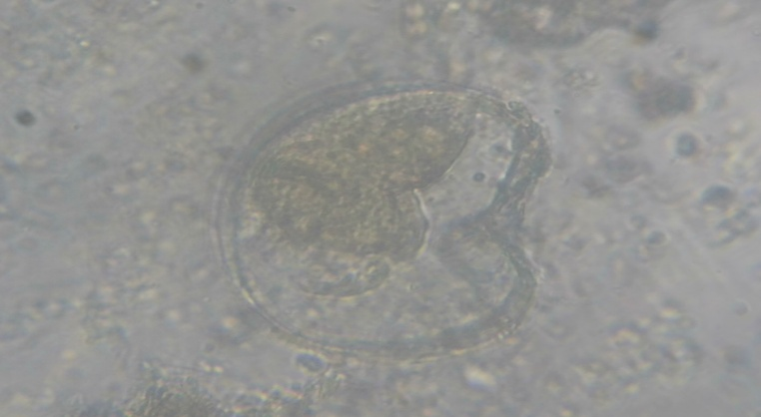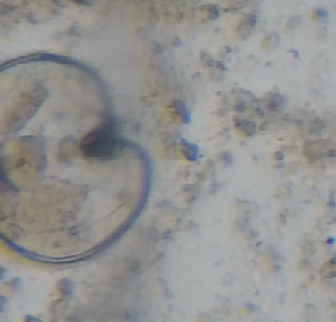
Fig 19 : Fish eggs

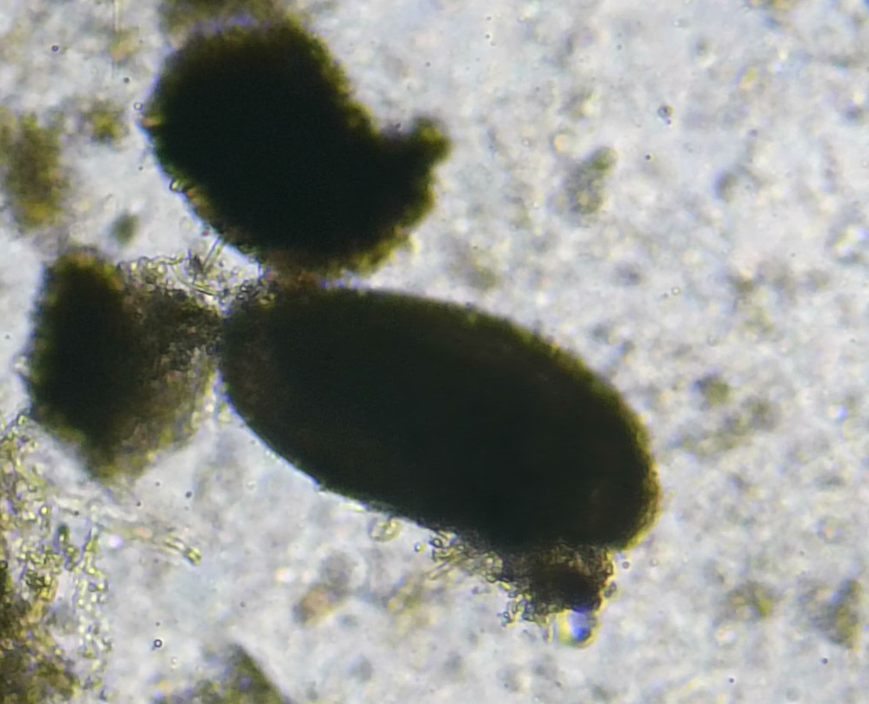
Fig 20 : Ostracod (small crustaceans with a bivalve-like shell)

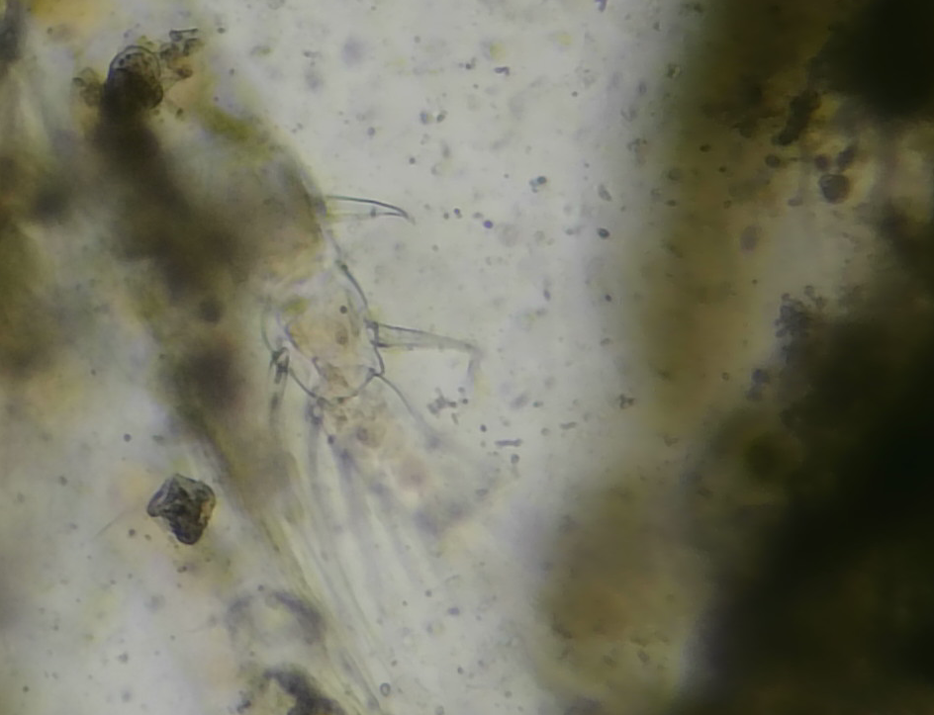
Fig 21 : Polychaete larvae

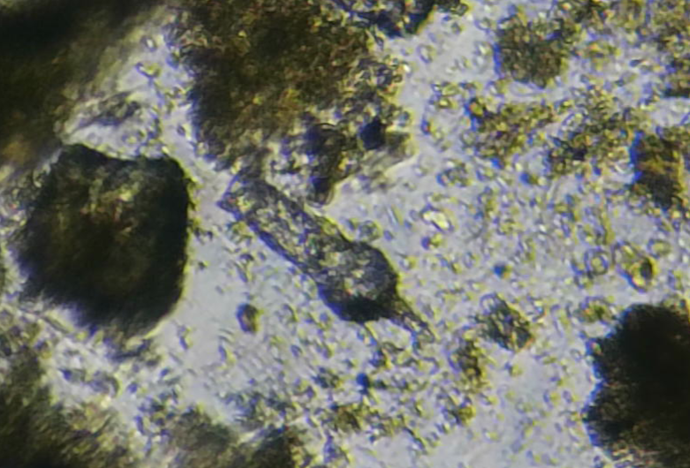
Fig 22 : Tintinnids

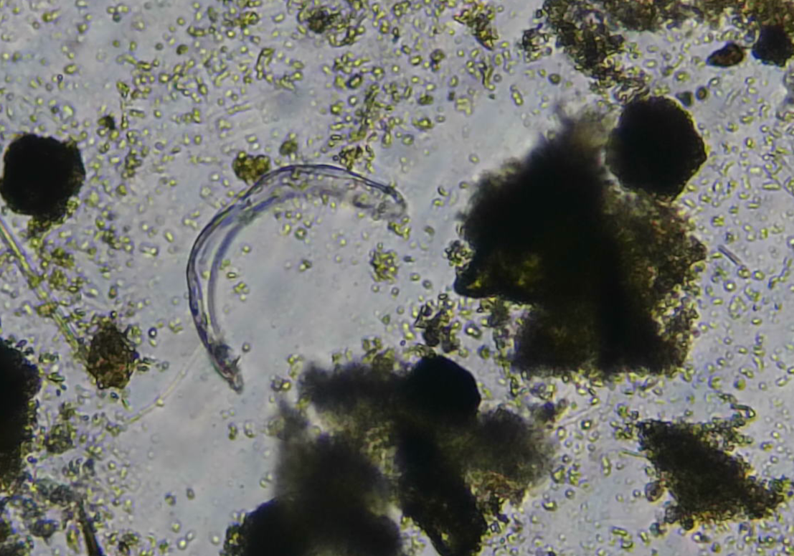
Fig 23 : Larvaceans

Non-living Matter

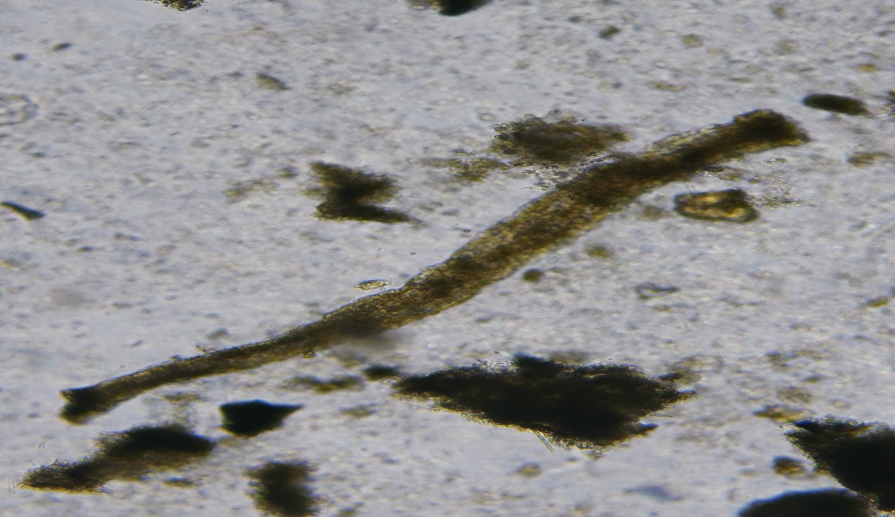
Fig 24 : Organic matter

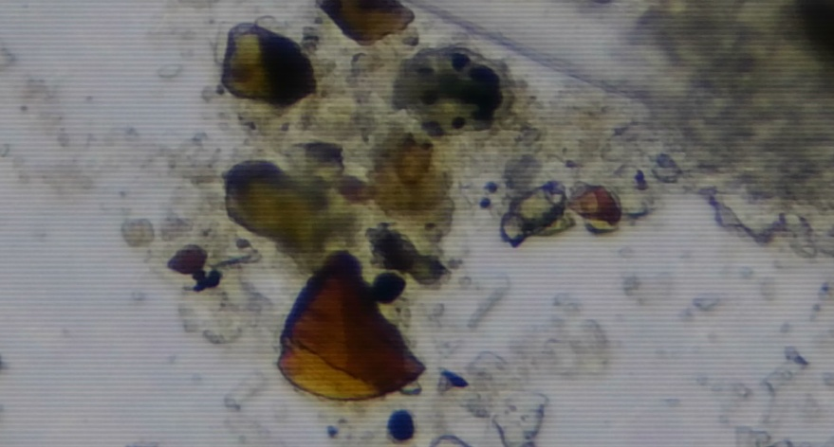
Fig 25 : Sand particles

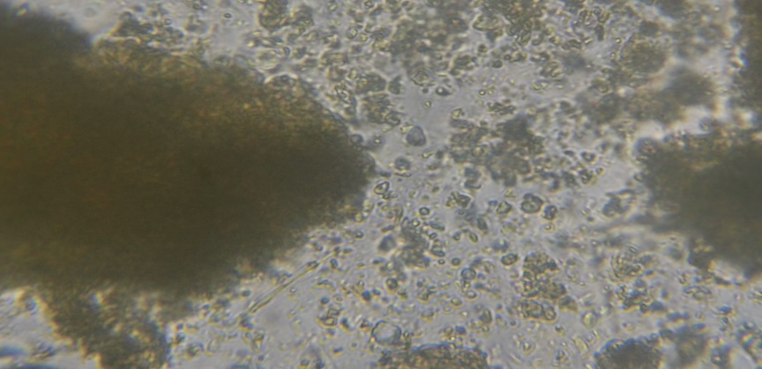
Fig 26 : Detritus
The dominance of diatoms (Fragilaria, Chaetoceros, Thalassiosira) in both seasons indicates that oil sardine feeding is strongly linked to primary productivity in coastal waters (Jyothibabu et al., 2008). Higher post-monsoon diatom abundance can be attributed to nutrient-rich waters following monsoon upwelling (Madhupratap et al., 1990).

The gut content analysis of Sardinella longiceps from Dabhol, Harnai, and Mirkarwada during pre- and post-monsoon seasons (2024) revealed a dominance of phytoplankton, particularly diatoms, with secondary contributions from zooplankton and detrital matter (Table 1)
Seasonal and Spatial Variation in Phytoplankton
Diatoms such as Fragilaria oceanica, Chaetoceros spp., and Thalassiosira spp. were consistently dominant across all sites, comprising 45–55% of the gut content. The higher occurrence of Fragilaria oceanica (22–24% in pre-monsoon, 20–22% in post-monsoon) indicates its importance as a staple food resource for sardines (Subramanian, 2001). The relative abundance of Chaetoceros spp. (17–21%) and Thalassiosira spp. (14–17%) supports earlier reports that these genera form the bulk of sardine diets in Indian coastal waters (Bhaskaran & George, 2003).
- Coscinodiscus spp.* showed moderate contribution (9–14%), aligning with findings that large centric diatoms are occasionally ingested but less preferred due to their larger size (Nair & Pillai, 2006).
- Biddulphia spp.* and Rhizosolenia spp. were present in low proportions (2–6%), consistent with prior studies showing seasonal fluctuations of these taxa in plankton communities (Qasim, 1973).
Dinoflagellates such as Ceratium spp. and Peridinium spp. contributed marginally (0–5%), reflecting their opportunistic ingestion rather than preference (Devassy & Bhattathiri, 1974).

Zooplankton Contribution
Zooplankton, especially copepods (Acartia spp. and Paracalanus spp.), were significant diet components, particularly in the post-monsoon period. Acartia spp. (7–12%) and Paracalanus spp. (6–12%) increased notably after the monsoon, suggesting enhanced secondary productivity due to nutrient enrichment from riverine influx (Madhupratap, 1987). Similarly, copepod nauplii (6–10%) indicated a seasonal dependence of sardines on larval copepods during post-monsoon (Smitha et al., 2008).
Other zooplankton groups such as fish eggs (2–5%), ostracods (0–1%), polychaete larvae (0–1%), tintinnids (2–3%), and larvaceans (0–2%) were recorded sporadically. Their low frequency suggests incidental ingestion while filter-feeding (Longhurst, 2007).

Non-living Matter
Non-living material, including organic detritus, sand particles, and unidentified organic matter, contributed 5–10% of gut content. The higher presence of detritus and sand in post-monsoon (up to 9% at Mirkarwada) indicates sediment resuspension and coastal turbulence during the season (Govindan et al., 1986).

Ecological Implications
The dominance of diatoms across sites highlights the sardine’s role as a primary consumer within the food web (Nair, 1970). Seasonal shifts towards zooplankton in post-monsoon underline the species’ dietary flexibility, which ensures sustenance during fluctuations in phytoplankton biomass (Horn, 1982). This adaptability explains the ecological success of S. longiceps in sustaining commercial fisheries along the Ratnagiri coast (Pillai et al., 2000).

Conclusion
The present study highlights the dominance of diatoms, particularly Fragilaria oceanica, Chaetoceros spp., and Thalassiosira spp., as the primary dietary components of Sardinella longiceps across the PFZs of Dabhol, Harnai, and Mirkarwada, reaffirming their role as key primary consumers in coastal food webs. Seasonal variations were evident, with post-monsoon periods showing increased ingestion of copepods such as Acartia spp. and Paracalanus spp., reflecting the sardine’s capacity to exploit secondary production during nutrient-enriched conditions. Spatial differences revealed that Dabhol and Harnai diets were strongly diatom-dominated, while Mirkarwada showed higher contributions from zooplankton and detritus, indicating localized environmental influences and fishing pressures.
The ability of oil sardines to adjust feeding strategies between phytoplankton and zooplankton ensures ecological resilience and supports their continued dominance in coastal fisheries of Ratnagiri. These findings provide valuable insights for understanding sardine feeding ecology in PFZs, with implications for fisheries management and the sustainable utilization of pelagic resources.

Disclaimer (Artificial intelligence)
Author(s) hereby declare that NO generative AI technologies such as Large Language Models (ChatGPT, COPILOT, etc.) and text-to-image generators have been used during the writing or editing of this manuscript.

References
- Amrutha, M. M., Mankodi, P. C., & Kumar, S. (2021). Environmental drivers of oil sardine distribution and implications for fisheries. Regional Studies in Marine Science, 45, 101815.
- Bensam, P. (1990). Biology and fishery of the Indian oil sardine. CMFRI Bulletin, 42, 69–85.
- Bhaskaran, P. K., & George, M. D. (2003). Feeding ecology of Indian oil sardine (Sardinella longiceps) in relation to phytoplankton distribution. Indian Journal of Marine Sciences, 32(1), 45–52.
- Bhargava, R., Parmar, R., & Shah, T. H. (2021). Food and feeding habits of Sardinella longiceps landed at Veraval Harbour, Gujarat. Indian Journal of Fisheries, 68(3), 59–64.
- Chavda, V. M., Shukla, A. D., & Kunjadia, A. P. (2019). Evaluation of fish catch in Potential Fishing Zones (PFZs) off Veraval coast, Gujarat. International Journal of Fisheries and Aquatic Studies, 7(3), 365–370.
- CMFRI (2012). Handbook on Indian Marine Fishes and their Ecology. Central Marine Fisheries Research Institute, Kochi.
- Desikachary, T.V. (1959). Marine Diatoms. CSIR Publications, New Delhi.
- Devassy, V. P., & Bhattathiri, P. M. A. (1974). Phytoplankton ecology of the Cochin backwaters. Indian Journal of Marine Sciences, 3(2), 122–130.
- Govindan, K., Nair, A. G., & Jacob, R. (1986). Seasonal sediment resuspension and its influence on plankton productivity. Journal of Coastal Research, 2(4), 321–329.
- Horn, M. H. (1982). Optimal diets in complex environments: feeding strategies of fish larvae and juveniles. Environmental Biology of Fishes, 7(2), 143–157.
- Hynes, H.B.N. (1950). The food of freshwater sticklebacks. Journal of Animal Ecology, 19(1), 36–58.
- INCOIS (2025). Potential Fishing Zone (PFZ) Advisory. Indian National Centre for Ocean Information Services, Hyderabad. Retrieved from https://incois.gov.in
- Jyothibabu, R. et al. (2008). The response of microzooplankton to coastal upwelling in the eastern Arabian Sea. Estuarine, Coastal and Shelf Science, 77(4), 518–528.
- Longhurst, A. R. (2007). Ecological Geography of the Sea. Academic Press, London.
- Madhupratap, M. (1987). Role of zooplankton in coastal upwelling ecosystems. Journal of the Marine Biological Association of India, 29(1-2), 24–33.
- Madhupratap, M., et al. (1990). Zooplankton biomass, composition and distribution in the Arabian Sea. Indian Journal of Marine Sciences, 19, 123–127.
- Nair, R. V. (1970). The food of the Indian sardine (Sardinella longiceps). Proceedings of the Indian Academy of Sciences, 72(1), 1–13.
- Nair, R. V. (1960). Studies on seasonal variation in the food components of Sardinella longiceps. Indian Journal of Fisheries, 7(1), 1–15.
- Nair, R. V., & Subrahmanyam, C. B. (1955). The food and feeding habits of the Indian oil sardine Sardinella longiceps. Proceedings of the Indian Academy of Sciences, 41(2), 49–56.
- Nair, R.V., et al. (1983). The Indian oil sardine. CMFRI Special Publication, 1–44.
- Nair, R. V., & Pillai, V. K. (2006). Seasonal distribution of diatoms in relation to sardine diet. Marine Biology Research, 2(3), 187–195.
- Newell, G. E., & Newell, R. C. (1977). Marine Plankton: A Practical Guide. Hutchinson Educational. Pillai, P. P., & Nair, R. V. (2010). Assessment of PFZ advisories and their utility in fisheries. Indian Journal of Fisheries, 57(3), 45–52.
- Pillay, T.V.R. (1952). A critique of the methods of study of food of fishes. Journal of the Zoological Society of India, 4, 185–200.
- Pillai, V. N., Gopakumar, G., & Mohamed, K. S. (2000). The oil sardine fishery along the southwest coast of India. Marine Fisheries Information Service, 164, 1–12.
- Qasim, S. Z. (1973). Some problems related to the food chain in a tropical estuary. Marine Biology, 18(4), 313–320.
- Shah, T. H., Chakraborty, S., & Parmar, R. (2025). Food and feeding habits of oil sardine Sardinella longiceps from Ratnagiri coast off Maharashtra, India. ResearchGate Preprint.
- Shenoi, S. S. C. (2012). Potential Fishing Zone advisories and ocean state forecasts. Journal of the Indian Institute of Science, 92(2), 155–163.
- Subrahmanyan, R. (1946). A systematic account of the marine plankton diatoms. University of Madras Press.
- Subramanian, S. (2001). Seasonal feeding dynamics of sardines in Indian coastal waters. Fisheries Research, 52(2-3), 123–132.
- Smitha, A., Nair, K. K. C., & Jayalakshmi, K. J. (2008). Feeding spectrum of oil sardine in relation to copepod abundance. Indian Journal of Fisheries, 55(2), 115–121.

