STUDIES ON ANTIBIOTIC RESISTANCE OF STAPHYLOCOCCUS SPP ISOLATED FROM COW MILK

Abstract
Ten samples of raw milk and 10 samples of pasteurized milk samples were collected from Puducherry and Cuddalore. After collection of samples, in case of raw milk, bacterial pre-enrichment was performed in 90ml of Tryptic Soy Broth with 10ml of raw milk sample and in case of pasteurized milk, pre-enrichment was performed in 90ml of tryptic soy broth with 10ml of pasteurized milk sample. After Pre enrichment, isolation and identification of the target organism, Staphylococcus spp was carried out. The pre enriched raw milk and pasteurized milk samples were streaked onto Baird Parker agar plate and Mannitol salt agar plates. Then they were incubated at 37℃ for 24-48hrs. Staphylococcus spp was identified by the yellow colour colonies in Mannitol Salt agar, If Baird Parker agar plate contains black colonies, they were considered as positive for Staphylococcus spp. The isolates were sub cultured to get pure culture. The isolates were identified based on morphological and biochemical characterization. The antibiotic susceptibility testing was carried out for the isolates against the selected antibiotics ampicillin, tetracycline, kanamycin, erythromycin, methicillin, streptomycin, amikacin, gentamicin, ciprofloxacin and chloramphenicol. Among the ten raw milk isolates and ten pasteurized milk isolates, raw milk isolate RMS 9 showed resistance towards six selected antibiotics. RMS 9 isolate was identified by 16S r RNA sequencing .

Key Words:Raw milk; Pasteurized milk; Pre-enrichment; Antibiotic Susceptibility and 16S r RNA sequencing.

1.INTRODUCTION
Food borne diseases are also referred as Food borne illness and Food poisoning are caused by in taking food or drink which has been contaminated by microbes or toxins [21]. These Microorganisms or their toxins can cause a wide range of symptoms ranging from mild gastroenteritis to life threatening illness. Symptoms can vary depending on the type of microbe and their toxins that caused the illness. Enterotoxins produced by Staphylococcus spp can cause food borne illness. These toxins can be found in contaminated food, especially if it has been stored improperly .
Milk and milk products are the prime habitat for the microbial ecosystems [21,11,12]. They cause infection if they are contaminated with bacteria, virus or parasites or toxins [19]. These pathogens are responsible for the variation in taste, aroma and texture of the food product. Sources of contamination are poor hygiene during milking, storage as well as the presence of sick animals or their waste .
Staphylococcus is a Gram positive bacteria found in clusters. It is considered as an substantial cause for food borne diseases. Staphylococcal food poisoning is occurred due to the absorption of Staphylococcal enterotoxins which are already preformed in the food samples. Staphylococcus spp are commonly found on the skin and in the nose of healthy people and animals. They contaminate the milk during the milking process or through handling or storage. The bacteria can also grow in milk that are not stored in sterile condition [1,2]. Staphylococcus spp produces enterotoxins which are toxins that can cause gastrointestinal symptoms in humans and animals. They are several type of Staphylococcal enterotoxins (SE) including SEA , SEB , SEC , SED , SEE , SEG , SEH , SEI ,SEJ. Illness caused through Staphylococcal enterotoxins(SE) produce gastrointestinal symptoms such as nausea, vomiting and abdominal pain [21,8]. Severity of the symptoms can vary depending on the dose and type of toxin as well as the individuals age, health status and immune system. Since the enterotoxins are highly resistant or heat stable and resistant to digestive enzymes, on heating the milk at normal temperature the bacteria may be killed but the toxins still remains intact in the milk.
Mastitis:
Mastitis is an infection of the mammary gland in dairy animals such as cow , goat and sheep which is caused by an bacterial infection. Staphylococcus sp is one of the major cause for Mastitis that enters the udder through the teat canal and lead to inflammation leading to reduced milk production. Staphylococcus causes skin infection leading to inflammation, redness, pain and warmth in the affected breasts . The milk may also become discoloured, thick, lumpy and there are also chances for flu – like symptoms such as body aches , fever and chills.
Staphylococcus can cause both clinical and subclinical Mastitis in dairy animals. Clinical mastitis is the more severe, obvious and severe form of the disease. It is characterized by swelling, visible inflammation and heat in the affected quarter [14]. The milk from the affected part will have a foul odour, clotted or even bloody. The cow shows symptoms like lethargy, decreased appetite and fever.
Subclinical Mastitis is a less obvious and asymptomatic form the infection [14] . However they still have an impact in the milk production and its quality. The cow infected with subclinical mastitis doesn’t show any symptoms and also the milk seems to appear normal, but the Somatic Cell Count (SCC) is increased due to the immune response towards the infection. This elevated SCC results in the poor milk quality, lower milk production and increased risk in the risk of transmission, spread of infection to other cows. The diagnosis of Clinical and Subclinical Mastitis is based on physical examination, milk culture and SCC testing.
Even though controlling of Mastitis is difficult, it is practiced with the use of antibiotics. Several antimicrobial agents are also adequately used for the prevention and control of Mastitis in cattles. Warm compressers and pain relievers are also recommended to help relieve symptoms. It is also important to pump milk and breast feed at the time of treatment, since emptying breast will help to prevent complications and improve the symptoms . But in some cases Mastitis can lead to formation of abscess which may need surgical drainage.
Antibiotic Resistance:
Several guidelines are also accessible for the appropriate administration of antibiotics in animals, but they aren’t followed by many livestock keepers which lead to the development of new Antibiotic-resistant strains [3,5,7,24]. The isolates which are antibiotic resistant had a great negative impact on therapy thus they are very challenging for both health professionals and veterinary [15,16,17] Antibiotics usage resulted in the emergence of antibiotic resistant traits within the strain of the pathogen [9,10,13]..
These traits are coded by particular genes that are being carried on the transposing, bacterial chromosomes, plasmid or on the gene cassettes which are incorporated into integrons [6,4,18], thus they are easily transferred among the isolates [20,22,23 This study will focus on the resistant profile of antibiotics and guidelines for the selection of effective treatment for mastitis.

2.MATERIALS AND METHODS
2.1.Collection of Samples:
Raw milk samples and pasteurised milk samples (Figure-1) were collected from places around Puducherry and Cuddalore districts. The samples were immediately transported to the laboratory and were analyzed for the presence of Staphylococcus strains.
2.2.Pre - Enrichment:
The samples were processed immediately upon arrival using aseptic techniques . Pre-enrichment was done using 90ml of Tryptic soy broth and 10ml of the milk sample (raw cow milk and pasteurised cow milk separately) and kept at 37 ̊C for 24 hrs (Figure-2 ).
2.3.Isolation of Staphylococcus sp:
For the isolation of the Staphylococcus sp, the pre-enriched sample were streaked onto the specific media like Baird Parker Agar and Mannitol Salt Agar and incubated at 37 ̊C for 24 hrs. In Baird Parker Agar, small, round, black, shiny, convex colonies in smooth or slightly rough texture is found after incubation for Staphylococcus spp .In Mannitol Salt Agar, the colonies are round, convex and are in small to medium sized, golden yellow colonies are formed. The isolates were purified by subculture technique. Further identification is carried out based on morphological, biochemical and molecular characterization.
2.4.Identification of the Isolates:
Morphological and biochemical characterization of bacterial isolates
The bacterial isolates were identified based on Morphological features such as Gram staining, spore staining and motility test. Isolates were subjected to biochemical test such as Indole, Methyl red, VogesProskauer, Citrate utilization, Catalase test, Oxidase test, DNAse test and Starch hydrolysis test. Molecular characterization of the potent antibiotic resistant isolate was identified by 16S rRNA sequencing.
COAGULASE TEST:
Coagulase test can be done by using two methods, Tube method (used for detecting free coagulase enzyme ) and Slide method (used for detecting bound coagulase enzyme ) (Figure-4) . But the most commonly used method is Tube method . The overnight culture of Staphylococcal isolate which has to be tested is prepared by using nutrient agar. Then a loopfull of culture is inoculated into a sterile saline solution. It is then mixed well to get a homogenous solution . Then using a sterile loop, a small amount of the bacterial suspension is transferred into a tube containing human or rabbit plasma and the tubes were then incubated at 37 ̊C in water bath for 3 – 6 hours . After incubation period the positive result is identified based on the clot formation and no clot formation and remains as an clear liquid is considered as negative result.
DNASE Test:
DNAse test (Figure-5) is used to determine the ability of the organism to produce DNAse enzyme which degrades DNA. Using DNAse agar media the agar plate is prepared. Then the purified culture of the Staphylococcus strain was streaked into the agar plate using a sterile loop and the inoculated plated is then kept for incubation at 37 ̊C for 24 hours . After incubation period positive result is observed by visualizing a clear zone around the bacterial streak line.
2.5.Antibiotic susceptibility testing:
The antibiotic susceptibility testing was carried out by Kirby-Bauer disc diffusion method using Muller-Hinton agar. The antibiotic discs were used with the isolates to identify the antibiotic resistance of it. The antibiotics used includes Tetracycline (TE), Gentamicin (GEN), Ciprofloxacin (CIP), Amikacin (AK), Streptomycin (S), Cephalothin (CEP). Kanamycin (K), Chloramphenicol (C), Ampicillin (AMP), Erythromycin (E) and Methicillin (MET). The plates were then kept for incubation at 37ºC 24 hours. After incubation period, the diameter of zone or zones of inhibition around each antibiotic discs were measured. The zone size are an indicator of the susceptibility of the bacteria to the antibiotics. The diameters are interpreted with the standard interpretation chart provided by Clinical and Laboratory Standard Institute based on the interpretation of zones size for the respective bacterial pathogens for treatment.
3.RESULTS AND DISCUSSION
Identification of bacterial isolates from raw milk and raw milk cheese:
The morphological, biochemical and cultural characteristics of the isolated strains from raw milk and pasteurized milk samples were studied. Raw milk and pasteurized milk isolates were screened for Staphylococcus spp using specific media, Baird Parker agar and Mannitol Salt agar (Figure-3). Isolates were identified by morphological, biochemical and molecular characterization. Blast analysis was carried out and the isolate was confirmed as Staphylococcus aureus with similarity percentage of 99.92% (Figure-7).
Antibacterial susceptibility testing:
Antibiotic susceptibility testing was carried out for the isolates of raw milk and pasteurized milk samples. Different antibiotic discs were used such as Ampicillin (Amp), Tetracycline (TE), Gentamicin (GEN), Streptomycin (S),Erythromycin (E), Kanamycin (K), Amikacin (AK), Ciprofloxacin (CIP),Chloremphenicol (C) and Methicillin (MET). Resistant pattern of isolates towards the antibiotics were studied. From those isolates, RMS – 9 showed resistance towards six antibiotics which was identified by 16S r RNA sequencing (Figure-6).

Figure 1 : Raw milk and Pasteurised milk samples

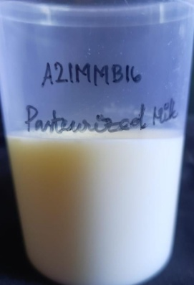
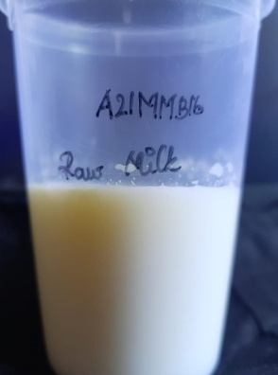
Raw Milk Pasteurised Milk

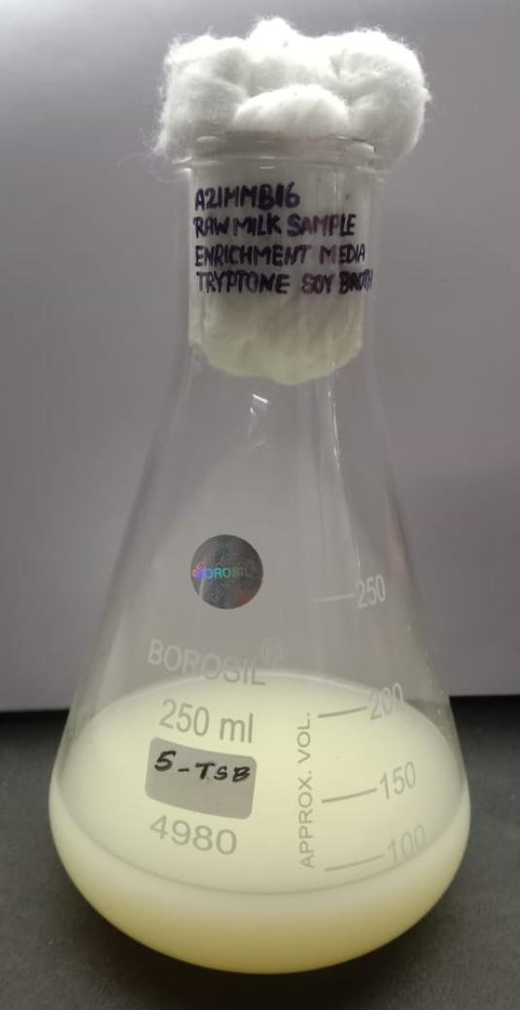
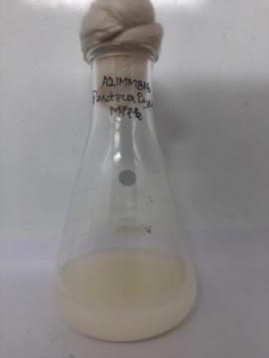
A.Pre enrichment for Pasteurized milk sample
B.Pre enrichment for raw milk sample

Figure 2:Pre Enrichment of Milk Samples

Table 1:Antibacterial susceptibility testing of bacterial isolates from Raw Milk
S.NO | ANTIBIOTICS | ISOLATES
S.NO | ANTIBIOTICS | RMS 1 |  | RMS 2 |  | RMS 3 |  | RMS 4 |  | RMS 5
S.NO | ANTIBIOTICS | Zone size in mm | Susceptibility | Zone size in mm | Susceptibility | Zone size in mm | Susceptibility | Zone size in mm | Susceptibility | Zone size in mm | Susceptibility
1 | Gentamycin (GEN) | 25 | S | 16 | S | 13 | I | 30 | S | 19 | I
2 | Ciprofloxacin (CIP) | 31 | I | 25 | I | 14 | R | 11 | R | 23 | I
3 | Chloramphenicol (C) | 31 | S | 30 | S | 22 | S | 20 | S | 9 | R
4 | Streptomycin (S) | 23 | S | 15 | S | 13 | I | 26 | S | 16 | S
5 | Methicillin (MET) | 39 | S | 35 | S | 16 | R | - | R | 6 | R
6 | Ampicillin (Amp) | 45 | S | 40 | S | 22 | R | - | R | 14 | I
7 | Erythromycin (E) | 32 | S | 20 | I | 16 | I | 20 | I | 24 | S
8 | Kanamycin (K) | 21 | S | 12 | R | 10 | R | 18 | S | 17 | I
9 | Amikacin (AK) | 25 | S | 17 | I | 9 | S | 21 | S | 24 | S
10 | Tetracycline (TE) | 28 | S | 24 | S | 21 | I | 20 | I | 23 | S
R-Resistant S-Sensitive I- Intermediate

Table 2: Antibacterial susceptibility testing of bacterial isolates from Raw Milk
S.NO | ANTIBIOTICS | ISOLATES
S.NO | ANTIBIOTICS | RMS 6 |  | RMS 7 |  | RMS 8 |  | RMS 9 |  | RMS 10
S.NO | ANTIBIOTICS | Zone size in mm | Susceptibility | Zone size in mm | Susceptibility | Zone size in mm | Susceptibility | Zone size in mm | Susceptibility | Zone size in mm | Susceptibility
1 | Gentamycin (GEN) | 13 | I | 22 | S | 15 | S | 30 | S | 22 | S
2 | Ciprofloxacin (CIP) | 22 | I | 19 | R | 24 | I | 21 | R | 27 | I
3 | Chloramphenicol (C) | 13 | I | 17 | S | 19 | S | 20 | S | 30 | S
4 | Streptomycin (S) | 12 | I | 17 | S | 19 | I | 14 | I | 16 | S
5 | Methicillin (MET) | 25 | S | 18 | R | 20 | S | - | R | 29 | S
6 | Ampicillin (Amp) | 27 | R | 32 | S | 31 | S | 13 | R | 28 | R
7 | Erythromycin (E) | 17 | S | 26 | S | 15 | S | - | R | 24 | S
8 | Kanamycin (K) | 13 | S | 15 | I | 15 | I | 11 | R | 21 | S
9 | Amikacin (AK) | 15 | S | 19 | S | 17 | S | 23 | S | 21 | S
10 | Tetracycline (TE) | 24 | S | 18 | R | 25 | S | 20 | R | 23 | S
R-Resistant S-Sensitive I- Intermediate

Staphylococcus spp in Baird Parker Agar Staphylococcus spp in Mannitol Salt Agar

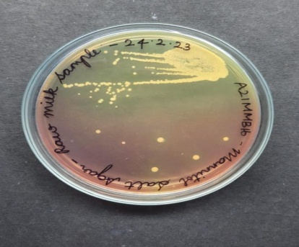
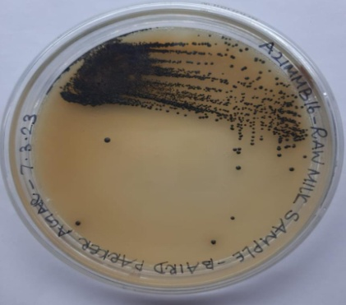

Figure-3 Showing Staphylococcus spp in Baird Parker Agar and Mannitol Salt Agar isolated from raw milk
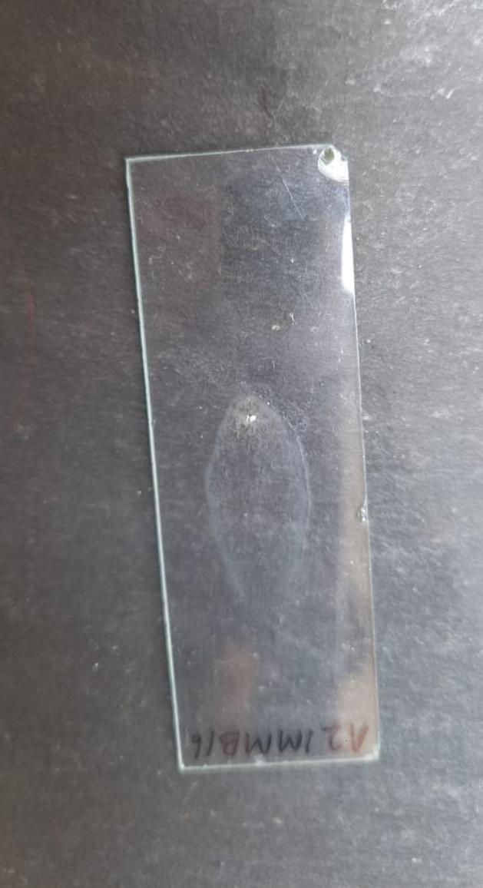
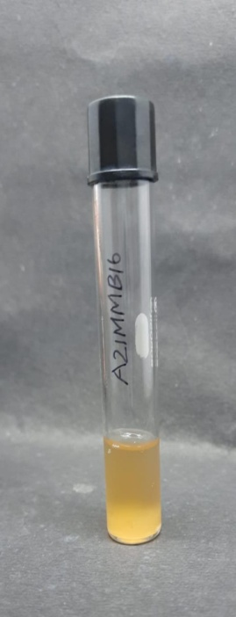
Figure-4:Coagulase Test

Slide Method Tube Method
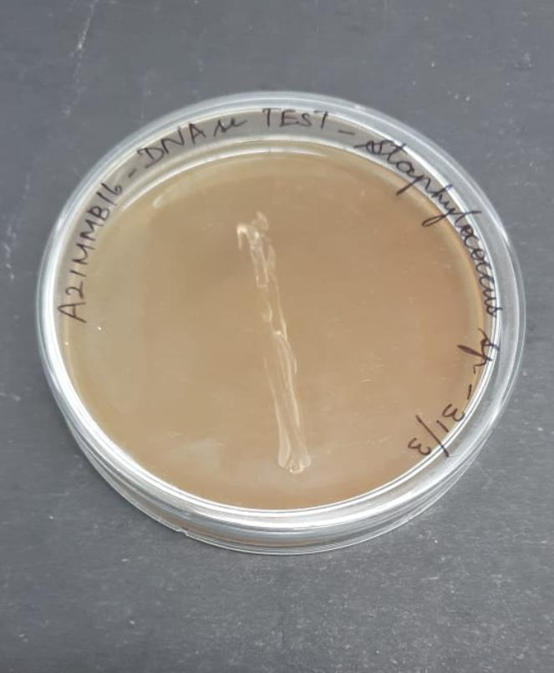
Figure-5:DNAse Test

Figure-6 Showing Antibiotic susceptibility testing of Isolate RMS 9 using antibiotics

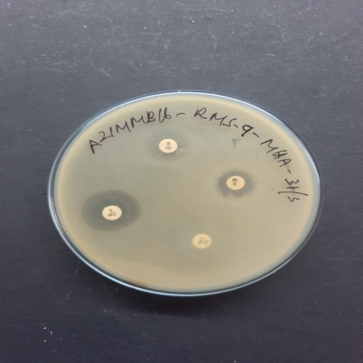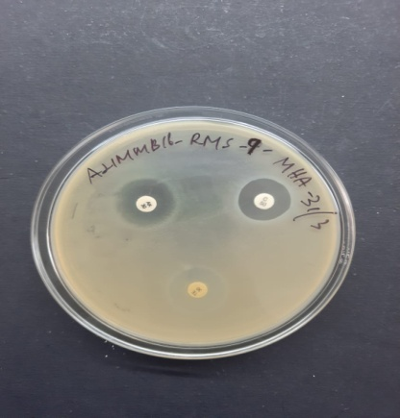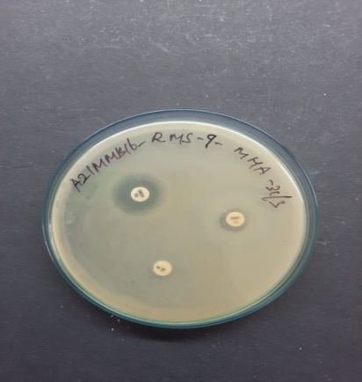

Ampicillin (Amp), Tetracycline (TE), Gentamicin (GEN), Streptomycin (S),Erythromycin (E), Kanamycin (K), Amikacin (AK), Ciprofloxacin (CIP),Chloremphenicol (C), Methicillin (MET).

Figure-7: Blast Result For RMS 9
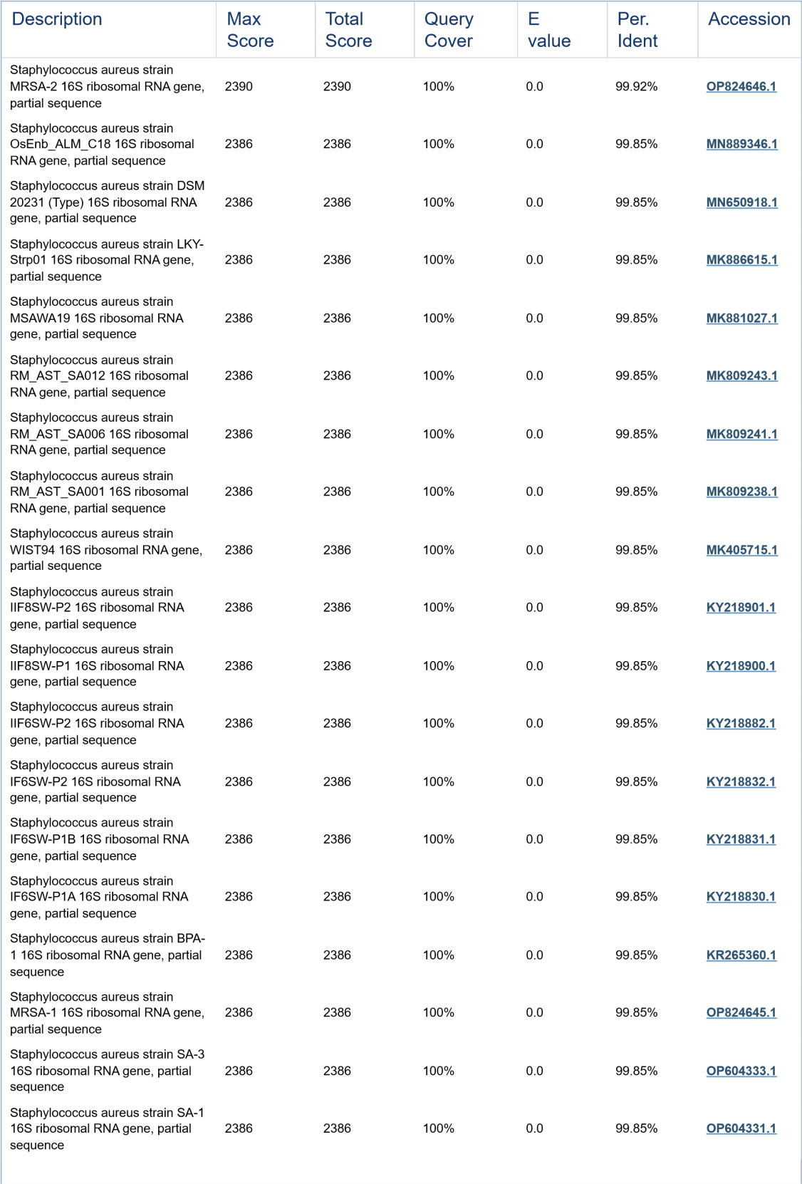

Collins N. Ateba et al., [6] found the presence of Staphylococcus spp in milk by spreading 100 µL of each serially diluted sample in the Mannitol Salt Agar plate. Then the plates were incubated at 37 °C for 18 -24hrs.After the incubation period yellow colour colonies were observed and the isolates were processed for biochemical and molecular characterization.
Thaker et al., [21] found out the presence of enterotoxigenic Staphylococcus aureus by enriching them in peptone water followed by isolation of sample in selective media, Baird Parker agar. A loopful of the pre-enriched inoculum is streaked onto the agar plate and incubated at 37 °C for 48 hrs. After incubation jet black colonies were observed. The isolates were then analysed for biochemical and molecular tests.
In the present study, the isolation of Staphylococcus spp from raw milk and pasteurized milk were studied by performing pre enrichment for both raw milk and pasteurized milk samples with tryptic soy broth and after incubation, they were streaked onto specific media Baird Parker agar and Mannitol Salt agar. After 24 hours of incubation, yellow colonies from Mannitol Salt agar and black colonies from Baird Parker agar were isolated. Morphological and biochemical characterization of the isolates were done.
Massawe et al., [14]carried out the antibiotic susceptibility testing using Kirby-Bauer disc diffusion method using Clinical Laboratory Standards Institute guidelines on Mueller-Hinton agar to determine the resistance or sensitivity of the antimicrobial agents. Multiple antibiotic-resistant (MAR) phenotypes were noted for isolates showing resistance to more than three antibiotics.
In the present study, antibiotic resistance for Staphylococcus spp isolates from raw milk and pasteurized milk were found out by using Kirby-Bauer disk diffusion method. The culture were inoculated on tryptic soy broth. After incubation the culture was swabbed on to the Muller-Hinton Agar plate. Ten antibiotic disks were placed on the plates. After incubation the zone of inhibition is measured and interpreted. Raw milk isolate RMS 9 showed resistance towards six selected antibiotics.
Azar Rahi et al., [4] found out the identification of the organism belonging to Staphylococci using a 16S rRNA specific PCR assay with specific primers to amplify the 16S rRNA gene sequence of Staphylococci. The PCR products were then analyzed using agarose gel electrophoresis to determine the identities of the Staphylococcus sp.
In the present study molecular characterization of the isolate, RMS 9 were carried out by 16S rRNA sequencing. The PCR was carried out by performing amplification, denaturation and annealing and it was identified as Staphylococcus aureus with 99.92% similarity was found out. The isolate was submitted in the GEN bank with the accession number OR244369.
CONCLUSION: Development of antibiotic resistance in Staphylococcus strains screened from raw milk and pasteurised milk samples denotes the drug resistance threat to human beings who used to consume milk and milk products. The results indicates the need for effective sanitary measures to improve the food safety because of the presence of Staphylococcus aureus in dairy products suggests possible contamination by Staphylococcus aureus due to lack of hygiene.

4.REFERENCES

1.Abdrezzak Bendahou, Mariam Lebbadi, Latifa Ennanei, Fatima Z. Essadqui, Mohammed Abid. Characterization of Staphylococcus species isolated from raw milk and milk products (lben and jben) in North Morocco. J Infect Developing Countries.2008; 2 (3): 218-225.
2.Abongile Pekana, Ezekiel Green. AntImicrobial resistance profiles of Staphylococcus aureus isolated from meat Carcasses and bovine milk in Abattoirs and Dairy Farms of the Eastern Cape, South Africa. Int J of Environ Res and Public Health.2018;15(10); 2223.
3.Alnazeer G, Alseed,Muna O, Elhaj,GE, Mohammed. Antibiotic resistance pattern of Staphylococcus species Isolated from raw cow milk in Ghebaish Locality. Sudan J of Sci and Technol.2019; 20(2): 69-74.
4.Azar Rahi, Hamidreza Kazemeini, Sedigheh Jafariaskari, Ali Seif, Sahar Hosseini, Farhad Safarpoor Dehkordi. Genotypic and Phenotypic-based assessment of antibiotic resistance and profile of Staphylococcal Cassette Chromosome mec in the methicillin-resistant Staphylococcus aureus recovered from raw Milk. Infection and Drug Resistance. 2020;13: 1339-1349.
5.Christine M. Mbindyo, George C. Gitao, Paul Joseph Plummer, Benard W. Kulohoma, Charles M. Mulei, Rawlynce Bett. Antimicrobial resistance profiles and genes of Staphylococci Isolated from Mastitic Cow’s Milk in Kenya. Antibiotics.2021;10(7):772.
6.Collins N. Ateba, Moses Mbewe, Modisane S. Moneoang, Cornelius C. Bezuidenhout. Antibiotic-resistant Staphylococcus aureus isolated from milk in the Mafikeng Area, North West province, South Africa. South African J of Sci.2010; 106: (11/12): 1-6.
7.Cuiping Shi, Zhongna Yu, Harvey Ho,Jun Wang, Wei Wu, Mengru Xing, Yutao Wang, Rahman SME, Rongwei Han. Occurrence, Antimicrobial resistance patterns and genetic characterization of Staphylococcus aureus isolated from raw Milk in the Dairy Farms over Two Seasons in China. Microbial drug resistance. 2020;27(1):99-110.
8.Deresse Daka, Solomon G/silassie and Dawit Yihdego.Antibiotic-resistance Staphylococcus aureus Isolated from cow’s milk in the Hawassa area,South Ethiopia. Annals of Clinical Microbiol and Antimicrobials.2012;11:26.
9.Haftay Abraha, Geberemedhin Hadish, Belay Aligaz, Goytom Eyas, Kidane Workelule Antimicrobial resistance profile of Staphylococcus aureus isolated from raw cow milk and fresh fruit juice in Mekelle, Tigray, Ethiopia. J of Veterinary Medicine and Animal Health.2018;10(4)106-113.
10.Hossein Jamali, Behrad Radmehr, Kwai Lin Thong Prevalence, characterisation, and antimicrobial resistance of Listeria Species and Listeria monocytogenes isolated from raw milk in farm bulk Tanks. Food Control.2013; 34(1): 121-125.
11.Kate McMillan, Sean C. Moore, Catherine M, McAuley, Narelle Fegan, Edward M. Fox. Characterization of Staphylococcus aureus Isolated from raw milk sources in Victoria, Australia.BMC Microbiol.2016;16:169.
12.Kirwa E, Aboge GO, Maitho TE, Mbindyo CM, Abuom TO, Mainga AO. Antimicrobial resistance phenotypes of Staphylococcus aureus and Coagulase negative Staphylococci species isolated from raw camel milk from Garissa County, Kenya. East African J of Science, Technol and Innovation. 2021;2(4)1-15.
13.Lencho Megersa Marami, Gemechu Berhanu, Muluken Tekle, GetahunEjeta Agga, Tariku Jibat Beyene, Takele Beyene Tufa, Ashenafi Feyisa Beyi, Bedaso Mammo Edao. Antimicrobial Resistance of Staphylococci at Animal Human Interface in Smallholders and Dairy Farms in Central Oromia, Ethiopia. Infection and Drug Resistance.2022;15:3767–3777.
14.Massawe HF, Mdegela RH, Kurwijila LR. Antibiotic resistance of Staphylococcus aureus isolated from milk produced by smallholder dairy farmers in Mbeya Region, Tanzania. Int J of One Health .2019; 5:31-37.
15.Mirandaa JM, Mondragon A, Vazqueza BI, Fentea CA, Cepedaa A and Francoa CM. Microbiological quality and antimicrobial resistance of Escherichia coli and Staphylococcus aureus isolated from conventional and organic ‘‘Arzu´a-Ulloa’’ cheese.CyTA – Journal of Food.2009;(2):103–110.
16.Miroslav Krocko, Margita Canigova, Viera Duckova, Anna Artimova, Jana Bezekova, Jennifer Poston. Antibiotic resistance of Enterococcus Species Isolated from Raw Foods of Animal Origin in South West Part of Slovakia. Czech J of Food Sci. 2011; 29(6): 654–659.
17.Muyiwa Ajoke Akindolire, Olubukola Oluranti Babalola, Collins Njie Ateba. Detection of Antibiotic Resistant Staphylococcus aureus from Milk: A Public Health Implication. Int J of Environ Res and Public Health.2015; 12(9):10254-10275.
18.Salvatore Virdis, Christian Scarano, Francesca Cossu, Vincenzo Spanu,Carlo Spanu, Enrico Pietro Luigi De Santis. Antibiotic Resistance in Staphylococcus aureus and coagulase Negative Staphylococci Isolated from Goats with Subclinical Mastitis. SAGE-Hindawi Access to Research Veterinary Medicine Int.2010; 2010:517060. doi: 10.4061/2010/517060.

19.Sasidharan S, Prema B, Yoga Latha L. Antimicrobial drug resistance of Staphylococcus aureus in dairy products. Asian Pacific J of Tropical Biomed.2011;1(2):130-132.
20.Tahlina Tanzin, Nazmul Hussain Nazir KHM, Mst.Nusrat Zahan, Shafiullah Parvej MD, Khalada Zesmin, Tanvir Rahman MD. Antibiotic resistance profile of bacteria isolated from raw milk samples of cattle and buffaloes. Journal of Advanced Veterinary and Animal Res.2016;3(1): 62-67.
21.Thaker HC, Brahmbhatt MN and Nayak JB. Isolation and identification of Staphylococcus aureus from milk and milk Products and their drug resistance patterns in Anand, Gujarat and Vet World. 2013;6(1):10-13.
22.Yakubu Aliy, Isa Obansa Abdullahi, Clement Zaman Whong, Busayo Olayinka Olalekan , Rine Christopher Reuben. Occurrence and antibiotic susceptibility of methicillin-Resistant Staphylococcus aureus in fresh milk and milk Products in Nasarawa State, North-Central Nigeria. J of Microbiol and Antimicrobials.2020;12(1):32-41.
23.Zeinab Torki Baghbaderani, Amir Shakerian, Ebrahim Rahimi. Phenotypic and Genotypic Assessment of Antibiotic Resistance of Staphylococcus aureus bacteria isolated from retail meat. Infection and Drug Resistance.2020;13:1339–1349.
24.Zouhairi.O, Saleh OI, Alwan N, Toufeili I, Barbour E, and Harakeh S. Antimicrobial resistance of Staphylococcus species isolated from Lebanese dairy-based products.Eastern Mediterranean Health Journal.2010;16(12):1221-1225.

