Original Research Article
Effects of Ethion (50% EC) on Acetylcholinesterase Activity in the Freshwater Fish Catla catla

.
ABSTRACT

Aims:
The present study was aimed to evaluate the toxic impact of the organophosphate pesticide Ethion (50% EC) on acetylcholinesterase (AChE) activity in the freshwater fish Catla catla, and to assess its potential as a biomarker of pesticide-induced neurotoxicity.
Study Design:
An experimental laboratory-based toxicological study was conducted, involving acute (lethal) and sublethal exposure trials.
Place and Duration of Study:
The study was carried out in the Department of Zoology & Aquaculture, Acharya Nagarjuna University, Guntur, Andhra Pradesh, India, over a period of three months.
Methodology:
Fish were exposed to a lethal concentration of Ethion (2.8 µg/L for 24 h) and a sublethal concentration (0.28 µg/L) for 24 h, 4 days, and 8 days. AChE activity was measured in brain, muscle, gill, liver, and kidney tissues using standard biochemical assays. Behavioural alterations were also recorded.
Results:
AChE activity was significantly inhibited in all tissues, showing a clear dose- and time-dependent trend. Under lethal exposure (24 h), brain tissue showed the highest inhibition (-44.59%) while liver showed the lowest (-31.83%). Sublethal exposure also revealed consistent inhibition, with brain (-33.60%) more affected than liver (-15.18%). Prolonged exposure intensified enzyme suppression, indicating cumulative neurotoxic effects. Behavioural abnormalities such as hyperactivity and impaired swimming were observed, correlating with the extent of AChE inhibition.
Conclusion:
The study demonstrates that AChE activity is a sensitive biomarker of Ethion toxicity in Catla catla. The findings highlight the ecological risks posed by organophosphate pesticide contamination in aquatic ecosystems and emphasize the need for regulated pesticide use in agriculture.

Keywords: Acetylcholinesterase, Catla catla, Ecotoxicology, Ethion (50% EC), Neurotoxicity, Organophosphate toxicity

- INTRODUCTION

The entry of agricultural pesticides into aquatic ecosystems has emerged as a serious environmental concern, especially in areas where intensive farming practices rely heavily on chemical inputs. Among these, organophosphate (OP) insecticides are widely applied in India and other developing nations to safeguard crops like rice, maize, and citrus from major pests (Kumar et al., 2016). While effective in crop protection, these compounds often enter surrounding water bodies through irrigation return flows and surface runoff, creating the risk of chronic exposure for non-target aquatic organisms.
Ethion, a nonsystemic OP insecticide, apply its toxic action through inhibition of acetylcholinesterase (AChE), an important key enzyme, which responsible for terminating synaptic transmission. Once AChE is blocked, then acetylcholine accumulates at nerve synapses, leading to uncontrolled stimulation, hyperexcitation, and in severe cases, it leads to mortality (Aroniadou-Anderjaska et al., 2023). Because of this well-characterized mechanism, AChE activity is commonly used as a biomarker of OP exposure and toxicity in fish and other aquatic species (Costa, 2018).
Freshwater carps such as Catla catla contain ecological as well as commercial importance in South Asia, where they are a major component of aquaculture and capture fisheries. The reasons of widely cultured and naturally inhabiting rivers and reservoirs, this Catla species is regularly subjected to anthropogenic pollutants, mainly pesticides. In the last previous studies, they reported that biochemical disruptions in related species. In the previous studies Prasanna et al., 2020, she exposed Labeo rohita to ethion, then it exhibited altered activities of hepatic enzymes such as alanine aminotransferase (ALT) and aspartate aminotransferase (AST), suggesting hepatic stress and metabolic imbalance. These observations highlight that the effects of OP pesticides extend beyond neural disturbances, reflecting their wide-ranging physiological impact. Despite this, detailed information on the neurotoxic effects of ethion in Catla catla, particularly its influence on acetylcholinesterase (AChE) activity, is still limited. Given the ecological significance of this species and its contribution to regional food security, assessing its susceptibility to OP pesticides is of considerable importance. In my present study to evaluate the effects of ethion (50% EC) on AChE activity in the brain, liver, kidney, gill, and muscle tissues of C. catla. By documenting tissue-specific responses under lethal and sublethal exposure conditions, my work aims to provide a clearer picture of the neurotoxic risks posed by ethion contamination in freshwater habitats.
2. MATERIALS AND METHODS
2.1 Experimental animals
We take Catla catla as the Specimens of my present study, measuring approximately 7–8 cm in length and weighing between 7.5 and 8.5 g, were procured from a local fish farm in Kuchipudi, Guntur District, Andhra Pradesh, India. After that we acclimated the fish to laboratory conditions at 28 ± 2 °C for a period of 15 days before the experiments were conducted. During this process, the fish were maintained in aerated dechlorinated water and fed a standard diet.
2.2 Experimental Design and Pesticide Exposure
After Acclimatization, fish were randomly divided into two groups, i.e., control and treatment groups. On the basis of preliminary LC₅₀ studies and literature reports (Prasanna et al., 2020), the treatment groups were exposed to sublethal and lethal concentrations of commercial grade ethion (50% EC). The exposure durations were 24 hours, 4 days, and 8 days. The control fish were maintained under identical conditions without pesticide exposure.
We maintained the water conditions at 28 ± 2°C, and the samples were continuously aerated, with a 12:12 h light: dark photoperiod. During the exposure period, we monitored the fish for behavioural changes, feeding activity, and mortality.
2.3 Tissue Sampling
At the end of each exposure period, we dissected the vital tissues, including muscle, brain, liver, gill, and kidney, from the fish for biochemical analysis. Then we stored the tissue samples under appropriate conditions until enzyme assays were performed.
2.4 AChE Assay
We measured AChE activity in the fish tissues by spectrophotometrically according to the methods of Ellman et al. (1961). We prepared tissue homogenates and also monitored the rate of hydrolysis of acetylthiocholine iodide.
2.5 Protein Estimation
The protein content of the tissue homogenates used for enzyme preparation was determined via the Lowry method (Lowry et al., 1951), with bovine serum albumin (BSA) used as the standard.
2.6 Statistical analysis
We conducted all experiments in triplicate, with 6-8 fish per group. The data are expressed as the means ± standard deviations, and the statistical significance between the control and treated groups was evaluated via appropriate statistical tests.
2.7 Safety and Ethical Considerations
We followed institutional guidelines for the care and use of laboratory animals in all experimental procedures. The handling and disposal of ethion (50% EC) were conducted according to standard safety protocols to minimize environmental and personnel exposure.
3. RESULTS
The exposure of Catla catla fingerlings to sublethal and lethal concentrations of ethion (50% EC) caused dose-dependent and time-dependent inhibition of AChE activity in the brain, gill, liver, kidney, and muscle tissues.
3.1 Short-term exposure (1 day):
After 24 hours of exposure, a marked decline in AChE activity was observed across all tissues. The brain showed the highest level of inhibition, with reductions of 33.60% at the sublethal concentration and 44.59% at the lethal concentration. In contrast, the liver exhibited the lowest inhibition (15.18% at sublethal and 31.83% at lethal concentrations). Gill, kidney, and muscle tissues showed intermediate decreases, ranging from 18.26% to 39.13% (Table 1, Figure 1).
3.2 Long-term exposure (4 and 8 days):
Sustained exposure to sublethal concentrations resulted in a progressive decline in AChE activity in all tissues. After 4 days, inhibition in brain and muscle tissues reached 39.63% and 35.79%, respectively. By day 8, brain activity decreased further to 49.12%, while muscle activity dropped to 37.37%. Liver tissue remained comparatively less affected throughout the exposure period (Table 2, Figure 2). Gill and kidney tissues displayed intermediate inhibition levels, consistent with their involvement in pesticide uptake and metabolism.
The findings indicate that the brain is the most sensitive tissue to ethion-induced neurotoxicity, followed by muscle, gill, and kidney, while the liver exhibits the lowest degree of inhibition. All observed changes were statistically significant (P < 0.05) across different tissues and exposure durations.
Table 1. AChE activity and % change in Catla catla after 1 day of exposure to sublethal and lethal concentrations of ethion (50% EC).
Tissue | Control | Sublethal | % Change | Lethal | % Change
Gill | 6.87 ± 0.18 | 5.49 ± 0.19 | -20.08 | 4.26 ± 0.26 | -37.99
Liver | 7.34 ± 0.29 | 6.23 ± 0.23 | -15.18 | 5.01 ± 0.19 | -31.83
Brain | 6.10 ± 0.19 | 4.05 ± 0.14 | -33.60 | 3.38 ± 0.10 | -44.59
Kidney | 5.75 ± 0.09 | 4.62 ± 0.18 | -19.65 | 3.50 ± 0.03 | -39.13
Muscle | 4.90 ± 0.17 | 3.89 ± 0.09 | -18.26 | 3.11 ± 0.17 | -36.53
Note: Values represent the means of five observations (± standard deviation). Differences are statistically significant at P < 0.05. AChE activity is expressed as µmol acetylthiocholine iodide hydrolysed/g tissue/min.
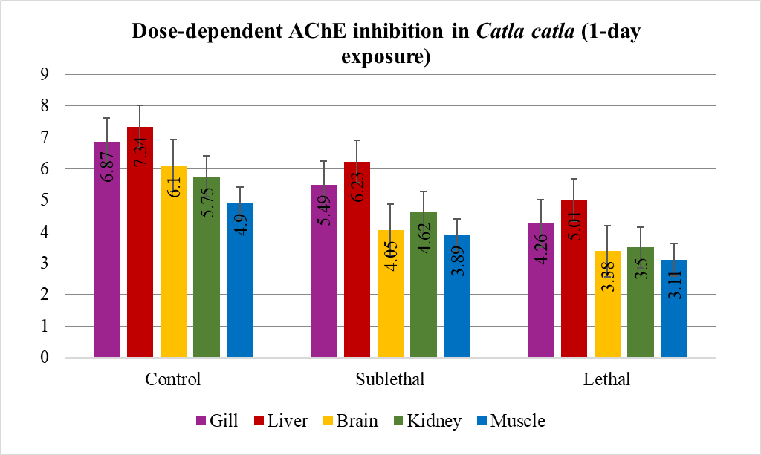
Figure 1. Changes in acetylcholinesterase (AChE) activity (µmol acetylthiocholine iodide hydrolysed/g tissue/min) and % change over the control in the brain, gill, liver, kidney, and muscle tissues of Catla cats exposed to sublethal and lethal concentrations of ethion (50% EC) for 1 day.
Table 2. AChE activity and % change in Catla catla after 4- and 8-day exposure to sublethal concentrations of ethion (50% EC).
Tissue | Control (4d) | Sublethal (4d) | % Change | Control (8d) | Sublethal (8d) | % Change
Liver | 6.53 ± 0.21 | 4.53 ± 0.01 | -30.62 | 6.10 ± 0.21 | 4.00 ± 0.13 | -34.42
Gill | 5.81 ± 0.10 | 3.99 ± 0.07 | -31.32 | 5.16 ± 0.10 | 3.15 ± 0.05 | -38.95
Kidney | 5.35 ± 0.15 | 4.01 ± 0.14 | -25.04 | 4.84 ± 0.15 | 3.57 ± 0.02 | -26.69
Brain | 6.03 ± 0.09 | 3.64 ± 0.05 | -39.63 | 5.70 ± 0.09 | 2.80 ± 0.09 | -49.12
Muscle | 4.61 ± 0.11 | 2.96 ± 0.05 | -35.79 | 3.05 ± 0.11 | 1.91 ± 0.07 | -37.37
Note: Values represent the means of five observations (± standard deviation). Differences are statistically significant at P < 0.05. AChE activity is expressed as µmol acetylthiocholine iodide hydrolysed/g tissue/min.
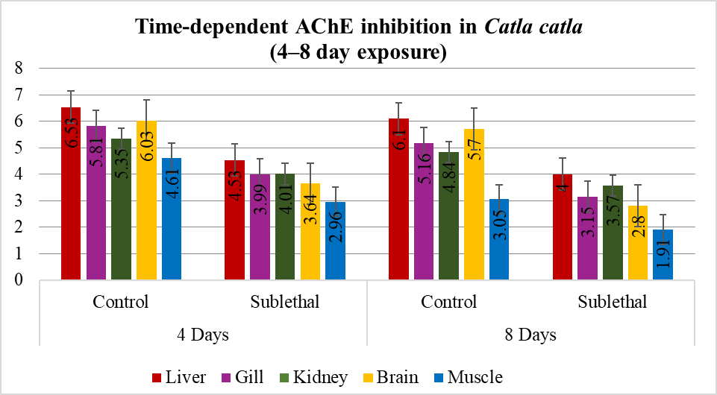
Figure 2. Changes in acetylcholinesterase (AChE) activity (µmol acetylthiocholine iodide hydrolysed/g tissue/min) and % change over the control in the brain, gill, liver, kidney, and muscle tissues of Catla cats exposed to sublethal concentrations of ethion (50% EC) for 4 and 8 days.
4. DISCUSSION
Acetylcholinesterase (AChE) is a key enzyme found primarily at cholinergic synapses and neuromuscular junctions, where it breaks down acetylcholine into acetate and choline, thereby terminating nerve impulses (Tang et al., 2021). OP pesticides, including ethion, inhibit this enzyme and cause acetylcholine to accumulate at synapses. This accumulation leads to prolonged stimulation of cholinergic neurons, impaired neuromuscular function, and ultimately, neurotoxic effects (Olivares-Rubio et al., 2021; Paduraru et al., 2021). In my present study, we demonstrated that exposure of Catla catla to ethion leads to significant, dose and time-dependent reduction of AChE activity in multiple tissues. Especially the brain consistently exhibited the highest degree of inhibition, followed by muscle tissue, whereas the liver showed comparatively lower reductions. The greater sensitivity of neural tissue is consistent with its direct dependence on AChE for neurotransmission, while the lower inhibition in liver can be partly attributed to its detoxification and metabolic capacity. In the present the observable behaviours such as erratic swimming, hyperactivity, and reduced coordination closely paralleled these biochemical changes, providing clear evidence of functional impairment.
Our findings are in good agreement with earlier studies across a variety of fish species. Previous studies have demonstrated that OP insecticides such as chlorpyrifos, diazinon, and imidacloprid significantly inhibit AChE activity in several fish species, including Oreochromis niloticus, Labeo rohita, and Oncorhynchus mykiss. The extent of inhibition was shown to depend on both pesticide concentration and duration of exposure (Faria et al., 2015; Topal et al., 2017; Reza et al., 2017; Sandoval et al., 2019). The consistency of these findings across diverse taxa supports the use of AChE inhibition as a reliable biomarker of OP pesticide exposure in aquatic organisms.
In our study also, the tissue-specific sensitivity observed here is also biologically meaningful. In our study the Brain and muscle, as primary effectors of neuromotor activity, appear more vulnerable to pesticide exposure, possibly due to their higher energy demands and susceptibility to oxidative stress. Reduced AChE activity in these tissues likely disrupts synaptic signalling and metabolic balance, leading to impaired feeding, locomotion, and escape responses (Shikha Singh et al., 2018; Madhu Sharma, 2019). In contrast, the detoxification organs (liver and kidney) showed comparatively lower inhibition, reflecting their protective role in biotransformation and excretion of xenobiotics.
Taken together, the results of our study confirm that ethion exerts neurotoxic effects in C. catla through interference with cholinergic neurotransmission, with brain tissue as the most sensitive site. The present findings build on earlier research by offering species-specific insights into the vulnerability of a commercially and ecologically significant fish in South Asia. The close association observed between enzyme inhibition and behavioural alterations highlights the ecological value of AChE as a biomarker of pesticide stress. In addition to ecological risks, the possibility of pesticide residues accumulating and biomagnifying through the food chain poses potential threats to human health, underscoring the need for stricter regulation of OP pesticide use in agriculture.
5. CONCLUSION
This study demonstrates that ethion (50% EC) causes significant, dose- and time-dependent inhibition of acetylcholinesterase activity in Catla catla. Among the examined tissues, the brain and muscle were most affected, reflecting their dependence on cholinergic signalling, whereas the liver exhibited comparatively lower inhibition, consistent with its detoxification role. The behavioural alterations observed, including restlessness and impaired swimming, closely paralleled the biochemical responses, underscoring the strong link between AChE inhibition and functional neurotoxicity.
Overall, the results affirm the utility of AChE activity as a sensitive biomarker for evaluating OP exposure in freshwater fish. More broadly, they emphasize the ecological risks associated with pesticide contamination, as disruptions in neural and behavioural functions can threaten fish survival, reproduction, and population stability. Combining biochemical biomarkers with behavioural endpoints offers a robust framework for assessing the impacts of agricultural chemicals, and such integrative approaches are essential for developing pesticide management strategies that safeguard aquatic biodiversity and the human communities reliant on these ecosystems.
6. DATA AVAILABILITY
The data will be available upon request.
10. COMPLIANCE WITH ETHICAL STANDARDS
Conflict of interest: The authors declare that they have no conflicts of interest related to this study.
Ethical approval: This study was conducted in strict accordance with the ethical standards for animal research outlined by the Institutional Animal Ethics Committee (IAEC), Acharya Nagarjuna University. All experimental procedures involving fish handling, exposure, and sampling followed the National Guidelines for the Care and Use of Laboratory Animals and adhered to international ethical standards for animal welfare in scientific research. Efforts were made to minimize stress and discomfort to the experimental animals throughout the study.
11. REFERENCES
- Kumar A, et al. Use of organophosphate insecticides in agriculture: A review. Environ Toxicol Pharmacol. 2016;45:1-9.
- Aroniadou-Anderjaska V, Figueiredo TH, Furtado MA, Pidoplichko VI, Braga MFM. Mechanisms of organophosphate toxicity and role of acetylcholinesterase inhibition. Toxics. 2023;11(10):866.
- Costa LG. Current issues in organophosphate toxicology. Clin Chem Lab Med. 2018;56(4):529-40.
- Prasanna CH, et al. Toxicity evaluation and behavioral studies of Catla catla exposed to Ethion (50% EC). Int J Creat Res Thoughts. 2020;8(2):1-5.
- Ellman GL, Courtney KD, Andres V, Featherstone RM. A new and rapid colorimetric determination of acetylcholinesterase activity. Biochem Pharmacol. 1961;7(2):88-95. doi:10.1016/0006-2952(61)90145-9
- Lowry OH, Rosebrough NJ, Farr AL, Randall RJ. Protein measurement with the Folin phenol reagent. J Biol Chem. 1951;193(1):265-75. doi:10.1016/S0021-9258(19)52451-6
- Tang A, et al. Acetylcholinesterase function in vertebrate neuromuscular junctions. Neurochem Int. 2021;147:105037.
- Olivares-Rubio HF, Espinosa-Aguirre JJ. Acetylcholinesterase activity in fish species exposed to crude oil hydrocarbons: A review and new perspectives. Chemosphere. 2021;264:128401. doi:10.1016/j.chemosphere.2020.128401
- Paduraru E, Flocea EI, Lazado CC, Simionov IA, Nicoara M, Ciobica A, et al. Vitamin C mitigates oxidative stress and behavioral impairments induced by deltamethrin and lead toxicity in zebrafish. Int J Mol Sci. 2021;22(23):12714.
- Faria M, Garcia-Reyero N, Padros F, Babin PJ, Sebastián D, Cachot J, et al. Zebrafish models for human acute organophosphorus poisoning. Sci Rep. 2015;5:15591.
- Topal A, Alak G, Ozkaraca M, Yeltekin AC, Comaklı S, Acıl G, et al. Neurotoxic responses in brain tissues of rainbow trout exposed to imidacloprid pesticide: Assessment of 8-hydroxy-2-deoxyguanosine activity, oxidative stress, and acetylcholinesterase activity. Chemosphere. 2017;175:186-91. doi:10.1016/j.chemosphere.2017.02.047
- Reza AHMM, Rakhi SF, Hossen MS, Hossain Z. Organ-specific histopathology and brain acetylcholinesterase inhibition in rohu, Labeo rohita, and silver barb, Barbonymus gonionotus: Effects of three widely used organophosphate pesticides. Turk J Fish Aquat Sci. 2017;17:821-32.
- Hassani S, Maqbool F, Salek-Maghsoudi A, Rahmani S, Shabdoorestan MC, Nili Ahmadabadi A, et al. Alteration of hepatocellular antioxidant gene expression pattern and biomarkers of oxidative damage in diazinon-induced acute toxicity in Wistar rat: A time course mechanistic study. EXCLI J. 2018;17:57-71.
- Ali M, Majid M, Hussain I, Kali S, Naz T, Niazi MB, et al. Chlorpyrifos mediated oxidative damage and histopathological alterations in freshwater fish Oncorhynchus mykiss in Northern Pakistan. Aquac Res. 2020;51(11):4583-94.
- Thanomsit C, Nualkaw C, Prasatkaew W, Wattanakornsiri A, Nanuam J, Nanthanawat P, et al. Adverse effects of chlorpyrifos and cypermethrin mixture on physiological alterations and cholinesterase expression in Nile tilapia (Oreochromis niloticus). Thai J Agric Sci. 2020;53(3):134-48.
- Sandoval-Herrera N, Mena F, Espinoza M, Romero A. Neurotoxicity of organophosphate pesticides could reduce the ability of fish to escape predation under low doses of exposure. Sci Rep. 2019;9(1):10530.
- Singh S, Tiwari RK, Pandey RS. Evaluation of acute toxicity of triazophos and deltamethrin and their inhibitory effect on AChE activity in Channa punctatus. Toxicol Rep. 2018;5:85-9.
- Sharma M, Thakur J, Verma S. Behavioural responses in effect to chemical stress in fish: A review. Int J Fish Aquat Stud. 2019;7(1):1-5.

