Biomechanical Strength and Anatomical Characteristics of Decellularized Bone from Goat as Bone Xenograft Candidate

.
ABSTRACT

Aims: To evaluate the histological, extracellular matrix (ECM), and biomechanical characteristics of goat bone before and after decellularization, and to determine its suitability as a xenograft material for bone regeneration.
Study Design: Experimental laboratory study.
Place and Duration of Study: Faculty of Veterinary Medicine, Universitas Brawijaya, Indonesia; duration of study is 2 years.
Methodology: Goat humerus bones were harvested, cleaned, and cut into standardized segments. Samples were decellularized using 0.1% sodium dodecyl sulfate (SDS) for 7, 14, and 25 days. Macroscopic dimensions were measured with digital calipers, and tensile strength was assessed using a universal testing machine. ECM integrity was evaluated using Masson's Trichrome staining, while bone morphogenetic protein-2 (BMP-2) expression was assessed via immunohistochemistry. Collagen content and BMP-2 expression were quantified using ImageJ, and statistical analysis was performed using one-way ANOVA with Tukey's post hoc test (P < 0.05).
Results: Decellularization effectively removed cellular components while preserving cortical structure, with no significant changes in bone dimensions or tensile strength among groups (p > 0.05). ECM collagen content gradually decreased with immersion time, with 14-day decellularization preserving the highest structural integrity. BMP-2 expression was reduced in decellularized bones, especially after 25 days, although residual expression was observed, indicating that the osteogenic potential was maintained. Fourteen days of SDS immersion was identified as optimal for balancing ECM preservation and cell removal.
Conclusion: Goat bone decellularized with SDS retains ECM integrity, biomechanical strength, and partial osteogenic potential, indicating its suitability as a xenograft scaffold. Future studies should focus on optimizing decellularization protocols to enhance BMP-2 retention and evaluating in vivo biocompatibility and regenerative potential.
Keywords: Biomechanical strength, BMP-2, Decellularization, ECM, Goat bone

1. INTRODUCTION

Significant bone defects caused by trauma, tumors, degenerative diseases, or infections often require surgical intervention with bone substitutes, as the intrinsic regenerative capacity of bone is limited to small defect sizes. In clinical practice, autografts are considered the gold standard due to their high integration potential; however, their application is limited by donor-site morbidity and restricted graft availability (Giannoudis et al., 2005; Amini et al., 2012). Consequently, alternative graft materials such as xenografts are increasingly explored due to their abundance and structural similarity to human bone (Rougier et al., 2023; Wang et al., 2024). Among potential sources, goats (Capra hircus) represent an attractive candidate due to their wide availability and bone size, which is comparable to that of human or pet animal bones in specific anatomical sites (Emami et al., 2020, 2025).

Decellularization has emerged as a promising strategy for preparing xenograft bone by removing cellular components while retaining an extracellular matrix (ECM) scaffold rich in collagen. A carefully preserved ECM is crucial for supporting cell adhesion, proliferation, migration, and differentiation, while also minimizing immune rejection (Permata et al., 2012, 2025). Previous studies in large-animal models, including bovine and deer, have demonstrated that decellularized bone matrices (DBMs) maintain their three-dimensional architecture and mechanical integrity while reducing antigenicity (Al Qabbani et al., 2023; Malagón-Escandón et al., 2021; Wang et al., 2024). These findings support the potential of DBMs as bone substitutes; however, research on goat bone remains limited.

Various decellularization methods—such as the use of sodium dodecyl sulfate (SDS), Triton X-100, enzymatic digestion, and freeze–thaw cycles—have been employed to effectively eliminate cellular material (Crapo et al., 2011; Permata et al., 2012, 2024, 2025). Mechanical and histological evaluations in bovine and porcine bone have revealed that such methods can remove cells while preserving collagen fibers and biomechanical properties (Malagón-Escandón et al., 2021; Nie et al., 2020). Nevertheless, suboptimal protocols can damage ECM components, particularly collagen, resulting in reduced biomechanical performance and rendering the scaffold unsuitable for use as a graft (Sun et al., 2025; Xing et al., 2014). Moreover, there is currently no consensus on the most effective decellularization protocol for goat bone, particularly concerning the optimal SDS concentration and immersion duration required to balance ECM preservation with mechanical strength.

Although substantial work has been carried out in other large animals, a clear research gap remains in understanding the histological and biomechanical properties of goat bone following decellularization. Specifically, data are lacking on the structural integrity of the ECM, collagen preservation, and tensile strength after SDS treatment. Such knowledge is crucial for evaluating the suitability of goat bone as a xenograft material.

The present study hypothesizes that goat bone subjected to decellularization will retain an adequate histological structure and biomechanical strength, making it a suitable candidate for xenograft use. Therefore, this research aims to evaluate the anatomical and biomechanical characteristics of goat bone before and after decellularization. Histological analyses will focus on ECM integrity and osteogenic marker expression, while biomechanical evaluation will include tensile strength assessment. By addressing this gap, the study is expected to contribute to the development of cost-effective, accessible, and standardized goat-derived xenografts for orthopedic and reconstructive applications.

2. experimental details

2.1. Sample collection and preparation
Goat humerus bones were obtained from a local public market in Malang, Indonesia, and were frozen for not more than 8 hours. All residual soft tissues and muscles were carefully removed, and the bones were cut longitudinally into standardized segments measuring approximately 0.5 × 0.5 × 25 cm using a bone saw.

2.2. Decellularization process
Bone segments were immersed in 40 mL of 0.1% sodium dodecyl sulfate (SDS; Merck, USA) in phosphate-buffered saline (PBS, w/v) within 45 mL Falcon® tubes, with immersion times of 7, 14, and 25 days. Following decellularization, segments were rinsed in PBS and fixed in neutral buffered formalin (NBF). The method was modified from Permata et al. (2012)
This approach is consistent with decellularization techniques reported in the literature, where chemical immersion methods, particularly SDS-based protocols, have demonstrated effective cellular removal while preserving ECM integrity in large-animal bone models (Emami et al., 2020).

Study groups comprised:
- Native (non-decellularized) goat bone
- Goat bone decellularized for 7 days
- Goat bone decellularized for 14 days
- Goat bone decellularized for 25 days
Each group included five replicates (n = 5).

2.3. Macroscopic and Dimensional Analysis
Bone segments, pre- and post-decellularization, were photographed and measured using a digital caliper (Taffware, China), with results presented as mean ± standard deviation (SD) in millimeters.

2.4. Mechanical Testing—Tensile Strength
A 2 cm portion of each sample was set aside for histological evaluation; the remaining 23 cm were fabricated into a dog-bone model by embedding each end (1.5 cm) in resin to prevent slippage during tensile testing (Figure 1). Tensile testing was performed at the Mechanical Testing Laboratory, Department of Mechanical Engineering, Universitas Brawijaya, using a universal tensile testing machine (MFL Piuf-Und Me Bsyteme GmbH; Mannheim, Germany) with a 0–20 kN load cell. Ultimate tensile strength (kPa) was calculated as the maximum load (kN) at fracture divided by the cross-sectional area (mm²).

Decellularization methods have been shown to primarily preserve mechanical properties, including tensile strength, in various tissues, such as decellularized tracheal scaffolds (Gomes et al., 2025), supporting the rationale for tensile testing in this study.

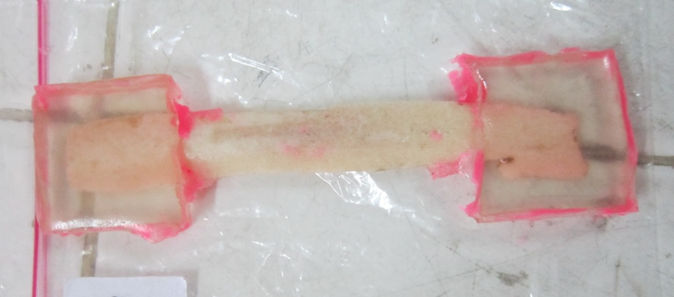
Figure 1. Preparation of goat bone segments into dog-bone models before and after decellularization, with both ends embedded in resin to prevent slippage during tensile testing.

2.5. Histological Characterization
A 2 cm portion of goat bone segments fixed in neutral buffered formalin (NBF) was rinsed in running water and decalcified by immersion in 5% hydrochloric acid (25 mL) for three days, with daily solution replacement. Once adequately softened, tissues were processed for paraffin embedding. Paraffin blocks were sectioned at 5 µm and mounted on both gelatin-coated slides and poly-L-lysine slides.

Gelatin-coated slides were stained with Masson's Trichrome according to a standard protocol to assess the integrity of the extracellular matrix (ECM), particularly the distribution of collagen. Sections were rehydrated, treated with Bouin's solution (56 °C, one h), and sequentially stained with Weigert's iron hematoxylin, Biebrich scarlet–acid fuchsin, phosphomolybdic–phosphotungstic acid, and aniline blue. Collagen fibers and ECM were visualized as blue, cytoplasm as red, and nuclei as dark blue/black. This staining method is widely used to assess the preservation of the extracellular matrix, such as collagen in bone (Sherman et al., 2025).

Poly-L-lysine slides were stained by immunohistochemistry (IHC) for bone morphogenetic protein-2 (BMP-2) using the UltraTek HRP Anti-Polyvalent (DAB) Staining System (Scytek, USA). After deparaffinization and rehydration, endogenous peroxidase activity was blocked with 3% H₂O₂ for 10 min, followed by antigen retrieval in citrate buffer (pH 6.0). Non-specific binding was blocked with casein for 30 min. Sections were incubated overnight at 4 °C with rabbit anti-BMP-2 polyclonal antibody (5 µg/mL, ab5285, Abcam, USA). After washing, slides were incubated with a universal biotinylated secondary antibody, followed by streptavidin-HRP. Visualization was performed with DAB and counterstaining with hematoxylin. Finally, slides were dehydrated, cleared in xylene, and mounted with Entellan. This protocol aligns with recent studies evaluating osteogenic protein expression in decellularized xenograft scaffolds (Amirazad et al., 2022).

Microscopic observations were performed under a light microscope at 400× magnification. Images were captured from five randomly selected fields per slide. Image analysis was performed using Fiji/ImageJ software to quantify collagen content (blue area, Masson's Trichrome) and BMP-2 expression (brown intensity, IHC).

2.6. Data analysis
Qualitative data included the macroscopic and microscopic features of goat bone before and after decellularization. Quantitative data included tensile strength, dimensional measurements, collagen staining intensity, and BMP-2 expression. Statistical analyses were performed using one-way ANOVA followed by Tukey's post hoc test, with a significance level set at p < 0.05 and statistical power of 95%. Analyses were conducted using GraphPad Prism software version 9.5.1 (GraphPad Software, USA). This statistical approach has been widely applied for biomechanical and histological evaluation of decellularized scaffolds (Al Qabbani et al., 2023).

3. results and discussion

3.1. Results
3.1.1. Macroscopic character
The gross morphology of goat bone segments was first examined to evaluate the effects of the decellularization process. This observation provided initial insights into whether structural integrity was preserved and whether visible cellular and marrow components were successfully removed.

Figure 2 shows a representative fresh bone sample prior to decellularization. The bone appeared reddish, opaque, and retained marrow remnants and soft tissue residues, which are typical features of native bone.

In contrast, Figure 3 demonstrates the appearance of bone after decellularization. The sample became whitish and slightly translucent, indicating the effective removal of marrow and cellular contents while maintaining the overall morphology of the cortical structure. The bone surface appeared clean and intact, with no signs of collapse, fragmentation, or gross deformation.

The dimensional data of all groups are summarized in Table 1. Statistical analysis revealed no significant differences in length, width, or base area among groups (P > 0.05). A slight reduction in thickness was observed in the 14-day and 25-day decellularization groups compared to fresh bone (2.75 ± 0.50 mm vs. 2.00 ± 0.00 mm; p = 0.062), although this difference was not statistically significant. These results indicate that the decellularization protocol effectively preserves the macroscopic morphology of goat bone while removing soft tissue and marrow components.

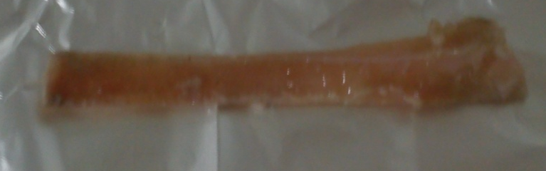
Figure 2. Fresh goat bone sample before the decellularization process, showing reddish and opaque appearance with visible marrow and soft tissue residues..

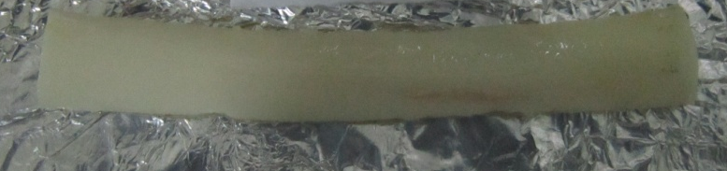
Figure 3. Goat bone sample after the decellularization process, appearing whitish and slightly translucent, indicating removal of marrow and cellular components while preserving cortical morphology.

Table 1. Macroscopic dimensions of goat bone samples in each group (mean ± SD)
 | Fresh | Immersion 7 days | Immersion 14 days | Immersion 25 days | P value
Lenght (mm) | 97.5±7.90 | 98.87±10.88 | 105.00±5.00 | 102.50±2.52 | 0.580
Lebar (mm) | 11.00±1.41 | 10.83±1.94 | 12.33±2.08 | 12.75±1.71 | 0.343
Thickness (mm) | 2.75±0.50 | 2.55±0.55 | 2.00±0.00 | 2.00±0.00 | 0.062
Base area (mm²) | 30.25±6,95 | 24.83±4.83 | 24.67±4.16 | 25.50±3.42 | 0.376
No significant differences were observed among groups for length, width, thickness, or base area (p > 0.05).

3.1.2. Biomechanical strength character
The ultimate tensile stress (MPa) of goat bone samples was measured to evaluate the effect of decellularization on the biomechanical properties. Table 2 summarizes the tensile strength data for fresh and decellularized bone samples after 7, 14, and 25 days of immersion in SDS.

The ultimate tensile stress of decellularized bone samples increased slightly compared to fresh bone, with the highest value observed in the 14-day decellularized group (112.26 ± 30.98 MPa) (Table 2). The fresh bone group had a tensile stress of 83.14 ± 7.89 MPa, while the 7-day and 25-day decellularized groups had values of 90.26 ± 15.94 MPa and 98.65 ± 4.31 MPa, respectively. However, statistical analysis revealed no significant differences in tensile stress among the groups (P = 0.154), suggesting that decellularization did not significantly affect the ultimate tensile stress within the tested time points.

Table 2. Ultimate tensile stress (MPa) of goat bone samples in each group (mean ± SD)
 | Fresh | Immersion 7 days | Immersion 14 days | Immersion 25 days | p-value
Ultimate tensile stress (MPa) | 83.14±7.89 | 90.26±15.94 | 112.26±30,98 | 98.65±4.31 | 0.154
No significant differences were observed among groups (p > 0.05).

3.1.3. Extracellular matrix (ECM) character
Histological analysis of the extracellular matrix (ECM) was conducted using Masson's Trichrome staining, which highlights collagen fibers in blue. This staining method provided insight into ECM preservation during decellularization at different time points.

In the fresh bone sample (Figure 4A), the ECM was fully intact, with dense, well-preserved collagen fibers (blue staining) visible throughout. The bone structure remained solid, with visible cellular components within the ECM, confirming its native state.

After 7 days of decellularization (Figure 4B), the ECM showed slight reductions in cellular content, but collagen fibers were still visible. The intensity of the blue staining decreased slightly, indicating that the decellularization process had begun to remove cellular components while retaining some of the ECM integrity.

Figure 4C, showing the bone after 14 days of decellularization, displayed a more noticeable reduction in cellular remnants. The intensity of the blue staining increased, indicating more effective removal of cells while preserving the collagen network.

At 25 days of decellularization (Figure 4D), the ECM showed minimal cellular remnants, and the collagen network was well-preserved. The matrix was nearly translucent, confirming that decellularization had successfully removed cellular material, leaving the collagen fibers intact.
Figure 5 quantifies ECM preservation by measuring the intensity and area of the blue staining, which represents collagen fibers in the samples. The fresh bone (Figure 5A) had the highest intensity and largest area of blue staining, reflecting a dense collagen network typical of native bone.

Figure 5B, showing the bone after 25 days of decellularization, exhibited a significant decrease in the intensity and area of blue staining. This decline in ECM intensity suggests that collagen was degraded during the decellularization process, resulting in a less preserved ECM after prolonged exposure to SDS.

Statistical analysis of the blue staining intensity and the area occupied by collagen showed significant differences between groups (P < 0.05). Both intensity and area of collagen were significantly lower in the 7-day, 14-day, and 25-day decellularized groups compared to fresh bone, reflecting the gradual destruction of ECM during the decellularization process. These results align with histological observations, confirming that longer immersion times resulted in more extensive degradation of the ECM, particularly the collagen network.

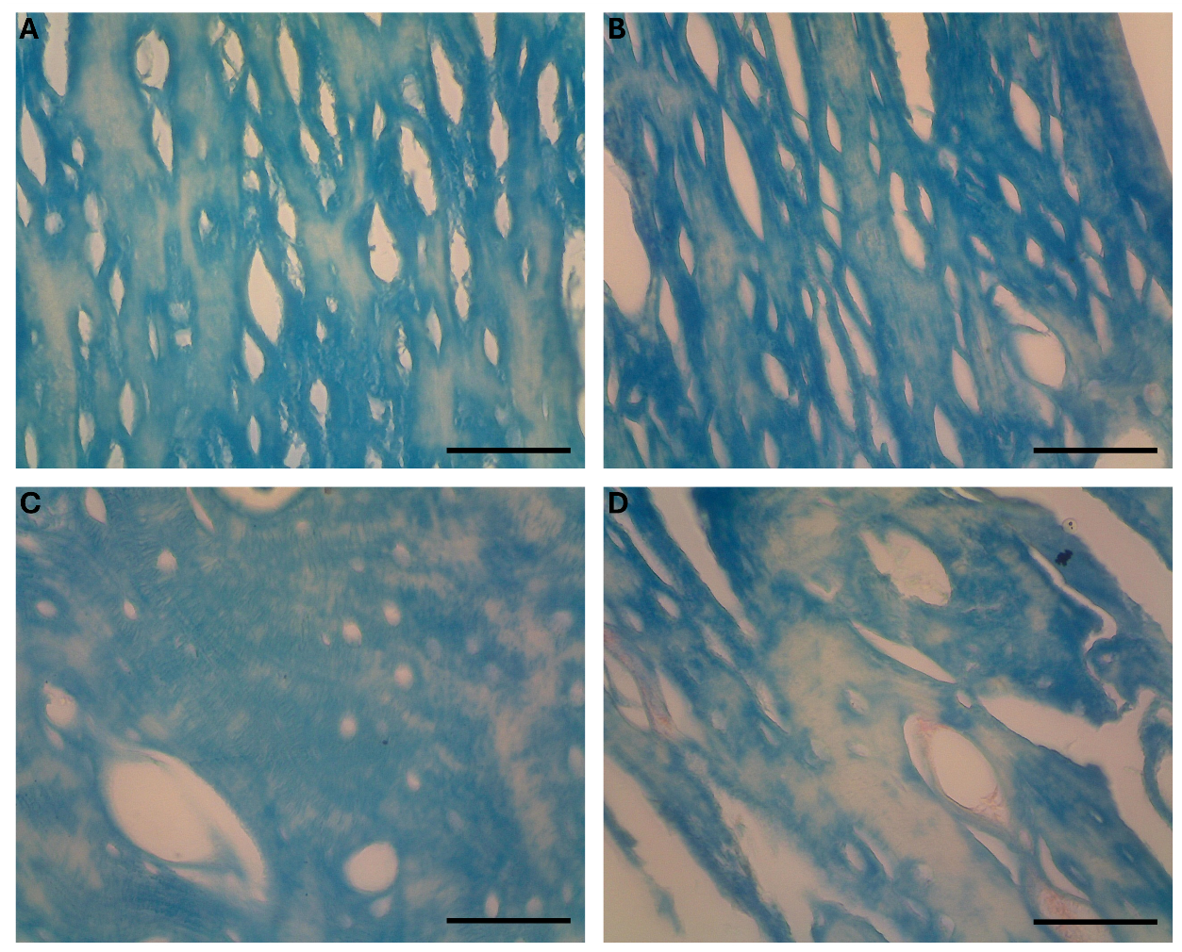
Figure 4. Histological sections of goat bone stained with Masson's Trichrome to assess extracellular matrix (ECM) preservation during decellularization. A. Fresh bone showing intact ECM with dense collagen fibers; B. Bone after 7 days of decellularization, with visible collagen fibers. C. Bone after 14 days of decellularization, with prominent collagen fibers, but some areas are already transparent. D. Bone after 25 days of decellularization, exhibiting a clear ECM with a decrement of collagen structure. Scale bar=200 µm

Figure 5. Quantification of ECM preservation by measuring the intensity and area of blue staining representing collagen fibers in goat bone samples at different decellularization time points. A. ECM percentage area: Fresh bone showing the largest area of blue staining, representing dense collagen fibers. B. Intensity of ECM: Bone after 25 days of decellularization showing reduced intensity of blue staining, indicating degradation of the ECM and loss of collagen integrity. Asterisk (*) means significant difference (p < 0.05), and ns means not significant (p ≥ 0.05).
3.1.4. BMP-2 expression character

Immunohistochemical (IHC) analysis was performed to assess the expression of Bone Morphogenetic Protein-2 (BMP-2), a key marker involved in osteogenesis, in goat bone samples after decellularization. The results are visually captured in Figures 6 and 7, which illustrate the presence and intensity of BMP-2 expression in various bone groups.

Figure 6 shows the BMP-2 expression in the fresh bone sample. The staining revealed moderate to intense brown staining in the osteoblasts and surrounding areas, indicating the natural expression of BMP-2 in the bone matrix. The presence of BMP-2 is critical for bone regeneration and osteogenesis, as it plays a significant role in the differentiation of stem cells into osteoblasts.

After 25 days of decellularization (Figure 6), BMP-2 expression was evaluated in the decellularized bone samples. The intensity of brown staining was significantly reduced compared to that of fresh bone, suggesting that the decellularization process may have impacted the expression of BMP-2. While some areas still showed weak BMP-2 expression, the overall intensity was lower, indicating that cellular components essential for BMP-2 production were effectively removed during the decellularization process. This result aligns with the histological findings, where ECM integrity was preserved, but the cellular material was progressively removed over time.

Statistical analysis confirmed that the intensity of BMP-2 staining was significantly lower in the 25-day decellularized group compared to the fresh bone (P < 0.05), indicating a reduction in BMP-2 production resulting from the removal of cells during the decellularization process (Figure 7). These findings offer valuable insights into the impact of decellularization on osteogenic markers, supporting the use of decellularized bone scaffolds for potential bone regeneration applications.

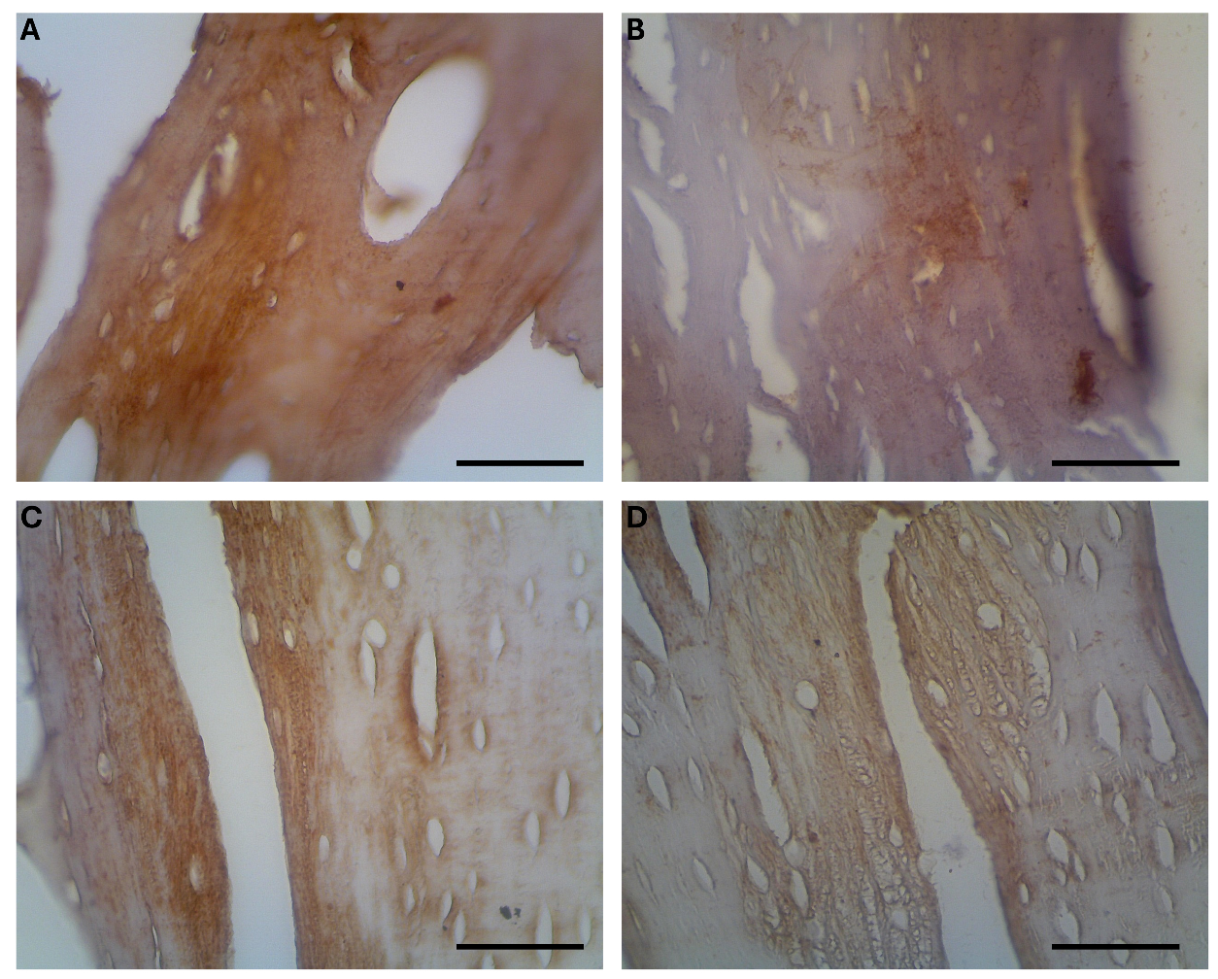
Figure 6. BMP-2 expression in fresh goat bone stained using IHC. A. Fresh bone showing intense brown staining, indicating BMP-2 expression in the surrounding matrix., B. Bone after 7 days of decellularization, showing moderate BMP-2 expression with slightly reduced. Intensity, C. Bone after 14 days of decellularization, with reduced BMP-2 expression and lighter brown staining, D. Bone after 25 days of decellularization, showing minimal BMP-2 expression, with very faint staining indicating a significant reduction in BMP-2 production.

Figure 7. Quantification of BMP-2 expression in goat bone samples after decellularization at different time points. A. Graph showing the percentage area of BMP-2 expression in fresh bone and decellularized samples at 7, 14, and 25 days. The area of BMP-2 expression decreases significantly (P < 0.01) with increasing decellularization time; B. Graph illustrating the intensity of BMP-2 expression in the bone samples, with an insignificant decrease (P≥0.05) in BMP-2 intensity after 7, 14, and 25 days of decellularization, compared to fresh bone.

3.2. Discussion
Bone defects resulting from trauma, degenerative diseases, or infections often require bone substitutes for successful healing. The body's intrinsic regenerative capacity is limited for significant bone defects. While autografts remain the gold standard in clinical practice due to their high integration potential, their use is constrained by donor-site morbidity and the limited availability of grafts. As a result, alternative materials, such as xenografts, have gained attention. Among these alternatives, goat bone is a promising candidate due to its structural similarity to human bone, availability, and suitable size for specific anatomical sites. This study investigated the potential of goat bone as a xenograft material by examining its macroscopic morphology, biomechanical properties, preservation of extracellular matrix (ECM), and expression of osteogenic markers following decellularization. Our results indicate that decellularized goat bone preserves ECM integrity, maintains biomechanical properties, and retains some osteogenic potential, making it a suitable candidate for bone graft applications.
The macroscopic analysis of the bone samples demonstrated that decellularization effectively removed marrow and soft tissue from the bone while preserving the cortical bone structure. The whitish appearance of decellularized bone, as shown in Figure 3, indicates the successful removal of cellular components, which is crucial for reducing immune rejection. The macroscopic preservation is essential for ensuring that the bone scaffold maintains its structural integrity and can integrate properly when used as a graft material. These results align with those of Wang et al. (2024), who observed a similar preservation of bone structure in decellularized porcine and bovine bones. Moreover, the dimensional measurements (Table 1) indicated that decellularization did not result in significant deformation, suggesting that the decellularization protocol was successful in maintaining the physical integrity of the bone.

Regarding biomechanical properties, we found a slight increase in tensile strength after decellularization, particularly at 14 days (Table 2). This increase, though statistically insignificant (p = 0.154), suggests that decellularization may enhance specific biomechanical properties. A similar trend was observed by Emami et al. (2020), who reported that decellularization in bovine bone scaffolds led to improved biomechanical strength, which is crucial for their application in bone regeneration. However, extended decellularization times, especially beyond 14 days, led to slight reductions in tensile strength, likely due to degradation of the ECM (as seen in the 25-day group). The fact that we did not observe a significant loss of tensile strength suggests that the decellularization protocol used in this study is effective in preserving the mechanical integrity of the bone for clinical applications.

The extracellular matrix (ECM) analysis, performed using Masson's Trichrome staining (Figure 4), revealed the extent of collagen preservation during the decellularization process. In fresh bone (Figure 4A), the ECM was dense with well-preserved collagen fibers. After decellularization, we observed a gradual reduction in the ECM's density and collagen content, particularly at 14 and 25 days of decellularization (Figures 4B–D). Figure 5 quantifies this reduction, showing a significant decline in both the intensity and area of blue staining in the decellularized bone, especially in the 25-day group. This decline in ECM preservation after prolonged decellularization is consistent with other studies, such as those by (Bracey et al., 2019), who found that extended decellularization times led to a significant loss of ECM components in bovine and porcine bones, thereby limiting their use as scaffolds for bone regeneration. The preservation of ECM, primarily collagen, is crucial for bone grafts because it provides the structural framework necessary for cell adhesion, differentiation, and mechanical support.

The BMP-2 expression, a key marker for osteogenesis, was also assessed using immunohistochemistry (IHC). BMP-2 plays a critical role in osteoblast differentiation and bone regeneration. Figure 6 and Figure 7 show that BMP-2 expression was significantly reduced in decellularized bone samples, particularly after 25 days of decellularization. Fresh bone showed strong BMP-2 expression, especially in osteoblasts and surrounding areas (Figure 6A), which is consistent with the high osteogenic potential of native bone. After decellularization, however, the intensity of BMP-2 staining decreased, particularly in the 25-day decellularized group (Figure 6D). These findings are in agreement with studies by Gomes et al. (, who reported a reduction in BMP-2 expression in decellularized bone matrices, potentially due to the loss of osteoblasts, which are the primary producers of BMP-2. Despite the reduction in BMP-2 expression, faint BMP-2 staining was still observed in decellularized samples, suggesting that the preserved ECM may still support some osteogenic activity, even in the absence of high BMP-2 levels.

One of the key findings of this study is the effect of decellularization using SDS. Sodium Dodecyl Sulfate (SDS) has been widely used for decellularization due to its ability to break down cellular membranes, thereby removing cells while preserving the ECM. However, prolonged exposure to SDS can degrade ECM components, particularly collagen, which is critical for maintaining the mechanical properties and osteogenic potential of the scaffold (Permata et al., 2012, 2025). In this study, 14 days of SDS immersion (0.1% concentration) resulted in optimal ECM preservation without significantly compromising the mechanical properties or the expression of osteogenic markers. These results align with findings from Wang et al. (2024), who demonstrated that 14 days of decellularization is optimal for preserving ECM and maintaining biomechanical strength in bone scaffolds.
Despite the promising results, this study has some limitations. Firstly, BMP-2 expression was evaluated only using IHC, which provides qualitative data. The studies should incorporate more quantitative analyses of osteogenic markers to gain a deeper understanding of the potential of decellularized goat bone as a bone graft material. Additionally, the immune response to decellularized goat bone was not evaluated in this study, which is crucial for determining the clinical feasibility of using goat bone xenografts. The long-term stability and osteointegration of the decellularized bone scaffolds in vivo were also not tested, which are essential factors for assessing their potential clinical application.

Future studies should aim to optimize the decellularization protocol to enhance BMP-2 expression while preserving ECM integrity. In vivo studies are crucial for evaluating the biocompatibility, immune response, and osteointegration of decellularized goat bone scaffolds. Furthermore, the long-term stability of the decellularized bone in clinical settings should be evaluated, as this will provide critical insights into the potential of goat bone as a xenograft bone material for orthopedic and reconstructive applications.

4. Conclusion

This study demonstrates that goat bone is a promising candidate for xenograft bone material, with the decellularization process effectively preserving the ECM and biomechanical properties while removing cellular components. The SDS protocol used in this study, with a 14-day immersion time, was found to be optimal for maintaining collagen integrity and preserving the mechanical strength of the bone, making it a suitable scaffold for bone regeneration applications. While BMP-2 expression was significantly reduced following decellularization, the preservation of the ECM provides a supportive environment for osteogenesis, suggesting that decellularized goat bone scaffolds can still facilitate bone healing.
Ethical approval

All experiments were conducted without direct animal involvement; the study only utilized goat bones obtained from the public market. We ordered the goat bone from the butcher, which was stored in the freezer for no more than 8 hours.

References
Al Qabbani, A., Rani, K. G. A., Syarif, J., AlKawas, S., Sheikh Abdul Hamid, S., Samsudin, A. R., & Azlina, A. (2023). Evaluation of decellularization process for developing osteogenic bovine cancellous bone scaffolds in-vitro. PLOS ONE, 18(4), e0283922. https://doi.org/10.1371/journal.pone.0283922
Amini, A. R., Laurencin, C. T., & Nukavarapu, S. P. (2012). Bone tissue engineering: Recent advances and challenges. Critical Reviews in Biomedical Engineering, 40(5), 363–408. https://doi.org/10.1615/critrevbiomedeng.v40.i5.10
Amirazad, H., Dadashpour, M., & Zarghami, N. (2022). Application of decellularized bone matrix as a bioscaffold in bone tissue engineering. Journal of Biological Engineering, 16(1), 1. https://doi.org/10.1186/s13036-021-00282-5
Bracey, D. N., Jinnah, A. H., Willey, J. S., Seyler, T. M., Hutchinson, I. D., Whitlock, P. W., Smith, T. L., Danelson, K. A., Emory, C. L., & Kerr, B. A. (2019). Investigating the Osteoinductive Potential of a Decellularized Xenograft Bone Substitute. Cells, Tissues, Organs, 207(2), 97–113. https://doi.org/10.1159/000503280
Crapo, P. M., Gilbert, T. W., & Badylak, S. F. (2011). An overview of tissue and whole organ decellularization processes. Biomaterials, 32(12), 3233–3243. https://doi.org/10.1016/j.biomaterials.2011.01.057
Emami, A., Izadi, E., & Oskouie, I. M. (2025). Preservation of extracellular matrix in decellularized bone scaffolds: Strategies, challenges, and future directions. Tissue and Cell, 97, 103047. https://doi.org/10.1016/j.tice.2025.103047
Emami, A., Talaei-Khozani, T., Tavanafar, S., Zareifard, N., Azarpira, N., & Vojdani, Z. (2020). Synergic effects of decellularized bone matrix, hydroxyapatite, and extracellular vesicles on repairing of the rabbit mandibular bone defect model. Journal of Translational Medicine, 18(1), 361. https://doi.org/10.1186/s12967-020-02525-3
Giannoudis, P. V., Dinopoulos, H., & Tsiridis, E. (2005). Bone substitutes: An update. Injury, 36(3), S20–S27. https://doi.org/10.1016/j.injury.2005.07.029
Gomes, K. T., Prasad, P. R., Sandhu, J. S., Kumar, A., Kumar, N. A. N., Shridhar, N. B., Bisht, B., & Paul, M. K. (2025). Decellularization techniques: Unveiling the blueprint for tracheal tissue engineering. Frontiers in Bioengineering and Biotechnology, 13, 1518905. https://doi.org/10.3389/fbioe.2025.1518905
Malagón-Escandón, A., Hautefeuille, M., Jimenez-Díaz, E., Arenas-Alatorre, J., Saniger, J. M., Badillo-Ramírez, I., Vazquez, N., Piñón-Zarate, G., & Castell-Rodríguez, A. (2021). Three-Dimensional Porous Scaffolds Derived from Bovine Cancellous Bone Matrix Promote Osteoinduction, Osteoconduction, and Osteogenesis. Polymers, 13(24), 4390. https://doi.org/10.3390/polym13244390
Nie, Z., Wang, X., Ren, L., & Kang, Y. (2020). Development of a decellularized porcine bone matrix for potential applications in bone tissue regeneration. Regenerative Medicine, 15(4), 1519–1534. https://doi.org/10.2217/rme-2019-0125
Permata, F. S., Amri, I. A., Nurmaningdyah, A. A., Mahardika, F., Budiarto, S., Vera, A. K. E., & Yulian, B. D. (2025). Antigen Removal Enhances Host Tolerance in Sheep-derived Xenogeneic Myocardial Scaffold: Modulating Acute and Chronic Inflammatory Responses in Mice. Regenerative Engineering and Translational Medicine. https://doi.org/10.1007/s40883-025-00417-w
Permata, F. S., Paramanandi, D. A., Nobilla, N., Manalu, R. O., & Amalia, R. (2024). The Use of Triton X-100 Absolute with Variations of Immersion Time in The Decellularization Process of Intestinal and Myocardial Xenograft. Jurnal Kedokteran Hewan, 18(2), 62–68. https://doi.org/10.21157/j.ked.hewan.v18i2.27712
Permata, F. S., Susilowati, R., Dharmastiti, R., Sirat, M. M. P., & Kartikasari, P. D. (2012). Optimization of Tissue Decellularization Method Based on Macroscopic and Microscopic Observation in The Sheep Peripheral Nerves. Jurnal Sain Veteriner, 30(20), 61–70. https://doi.org/10.22146/jsv.2606
Rougier, G., Maistriaux, L., Fievé, L., Xhema, D., Evrard, R., Manon, J., Olszewski, R., Szmytka, F., Thurieau, N., Boisson, J., Kadlub, N., Gianello, P., Behets, C., & Lengelé, B. (2023). Decellularized vascularized bone grafts: A preliminary in vitro porcine model for bioengineered transplantable bone shafts. Frontiers in Bioengineering and Biotechnology, 10, 1003861. https://doi.org/10.3389/fbioe.2022.1003861
Sherman, K. M., Silveira, C. J., Yan, M., Yu, L., Leon, A., Klages, K., White, L. G., Smith, H. M., Wolff, S. M., Falck, A., Muneoka, K., Brunauer, R., Gaddy, D., Suva, L. J., & Dawson, L. A. (2025). Male Down syndrome Ts65Dn mice have impaired bone regeneration. Bone, 192, 117374. https://doi.org/10.1016/j.bone.2024.117374
Sun, S.-X., Li, D., Yang, Y., Zheng, T.-H., & Xiao, Z. (2025). Effect of decellularization protocols on the biomechanical properties of porcine ovarian extracellular matrix. Journal of Biomechanics, 190, 112877. https://doi.org/10.1016/j.jbiomech.2025.112877
Wang, Y., Zong, Y., Chen, W., Diao, N., Zhao, Q., Li, C., Jia, B., Zhang, M., Li, J., Zhao, Y., Du, R., & He, Z. (2024). Decellularized Antler Cancellous Bone Matrix Material Can Serve as Potential Bone Tissue Scaffold. Biomolecules, 14(8), 907. https://doi.org/10.3390/biom14080907
Xing, S., Liu, C., Xu, B., Chen, J., Yin, D., & Zhang, C. (2014). Effects of various decellularization methods on histological and biomechanical properties of rabbit tendons. Experimental and Therapeutic Medicine, 8(2), 628–634. https://doi.org/10.3892/etm.2014.1742

