First record of the snapping shrimp Alpheus bisincisus De Haan, 1844 (Decapoda: Alpheidae) from the southeast coast of India (Bay of Bengal)
ABSTRACT
This study provides a detailed morphological characterization of Alpheus bisincisus de Haan, 1844 (Decapoda: Alpheidae), collected as bycatch from Mudasalodai on the southeast coast of India. Morphometric and morphological analyses revealed key diagnostic features, including a distinct rostrum, specialized chelipeds, and characteristic body proportions, which were compared with existing descriptions. Notable morphological differences from the closely related A. chiragricus, particularly in claw structure and rostral shape, are documented. This work represents the first record of A. bisincisus from Tamil Nadu, thereby extending its known distribution along the Indian coastline. These findings contribute valuable baseline data to the understanding of species distribution and morphological variation of snapping shrimps in Indian coastal waters.
Keywords: Alpheus bisincisus, Morphometric analysis, Crustacean taxonomy, Marine biodiversity, Morphological variation.
1. INTRODUCTION
The snapping shrimps, or pistol shrimps (family Alpheidae, genus Alpheus), are found to have a broad distribution in marine habitats from shallow coastal waters to deep-sea environments (Chace, 1988). Their distribution is not even, since species have specific habitat preferences based on substrate type, environmental factors, and symbiotic relationships (Dworschak et al., 2000). They are also influenced by ocean currents and local climatic conditions, with certain species limited to shallow shores while others live in deeper offshore areas (Anderson, 2010).
Alpheus shrimp have essential functions in ensuring the health and community processes in marine ecosystems (Pérez-Botello et al., 2021). Their abundance is greatly determined or closely linked to environmental factors such as modifications in water temperature, salinity, and the quality of habitat can affect their abundance and distribution (Jean et al., 2022). They exhibit different ecological interactions with other species, such as symbiotic interactions with marine sponges, corals, fishes and other on benthic communities. Within fish, gobies are tiny fish that live in burrows together with alpheus shrimp. The symbiotic interaction is for the protection of the gobies, while the shrimp gains from getting warning cues about potential predators (Karplus,1987). In sponges, shrimp find refuge, gaining protection and a secure breeding environment. In return, the shrimp's activities enhance the sponge's health by preventing overgrowth and improving water circulating (Dufft et al., 2000). In coral, the shrimp find protection in between coral branch and sea urchin spine without injuring their hosts. This symbiotic relationship offers protection for the shrimp through the utilization of pre-existing structures while the host organism is not appreciably affected (Bruce, 1976).
Their unique snapping behaviour, which involves an unusually large claw can generate high-speed water jet, differentiates them from other crustaceans (Versluis et al., 2000). Accurate and detailed descriptions of the morphological characteristics like carapace, chelae, antennae, and special structures like snapping claw are required for knowledge of their adaptations and ecological functions (Anker et al., 2006). The unique snapping behaviour of Alpheus shrimp is explored for its purposes in communication, predation, and territorial defence, reveals insights into the intricate social structures and interactions of Alpheus shrimp (Anker et al., 2006).
In India, Alpheus spp. have been found in a wide range of marine habitats, from shallow coastal waters to deeper offshore areas of the Arabian Sea (Jha et al., 2019) and the Bay of Bengal (Thomas, 1976). They live in coral reefs, mangroves, seagrass habitats, and sandy or rocky substrates. The initial report of Alpheus from Indian waters was made by Thomas (1976), who recorded four species, while Radhakrishnan et al., (2012) recorded 16 species within the genus in a broader review of the family Alpheidae. Among these, Alpheus bisincisus de Haan, 1844 has been reported from Japan, the Maldives, and more recently from the southwest coast of India (Ramachandran et al., 2019). However, no records exist from the southeast coast. The present study provides the first distributional record of this species from Tamil Nadu, Bay of Bengal, thereby extending its known range and contributing to baseline faunal data on snapping shrimps in Indian waters.
2. MATERIALS AND METHODS
2.1 Sample Collection
Two specimens of Alpheus bisincisus (Fig:2) were collected as bycatch at the Mudasalodai landing site (Fig:1) during July 2023. The specimens were preserved immediately for further examination.
2.2 Identification
Specimens were examined and identified following standard taxonomic keys (Banner, 1982; Yang et al., 2007). Diagnostic morphological characters were meticulously compared with previously published descriptions to ensure accurate species identification. For supplementary illustrations and reference material, see Coutière and Gardiner (1906), Tiwari (1963), and Banner and Banner (1979); additional comparative insights can also be found in Ramachandran et al., (2019).
2.3 Morphometric Analysis
Morphological measurements were taken using a Mitutoyo CD-6” ASX digital caliper and recorded to the nearest 0.1 mm, following the standard protocol described by McClure and Wicksten (1997). The following morphometric parameters were recorded: Carapace length (Cl); Abdomen length (AL); Telson length (TIL); Ocular width (OW); Antennal spine length (ASL); First antennular segment (Al1); Second antennular segment (Al2); Third antennular segment (Al3); Telson width Proximal (TiP); Telson width Distal (TiD); Major chela dactyl length (MpL); Major chela propodus length (MpH); Minor chela dactyl length (NdL); Minor chela propodus length (NpL);

c
b
a
Figure 1. Mudasalodai landing centre, located on the southeast coast of India, represents (a) the state of Tamil Nadu within India, (b) the Cuddalore district within Tamil Nadu, and (c) the Mudasalodai region within Cuddalore.
Characters
Total length (mm) | 28.54
Proportions
Carapace Length (%TL) | 40.15
Abdominal Length (%TL) | 59.85
Ocular Width (%AL) | 21.49
First antennular segment (%ASL) | 26.68
Second antennular segment (%ASL) | 38.52
Third antennular segment (%ASL) | 22.27
Telson length (%AL) | 24.65
Telson width Proximal (%TIL) | 67.70
Telson width Distal (%TIL) | 44.89
Major chela propodus height (%MpL) | 38.56
Minor chela propodus height (%NpL) | 19.79
Minor dactylus height (%NpL) | 53.38
Table 1. Morphometric data of A. bisincisus specimen

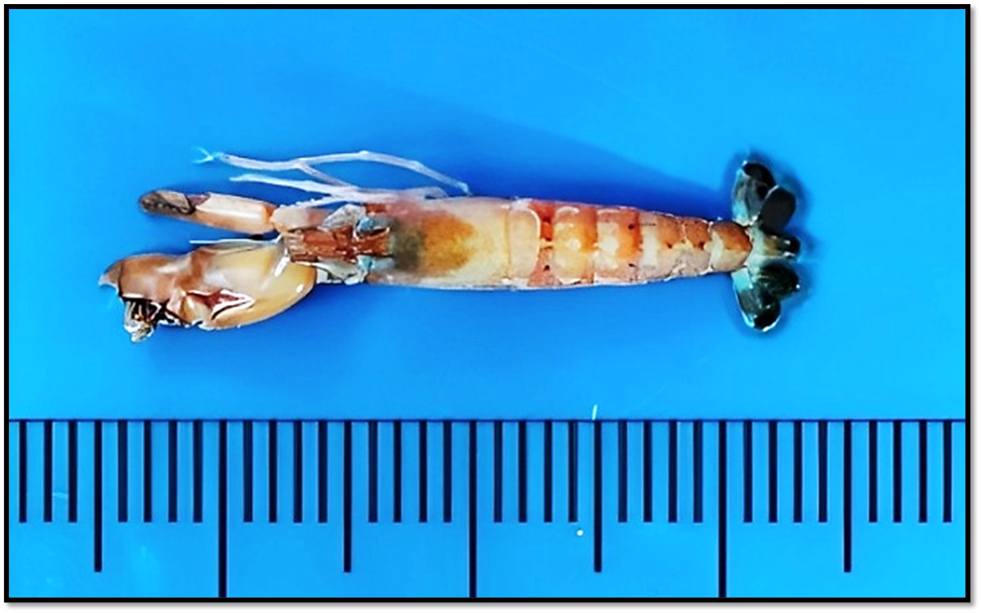
Figure 2. Alpheus bisincisus de Haan, 1844; Dorsal view. (Scaling: cm)

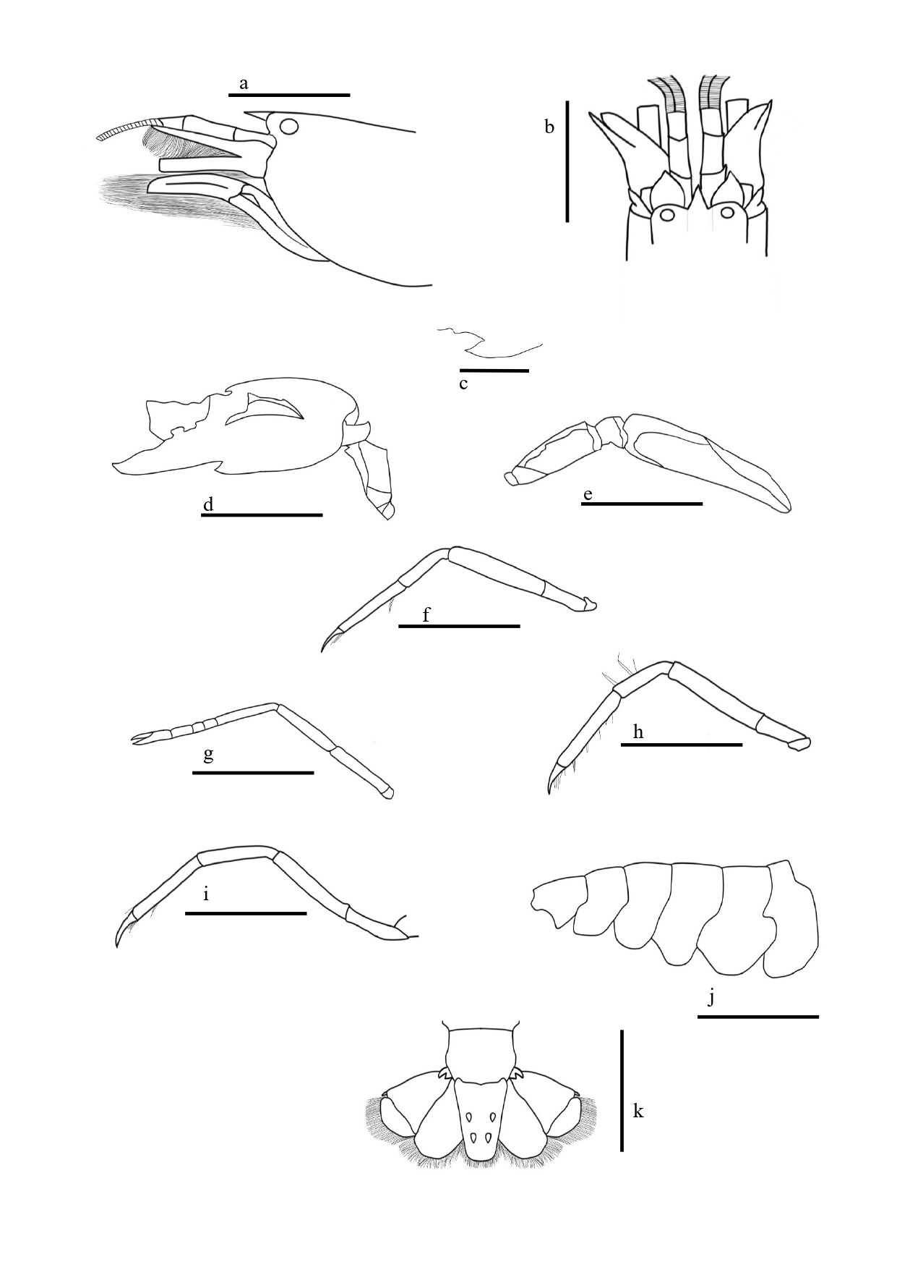

Figure 3. Alpheus bisincisus, male specimen, cl 11.46 mm from Parangipettai, India: a, anterior region, lateral view; b, same, dorsal view; c, carina below right first antennular segments; d, major first pereopod; e, minor first pereopod; f, right second pereopod; g, right third pereopod; h, right fourth pereopod; i, right fifth pereopod; j, abdomen; k, telson and uropods. (Scale 10 mm: a, b, d, e, f, g, h, i, j ; scale 5 mm: c, and k)

3. RESULT
3.1 Material Examined
The examined specimen were deposited at the Crustacean Collection, Centre of Advanced Study in Marine Biology, Annamalai University, Tamil Nadu, India.
Voucher ID: CASMB/FMS/AU/005.
3.2 Restricted synonyms:
Alpheus avarus De Haan, 1844
Alpheus bis-incisus var. malensis Coutiere, 1905
Alpheus bis-incisus var. stylirostris Coutiere, 1905
Alpheus bis-incisus var. variabilis Coutiere, 1905
Alpheus bisincisus Kim, 1981
3.3 Diagnosis (Key Traits):
Alpheus bisincisus de Haan, 1844 is readily distinguished by a narrowly triangular, dorsoventrally flattened rostrum extending anterior to the eyes, with orbital hoods prominently inflated and separated by a shallow median groove. The carapace is smooth, lacking any median teeth. The major cheliped is markedly robust, characterized by transverse U-shaped grooves along both margins; in males, the minor cheliped bears a prominent balaeniceps crest densely setose. The third pereopod possesses a merus with a movable spine and a propodus furnished with several ventral spines. The telson is elongate, bearing two pairs of dorsal spines and weakly developed posterolateral spines, while the uropodal exopod terminates in a strong distolateral tooth with diacritical mark.
3.4 Description:
Body smooth, stout and not unusually compressed. Rostrum acute, narrowly triangle, flattened, longer than broad, about 2.1 times as long as broad at base, sharp distally, reaching to middle area of first article of antennular peduncle with absence of teeth. Rostral carina strong compressed, acute, long and narrow extending posteriorly of carapace and elongated triangle passing far behind posterior end of eye. Carina is reaching to 1st distal margin of antennular segment. Orbital hoods inflated, round, separated from mid dorsal carina by shallow groove and reach proximal margin of stylocerite. Carapace is smooth, compressed, and narrow with small groove near to ocular width. Pterygostomial angle rounded with no spines. They have a tiny carina, almost merely angle runs along the anterior surface towards the antennule’s articulation. Further carapace without median tooth or tubercle on gastric region, flattened teeth overhanging posterior ends of adrostral furrows, anterior margin between rostrum and orbital hood unarmed, concave near rostrum.
Ocular hood is developed anteriorly and dorsally above the levels of the rostrum, and it is separated by a relatively deep orbito-rostral groove, noticeable depression. Ocular hood anterior edge is slightly concave near to the rostrum. Eyes with antero-medial lobe extending beyond anterior margins of orbital hoods. Carapace with pterygostomian margin produced anteriorly below base of basicerite (Fig: 3a-c).
Abdomen smooth, pleura of 2nd somites is round in shape, 3rd and 4th somites somewhat U in structure and 5th somites sub-triangular in shape slightly elongate posterior ventral margin (Fig: 3j). Ocular hood totally encloses the eye. First antennular segment with carina extending from ventral inner margin, ventral portion spined with directing anterior. Antennule with stylocerite carrying a acute, sharp edge in distolateral end and almost reaching the distal margin of first antennular article. Second antennular article twice as long as broad, 1.4 times as long as first article, about 1.7 times as long as third. Blunt end of basicerite with moderate development not as long as stylocerite. The lateral spine of scaphocerite has a tip is almost reach the distal end of antennular peduncle and is longer than the flattened part. Carpocerite little longer than scaphocerite.
Tooth of the stylocerite was directed outward. Scaphocerite 2.6 times as long as broad. Scaphocerite distal spine overreaching distal end of antennular article, inner blade, and the distal end of carpocerite. Inner blade narrow distal and reaching the antennular article distal end. Cleft between the distal spine and inner blade and its reach half of the distal end of scaphocerite. Carpocerite overreaching the distal end of the third antennular peduncle segment. Basicerite small with dull end, no longer than the rostrum and the stylocerite.
The third maxilliped are slender and extended straight well towards the end of carpocerite; mandible with bi-segmented Palp. Tip compressed, unarmed distally with very long setae on distal margin, scale on inner surface dense. Ultimate segment about 4.3 times as long as broad at distal end, with very long, stiff setae on inferior distal margin; setae overreaching distal end of proximal segment. Penultimate segment rather short, broad about 2.2 times as long as broad near distal end. Exopod not overreaching the penultimate segment. Short and dense of tufts setae on inner margin
Major cheliped noticeably not compressed laterally with immoveable fingers occupying numerous setae in distal and overreaching distal end of carpocerite. The hand is very large, compressed dorsally, absence of granules. In front of both superior margin and inferior margin has transverse U-shaped blunt groove, in superior which is behind the dactylar articulation and distance between them are depression depth. The hands are smooth and have soft texture. A well-defined superior saddle exhibits subacute proximal shoulder, which is overhanging on the transverse groove. Inferior shoulder robust, distal margin with subacute tooth projecting towards the outer face on inferior shoulder. Palmar broad, bearing humps and bumps. Lateral palmar shallow deep, quadrangular, reaching the linea impressa. Mesial palmar shallow depression with triangular. A mobile claw carrying a sturdy plunger, while an immovable claw features a robust socket with sharp edge. Carpus with tooth like projection on superior distal margin. Merus about 2.5 times as long as broad with inferior margin smooth, no spines and spiky edges in the distal end (Fig: 3d).
Minor chela of first pereopods is sexually dimorphic, male has balaeniceps crest of hairs on dactylus, about 3.9 times as long as broad with fingers 2.6 times as long as palm. Fingers not gaping and tip crossed when they closed, series of sweeping hairs from propodus to ductylus. Hand concave, soft texture with very long hairs, and dentate near dactylus. Presence of small transverse groove behind the dactylar articulation and lateral palmar portion has tooth like projection near to ductylus. Moveable fingers narrow, balaeniceps. Both dactylus and pollex bearing dense long setae on crest of each of both lateral faces. Cup shaped carpus bearing a sharp edge. Merus about 2.5 times as long as broad, carrying spiky edges, ventral side of merus smooth in texture with absence of spine (Fig: 3e).
Going beyond the proximal of the second carpus segment to the distal end of the carpocerite with the second pereopod. Fingers of chela slightly less than 4 times as long as palm. First segment of carpus about 1.8 times as long as second: second segment 1.7 times as long as third; third segment equal to fourth; fifth segment about 1.8 times as long as fourth (Fig: 3f).
Merus of third pereopod 5 times as long as wide, with long setae, ischium bearing a moveable spine. Carpus bearing inermous and several long setae on superior margin, projecting as tooth-like process on superior distal margin. Propodus little longer than carpus, presence of 10 spines (Fig: 4) on inferior margin, series of setae on the distal end. Dactylus simple, conical about 2.3 length of the propodus, ventral surface slightly excavates (Fig: 3g).
Fourth pereopod almost as same as third pereopod, which includes ischium bearing a moveable spine (Fig: 3h).
Fifth pereopods are considerably narrower than third pereopods. Absence of moveable spine. There are several lengthy setae in the corpus and propodus. Propodus is two times smaller than Dactylus (Fig: 3i).
Telson long, symmetrical, anterior 1.5 time as long as wider than the anterior, armed with two sets of dorsal spines and with no longitudinal depression the dorsal surface. Lateral margin almost straight. Posterior margin regularly convex, bearing series of seta-like spines and armed with pair of rather weak spines at each lateral end. Dorsal pairs situated approximately at positions dividing telson into three roughly equal parts (Fig: 3k).
Uropodal endopod with distinct inner depression at anterior half, protopod bearing two subacute teeth. The distal margin of a uropodal exopod bears a numerous of thick long seta. The lateral margin ends in an acute, immovable lobe that is internally flanked by rounded lobes with distolateral tooth. The transverse suture creates two lobes that are extremely convex. Presence of exopodal diaeresis.
3.5 Colour pattern
The carapace displays a predominant brownish-orange shade adorned with white band. Distal end of the carapace bearing falu red line over the rostrum and post-orbital. The abdomen region displays an orange tone featuring with sequence of linear white patches extending from the 2nd to 6th segment. The initial segments bear four small black dots on the dorsal side, while the third segment carries two black dots on the dorsal side. The fourth and fifth segments each have two black dots on the ventral side and one on the dorsal side. The pleura’s exhibit a glassy texture with a light orange hue, adorned with translucent white markings. At the distal end of the carpocerite, a caramel hue emerges. The rostrum takes on a brick red shade, and its orbital hoods possess a translucent white quality. Both the antennal and antennular peduncles are adorned with caramel shading and scaphocerite with inner blade adorned with single layer of translucent with rust colour. The primary chela finger boasts a rust with pale orange colour, with fingertips displaying ginger colour situated in distal end of ductulus. The telson is characterized by a lower region is black-orange coloration, while the uropod the endopod bearing dark blue hue. In exopod bearing black hue surrounded by grey colour.
3.6 Distribution:
Widely distributed throughout the Indo-Pacific region, including South Korea, Japan, South China, Taiwan, Singapore, the Philippines, Indonesia, Australia, Vietnam, Madagascar, Sri Lanka, the Maldives, the Persian Gulf, and the eastern and southern coasts of Africa (Yang et al., 2007).
3.6.1 Global: Indo-Pacific Ocean. Reported from Japan (Holotype: De Man, 1844, Voucher RMNH D5545), Maldives (Paratype: Coutière, 1905).
3.6.2 India: Previously recorded from the southwest coast of India (Ramachandran et al., 2019). The present study represents a new distributional record from the southeast coast (Mudasalodai, Tamil Nadu).
3.7 Ecology:
Marine, mixed rocky-sandy shores and coral reef flats, under rocks and coral rubble; intertidal zone. In India, the species was reported at a depth of 33 meters (Ramachandran et al., 2019).
3.8 REMARKS
Alpheus bisincisus and Alpheus chiragricus share a close phylogenetic relationship, as noted by Banner (1982). Their claw morphology and colour patterns are remarkably similar, with only subtle differences, such as the U-shaped modification in the major claw. Both species also exhibit transverse grooves on the superior and inferior regions of the major claw, further contributing to their striking resemblance.
A more distinct difference lies in the rostrum: in A. bisincisus it is flattened and extends beyond the grooves, a feature not observed in A. chiragricus. This pronounced rostral morphology, along with claw characteristics, provides reliable diagnostic traits that help separate the two closely related species.
Given their high degree of similarity, detailed morphological descriptions and comparisons are essential to avoid misidentification. Clear diagnostic features not only strengthen taxonomic accuracy but also provide a robust framework for species identification. This, in turn, enhances biodiversity assessments and supports more precise biogeographic records. In Indian coastal regions, where species richness and overlaps are common, such accurate identification is especially vital for documenting true species distribution, understanding ecological roles, and informing conservation priorities for snapping shrimps.
4. DISCUSSION
The present study provides detailed morphometric and morphological data for Alpheus bisincisus collected from the southeast coast of India, allowing direct comparison with previous descriptions from other regions. Overall, the diagnostic features of the rostrum, chelae, pereopods, and telson conform closely to earlier accounts (Banner, 1982; Yang et al., 2007; Ramachandran et al., 2019), while also exhibiting certain proportional differences that reflect geographic variation.
The largest specimens of this species are known to reach 2–7 cm in total length (Banner & Banner, 1979). From the east coast of India, Ramachandran et al. (2019) reported specimens measuring 8 mm CL and 29.5 mm TL, whereas in the present study the examined material measured 11.46 mm CL and 28.54 mm TL.
The rostrum in our specimens exhibited a length-to-breadth ratio of 2.2, consistent with the ratio of 2.2 reported by Ramachandran et al., (2019), and within the range of 1.8–3.0 recorded by Banner (1982). Yang et al., (2007) noted a ratio of 2.0 from Korean waters, suggesting that the rostrum of A. bisincisus demonstrates only minor variability across its range.
Variation is more apparent in the merus of the first pereopod. While Banner (1982) reported a ratio of 1.6, Yang et al., (2007) described a higher value of 2.4, and Ramachandran et al., (2019) recorded 2.6 from the west coast of India. Our present material shows an intermediate value of 2.5, with distinct spiny edges at the distal end. This indicates a degree of intraspecific variability that may be associated with local environmental conditions.
Sexual dimorphism in the minor chela was evident in our specimens, with males bearing a balaeniceps crest of hairs on the dactylus. The observed length-to-breadth ratio of 3.9, with fingers 2.6 times as long as the palm, is in close agreement with values from the Arabian Sea 4.0 (Ramachandran et al.,2019) and slightly higher than the 3.6 reported by Yang et al., (2007). Banner (1982) emphasized the wide variability in this trait (2.3–4.0), supporting the interpretation that this dimorphism may be influenced by geographical and possibly ecological factors.
The carpus of the second pereopod also showed proportional differences. In our specimens, the first carpal segment was 1.8 times longer than the second, and the second 1.7 times longer than the third, while the fifth segment was 1.8 times longer than the fourth. These proportions partially agree with Banner (1982), who reported a 10:7:2:2:3 ratio, but differ from both Yang et al., (2007) and Ramachandran et al., (2019), who documented alternate segmental proportions. Such variation highlights the importance of regional comparisons to refine the morphological range of this species.
For the third pereopod, the merus was five times as long as wide and carried a movable spine, consistent with Banner (1982). In contrast, Yang et al., (2007) and Ramachandran et al., (2019) reported a slightly higher ratio of 6.1. The dactylus in our material measured 0.3 times the length of the propodus, which aligns with Yang et al., (2007), but is marginally smaller than the 0.4 ratio noted by Banner (1982). The propodus exhibited 10 spines (Fig: 4), exceeding the 7 reported by Banner (1982) and the 8 noted by Yang et al., (2007). Such spine count variability has also been observed across populations, suggesting that it may serve as a useful but flexible diagnostic trait.
Taken together, these comparisons demonstrate that A. bisincisus exhibits a generally stable suite of diagnostic characters across its Indo-Pacific distribution, with certain morphometric ratios (especially in pereopods and chelae) showing measurable variation. These variations may reflect ecological differences across habitats, geographic isolation, or phenotypic plasticity within populations. The present study contributes new baseline data from the Bay of Bengal, extending the known range of this species along the Indian coastline and underscoring the importance of regional taxonomic surveys for documenting biodiversity and morphological variation in alpheid shrimps.

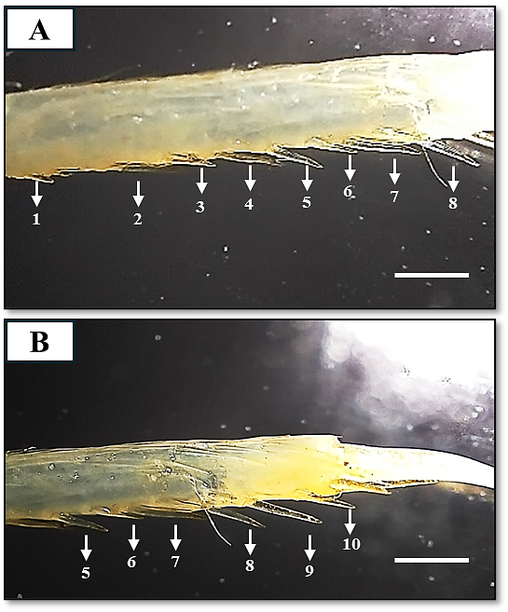
Figure 4. Merus of third pereopod (A) showing 1 to 8 spines and (B) showing 5 to 10 spines
5. CONCLUSION
This study records the first definitive record of Alpheus bisincisus de Haan, 1844 from the Indian southeast coast, thus expanding its distribution within the Bay of Bengal. Comparative morphological and morphometric analysis with previous records from other localities show general conformity in diagnostic characters, and also indicate minor differences in rostrum, chelae, and pereopod proportion that are probably indicative of geographic or environmental factors. These data not only reinforce the taxonomic structure of A. bisincisus but also provide worthwhile baseline data for biodiversity evaluations and subsequent biogeographic research on alpheid shrimps in Indian waters.
ACKNOWLEDGEMENTS
I sincerely thank Dr. Arthur Anker for his valuable assistance and expert guidance and deeply appreciate his support through personal communication.
ETHICAL APPROVAL
Ethical approval was not required for this study

Disclaimer (Artificial intelligence)
Option 1:
Author(s) hereby declare that NO generative AI technologies such as Large Language Models (ChatGPT, COPILOT, etc.) and text-to-image generators have been used during the writing or editing of this manuscript.

REFERENCES
Anderson, L.C. (2010). Predictive habitat model for the snapping shrimp genus Alpheus in the coastal southeastern United States. Master Thesis, University of Southern Mississippi, United States. University Press 391pp.
Anker, A., S.T. Ahyong, P.Y. Noel & A.R. Palmer. (2006). Morphological phylogeny of alpheid shrimps: parallel preadaptation & the origin of a key morphological innovation, the snapping claw. Evolution 60: 2507-2528.
Banner, A.H. & Banner, D.M. (1979). Some small collections of alpheid shrimp from the Indian Ocean, including two new species of the genus Synalpheus. Pacific Science 33: 25-35.
Banner, D.M. (1982). The alpheid shrimp of Australia Part III: The remaining alpheids, principally the genus Alpheus, and the family Ogyrididae. Rec. Australian Mus. 34: 1-357.
Bruce, A.J. (1976). Shrimps and prawns of coral reefs, with special reference to commensalism. Biology and geology of coral reefs 3: 37-94.
Chace F A (1988). The caridean shrimps (Crustacea: Decapoda) of the Albatross Philippine expedition, 1907-1910, part 5: family Alpheidae. Smithsonian Institution Press. Control. Zoology. 466: vi+99.
Coutiere, H. (1905). Les Alpheidae. In: The fauna and geography of the Maldive and Laccadive Archipelagoes. Vol. 2 (ed. J.S. Gardiner), pp. 852-921. University Press, Cambridge, England.
Duffy, J.E., C.L. Morrison & R.N. Rios. (2000). Multiple origins of eusociality among sponge-dwelling shrimps (Synalpheus). Evolution 54: 503-516.
Dworschak, P.C., A. Anker and D. Abed-Navandi. (2000). A new genus and three new species of alpheids (Decapoda: Caridea) associated with thalassinids. Annalen des Naturhistorischen Museums in Wien. Serie B für Botanik und Zoologie, 301-320.
Jean, L., A. Lugo, L. Ramo, M.D. Rabia & S. Rabia. (2022). Salinity and temperature tolerance of snapping shrimps (Alpheus sp.). International Journal of Biosciences 20: 378-382.
Jha, P.N., P. Purushothaman, S. Chinnadurai, R.K. Renjith, M.P. Remesan, M.V. Baiju et al.,(2019). Occurrence of Alpheus euphrosyne de Man, 1897 (Crustacea: Decapoda: Alpheidae) from the south-eastern Arabian Sea, India. Indian Journal of Geo Marine Science 48: 1695-1698
Karplus, I. (1987). The association between gobiid fishes and burrowing alpheid shrimps. Oceanography and Marine Biology 25: 507-562.
Pérez-Botello, A.M., M. Mascaró & N. Simões. (2021). The importance of home cleaning: sediment transport by alpheid shrimps provides a competitive advantage to their host anemones. Frontiers in Marine Science 8: 677024.
Radhakrishnan, E.V., V.D. Deshmukh, G. Maheswarudu, J. Josileen, A.P. Dineshbabu, K.K. Philipose et al., (2012). Prawn fauna (Crustacea: Decapoda) of India—an annotated checklist of the Penaeoid, Sergestoid, Stenopodid and Caridean prawns. Journal of the Marine Biological Association of India 54: 50-72.
Ramachandran, S., S.P. Varghese, N. Unnikrishnan, D.K. Gulati, A.E. Ayoob and L. Ramalingam. (2019). New record of Alpheus bisincisus De Haan, 1844 (Caridea: Alpheidae) from the west coast of India. Journal of the Marine Biological Association of India 61: 95-99.
Thomas, M.M. (1976). New records of four alpheid shrimps from Indian waters. Journal of the Marine Biological Association of India 18: 667-669.
Tiwari, K. K. (1963). Alpheid shrimps (Crustacea: Decapoda: Alpheidae) of Vietnam.
Versluis, M., B. Schmitz, A. Von der Heydt & D. Lohse. (2000). How snapping shrimp snap: through cavitating bubbles. Science 289: 2114-2117.
Wicksten, M.K. & M.R. McClure. (1997). Morphological variation of species of the edwardsii group of Alpheus in the northern Gulf of Mexico and northwestern Atlantic (Decapoda: Caridea: Alpheidae). Journal of Crustacean Biology 17: 480-487.
Yang, H.J., H.S. Ko & W. Kim. (2007). Redescription of Alpheus bisincisus De Haan (Decapoda: Alpheidae) from Korea. Fisheries and Aquatic Sciences 10: 37-42.

