Breed-Specific Growth and Development of Bombyx mori L. under Temperature and Humidity Stress

Abstract:
Heat stress is one of the major environmental challenges effects on the growth, survival, and silk productivity of Bombyx mori, the most economically important insect in sericulture. With rising global temperatures, the identification of thermotolerant silkworm breeds has become important for supporting silk production. While several studies have addressed thermal effects on silkworm physiology, limited research exists on evaluation of multiple bivoltine breeds under uniform controlled conditions, creating a critical gap in understanding breed-specific thermotolerance. In this study, bivoltine silkworm breeds were reared as control (26 ± 1 °C, 85 ± 5% RH) and high-temperature (34 ± 1 °C, 50 ± 5% RH) conditions to evaluate key quantitative traits including fecundity, survival rate, cocoon weight, shell ratio, and filament length. Data were statistically analyzed using ANOVA, coefficient of variation (CV%), and critical difference (CD) tests to determine the significance of inter-breed variation. Results show highly significant differences among breeds under heat stress. Breeds such as APDR105, APS45, and AC9 maintained higher survival, better cocoon weight, and longer filament length, whereas APS9 exhibited acute sensitivity, with drastic reduction in survival and complete cocoon failure. Elevated CV% values under heat stress indicated enhanced phenotypic variability across traits. The outcomes demonstrate that certain breeds possess inherent thermotolerant mechanisms, making them potential candidates for selective breeding programs targeting climate resistance. The study not only bridges the gap in identifying robust thermotolerant genotypes but also provides a foundation for breeding strategies to safeguard sustainable sericulture in heat-prone regions.
Keywords: Bombyx mori, thermal stress, fecundity, survival rate, cocoon weight, filament length
Introduction:
Lepidoptera experienced significant evolution throughout the Palaeozoic era, spanning 200 million years, with extensive radiations unparalleled by any other living form. These are highly successful organisms that serve an important purpose as pollinators, biological controllers, recyclers, and components of the food chain within the environment (Grimaldi and Engel, 2005). Various insect species are used as food in many South Asian nations. Many lepidopteran orders possess the ability to produce specialised products that are highly beneficial to human life. It includes silk, honey, wax, pheromones, shellac, and cochineal colour. Among these products, silk is a premium material that cannot be artificially replicated; therefore, it maintains our dependence on silkworms. Lepidoptera serve as significant model systems for studying aspects of genetics, physiology, development, ecology and evolutionary biology (Mitter et al., 2017). All silk-producing lepidopterans are limited to the families Saturniidae and Bombycidae. All wild silkworms have been placed within the family Saturniidae, whereas the mulberry silkworm, Bombyx mori L., belongs inside the family Bombycidae (Schmidt et al., 2023). The domestic silkmoth, Bombyx mori is an ideal animal for genetic research. It is the insect that is fully domesticated, relying totally on humans for both survival and reproduction (Goldsmith et al., 2005). Bombyx mori has been used for silk production for almost 5,000 years. As an entirely domesticated insect, its existence and reproduction are reliant upon humans (The International Silkworm Genome Consortium, 2008).
In evolutionary studies, during the Palaeozoic Era, especially in the Devonian to Carboniferous periods, approximately 300 million years ago, insect species emerged. Approximately 200 million years ago, during the Permian period, Lepidopterans evolved, alongside the emergence of the wild silkworm Bombyx mandarina. Domestication of silkworms commenced in approximately 4000 BC in China, coinciding with the evolution of Bombyx mori and other silkworm species (Banno et al., 2010).
Sericulture involves raising silkworms for the production of silk. Many types of silkworms exist, but Bombyx mori (the larva of the domesticated moth) is the most commonly used and studied. Silk is a continuous fibre made of fibroin protein, which is released by silkglands which is modified salivary glands. A specific protein, sericin holds the fibroin filament together. Silkworm larvae are highly susceptible to environmental factors, particularly temperature fluctuations. The life cycle of the silkworm is significantly affected by changes in temperature and even voltinism (the number of generations per year) can be altered by a one-degree increase in temperature. Temperature also plays a significant role in cocoon quality and silk yield during larval spinning. In tropical regions, high temperatures are a key factor that disrupts and influences the silkworms' lifecycle. Sericulturists in tropical countries, such as India, mainly rely on climate conditions to determine their silk output.
Material and Methods:
Breed selection and thermal challenging experimentation
Breed selection and thermal challenge experiments, based on silk production traits, involved 14 top-performing bivoltine breeds (APS12, APS50, APS8, APJ1, AP72, APS45, APS27, AC9, APDR105, AP71, APS9, HTO5, HTO2, HT) chosen from the germplasm available at Andhra Pradesh State Sericulture Research and Development Institute (APSSRDI), Hindupuram, Andhra Pradesh, India. An initial screening was conducted by rearing the breeds at high temperature (34°C ± 1°C) and low humidity conditions (50% ± 5% RH), following the Standard Rearing Procedure (Kumar et al., 2002). All breeds were reared for nine generations in two groups: one maintained as a control, reared at 26°C and 85% relative humidity, and the other subjected to the thermal challenge. During this screening, only eight breeds (APS50, APS45, APS27, AC9, APDR105, APS9, HTO2, HTP5) showed better performance.
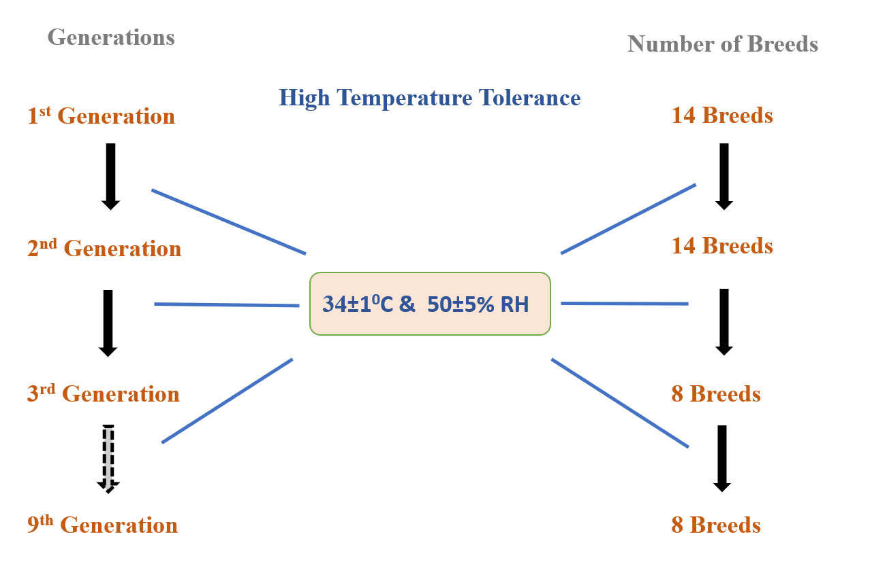
Figure 1. Heat and humidity stress treatment for silkworm strains
These breeds were evaluated for thermal tolerance for all life stages. An experimental set up having an arrangement to increase temperature from with an incremental interval of 0.5 degree Celsius for every six hour and stabilize at 34 degrees Celsius for six hours followed by lowering temperature in a decreasing interval of 0.5 degree Celsius per hour till reaching room temperature. The experimental temperature cycling is presented in Figure 2.
Each treatment group consisted of five replications with 100 larvae per replication. The experimental setup was designed to record key quantitative traits, including fecundity, survival rate, cocoon weight, shell ratio and filament length. The statistical tool ANOVA used for analysis. In the rearing conditions hygiene were maintained uniformly throughout the rearing period.
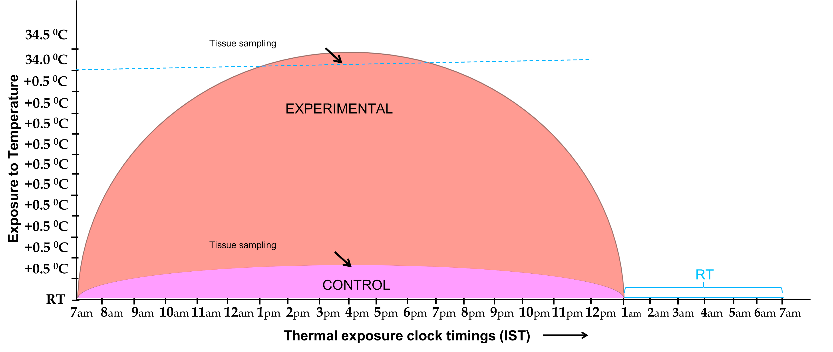
Figure 2 Experimental design for thermal treatment to a rearing population
Trait Evaluation
Fecundity
Fecundity defines the reproductive capacity of female silkworm moths, evaluated by the total number of eggs discharged by each female. After the emergence of the moths from their cocoons, male and female moths were permitted to copulate. During mating, each female moth was individually positioned on an oviposition card within an appropriate chamber, and the quantity of eggs deposited was recorded. The count was averaged across all females from each replication. This measure serves as a vital indicator of the breed's reproductive viability under both stress and controlled situations (Eltayb and Magid, 2013).
Survival Rate
Survival rate is the percentage of larvae that successfully develop into the spinning stage and form cocoons out of the total number of hatched larvae. It was calculated by tracking the number of larvae that reached the cocoon formation stage in each replicate and dividing it by the total number of larvae initially reared (Guncheva, 2016). This parameter provides insights into breed robustness, tolerance to environmental conditions and disease resistance.
$$Survival Rate (\%)=\frac{Number of larvae forming cocoons}{Total number of larvae reared​}×100$$
Cocoon Weight
Cocoon weight refers to the gross weight of the cocoon, including both the shell and the pupa inside (Jyothi et al., 2010). For each replicate, ten healthy and well-formed cocoons were randomly selected and their individual weights were recorded using a digital balance. The average cocoon weight was then calculated for each breed. This parameter reflects the productivity potential of a breed in terms of silk output and biomass accumulation under both normal and high-temperature conditions.
Shell Ratio
The shell ratio is the weight of the silk shell divided by the weight of the whole cocoon, shown as a percentage. It is an important economic feature that shows how much silk that a cocoon can make (Chanda et al., 2013). After carefully taking out the pupa and drying the shell, the weight of the shell was calculated using the following formula:
$$Shell Ratio \%=\frac{Shell Weight}{Cocoon Weight}×100$$
A higher shell ratio signifies greater silk content and is preferred in commercial silk production.
Filament Length
Filament length describes the total length of silk thread reeled from a single cocoon. For each breed, control and treatment, ten randomly selected cocoons were boiled and reeled using a conventional Epprovate and multi-end reeling machine. The silk filament was reeled until it broke, and its length was measured using a meter counter. The average of these readings was recorded as the filament length per cocoon for each replicate. Filament length is a direct indicator of the reelability and quality of silk produced and is crucial for assessing the commercial potential of silkworm breeds (Kumar et al., 2025).

Results:
Comparative Rearing Performance of Silkworm Breeds under High Temperature and Control Conditions
Breeds | Fecundity (No.) |  | Survival rate (%) |  | Cocoon Wt. (g) |  | Shell Ratio (%) |  | Filament length (m)
Breeds | HT | Control | HT | Control | HT | Control | HT | Control | HT | Control
APS50 | 462 | 510 | 81.0 | 92.7 | 1.54 | 1.66 | 20.48 | 21.41 | 704.00 | 750.00
APS45 | 437 | 515 | 85.0 | 91.8 | 1.44 | 1.56 | 20.25 | 21.34 | 835.00 | 841.00
APS27 | 476 | 513 | 83.0 | 92.0 | 1.39 | 1.47 | 19.72 | 21.28 | 888.00 | 828.00
AC9 | 470 | 564 | 75.0 | 91.0 | 1.49 | 1.59 | 20.00 | 21.10 | 830.00 | 974.00
APDR105 | 467 | 550 | 86.0 | 91.4 | 1.43 | 1.54 | 20.10 | 21.00 | 942.00 | 957.00
APS9 | 400 | 524 | 47.0 | 85.8 | 0.00 | 1.52 | 0.00 | 19.20 | 00.00 | 00.00
HTO2 | 518 | 513 | 81.0 | 89.0 | 1.37 | 1.54 | 19.90 | 20.80 | 810.00 | 908.00
HTP5 | 467 | 509 | 67.0 | 78.0 | 1.24 | 1.39 | 19.30 | 20.20 | 821.00 | 711.00
Average | 462 | 525 | 75.6 | 88.9 | 1.40 | 1.54 | 19.96 | 20.79 | 833.00 | 853.00
S.D | 12.53 | 9.65 | 1.78 | 1.64 | 0.06 | 0.03 | 0.18 | 0.131 | 49.80 | 72.40
CV% | 4.2 | 2.96 | 3.92 | 2.99 | 1.73 | 2.63 | 1.47 | 0.99 | 5.84 | 8.02
F value | 61.58 | 27.54 | 130.8 | 49.53 | 707.2 | 48.40 | 759.00 | 116.49 | 6.73 | 136.63
CD @ 1% | 24.68 | 19.01 | 3.505 | 3.22 | 0.029 | 0.05 | 0.36 | 0.257 | 84.67 | 23.60
Table 1 Comparative rearing performance of silkworm breeds at high temperature and control conditions (Mean of 5 replications)
We evaluated the rearing efficiency of eight bivoltine Bombyx mori breeds—APS50, APS45, APS27, AC9, APDR105, APS9, HTO2 and HTP5—under high temperature (HT) stress (35 ± 1°C) and control (25 ± 1°C) conditions. There were significant variations (p < 0.01) in all evaluated variables between breeds and between treatments.
1. Fecundity
The average fecundity decreased under high temperature conditions from 525 eggs (control) to 462 eggs. The highest fecundity under HT was recorded in HTO2 (518), while APS9 showed the lowest (400). Except HTO2, All breeds exhibited reduced egg-laying under HT, indicating a stress-induced decline in reproductive efficiency.

Figure-3: Fecundity Number of various breeds of silkworm
2. Survival Rate
Survival rate was significantly affected by high temperature. The average survival dropped from 88.9% (control) to 75.6% (HT). APDR105 (86%) and APS45 (85%) recorded the highest survival under HT, while APS9 showed drastic reduction (47%), indicating poor thermal tolerance.

Figure 4: Survival rate of various breeds of silkworm
3. Cocoon Weight
The cocoon weight also declined under heat stress. The overall average dropped from 1.54 g (control) to 1.40 g (HT). APS50 (1.54 g) and AC9 (1.49 g) maintained relatively better cocoon weights under HT, whereas APS9 produced no cocoons at all, confirming its heat sensitivity.

Figure 5: Cocoon weight of various breeds of silkworm
4. Shell Ratio
The shell ratio was less affected, showing a minor reduction from 20.79% (control) to 19.96% (HT). APS50 (20.48%), APS45 (20.25%), and APDR105 (20.10%) maintained higher shell ratios under HT, reflecting good silk accumulation capacity despite thermal stress. APS9 produced no cocoons.

Figure 6: Shell Ratio of various breeds of silkworm
5. Filament Length
Filament length exhibited high variability under thermal stress. The average length reduced from 853.0 m to 833.0 m. APDR105 (942 m), APS27 (888 m), and AC9 (830 m) showed long filaments even under HT, suggesting stability in silk gland activity. APS9 failed to yield any filament under HT, absence of its performance.

Figure 7: Filament length of various breeds of silkworm
Statistical Significance
ANOVA results showed highly significant differences (p < 0.01) among treatments and breeds for all traits. The highest F value was observed for shell ratio (759.00), indicating large variability in this trait among breeds. The coefficient of variation was highest for filament length (8.02% under control) and the critical difference (CD at 1%) was particularly high for filament length under HT (84.67 m), indicating substantial differences in breed performance.
Discussion
The present study investigated the impact of elevated temperature on the economic and biological traits of eight Bombyx mori breeds, comparing their performance under normal and heat-stress conditions. The traits analysed included fecundity, survival rate, cocoon weight, shell ratio, and filament length. The temperature higher or lower than 25⁰C act as a stress and tends to increase the larval susceptibility to viral infections (Sharma et al., 2023). The statistical parameters such as standard deviation (S.D), coefficient of variation (CV%), F value, and critical difference (CD at 1%), further validated the variability and significance of the observed differences. Fecundity increased in all breeds under HT conditions, indicating a helpful physiological response through economic traits to thermal stress. The highest fecundity increase was recorded in AC9 (from 470 to 564 eggs), while APS9, although improving from 400 to 524 eggs, showed relatively poor thermal changes in other traits. The F value for fecundity under HT (61.58) was statistically significant and the CD at 1% (24.68) shows that these variations were not due to random chance. Survival rate showed a clear difference among breeds under thermal stress. While APDR105 (86.0%) and APS45 (85.0%) maintained a high survival rate, APS9 showed the lowest (47.0%), reflecting less heat tolerance. The average survival rate decreased from 88.9% to 75.6%, indicating that high-temperature stress had a substantial impact on larval viability. The F-value (130.8) and CD at 1% (3.505) indicate significant differences among the breeds. Cocoon weight and shell ratio were considerably affected by heat stress. APS9 completely failed to produce cocoons under HT, which suggests a highly physiological disruption. Among the successful breeds, APS50 and APDR105 showed marginal reductions, indicating their resilience. The cocoon weight dropped on average from 1.54 g to 1.40 g, while the shell ratio declined from 20.79% to 19.96%. The high F values (707.2 and 759.00) for these parameters highlight significant inter-breed variation under stress. The filament length reduction was observed in most breeds under HT. The APS9, again produced no filament under heat stress, whereas APDR105 maintained the most extended filament length (942 m), followed by AC9 and APS27. The average filament length decreased from 853 m to 833 m, and the high F value (136.63) and CD at 1% (23.60) confirmed the statistical significance of these differences. Among the breeds, APDR105, APS45 and AC9 show better thermotolerance, as evidenced by minimal losses across all parameters. In contrast, APS9 performed poorly under stress, particularly in terms of survival rate, cocoon formation and filament production. The higher values of standard deviation and CV% under HT treatment for traits such as filament length and fecundity indicate increased phenotypic variability under stress, suggesting that heat exposure amplifies genetic differences among breeds. This finding aligns with earlier studies by Ardehjani et al. (2023) that demonstrate the role of genetic background in thermotolerance in Bombyx mori.
Conclusion
The current study clearly states that increased temperature has a significant impact on the economic traits of Bombyx mori across different breeds. At the same time, all breeds showed some level of stress response. APDR105, APS45 and AC9 exhibit comparatively better thermotolerance, as evidenced by maintaining higher survival rates, stable cocoon weights, and superior filament lengths under heat treatment. In contrast, APS9 exhibited drastic reductions in survival and failed to form cocoons under stress, indicating poor heat adaptability. The significant F values and low critical difference (CD @ 1%) across most traits confirm that the observed differences are statistically reliable. These findings highlight the importance of breed selection in sericulture under changing or adverse climate conditions. The study provides a baseline for identifying thermotolerant breeds for future breeding programs. Further, it supports the need for integrating physiological traits with molecular markers for sustainable silkworm cultivation in the face of rising global temperatures.
Disclaimer (Artificial intelligence)
Option 1:
Author(s) hereby declare that NO generative AI technologies such as Large Language Models (ChatGPT, COPILOT, etc.) and text-to-image generators have been used during the writing or editing of this manuscript.
Option 2:
Author(s) hereby declare that generative AI technologies such as Large Language Models, etc. have been used during the writing or editing of manuscripts. This explanation will include the name, version, model, and source of the generative AI technology and as well as all input prompts provided to the generative AI technology
Details of the AI usage are given below:
1. option 1
2.
3.

References
- Eltayb, M. and Magid, T. (2013). Relation Between Female Cocoons (pupae) Measurements and the Number of Eggs Laid (fecundity) by the Wild Silk Moth Epiphora bauhiniae (Gurinmeneville) Lepidopetera: Saturniidae. International Journal of Advance Industrial Engineering, 1(01).
- Jyothi, P. N., Suneetha, Y., Nagalakshmamma, K., and Prasad, S. S. (2010). Studies on economic parameters of the cocoon the silkworm, Bombyx mori under the influence of ultrasound treatment., Journal of Experimental Zoology, India, 2010, Vol. 13, No. 2, 383-387 ref. 10
- Chanda, S., Saha, L. M., Das, N. K., Kar, N. B., and Bindroo, B. B. (2013). Correlation among shell percent, cocoon yield and reeling parameters of Multi X Bivoltine cocoons under different agro-climatic conditions of West Bengal, India. International Journal of Industrial Entomology and Biomaterials, 26(2), 74-80.
- Ardehjani, A. A., Moghaddam, S. H. H., Rabiei, B., Zarbafi, S. S., Mirhoseini, S. Z., and Nematollahian, S. (2023). The effect of temperature on combining ability and genetic parameters of parental silkworm Lines (Bombyx mori L.). Ecological Genetics and Genomics, 26, 100161.
- Kumar, Arun, Nishant Singhal, Neha Hore, and Abhishek Tripathi (2025). Impact of Seasonal Variations on Filament Length and Non-Broken Filament Length in Relation to Silk Reeling Performance, Uttar Pradesh Journal of Zoology, 46 (8):15-25. DOI-https://doi.org/10.56557/upjoz/2025/v46i84890
- Schmidt, T., Puchalla, N., Schendzielorz, M., and Kramell, A. E. (2023). Degumming and characterization of Bombyx mori and non-mulberry silks from Saturniidae silkworms. Scientific Reports, 13(1), 19504.
- Grimaldi, D., and Engel, M. S. (2005). Book- Evolution of the Insects. Cambridge University Press.
- Charles Mitter, Donald R. Davis, Michael P. Cummings (2017) Phylogeny and Evolution of Lepidoptera, Annual Review of Entomology 62 (1): 0265-283. doi: 10.1146/annurev-ento-031616-035125
- Marian R. Goldsmith, Toru Shimada, and Hiroaki Abe (2005), The genetics and genomics of the silkworm, Bombyx mori, Annual Review of Entomology 50: 71–100 doi: 10.1146/annurev.ento.50.071803.130456
- Yutaka Banno, Toru Shimada, Zenta Kajiura, and Hideki Sezutsu (2010), Review series-The Silkworm -an attractive Bio-resource supplied by Japan, Experimental Animals 59(2), 139–146
- Kumar, N. S., Basavaraja, H. K., Kumar, C. M., Reddy, N. M., and Datta, R. K. (2002). On the Breeding of “CSR18 X CSR19”-A Robust Bivoltine Hybrid of Silkworm, Bombyx mori L. for the Tropics. International Journal of Industrial Entomology and Biomaterials, 5(2), 153-162.
- Guncheva, R. P. (2016). Study on the Receptivity of Breeds Silkworm, Bombyx mori L. to Artificial Diet low in Mulberry Powder. Int. J. Curr. Microbiol. App. Sci, 5(5), 10-18.
- Sharma P., Sharma A., Choudhary S., Attri K., Afreen S., Bali K., and Gupta R. K. (2023). Response of Silkworm (Bombyx mori L.) Breeds to Temperature and BmNPV Stress. International Journal of Environment and Climate Change, 13(9), 2332–2337. https://doi.org/10.9734/ijecc/2023/v13i92466

