COMPARATIVE STUDY OF SAGITTAL OTOLITH MORPHOMETRY WITH FISH SIZE BETWEEN 4 SPECIES OF GENUS Puntius (HAMILTON, 1822) OF FAMILY CYPRINIDAE FROM GANGA RIVER, INDIA

ABSTRACT: This study was conducted to determine inter-specific and intra- specific relationship of otolith morphometry of Genus Puntius i.e. Puntius ticto, Puntius sophore, Puntius muzaffarpurensis and Puntius conchonius. Linear regression model was applied to correlate the otolith morphometry with fish morphometry and it showed strong and positive relationship between total fish length with otolith length, otolith breadth and fish mass with otolith mass. NIS Element D5.10.00 64-bit imaging software was used to measure the length and breadth of otolith of each species studied (Puntius ticto, Puntius sophore, Puntius muzaffarpurensis and Puntius conchonius). To find the discrimation if any between left and right sagittal otolith t-test (p>0.05) was used and it showed no significant difference. Puntius ticto showed largest otolith as otolith length and otolith breadth is 0.13% and 0.10% respectively of the total fish length while Puntius sophore showed smallest otolith as otolith length and otolith breadth is 0.10% and 0.08% respectively of the total fish length among the group of four species investigated of genus Puntius. This study deals with detailed study of otoliths of Puntius fishes, which would be helpful as a taxonomic tool in identification of species of genus Puntius. Results showed that otolith morphometry is an important index to predict the fish size, fish stock monitoring, fish stock identification, systematic study of fishes. This is applicable in various dimensions of Ichthyology, fishery management, fish biology and paleontological studies.
Key words: Puntius, Otolith morphometry, linear regression, sagittal otolith, ichthyology, NIS Element D5.10.00 64-bit imaging software.
INTRODUCTION: The Genus Puntius (family Cyprinidae) (Fig. 1) are usually silver coloured ornamental, aquarium, edible and economically important small sized beautiful and attractive fresh water fishes which are commonly known as “Barb or Pothi”. During breeding season bright colour pattern is visible, mostly on fins. Characteristic feature is presence of identical blotches (1 or 2) at peculiar spot on fish body (Jayaram, 1981). This feature is used as an identification key to discriminate between Puntius species viz. a black blotch at the base of caudal fin and another one is on center of dorsal fin represents Puntius sophore (fig 1-a), a black blotch above the pectoral fin and second one on caudal peduncle represents Puntius ticto (fig1 –b), an identical blotch on lateral line represents Puntius muzaffarpurensis (fig 1-c) and a black blotch on caudal peduncle at edges of caudal fin represents Puntius conchonius (fig 1-d). These are omnivorous fishes, feeds on plant matter, insects, worms, planktons and small fishes. Breeding season is between March- August at moderate temperature like 25-26° C. Usually Genus Puntius is distributed throughout India, Nepal, Bangladesh, Pakistan, Burma, Sri Lanka and Thailand (Day, 1878).
In the inner ear cavity of Teleost fishes three paired acellular and calcareous structures are present, which are called as “Ear stones or Otoliths” namely Sagitta, Lapillus and Asteriscus. Out of these three, Sagitta is usually used for the systematic study (Akkiran, 1985). According to a study (Platt and Popper, 1981) there are variability of Sagitta between different species, these are species- specific and have particular shape, size and features, which helps in hearing and balancing. For this reason, otoliths can be used as a taxonomic tool to estimate the fish growth and age. Very limited information about otolith morphometry is available for these species of Genus Puntius.
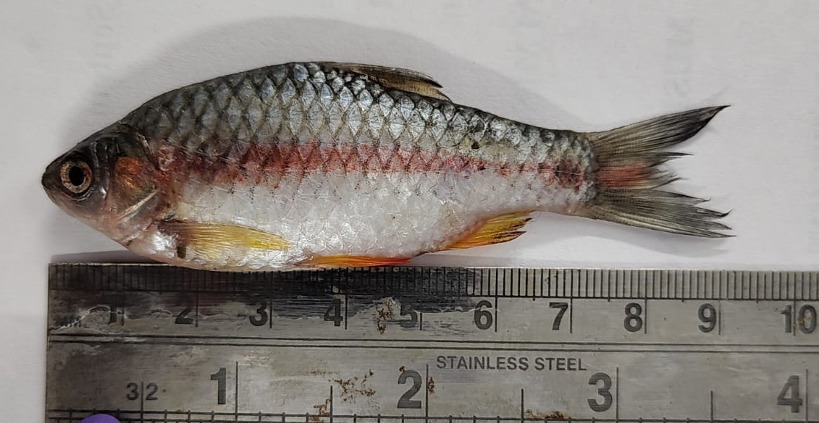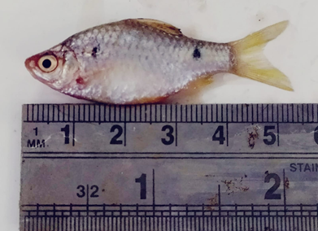
a b
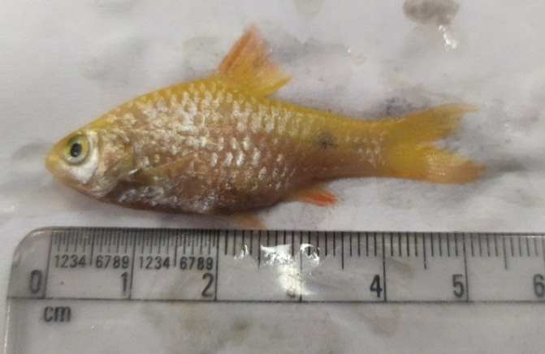
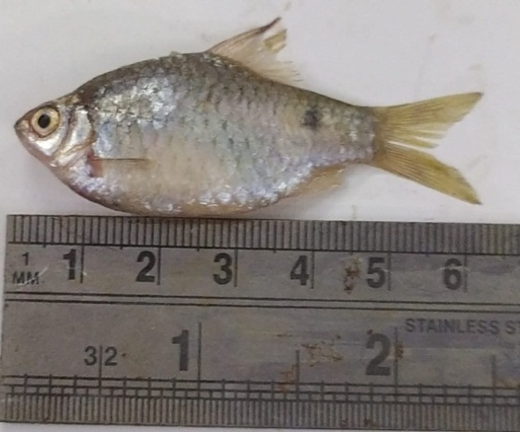
c d
Figure 1.- Puntius sophore (a), Puntius ticto (b), Puntius muzaffarpurensis (c) and Puntius conchonius (d).

MATERIALS AND METHODS: Study material for the study of these 4 species viz. Puntius ticto (30), Puntius sophore (30), Puntius muzaffarpurensis (30) and Puntius conchonius (30) were obtained during the period of March 2022- July 2024 from Ganga river water near and around Meerut region. Fish samples were caught by local fisherman and carried to the laboratory on an ice layer. Each species of Puntius were identified with the help of Day (1878) and Jayaram (1981).
Morphometric measurements: After identification, morphometry of each fish sample was done; total length and mass were measured. Otoliths of each sample were removed by making a horizontal cut in the cranium at dorsal side between both eyes. Left and right otoliths were kept separately. Cleaning was done with 10% KOH solution followed by washing with distilled water. Washed otoliths were air dried and stored in transparent plastic vials, labeled with identification no., date of collection, generic and specific name.
Otolith morphometry was done with the help of NIS Element D5.10.00 64-bit imaging software as length and breadth of each otolith were measured and same is used for light microscopic photographs of otoliths (Figure 2 a-d) Otolith length is the distance between the anterior and posterior tips of otolith (Harvey et al., 2000) and otolith breadth is the distance from the dorsal to ventral edges of otolith, at right angle to the length (Battaglia et al., 2010; Hunt J., 1992) (Figure 2 e). Photographs were taken of left and right otoliths of each species of genus Puntius (Figure 3). Mass of each otolith was taken.
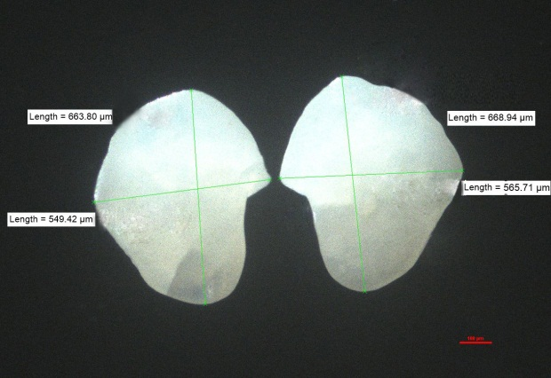
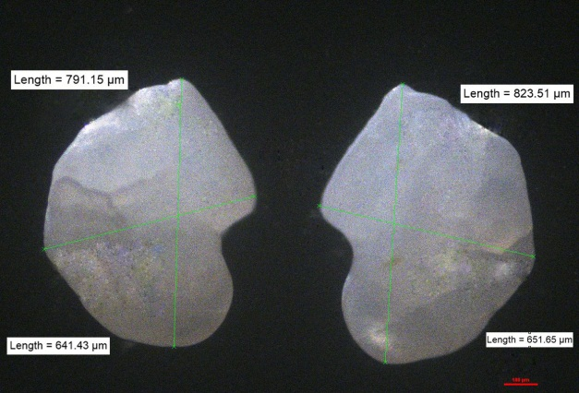
a- Puntius ticto b- Puntius sophore
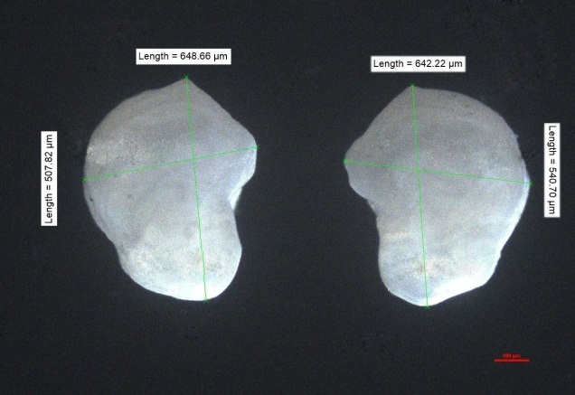 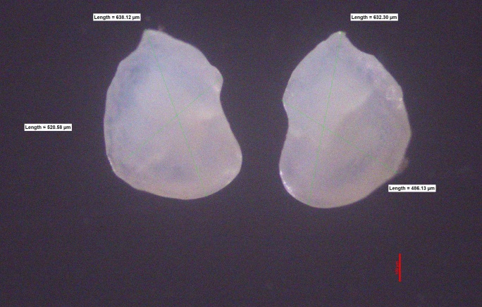
c- Puntius muzaffarpurensis d- Puntius conchonius
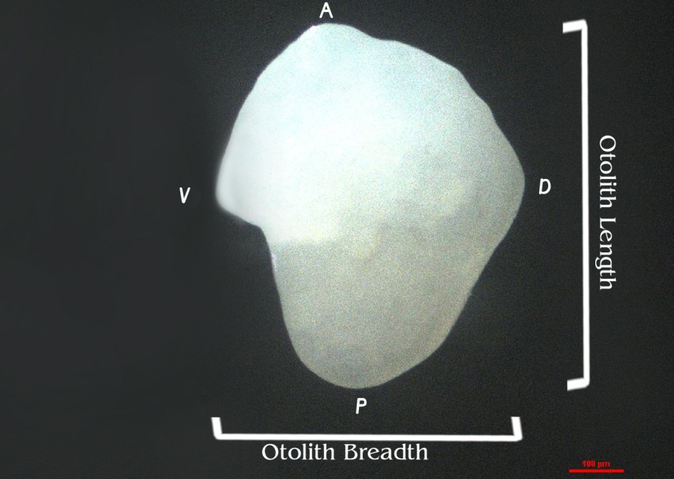
e- Morphometric measurements of otoloith
Figure 2- Otolith images with morphometric measurements (length and breadth) of Puntius ticto (a), Puntius sophore (b), Puntius muzaffarpurensis (c) and Puntius conchonius (d) using NIS Element D5.10.00 64-bit imaging software.

Figure 3- Otolith images (specimens- 30, otoliths-60) of Puntius ticto, Puntius sophore, Puntius muzaffarpurensis and Puntius conchonius using NIS Element D5.10.00 64-bit imaging software.
Statistical Analysis: Standard statistical methods were used to recognize the relationship among various measured parameters of otolith morphometry with fish morphometry. Discrimination between left and right otolith were checked by independent t-test and it showed no substantial difference, so any one of them can be choosen randomly. Otolith length and otolith breadth were compared with fish length as well as otolith mass was compared with fish mass. Linear regression model was applied to examine the relationship between fish length with otolith length and otolith breadth and fish mass with otolith mass. To find out inter-specific variations among the Puntius species investigated, ANOVA was applied between measured parameters and fish types.
RESULTS: Standard statistical methods were used to analyze the data statistically. No significant difference was found between left and right otolith in 4 species of genus Puntius studied, hence right otolith was selected for study of each fish sample. The values of measured parameters are given in table-1 of the species studied.
Table 1- values of measured parameters of species studied
Linear regression model showed strong and positive relationship between fish length with otolith length and otolith breadth and fish mass with otolith mass, results are represented by plots (Fig.4 A-D).

a b c
A- Linear relationship between Fish length- otolith length (a), Fish length-otolith breadth (b) and fish mass with otolith mass (c) in Puntius ticto.

a b c
B- Linear relationship between Fish length- otolith length (a), Fish length-otolith breadth (b) and fish mass with otolith mass (c) in Puntius sophore.

a b c
C-Linear relationship between Fish length- otolith length (a), Fish length-otolith breadth (b) and fish mass with otolith mass (c) in Puntius muzaffarpurensis.

a b c
D- Linear relationship between Fish length- otolith length (a), Fish length-otolith breadth (b) and fish mass with otolith mass (c) in Puntius conchonius.
Figure 4- Showing linear relationship between measured parameters of fish morphometry (fish length and fish mass) and otolith morphometry (otolith length, otolith breadth and otolith mass) in 4 species of genus Puntius studied viz. Puntius ticto (A), Puntius sophore (B), Puntius muzaffarpurensis (C) and Puntius conchonius (D.)
To show the inter-specific variations among Puntius species studied, analysis of variance (ANOVA) was done between measured parameters and fish types viz. Puntius ticto, Puntius sophore, Puntius muzaffarpurensis and Puntius conchonius and results are represented by mean plot (Fig. 5 a-e).
Remarkable differences can be observed clearly among the 4 species studied in otolith morphometry and structures (Table- 2 and 3).
Table 2 and 3: inter-specific variations between measured parameters and fish types of genus Puntius using ANOVA

a b

c d

e
Figure 5- Mean plot showing inter-specific variations between mean of measured parameters and fish types of genus Puntius (a-e).
In Puntius ticto, otolith length is 0.13% and otolith breadth is 0.10% of the total fish length. In Puntius sophore, otolith length is 0.10% and otolith breadth is 0.08% of the total fish length. In Puntius muzaffarpurensis, otolith length is 0.12% and otolith breadth is 0.09% of the total fish length. In Puntius conchonius, otolith length is 0.12% and otolith breadth is 0.10% of the total fish length. The above statistics state that Puntius ticto show largest otolith and Puntius sophore shows smallest otolith.
DISCUSSION: In the present study, otolith morphometry of 4 native species of genus Puntius (family Cyprinidae) i.e. Puntius ticto, Puntius sophore, Puntius muzaffarpurensis and Puntius conchonius was done. Comparison was done among various morphometrical parameters of left and right otolith for each species to find out intra-specific variations as well as to find out inter-specific variations, comparison was done among measured parameters and fish types. This is the first study which is centered on these groups of Puntius fishes for otolith morphometry in India. A few such kind of studies have been done in India via Kumar et al, 2012; Mathur et al, 2014; Singh N, 2015; Aneesh- Kumar et al, 2017; Nimesh and Jain, 2018; Nimesh N, 2019; Nazir and Khan, 2019; Borah et al, 2019, Nimesh et al, 2021; Nimesh N, 2024.
Lack of significant difference between left and right otolith of each species studied of genus Puntius viz. Puntius ticto, Puntius sophore, Puntius muzaffarpurensis and Puntius conchonius, is compatiable with the observation that paired otoliths are specular images of each other as supported by many other studies (Hunt, 1979; Felix et al, 2013; Zengin et al, 2015; Saygin et al, 2017). Dehghani et al, 2016 studied Sardinella sindensis and found no remarkable difference between left and right otolith, also same was observed between male and female specimens. Rhynchorhamphus georgi also showed no significant differences between left and right otoliths (Jawad et al, 2011). Nimesh, (2018) and Nimesh et al, (2021) also observed similarity between left and right otolith in Amblypharyngodon mola and Rasbora daniconius respectively. Left and right otoliths of Rasborine fishes did not vary morphometrically and they lack significant difference from each other (Nimesh N, 2024). A comparative study with special reference to its taxonomic importance of otolith morphometry was done by Mathur (2014), Singh (2015) and Nimesh (2019) in native species of genus Channa (Gronovirus), Labeo and Rasborine fishes respectively.
According to this study otolith length and breadth can be a best tool to estimate fish length because of its strong and positive relationship via linear regression model. This study is in accordance with many other studies like Jawad et al, (2011) found positive relationship between fish length and otolith length and breadth in the lutjanid fish, Lutjanus bengalensis (Lutjanidae) collected from Muscat City coast on the Sea of Oman. Jawad et al, (2011) reported strong correlation between fish length and otolith dimensions and mass in Rhynchorhamphus georgi with the help of linear regression model. Zengin et al, (2017) found such kind of correlation between otolith size and total length of bluefish, Pomatomus saltatrix in Black sea. Kumar et al, (2017) established length- weight relationships between fish size and otolith size in four bathydermersal fish species (Psenopsis cyanea, Pterygotrigla hemisticta, Bembrops caudimacula, Hoplostethus rubellopterus) from the south eastern Arabian Sea, India and it showed negative allometric growth pattern. In Amblypharyngodon mola strong and positive correlation was observed between fish length- otolith length and breadth and same is found between fish mass with otolith mass by linear regression model (Nimesh and Jain, 2018). Basusta and Basusta, (2018) also reported positive relationship between otolith length and breadth with total fish length in Hoplostethus mediterranean. A linear relationship between fish length, otolith size and otolith mass was observed in Sperata aor and Labeo bata from the Ganga River (Nazir and Khan, 2019). In Puntius sophore otolith length was linearly correlated with total fish length via linear regression model (Rani et al, 2019).
According to Zengin et al, (2015) and Bostanci et al, (2015) for estimation of fish size, otolith length, breadth and mass were considered as important taxonomic tool. Otoliths of Teleost fishes play an important role in hearing and equilibrium; otoliths of these fishes are helpful in understanding of fish systematics, age, back calculation of the fish length, paleontological studies and fish biology (Popper et al., 2005). Otoliths have been used to collect useful information about age, rate of growth, fish size and taxon (Mendoza, 2006). Otoliths are inert structures as once the material deposited on its surface, the fish body would not use these minerals in hunger or starving conditions. Due to these specular characteristics otoliths are best tool to reconstruction of habitat and migratory pattern estimation (Campana and Thorrold, 2001).
CONCLUSION: We can conclude that due to strong positive linear correlation between otolith length and otolith breadth with fish length, in 4 native species studied of genus Puntius, otolith morphometry is a good taxonomic tool for calculation of fish size, growth, age, fish stock identification and fishery management. It is also concluded that intra-specific and inter-specific variations are clearly established by ANOVA among parameters studied and fish types in Puntius fishes.
COMPETING INTERESTS: Authors have declared that no competing interests exist.
Disclaimer (Artificial intelligence): Author(s) hereby declare that NO generative AI technologies such as Large Language Models (ChatGPT, COPILOT, etc.) and text-to-image generators have been used during the writing or editing of this manuscript.
REFERENCES:
- Akkiran, N. (1985). A systematic study on Carangidae (Pisces) Employing the otolith characters in the Eastern Mediterranean. Biljeske-Notes, 63, 1-9.
- Aneesh, Kumar, K. V., Nikki, R., Oxona, K., Hashim, M., & Sudhakar, M. (2018). Relationship between fish and otolith size of nine deep sea fishes from the Andaman and Nicobar waters, North Indian Ocean. Journal of Applied Ichthyology, 33(6), 1187-1195.
- Basusta, A., Bal, H., & Aslan, E. (2013). Otolith Biometry- Total length relationships in the population of Hazar Bleak, Alburnus heckeli (Battalgil, 1943) inhabiting Lake Hazar, Elazig, Turkey. Pak. Journal of Zoology, 45(4), 1180-1182.
- Battaglia, P., Malara, D., Romeo, T., & Andloro, F. (2010). Relationships between otolith size and fish size in some mesopelagic and bathypelagic species from Mediterranean Sea (Strait of Messina, Italy). Scientia Marina, 74, 605-612.
- Borah, S., Vaisakh, G., Jaiswar, A. K., Bhattacharjya, B. K., Sahoo, A. K., Deshmukhe. G., Behera, B. K., Meena, D. K., Raman, R. K., & Das, B. K. (2019). Association patterns between dimensions of fish and otolith to expedite morphometric variations of three geographically isolated stocks of Tenualosa ilisha (Hamilton, 1822) from diverse ecosystems. Indian Journal of Fisheries, 66(3), 48-52.
- Bostanci, D., Polat, N., kurucu, G., Yedier, S., Kontas, S., & Darcin, M. (2015). Using otolith shape and morphometry to identify four Alburnus species (A. chalcoides, A. escherichii, A. mossulensis and A. tarichi) in Turkish inland waters. Journal of Applied Ichthyoogy, 31 (6), 1013-1022.
- Campana, S. E., Thorrold, S. R. (2001). Otoliths, increments and elements: keys to a comprehensive understanding of fish populations? Canadian Journal of Fisheries and Aquatic Science, 58, 30-38.
- Day, F. (1875-1878). The Fishes of India; Being a Natural History of the Fishes Known to inhabit the Seas and Fresh Waters of India, Burma, and Ceylon. Parts1-4 William Dawson & Sons Ltd., London.
- Dehghani, M., Kamrani, E., Salarpouri, A., & Sharifian, S. (2016). Otolith dimensions (length, width), Otolith weight and fish length of Sardinella sindensis (Day, 1878), as index for Environmental studies, Persian Gulf, Iran. Marine Biodiversity Records, 9, 44.
- Felix, V. R., Perez, J. A. M., Molina, J.R., Zuniga, R.E.Q. & Lopez, J. F. (2013). Morphology and morphometric relationships of the Sagitta of Diapterus auratus (Perciformes: Gerreidae) from Veracruz, Mexico. Revista de Biologia Tropical. 61
- Harvey, J. T., Loughlin, T. R., Perez, M. A., & Oxman, D. S. (2000). Relationship between fish size and otolith length for 63 species of fishes from the Eastern North Pacific Ocean. U. S. Dept. of Commerce NOAA. Technical Report NMFS 150.
- Hunt, J. J. (1979). Back-calculation of length-at-age from otoliths for silver hake of the Scotian Shelf. International Commission for the Northwest Atlantic Fisheries Sel. Papers, 5, 11-17.
- Hunt, J. J. (1992). Morphological characteristics of otoliths for selected fish in Northwest Atlantic. Journal of Northwest Atlantic Fisheries Science, 13, 63-75.
- Jawad, L., Al-Mamry, J., Al-Busaidi, H. (2011). Relationship between fish length and otolith length and width in the lutjanid fish, Lutjanus bengalensis (Lutjanidae) collected from Muscat City coast on the Sea of Oman. Journal of the Black Sea/Mediterranean Environment 17(2), 116-126.
- Jawad, LA., Al-Mamry, JM., Al –Mamari, HM., Al-Yarubi, MM. & AL-Busaidi, HK. (2012). Relationship between fish length and otolith length, width and weight of Rhynchorhamphus georgi (Valenciennes, 1846) (Family: Hemiramphidae) collected from Oman Sea. Romanian Journal of Biology, 56, 189–200.
- Jayaram, K. C. (1981). The Freshwater Fishes of India- A Handbook. Zoological Survey of India (Ed. 1994).
- Kumar, P., Chakraborty, S. K., & Jaiswar, A. K. (2012). Comparative otolith morphology of sciaenids occurring along the North – West coast of India. Indian Journal of Fisheries, 59(4), 19-27.
- Kumar, K. V. A., Deepa, K. P., Hashim, M., Vasu, C. & Sudhakar, M. (2017). Relationships between fish size and otolith size of four bathydemersal fish species from the south eastern Arabian Sea, India, Journal of Applied Ichthyology, 33, 102-107.
- Mathur, S. (2014). Comparative study of otolith in native species of Genus Channa (Gronovirus) with reference to taxonomic importance. Ph. D. Thesis, Ch. Charan Singh University, Meerut, India.
- Mathur, S., Jain, S., & Varma, M. (2014). Fish otoliths and their significance in Taxonomy. Journal of Experimental Zoology. India, 17(2), 407- 410.
- Mendoza, R. P. R. (2006). Otoliths and their applications in fishery science. Ribarstvo, 64 (3), 89-102.
- Nazir, A., & Khan, M. A. (2019). Relationship between fish length, otolith size and otolith weight in Sperata aor (Bagridae) and Labeo bata (Cyprinidae) from the Ganga River India. Zoology and Ecology 29(2), 90-95.
- Nimesh, N., & Jain, S. (2018). Otolith morphometry and fish length relation of Amblypharyngodon mola (Ham.) from middle Ganga region (India). International Journal of Fisheries and Aquaculture, 10(10), 122-128.
- Nimesh, N. (2019). Studies on Microstructure and Microchemistry of sagittal otolith of Rasborine fishes. Ph.D. Thesis, Ch. Charan Singh University, Meerut (Uttar Pradesh, India).
- Nimesh, N., Jain, S., Kang, R., & Nimesh, M. (2021). Otolith morphometry- Total fish length relationship in the population of Rasbora daniconius (Hamilton, 1822) (Cyprinidae). Uttar Pradesh Journal of Zoology, 42(24), 958-964.
- Nimesh, N. & Jain, S. (2024). Otolith morphometry and body size relationship of Raborine fishes in Ganga River water. Journal of Experimental Zoology. India, 27, 635-641.
- Platt, C., & Popper, A. N. (1981). Fine structure and function of the ear. In: Hearing and Sound Communication in Fishes. (edited by Tavolga, W. N., Popper, A. N, & Fay, R. R.). New York: Springer-Verlag, 3-38.
- Popper, A. N., Ramcharitar, J., & Campana, E. S. (2005). Why otoliths? Insights from inner ear physiology and fisheries biology. Marine and freshwater research, 56, 497-504.
- Rani, A., Rai, D., & Tyor, K. A. (2019). Morphometric Analysis of Sagitta Otolith in Pool Barb, Puntius sophore (Hamilton, 1822). Journal of Morphological Sciences, 36, 85-90.
- Saygin, S., Ozpicak, M. ELP. M., Polat, N., Atici, A. A., & Odun, N. A. (2017). Comparative analysis of otolith features of Tarek, Alburnus tarichi (Guldenstadt, 1814) from different lakes across Van Basin (Van Ercek, Nazik, Aygir)( Turkey) Limnofish. Journal of Limnology and Freshwater Fisheries Research, 3(2), 91-99.
- Singh, N. (2015). Comparative studies of otolith in native species of Genus: Labeo with special reference to its taxonomic importance. Ph. D. Thesis. C.C.S. University, Meerut.
- Zengin, M., Saygin, S., & Polat, N. (2015). Otolith shape analysis and dimensions of Anchovy, Engraulis encrasicolus L. in the Black and Marmara Seas. Sains Malaysiana, 44(5), 657-662.
- Zengin, M., Saygin, S., & Polat, N. (2017). Relationships between otolith size and total length of bluefish, Pomatomus saltatrix (Linnaeus, 1766) in Black Sea (Turkey). North-Western Journal of Zoology, 13(1), 169- 171.

