Original Research Article
Antibiotic Resistance in Bacteria from Penaeus vannamei Shrimp Farming: Challenges and importance of Sustainable Aquaculture Practices in West Bengal

ABSTRACT
West Bengal playing a pivotal role in Indian economy for its shrimp export, particularly Penaeus vannamei thus providing livelihood for thousands in coastal regions. Antibiotic resistance in bacteria infesting shrimp farming poses significant threat to the aquaculture system and public safety. This study investigates the prevalence of antibiotic-resistant bacteria in Penaeus vannamei (whiteleg shrimp) farmed in the Purba Medinipur district of West Bengal, India. Shrimp samples were collected from 48 aquaculture farms. The identified bacterial isolates were assayed for Antibiotic susceptibility testing against commonly used aquaculture antibiotics following the standard CLSI protocol. Results revealed a high prevalence of Multiple antibiotic resistance (MAR) bacterial strains, particularly within the genera Vibrio, Aeromonas, Acinetobactor and Enterobacterales. These findings highlight the potential risk of antibiotic-resistant pathogen transmission to human consumers, raising the need for resilient aquaculture practices, including judicious antibiotic use and exploring alternative disease management strategies. The importance of routine monitoring of antibiotic resistance in aquaculture is strongly recommended to promote sustainable shrimp farming in West Bengal.
Keyword: Antibiotic resistance, Multiple antibiotic resistance (MAR), Sustainable aquaculture, Shrimp farming, Antibiotics.
- INTRODUCTION

Antibiotic-resistant bacteria are widespread in shrimp farming environments, posing significant risks to human health and the environment (Jana et al., 2014). Bacterial resistance power has been observed against various antibiotics, including ampicillin, chloramphenicol, oxytetracycline, trimethoprim, and ciprofloxacin (Nadella et al., 2021and Zhang et al., 2011). The prevalence of antibiotic-resistant bacteria varies across different farming locations and can be influenced by factors such as antibiotic usage and farming practices (Nadella et al., 2021and Zhang et al., 2011). Interestingly, antibiotic resistance is not limited to farm-raised shrimp but has also been detected in ready-to-eat shrimp products available in grocery stores (Durán and Marshall, 2005). This raises concerns about the potential for internationally disseminating antibiotic-resistant pathogens through widespread trade.
Additionally, some studies have found higher levels of antibiotic resistance in shrimp hatcheries compared to grow-out ponds (Zhang et al., 2011). Antibiotic-resistant bacteria in shrimp aquaculture are a complex issue with potential implications for food safety and public health. The overuse and misuse of antibiotics in shrimp farming contribute to the selection and proliferation of resistant bacteria in aquatic environments. These resistant organisms can persist in water, sediments, and shrimp tissues, potentially transferring resistance genes to other bacterial species. The impact of antibiotic-resistant bacteria in shrimps is significant and concerning for human consumption, affecting not only the aquaculture environment but also surrounding ecosystems. From a food safety perspective, the presence of these bacteria poses risks to human health. Exposure to antibiotic-resistant bacteria can lead to infections that are difficult to treat with conventional antibiotics, potentially resulting in more severe and prolonged illnesses. To address this problem, it is crucial to implement better management practices, reduce antibiotic use, and develop alternative disease prevention strategies in shrimp aquaculture.
- MATERIALS AND METHODS

The current investigation was carried out in four subdivisions (Haldia, Contai, Tamluk, and Egra) of Purba Medinipur District, West Bengal, India. In every subdivision, three Blocks were chosen, and within each Block, four farms were designated, resulting in a total of 48 farms (n= 48). Monthly samplings were done from October 2022 to March 2024, to assess the occurrence of bacterial diseases in Penaeus vannamei in Purba Medinipur District.
2.1 BACTERIOLOGICAL ANALYSIS
In the laboratory, affected external and internal organs of moribund shrimp sample were processed for bacteriological test as described by Fadel and El-Lamie, (2019). The pure cultures obtained, were inoculated in Tryptone Soya Broth (TSB) and incubated overnight to isolate bacterial cells. Universal primers (forward primer 8F 5’-AGA GTT TGA TCC TGG CTC AG-3’ and reverse primer 1492R 5’-ACG GCT ACC TTG TTA CGA CTT-3’) were used to amplify the 16S rDNA gene of bacterial isolates.
2.2 ANTIBIOGRAM PROFILING
The phenotypic sensitivity of bacterial strains against 12 potential antibiotics were assessed using the agar disc diffusion technique (Bauer et al., 1966) on Mueller–Hinton agar plates. Plates were incubated at 30±2°C for 18 hours, and the zone of inhibition was measured in millimetres. Sensitivity was interpreted using the zone size interpretation table given by the antibiotic disc manufacturer.
2.2.1 MULTIPLE ANTIBIOTIC RESISTANCE (MAR) INDEX

MAR index for the above-mentioned antibiotics were determined from antibiogram data. MAR index were calculated as per Orozova et al., (2010) following the below stated formula
$MAR index (Resistant to at least three antibiotics)=\frac{Number of antibiotics to which the bacterium is resistant }{Total number of antibiotics tested. }$
2.3 STATISTICAL ANALYSIS
The data on season-wise prevalence of different bacteria were analysed using two-way ANOVA. They confirmed the significance of the difference by Tukey post-hoc test for comparison of means. All the statistical analyses were done using Statistical Package Tools for Social Sciences (IBM-SPSS), version: 22.0 and R Package. GraphPad Prism was used to generate a heatmap displaying the antibiotic resistance patterns of the bacteria isolated in this study.

- RESULTS AND DISCUSSION

Ten randomly selected antibiotic resistant bacterial strains were identified using 16S rDNA analysis using 8F primer and 1492R primer for the molecular confirmation. The isolates were identified as Vibrio parahaemolyticus (OR941081, PP106503 and PP116102), Morganella morganii (PP087089 and PP125034), Acinetobacter schindleri (PP087139), Aeromonas caviae (PP087423), Enterobacter hormaechei subsp. Xiangfangensis (PP112107), Vibrio alginolyticus (PP112134) and Vibrio vulnificus (PP116082). Bacterial pathogens isolated from diseased shrimp pose significant threats to human health, as these microbial agents are responsible for serious food poisoning outbreaks. Also, the consumption of antibiotic-resistant bacteria in contaminated shrimp poses a significant threat to human health, leading to difficult-to-treat infections and increased public health risks. The research highlighted the occurrence of pathogenic bacteria isolated from diseased shrimp, along with seasonal variations. Vibrio parahaemolyticus were most prevalent during the rainy season and least prevalent in the spring. According to Huehn et al., (2014) rainy season had higher concentrations of the virulence genes (tdh and trh) in Vibrio parahaemolyticus than other months. Those findings are quite similar with present study. Phylogenetic tree has been constructed by using MEGA XI software (Fig 1). The evolutionary history was inferred by using the Neighbour Joining method (Saitou and Nei, 1987). The optimal tree with the sum of branch length = 0.41736115 is shown. The percentage of replicate trees in which the associated taxa clustered together in the bootstrap test (1000 replicates) were shown next to the branches (Felsenstein, 1985). The evolutionary distances were computed using the Maximum Composite Likelihood method (Tamura et al., 2004) and were in the units of the number of base substitutions per site. 16S rDNA sequences of 10 antibiotic resistant bacterial strains, isolated from diseased cultured shrimp were identified by (●).The analysis involved 29 nucleotide sequences. All positions containing gaps and missing data were eliminated. There were a total of 491 positions in the final dataset. Evolutionary analyses were conducted in MEGA XI (Tamura et al. 2013).
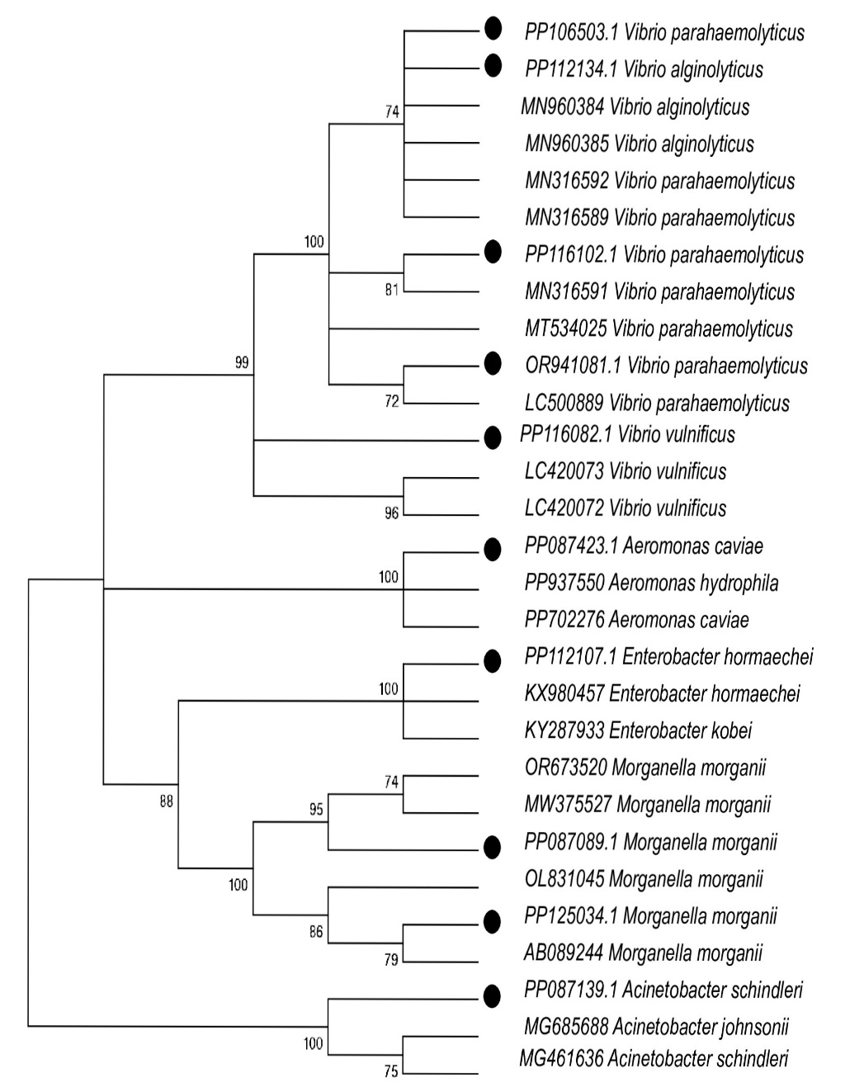

Fig. 1. Phylogenetic tree of 10 antibiotic resistant bacterial strains, isolated from diseased cultured shrimp were identified by (●).
3.1 PREVALENCE OF DIFFERENT PATHOGENIC BACTERIA DURING DIFFERENT SEASONS
The pathogenic bacteria include Vibrio parahaemolyticus, Vibrio harveyi and Vibrio alginolyticus were recovered in all seasons. The infestations of V. parahaemolyticus were highest during rainy season (43.38%) and lowest in spring (20.96%). In previous study, it had been noted that Vibrio parahaemolyticus had the highest seasonal prevelance during the summer, attributed to the rapid multiplication of its cells in ambient temperature (Zarei et al.,2012). Numerous environmental conditions, such as water temperature, salinity and oxygen concentrations, exposure to plankton, presence of sediment, suspended organic matter, and marine creatures, have been shown to influence the prevalence and variation of V. parahaemolyticus (Cabrera-García et al.,2004). Infestations were increased constantly from summer to rainy season and decreased in winter and spring season. The prevalence of Vibrio harveyi was highest during the rainy season at 30%, gradually decreasing to 22.49% in winter. Higher water temperatures and more nutrient availability might promote bacterial development. Previously reported that most outbreaks of luminous bacterial disease in Indonesia occur during the rainy season (Prayitno and Latchford., 1995). During the study period Vibrio alginolyticus were found in all seasons. Infestations of these bacteria were highest during summer season (27%), followed by decreased in winter (lowest, 12.83%). During the present study Vibrio alginolyticus was present throughout the year, having highest infection during summer which are similar with the previous findings (Huehn et al., 2014, Sabir et al., 2011). Vibrio cambelli, Vibrio proteolyticus and Vibrio mimicus were found in the summer season (6.23%, 12.2% and 5.97%) and in the rainy season (6.61%, 7.1% and 2.2%). They were not found in rest of the seasons. The prevalence of Aeromonas sp. was highest in summer (10.18%), followed by a decrease in rainy season (7.72%). Vibrio cholerae were present during rainy season (4.29 %) and Enterobacter hormaeche were present only in summer (3.43%). Acinetobacter sp. were found more in rainy season (19.24%) and absent in summer and spring season. Infestations of these Vibrio vulnificus were highest during summer (9.54%). Proteus penneri and Morganella morganii were found in summer season (3% and 4%) and in rainy season (4.29% and 5.51%). Among these isolates, V. parahaemolyticus was most frequently observed. Vibrio vulnificus, Vibrio proteolyticus, Vibrio mimicus, Enterobacter hormaecheand Aeromonas sp. were mostly present during summer. V. vulnificus was only found in the summer (Di et al., 2017). While the prevalence of Vibrio cholerae and Vibrio cambelli were mostly found during the rainy season. Previously observed that Vibrio cholerae outbreaks happened due to surface-water contamination showed the strongest association with excessive rainfall which supported the result of present study (Sedas, 2007). Acinetobacter sp. was common during the rainy season. According to previous study, the warmer months, Acinetobacter species were more active, especially in areas with high temperatures and humidity (Kritsotakis and Groves-Kozhageldiyeva., 2020). However, certain seasonal patterns might differ based on local environmental circumstances and geographic location. However, Proteus penneri and Morganella morganii were found in both summer and rainy seasons. Implementing proactive measures during the rainy season, such as enhancing water quality management and monitoring bacterial levels, may help prevent outbreaks of harmful bacteria like Vibrio sp. Overall, the findings of this study provide a comprehensive understanding of the seasonal patterns and environmental influences on bacterial prevalence in aquatic environments.

Statistical analysis by two-way Anova (Table 1) showed a significant difference (P<0.05, df = 3) exist in bacterial prevalence with the change in seasons. Similarly, there were significant differences (P<0.05, df = 12) in prevalence among bacteria isolated from diseased shrimp.
Table 1. Two way ANOVA Test for Season wise prevalence of different bacteria isolated from diseased Penaeus vannamei of Purba Medinipur district of West Bengal from October 2022 to March 2024
Source | Type II Sum of Squares | df | Mean Square | F | Sig.
SEASON | 43587.442 | 3 | 14529.147 | 12.046 | 0.000
BACTERIA | 269298.308 | 12 | 22441.526 | 18.606 | 0.000
Error | 43422.308 | 36 | 1206.175
Total | 575099.000 | 52

3.2 ANTIBIOGRAM PROFILING OF BACTERIAL ISOLATES
The antimicrobial susceptibility test showed that the highest percentage of the bacterial isolates were phenotypically resistant to Amoxyclav (30µg) (76.71%), followed by Clindamycin (2µg) (75.34%), Vancomycin (30µg) (68.49%) and Erythromycin (15µg) (60.27%), Nitrofurantoin (300µg) (31.5%) and Ciprofloxacin (5µg) (28.76%), Gatifloxacin (5µg) (20.54%) and Cotrimoxazole (25µg) (20.54%), Gentamycin (10µg) (19.17%) and Oxytetracycline (30µg) (13.74%), Sulphafurazole (300µg) (6.84%) and Chloramphenicol (30µg) (5.48%) (Fig. 2). The public health is increasingly at risk from resistant antimicrobial bacteria (Miyamori et al., 2022, Bag et al., 2022). In addition to having an international impact on human health, antibiotic resistance in Vibrio species may make it more difficult to treat infectious diseases that affect mostly aquatic animals. The most significant causes of Vibrio drug resistance are the frequent acquisition of extra chromosomal mobile genetic elements (such as replicating plasmids and integrating conjugative elements) and/or insertion sequences from closely or distantly related bacterial species, even though chromosomal mutations can play a role in AMR in Vibrio species (Das et al., 2020). In this study, most of the isolated bacteria were resistant to Amoxyclav (30µg) (76.71%) which shows agreement with the previous study (Sudha et al., 2014). According to previous study, bacterial isolates of V. vulnificus, V. harveyi, V. alginolyticus, V. parahaemolyticus, V. anguillarum, and V. splendidus were sensitive to OTC, norfloxacin, and ciprofloxacin (Jayasree et al., 2006). According to previous findings, P. penneri, Enterobacter hormaechei subsp. xiangfangensis, and M. morganii showed resistance to azithromycin and co-trimethoprim (Khan et al., 2022). All Vibrios and non-vibrios from shrimp around the West Bengal coast were sensitive against gentamycin and ciprofloxacin but resistant in decreasing order to nitrofurantoin, oxytetracycline, co-trimoxazole, and chloramphenicol which is similar with the present study (Sasmal et al., 2005). The heavy use of antibiotics in shrimp culture could cause the development of antibiotic-resistant bacteria. For that, the Indian government had banned the use of aqua drugs and supplements in the culture system (OTC, tetracycline, gentamycin, streptomycin, etc.), and it was essential to use prescribed antibiotics wisely (Jayasree et al., 2006). Probiotics were advised to use in hatcheries and grow-out culture ponds to reduce the need for antibiotics.
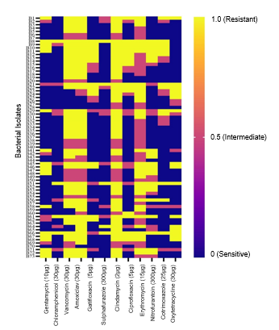

Fig. 2. Heatmap showing the antimicrobial resistance pattern of each bacterial isolates sourced from diseased shrimp.
By the correlation analysis, a high significant positive correlation was observed between the resistance pattern of Amoxyclav and Vancomycin (Corr: 0.988), Clindamycin and Amoxyclav (Corr: 0.930), Clindamycin and Vancomycin (Corr: 0.929), Cotrimoxazole and Clindamycin (Corr: 0.927), Cotrimoxazole and Amoxyclav (Corr: 0.853), Ciprofloxacin and Gatifloxacin (Corr: 0.852), Cotrimoxazole and Ciprofloxacin (Corr: 0.850), Cotrimoxazole and Vancomycin (Corr: 0.842) (Fig. 3). Furthermore, the higher, moderate, and lower resistance levels between any two antibiotics were evaluated in relation to the isolated bacterial strains (Fig. 3). The findings are significant since Vibrio isolates have demonstrated indications of becoming resistant to several antibiotics (Roy et al., 2022). To prevent the emergence and spread of antibiotic resistance in aquatic environments, the results highlight the critical need to control the use of antibiotics in aquaculture, put antimicrobial stewardship programs into place, and embrace alternative tactics like probiotics, immunostimulants, and biosecurity measures.
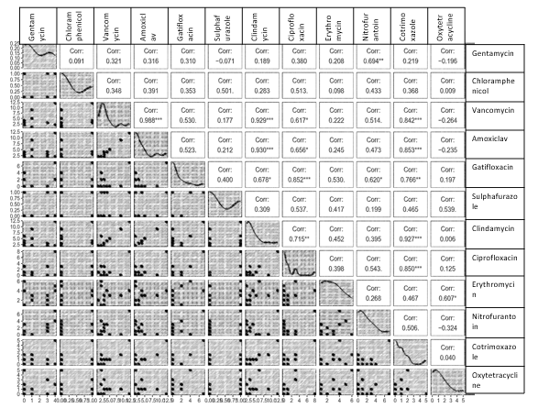
Fig. 3. Correlation to assess the significant association between any of the two antibiotics resistant to bacterial isolates from shrimp.

3.3 MAR INDEX AND MAR PROFILES OF BACTERIAL ISOLATES ASSOCIATED WITH DISEASED CULTURED SHRIMP
The details of the MAR index and MAR profiles of bacterial flora associated with diseased cultured shrimps were presented in Table 2. The MAR index of bacterial strains ranged as follows: 0.25-0.416 for Morganella morganii, 0.25-0.66 for Vibrio parahaemolyticus, 0.25-0.583for Vibrio harveyi, 0.25-0.33for Vibrio alginolyticus, 0.33-0.416 for Vibrio vulnificus, 0.33-0.583 for Vibrio proteolyticus, 0.33-0.50 for Vibrio mimicus, 0.25-0.46 for Vibrio cambelli, 0.41-0.58 for Vibrio cholerae, 0.41-0.75for Aeromonas sp,. 0.33-0.5 for Enterobacter hormaechei, 0.33-0.66for Acenetobactor sp., 0.33-0.50 for Proteus penneri. MAR in bacteria is usually associated with the existence of plasmids carrying one or more resistance genes (Gxalo et al., 2021). Antibiotic treatment was less likely for bacterial strains with MAR indices below 0.2, but those with values above 0.2 were probably exposed to several antibiotics or isolated from contaminated environments (Krumperman., 1983, Ballah et al., 2022). A higher percentage of the bacterial isolates (71.23%) in this investigation had MAR index values more than 0.2, indicating that the samples originated from a source of high-risk contamination where several antibiotics. These outcomes are quite similar with the previous studies (Noorlis et al., 2011, Lee et al., 2018). The use of furazolidone, neomycin, sulphamethoxazole, nalidixic acid, and chloramphenicol in Indian shrimp aquaculture has been banned by the Marine Products Export Development Authority (MPEDA., 2001). Albuquerque et. al. (2015) observed that antibiotic resistance was verified and confirmed in all V. parahaemolyticus, V. cholerae, V. alginolyticus, V. diazotrophicus,and V. vulnificus B3strains collected from farmed shrimp which is quite similar with present study. Additionally, it has been shown that the amount of antibiotics utilized correlates directly with the prevalence, rates of infection, and increase of antibiotic resistance in bacterial populations (Andersson et al., 2007). The environmental pollution of coastal and estuary waters, particularly from wastewater treatment plants and agricultural runoff, which may contain a range of antimicrobials and heavy metals, is the cause of antimicrobial resistance in aquatic bacteria (Siddique et al., 2021). According to the current study, farmers frequently release wasted culture water into rivers or cannels without adequately treating it to save money, which contributes to water contamination. Proper training of farmer on antibiotic resistance bacteria may reduce the problem.
Table 2. MAR Index of bacteria isolated from Penaeus vannamei shrimp
Sl No | Isolated Species | Total Isolates | Isolates Multidrug Resistant (%) | MAR Index
1 | Morganella morganii | 7 | 5 (71.42%) | 0.25-0.416
2 | Vibrio parahaemolyticus | 13 | 12(93.30%) | 0.25-0.66
3 | Vibrio harveyi | 8 | 6(75%) | 0.25-0.583
4 | Vibrio alginolyticus | 12 | 9(75%) | 0.25-0.33
5 | Vibrio vulnificus | 4 | 2(50%) | 0.33-0.416
6 | Vibrio proteolyticus | 6 | 2(33.33%) | 0.33-0.583
7 | Vibrio mimicus | 5 | 4(80%) | 0.33-0.50
8 | Vibrio cambelli | 2 | 2(100%) | 0.25-0.46
9 | Vibrio cholerae | 3 | 2(66.66%) | 0.41-0.58
10 | Aeromonas sp. | 3 | 3(100%) | 0.41-0.75
11 | Enterobacter hormaechei | 2 | 2(100%) | 0.33-0.5
12 | Acenetobactorsp | 5 | 3(60%) | 0.33-0.66
13 | Proteus penneri | 3 | 3(100%) | 0.33-0.50
 | Total | 73 | 52(71.23%)

- CONCLUSION

The findings from this study provide valuable insights into the prevalence and antimicrobial resistance patterns of pathogenic bacteria isolated from shrimp and their surrounding environments. These results highlight the contamination of shrimp with antimicrobial-resistant bacteria, emphasizing the need for comprehensive surveillance involving a larger number of farms and sample. Consequently, it is imperative for the shrimp aquaculture industry to recognize the potential risks associated with antimicrobial-resistant bacteria and adopt crucial measures during shrimp culture, harvesting, and processing to mitigate contamination. Considering these concerns, there is an urgent need for sustainable alternatives to antibiotics, such as probiotics, immuno-stimulants for better management practices in shrimp aquaculture. The establishment of robust regulatory frameworks and comprehensive monitoring systems is imperative to effectively manage antibiotic usage and mitigate potential risks to both environmental integrity and public health.

DATA AVAILABILITY
The assembled contigs analysed during the current study are available in https://www.ncbi.nlm.nih.gov under the accession numbers OR941081, PP106503, PP116102, PP087089, PP125034, PP087139, PP087423, PP112107, PP112134, and PP116082.
ETHICS STATEMENT
Not applicable.

Disclaimer (Artificial intelligence)
Option 1:
Author(s) hereby declare that NO generative AI technologies such as Large Language Models (ChatGPT, COPILOT, etc.) and text-to-image generators have been used during the writing or editing of this manuscript.
Option 2:
Author(s) hereby declare that generative AI technologies such as Large Language Models, etc. have been used during the writing or editing of manuscripts. This explanation will include the name, version, model, and source of the generative AI technology and as well as all input prompts provided to the generative AI technology
Details of the AI usage are given below:
1.
2.
3.

REFERENCES

Andersson, D. I., Patin, S. M., Nilsson, A. I., & Kugelberg, E. (2007). The biological cost of antibiotic resistance. Enzyme‐Mediated Resistance to Antibiotics: Mechanisms, Dissemination, and Prospects for Inhibition, 339-348.
Albuquerque Costa, R., Araújo, R. L., Souza, O. V., & Vieira, R. H. S. D. F. (2015). Antibiotic‐resistant vibrios in farmed shrimp. BioMed Research International, 2015(1), 505914.
Bag, M. A. S., Arif, M., Riaz, S., Khan, M. S. R., Islam, M. S., Punom, S. A., ... & Hassan, J. (2022). Antimicrobial resistance, virulence profiles, and public health significance of Enterococcus faecalis isolated from clinical mastitis of cattle in Bangladesh. BioMed Research International, 2022(1), 8101866.
Ballah, F. M., Islam, M. S., Rana, M. L., Ullah, M. A., Ferdous, F. B., Neloy, F. H., ... & Rahman, M. T. (2022). Virulence determinants and methicillin resistance in biofilm-forming Staphylococcus aureus from various food sources in Bangladesh. Antibiotics, 11(11), 1666.
Bauer, A. W., Kirby, W. M., Sherris, J. C., & Turck, M. (1966). Antibiotic susceptibility testing by a standardized single disk method. American journal of clinical pathology, 45(4_ts), 493-496.
Cabrera-García, M. E., Vázquez-Salinas, C., & Quiñones-Ramírez, E. I. (2004). Serologic and molecular characterization of Vibrio parahaemolyticus strains isolated from seawater and fish products of the Gulf of Mexico. Applied and environmental microbiology, 70(11), 6401-6406.
Das, B., Verma, J., Kumar, P., Ghosh, A., & Ramamurthy, T. (2020). Antibiotic resistance in Vibrio cholerae: understanding the ecology of resistance genes and mechanisms. Vaccine, 38, A83-A92.
Di, D. Y., Lee, A., Jang, J., Han, D., & Hur, H. G. (2017). Season-specific occurrence of potentially pathogenic Vibrio spp. on the southern coast of South Korea. Applied and environmental microbiology, 83(3), e02680-16.
Duran, G. M., & Marshall, D. L. (2005). Ready-to-eat shrimp as an international vehicle of antibiotic-resistant bacteria. Journal of food protection, 68(11), 2395-2401.
Fadel HM, El-Lamie MM. (2019) Vibriosis and Aeromonas infection in shrimp: Isolation, sequencing, and control. International Journal of One Health. 5(10):38-48.
Felsenstein, J. (1985). Confidence limits on phylogenies: an approach using the bootstrap. evolution, 39(4), 783-791.
Gxalo, O., Digban, T. O., Igere, B. E., Olapade, O. A., Okoh, A. I., & Nwodo, U. U. (2021). Virulence and antibiotic resistance characteristics of Vibrio isolates from rustic environmental freshwaters. Frontiers in cellular and infection microbiology, 11, 732001.
Huehn, S., Eichhorn, C., Urmersbach, S., Breidenbach, J., Bechlars, S., Bier, N., ... & Strauch, E. (2014). Pathogenic vibrios in environmental, seafood and clinical sources in Germany. International Journal of Medical Microbiology, 304(7), 843-850.
Jana, T. K., Banerjee, R. D., Lahiri, S., & Jana, B. (2014). Management induced changes of antibiotic resistant strains of heterotrophic bacteria in shrimp farming ponds. Indian Journal of Animal Sciences, 84(3), 323-328.
Jayasree, L., Janakiram, P., & Madhavi, R. (2006). Characterization of Vibrio spp. associated with diseased shrimp from culture ponds of Andhra Pradesh (India). Journal of the world aquaculture society, 37(4), 523-532.
Khan, M., Paul, S. I., Rahman, M. M., & Lively, J. A. (2022). Antimicrobial resistant bacteria in shrimp and shrimp farms of Bangladesh. Water, 14(19), 3172.
Kritsotakis, E. I., & Groves-Kozhageldiyeva, A. (2020). A systematic review of the global seasonality of infections caused by Acinetobacter species in hospitalized patients. Clinical Microbiology and Infection, 26(5), 553-562.
Krumperman, P. H. (1983). Multiple antibiotic resistance indexing of Escherichia coli to identify high-risk sources of fecal contamination of foods. Applied and environmental microbiology, 46(1), 165-170.
Kumar, S., Tamura, K., & Nei, M. (2004). MEGA3: integrated software for molecular evolutionary genetics analysis and sequence alignment. Briefings in bioinformatics, 5(2), 150-163.
Lee, L. H., Ab Mutalib, N. S., Law, J. W. F., Wong, S. H., & Letchumanan, V. (2018). Discovery on antibiotic resistance patterns of Vibrio parahaemolyticus in Selangor reveals carbapenemase producing Vibrio parahaemolyticus in marine and freshwater fish. Frontiers in microbiology, 9, 2513.
Miyamori, D., Kamitani, T., Kashiyama, S., Ito, M., Ohge, H., & Yamamoto, Y. (2022). Bacterial susceptibility changes post national shortage of first cephalosporin in Japan: a longitudinal retrospective database study using interrupted time series analysis. Journal of Global Antimicrobial Resistance, 30, 348-353.
MPEDA. Notification of ban on use of antibiotics/drugs etc. in aquaculture. Deputy director (Aqua.), MPEDA, Ministry of Commerce, Govt. of India, Calcutta – 700054, dt. 24.11.2001.
Nadella, R. K., Panda, S. K., Rao, B. M., Prasad, K. P., Raman, R. P., & Mothadaka, M. P. (2021). Antibiotic resistance of culturable heterotrophic bacteria isolated from shrimp (Penaeus vannamei) aquaculture ponds. Marine Pollution Bulletin, 172, 112887.
Noorlis, A., Ghazali, F. M., Cheah, Y. K., Zainazor, T. T., Wong, W. C., Tunung, R., ... & Son, R. (2011). Antibiotic resistance and biosafety of Vibrio cholerae and Vibrio parahaemolyticus from freshwater fish at retail level. International Food Research Journal, 18(4), 1523.
Orozova, P., Chikova, V., & Najdenski, H. (2010). Antibiotic resistance of pathogenic for fish isolates of Aeromonas spp. Bulg. J. Agric. Sci, 16, 376-386.
Prayitno, S. B., & Latchford, J. W. (1995). Experimental infections of crustaceans with luminous bacteria related to Photobacterium and Vibrio. Effect of salinity and pH on infectiosity. Aquaculture, 132(1-2), 105-112.
Roy, K., Islam, M. S., Paul, A., Ievy, S., Talukder, M., Sobur, M. A., ... & Rahman, M. T. (2022). Molecular detection and antibiotyping of multi‐drug resistant Enterococcus faecium from healthy broiler chickens in Bangladesh. Veterinary Medicine and Science, 8(1), 200-210.
Sabir, M., Cohen, N., Boukhanjer, A., & Ennaji, M. M. (2011). Occurance and survival of Vibrio alginolyticus in Tamouda Bay (Morocco). Cellular and Molecular Biology, 57(2), 1592-99.
Saitou, N., & Nei, M. (1987). The neighbor-joining method: a new method for reconstructing phylogenetic trees. Molecular biology and evolution, 4(4), 406-425.
Sasmal, D., Qureshi, T., & Abraham, T. J. (2005). Comparison of antibiotic resistance in bacterial flora of shrimp farming systems. Internet J Microbiol, 1, 1-7.
Sedas, V. T. P. (2007). Influence of environmental factors on the presence of Vibrio cholerae in the marine environment: a climate link. The Journal of Infection in Developing Countries, 1(03), 224-241.
Siddique, A. B., Moniruzzaman, M., Ali, S., Dewan, M. N., Islam, M. R., Islam, M. S., ... & Mahmud, Z. H. (2021). Characterization of pathogenic Vibrio parahaemolyticus isolated from fish aquaculture of the southwest coastal area of Bangladesh. Frontiers in Microbiology, 12, 635539.
Sudha, S., Mridula, C., Silvester, R., & Hatha, A. A. M. (2014). Prevalence and antibiotic resistance of pathogenic Vibrios in shellfishes from Cochin market. Indian Journal of Geo-Marine Sciences, 43(5), 815-824.
Tamura, K., Stecher, G., Peterson, D., Filipski, A., & Kumar, S. (2013). MEGA6: molecular evolutionary genetics analysis version 6.0. Molecular biology and evolution, 30(12), 2725-2729.
Zarei M, Borujeni MP, Jamnejad A, (2012) Seasonal prevalence of Vibrio species in retail shrimps with an emphasis on Vibrio parahaemolyticus. Food Control. 25(1):107-9.
Zhang, Y. B., Li, Y., & Sun, X. L. (2011). Antibiotic resistance of bacteria isolated from shrimp hatcheries and cultural ponds on Donghai Island, China. Marine pollution bulletin, 62(11), 2299-2307.

