Qualitative and Molecular Characterization of Rugda Mushroom: A Comprehensive Analysis

Abstract
Rugda mushrooms are valued for their nutritional and therapeutic properties, yet detailed compositional and taxonomic studies remain scarce. In this work, we present an integrated quantitative analysis of phytochemicals and molecular characterization of Rugda fruiting bodies, employing Gas Chromatography–Mass Spectrometry (GC-MS), Fourier-Transform Infrared Spectroscopy (FTIR), Scanning Electron Microscopy (SEM), and DNA-based phylogenetic analysis. GC-MS analysis revealed nine compounds. Quantitative analysis further determined total phenolic content and total flavonoid content and the total phenolic content was 9.01±0.31 mg GAE⋅g⁻¹ and total flavonoid content was 4.13 ± 0.12 mg QE·g⁻¹ observed. FTIR spectra exhibited characteristic peaks at O–H stretching, N-H bend, C–O strech, indicating phenol, amine & ester. SEM images showed a compact hyphal network with ellipsoid spores bearing reticulate ornamentation. ITS sequencing confirmed Rugda as belonging to the Astraeus asiaticus. The combined GC-MS, FTIR, and SEM data elucidate the chemical and morphological attributes of Rugda mushroom, while ITS-based molecular analysis provides accurate taxonomic placement. This multidisciplinary profiling lays a foundation for future exploration of Rugda’s bioactive compounds and supports its authentication for nutritional, pharmaceutical, and industrial applications.
Keywords- Rugda, Mushroom, Astraeus asiaticus, GC-MS, phylogenetic, FTIR.
INTRODUCTION
Mushrooms, due to their medical and culinary qualities, have historically been seen as a beneficial member of human civilization, occasionally replacing plant and animal-derived things. They have long been respected in numerous cultures around the world, not just for their nutritional value, but also as agents of healing and wellbeing in traditional medicine systems. Mushrooms have been used to cure a variety of maladies, including inflammation and infections, as well as more chronic conditions such as diabetes and cancer, dating back to ancient Chinese and Japanese medical methods. Mushrooms are now acknowledged as functional foods with nutritional value, structural quality, and acceptance (Mwangi et al., 2022). These bioactive-rich mushrooms are rapidly being researched and consumed, not only for their high nutritional value, but also for their medicinal bioactivity and therapeutic potential.
Furthermore, mushrooms will endure amazing adjustments in the next days to adapt as well-functioning therapeutic foods. Advances in cultivation technologies, processing, and storage procedures have increased the shelf life and bioavailability of active ingredients in mushrooms. Mushrooms are currently being used in novel food products, functional beverages, and nutraceuticals thanks to advancements in food science and biotechnology. This innovation demonstrates their adaptability and emphasizes the growing global desire for sustainable and plant-based medical options. Mushroom consumption is quickly increasing across Asia, particularly in India and Japan. According to Research and Markets (2021), the mushroom farming industry was valued at 16.7 billion USD in 2020 and is predicted to expand to 20.4 billion USD by 2025 (Landínez-Torres et al., 2021). The rapid growth is due to greater consumer health awareness, rising vegetarianism and veganism, and the expansion of the food and pharmaceutical businesses. Palatable mushrooms are low-calorie, low-fat food supplements that include moderate amounts of protein, carbs, vitamins, minerals, amino acids, and fibre (Pandey and Ghosh, 2023). These critical components make mushrooms ideal for people looking for nutrient-dense, low-energy diets. In addition to their nutritional value, edible mushrooms contain high levels of bioactive chemicals such as polysaccharides, phenolic compounds, terpenoids, lectins, and alkaloids. These chemicals help to explain mushrooms' broad-spectrum health benefits. Mushrooms have been shown to have a variety of pharmacological properties, including antibacterial, antifungal, antiviral, antiparasitic, antioxidant, anti-inflammatory, antiproliferative, anticancer, anti-HIV, hypocholesterolemic, antidiabetic, and anticoagulant activities (Ghosh et al., 2020a; Manimaran et al., 2021).
In this study, we focused on the fungus Astraeus sp. because of its nutritional value and extensive use as a restorative drug due to its antidiabetic, anticancer, hepatoprotective, anti-inflammatory, and cardioprotective qualities (Phadannok et al., 2020). Astraeus asiaticus, a plant present in various Indian woodlands, has received little attention despite its historic use in tribal and rural cultures. The primary purpose of this study was to find the biodiversity of Astraeus asiaticus by morphological, biochemical, and molecular research in diverse woodlands or forests of the Bankura district, West Bengal's red lateritic zone. Such biodiversity studies are critical for realising the fungus's full nutritional and medicinal potential. Mycorrhizae are symbiotic relationships between fungus and plant roots that play an important role in nutrient cycling and ecosystem productivity. They transfer nutrients from the host plant's roots to soil-dwelling fungus, promoting plant health and growth. In this context, biodiversity represents immensely important "natural capital." A functional ecosystem and profitable economy rely on various types, species, and genera, as well as their intricate interactions (World Bank, 2022). The preservation of fungal diversity is critical not just for ecosystem balance, but also for the continuous availability of innovative bioresources for food, medicine, and industry.
Although wild mushrooms and fungus play a crucial role in any ecosystem, little research has been conducted on their variety and types, particularly in tropical countries such as India. As a result, a knowledge gap exists. Bhattacharya et al. (2023) highlight the importance of systematic surveys and molecular characterization of wild fungus in these places. Wild edible mushrooms are a natural resource that provides nutrition and revenue in rural populations (Meena et al., 2020). These mushrooms frequently grow without requiring significant agricultural input, making them both environmentally friendly and economically accessible to indigenous and low-income groups. As a result, studying the biodiversity and uses of wild edible mushrooms is vital to the economy. Astraeus species are economically significant since they are harvested for human consumption and commercial sale (Pandey and Ghosh, 2023). The Porahat forest division in Jharkhand, India, is well-known for its abundance of Astraeus, and locals can supplement their income by selling wild edible mushrooms. As a result, Astraeus asiaticus has a substantial socioeconomic influence on rural livelihoods in eastern India by providing both nutritional and financial support. Despite its popularity as a food source, A. asiaticus' medicinal potential has not been fully explored. As a result, the molecular characteristics, biodiversity, mycochemistry, antioxidant content, and antioxidant activity of this mushroom were determined in this study, allowing for future investigation into its therapeutic value. As the world's interest in natural health solutions rises, fungus like Astraeus asiaticus may hold the key to future pharmacological discoveries. Future research should focus on isolating and characterizing potential bioactive chemicals from these understudied fungus, as well as assessing their pharmacokinetic and pharmacodynamic effects in therapeutic settings.
MATERIALS AND METHODS
Sample Collection
A comprehensive mushroom survey was carried out in the Porahat Forest Division of Jharkhand to investigate the occurrence and diversity of Astraeus asiaticus. This location is recognized for its rich lateritic soil and damp deciduous forest cover, which provide ideal circumstances for wild mushroom development. From mid-July to August 2023, a periodic field survey was conducted during the peak of the monsoon season, which is considered the best time for collecting A. asiaticus due to favorable temperature, humidity, and soil moisture conditions.
Identification of the Species
Macroscopic analysis of mushroom morphology was used to aid in correct identification and categorization, with a focus on factors such as size, shape, texture, colour, and growth behaviour (Phosri et al., 2007). These physical characteristics were meticulously noted throughout field and laboratory observations. In addition to morphological analysis, biochemical assays were performed to determine metabolic activity and nutritional content, in accordance with the standard protocols given by Khaund and Joshi (2014), ensuring the samples' reliability and reproducibility.
Scanning electron microscopy analysis
Spore samples were fixed and preserved for scanning electron microscopy (SEM) using a graded ethanol dehydration series (30%, 50%, 70%, 80%, 90%, 95%, and 100%) containing 2% glutaraldehyde, with 15 minutes of incubation at each step to ensure gradual dehydration and structural integrity. After dehydration, the samples were centrifuged to remove surplus liquid, with the supernatant discarded. The dried samples were then mounted on stubs and coated with a small layer of gold using a sputter coater to increase conductivity. SEM was utilised for high-resolution imaging, with a focus on capturing detailed surface morphology (Phosri et al., 2007).
Molecular Identification
The modified CTAB (cetyltrimethylammonium bromide) approach, reported by Doyle and Doyle (1987), was used to extract DNA from fresh mushroom tissue, ensuring rapid separation of high-quality genomic DNA. The recovered DNA was further purified with the HiMedia Purification Kit to eliminate impurities and polysaccharides prevalent in fungal tissues. The purity and integrity of the DNA were validated by electrophoresis on a 0.8% agarose gel, which revealed distinct bands indicating successful extraction. The ITS1-5.8S-ITS2 region of ribosomal RNA was amplified using a polymerase chain reaction (PCR) procedure modified from Gardes and Bruns (1993), with the fungal-specific primers ITS-1F and ITS4. These primers are commonly used for fungal barcoding because of their great specificity and dependability. The amplified products were sequenced, and the obtained nucleotide sequences were used to identify closely related fungal species by comparing them to existing sequences in the NCBI database (Pandey & Ghosh, 2023).
Preparation of Mushroom Extract
The acetone extract of the mushroom sample was produced to determine its phytochemical and antioxidant capabilities. For extraction, 10 grammes of finely powdered dried mushroom basidiomata were immersed in hot acetone at a 1:10 (w/v) ratio to ensure complete saturation. To ensure effective solubilization of bioactive chemicals, the mixture was constantly agitated on a rotary shaker at 150 rpm for 1 hour. The combination was incubated at 38 °C for 72 hours to extract heat-stable secondary metabolites more effectively. After incubation, the extract was passed through Whatman No. 4 filter paper to remove solid residues before being centrifuged at 3000 rpm for 15 minutes to clarify the solution and separate any fine particulate matter. The supernatant was concentrated by evaporating the solvent under reduced pressure with a rotary evaporator. This technique preserved the bioactive ingredients while efficiently removing acetone. The thick, dark crude extract was collected and stored in amber vials at 4°C for phytochemical screening, antioxidant tests, and biochemical analysis. This extraction process is extensively used because it preserves thermolabile chemicals while producing concentrated phytoconstituents from fungal sources.
Quantitative Analysis of Acetone Extract
The total phenolic content of the mushroom acetone extract was determined using the Folin-Ciocalteu colorimetric method, which is a popular approach for assessing phenolic compounds due to its simplicity and sensitivity. This approach is based on the reduction of the Folin reagent by phenolic compounds in alkaline circumstances, which results in a blue complex that can be detected spectroscopically. Total phenols were calculated as milligrammes of Gallic acid equivalents (GAEs) per gramme of acetone extract dry weight. For flavonoid quantification, the approach reported by Ghosh et al. (2025) was used, which involves the production of an aluminium chloride combination, resulting in a stable colour observed at 415nm. The findings were expressed as milligrammes of Quercetin equivalents (QEs) per gramme of acetone extract dry weight. These tests are critical for determining the antioxidant capacity and therapeutic usefulness of the mushroom extract, as phenolics and flavonoids are renowned for their radical scavenging, anti-inflammatory, and antibacterial capabilities (Rijia et al., 2024).
FT-IR analysis
Fourier Transform Infrared Spectroscopy (FT-IR) is a sophisticated analytical technique that is commonly used to identify distinct functional groups in complex organic and inorganic substances. In this experiment, 10 mg of crude ethyl acetate extract powder was thoroughly combined with 100 mg of potassium bromide (KBr) to produce a fine, uniform slurry. This combination was then compressed into a translucent pellet using a hydraulic press. The pellet was analysed using an FT-IR spectrophotometer with a scan range of 400-4000 cm⁻¹ and a spectral resolution of 4 cm⁻¹, following Ashok and Ramaswamy's (2014) protocol. The resulting infrared spectrum (chromatogram) showed several absorption peaks, each representing a distinct functional group, such as hydroxyl, carbonyl, amine, or alkene. These peaks were interpreted by comparing their wavenumber positions to those listed in standard reference databases, which enabled the identification of bioactive chemicals in the extract.
GC-MS analysis
The Gas Chromatography-Mass Spectrometry (GC-MS) study was carried out on an Agilent GC-6860 N Network GC System, which included both a Gas Chromatograph and a Mass Spectrometer for precise and sensitive detection of volatile and semi-volatile chemicals. The sample was injected in split mode, with helium as the carrier gas at a constant flow rate. The temperature program was optimized to achieve proper compound separation. During the investigation, electron impact ionization (EI) at 70 electron volts (eV) was used, a common energy setting that aids in the fragmentation of molecules for mass spectrum analysis. The ensuing chromatogram showed several peaks that corresponded to different elements of the extract. Each peak was recognized by matching the mass spectra to known compounds in the NIST library database with the Post Run Solution Software. Sanyal and Ghosh (2019) employed the total ion chromatogram (TIC) to evaluate the chemicals qualitatively and quantitatively.
RESULT AND DISCUSSION

Phenotypical Identification of Mushroom
The fruiting season of this mushroom is from June to August. It is globose and smooth, with an unexpanded diameter of 10-16 × 8-14 mm and an inflated diameter of 14-23 × 8-12 mm. The gleba was initially white; but, as the spores matured, the gleba and its granulate outer peridium became purplish chestnut. The exoperidium was slightly viscous and smooth, with a white colour covering the endoperidium (Figure 1). The endoperidium is a thin membrane layer of tissue that surrounds the spore mass in a 20-30 mm diameter sac with an irregularly formed ostiole at the top. The surface is rough, white, and grey to brown in colour. The basidiospore mass was yellowish while young, but black and powdery when mature. The spores were reddish-brown, generally spherical with minute warts, and were 7.5-11 µm in diameter. The mycelial layer consisted of branched hyphae measuring 4-7 µm in diameter. The fibrous layer's hyphae were 6-9 µm in diameter and branched, while the collenchyma-type layer had branched hyphae 3-4 µm in diameter (Figure 2). Scanning electron micrographs produced a clear three-dimensional image and stereoscopic view of the mushroom spore and hyphal structures. Ornamentation on the spore surface and hyphal structure were clearly visible (Figure 3). The basidiospores showed wide, dense, and rounded spine and were globose, ranging from 8.65–15.3 mm diameter.
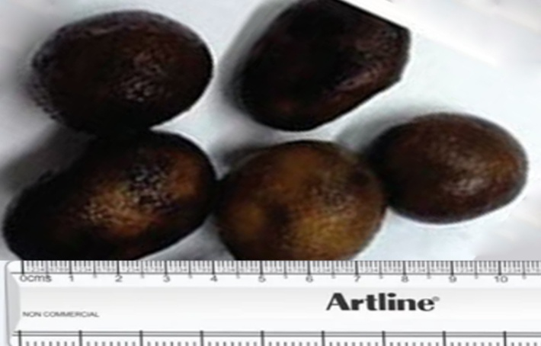 | 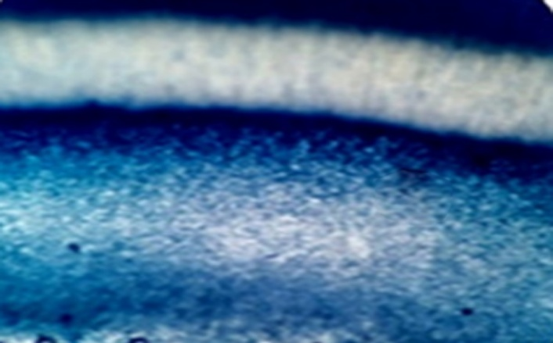
Fig. 1- Mature sporocarp of Astraeus asiaticus. | Fig. 2- The anatomy of Astraeus asiaticus- Cross section of the gleba.
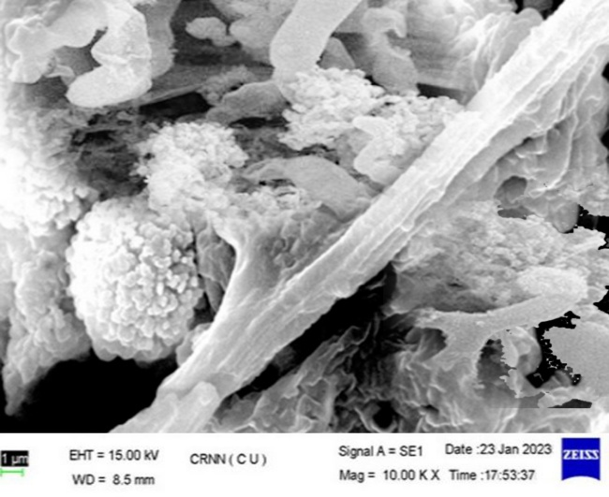
Fig. 3- Scanning electron micrograph of the hyphae of Astraeus asiaticus.
Molecular Identification of Fungal Species
The mushroom sample was conclusively identified as Astraeus asiaticus through a BLAST search conducted using the NCBI GenBank database. The sequence alignment yielded a query coverage of 100.0% and an identity score of 97.00%, strongly supporting the taxonomic placement (Fig. 4). Additionally, a phylogenetic tree was constructed using related ITS sequences, which further confirmed the close genetic relationship between the test organism and A. asiaticus (Fig. 5). Therefore, the wild mushroom was accurately classified under the genus Astraeus, species asiaticus.
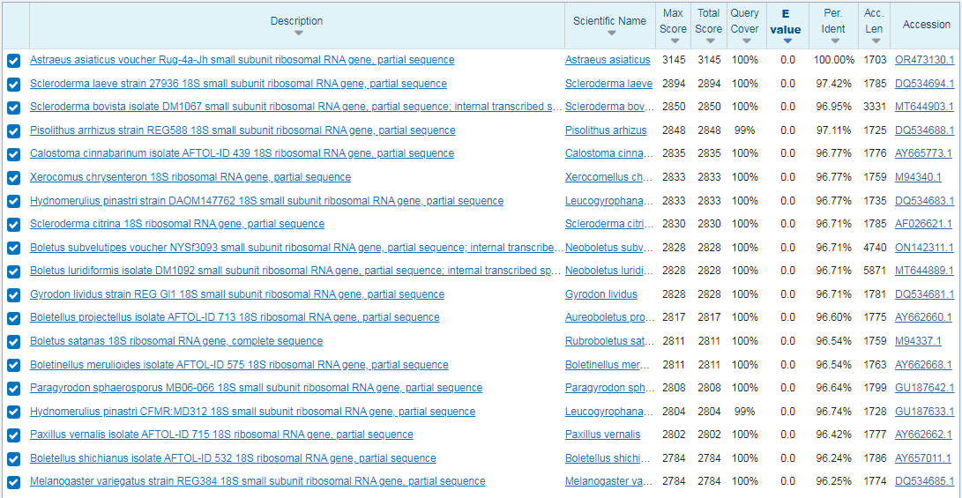
Fig.4- BLAST result of the highest sequence similarity of Astraeus asiaticus.
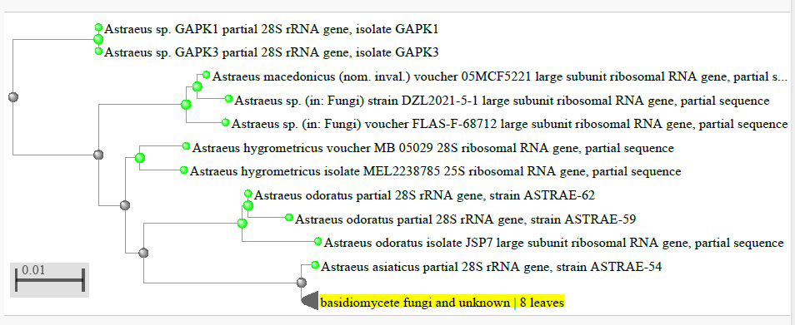
Fig. 5- Neighbor-joining phylogenetic tree showing the evolutionary relationship with gene isolated gene sequence.
Quantitative Analysis of Acetone Extract
The total phenolic content (TPC) of the acetone extract was determined to be 9.01 ± 0.31 mg GAE·g⁻¹, indicating a significant presence of phenolic compounds known for their antioxidant and health-promoting properties. In addition, the total flavonoid content (TFC) was found to be 4.13 ± 0.12 mg QE·g⁻¹, suggesting the extract also contains a substantial amount of flavonoids, which are associated with anti-inflammatory and antimicrobial activities. These results highlight the mushroom's strong nutraceutical potential.
FT-IR spectral data analysis
Acetone extract showed the different absorption peaks (functional groups) like 3274 cm⁻¹ (–OH stretching vibrations), 2973 cm⁻¹ (aliphatic C–H stretching), 2492 & 2354 cm⁻¹ (CO₂ interference), 1642 cm⁻¹ (C=O, carbonyl or C=C stretching), 1589 cm⁻¹ (C=C stretching), 1394 cm⁻¹ (O–H bending or C–H deformation), 1302 cm⁻¹ (C–N stretching), 1104 cm⁻¹ (C–O stretching band), 654 cm⁻¹ (C–H or halogen-containing functional groups). (Fig. 6; Table 1).
Table 1- FTIR Peak Assignment of Acetone Extract.
Wavenumber (cm⁻¹) | Functional Group | Vibration Type | Possible Assignment
3274 | O–H or N–H stretch | Broad Stretching | Alcohols, phenols, or amines
2973 | C–H stretch | Asymmetric Stretching | Alkanes (methyl, methylene groups)
2492, 2354 |  | Possible overtone or CO₂ interference | Atmospheric CO₂ (artifact) or thiol/acid overtones
1642 | C=O or C=C stretch | Stretching | Carbonyl group (ketones, aldehydes, esters) or alkenes
1589 | C=C or N–H bend | Stretching or bending | Aromatic ring or amine group
1394 | O–H bend or C–H deformation | Bending | Phenols or alkanes
1302 | C–N or C–O stretch | Stretching | Amines or carboxylic acids
1104 | | C–O stretch | Stretching | Alcohols, esters, or ethers
654 | Out-of-plane bending | Bending | Aromatic C–H (substitution pattern) or halo compounds

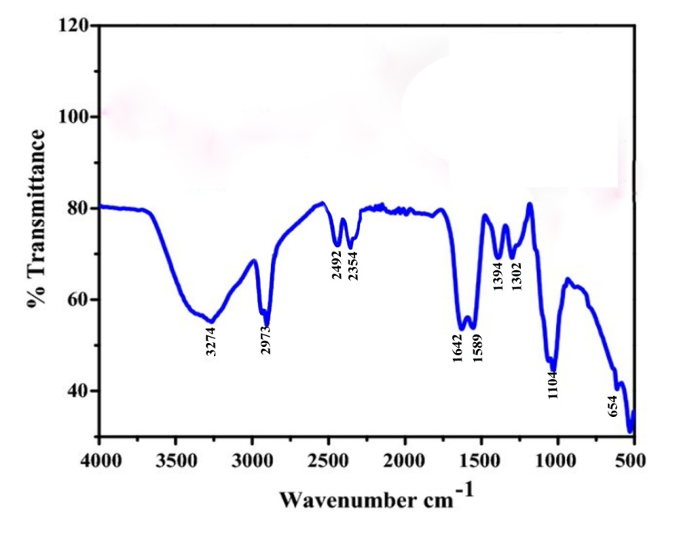
Fig.6- FT-IR Chromatogram of Acetone Extract.
GC-MS analysis
Acetone extract was analyzed by Gas Chromatography–Mass Spectrometry (GC-MS), and the chemo-profiling study revealed the presence of nine distinct bioactive compounds (Fig. 7). These compounds were identified through comparison with the National Institute of Standards and Technology (NIST) mass spectral library database, ensuring reliable identification based on fragmentation patterns and retention times. Each peak in the chromatogram corresponds to a unique compound that was separated by the GC column and subsequently identified via MS analysis. Notably, the most prominent peak was observed at a retention time of 10.0 minutes, suggesting this is the major constituent within the extract and possibly the most abundant bioactive compound. Other peaks appearing at 3.71, 6.35, 6.71, 15.36, 19.72, 19.82, 20.49, 25.36, and 25.77 minutes indicate the presence of minor yet potentially significant phytochemical constituents. The initial broad peak near 0 minutes is likely due to the presence of solvent remnants or highly volatile low molecular weight compounds. Importantly, the overall chromatogram exhibited a stable baseline post-initial elution phase, which reflects efficient column performance and adequate sample preparation. The diversity of identified compounds highlights the chemical richness of the acetone extract and supports its potential for further biological or pharmacological investigations (Table 2).
Table 2 – Compounds analysis of acetone extract using GC-MS.
Retention Time (min) | Area % | Compound Name
4.657 | 15.57 | 4-Phenylbut-3-ene-1-yne
7.971 | 1.93 | Benzene, (1-methyldecyl)
8.871 | 0.93 | Benzene, (1-methylundecyl)
10.489 | 4.89 | 1-Nonadecene
11.570 | 2.74 | Phytol
17.262 | 1.17 | Decanedioic acid, bis(2-ethylhexyl) ester
18.003 | 1.03 | Pentatriacontane
20.080 | 2.36 | Vitamin E
22.404 | 2.73 | Stigmasta-7,25-dien-3-ol, (3.beta.,5.alpha.)

~

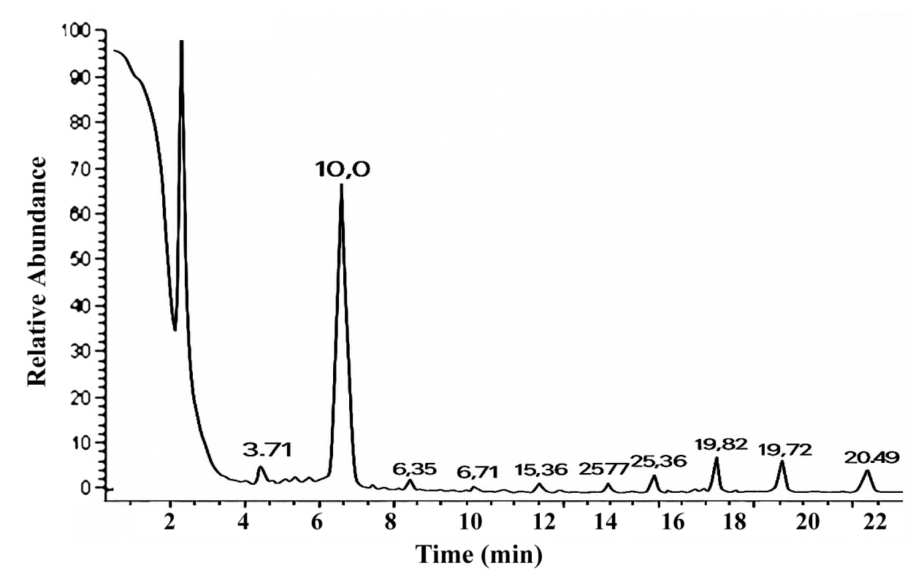
Fig. 7- GC-MS chromatogram of acetone extract.
CONCLUSION
This study presents a comprehensive qualitative and molecular characterization of the Rugda mushroom, offering valuable insights into its taxonomy, morphology, and genetic identity. Macroscopic and microscopic observations confirmed distinct phenotypic traits, while molecular analyses, particularly ITS region sequencing, provided accurate species-level identification. Phylogenetic analysis revealed close genetic relationships with other edible and medicinal fungi, reinforcing its potential for nutritional and pharmacological applications. The integration of morphological and molecular approaches proved essential for resolving taxonomic ambiguities and ensuring reliable identification. Furthermore, the findings highlight the importance of preserving indigenous mushroom species like Rugda, which hold ecological, cultural, and economic significance. This research lays the groundwork for future studies on the bioactive compounds, cultivation methods, and biotechnological applications of Rugda. Overall, this characterization contributes to the expanding knowledge base on wild mushrooms and supports their sustainable utilization in food, medicine, and environmental management.
Disclaimer (Artificial intelligence)
Author(s) hereby declare that NO generative AI technologies such as Large Language Models (ChatGPT, COPILOT, etc.) and text-to-image generators have been used during the writing or editing of this manuscript.
REFERENCE
Ashok kumar, R. & Ramaswamy, M. (2014) Phytochemical screening by FTIR spectroscopic analysis of leaf extracts of selected Indian medicinal plants. IJCMAS 3 (1), 395–406.
Bhattacharya, S., Roy, P., & Sinha, S. (2023). *Diversity and ecological significance of wild mushrooms in lateritic regions of eastern India*. Mycology Journal, 12(3), 155–168.
Doyle J., Doyle J. (1987). A rapid DNA isolation procedure for small quantities of fresh leaf tissue. Phytochemistry Bulletin. 19: 11-15.
Ghosh, S., Banerjee, A., & Mandal, N. (2020a). Antioxidant and therapeutic potential of wild edible mushrooms from lateritic region of West Bengal, India. Journal of Applied Pharmaceutical Science, 10(5), 86–95.
Ghosh S., Bera T., Pal S. (2020a). Antiproliferative, apoptotic, and antimigration property of ethyl acetate extract of Calocybe indica against HeLa and CaSki cell lines of cervical cancer, and its antioxidant and mycochemistry analysis. Middle East Journal of Cancer. 11 (4): 454-468.
Ghosh, S.K., Pandey, K., Ghosh, M. (2025). Mycochemistry, antioxidant, anticancer activity, and molecular docking of compounds of F12 of ethyl acetate extract of Astraeus asiaticus with BcL2 and Caspase 3. Sci Rep 15, 4313. https://doi.org/10.1038/s41598-025-87775-1
Gardes M., Bruns T. (1993). ITS primers with enhanced specificity for Basidiomycetes-application to the identification of mycorrhizae and rusts. Molecular Ecology. 2: 113-118.
Khaund, P., Joshi, S. (2014). Micromorphological characterization of wild edible mushroom spores using scanning electron microscopy. National Academy Science Letters. 37 (6): 521-527.
Landı́nez-Torres A., Fagua C., López A., Oyola Y., Girometta C. (2021). Pruning wastes from fruit trees as a substrate for Pleurotus ostreatus. Acta Mycologica. 56: 1-13.
Mwangi R., Macharia J., Wagara I., Bence R. (2022). The antioxidant potential of different edible and medicinal mushrooms. Biomedicine & Pharmacotherapy. 147.
Meena B., Sivakumar V., Praneetha S. (2020). Prospects of biodiversity and distribution of mushroom fungi in India. GSC Biological and Pharmaceutical Sciences. 13 (01): 078-085.
Mwangi, F. W., Waweru, B., & Oduor, R. (2022). Nutritional composition and medicinal potential of selected edible mushrooms: A review. *Food Research*, 6(1), 85–96.
Manimaran K., Balasubramani G., Ragavendran C., Natarajan D., Murugesan S. (2021). Biological applications of synthesized ZnO nanoparticles using Pleurotus djamor against mosquito larvicidal, histopathology, antibacterial, antioxidant and anticancer effect. Journal of Cluster Science. 32 (6): 1635-1647.
Pandey, K., Ghosh, S. K. (2023). Biodiversity of Astraeus asiaticus, a wild indigenous edible mushroom, in the forests of Bankura district, West Bengal and its antioxidant property. Acta Mycologica, 58, 1-19. https://doi.org/10.5586/am.575
Phosri C., Martı́n M., Sihanonth P., Whalley A., Watling R. (2007). Molecular study of the genus Astraeus. Mycological Research. 111 (3): 275-286.
Phadannok P., Naladta A., Noipha K., Nualkaew N. (2020). Enhancing glucose uptake by Astraeus odoratus and Astraeus asiaticus extracts in L6 myotubes. Pharmacognosy Magazine. 16 (67): 3-42.
Research and Markets. (2021). *Global Mushroom Market - Growth, Trends, COVID-19 Impact, and Forecasts (2020–2025).
Rijia A, Krishnamoorthi R, Rasmi M, Mahalingam PU, Kim KS. (2024). Comprehensive analysis of bioactive compounds in wild Ganoderma applanatum mushroom from Kerala, South India: insights into dietary nutritional, mineral, antimicrobial, and antioxidant activities. Pharmaceuticals, 17(4):509.
Sanyal, T. & Ghosh, S. K. (2019) Anti-cancer property of Lenzites betulina (L) Fr. on cervical cancer cell lines and its anti-tumor effect on HeLa-implanted mice. BioRxiv 540567.
World Bank. (2022). The Economic Case for Nature: A Global Earth-Economy Model to Assess Development Policy Pathways. Washington, DC: World Bank.

