Riboflavin Enrichment of Oziotelphusa senex senex Meat via Microbial Biofortification Using Bacillus subtilis

Abstract:
Micro-nutrient deficiency has been a contributing factor to several metabolic and health-related defects. Incorporation of these micronutrients in food products is the sole remedy for this deficiency, and this could be satisfied by the process of biofortification. In India, crabs are cultured within an integrated farming system. Malnutrition, particularly micronutrient deficiencies, remains a leading factor behind non-communicable diseases. In this study, we used riboflavin (vitamin B2) produced by Bacillus subtilis to enhance the nutritional value of crabs. The crabs that received riboflavin showed signs of reduced stress, better immunity, and higher levels of protein, carbohydrates, and fats. There was also a noticeable drop in harmful bacterial count, and histology studies showed increased muscle fibers among the riboflavin-treated groups. These findings highlight the potential of utilizing natural, microbe-based methods to enhance the nutritional value of everyday food and promote better public health. The solution for the micronutrient deficiency is the usage of the biofortified food.
Keywords: Biofortification, Bacillus subtilis, Micronutrient, Riboflavin.
Introduction:
Micronutrients are crucial for human growth and development because they support a number of metabolic processes. The majority of the world's population relies on plant-based meals, which frequently fall short of the recommended daily allowances (RDA) for important micronutrients (Waters et al., 2008). One in three people worldwide suffers from micronutrient deficiency, sometimes known as "hidden hunger"(FAO, 2013). Poor development, intellectual impairments, prenatal problems, and an increased risk of morbidity and death are just a few of the major disorders that micronutrient deficiencies can cause (Bailey et al., 2015). Additionally, they significantly lower the quality of life by exacerbating infectious and chronic illnesses, including osteoporosis, osteomalacia, thyroid dysfunction, colorectal cancer, and cardiovascular disorders.
Nearly 50% of the world's population suffers from micronutrient deficiencies, which can result in intrauterine growth restriction, low birth weight, protein-energy malnutrition, and chronic energy deficit (Ahmed et al., 2012). Even though rates are greater in Africa and Asia, a lack of the four common micronutrients Fe, I, Zn, and vitamin A accounts for around 12% of all under-five fatalities worldwide (Ahmed et al., 2012). In recent decades, efforts have been undertaken to address micronutrient deficiency on a worldwide scale. These initiatives include increasing food production, supplementing, food fortification, and biofortification.
The process of biofortification involves improving the traits of agricultural plants through plant breeding and biotechnology, which increases the production of nutrients vital to human existence. The sole remedy for all nutrient shortages is biofortification. Sustainability is also a result of biofortification.

Since it is inexpensive, it is a viable solution. Food that has been nutritionally improved may be produced at a low cost through biofortification, which benefits the community. Humans may currently overcome nutritional inadequacies with the use of dietary supplements, nutraceuticals, or any industrial-grade foods, since dietary supplements should not be made from such foods. Consequently, biofortification is an excellent alternative strategy. Biofortified crops are a viable remedy for micronutrient shortages since they are a good source of vitamin supplements for people. The use of micronutrient treatments is thus appropriate (Van et al., 2020).
A water-soluble member of the B vitamin family is Riboflavin (RF). A sufficient intake of dietary and supplementary RF appears to have a protective impact on a number of illnesses, including sepsis, ischemia, etc., and it also lowers the risk of several types of cancer in people. Numerous studies have been conducted on these biological effects of RF to determine whether they have anti-oxidant, antiaging, anti-inflammatory, anti-nociceptive, or anti-cancer qualities. The use of RF to combat infections using UV light is a motivating strategy since it avoids negative side effects. Numerous illnesses could be averted by eating foods that have been functionally RF-enhanced (Suwannaosom et al., 2020).
For many years, riboflavin-deficient rat models have been utilised to evaluate the biological consequences of the vitamin. Riboflavin is crucial for the early postnatal development of the brain and gastrointestinal system, according to these models. It has the capacity to control a variety of metabolic processes, including DNA damage brought on by carcinogens. A change in agricultural practices to meet the nutritional needs of the consumer is referred to as biofortification (Shoba et al., 2022). Micronutrient needs are among those that must be addressed through sustainable agricultural practices. The development of innovative aquatic feed, which is likewise essential to humans, is improved through aquaculture. Numerous studies on aquaculture conducted throughout the world show that the levels of key micronutrients such as minerals, vitamins, essential amino acids, eicosapentaenoic acid (EPA), and docosahexaenoic acid (DHA) may be raised by using an alternate feed formulation approach. Therefore, this study evaluated biofortification of riboflavin in Oziothelphusa senex senex crab meat released from Bacillus subtilis.
Materials and Methods
Bacterial isolation and identification:
Sivasubramanian et al. (2017) method has been followed for isolating bacteria from the gut of Scylla serrata crab. The bacterium Bacillus subtilis was isolated from the crab gut and subjected to biochemical characterization for bacterial identification.
Growth of Bacillus Differential Medium and enrichment for Riboflavin production:
Bacillus subtilis and Bacillus cereus can be distinguished and named based on the mannitol fermentation pathway. Magnesium sulphate and potassium chloride are favourable for sporulation. The pH indicator is bromocresol purple. The sterile Bacillus differential media was streaked with the gut isolate, and after 24 hours, the bacterial colony's morphology was observed. Bacillus subtilis was subjected to growth in enrichment medium for 7 days, for the enriched production of riboflavin (Mohamed et al., 2016). Bacillus subtilis was injected into 250 ml of the sterile medium indicated above overnight. For 10 days, the medium was incubated at 30°C under shaking conditions. The synthesis of riboflavin was discovered after the sample medium had been removed.

Molecular characterization of Bacteria
The genomic DNA (William et al., 2012), total RNA (Chomczynski et al., 1987), and protein profiling (Clara et al., 2021) were performed to confirm any stress in the wild and enriched culture of bacteria.

Estimation and Analysis of Riboflavin
Thin-layer chromatography was used to identify the riboflavin present in the solution. Given that riboflavin is a yellow-orange molecule, Ronald and Tasloach (2014) determined that the absorbance of both the standard and the unknown (riboflavin isolated from the medium) was 440nm.
The Bitsch et al. (2011 technique was modified for the purification of folic acid.

Antibacterial activity of Riboflavin
The antibacterial activity of the standard and bacterial riboflavin was determined by Kirby-Bauer’s method, minimal inhibitory concentration assay (MIC), and minimal bactericidal concentration.

Biochemical estimation from the muscle tissue of an experimental animal
Lowry et al. (1951), Anthrone method (Trevelyan et al., 1952), and Vanillin methods were employed for the estimation of protein, carbohydrate, and lipid, respectively. Geeta et al. (1975) were employed for estimating riboflavin from muscle fibers of the experimental group. Statistical analysis, such as mean and SD, was proceeded further.
Results

Preparation of Gut Sample

The bacteria were isolated from the gut sample of Scylla serrata. The whole gut sample was used for the bacterial isolation (Fig. 1).

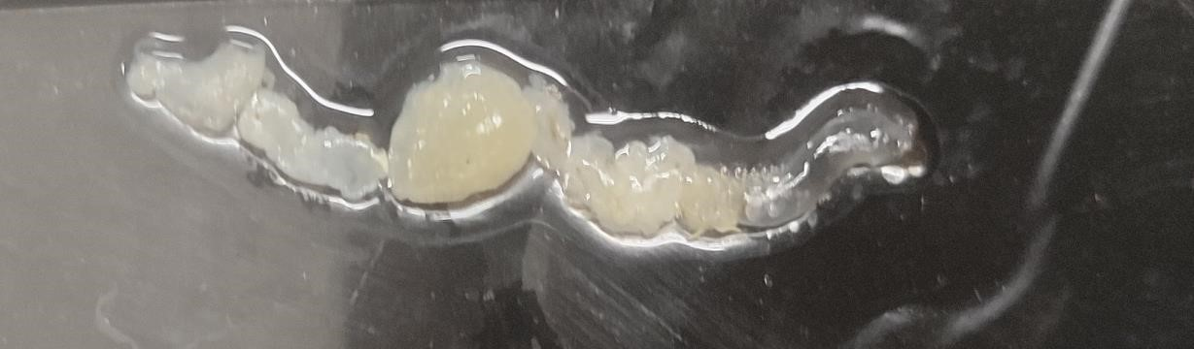
Fig 1: Gut sample of S. serrata

Isolation of Bacillus bacteria from the differential medium
Bacillus subtilis was confirmed by its growth on Bacillus differential medium. The colonies were dry, wrinkled yellow coloured colonies against the purple background of the medium (Fig 2).
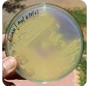

Fig 2: Growth of Bacillus subtilis bacteria on Bacillus differential medium
Table 1: Biochemical characterization of bacterial isolate from gut sample
S.No. | Test | Isolate-II (Bacillus subtilis)
1. | Gram’s staining | Gram positive rods arranged in chains
2. | Capsule staining | Positive
3. | Spore staining | Positive
4. | Indole test | Positive
5. | Voges-Proskauer test | Positive
6. | Methyl red test | Positive
7. | Triple sugar iron test | H₂S gas positive
8. | Nitrate reduction test | Positive
9. | Oxidase test | Positive
10. | Catalase test | Positive

Table 2: Carbohydrate test
S.No. | Sugar analysed | Isolate-II
1. | Dextrose | Positive
2. | Sucrose | Positive
3. | Maltose | Negative
4. | Lactose | Positive
5. | Fructose | Negative

Table 3: Amino acid decarboxylase test
S.No. | Sugar analyzed | Isolate-II
1. | Proline | Positive
2. | Lysine hydrochloride | Positive
3. | Arginine hydrochloride | Negative
4. | Ornithine hydrochloride | Negative
Based upon the growth on the selective medium, isolate-II as Bacillus subtilis.

PRODUCTION OF RIBOFLAVIN
Bacillus subtilis was cultured in riboflavin production medium (Fig 3).
Fig 3: Bacillus subtilis for Riboflavin production medium
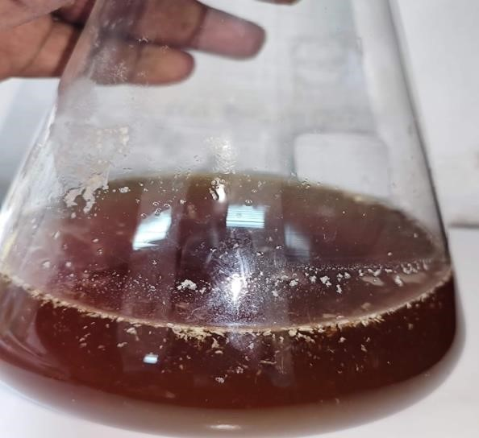

Confluence growth and positive for the
formation of Biofilm

Bacterial Growth
The sample media was removed from the conical flask, and the bacterial growth pattern was verified, in order to validate the medium composition to support bacterial growth and to confirm the products. At 630 nm, the absorbance of the bacterial cultures was measured, and a graph was created.


0
1
2
3
4
5
6
7
8
0
200
400
600
800
1000
1200
Isolate
-
2
Time duration,
minutes
Absorbance, nm
Fig 3a: Bacterial Growth Curve

Molecular Analysis
In order to confirm that both bacterium are not stressed, while culturing them in the formulated medium, the genomic DNA isolation and total RNA isolation were performed. The protein profiling was also performed.

Genomic DNA
If microbes do not experience stress, the genomic DNA is intact. The isolated genomic DNA by the

The CTAB method was electrophoresed in 1% Agarose gel. The bands clearly confirm that both the bacteria in the respective medium do not create any stress on the genomic DNA. The isolated DNA was profiled as a single linear band. The genomic DNA from the activated bacteria confirms there is an increase in the genotype of Bacillus subtilis (Fig. 4).

Fig 4: Isolation of the Total genomic DNA by CTAB method

Ln₁ Ln₂ Ln₃ Ln₄
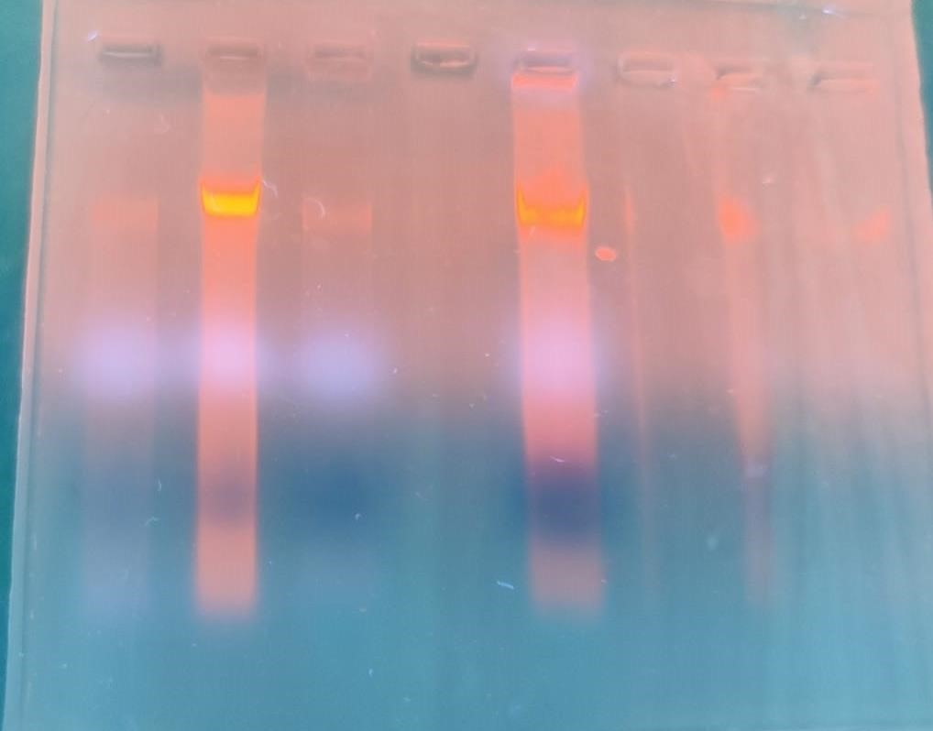
Ln_{1- 3:} Control genomic DNA extracted from Bacillus subtilis
Ln₂: Presences of unrestricted genomic DNA band from the microbes cultured in
Riboflavin production medium
Ln_{3:} Control genomic DNA extracted from

Molecular Analysis: Total RNA
When the bacterium expresses increased proteins, there is also an increase in the total RNA content. The total RNA extracted by using lithium chloride was electrophorised with 1% Agarose using MOPS buffer. The total RNA extracted from the bacteria Bacillus subtilis grown in the riboflavin production medium yielded more concentrated RNA (Fig. 5). This confirms that both the bacteria were well suited in the formulated medium and produced an increased concentration of riboflavin.

Fig.5: Total RNA
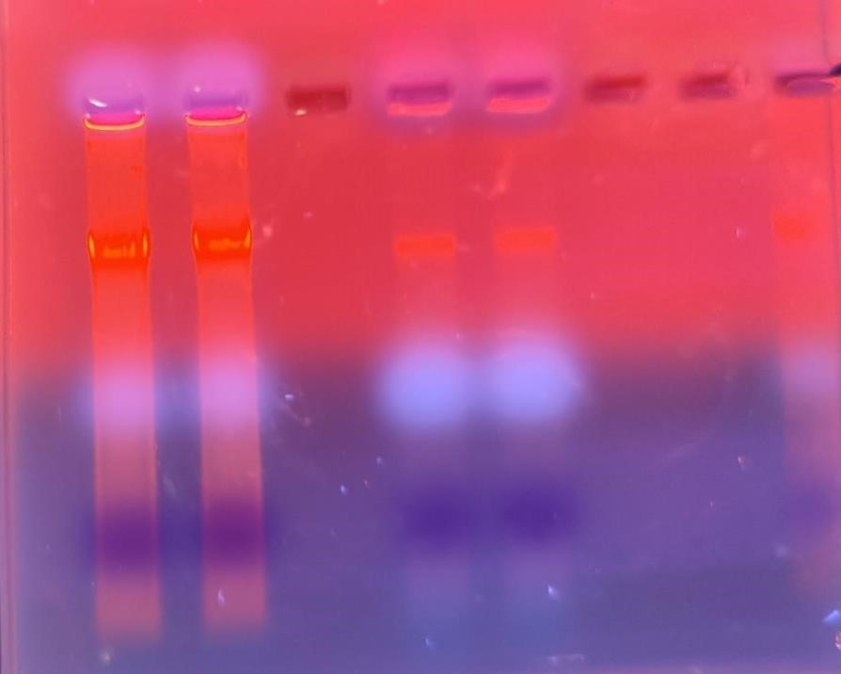

Ln
2

Ln
5

Ln₂: Presences of total RNA band from Bacillus subtilis- Riboflavin production medium
Ln₅: Total RNA from Control Bacillus subtilis

Molecular Analysis: Protein Profiling
The protein profiling of B. subtilis from the production medium exhibited an increase in protein expression by the individual cells (Fig. 6).
Fig.6: Protein Profiling by SDS-PAGE

Ln4 Ln6

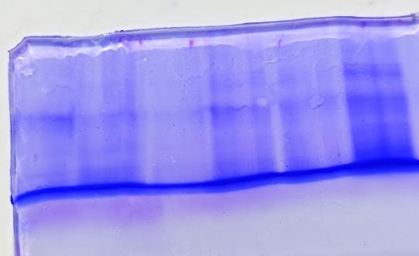

Ln₄: Protein profile of Control Bacillus subtilis
Ln₆: Protein profile of Bacillus subtilis from Riboflavin production medium

Detection of Folic Acid And Riboflavin By TLC
This confirms the medium composition supports the growth of Bacillus subtilis, and production of riboflavin was confirmed by thin-layer chromatography.
Fig.7: Thin Layer Chromatography for Folic Acid And Riboflavin
Detection of Riboflavin by TLC
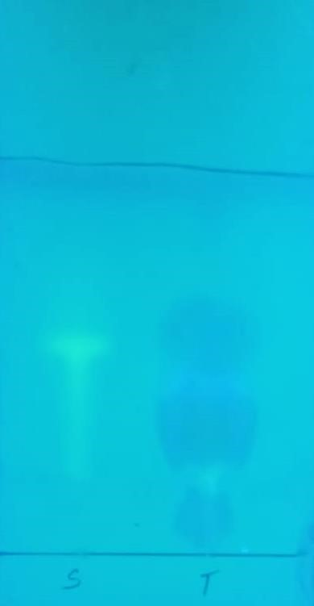

S: Standard Sample ; T: Test sample

Colorimetric Estimation
The total riboflavin was estimated colorimetrically as 15.96 µg/ ml (Table 4).
Table 4: Estimation of Riboflavin extracted from the production medium
S.No. | Concentration of extracted riboflavin, µg/ml
1. | 15.96 ± 0.06

HPLC Analyses of Riboflavin from the Production Medium
The quantification of riboflavin from the formulated respective medium was performed by colorimetric and by HPLC. The HPLC compound analyses confirm the presence of riboflavin extracted from the respective medium.
Fig 8: HPLC analysis of standard riboflavin
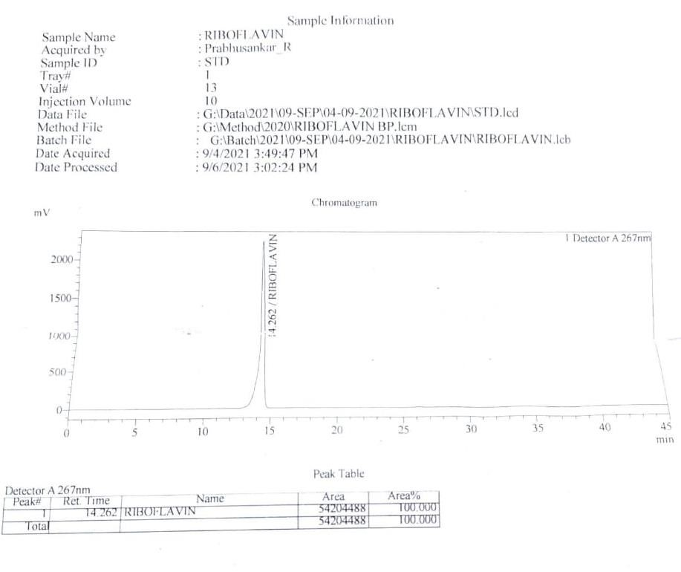

Fig 9: HPLC analysis of riboflavin extracted from the medium
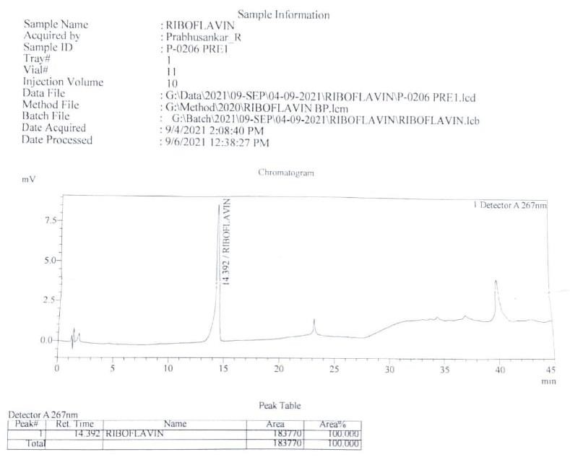

Antioxidant analysis by DPPH method
The antioxidant assay confirms that riboflavin has good antioxidant properties. The extracted riboflavin from the production reveals that the compounds have good antioxidant properties.
Table 5: Antioxidant Analysis
S.No. | Compounds | Antioxidant property, %
1. | Standard Riboflavin | 98.02 ± 0.03
2. | Extracted Riboflavin | 77.25 ± 0.7
Mean ± SE of 3 individual observations of each group; P-value of Group- A Vs B < *0.001, Group- A Vs C < ***0.05

EXPERIMENTAL FEED

6 mg of the compound was suspended in 10 ml of DMSO, and with this, the experimental feed was prepared (Fig.12a-c).

4.10: EXPERIMENTAL SET-UP FOR ANALYSING THE EFFECT OF FOLIC ACID AND RIBOFLAVIN
Oziotelphusa senex senex was used as the experimental animal to monitor the effect of both folic acid and riboflavin upon growth. Group I and Group II were fed with Commercial feed, Group III and Group IV crabs were fed with Riboflavin feed
Fig.10: Experimental Feed
(a.) Commercial Feed (b) Feed incorporated with extracted Riboflavin
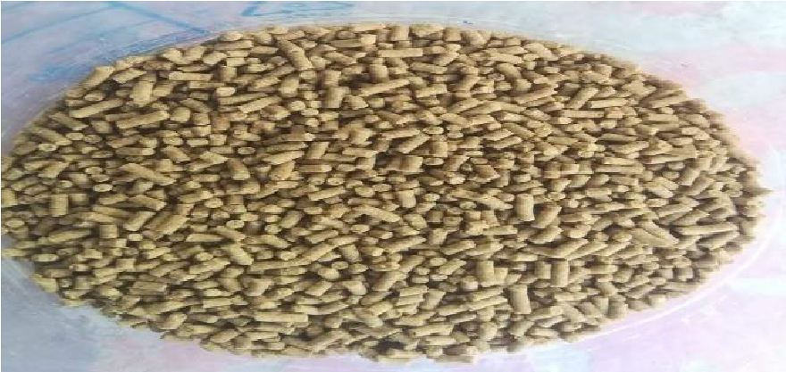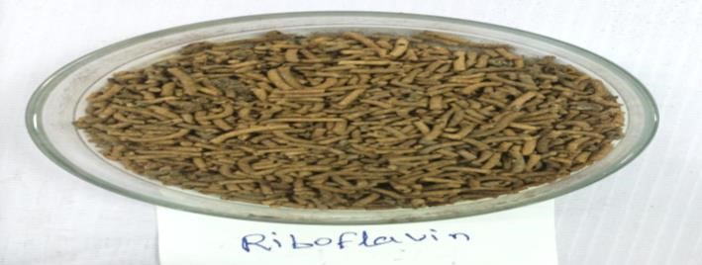
Fig.11: Experimental Animal: Oziotelphusa senex senex

(a.) Dorsal View (b.) Ventral View
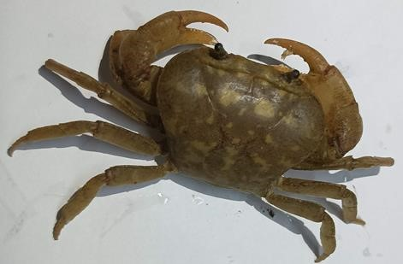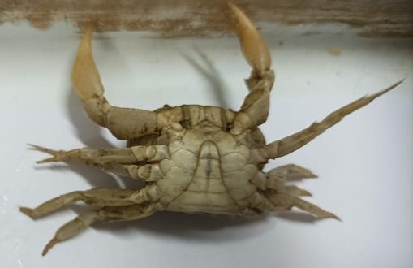
Oziotelphusa senex senex: Male crab

Fig.12: Experimental Design
Group-I | Group-II | Group-III | Group-IV
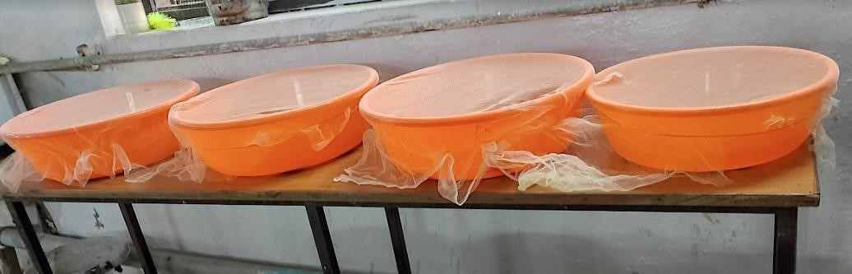
Group-1 and Group2: Control Crabs- Fed with commercial feed
Group-3 and Group-4: Crabs fed with Riboflavin feed

Morphological Analyses Experimental Animals
The length and weight of the experimental animals in all groups were recorded every 7th day for three weeks and were tabulated. It was estimated that the riboflavin-treated group of animals exhibited better weight and length increase when compared to the other experimental group of crabs. This also confirms that 0.6 mg of each of the extracted vitamins is a suitable concentration to promote growth among Oziotelphusa senex senex.

Table .6: Morphological analysis of Crab: length and weight
Experimental Group | 1 week |  | 2week |  | 3week
Group-1 | 2.9 ± 0.03 | 7.20 ± 0.26 | 2.9 ± 0.07 | 8.35 ± 0.02 | 2.9 ± 0.16 | 8.70 ± 0.06
Group-1 | 2.5 ± 0.02 | 6.34 ± 0.03 | 2.5 ± 0.04 | 6.62 ± 0.02 | 2.5 ± 0.11 | 6.96 ± 0.74
Group-1 | 1.8 ± 0.01 | 4.62 ± 0.01 | 1.8 ± 0.02 | 4.80 ± 0.05 | 1.8 ± 0.07 | 5.26 ± 0.06
Group-2 | 2.5 ± 0.08 | 6.45 ± 0.45 | 2.5 ± 0.09 | 6.86 ± 0.05 | 2.5 ± 0.97 | 7.24 ± 0.48
Group-2 | 2.4 ± 0.01 | 6.57 ± 0.03 | 2.4 ± 0.25 | 6.78 ± 0.4 | 2.4 ± 0.63 | 7.00 ± 0.44
Group-2 | 2.2 ± 0.05 | 5.74 ± 0.07 | 2.2 ± 0.07 | 5.86 ±0.14 | 2.2 ± 0.45 | 5.9 ± 0.08
Group-3 | 3.2 ± 0.01 | 10.6 ± 0.04 | 3.2 ±0.05 | 10.7 ± 0.05 | 3.2 ± 0.07 | 6.12 ± 0.02
Group-3 | 2.2 ± 0.02 | 5.62 ± 0.04 | 2.2 ± 0.03 | 5.82 ± 0.04 | 2.2 ± 0.04 | 6.24 ± 0.04
Group-3 | 2.3 ± 0.06 | 5.72 ± 0.14 | 2.3 ± 0.06 | 5.91 ± 0.14 | 2.3 ± 0.07 | 6.24 ± 0.08

Mean ± SE of 3 individual observations of each group; P-value of Group- A Vs B < *0.001, Group- A Vs C < ***0.05

Antibacterial Analysis

The antibacterial well diffusion test confirms that the riboflavin exhibits antibacterial activity against Streptococcus pyogenes.

Table 7: Bacterial growth inhibition with Riboflavin
S.No. | Volume of Sample, µl | Zone of inhibition with Standard Riboflavin, mm | Zone of inhibition with extracted Riboflavin, mm
1. | 10 | Nil | Nil
2. | 20 | Nil | 5
3. | 30 | Nil | 12
4. | 40 | 3 | 13
5. | 50 | 14 | 34

Analyses of Stress Parameters
The stress parameters such as glutathione-s-transferase, glutathione reductase, and it was examined that in all the experimental groups, there is no great different in the enzymatic stress parameters.
Table 8: Stress Parameters
Enzymatic Stress parameters: Glutathione-S-Transferase
S.No. | Experimental Groups | Concentration of enzyme (µg/ml)
1. | Control Group | 1.7 ± 0.56
2. | Riboflavin treated group | 2.06± 0.79
Mean ± SE of 3 individual observations of each group; P-value of Group- A Vs B < *0.001, Group- A Vs C < ***0.05

Fig 13: Enzymatic Stress parameters: Glutathione-S-Transferase

0
0.5
1
1.5
2
2.5
3
Control group
Riboflavin treated group
Concentration of enzyme

Enzymatic Stress parameters: Glutathione-Reductase
Table 9: Stress parameter- Glutathione-reductase
S.No. | Experimental Groups | Concentration of enzyme, µg/ml
1. | Control Group | 332.2 ± 2.03
2. | Riboflavin treated group | 389.7 ± 0.4
Mean ± SE of 3 individual observations of each group; P-value of Group- A Vs B < *0.001, Group- A Vs C < ***0.05
Fig 14: Enzymatic Stress parameters: Glutathione-Reductase

300
310
320
330
340
350
360
370
380
390
400
Control group
Riboflavin treated group
Conc. of enzyme
Mean ± SE of 3 individual observations of each group; P-value of Group- A Vs B < *0.001, Group- A Vs C < ***0.05

Non-Enzymatic Stress parameters: Reduced Glutathione
S.No. | Experimental Groups | Concentration of biomolecule, µg/ml
1. | Control Group | 5.3 ± 0.72
2. | Riboflavin treated group | 6.2 ± 0.51
Mean ± SE of 3 individual observations of each group; P-value of Group- A Vs B < *0.001, Group- A Vs C < ***0.05
Fig 15: Non- Enzymatic Stress parameters: Reduced Glutathione

0
1
2
3
4
5
6
7
8
Control group
Riboflavin treated group
Conc. of enzymes

ANALYSES OF BIOMOLECULES
The total protein, carbohydrates, and lipids confirmed that the riboflavin-treated group exhibited an increase in all the tested biomolecules.
Tab.9: Analysis of total Protein estimation
S.No. | Experimental Groups | Concentration of Protein, mg/ml
1. | Control Group | 6.8 ± 0.10
2. | Riboflavin treated group | 12.75 ± 0.27
Mean ± SE of 3 individual observations of each group; P-value of Group- A Vs B < *0.001, Group- A Vs C < ***0.05

Fig 16: Analysis of total Protein estimation


6.8
12.75
0
2
4
6
8
10
12
14
Control group
Riboflavin treated group
Conc. of protein

Table.10: Analysis of total Carbohydrate
S.No. | Experimental Groups | Concentration of Carbohydrate, mg/ml
1. | Control Group | 46.37 ± 0.49
2. | Riboflavin treated group | 72.27 ± 0.3
Mean ± SE of 3 individual observations of each group; P-value of Group- A Vs B < *0.001, Group- A
Vs C < ***0.05
Fig 17: Analysis of total Carbohydrate

0
10
20
30
40
50
60
70
80
Control group
Riboflavin treated group
Conc. of carbohydrate
Tab.11: Analysis of total Lipid
S.No. | Experimental Groups | Concentration of Lipid, mg/ml
1. | Control Group | 4.76 ± 0.58
2. | Riboflavin treated group | 8.76 ± 0.92
Mean ± SE of 3 individual observations of each group; P-value of Group- A Vs B < *0.001, Group- A Vs C < ***0.05
Fig 18: Analysis of Total Lipid

0
2
4
6
8
10
12
Control group
Riboflavin treated group
Conc. of lipid
Among the group-III and group-IV animals, riboflavin concentration was found to the good, when compared with the other groups.

TOTAL BACTERIAL COUNT FROM HEMOLYMPH
The riboflavin-fed experimental group of animals exhibited a slight increase in the immune response, and the riboflavin-treated groups showed reduced bacterial count.

Tab. 13: Total bacterial count from the hemolymph
S.No. | Experimental Groups | Bacterial Colonies, CFU/ µl of hemolymph
1. | Control Group | 356. 83± 0.32
2. | Riboflavin treated group | 185.51 ± 0.81
Mean ± SE of 3 individual observations of each group; P-value of Group- A Vs B < *0.001, Group- A Vs C < ***0.05
Fig 19: Total bacterial count from the hemolymph

0
50
100
150
200
250
300
350
400
Control group
Riboflavin treated group
Bacterial colonies

HISTOLOGICAL STUDY OF MUSCLE FIBERS
The histology of the experimental animals exhibited good muscle fibers in the riboflavin-treated group.

Fig.20: Histology of muscle fibers

(a) Control sample: Muscle fibers (b) Riboflavin treated experimental
animal muscle fibers
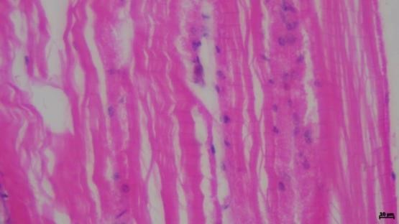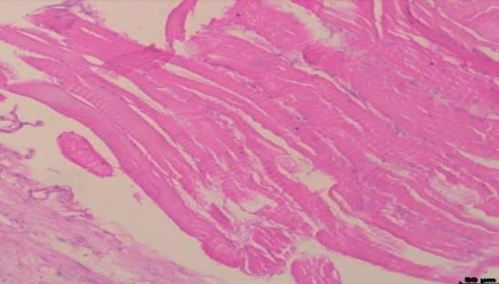

Analyses of vitamins from muscle tissue of Oziotelphusa senex senex
As the experimental animal is fed with the formulated feed fortified with riboflavin, the nutrients were extracted from all the experimental groups. .
Tab. 14: Estimation of Vitamins from the Muscle extract of experimental animal
S.No. | Experimental Groups | Concentration of  Riboflavin, mg/mg of muscle tissue extract
1. | Control Group | 0.12 mg
2. | Riboflavin treated group | 0.4 mg
Mean ± SE of 3 individual observations of each group; P-value of Group- A Vs B < *0.001, Group- A Vs C < ***0.05
Discussion
The Scylla genus includes the mud crabs, which are significant commercially. Scylla serrata, a kind of mangrove crab found in the Indo-West Pacific, is a highly commercialised species. The most significant aquatic species for commerce and a key component of local fisheries are mud crabs. One of the most studied aquatic animals is this one. It is commonly known that this species can thrive in the habitats of coastal ecosystems, estuaries, and rivers. Numerous studies have been conducted on a global scale to better understand how animals adapt to their environments and the role that ecosystems play in animal survival. These studies have aided aquaculture farmers in their efforts to cultivate animals with significant economic value (Dennison et al., 2007; Pascoe et al., 2016; McIntosh et al., 2019; Logan et al., 2020).
Crustaceans, particularly those that are edible like lobster, crab, prawns, and crayfish, are regarded as the main source of alternative nutrition. The crustacean feed's molecular makeup includes physiologically significant macromolecules, including protein, amino acids, lipid, fatty acids, carbohydrate, vitamins, and minerals, which increase animal survival and cause weight gain. The human population consumes the freshwater crabs that are present in different regions of India based on their geographic location. But as environmental toxicity has increased, the crab population has shrunk. When ingested, those that are readily available do not support physiology (Das et al., 2015).
According to Ramamoorthy et al.'s 2016 study, C. reversendersoni has the highest concentration of essential fatty acids, with 9.13 g/100g in the meat of C. lucifera. The monosaturated fatty acid content of C. lucifera is very high. According to a mineral examination of the meat of the freshwater crab Potamon potaminos, the female crab has an excellent concentration of chitin and the greatest quantity of sodium and potassium (Bilgin et al., 2011). The meat of the crabs is a rich source of enzymes, bioactive substances, such as vital lipids, carotenoids, which are turned to pharmaceutical and medicinal relevance, and the crab exoskeleton is an excellent source of chitin, which may subsequently be converted into chitosan (Pramod et al., 2021).
Probiotics are live bacteria that, at certain quantities, improve the gut microbial balance and benefit human health (Araya et al., 2002). In addition, they promote host immunity, compete with harmful bacteria for nutrients and adhesion receptors, and prevent pathogenic bacteria from colonising the digestive system (Tannock et al., 1999). As probiotics, several species of Lactobacillus, Lactococcus,
Streptococcus, Bacillus, Bifidobacterium, Enterococcus, Lactobacillus, and Saccharomyces cerevisiae have been employed. In the marine environment, titanium alloys are prone to biofouling and bacterial attachment because of their biocompatibility characteristics (Arroussi et al., 2024). S. oneidensis MR-1 also offers great opportunities, such as the easy genetic manipulation in this bacterium and corrosion inhibition capability. It will also be of significance to evaluate and understand the corrosion mechanisms of mixed microbial communities, including direct interspecies electron transfer (DIET) and mediated interspecies electron transfer (MIET) (Arroussi et al.,2025).
The Bacillus genus comprises enzymatic and metabolic compounds that may be beneficial. In contrast to the more common probiotic species, they are resistant microbes that may live in a range of food items as endospore formers (Schultz et al., 2017). The Bacillus species that produce spores that have been the subject of the most extensive research are B. subtilis, B. licheniformis, B. clausii, B. coagulans, and B. cereus (Shahcheraghi et al., 2015). Only two Bacillus species—B. Coagulans and B. subtilis var. natto have been widely recognised as acceptable probiotics for human ingestion out of hundreds of Bacillus species. Each of these species' positive traits is looked at separately. B. coagulans was referred to as a helper for the absorption and utilisation of proteins, while B. Subtilis var. natto was thought to boost the immune system, possess anti-cancer characteristics, and create vitamin K2 (Jager et al., 2018).
Riboflavin is essential for the production of many flavins, which are known as energy carriers and are used in the metabolism of proteins, lipids, and carbohydrates. Healthy skin and strong vision are two benefits of riboflavin. According to some reports, riboflavin aids in the conversion of the amino acid tryptophan into niacin. Additionally, riboflavin is known to enhance the utilisation and absorption of iron.
According to a research, exposure to UVA and riboflavin completely eliminated the colony forming units (CFU) of S. aureus, P. aeruginosa, and S. epidermis grown on blood/hematin-agar plates. The researchers also came to the conclusion that increasing the UVA dose and using riboflavin in addition to it had more antibacterial effects than UVA alone (Maharana et al., 2016). Attachment of bacteria on surface of 2205 DSS is determined by the sensing ability of bacteria as well as physico-chemical characteristics of surface. Similar to this, an in vitro study found that the combination of UVA and riboflavin had antibacterial action against a wide range of bacteria, including S. aureus, methicillinresistant S. aureus (MRSA), and P. aeruginosa (Schrier et al., 2009). According to research utilising the Kirby-Bauer technique, UVA/riboflavin was effective against S. aureus, P. aeruginosa, and S. epidermis, MRSA, multidrug-resistant P. aeruginosa (MDRPA), and drug-resistant Streptococcus pneumonia (DRSP) (Martins et al., 2008).
Riboflavin has a reputation for being an antioxidant. This may have been the cause of the reduction of stress indicators in the riboflavin-treated experimental animal Oziotelphusa senex senex, including glutathione-s-transferase, glutathione reductase, reduced glutathione, and decreased bacterial count. Riboflavin was extracted and measured from crab muscle tissue, which further supports the existence of a good concentration of both riboflavin and folic acid. This study unequivocally establishes that riboflavin-fed animals are a reliable source of riboflavin and are therefore suitable for use as biofortified foods.

Disclaimer (Artificial intelligence)
Author(s) hereby declare that NO generative AI technologies such as Large Language Models (ChatGPT, COPILOT, etc.) and text-to-image generators have been used during the writing or editing of this manuscript.
Conclusion:
The findings of this study indicate a significant positive impact of riboflavin enrichment in crabs. Overall, the crabs exhibited better stress tolerance, elevated levels of essential nutrients like proteins, carbohydrates, and lipids, and strengthened immune responses. A concurrent reduction in harmful bacteria and improvement of muscle structure were also observed. Collectively, these results highlight that biofortifying food sources like crabs with important micronutrients such as riboflavin could be a natural and effective way to tackle micronutrient deficiencies and related health issues.
References:
Ahmed, T.; Hossain, M.; Sanin, K.I. (2012), Global burden of maternal and child undernutrition and micronutrient deficiencies. Ann. Nutr. Metab., 61, 8–17.
Araya M, Morelli L, Reid G, Sanders ME, Stanton C. (2002), Joint FAO/WHO Working Group Report on Guidelines for the Evaluation of Probiotics in Food London, Ontario, 2002.
Arroussi, M., Jia, Q., Zhao, J., Xia, Z., Bai, C., & Yang, K. (2024). Modification of passive film on Ti–
6Al–4V alloy induced by Bacillus vietnamensis. Materials Chemistry and Physics, 313, 128679.
Arroussi, M., Yang, K., Shams, A., Toor, I. U. H., & Wei, B. (2025). Advances in microbial corrosion of metals induced via extracellular electron transfer by Shewanella oneidensis MR-1. npj Materials Degradation, 9(1), 47.
Arroussi, M., Wu, J., Zhu, L., Wang, P., Zhang, D., & Wang, W. (2025). Effect of preferential growth of Shewanella oneidensis MR-1 on microbial corrosion of constituent phases of 2205 duplex stainless steel. Bioelectrochemistry, 163, 108859.
Bailey, R.L.; West, K.P., Jr.; Black, R.E. (2015), The epidemiology of global micronutrient deficiencies. Ann. Nutr. Metab., 66, 2233.
Bilgin, Şengül & Fidanbaş, Zeliha. (2011). Nutritional properties of crab (Potamon potamios Olivier, 1804) in the Lake of Eǧirdir (Turkey). Pakistan Veterinary Journal. 31. 239-243
Bitsch, RolandandBitsch, Irmgard. HPLC Determination of Riboflavin in Fortified Foods. Fortified Foods with Vitamins, (2011): 103 - 110, Edition: first, Chapter: 7, Publisher: WILEY-VHC Verlag GmbH & Co. KGaA
Chomczynski, P., & Sacchi, N. (1987). Single-step method of RNA isolation by acid guanidinium thiocyanate-phenol-chloroform extraction. Analytical biochemistry, 162(1), 156-159.
Clara Kielkopf, William Bauer, Ina Urbatsch, L. (2021). Sodium Dodecyl Sulphate-polyacrlamide gel electrophoresis of protein. Cold Spring Harb.Proctoc, (2021); 12, doi: 10.1101/pdb.prot102228.
Das Mohua, Kundu Jayanta and Misra, Kamales kumar. Nutritional aspect of crustaceans especially freshwater crabs of India. International journal of advanced research in biological science., (2015), 2. 7-19
Dennison, W.C., Lookingbill, T.R., Carruthers, T.J.B.., Hawkey, J.M. and Carter,A. “An Eye-Opening
Approach to Developing and Communicating Integrated Environmental
Assessments.” Frontiers in Ecology and the Environment, (2015), 5 (6): 307–314
FAO. (2013), The State of Food and Agriculture; Food and Agriculture Organization: Rome, Italy.
Jager R, Purpura M, Farmer S, Cash HA, Keller D (2018), Probiotic Bacillus coagulans GBI-30, 6086 improves protein absorption and utilization. Probiotics Antimicrob Proteins; 10: 611–615
Logan, M., Z. Hu, R. Brinkman, S. Sun, X. Sun, and B. Schaffelke. “Ecosystem Health Report Cards:
An Overview of Frameworks and Analytical Methodologies.” Ecological Indicators, (2020); 113: 105834.
Lowry, O. H., Rosebrough, N. J., Farr, A. L. and Randall, R. J. (1951) Protein measurement With the FolinPhenol reagent. J. Biol. Chem. 193: 265- 275.
Maharana P.K., Sharma N., Nagpal R., Jhanji V., Das S., Vajpayee R.B. (2016), Recent advances in diagnosis and management of Mycotic Keratitis. Indian journal of ophthalmology;64(5):34.
Martins S.A.R., Combs J.C., Noguera G., Camacho W., Wittmann P., Walther R., Behrens A. (2008), Antimicrobial efficacy of riboflavin/UVA combination (365 nm) in vitro for bacterial and fungal isolates: a potential new treatment for infectious keratitis. Investigative ophthalmology & visual science;49(8):3402–3408.
McIntosh, E.J., Rolfe,J., Pinto, U., Kirkwood,J., Greenlee, M and Poiner. I, R. “Designing Report Cards for Aquatic Health with a Whole-of-System Approach: Gladstone Harbour in the Great Barrier Reef.” Ecological Indicators, (2019); 102: 623–632.
Pascoe, S., Tobin, R., Windle, J., Cannard, T., Marshall, N., Kabir, Z. and Flint, Z. “Developing a
Social, Cultural and Economic Report Card for a Regional Industrial Harbour.” PLoS ONE, (2016); 11 (2): e0148271.
Pramod Kumar Nanda Arun, K., Das Premanshu Dandapat, Pubali Dhar, Samiran Bandyopadhyay, Amira Leila Dib, José Lorenzo, M. and Mohammed Gagaoua. Nutritional aspects, flavour profile and health benefits of crab meat based novel food products and valorisation of processing waste to wealth: A review. Trends in Food Science and technology, (2021); Vol.112: 252-267
Ronald Bartzatt and Tasloach Wol, "Detection and Assay of Vitamin B-2 (Riboflavin) in Alkaline Borate Buffer with UV/Visible Spectrophotometry", International Scholarly Research Notices, Vol. 2014: 1-7
Schrier A., Greebel G., Attia H., Trokel S., Smith E.F. (2009), In vitro antimicrobial efficacy of riboflavin and ultraviolet light on Staphylococcus aureus, methicillin-resistant Staphylococcus aureus, and Pseudomonas aeruginosa. Journal of refractive surgery;25(9)
Schultz M, Burton JP, Chanyi RM. (2017). Chapter 11-Use of Bacillus in human intestinal probiotic applications. In: Floch MH, Rngel Y, Walker WA. (ed) The Microbiota in Gastrointestinal Pathophysiology, 1st edn Elsevier, Amsterdam, pp 119–123
Shahcheraghi SH, Ayatollahi J, Lotfi M. (2015), Applications of Bacillus subtilis as an important bacterium in medical sciences and human life. Trop J Med Res; 18: 1–4.
Sivasubramanian, K., Ravichandran, S., & Rajan, D. K. (2017). Isolation of gut associated bacteria from mangrove crabs collected from different mangrove regions of Tamil Nadu, South east coast of India. African Journal of Microbiology Research, 11(14), 586-595.
Suwannasom, N., Kao, I., Pruß, A., Georgieva, R., & Bäumler, H. (2020). Riboflavin: The Health Benefits of a Forgotten Natural Vitamin. International Journal of Molecular Sciences, 21(3). https://doi.org/10.3390/ijms21030950
Suwannasom, N., Kao, I.,Prub, A., Georgieva, R. and Bäumler, H. (2020), Riboflavin: The Health benefits of a forgotten natural vitamin. Int. J. Mol. Sci.,; (21): 950.
Tannock GW. (1999). Probiotics: a critical review. Horizon Scientific Press, Norfolk, United Kingdom
Van Der Straeten, D., Bhullar, N.K., De Steur, H., Gruissem, W., MacKenzie, D., Pfeiffer, W., Qaim, M., Slamet-Loedin, I. and Strobbe Sand Tohme, J (2020), Multiplying the efficiency and impact of biofortification through metabolic engineering. Nat. Commun. (2020); 11: 5203.
Waters, B.M.; Grusak, M.A. (2008), Quantitative trait locus mapping for seed mineral concentrations in two Arabidopsis thaliana recombinant inbred populations. New Phytol., 179, 1033–1047.
William, S., Feil, H., & Copeland, A. (2012). Bacterial genomic DNA isolation using CTAB. Sigma, 50(6876).

