New distributional record of Two Sponges along the Gulf of Kachchh, West Coast of India
Abstract:
The current study reports range extensions of marine sponges to the Indian subcontinent and within it. Stelletta clavosa (Ridley, 1884) is being reported from the Gulf of Kachchh for the first time. Dragmacidon coccineum (Keller, 1891) is being reported to the Indian subcontinent for the first time. The animals were collected by SCUBA diving. The spicules and skeletal structures of the animal were analysed to identify the species. A regional checklist of marine sponges from the Gulf of Kachchh region (formerly known as the Kathiawar or Kathiawad region) has been included as a supplement to the paper, highlighting the importance of new records and distributional records that contribute to the nation's biodiversity.
Keywords:
Stelletta clavosa, Gulf of Kachchh, India, New Distributional Record, Dragmacidon coccineum,Lakshadweep Islands.
Introduction:
Marine sponges (Phylum Porifera) are ancient, ecologically vital filter-feeders that enhance water quality, support nutrient cycling, and provide habitat for diverse marine life. With over 9,600 described species (de Voogd et al., 2025), their role as bioindicators (Mohammed et al., 2023) and sources of bioactive compounds makes them both ecologically and biotechnologically important; yet, they remain understudied, with few conservation assessments (Hooper & Van Soest, 2002).
India’s vast coastline and EEZ host over 100 marine sponge species, with additional freshwater endemics (George et al., 2020; Saxena, 2021). Regions like the Gulf of Kachchh and Lakshadweep have rich sponge diversity, documented since early surveys by Dendy and others. However, threats such as pollution, sedimentation, and coral bleaching (Hoegh-Guldberg et al., 2023) are impacting these fragile ecosystems. While conservation strategies like the erection of biodiversity hotspots, declaration of biodiversity reserves, and implementing the Wildlife Protection Amendment Act, 2022 are in full swing, grassroots-level conservation is yet to be set in place. Raising awareness amidst fisherman to prevent trawling, that severely impacts not only marine sponge diversity but also other flora and fauna, especially in reef ecosystems like the Gulf of Kachchh.
Research in India has largely focused on taxonomy, with limited ecological or conservation studies (Sabapara & Poriya, 2024). While molecular tools are emerging, classical taxonomy remains crucial for accurate identification and uncovering cryptic diversity (Lukowiak, 2020).
Materials and Method
Sponge specimens were collected during two separate marine surveys: the first in the Gulf of Kachchh, Gujarat (Latitude: N22°27’22.66’’, Longitude: E69°40’33.87’’) on 18 December 2022, and the second at Androth Island, Lakshadweep (Latitude: 10°49.931'N, Longitude: 73°41.235'E) in October 2019. Specimens were photographed in situ before collection via hand-picking (Gulf of Kachchh) and SCUBA diving (Lakshadweep) at depths of 10–30 meters. Post-collection, Gulf of Kachchh specimens were preserved in wet conditions using 30% formalin, while Lakshadweep samples were preserved in shadow drying conditions for transport. The shadow drying process in sponges refers to a drying technique where sponges are dried in the shade rather than using direct sun or high-temperature air drying. This approach is used to better preserve the structural and biochemical properties of the material. Taxonomic identification followed standardized protocols for sponge morphology, emphasizing on spicule architecture and skeletal organization as per Keller (1891) and Hooper & Van Soest (2002), with species validity cross-referenced against the World Porifera Database (WPD) and World Register of Marine Species (WoRMS) (de Voogd et al., 2025). For skeletal analysis, 0.1 cm-thick sections were dehydrated in xylene and mounted on micro-slides using DPX medium. Spicule isolation involved dissolving sponge tissue in nitric acid to liberate diagnostic spicules. Light microscopy (Nikon Eclipse 50i compound microscope) facilitated spicule imaging and morphometry; for each spicule type, 25 individual spicules were measured (dimensions recorded in mm/µm), with skeletal structures documented using scale-bar-referenced photomicrographs. Voucher specimens were deposited in the National Zoological Collections of the Marine Biology Regional Centre, Zoological Survey of India (MBRC/ZSI), Chennai, with assigned registration numbers (Reg.No: S.634 - Stelletta clavosa) (Reg.No: S.408 - Dragmacidon coccineum) catalogued for future reference.

Systematic accounts:
Phylum Porifera (Grant, 1836)
Class Demospongiae (Sollas, 1885)
Subclass Heteroscleromorpha (Cárdenas, Pérez and Boury-Esnault, 2012)
Order Tetractinellida (Marshall, 1876)
Suborder Astrophorina (Sollas, 1887)
Family Ancorinidae (Schmidt, 1870)
Genus Stelletta (Schmidt, 1862)
Species Stelletta clavosa (Ridley, 1884)

Synonymized names:
Myriaster clavosa (Ridley, 1884); Myriaster quadrata Sollas, 1886; Myriaster toxodonta; Myriastra clavosa (Ridley, 1884); Myriastra clavosa var. quadrata Sollas, 1886; Myriastra quadrata Sollas, 1886;
Myriastra toxodonta Sollas, 1886.

Materials examined:
Registration Number: MBRC/ZSI/S.634 entire specimen, slides of spicules, Locality: Narara, Gulf Kachchh (Lat.: N22°27’22.66’’ E 069°40’33.87’’), (Fig.1); Date of collection: 18.12.2022. Collected by: Sivaleela & Party.
Description:
Sponge spherical or hemispherical, and growth form is branched to club-shaped, 2-3 cm in height. Color, light grey in the spot. Consistency, hard and incompressible. The surface is hispid due to the presence of Spicules. Projecting from the interior. The original lacks any additional details. Table 2: A comparison of Stelletta species found in India (has been drawn to better understand the status of the genera in the country).

Spicules:
Fig.3(A-H): (I) Dichotriaenes. Shaft, 0.9 x 0.052 mm; chord, 0.46 mm. (2) Protriaenes. Shaft long; clads up to 0.05 mm. These spikes project out of the face considerably. (3) Anatriaenes. Clads up to 0.1 mm. (4) Oxea - Size: 0.54 x 0.017 mm. (5) Asters. Rays conical; diameter up to 0.018 mm. Fig.2.Preserved specimen (Wet preservation); In situ specimen.
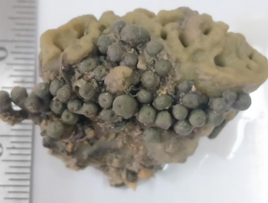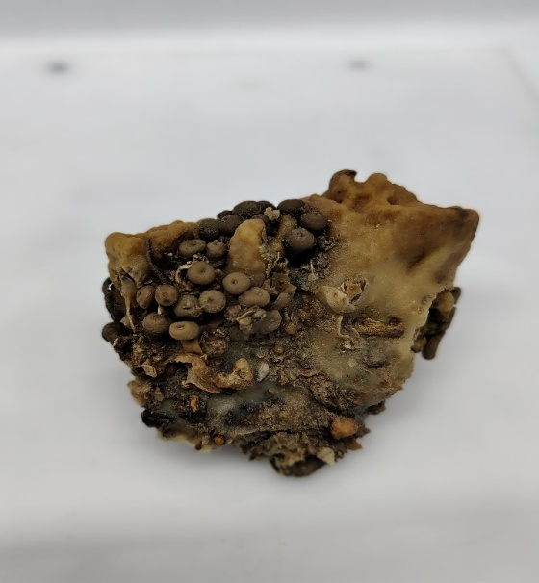
Figure.1. Stellata clavosa (ex situ) Figure.2.Stellata clavosa (wet preservation)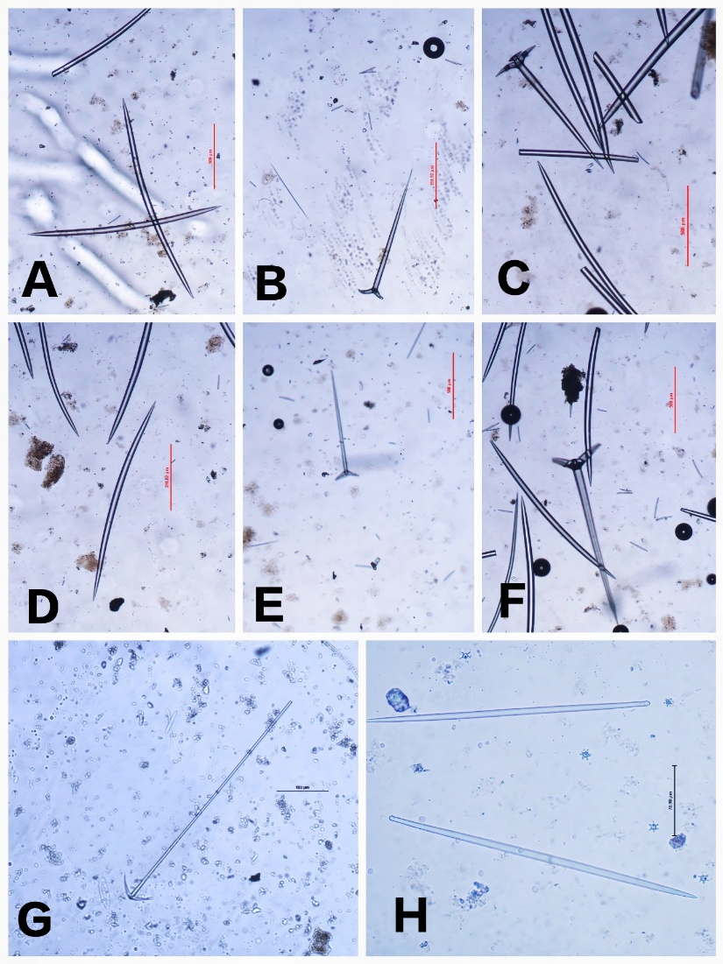
Figure.3. A, D - Oxea; B, E- Dichotriaenes; C, F- Oxea and Dichotriaenes; G - Anatriaenes; H- Asters and Oxea

Systematic accounts:
Phylum Porifera (Grant, 1836)
Class Demospongiae (Sollas, 1885)
Subclass Heteroscleromorpha (Cárdenas, Pérez and Boury-Esnault, 2012)
Order Axinellida (Lévi, 1953)
Family Axinellidae (Carter, 1875)
Genus Dragmacidon (Hallmann, 1917)
Species Dragmacidon coccineum (Keller, 1891)

Synonyms:
Hymeniacidon coccineum (Keller, 1891); -Pseudaxinella coccinea Keller, 1891;- Reniera coccineum Keller, 1891); Stylissa coccinea (Keller, 1891)

Materials examined: Registration Number: MBRC/ZSI/S.340/01, entire specimen, dry. Plus slides of spicules, Locality: Androth Island (Lat: 10°49.931'N, Long: 73°41.235'E), Lakshadweep Archipelago, Arabian Sea (Fig. 1A- D); Date of collection: 22.10.2019. Collected by: Tamal Mondal, SCUBA diving.

Description:
The studied specimen (Fig.4.A) has a growth form that is encrusting to branched and club-shaped, 2-5 cm in height. Colour orange or red when alive and dark red to violet after drying. The texture is soft and compressible when alive, with a mucous surface and tough after drying. The surface is irregular, with short conules or tubercles. Oscules are slightly elevated, circular, and wide. The choanosomal skeleton (Fig.4.B-D) is a plumoreticulate network (with rounded meshes) interconnected by secondary multi-spicular tracts. It consists of radiate spiculate fibers connected by loose spicules. Thickly encrusting species, a surface covered in tubercles, an ectosome lacking a specific skeleton, and a skeleton that has not been separated into an axial or extra-axial region are among them. The skeleton is composed of thick, multispicular fibers that combine to form irregular or oval meshes with a diameter ranging from 100 to 400 µm. 1-3 spicules are connecting the thick primary fibers, which range in thickness from 50 to 150 µm. Megascleres are styles. Table 1: A comparison of Dragmacidon species found in India (has been drawn to better understand the status of the genera in the country).

Spicules:
Megascleres are smooth styles 300 μm in length, slightly curved, with a proximal blunt end and a distal. Sharply pointed end. (Figs.4.E and F). Megascleres are smooth styles, 0.3–0.32 mm in length, slightly curved, with a proximal blunt end and a distal point. Microscales are absent.

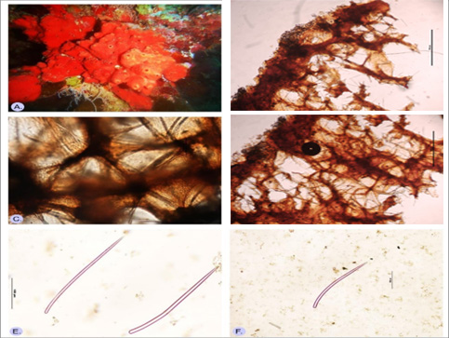
Figure.4. Dragmacidon coccineum (Keller, 1891) from Androth Island, Lakshadweep Archipelago; A - red to orange studied specimen inhabiting the coral reef; B, C, D- Skeletal network of styles arranged E , F - Skeletal spicules as smooth styles of variable length

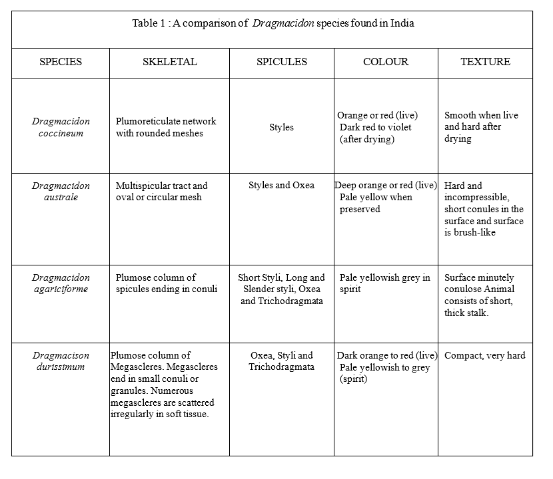

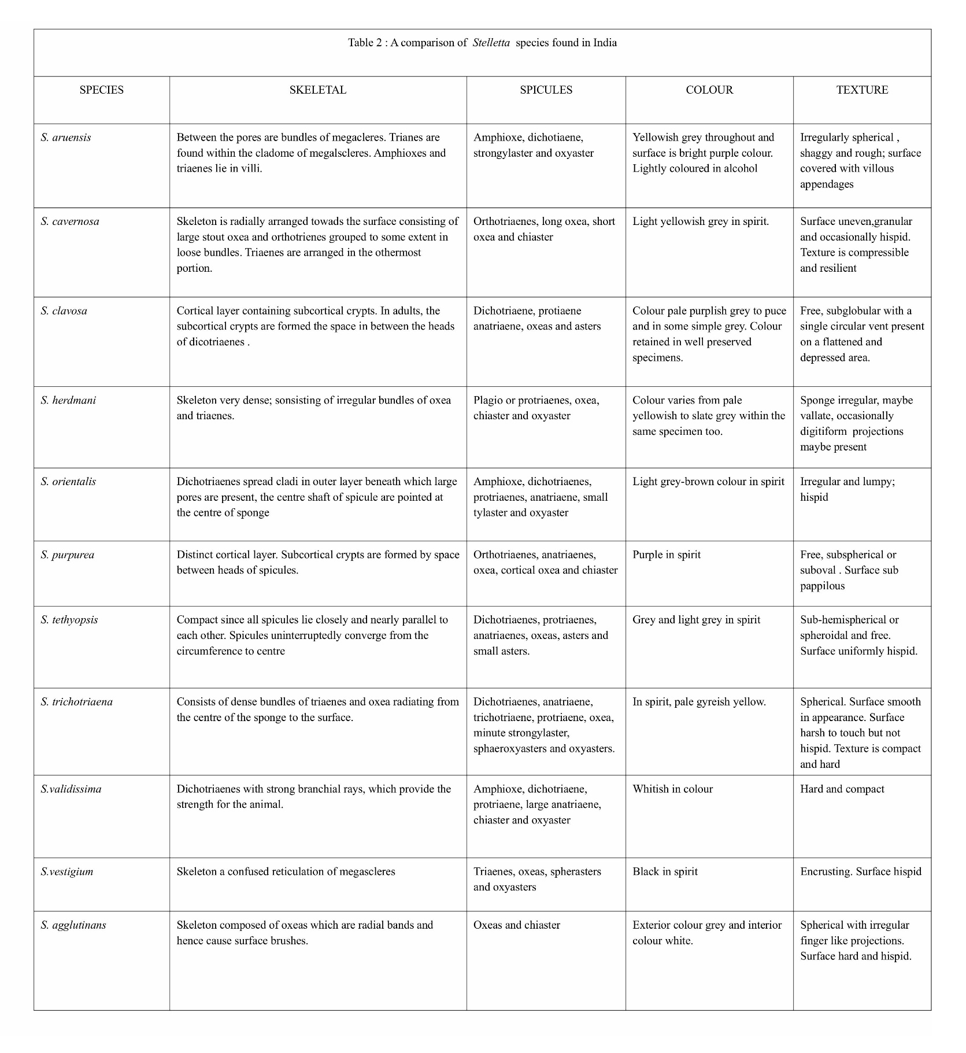

Check List of Marine Sponges from Gujarat:
In the British period, the present-day Gujarat was originally called the Kathiawar peninsula. It is also known as Sourashtra. The modern borders came into existence when the princely states of Kathiawad and Bombay were merged and then separated again based on linguistic grounds into Gujarat and Maharashtra.
A total of 124 species belonging to 72 genera, 47 families, and 17 orders were found to be in the checklist of marine sponges of Gujarat.
Order: Axinellida
Family: Axinellidae
- Axinella donnani (Bowerbank, 1873)
Family: Raspailiidae
- Endectyon (Endectyon) fruticosum (Dendy, 1887)
- Raspailia (Clathriodendron) arbuscula (Lendenfeld, 1888)
- Thrinacophora cervicornis Ridley & Dendy, 1886
Family: Stelligeridae
- Higginsia Higgins, 1877
Order: Biemnida
Family: Biemnidae
- Biemna fortis (Topsent, 1897)
- Biemna tubulata (Dendy, 1905)
Order: Bubarida
Family: Bubaridae
- Auletta aurantiaca Dendy, 1889
- Auletta elongata Dendy, 1905
- Phakellia radiata (Dendy, 1916)
Family: Dictyonellidae
- Phakettia virgultosa (Carter, 1887)
- Acanthella cavernosa Dendy, 1922
- Acanthella ramosa Kumar, 1925

Order: Chondrillida
Family: Chondrillidae
- Chondrilla mixta Schulze, 1877
- Chondrilla australiensis Carter, 1873
Order: Clathrinida
Family: Clathrinidae
- Clathrina coriacea (Montagu, 1814)
Order: Clionaida
Family: Clionaidae
- Cliona viridis (Schmidt, 1862)
- Cliona celata Grant, 1826
- Cliona varians (Duchassaing & Michelotti, 1864)
- Spheciospongia vagabunda (Ridley, 1884)
- Cliothosa aurivillii (Lindgren, 1897)
- Pione vastifica (Hancock, 1849)
Family: Placospongiidae
- Placospongia melobesioides Gray, 1867
- Placospongia carinata (Bowerbank, 1858)
Family: Spirastrellidae
- Spirastrella coccinea (Duchassaing & Michelotti, 1864)
Order: Dendroceratida
Family: Darwinellidae
- Darwinella australiensis Carter, 1885
Family: Dictyodendrillidae
- Spongionella retiara (Dendy, 1916)
Order: Dictyoceratida
Family: Dysideidae
- Dysidea tupha (Pallas, 1766)
- Dysidea avara (Schmidt, 1862)
- Dysidea granulosa Bergquist, 1965
- Dysidea cinerea Keller, 1889
- Dysidea fragilis (Montagu, 1814)
Family: Spongiidae
- Hippospongia spp. Schulze, 1879
- Hyattella tubaria Lendenfeld, 1889
- Hyattella intestinalis (Lamarck, 1814)
Order: Haplosclerida
Family: Callyspongiidae
- Callyspongia (Cladochalina) aculeata (Linnaeus, 1759)
- Callyspongia (Cladochalina) diffusa (Ridley, 1884)
- Callyspongia crassifibra (Dendy, 1889)
Family: Chalinidae
- Haliclona (Gellius) ridleyi (Hentschel, 1912)
- Haliclona (Soestella) hornelli (Dendy, 1916)
- Haliclona (Reniera) cinerea (Grant, 1826)
- Haliclona (Gellius) cymaeformis (Esper, 1806)
- Haliclona (Reniera) fascigera (Hentschel, 1912)
- Haliclona (Soestella) hornelli (Dendy, 1916)
- Haliclona pacifica Hooper in Hooper & Wiedenmayer, 1994
- Haliclona semifibrosa (Dendy, 1916)
- Haliclona (Gellius) fibulata (Schmidt, 1862)
- Haliclona (Haliclona) oculata (Linnaeus, 1759)
- Haliclona (Reniera) tubifera (George & Wilson, 1919)
- Haliclona (Reniera) topsenti (Thiele, 1905)
Family: Niphatidae
- Gelliodes fibroreticulata (Dendy, 1916)
- Amphimedon viridis Duchassaing & Michelotti, 1864
- Gelliodes fibrosa Dendy, 1905
- Gelliodes petrosioides Dendy, 1905
Family: Petrosiidae
- Neopetrosia chaliniformis (Thiele, 1899)
- Neopetrosia similis (Ridley & Dendy, 1886)
Family: Phloeodictyidae
- Siphonodictyon minutum (Thomas, 1972)
Order: Homosclerophorida
Family: Plakinidae
- Plakina monolopha Schulze, 1880
- Plakortis simplex Schulze, 1880
- Corticium candelabrum Schmidt, 1862
Order: Leucosolenida
Family: Grantiidae
- Leucandra donnani Dendy, 1905
- Leucandra dwarkaensis Dendy, 1916
- Leucandrilla wasinensis (Jenkin, 1908)
- Leucandra barbata (Duchassaing & Michelotti, 1864)
Family: Heteropiidae
- Sycettusa hastifera (Row, 1909)
- Heteropia glomerosa (Bowerbank, 1873)
Family: Syconidae
- Sycon grantioides Dendy, 1916
Order: Poecilosclerida
Family: Acarnidae
- Acarnus tortilis Topsent, 1892
- Acarnus spp. Gray, 1867
Family: Chondropsidae
- Chondropsis kirkii (Bowerbank, 1841)
Family: Coelocarteriidae
- Coelocarteria singaporensis (Carter, 1883)
Family: Coelosphaeridae
- Lissodendoryx (Waldoschmittia) schmidti (Ridley, 1884)

Family: Crellidae
- Crella (Grayella) cyathophora (Carter, 1869
- Crella (Yvesia) ridleyi (Topsent, 1890)
Family: Desmacididae
- Desmapsamma anchorata (Carter, 1882)
- Desmacidon minor Dendy, 1916
Family: Guitarridae
- Guitarra indica Dendy, 1916
Family: Iotrochotidae
- Iotrochota baculifera Ridley, 1884
Family: Microcionidae
- Clathria (Clathria) gorgonioides (Dendy, 1916)
- Clathria (Thalysias) procera (Ridley, 1884)
- Clathria (Thalysias) vulpina (Lamarck, 1814)
- Clathria (Microciona) atrasanguinea (Bowerbank, 1862)
- Clathria (Thalysias) procera (Ridley, 1884)
- Clathria (Microciona) aceratoobtusa (Carter, 1887)
Family: Mycalidae
- Mycale (Zygomycale) parishii (Bowerbank, 1875)
- Mycale (Mycale) grandis Gray, 1867
Family: Myxillidae
- Myxilla (Ectyomyxilla) arenaria Dendy, 1905
- Psammochela elegans Dendy, 1916
Family: Tedaniidae
- Tedania (Tedania) anhelans (Vio in Olivi, 1792)
Order: Polymastiida
Family: Polymastiidae
- Polymastia gemmipara Dendy, 1916

Order: Suberitida
Family: Halichondriidae
- Halichondria (Halichondria) tenuiramosa Dendy, 1922
- Halichondria (Eumastia) sitiens (Schmidt, 1870)
- Halichondria (Halichondria) bowerbanki Burton, 1930
- Halichondria (Halichondria) panicea (Pallas, 1766)
- Hymeniacidon perlevis (Montagu, 1814)
- Amorphinopsis excavans Carter, 1887
- Amorphinopsis dichotoma (Dendy, 1916)
Family: Suberitidae
- Terpios cruciatus (Dendy, 1905)
- Pseudosuberites andrewsi Kirkpatrick, 1900
- Suberites carnosus (Johnston, 1842)
- Suberites flabellatus Carter, 1886
- Aaptos aaptos (Schmidt, 1864)
Order: Tethyida
Family: Tethyidae
- Tethya robusta (Bowerbank, 1873)
- Tethya seychellensis (Wright, 1881)
Family: Timeidae
- Timea spp. Gray, 1867
- Timea stelligera (Carter, 1882)
Order: Tetractinellida
Family: Ancorinidae
- Stelletta clavosa Ridley, 1884
- Asteropus simplex (Carter, 1879)
- Jaspis reptans (Dendy, 1905)
- Stelletta purpurea Ridley, 1884
- Dercitus (Stoeba) plicatus (Schmidt, 1868)
- Jaspis diastra (Vacelet & Vasseur, 1965)

Family: Geodiidae
- Geodia variospiculosa Thiele, 1898
- Geodias spp. Lamarck, 1815
Family: Samidae
- Samus anonymus Gray, 1867
Family: Tetillidae
- Tetilla barodensis Dendy, 1916
- Tetilla dactyloidea (Carter, 1869)
- Cinachyrella australiensis (Carter, 1886)
- Cinachyrella hirsuta (Dendy, 1889)
- Tetilla pilula Dendy, 1916
- Cinachyrella cavernosa (Lamarck, 1815)
Order: Verongiida
Family: Aplysinidae
- Aiolochroia crassa (Hyatt, 1875)
- Aplysina lacunosa (Lamarck, 1814)
Family: Pseudoceratinidae
- Pseudoceratina purpurea (Carter, 1880)

Result and Discussion:
Based on the current understanding of marine sponge biodiversity in India, the distribution of Stelletta and Dragmacidon species reflects significant taxonomic and biogeographical patterns. For Stelletta, a genus within the family Ancorinidae, the most recent checklist by Sivaleela and Raghunathan (2024) confirms 11 species in Indian waters: S. agglutinans, S. aruensis, S. cavernosa, S. clavosa, S. herdmani, S. orientalis, S. purpurea, S. tethyopsis, S. trichitriaena, S. validissima, and S. vestigium. Among these, S. agglutinans was originally described by Dendy (1905) from Sri Lanka and South India, with subsequent records in the Gulf of Mannar and Palk Bay confirming its presence in these regions (Thomas 1985). Notably, S. clavosa, initially documented from the Red Sea by Keller (1891), has recently been reported as a zoogeographical range extension in the Gulf of Kachchh, with Indian specimens matching Keller's description in external morphology (dark grey in vivo, brown in preservative), skeletal features, and spicule composition (Sivaleela and Raghunathan 2024). Similarly, S. tethyopsis, first described by Carter (1880) from the Gulf of Mannar, remains a consistent component of the regional sponge fauna.
Conversely, the genus Dragmacidon in India (family Axinellidae) is represented by three confirmed species in India: D. durissimum, D. agariciforme, and D. australe. D. agariciforme, originally described as Thrinacophora agariciformis by Dendy (1905) from Ceylon (Sri Lanka), is documented in the Gulf of Mannar (Thomas 1985; George et al. 2020). D. durissimum, also reported from Sri Lanka and South India by Dendy (1905), includes varieties such as D. durissimum var. massalis (Dendy 1922), though Burton (1959) suggested synonymy of these varieties, indicating unresolved taxonomic complexities. D. australe, first described from New Zealand, has extended its range to the Andaman Islands' Ritchie’s Archipelago, with Indian specimens aligning morphologically in spicule types (oxeas and styles) and skeletal architecture (Pereira and Raghunathan 2020). Additionally, D. coccineum, initially reported as Reniera coccinea from the Red Sea by Keller (1891), has been identified as a new subcontinental record from the Lakshadweep archipelago, exhibiting congruence in shape and spicule characteristics with Keller's description.
Conclusion:
Marine sponges are species that have survived a number of mass extinctions. Whether it was genetic drift, which means a chance mutation or a chance event, promotes the survival of a particular adaptation or natural selection, which is the active promotion of a particular adaptation over another, since it has better survival value, marine sponges have been able to populate marine, freshwater and estuarine ecosystems. Keeping close tabs on the species of a particular region or niche becomes indispensable in a country like India, which has the snow-capped Himalayas in the north and the confluence of three oceans in the south. The mangrove ecosystems of the Sundarbans to the east and the coral reef ecosystem of the Gulf of Kachchh to the west. Due to the vast expanse of this subcontinent, it is important not only to focus on the national level but regional checklists, which will help understand and check the fauna and flora of a particular ecosystem and regular checklists will help us understand if the ecosystem is being disturbed or even if conservation strategies are working.

Acknowledgement:
The authors would like to thank the Director of Zoological Survey of India, Dr. Dhriti Banerjee, Scientist G, for her support and encouragement. The authors are indebted to the Officer in Charge, MBRC, Dr. Rajkumar Rajan, Scientist F. A note of appreciation to Cedric from Loyola College, or his assistance in Q-GIS mapping.

Map 1: Sampling site of Stelletta clavosa

Map 2 : Sampling site of Dragmacidon coccineum

Map 3: A comparative atlas of Kathiawad peninsula and Modern Day Gujarat

References
- Burton, M. (1959). Sponges. Scientific Reports of the John Murray Expedition 1933-34, 10, 151–281.
- de Voogd, N. J., Alvarez, B., Boury-Esnault, N., Cárdenas, P., Díaz, M.-C., Dohrmann, M., Downey, R., Goodwin, C., Hajdu, E., Hooper, J. N. A., Kelly, M., Klautau, M., Lim, S. C., Manconi, R., Morrow, C., Pinheiro, U., Pisera, A. B., Ríos, P., Rützler, K., Schönberg, C., Turner, T., Vacelet, J., van Soest, R. W. M., & Xavier, J. (2025). World Porifera Database. https://www.marinespecies.org/porifera https://doi.org/10.14284/359
- Dendy, A. (1905). Report on the Sponges Collected by Prof. Herdman at Ceylon in 1902. Report to the Government of Ceylon Pearl Oyster Fisheries, Gulf of Mannar Supplement 18, 57–246.
- Dendy, A. (1922). Report on the Sigmatotetraxonida collected by HMS 'Sealark' in the Indian Ocean. Transactions of the Linnean Society of London, 18(1), 1–164.
- George, A. M., van Soest, R. W. M., Sluka, R. D., & Lazarus, S. (2020). A checklist of marine sponges (Porifera) of the peninsula of India. Zootaxa, 4885, 277–300.
- Hooper, J. N. A., & Van Soest, R. W. M. (2002). Systema Porifera. A Guide to the Classification of Sponges (pp. 1–7). Springer, Boston, MA. https://doi.org/10.1007/978-1-4615-0747-5_1
- Keller, C. (1891). Die Spongienfauna des Rothen Meeres (II. Hälfte). Zeitschrift für Wissenschaftliche Zoologie, 52, 294–368.
- Łukowiak, M. (2020). Utilizing sponge spicules in taxonomic, ecological, and environmental reconstructions: a review. PeerJ, 8, e10601. https://doi.org/10.7717/peerj.10601
- Mohammed, O. A., Aljahdali, A. B., & Alhassan, B. (2023). The use of marine sponge species as a bioindicator to monitor metal pollution in the Red Sea, Saudi Arabia. Marine Pollution Bulletin. https://doi.org/10.1016/j.marpolbul.2023.115618
- Ove Hoegh-Guldberg, et al. (2023). Coral reefs are in peril in a record-breaking year. Science, 382, 1238–1240. https://doi.org/10.1126/science.adk4532
- Pereira, P., & Raghunathan, C. (2020). Porifera. In K. Chandra, C. Raghunathan, & T. Mondal (Eds.), Faunal Diversity of Biogeographic Zones: Coasts of India (pp. 57–82). Kolkata: Director, Zoological Survey of India.
- Pereira, Preeti, & Raghunathan, C. (2020). New records of Indo-Pacific sponges from the Andaman and Nicobar Islands, India. Zootaxa, 4894, 81–97. https://doi.org/10.11646/zootaxa.4894.1.4
- Sabapara, Z., & Poriya, P. (2024). Diversity and first record of Porifera (sponges) from Gujarat Coast, India. Indo-Pacific Journal of Ocean Life, 8(1), 24–
- Saxena, M. M. (2021). Freshwater sponge fauna (Porifera) of coastal waters of India. Wetlands Ecology and Management, 29(5), 767–774. https://doi.org/10.1007/s11273-020-09761
- Thomas, P. A. (1985). Demospongiae of the Gulf of Mannar and Palk Bay. In P. D. B. R. James (Ed.), Recent Advances in Marine Biology (pp. 205–365). Today & Tomorrow’s Printers and Publishers, New Delhi.
- Ridley, S. O. (1884). Spongiida. Report on the zoological collections made in the Indo-Pacific Ocean during the voyage of H.M.S. 'Alert' 1881-1882. pp. 366-482, 582-630.

FUNDING
The authors declare that the funding for this project was received from Zoological Survey of India.

COMPETING INTERESTS
The authors have no competing interests to disclose.

AUTHOR CONTRIBUTION
All authors contributed towards the preparation of the manuscript.

DATA AVAILABILITY
Data not available elsewhere.

Ethical Approval:
As per international standards or university standards written ethical approval has been collected and preserved by the author(s).
Disclaimer (Artificial intelligence)
Author(s) hereby declare that NO generative AI technologies such as Large Language Models (ChatGPT, COPILOT, etc.) and text-to-image generators have been used during the writing or editing of this manuscript.

