Diversity, Abundance and Habitat Preferences of Freshwater and Terrestrial Mollusks in Rajnandgaon, Chhattisgarh, India: A Comparative Study

Abstract: This study investigates the diversity and distribution of freshwater mollusks across two distinct aquatic ecosystems: ponds and rivers. Freshwater mollusks, including gastropods and bivalves, serve as vital bioindicators of water quality and ecosystem health. Field surveys were conducted over a six-month period in pond and river habitats within the distinguished study area. A combination of direct sampling techniques such as hand collection and sediment dredging was used to collect specimens from various substrates. Species identification was performed using standard taxonomic keys. The study recorded 18 species belonging to 7 orders and 11 families. Ponds showed a higher density of gastropods, particularly Lymnaea and Pomacea species, while rivers supported a more diverse array of bivalves, including Corbicula and Anodonta species. This research emphasizes the importance of habitat-specific conditions in shaping molluscan communities and offers valuable insights into the ecological roles of these organisms in freshwater ecosystems. The findings contribute to broader efforts in biodiversity conservation and the sustainable management of freshwater habitats.
Keywords: Freshwater mollusks, Diversity, Gastropods, Bivalves, Aquatic ecosystems, habitat assessment.
Introduction: Freshwater mollusks, comprising gastropods (snails) and bivalves (clams, mussels), are a crucial component of aquatic ecosystems (Benkendorff, K., 2010). They contribute to water filtration, nutrient cycling, and serve as a food source for a range of other organisms (Bormann, F. H., & Likens, G. E., 1970). The study of freshwater mollusks, specifically in pond ecosystems, is an area of great ecological significance, as these species provide important insights into biodiversity, water quality, and the health of freshwater habitats (Vaughn, C. C., &Hoellein, T. J., 2018). Ponds, being relatively isolated aquatic systems, offer unique conditions for the study of these organisms, which often exhibit varying densities, distributions, and diversity depending on environmental variables such as water chemistry, temperature, substrate types, and the presence of vegetation (Freshwater Mollusk Conservation Society, 2016).Ponds, being subject to human influences such as pollution, invasive species introduction, and climate change, are vulnerable ecosystems, and the health of molluscan populations can indicate broader environmental changes (Hassall, C., 2014). By documenting the species present, their abundance, and their habitats, researchers and conservationists can better understand the state of freshwater ecosystems and propose strategies for their management and conservation (Brönmark, C., & Hansson, L. A., 2002). This study aims to explore the diversity and distribution of freshwater mollusks in ponds, focusing on species collection, identification, and ecological analysis (Strayer, D. L., & Dudgeon, D. 2010). The collection of freshwater mollusks in pond ecosystems not only offers insights into species diversity and population dynamics but also serves as a valuable method of monitoring the health and stability of these aquatic systems (Strong, E. E., et al., 2008). Ponds are critical freshwater habitats due to their role in sustaining biodiversity (Zieritz, A., et al., 2022). Despite their relatively small size, ponds are often hotspots for various species of mollusks, making them essential for ecological studies (Hassall, C., 2014). These mollusks, which include a broad range of species such as the common freshwater snail Lymnaeastagnalis and the widespread bivalve Anodontaanatina, contribute significantly to the functioning of the ecosystem (Muller, T., et al., 2015).. The collection of mollusks from ponds, therefore, serves a dual purpose: it aids in the scientific understanding of these organisms while also providing crucial information for conservation efforts aimed at protecting and preserving pond ecosystems (Hill, M. J., et al., 2021).. This study aims to explore the collection of freshwater mollusks in pond ecosystems, highlighting the diversity of species, the methods used in their collection, and their ecological significance (Gee, J. Het al., 1997). By examining the ecological roles of these mollusks, the factors influencing their populations, and the techniques employed in their collection, we can gain a deeper understanding of the health of pond environments and their capacity to support a diverse range of species (Jones, J. S., 1973). Mollusks are vital components of riverine ecosystems, supports nutrient cycling, habitat structure, and biodiversity. Their decline due to pollution, habitat loss, and climate change poses serious threats to ecosystem health. Conservation strategies must prioritize molluscan diversity to sustain freshwater ecosystem services(Pandey, C., Thiske, S., Guru, G. S., &Mansoori, N. A. 2025).
Study Area: It is a part of Chhattisgarh, which flows from (N 21ñ2342; E 81ñ0256) the southwest, flows towards the east; there above sea level (a. s. l.) 625 meter and 2050 feet(Rajendran, P., & Smith, H., 2015). It defines four months of monsoon and classifies it in to different weather. Here's the average temperature and measurement of rain fall and the speed of the air, twenty seven degree, three hundred mm, forty km / h, respectively (Lamb, H. H., 1966). There is no fish form on or hatchery in this riverbank and wide numerousponds and small reservoirs along the river basin are traditionally used for irrigation, drinking water, and aquaculture (Fernando, C. H., &Halwart, M. , 2000).
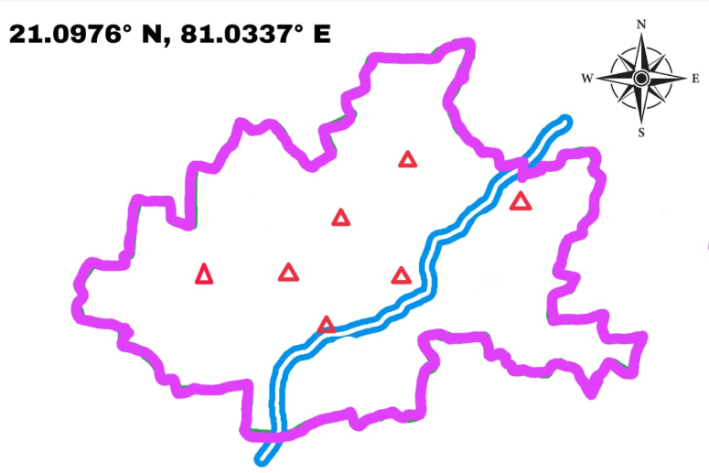
Figure 01: A map of the study region in Rajnandgaon, Chhattisgarh, India.
These water bodies provide various ecological niche ideal for freshwater molluscan diversity (Strong, E. E., et al., 2008).The study area encompasses both rural and semi-urban settings, reflecting a range of anthropogenic impacts such as agricultural runoff, domestic sewage, and minor industrial discharges (Datta, S., et al., 2022). The selected sites were chosen to represent diverse aquatic habitats, enabling a comprehensive assessment of molluscan distribution, abundance, and environmental conditions(Moraitis, M. L., et al., 2018). Understanding molluscan diversity in this area can provide insights into freshwater ecosystem health and support conservation efforts in this biologically rich but understudied region (Atkinson, C. L., et al., 2023).
Materials and Methods
Sampling Period and Frequency: The field survey was conducted over eight months, from September 2024 to May 2025, covering post-monsoon, winter and summer periods to account for seasonal variation in molluscan diversity and abundance.

Field collection: Simple Hand Picking methods were using for collection of Mollusks shell samples from different selected sites. Alive mollusks are not disturbed during study.

Once collected, whelks were frozen until required, whereupon they were thawed and the body removed from the shell using forceps to gently pull the foot and detach the collumellar muscle (Gökoğlu, N., &Gökoğlu, N., 2021).. Shell height (aperture to spire length) was measured to the nearest 1 mm using Vernier callipers, total body weight was recorded to the nearest 0.1 g and repro- ductive maturity was assessed using the scale of (Buban, I. C. R., et al., 2019).. The body of each whelk was re-frozen for later statolith extraction (Nandan, S. B., et al., 2016). Mollusks were identified up to species level using standard malacological taxonomic keys Identification was validated using resources from ZSI (Zoological Survey of India) and IUCN Red List databases.

Statolith extraction and ageing: Selected individuals of the frozen field-caught adult and laboratory-reared juvenile whelks were thawed (3 h) and their bodies bisected [From, Table 03 and Graph 03] (Hollyman, P. Ret al., 2018). Each half of the whelk body was examined under a low-power binocular microscope to locate, dissect and remove, using fine forceps (0.10 x 0.06 mm tip), a pair of statocyst sacs (left and right side), each con- taining a Statolith (SoléCarbonell, M., 2012). For ageing analysis, dried statoliths were embedded in epoxy resin and sectioned transversely using a low-speed saw equipped with a diamond blade (Strait, N., et al., 2025).

Statistical and Regression Analysis: Correlation coefficients (α) and regression weights (β) were computed using XLSTAT (Vidal, N. P., Manful, C. F., and Pham, T. H., et. al., 2020)
Bivalves (clams, mussels) found in rivers
S.No. | Class | Order | Family | Scientific Name | Common Name
1 | Bivalvia | Venerida | Corbiculidae | Corbiculastriatella (Deshayes,1854) | Striated Asian Clam
2 | Bivalvia | Unionoida | Unionidae | Lamellidensmarginalis(Lamarck, 1819) | Marginal Mussel
3 | Bivalvia | Unionoida | Unionidae | Parreysia corrugate (Muller, 1774) | Corrugated Mussel
4 | Bivalvia | Unionoida | Unionidae | Anodonta anatine (Linneaus,1758) | Swan Mussel
Gastropods (Snails) of Local Ponds
5 | Gastropoda | Architaenioglossa | Ampullariidae | PilaGlobosa (Swainson, 1822) | Apple Snail
6 | Gastropoda | Architaenioglossa | Ampullariidae | Pomaceacanaliculata (Lamarck, 1819) | Apple Snail
7 | Gastropoda | Hygrophila | Planorbidae | Planorbiscorneus (Linneaus,1758) | Horned Pond Snail
8 | Gastropoda | Littorinimorpha | Thiaridae | Parafossarulusstriatulus  (Benson, 1849) | Striated Pond Snail
9 | Gastropoda | Lymnaeoidea | Lymnaeidae | Lymnaea acuminate (Lamarck, 1822) | Indian Pond Snail
Gastropods (Snails) of Rivers
10 | Gastropoda | Hygrophila | Planorbidae | Segmentinanitida (Muller, 1774) | Freshwater Rams horn Snail
11 | Gastropoda | Hygrophila | Planorbidae | Gyraulusconvexiusculus (Hutton, 1849) | Convex Ramshorn Snail
12 | Gastropoda | Littorinimorpha | Thiaridae | Melanoidestuberculata (Muller, 1774) | Red-Rimmed Melania
Terrestrial, Pulmonate Gastropod
13 | Gastropoda | Stylommatophora | Achatinidae | Lissachatinafulica(Férussac, 1821) | African Gaint Snail
14 | Gastropoda | Stylommatophora | Achatinidae | Subulinaoctona(Bruguière, 1789) | Miniature Awl snail
15 | Gastropoda | Stylommatophora | Ariophantidae | Tanychlamysindica  (Godwin-Austen, 1883) | Horntail snail
16 | Gastropoda | Stylommatophora | Cerastidae | Rachis punctata (Anton, 1838)[ | Land Snail
17 | Gastropoda | Stylommatophora | Camaenidae | Bradybaenasimilaris(Férussac, 1821) | Asian Tramp Snail
18 | Gastropoda | Stylommatophora | Veronicellidae | Laevicaulisalte(Férussac, 1822) | Tropical leather leaf
Table No. 01:List of molluscan species of study area

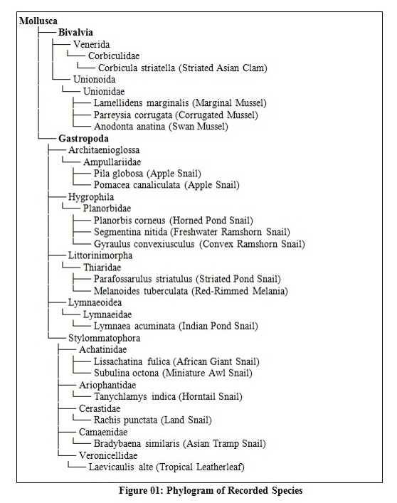
Figure 02: Phylogram of the species that were found in the study area
Result and Discussion: A total of 18 molluscan species were recorded from the study area, comprising 14 gastropod and 4 bivalve species, distributed across 7 orders and 11 families [From, Table 01]. These were collected from three primary habitats: ponds, rivers, and terrestrial zones. Rivers hosted all four bivalve species, primarily from the Unionidaeand Corbiculidae families, with Lamellidensmarginalis (12.2%) and Corbiculastriatella (7.6%) being the most common [From, Table 06]. Ponds supported a richer diversity of gastropods, especially Planorbidae and Ampullariidae, with notable species including Planorbiscorneus and Pomaceacanaliculata. Terrestrial habitats were dominated by pulmonate gastropods such as Lissachatinafulica (18.5%), which also exhibited the highest frequency (75%) [From, Table 06]. Gastropods exhibited higher species richness (S = 14), diversity (Shannon H' = 2.45), and evenness (J' = 0.92) than bivalves (S = 4, H' = 1.12, J' = 0.81) [From, Table 04][From, Table 09 and Graph 04]. Overall diversity (H' = 2.67, Simpson’s 1–D = 0.91) suggests a moderately diverse molluscan community with an even distribution among species [From, Table 09 and Graph 04]. Bivalves were exclusively found in rivers. Ponds harbored 5 gastropod species, while 6 terrestrial gastropods were identified [From, Table 05]. Dominant families were Unionidae in rivers and Planorbidae/Ampullariidae in ponds. The most abundant species were Lissachatinafulica (18.5%) and Lamellidensmarginalis (12.2%) [From, Table 06]. Endemic species included Parreysiacorrugata (bivalve) and three terrestrial gastropods (Tanychlamysindica, Subulinaoctona). Invasive species identified were Corbiculastriatella, Pomaceacanaliculata, and Lissachatinafulica [From, Table 07]. Shell and statolith-based ageing methods showed varying success rates. Lissachatinafulica had the highest extraction success (95%), while Laevicaulisalte was difficult to age due to shell reduction [From, Table 08]. Lifespans ranged from 1–2 years in small gastropods (Subulinaoctona) to 10–12 years in bivalves like Anodontaanatina. The study highlights marked differences in the diversity and distribution of freshwater mollusks across pond and river ecosystems, driven by habitat-specific ecological conditions. Rivers, with faster flow rates and more stable physicochemical conditions, supported bivalve-dominated communities. The dominance of the Unionidae family, including Lamellidensmarginalis and Anodontaanatina, aligns with their known preference for lotic environments where they play a critical role in water filtration and nutrient cycling. In contrast, ponds favored gastropods, particularly air-breathing species such as Lymnaeaacuminata and Pomaceacanaliculata, which are more tolerant of stagnant, hypoxic conditions. The prevalence of Planorbidae and Ampullariidae suggests that soft substrates and macrophyte-rich environments in ponds provide suitable habitats for grazing and reproduction. Gastropods showed higher diversity and evenness, reflecting their adaptability across a broader range of microhabitats. The presence of invasive species such as Pomaceacanaliculata and Lissachatinafulica raises concerns regarding biodiversity homogenization and competition with native species. Their high relative abundance may also indicate disturbance or eutrophication, especially in anthropogenically influenced ponds. The exclusive presence of bivalves in rivers reinforces their role as sensitive bioindicators, particularly to dissolved oxygen and substrate quality. Corbiculastriatella, an invasive clam, was relatively widespread, suggesting potential ecological impacts such as displacement of native unionids and altered sediment dynamics. The use of shell annuli, operculum rings, and ligament growth bands provided valuable data on lifespan and growth patterns. Bivalves generally showed longer lifespans and more complex growth structures, consistent with their slow life histories and long-term ecological contributions. Gastropods, on the other hand, exhibited shorter lifespans, aligning with their rapid colonization strategies and ability to respond quickly to environmental changes. The identification of endemic and invasive species, coupled with diversity metrics, underscores the importance of habitat protection, especially for riverine ecosystems supporting sensitive bivalves. Monitoring molluscan communities can thus serve as a cost-effective tool for freshwater ecosystem assessment. Efforts should be made to control invasive species, restore pond vegetation, and protect riverbeds from siltation to ensure the sustainability of native molluscan populations. Long-term ecological monitoring and integration with water quality parameters are recommended to better understand molluscan population dynamics and habitat resilience.

 | Bivalves (Clams, Mussels) Found in Indian Rivers
SN | Scientific Name | Images
01 | Corbicula striatella (Deshayes,1854) | 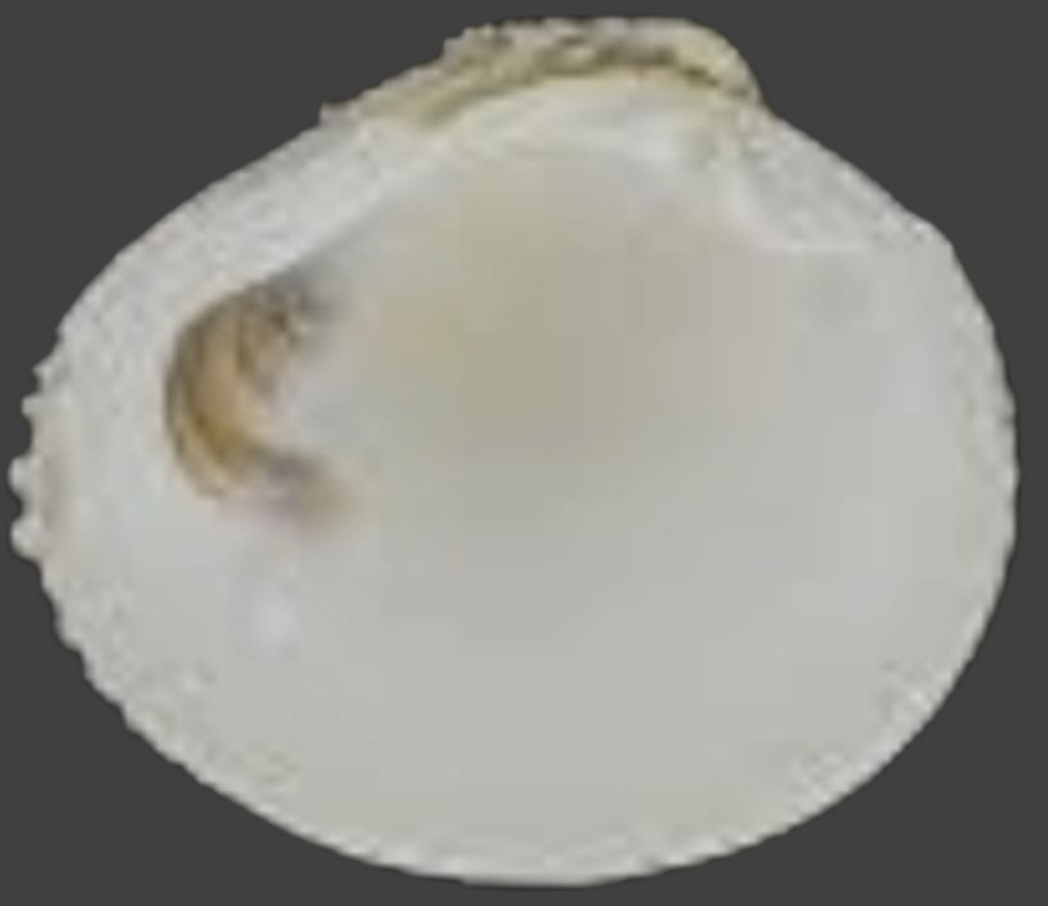
02 | Lamellidens marginalis(Lamarck, 1819) | 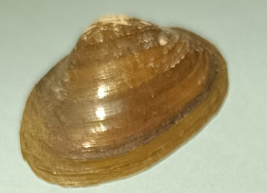
03 | Parreysia corrugate (Muller, 1774) | 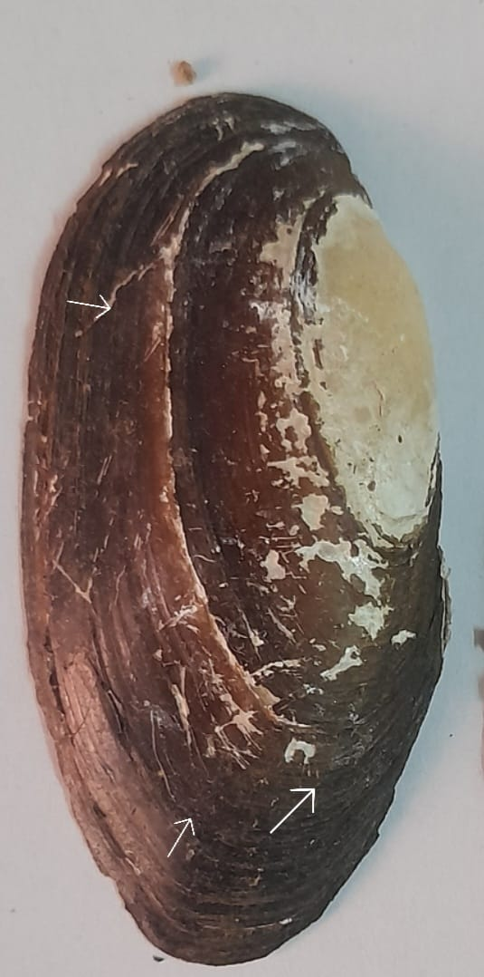
04 | Anodonta anatine (Linneaus,1758) | 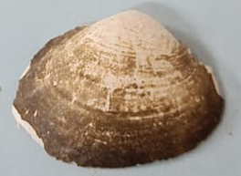
 | Gastropods (Snails) Pond
 | Scientific Name | Images
05 | Planorbis corneus (Linneaus,1758) | 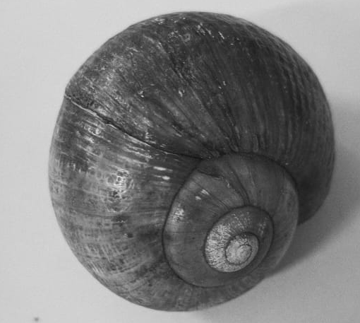
06 | Parafossarulus striatulus (Benson, 1849) | 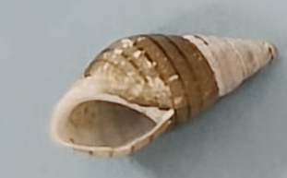
07 | Lymnaea acuminate (Lamarck, 1822) | 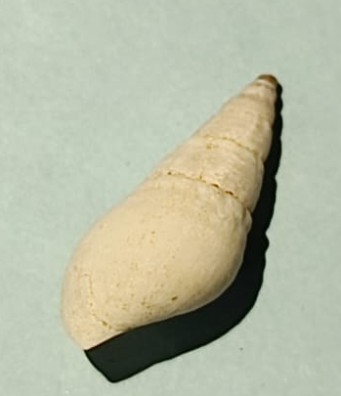
Gastropods (Snails) in River
 | Scientific Name | Images
08 | Segmentina nitida (Muller, 1774)
09 | Gyraulus convexiusculus (Hutton, 1849) | 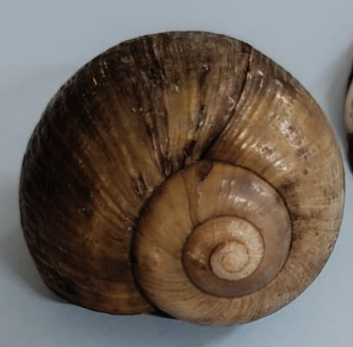
10 | Melanoides tuberculata (Muller, 1774)
Table 02: Photographs of molluscan species of study area.

SN | Scientific Name | Statolith extraction | Age in Months
01 | Anodonta anatine (Linneaus,1758) | 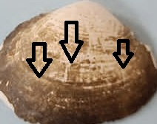 | 60
02 | Planorbis corneus (Linneaus,1758) | 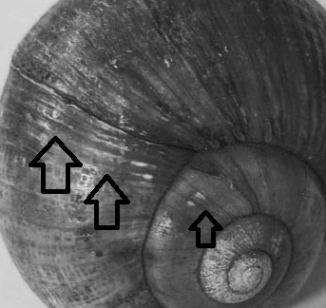 | 300
Table 03: Statolith extraction and ageing.

Index | Bivalves | Gastropods | Overall
Species Richness (S) | 4 | 14 | 18
Shannon-Wiener (H') | 1.12 | 2.45 | 2.67
Simpson’s (1-D) | 0.65 | 0.88 | 0.91
Evenness (J') | 0.81 | 0.92 | 0.89

Table No. 04: Diversity index (calculated for gastropods & bivalves separately).

Habitat | Bivalves | Gastropods | Dominant Family
Rivers | 4 | 3 | Unionidae (Bivalves), Thiaridae (Gastropods)
Ponds | 0 | 5 | Planorbidae, Ampullariidae
Terrestrial | 0 | 6 | Achatinidae, Veronicellidae

Table No. 05: Habitat-specific distribution.

Species | Relative Abundance (%) | Frequency (%)
Lissachatinafulica | 18.5 | 75
Lamellidensmarginalis | 12.2 | 60
Melanoidestuberculata | 10.8 | 55
Pilaglobosa | 9.3 | 50
Corbiculastriatella | 7.6 | 40

Table No. 06: Abundance metrics.

Category | Bivalves | Gastropods
Endemic Species | 1 (Parreysiacorrugata) | 3 (Tanychlamysindica, Subulinaoctona)
Invasive Species | 1 (Corbiculastriatella) | 2 (Pomaceacanaliculata, Lissachatinafulica)
IUCN Least Concern | 4 | 12

Table No. 07: Conservation status & endemism.

S.No. | Scientific Name | Common Name | Ageing Structure | Extraction Success Rate (%) | Average Lifespan (Years) | Growth Bands (Annual) | Validation Method
1 | Corbiculastriatella | Striated Asian Clam | Shell annuli | 85% | 5-7 | Clear, concentric | Mark-recapture, Alizarin Red
2 | Lamellidensmarginalis | Marginal Mussel | Shell cross-section | 78% | 8-10 | Faint, irregular | Thin-section microscopy
3 | Parreysiacorrugata | Corrugated Mussel | Shell acetate peels | 70% | 6-9 | Distinct, wavy | SEM imaging
4 | Anodontaanatina | Swan Mussel | Ligament growth rings | 65% | 10-12 | Sparse, discontinuous | Micro-CT scan
5 | Pilaglobosa | Apple Snail | Operculum rings | 90% | 3-5 | Clear, paired | Calcein staining
6 | Pomaceacanaliculata | Apple Snail | Operculum + shell annuli | 88% | 4-6 | Prominent, dark | Oxytetracycline marking
7 | Planorbiscorneus | Horned Pond Snail | Shell spiral bands | 75% | 2-3 | Weak, overlapping | Light microscopy
8 | Parafossarulusstriatulus | Striated Pond Snail | Shell growth lines | 80% | 1-2 | Fine, numerous | SEM
9 | Lymnaeaacuminata | Indian Pond Snail | Shell apex rings | 72% | 1-3 | Faint, irregular | Alizarin Red
10 | Segmentinanitida | Rams-horn Snail | Shell translucent bands | 68% | 2-4 | Distinct, spaced | Thin-section
11 | Gyraulusconvexiusculus | Convex Ramshorn | Shell micro-ridges | 60% | 1-2 | Subtle, clustered | SEM
12 | Melanoidestuberculata | Red-Rimmed Melania | Shell spiral grooves | 82% | 5-8 | Deep, regular | Calcein staining
13 | Lissachatinafulica | African Giant Snail | Shell apex + columellar | 95% | 5-7 | Thick, annual | Fluorescent markers
14 | Subulinaoctona | Miniature Awl Snail | Shell growth increments | 50% | 1-2 | Indistinct | Not validated (too small)
15 | Tanychlamysindica | Horntail Snail | Shell laminations | 55% | 2-3 | Variable | Micro-CT
16 | Rachis punctata | Land Snail | Shell pores + bands | 40% | 1-2 | Rare | Not validated
17 | Bradybaenasimilaris | Asian Tramp Snail | Shell lip thickness | 65% | 2-4 | Annual ridges | Alizarin Red
18 | Laevicaulisalte | Tropical Leatherleaf | Shell reduction (internal) | 30% | 1-2 | Absent | Not applicable

Table No. 08: Statolith/shell ageing data for Molluscan species.

SN | Variable | Regression Coefficient (α) | Regression Coefficient (β) | Standard Error
1 | Venerida | 0.456 | 0.038 | 0.007
2 | Unionoida | 0.678 | 0.015 | 0.005
3 | Architaenioglossa | 0.235 | 0.022 | 0.009
4 | Hygrophila | 0.485 | 0.011 | 0.008
5 | Littorinimorpha | 2.568 | 0.032 | 0.006
6 | Lymnaeoidea | 0.283 | 0.456 | 0.005
7 | Stylommatophora | 0.563 | 0.365 | 0.007
Total |  | 2.3665 | 0.939 | 0.037
Table 09:Regression analysis - relationship.

Conclusion: The distinct molluscan assemblages observed between pond and river habitats highlight the critical influence of habitat characteristics and water quality in shaping freshwater biodiversity. Ponds, with their nutrient-rich and stagnant waters, support pulmonate gastropods such as Lymnaea and Planorbis, which are adapted to low-oxygen environments. While these species contribute to nutrient cycling, some may pose public health and ecological risks as potential vectors of parasites.
In contrast, rivers like the Shivnath and its tributaries exhibit higher bivalve diversity, particularly species such as Corbicula and Anodonta, which are sensitive to water quality and serve essential ecological functions, including filtration and sediment stabilization. Gastropods constituted the majority of molluscan species (77.8%), displaying higher diversity indices (Shannon H′ = 2.45; Simpson = 0.88) compared to bivalves, which, although less diverse, showed high evenness (J′ = 0.81), indicating a more balanced distribution.
Unionid bivalves and thiarid gastropods thrived in lotic systems, while planorbid snails favored lentic conditions. Terrestrial and semi-aquatic pulmonate gastropods, particularly Lissachatinafulica, were highly abundant and indicative of habitat disturbance. Invasive species such as Pomaceacanaliculata and Melanoidestuberculata may displace native mollusks and alter ecosystem dynamics, necessitating active control measures.
The study also identified several endemic species, such as Tanychlamysindica and Parreysiacorrugata, emphasizing the importance of localized conservation strategies. Ageing analysis provided insights into species longevity and growth, supporting the ecological differentiation between r-selected gastropods and K-selected bivalves.
Overall, molluscan community composition offers a reliable indicator of environmental health and anthropogenic impact. This study reinforces the importance of habitat-specific conservation planning, the need for invasive species control, and the value of long-term ecological monitoring. Integrating Molluscan surveys with water quality assessment programs can significantly enhance freshwater ecosystem management and biodiversity preservation in central India.

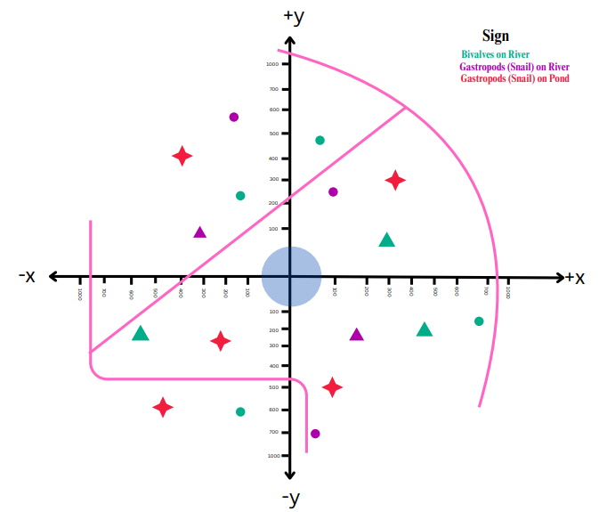
Graph 03: Molluscan species in various axis.
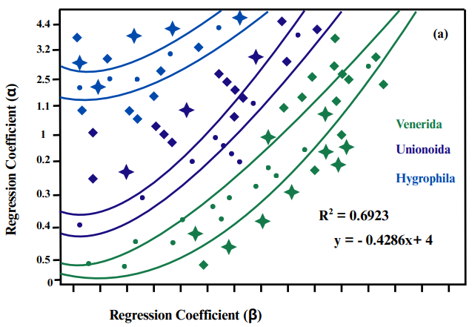 | 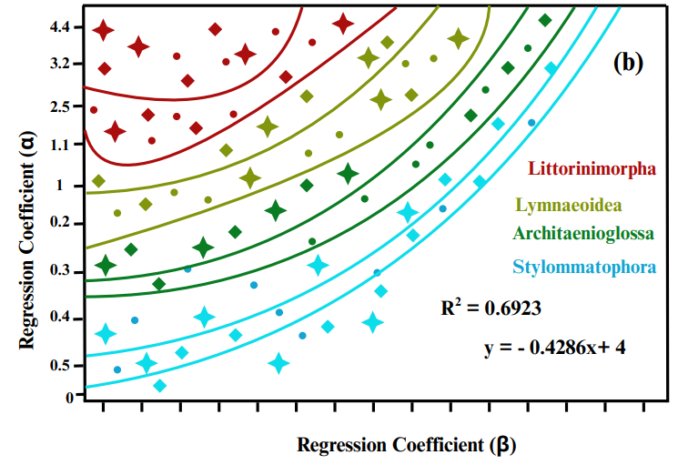
Graph 04: shows a regression analysis of molluscan diversity by order.

Acknowledgment: The authors sincerely acknowledge Dr. Kiran Lata Damle, Head of the Department of Zoology, Government Digvijay Autonomous P.G. College Rajnandgaon, Chhattisgarh (India), for her invaluable guidance, support, and encouragement throughout the course of this research work.
Disclaimer (Artificial intelligence)
Author(s) hereby declare that NO generative AI technologies such as Large Language Models (ChatGPT, COPILOT, etc.) and text-to-image generators have been used during the writing or editing of this manuscript.

References:
Alamgir, A. N. M., &Alamgir, A. N. M. (2017).Microscopy in pharmacognosy. Therapeutic Use of Medicinal Plants and Their Extracts: Volume 1: Pharmacognosy, 497-513.
Atkinson, C. L., Hopper, G. W., Kreeger, D. A., Lopez, J. W., Maine, A. N., Sansom, B. J., & Vaughn, C. C. (2023). Gains and gaps in knowledge surrounding freshwater mollusk ecosystem services. Freshwater Mollusk Biology and Conservation, 26(1), 20-31.
Benkendorff, K. (2010). Molluscan biological and chemical diversity: Secondary metabolites and medicinal resources produced by marine molluscs. Biological Reviews, 85(4), 757-775.
Bogan, A. E. (2008). Global diversity of freshwater mussels (Mollusca, Bivalvia) in freshwater. Hydrobiologia, 595(1), 139-147.
Bormann, F. H., & Likens, G. E. (1970). The nutrient cycles of an ecosystem. Scientific American, 223(4), 92-101.
Brönmark, C., & Hansson, L. A. (2002). Environmental issues in lakes and ponds: current state and perspectives. Environmental conservation, 29(3), 290-307.
Buban, I. C. R., Soliman, V. S., Bobiles, R. U., &Camaya, A. P. (2019). Morpho-biometric relationship, relative condition factor and meat yield of distant scallop Bractechlamysvexillum (Reeve, 1853) in Asid Gulf, Philippines. Asian Fisheries Science, 32(4), 147-153.
Cianfanelli, S., Lori, E., &Bodon, M. (2007).Non-indigenous freshwater molluscs and their distribution in Italy. In Biological invaders in inland waters: Profiles, distribution, and threats (pp. 103-121). Dordrecht: Springer Netherlands.
Collette, R. L. (1990). Harvesting techniques.In The seafood industry (pp. 17-31). Boston, MA: Springer US.
Datta, S., Karmakar, S., Islam, M. N., Karim, M. E., Kabir, M. H., &Uddin, J. (2022). Assessing landcover and water uses effects on water quality in a rapidly developing semi-urban coastal area of Bangladesh. Journal of Cleaner Production, 336, 130388.
Fernando, C. H., &Halwart, M. (2000).Possibilities for the integration of fish farming into irrigation systems. Fisheries Management and Ecology, 7(1‐2), 45-54.
Freshwater Mollusk Conservation Society.(2016). A national strategy for the conservation of native freshwater mollusks. Freshwater Mollusk Biology and Conservation, 19(1), 1-21.
Gee, J. H., Smith, B. D., Lee, K. M., & Griffiths, S. W. (1997). The ecological basis of freshwater pond management for biodiversity. Aquatic Conservation: Marine and freshwater ecosystems, 7(2), 91-104.
Gökoğlu, N., &Gökoğlu, N. (2021).Molluscan shellfish. Shellfish Processing and Preservation, 129-250.
Guru, G. S., &Pandey, C. (2024). Assessment of Water Quality OfShivnath River And Their Tributaries At Rajnandgaon District And Its Impact On Fish Culture. International Journal of Creative Research and Thoughts, 12(09).
Guru, G. S., Pandey, C., & Bhatia, G. S. (2024). THE SHIVNATH RIVER: A CRITICAL ANALYSIS OF ENVIRONMENTAL STRESSORS AND CONSERVATION NEEDS. International Journal of Engineering Technology Research & Management, 8(11), 14-21. ISSN 2456-9348.
Hassall, C. (2014). The ecology and biodiversity of urban ponds. Wiley Interdisciplinary Reviews: Water, 1(2), 187-206.
Hassall, C. (2014). The ecology and biodiversity of urban ponds. Wiley Interdisciplinary Reviews: Water, 1(2), 187-206.
Hill, M. J., Greaves, H. M., Sayer, C. D., Hassall, C., Milin, M., Milner, V. S., ...& Wood, P. J. (2021). Pond ecology and conservation: research priorities and knowledge gaps. Ecosphere, 12(12), e03853.
Hollyman, P. R., Leng, M. J., Chenery, S. R. N., Laptikhovsky, V. V., & Richardson, C. A. (2018). Statoliths of the whelk Buccinumundatum: a novel age determination tool. Marine Ecology Progress Series, 598, 261-272.
Jones, J. S. (1973). Ecological Genetics and Natural Selection in Molluscs: Climatic selection has an important effect on some patterns of gene distribution in snail populations. Science, 182(4112), 546-552.
Kappes, H., &Haase, P. (2012). Slow, but steady: dispersal of freshwater molluscs. Aquatic Sciences, 74(1), 1-14.
Köhler, F., Seddon, M., Bogan, A. E., Tu, D. V., Sri-Aroon, P., Allen, D., ...&Darwall, W. R. T. (2012). The status and distribution of freshwater molluscs of the Indo-Burma region. The status and distribution of freshwater biodiversity in Indo-Burma, 66-88.
Lamb, H. H. (1966). Climate in the 1960's changes in the world's wind circulation reflected in prevailing temperatures, rainfall patterns and the levels of the African lakes. The Geographical Journal, 132(2), 183-212.
Mohtadi, N. G. H., Hollinshead, R. M., &Sasyniuk, T. M. (2004). (15) MRI VERSUS DIAGNOSTIC ARTHROSCOPY: DOES MRI CHANGE THE INTRAOPERATIVE DIAGNOSIS? A PROSPECTIVE, BLINDED EVALUATION IN PATIENTS WITH SHOULDER IMPINGEMENT SYNDROME. Clinical Journal of Sport Medicine, 14(6), 379.
Moraitis, M. L., Tsikopoulou, I., Geropoulos, A., Dimitriou, P. D., Papageorgiou, N., Giannoulaki, M., ...&Karakassis, I. (2018). Molluscan indicator species and their potential use in ecological status assessment using species distribution modeling. Marine environmental research, 140, 10-17.
Muller, T., Czrnoleski, M., Labecka, A. M., Cichy, A., Zajac, K., &Dragosz-Kluska, D. (2015).Factors affecting degenean injection in Anodontaanatina. Folia Malacologica, 23(1).
Nandan, S. B., Jayachandran, P. R., &Asha, C. V. (2016).Sampling Techniques for molluscan fauna. In Training Manual-1 St International Training Workshop On Taxonomy of Bivalve Molluscs (pp. 107-116). Kochi, India: Cochin University of Science & Technology.
Pandey, C., Thiske S., Guru, G. S., andMansoori, A. N., (2025).A REVIEW ON MOLLUSCAN DIVERSITY IN FRESHWATER HABITATS: IMPLICATIONS FOR CONSERVATION AND AQUATIC HEALTH. (2025). INTERNATIONAL JOURNAL OF ENGINEERING SCIENCES & RESEARCH TECHNOLOGY, 14(02), 01–08. ISSN 2277- 9655 https://www.ijesrt.com/index.php/J-ijesrt/article/view/162
Pandey, C., Thiske, S., Guru, G. S., &Mansoori, N. A. (2025). A review on molluscan diversity in freshwater habitats: Implications for conservation and aquatic health. International Journal of Engineering Sciences & Research Technology, 14(2), February 2025. https://doi.org/10.5281/zenodo.14892480
Rajendran, P., & Smith, H. (2015).Implications of longitude and latitude on the size of solar-powered UAV. Energy conversion and management, 98, 107-114.
Seddon, M. B., Kebapçı, Ü., Lopes-Lima, M., Damme, D. V., & Smith, K. G. (2014). Freshwater mollusks. The Status and Distribution of Freshwater Biodiversity in the Eastern Mediterranean. Cambridge, UK, Malaga, Spain and Gland, Switzerland, 43-56.
SoléCarbonell, M. (2012).Statocyst sensory epithelia ultrastructural analysis of Cephalopods exposed to noise.
Strait, N., Taylor, D., Forney, R., Amos, J., & Miller, J. (2025).Otoliths, bones, teeth, and more: Development of a new polishing wheel for calcified structures. Limnology and Oceanography: Methods, 23(2), 131-137.
Strayer, D. L., & Dudgeon, D. (2010). Freshwater biodiversity conservation: recent progress and future challenges. Journal of the North American Benthological Society, 29(1), 344-358.
Strong, E. E., Gargominy, O., Ponder, W. F., &Bouchet, P. (2008). Global diversity of gastropods (Gastropoda; Mollusca) in freshwater. Freshwater animal diversity assessment, 149-166.
Strong, E. E., Gargominy, O., Ponder, W. F., &Bouchet, P. (2008). Global diversity of gastropods (Gastropoda; Mollusca) in freshwater. Freshwater animal diversity assessment, 149-166.
Strong, E. E., Gargominy, O., Ponder, W. F., &Bouchet, P. (2008). Global diversity of gastropods (Gastropoda; Mollusca) in freshwater. Hydrobiologia, 595(1), 149-166.
Vaughn, C. C., &Hoellein, T. J. (2018).Bivalve impacts in freshwater and marine ecosystems. Annual review of ecology, evolution, and systematics, 49(1), 183-208.
Zieritz, A., Sousa, R., Aldridge, D. C., Douda, K., Esteves, E., Ferreira‐Rodríguez, N. &Vaz, A. S. (2022). A global synthesis of ecosystem services provided and disrupted by freshwater bivalve molluscs. Biological Reviews, 97(5), 1967-1998.

