EXPLORING THE SAFETY AND UV DEFENSIVE PROPERTIES OF HERBAL MICROSPONGE GEL IN ALBINO RATS
Abstract :
Aim: The present study was aimed with the formulation of herbal micro-sponge gel to improve protection against UV rays and also blocks the UVA ,UVB,UVC radiation from the sun.
Methods: Citrus sinensis (Family: Rutaceae ) and Eucalyptus globulus oil (Family: Myrtaceae) were used for the UV protection activity. Extraction was performed using water by the hydro distillation method and screened for the presence of active components using phytochemical tests and GS-MS analysis. Six different herbal micro-sponge formulations were prepared using the quasi-emulsion solvent diffusion method. By varying the polymer and drug ratios. The prepared herbal micro-sponges were evaluated for various parameters like particle size, Drug entrapment efficiency,% yield, SEM analysis, DSC analysis, and in vitro dissolution studies. From the above formulations, select the optimized formulation and incorporate it into gel. Here, the prepared herbal micro-sponge gel was evaluated for various parameters: pH, Viscosity, Spreadability, Drug content, in vitro diffusion studies, and in-vitro UV studies. Furthermore, for best formulation the skin irritation test was carried out in albino wistar rats model respectively were performed. A stability study was performed for the best formulation for 3 months.
Results: The best formulation (F2) was selected based on various physical parameters. F2 showed the particle size ranging from 129.3 to 149μm and also a spherical in shape. The zeta potential was found to be -31mV. In-vitro drug release of orange peel oil is 96.24% and also eucalyptus oil is 90.66% at 9hrs. F2 formulation showed the first-order release kinetics, and it’s a sustained release.SPF was calculated using an in vitro UV spectroscopic method. The highest SPF value was found to be 46.03. This herbal micro-sponge sunscreen gel blocks the UVA, UVB, and UVC radiation. The F2 formulation was subjected to dermal irritation test, which showed no signs of erythema, skin irritation or redness at the end of the 24-hour observation period.
Conclusion: Citrus sinesis and eucalyptus oil base microsponges loaded in carbopol gel exhibited sustained drug release and showed potential as a safe and effective formulation. Thus, the extract of Citrus sinesis and Eucalyptus oil could be a potential herbal drug for the treatment against UV radiation, and the developed formulation strategy poses a suitable formulation to treat patients, addressing the need for safe and effective
treatment. This result indicated that formulation F2 herbal microsponge sunscreen gel showed the highest SPF value. This outcome suggests that F2 formulation is safe for topical applications..
Keywords: Citrus sinensis ;Eucalyptus globulus; SPF ,UV radiation ;Microsponges ;Physical parameters;

INTRODUCTION :
More than 80% of people on the planet get their primary medical care from medicinal plants. Compared to the majority of contemporary synthetic pharmaceuticals, herbal remedies are readily accessible, less expensive, tried-and-true, and thought to be safer. More than half of the top-selling medications on the market today were made from natural sources.¹
MICROSPONGE DRUG DELIVERY SYSTEM.
In 1987, microsponge technology was created and advanced polymer systems were granted the first patents. In the rapidly evolving field of innovative drug delivery technology, microsponges are at the forefront. It is a polymeric delivery system based on porous microspheres. These are microscopic, porous particles that resemble sponges. A novel technique for regulating drug release and delivering medications to specific areas is microsponges . A suitable Analytical methods such as surface morphology, porosity, density, and particle size and distribution are discussed when characterizing microsponges.²
The microsponges are utilized in topical skin care products such as sunscreens, lotions, ointments, and over-the-counter medicines. There can be up to 250000 holes in a standard 25 μm spherical and an interior pore configuration equal to 10 feet in extended . This means that the microsponges range in size from 5 to 300 μm in diameter, with a overall amount of pores of roughly 1 ml/g for substantial pharmacological retention . When applied to the skin, the microsponge drug delivery system responds to temperature, pH, rubbing, and other stimuli to release its active ingredient on a timed basis. It also has the ability to absorb a large concentration of active ingredients into the either onto its surface or as a particle. A fresh cohort of extremely effective and well handlled novel products has been produced as a result of the recent, systematic exploration of microsponge delivery systems for the medicine administered topically under controlled conditions.^{3,4}
Every microsphere has a high porous surface area and a non-collapsible structure made up of countless interconnected spaces, much like a real sponge.⁵
SUNSCREEN PROTECTION
UV defense, The sun is the source of energy and life. Humans have historically been exposed to UV radiation mostly from sunlight exposure at work. However, recent research acknowledges that the sun is mostly to blame for harmful consequences, including both acute and long-term risks. Due to outdoor recreational activities, UV exposure has increased considerably in recent times. Subsequently, the UV photon component of the electromagnetic spectrum lies in the wavelength range between visible light and gamma radiation. Sun tan, skin cancer, oxidative harm to the cells in the skin, and aging photoscopic are among the skin conditions caused by UV radiation.⁶
Based on wavelengths, UV energy is separated into UVA, UVB, and UVC components.100% of UVC, 90% of UVB, and very little UVA are absorbed by the ozone layer .Pigmentation and aging are linked to UVA. UVB light has a wavelength of (290 to 320 nm).UVA is separated into UVA II (320 to 340 nm) and UVAI (340 to 400 nm).Both UVA and UVB rays are absorbed by broad spectrum sunscreen. UVA is the weakest UV radiation wavelength band; it emits long-wavelength, black light that is not absorbed by the ozone layer .It mostly causes the skin's melanin pigments to oxidize, or darken.⁷
A suggested blocking strength is 15 or greater for sun protection factor. Organic sunscreens are chemical-based sunscreens. Chemical sunscreens have the potential to induce sunburn or offer sun protection.⁸
MATERIALS AND METHODS
Materials
Citrus Sinensis was Collected from fruit shops of Bangalore, Eucalyptus globulus oil ethanol from Chagshu hongsheng fine chemicals,China,Carbopol 940 from yarrow chem, Triethanolamine, methyl paraben ,dichlormethane propyl paraben,glacial acetic acid ad sodium acetate are procured from Karnataka Fine Chemicals Begalururu.
Wister albino rats of either sex was selected for studies. Animals procured for a registered CPCSEA vendor. The animals housed was maintained under standard laboratory conditions at 25± 1°C under 12/12 h light/ dark cycle and fed with standard pellet diet and water ad libitum. The experiment was carried out according to the guidelines of the committee for the purpose of control and supervision of Experiments on animals (CPCSEA), New Delhi, India and the study protocol was approved by the Institutional Animal Ethical Committee (IAEC) Mallige college of pharmacy, Bengaluru with Ref: MCP139/2023-24.
Method of Extraction of Citrus Sinensis Peel oil by using Clevenger’s apparatus
The Orange peels were washed initially with tap water and then with distilled water to make the outer surface sterilized.
The fresh orange after surface sterilization were gently pressed against the grater to remove the zest without removing any part of the white flesh .The peel of citrus sinensis were transferred to round bottom flask .After that water was added into round bottom flask along with porcelain chips to prevent splashing of the zest and peels to the neck and allow boiling
The distillation process was proceeded at a temperature of 70̊ C .The oil was separated and dried by sodium sulfate. The essential was kept in a dark vial at a cold place until analysis.⁹
Standard curve of Orange peel oil and Eucalyptus globulus oil.
Preparation of standard stock solution of orange peel oil and eucalyptus globulus oil.
Accurately weighed about 25 mg(0.025g) of Orange peel oil and Eucalyptus globulus oil was separately transferred into 25ml volumetric flask ,and dissolved using alcohol as solvent and volume made up to the mark using the same solvent .Then ,the standard stock solution was then serially diluted with alcohol to get a concentration of 5 , 10 ,15 ,20 μg/ml and absorbance was recorded at 276 nm of Orange peel oil and for eucalyptus globulus oil was recorded at 310 nm using UV -Visible spectroscopy.
FORMULATION OF HERBAL MICROSPONGE
Eucalyptus leaves extract and orange peel extract loaded microsponge was formulated by using quasi emulsion solvent diffusion method.
The internal phase consists of polyherbal extract , ethyl cellulose. They are dissolved in dichloromethane and ethanol(1:1) kept under magnetic stirrer for about 15mins. A uniform polymeric solution is formed.Addition of extracts to this solvent by gradually stirring at a speed of 500rpm.The internal phase will added dropwise into aqueous external phase . External phase containing 100ml of 0.5 % of PVA solution and 1ml of glycerol .Then continuous stirring up to 2hr using mechanical stirrer .The removal of dichloromethane and ethanol from the system resulted in the formation of microsponges. Microsponges obtained will be filtered through Whatman filter paper and dried at 40̊ C for 48 hrs. Then dried microsponges were stored in air tight container for further evaluation.¹⁰
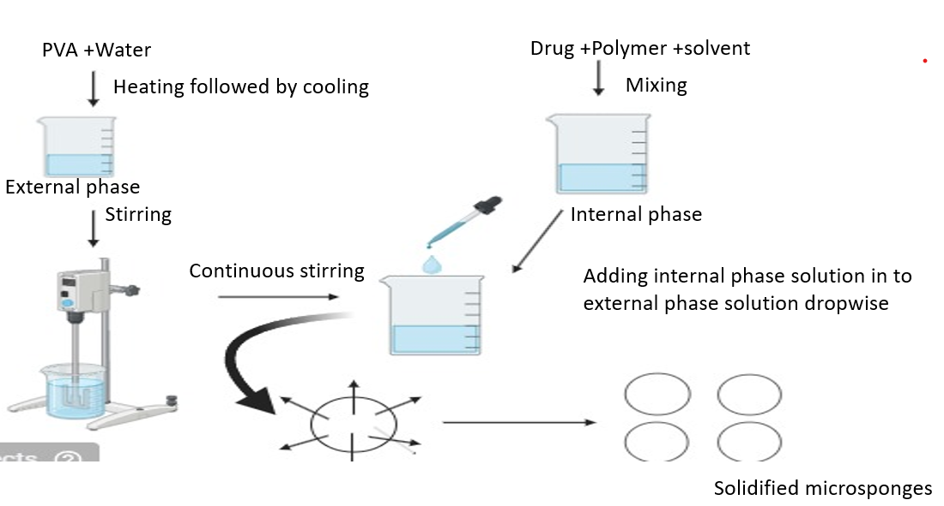

Figure 1 : Method of preparation of microsponges

FORMULATION TABLE FOR HERBAL MICROSPONGES
Formulation code | F1 | F2 | F3 | F4 | F5 | F6
Orange peel oil (ml) | 1 | 0.5 | 1 | 1 | 0.5 | 1.5
Eucalyptus oil (ml) | 1 | 0.5 | 1.5 | 1 | 0.5 | 1
Ethylcellulose (g) | 2.5 | 0.5 | 1.5 | 1 | 1 | 2
PVA (g) | 0.5 | 0.5 | 0.5 | 0.5 | 0.5 | 0.5
Dichloromethane :Ethanol (ml) | 5:5 | 5:5 | 5:5 | 5:5 | 5:5 | 5:5
Glycerol (ml) | 1 | 1 | 1 | 1 | 1 | 1
Water (ml) | 100 | 100 | 100 | 100 | 100 | 100
Table 1 : Formulation table for herbal microsponges

EVALUATION OF HERBAL MICROSPONGES
PERCENTAGE YIELD
The manufactured microsponges were collected and weighed in various formulations. The actual weight of the microsponges was divided by the total weight of the drugs and polymers utilized in their manufacture.¹¹
The percentage yield was calculated using the following formula:
% YIELD= (Actual weight of microsponges / Total weight of Drug & Polymer) X 100
DRUG ENTRAPMENT EFFICIENCY
The microsponges containing 100mg of Herbal microsponge from each batch were precisely weighed and crushed. The powdered microsponges were placed in a 100ml volumetric flask, and pH 5.5 acetate buffer was added to make it up to the mark before filtering through Whatman filter paper.After filtering, an exact quantity (1ml) of this solution was obtained and diluted to 10ml with pH 5.5 acetate buffer. An exact volume (1ml) of this solution was pipetted out and diluted to 10ml with pH 5.5 acetate buffer.The absorbance was measured at 276nm.¹²
The drug entrapment efficiency was calculated using the following formula:
%Drug Entrapment Efficiency=(Practical drug content/Theoretical drug content)X100
PARTICLE SIZE ANALYSIS
The particle size of the produced microsponges was measured using optical microscopy. The optical microsponges were equipped with an ocular micrometer and a stage micrometer. The eyepiece micrometer was calibrated. The sizes of particles in more than 200 microsponges were randomly measured using an optical microscope.¹³
SHAPE AND SURFACE MORPHOLOGY
Scanning electron microscopy was used to determine the form and surface properties of the prepared microsponges. The samples for scanning electron microscopy were produced by gently distributing microsponges over a double adhesive tape that was adhered to an aluminum stub. The stubs were then coated with gold using a sputter coater operating at high vacuum and voltage to create a film thickness of 30nm. The materials were then scanned with a 20KV electron beam.¹⁴
DIFFERENTIAL SCANNING CALORIMETRY (DSC):
Differential Scanning Calorimetry was used to investigate the thermal properties of drugs alone and in combination with polymers. DSC can be used to explore and anticipate any physicochemical interactions between formulation components, allowing for the selection of appropriate chemically compatible excipients.
Samples of roughly 1-3 mg were weighed and placed in aluminum pans, with the lids crimped with a Shimadzu crimper. An empty pan sealed in the same way as the sample served as a reference. The thermal behavior of the samples was studied using nitrogen gas at a scanning rate of 20°C/min, with a temperature range of 30-300°C.¹⁵
IN -VITRO DISSOLUTION STUDIES
Sl no. | Ingredients | Quantity (mg/ml)
01 | Herbal microsponges | 0.5 mg
02 | Carbopol 940 | 1g
03 | Propylene glycol | 300mg
04 | Methyl paraben | 5ml
05 | Propyl paraben | 1ml
06 | Triethanolamine | Qs
07 | Distilled water | Qs
Herbal-loaded microsponges were described for in vitro drug release testing utilizing dissolving equipment 1 (basket type).Take a precisely weighed amount of microsponge equal to 100mg of herbal microsponges and place it in a clean muslin towel. The basket was suspended in 900 cc of 5.5 pH acetate buffer as a dissolving media, rotating at 75 rpm and 37 ±0.5C. Samples were collected from the dissolution liquid at predefined intervals every 1 hour for 7 hours, and the amount of herbal microsponge released was measured spectrophotometrically at an appropriate nm. The experiment was carried out in triplicate over a period of 7 hours. A cumulative percentage of drug release against time plot of the prepared microsponge was created.¹⁶
Table 2: Formulation table for gel containing herbal microsponges

EVALUATION OF HERBAL MICROSPONGES GEL
DETERMINATION OF pH :
A digital pH meter was used to determine the pH of prepared gels. Three trials were conducted, with an average value taken for each formulation.¹⁷
SPREADABILITY:
The apparatus consisted of two glass slides, one fixed to a wooden board and the other moveable and attached to a thread that went over a pulley to carry a weight. The formulation (0.5 g) was placed on one side of the glass slide. Weight (100g) was allowed to rest on the upper slide for 1 to 2 minutes to evacuate trapped air between the slides and create a homogeneous film of the formulation. The weight was removed, and the top slide was given a pull by connecting a 30 g weight to the pulley. Spreadability was calculated by noting the time (sec) taken to move a slide 6.5 cm to a predetermined distance.Weight of the the glass slide is also taken into consideration.¹⁸
VISCOSITY :
The viscosity was measured for all the formulated gels using a Brookfield viscometer (LVDV-E model) with spindle number 64 at varying rpms of 5, 10, 20, 30, 40, 50, 100, and 200 at 37°C.¹⁹
DRUG CONTENT DETERMINATION:
1g of polyherbal-loaded microsponge gel was weighed, dissolved in ethanol, sonicated for 10-15 minutes, and filled a 100ml volumetric flask with acetate buffer pH 5.5. To get a concentration within Beer's range, 10 ml was pipetted and diluted to 100 ml using acetate buffer pH 5.5, followed by a final dilution with distilled water. The absorbance was measured at appropriate nm using a UV spectrophotometer against a blank gel made in the same way as the sample. ²⁰
IN-VITRO DIFFUSION STUDY:
The drug release investigations were conducted using the Franz diffusion cell. Microsponge gel (1g) was applied to the surface of egg membrane. The membrane was clamped between the donor and receptor chambers of the diffusion cells. To solubilise the medication, the receptor chamber was filled with freshly produced 5.5 acetate buffer. The receptor chamber was agitated using a magnetic stirrer. Samples (5.0 ml aliquots) were collected at appropriate intervals and replenished with 5 ml of the same acetate buffer. Following proper dilutions, samples were analysed for drug concentration using a UV-visible spectrophotometer at two distinct nanometres (264, 310).²¹
IN-VITRO UV STUDY
The Sun Protecting Factor (SPF) compares the amount of UV radiation required to produce a minimal erythemal dose (MED) in protected vs unprotected skin. Screening the product's absorbance between 290 and 320nm at 5nm intervals is an easy and rapid way to determine the SPF in vitro.The following formulas can be used to compute the sun protection factor (SPF).²²
$$\% Yield =\frac{ Practical yield}{Theoretical yield(herbal extracts+polymer)}×100$$
ACUTE DERMAL IRRITATION STUDY
The acute dermal irritation study will follow the OECD 404 test requirements, and the experimental technique will be handled in compliance with CPCSEA norms. The Animal Ethical Committee (IAEC) MCP139/ 2023-24 review and approved the experimental protocol.
Approximately 24 hours before the test, the animal's fur will be removed using a sterilised electric razor to closely trim the neck hairs of the animals. To avoid abrading the skin, only animals with healthy, intact skin will be used. The test material (Polyherbal Microsponge gel), control (Carbopol base gel), and standard (Dermaco) will be applied in a single dose to the skin of an experimental animal wrapped with gauze and non-irritating tapes. After the exposure duration of four hours, the formulation will be removed with an appropriate solvent. The initial test will be undertaken on one rat, followed by a confirmatory test on two additional animals to confirm any irritating or negative response. The rat's skin will be examined after 1, 24, 48, and 72 hours for any apparent changes (erythema, redness, and oedema), and the responses will be assessed based on the parameters.²³
DRUG RELEASE KINETICS
The kinetic drug release study of polyherbal extract was conducted using a DD (differential
dissolution) solver. The best formulation was subjected to Drug release kinetics . The study
tested various models and equations to determine the goodness of fit parameters for the release of extract. The models tested include zero-order, first-order, Higuchi, Korsmeyer-Peppas.
STABILITY STUDIES
Stability study was performed to check any considerable changes that may occur in formulation during its storage. All the formulation was kept for 3 months at room temperature. Stability of the formulation was evaluated by determining their visual appearance, pH, viscosity, spreadability, drug content, in-vitro drug release.²⁴
RESULTS AND DISCUSSION
Phytochemical Screening
Phytochemical screening confirms the presence of D-limonene .
A dilute Bromine-water solution is prepared and taken in a test tube.
To Bromine water solution citrus sinensis oil is added. If limonene is present in the oil extracted, the colour of the bromine water gets changed from red brown to pale yellow. (This is because of the fact that bromine present in the Bromine –Water solution occupies the space between the two double bonds present in limonene.)
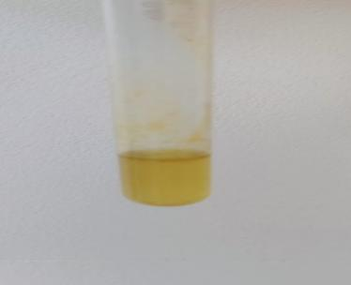
Figure 2: Phytochemical test for presence of D-limonene.

GC-MS analysis of extract:
GC-MS is used to separate complex extract mixtures by gas chromatography and to quantify and identify analytes by mass chromatography.
This GC-MS analysis revealed that D-limonene as a prominenet component, constituting area of percentage 81.64.The presence of other terpenes such as Gamma terpinene, Beta pinene suggests antibacterial and antioxidants properties .These finding supports the application of orange peel oil in natural antioxidant formulations, although further in-vitro studies required.
The obtained peaks of GC-MS analysis for orange oil extract are shown in graph .
Table 3 : GC-MS data of orange peel oil extract.

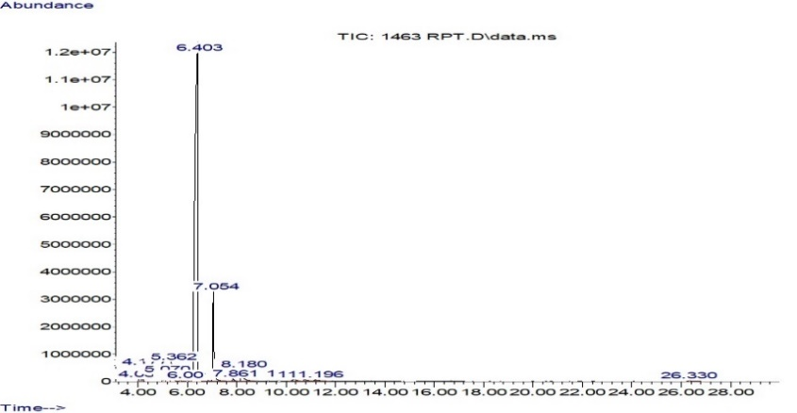

Retention time | Area percentage | Formula | Name | Properties
6.406 | 81.64 | C₁₀H₁₆ | D-limonene | Photoprotective,  Anti-inflammatory  ,Anti-Oxidant
8.179 | 2.49 | C₁₁H₁₈O₂ | 1,6 Octodien-3-ol | Anti-inflammatory,Anti-bacterial,Anti-oxidant.
7.052 | 8.16 | C₁₀H₁₆ | Gamma-terpinene | Anti-bacterial,Anti-oxidant.
5.364 | 2.25 | C₁₀H₁₆ | Beta-pinene | Anti-bacterial,Anti-deprassant, Anti-microbial.
4.174 | 1.15 | C₁₀H₁₆ | (1s)-2,6,6-trimethyl bicycle(3,1,1)hept-2-ene | Anti-microbial, Anti-bacterial

Figure 3: Phytochemical test for presence of D-limonen

Determination of ⅄ max of Orange peel oil and eucalyptus oil

The UV spectrophotometric analysis of herbal oils revealed the distinct absorption maxima corresponding to their unique phyto chemical constituents. Orange peel oil extracted in alcohol exhibited a prominent ⅄ max at 276 nm whereas Eucalyptus oil found at 310nm which were shown in the figure 4 and 5.
The ⅄ max at 276 nm for orange peel oil suggests the presence of limonene , phenolic compounds, falvonoids and terpenoids were found in citrus peel. This absorption is characteristic of aromatic or double bond system that absorbs in the UV region,indicating potential antioxidant and photoprotective properties which is attributed to these compounds.
In contrast , eucalyptus oils showed ⅄ max at 310nm, which is associated with bioactive compounds such as phenolic acid or terpenoids like eucalyptal,known to absorb at higher wavelength , possibly indicating the prsence of com[pounds responsible for anti microbial properties .
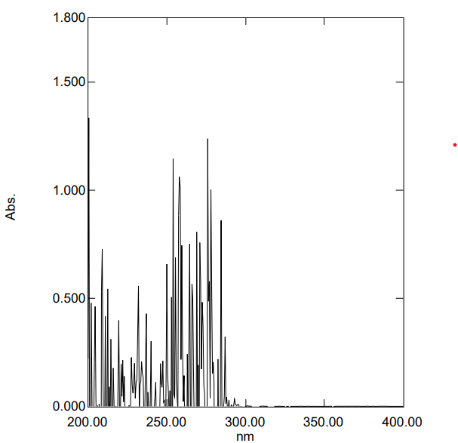
Figure 4: ⅄ max of Orange peel oil

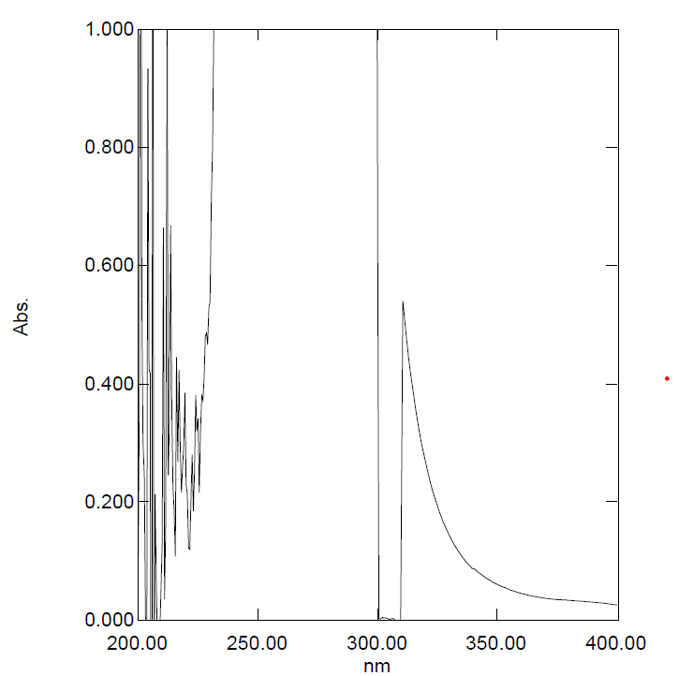
Figure 5: ⅄ max of Eucalyptus oil.
COMPATIBILITY STUDIES
Table 4: Interpretation of FT-IR
Groups | Compound class | Orange peel oil | Ethylcellulose | Carbopol
C – OH  Stretching  (3600-3200) | Alcohol | 3420.95 | 3479.26 | 3443.41
C – CH  Stretching  (2800 -2700) | Alkane | 2923.25 | 2974.86 | 2924.03
C = O  Stretching  (1700 –1725) | Carboxylic acid | 1732.45 | 1746.52 | 1730.27
C = C  Stretching  (1700 –1500) | Alkene | 1633.90 | 1644.46 | 1635.16

FTIR was performed to detect the possible interaction between Orange peel oil and other components of microsponge formulatio and to assess the degradation of selected herbal extract during the preparation of microsponges.The FT-IR spectra of Orange peel oil, Ethyl cellulose and carbopol are illustrated in figure 6-8.The extract displays peak at 3420.95 for C – OH Stretching, 2923.25 for C-CH stretching,1732.45 for C=O stretching.These obtained data confirmed that selected herb and polymers was found to be compatible with formulation as there were no physical interactions seen between the other ingredients which are used in the formulation.
Figure 6:FT-IR characteristics peak of Orange peel oil (Drug)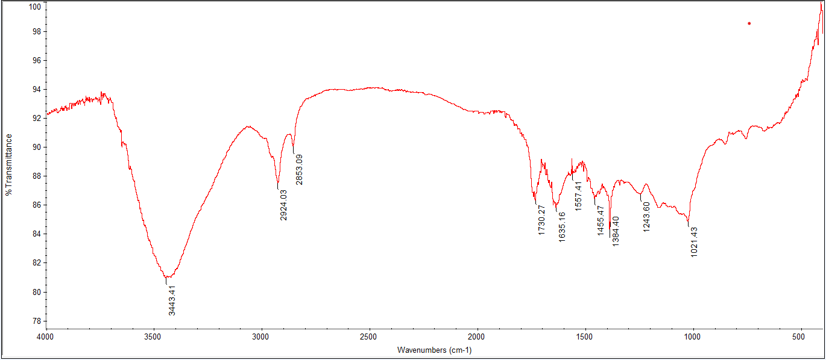 Figure 7:FT-IR characteristics of Drug + Carbopol 940

Figure 8: FT-IR characteristics of Drug + Ethylcellulose

FORMULATION OF HERBAL MICROSPONGE
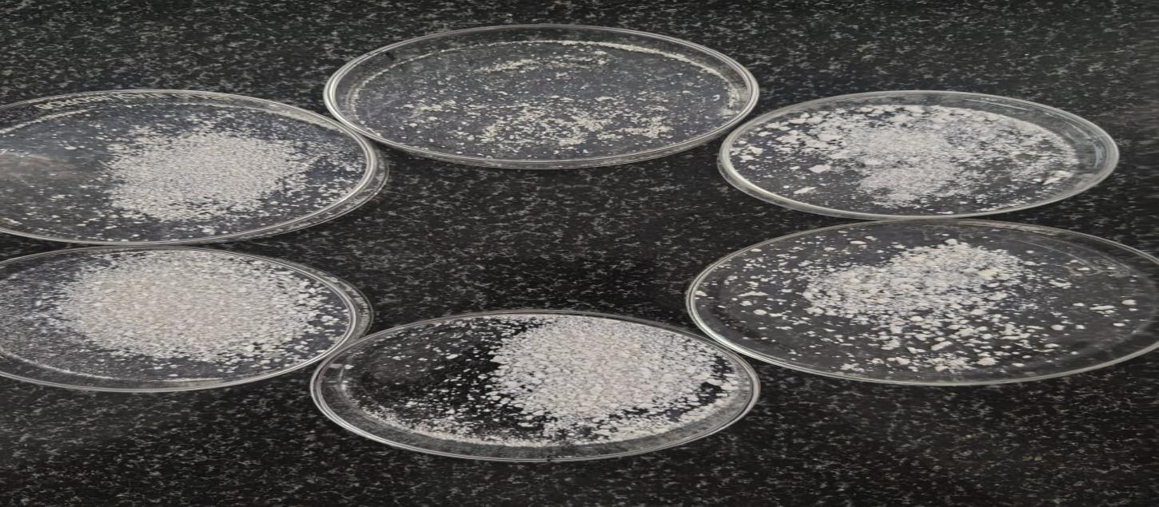
Figure 9: Prepared herbal microsponges

EVALUATION OF PREPARED HERBAL MICROSPONGES

PERCENTAGE YIELD

The % yield of prepared Herbal microsponge (F1 to F6) was in a range of 57 to 78 %.The high % yield was shown by F6.

Figure 10: % yield of microsponge

DRUG ENTRAPMENT EFFICIENCY
The drug entraptment efficiency of prepared Herbal microsponges(F1 to F6) was in the range of 52 to 71.2%.The highest % drug entrapment efficiency was shown in F2.

Figure 11: Drug entrapment efficiency of microsponges

PARTICLE SIZE ANALYSIS

The mean particle size of microsponge formulations should be in the range of 123-149 um. The F2 batch possessed more percent of intact, uniform, spherical particles in optical microscopy; so this batches was chosen for further analysis Particle size of herbal microsponge formulations were in Results of best formulation F2 shown below.

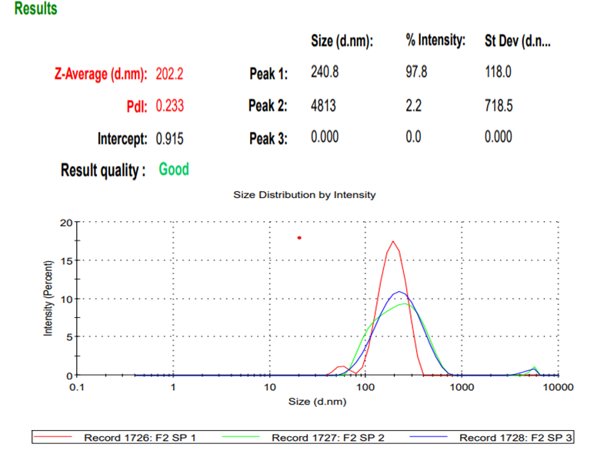

Figure 12: Particle size profile for optimized formulation F2

SHAPE AND SURFACE MORPHOLOGY
SEM analysis of the formulated microsponges was performed to evaluate the surface morphology of the microsponges.The obtained microsponges shows spherical shape. The SEM images are shown below.
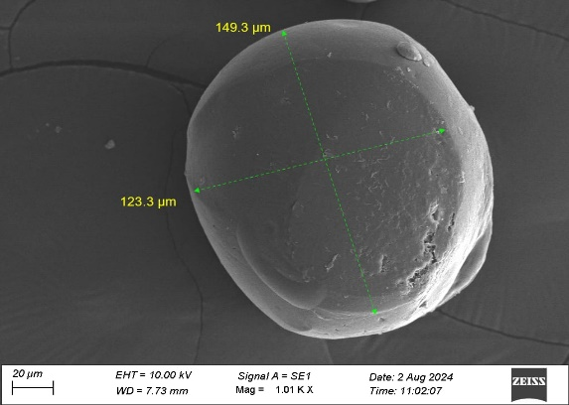

Figure 13: SEM analysis for microsponge

ZETA POTENTIAL
The best formulation F2 is carried out for zeta potential determination , where the value has to be ranging between +31 to -30 and the zeta potential value for the best formulation F2 was found to be -31.4 . Zeta potential plays an important role in maintaining the stability of the formulation.

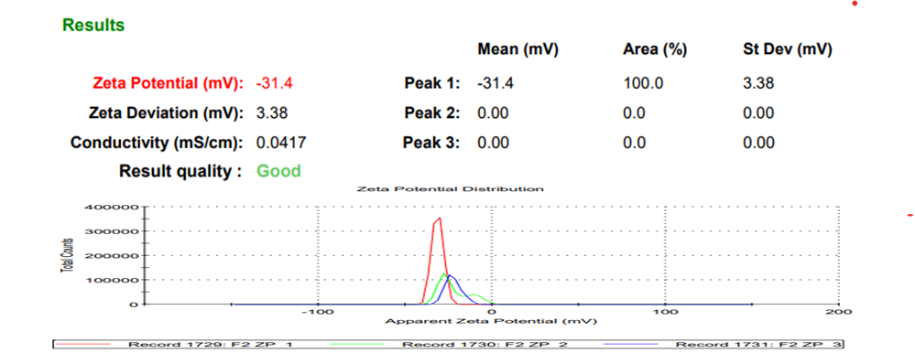
Figure 14: Zeta analysis profile for optimized formulation F2.

DIFFERENTIAL SCANNING CALORIMETRY
In DSC studies, dispersed in polymer showed the same thermal behaviour as a pure compound. In the thermogram, the endothermic peak was observed at 61 °C whereas the melting point of the pure drug extract (lemonene) is -74.35 °C. During formulation of microsponges, the drug was entrapped inside the microsponges and was not available for showing any exothermic peak. Therfore no endothermic peak near to the melting point of the drug was observed confirming the entrapment of drug in microsponges. This shows that the physical properties of citrus sinesis microsponges are altered during formulation of microsponges using ethyl cellulose .
Figure 15:DSC analysis for optimized formulation.

IN-VITRO DISSOLUTION STUDIES
In-vitro dissolution studies were performed for herbal microsponges. F2 shows the highest drug release with 92.16% .

Figure 16: In-vitro dissolution of microsponges
It was observed that the formulation F2 showed a higher amount of drug diffused at the end of 9 hr while that of F2. Formulation containing of eukalyptus oil showed the higher amount of drug diffused at 10 hrs.The results indicated that the value (cumulative amount of drug permeated per unit skin surface area) was controlled for 10 h at drug: polymer ratio . The cumulative amount of drug permeated per unit skin surface area from the microsponge loaded gel formulation was 92.16%. Hence, the microsponge loaded gel F2 formulation was taken as best and fitted to drug release kinetic studies.

EVALUATION OF HERBAL MICROSPONGE GEL
PHYSICAL PROPERTIES
The gel formulation were evaluated for its appearance in terms of colour, homogeneity and phase separation. The extracts incorporated in the formulations are White in colour. Thus, all the formulations are White in colour. No phase separation was seen and all the formulations were homogeneous.
DETERMINATION OF pH
The pH was determined and were found in the range of 5.3 ± 0.24 which were compatible with the skin pH.
SPREADABILITY
Spreadability of the Gel formulation was determined and depicted in the table .It showed that spreadability were found in the range of 29.17 ± 1.79.
VISCOSITY
Viscosity of the Gel formulation was measured by using the Brookfield viscometer . The spindle number 64 was used for the same at various RPM and result showed to 10 RPM was suitable for the formulation of gel was directly proportion with the temperature (from 29 ̊ C to 30 ̊C) were found in the range of 43,860.
DRUG CONTENT ESTIMATION
The drug content for the Gel formulation was estimated by UV visible Spectroscopy. The absorbance was checked at two different nanometers 276 nm and 310 nm and the standard curve was prepared at concentration of 5 to 20 μg/ml. The values of the Drug content of Orange peel oil were found to be 94.25% and Eucalyptus oil were found to be 68.9%.
IN-VITRO UV STUDY (SPF VALUE)
The SPF value for the Gel formulation was estimated by UV visible Spectroscopy . The SPF value were found to be in the range of 46.03 ± 2.87.
Formulation | pH | Spreadability | Viscosity | % Drug Content | SPF Value
F2 | 5.3 ± 0.24 | 29.17 ±1.79 | 43,860 | Orange oil=94.2%  Eucalyptus oil=68.9% | 46.03 ± 2.87
Table 5: Data of herbal microsponge gel for pH, spreadability, viscosity, % dug content, SPF value
IN-VITRO DIFFUSION STUDY FOR MICROSPONGE GEL
The percentage cumulative drug release of the gel formulation was found to increase gradually up to 9 hours .The drug release of gel formulation were found to be 90.66 ± 0.39 of eucalyptus oil and orange oil were found to be 96.24 ± 0.40

Figure 17 : In-vitro drug release for Eucalyptus oil and orange peel oil

SKIN IRRITATION TEST
The skin irritation test which was carried out on albino wistar rats shown the following results. The results were recorded before,after and one day after the application of formulation which was comapared with control and standards.
Signs of skin irritation | Score  (4 hours) | Score  (24 hours) | Inference
Erythema | 0 | 0 | No erythema
Oedema | 0 | 0 | No oedema
Table 6: Data of skin irritation test (Sign of erythema and oedema)

Standard (Dermaco sunscreen)
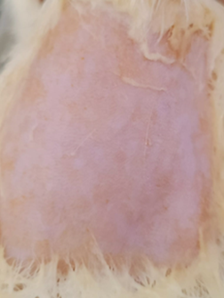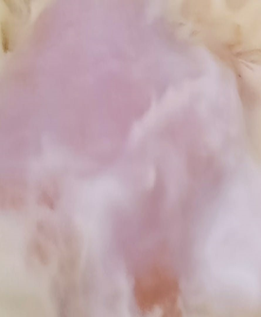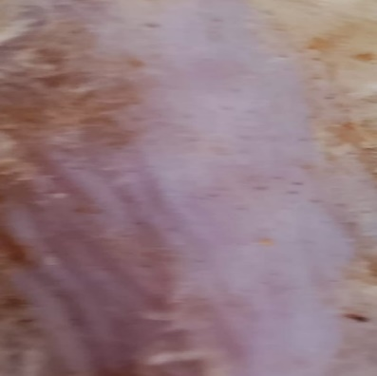
Test
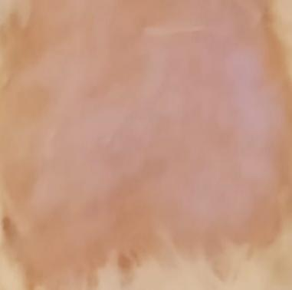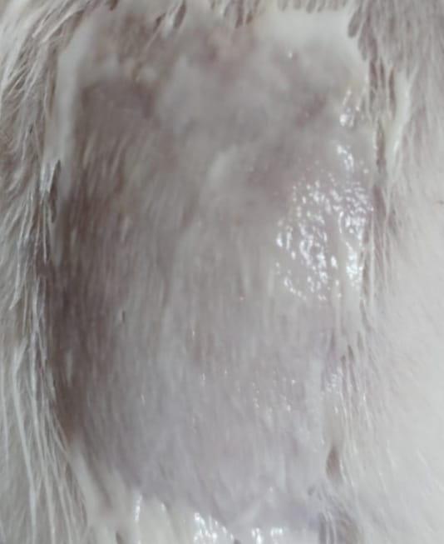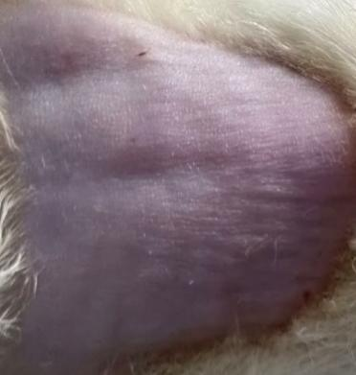
Control
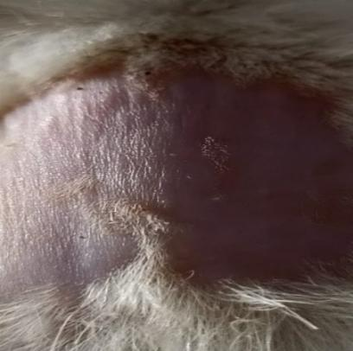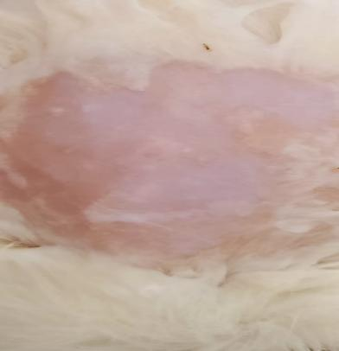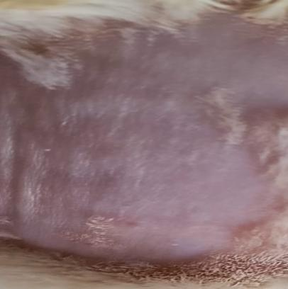
Before application After gel applied After 1 day
Figure 18:Skin irritation test on Albino Wistar rats
DRUG RELEASE KINETICS
The in vitro release pattern of herbal microsponges gel F2 was investigated using various kinetic models. Table 7 presents the R ² values for each employed model.
Korsmeyer-Peppas models had the highest R² values for in vitro drug release of F2 and as a result, this model was determined to be the best fit. The values of "n" for F2 of both herbal microsponges gels F2 of Orange peel oil and Eucalyptus oil shown in below table , displaying release following the Fickian diffusion model.
FORMULATION CODE | BEST FIT MODEL | SIGNIFICANCE
F 2 Orange peel oil | Korsmeyer-peppas model,First order(n=0.594) | Diffusion and  sustained release of drugs.
F 2 Eucalyptus oil | Korsmeyer-peppas model,First order(n=0.487) | Diffusion and sustained release of drugs.
Table 7 : Drug release kinetics

STABILITY STUDIES
Stability studies were performed for the optimized formulation F2 and result indicated that there was no significant change in the visual appearance, pH, gel viscosity ,percentage drug content and In -vitro UV study (SPF).
Table 8: Data for Stability studies
Evaluation parameters | Results
Visual appearance | White
pH | 5.2 ± 0.23
viscosity | 43790 CPS
Spreadability | 28.44 ±1.69
% drug content ( Orange oil)  ( Eucalyptus oil) | 93.8 %  67.8%
% drug release (Orange oil)  (Eucalyptus oil) | 95.66 ± 0.39  89.99 ± 0.36
SPF Value | 45.98 ± 2.56

CONCLUSION
In the present work, herbal microsponge gel was formulated to protect the skin from UV radiation.
Orange oil was extracted and subjected to active phytochemical screening of constituents present in the extract. Obtained extracts were subjected to Preliminary phytochemical screening to determine the class of compounds, and further GC-MS analysis was done to determine the major active compounds present in the extract. Eucalyptus oil was borrowed from the manufacturer.
Then, Compatibility studies were carried out between polymer and excipients. FT-IR analysis was done with Carbopol and ethyl cellulose, which are used in the formulation, and it was found that the extract and polymers were compatible with each other.
Obtained extracts studies used for the formulation of Herbal microsponge, and various Concentrations of Oils and polymer were added in the formulations. The formulation was prepared by using the Quasi-emulsion solvent diffusion method for microsponges.
The microsponges are to be tested for various evaluation tests like percentage yield determination, % drug entrapment efficiency, particle size, zeta potential, SEM analysis, in-vitro dissolution studies, and DSC analysis.
Based on % drug entrapment efficiency, the best F2 formulation because it shows the highest drug entrapped in microsponges and in in-vitro dissolution studies, F2 has the highest drug release compared to other formulations. According to these two evaluation tests, F2 formulation is best. Particle size analysis shows the size range from 129.3 to 149μm.
The prepared F2 formulation was incorporated into gel. The evaluation parameters like pH, spreadability, viscosity, drug content, in-vitro diffusion study, and also in-vitro UV studies, in-vitro release kinetics are performed.
The SPF values were found to be in the range of 46.03 ± 2.87. It shows the highest protection level. It blocks UVA, UVB, UVC radiation.
optimized formulation was subjected to a Dermal irritation test. The skin of albino Wistar rats was used to test the erythema and oedema formation with the formulation, which showed negative results with no oedema and erythema, and no irritation.
Thereafter, a stability study was carried out for the best formulation for a period of 3 months and showed no changes. This was due to the polymers and formulation responsible for maintaining stability.
Therefore, the present study satisfactorily fulfilled the aim of the desired study, giving a better and highest SPF value of 46.03 and also showed a negative result with no oedema, erythema, and no irritation.

Disclaimer (Artificial intelligence)
Author(s) hereby declare that NO generative AI technologies such as Large Language Models (ChatGPT, COPILOT, etc.) and text-to-image generators have been used during the writing or editing of this manuscript.

REFERENCES
- Sultana SS, Swapna G, Lakshmi GS, Swathi S, Jyothi GN, Devi AS. Formulation and evaluation of herbal emulgel of Lantana camara leaves extract for wound healing activity in diabetic rats. Indo American J Pharm Res. 2016; 6(8):6404-17.
- Kappor D, Patel M, Vyas RB, Lad C, Tyagi BL. A review on microsponge drug delivery system. Journal of Drug Delivery and Therapeutics. 2014 Sep 14;4(5):29-35.
- Shafi SK, Duraivel S, Bhowmik D, Kumar KS. Microsponge drug delivery system. Indian Journal of Research in Pharmacy and Biotechnology. 2013 Mar 1;1(2):206.
- Choppadandi Mounika CM, Naresh G, Abhishek Chawan AC, Prasanna RK, Raju Manda RM, Suthakaran R. Design, formulation in-vitro evaluation of herbal microsponge by using" Ricinus communis" leaf extract. World Journal of Pharmaceutical Research. 2015:4:5:1923-1940(12)
- Kaity S, Maiti S, Ghosh AK, Pal D, Ghosh A, Banerjee S. Microsponges: A novel strategy for drug delivery system. Journal of advanced pharmaceutical technology & research. 2010:1;1(3):283-90.
- Tiwari R, Singh I, Gupta M, Singh LP, Tiwari G. Formulation and Evaluation of Herbal Sunscreens: An Assessment Towards Skin Protection from Ultraviolet Radiation. Pharmacophore. 2022;13(3-2022):41-9.
- Xiaoyou Tang, Tingyi Yang, Daojiang Yu, Hai Xiong, Shuyu Zhang, Current insights and future perspectives of ultraviolet radiation (UV) exposure: Friends and foes to the skin and beyond the skin,Environment International, 185,2024; 0160-4120.
- Xu S, Kwa M, Agarwal A, Rademaker A, Kundu RV. Sunscreen product performance and other determinants of consumer preferences. JAMA dermatology. 2016 Aug 1;152(8):920- 9) Kashyap PP,Temble SP, Kakde SK, Dhawangale SD, Yeole SA. The extraction and phytochemical screening of certain flavour enhancing herbs.
10) Muruganantham V, Venkateswarlu BS, Chinraj V. Design and evaluation of isolated herbal extracts of aloin, proanthocyanidin, quercetin loaded microsponge as sunscreen gel. Asian Journal of Biological and Life Sciences. 2022 May;11(2):357.
11) Kiliçarslan M. Baykara T. The effect of the drug/polymer ratio on the properties of the verapamil HCI loaded microspheres. Int J Pharm. 2003;252:99-109.
12) Jelvehgari M, Siahi-Shadbad MR, Azarmi S, Martin GP, Nokhodchi A. The microsponge delivery system of benzoyl peroxide: Preparation, characterization and release studies. Int J Pharm. 2006 3:308(1-2):124-32.
13) Patel JK, Patel RP, Amin AF, Patel MM. Formulation and evaluation of mucoadhesive Glipizide microspheres. AAPS Pharm Sci Tech 2005;6(1):E49-E54
14) Nokhodchi A, Jelvehgari M, Siahi MR, Mozafari MR. Factors affecting the morphology of benzoyl peroxide microsponges. Micron 2007;38:834-40.
15) Gaber, D. A., Radwan, M. A., Alzughaibi, D. A., Alail, J. A., Aljumah, R. S., Aloqla, R. M., Abdoun, S. A. (2023). Formulation and evaluation of Piroxicam nanosponge for improved internal solubility and analgesic activity. Drug Delivery, 30(1).
16) Kolev I, Ivanova N, Topouzova-Hristova T, Dimova T, Koseva P, Vasileva I, Ivanova S, Apostolov A, Alexieva G, Tzonev A, Strashilov V. Ammonio methacrylate copolymer (Type B)-Diltiazem interactions in solid dispersions and microsponge drug-delivery systems. Polymers. 2022 May 23;14(10):2125.
17) Moin A, Deb TK, Osmani RA, Bhosale RR, Hani U. Fabrication, characterization, and evaluation of microsponge delivery system for facilitated fungal therapy. J Basic Clin Pharm. 2016 Mar;7(2):39-48. doi: 10.4103/0976-0105.177705. PMID: 27057125; PMCID: PMC4804404.

18) Panwar A, Upadhyay N, Bairagi M, Gujar S, Darwhekar G, Jain D. Emulgel: A review. Asian J Pharm Life Sci. 2011;2231:4423.
19) Das B, Nayak AK, Nanda U. Topical gels of lidocaine HCl using cashew gum and Carbopol 940: preparation and in vitro skin permeation. Int J Bio Macro. 2013 Nov 1;62:514-7.
20) Dasankoppa FS, Solankiy P, Sholapur HN, et al. Design, formulation, and evaluation of in situ gelling ophthalmic drug delivery system comprising anionic and nonionic polymers. Ind J.Health Sci. Biomed. Res.KLEU. 2017; 10(3):323-30.
21) Biondo NE, Argenta DF, Caon T. A Comparative Analysis of Biological and Synthetic Skin Models for Drug Transport Studies. Pharmaceutical Research. 2023 May;40(5):1209-1221. DOI: 10.1007/s11095-023-03499-9. PMID: 36959412.

22)Farsana T, Geetha VS, Jumana KK, Mubashira NP. Formulation development and evaluation of antimicrobial drug loaded microsponges for topical drug delivery. World J Pharm Res. 2023 May 20.
23) Rathod MB, Bhogeka SP, Arekar VV. Formulation and evaluation of an herbal anti-inflammatory gel containing Trigonella foenum-graecum seed extract. TIJER . 2024 May;11(5):b291.
24) Nigam V. Emulgel: A dual release system for hydrophobic drug delivery. World Journal of Biology Pharmacy and Health Sciences.
.

