Kalicephalus (Schadius) bilaspurense n.sp. (Nematoda: Diaphanocephalidae): A parasite of Bengal lizard, Varanus bengalensis (Daudin, 1802) in Bilaspur, Himachal Pradesh, India

ABSTRACT: Kalicephalus species are nematode parasites commonly found in the intestines of reptiles. In the present study, Kalicephalus (Schadius) bilaspurense n.sp. (Nematoda: Diaphanocephalidae) recovered from the small intestine of Bengal lizard, Varanus bengalensis (Daudin, 1802) collected at village Naswal, Ghumarwin, District Bilaspur, Himachal Pradesh, India is described. The worms were killed and fixed in formalin and cleared in bulk in lactophenol for microscopic examination. The new species differs from the congeners, mainly oesophagus claviform with three oesophageal teeth; genital cone with two pairs of papillae; shape and size of species and tips of spicules, spatula shaped; gubernaculum lamina shaped and presence of telemon. Moreover, Kalicephalus spp. serves as ecological regulators of its host (Bengal lizard) populations.

Keyword: Nematode, bacterial infections, life cycle, growth.

INTRODUCTION: Some nematode species found in wild animals can be transmitted to humans (zoonotic) to affect human health (Purwaningsih, 2011). Kalicephalus belongs to family Diaphanocephaloidea, found in the small intestines and are hookworm-like nematode parasites (Matt et al., 2020; Larki et al., 2023). Life cycle, growth patterns, and physical features of Kalicephalus are similar to hookworms but they are not part of the hookworm superfamily Ancylostomatoidea (Anderson, 2000). The eggs laid by females develops into third-stage larvae in the surrounding environment and have thin shells and contain morula (Anderson, 2000; Matt et al., 2020). Numerous gastrointestinal problems can be caused by this Kalicephalid nematode in its host, from mild inflammation of the intestines to more serious conditions such as enteritis to anorexia, dyspnoea, and dysentery. Moreover it can also cause secondary bacterial infections in severe cases, and even death (Junker et al., 2009).
The Bengal lizard (Varanus bengalensis) can be found in diverse habitats, including those affected by human activities. It is a large, adaptable species which is well known for its ecological adaptability (Jaman et al., 2024). It weighs about 7.2 Kg with a 100 cm tail and can grow up to 175 cm in snout-to-vent length. Generally males are larger than females. Some Varanus species exhibit arboreal or semiaquatic habits while most of them are land-dwelling carnivores (Doneley et al., 2018; Cieri, 2018). Bengal lizards preys on insects, rodents, bird eggs, snakes, fish, and crabs therefore, maintains ecological balance in agricultural and forest ecosystems. However, exploitation of their body parts in traditional medicine causing a serious decline in their number (Evans, 1986; Freedman and Wayne, 2017; Islam et al., 2023). The aim of the present study is to recover the Kalicephalus (Schadius) bilaspurense n.sp. (Nematoda: Diaphanocephalidae) from the small intestine of Bengal lizard, Varanus bengalensis.
During nematode parasite study survey, 15 specimens of the present species were recovered from the small intestine of the host Varanus bengalensis (Daudin, 1802), the carcass of which found along the roadside at village Naswal, Ghumarwin, District Bilaspur, Himachal Pradesh, India. The species has been described and discussed in the light of already known species of the subgenus Kalicephalus (Schadius), Litchenfels, 1980 and has been found new to science.

MATERIAL AND METHODS: The specimens were recovered from the small intestine of the host Varanus bengalensis (Daudin, 1802), at village Naswal, Ghumarwin, District Bilaspur, Himachal Pradesh, India in the month of April, 2010. The worms were killed and fixed in formalin and cleared in bulk in lactophenol for microscopic examination, as per ethical approval of Department of Biosciences, Himachal Pradesh University, Shimla. The sketches incorporated were made with the help of camera lucida and measurements were taken with the help of ocular and stage micrometers and Scanning Electron Microscopic (SEM) micrographs JSM-6100. All the specimens (Holotypes and Paratypes) were deposited in the Parasitic Collection of Parasitology Laboratory (PCPL), Department of Biosciences, Himachal Pradesh University Shimla, India.

Description: (based on 4 males and 5 females) Worm medium sized, head directed anteriorly, male longer than the female; buccal capsule complex, bivalved in appearance, buccal capsule composed of 4 pairs of anterior plates, one pair of posterior and one pair of posterior dorsal pieces; anterior ridge bears two lips, delimited by peri-oral groove (Fig.1, 2); oral opening dorso-ventrally elongated, bears two lips, it contains one pair of amphids and three pairs of papillae (Fig. 8, 9); nerve ring located in the anterior of oesophagus; cervical papillae/deirids just behind the nerve ring; excretory pore at the anterior end of intestine/ just behind the oesophagus; oesophagus claviform with 3 oesophageal teeth (Fig. 1).
Male: Body 7.32-7.92 long, 0.224-0.280 in maximum thickness; buccal capsule 0.176-0.184× 0.16 in size; oesophagus 0.416-0.44 in length and 0.12-0.128 in width; nerve ring 0.216-0.24 and excretory pore 0.40-0.44 from the cephalic extremity; caudal bursa trilobed, dorsal lobe projecting the lateral lobes; ventral rays parallel and almost approaching the bursal margin, lateral rays unequal, running parallel, externo-lateral shorter than the medio-lateral and latero-lateral, not attaining the bursal margin; externo- dorsal arising from the common trunk just in the middle, shorter and not reaching the bursal margin; dorsal ray bifurcates distally and each branch further trifurcate (Fig. 3, 4,10); genital cone small with two pairs of genital papillae; spicules 6.48-6.92 long equal, thin, alate almost three quarter of the body length, tip of each spicule is spatula shaped (Fig. 3, 5); gubernaculum 0.114-0.124 long and lamina shaped; telemon small 0.047-0.057 long and ring shaped (Fig. 3, 5).
Female: Body 6.48-6.88 long, 0.28-0.36 in maximum thickness; buccal capsule 0.2-0.21× 0.21-0.216 in size; oesophagus 0.48-0.496 in length and 0.144-0.16 in thickness; nerve ring 0.24-0.25 and excretory pore 0.44-0.48 from the cephalic extremity; utri prodelphic (Fig. 6); vulva anterior to anus, 0.48-0.56 from the tip of tail (Fig. 6, 11, 12); eggs 0.046-0.063× 0.028-0.034 in size (Fig. 7); tail short, pointed 0.176-0.20 in length with a small papilla at the tip (Fig. 6, 12).
Results
Kalicephalus (Schadius) bilaspurense n.sp.
Taxonomic Summary
Type Host: Dragon lizard, Varanus bengalensis (Daudin, 1802)
Site of Infection: Small Intestine
Type Locality: Naswal district Bilaspur (H.P.)
Specimens deposited: Holotype (male), allotype (female); PCPL 01 each, paratype.
Date of collection: April, 2010
Etymology: The specific epithet refers to the locality of the host.
Differential diagnosis: Oesophagus claviform with three oesophageal teeth; genital cone with two pairs of genital papillae; spicules thin, 6.48-6.92 long with spatula shaped spicular tips; gubernaculum 0.114-0.124 long; telemon small 0.047-0.057 in size.
Specific diagnosis: Oesophagus claviform with three oesophageal teeth; spicules thin, 6.48-6.92 long more than the three quarter of the body, with spatula shaped spicular tips; telemon present.

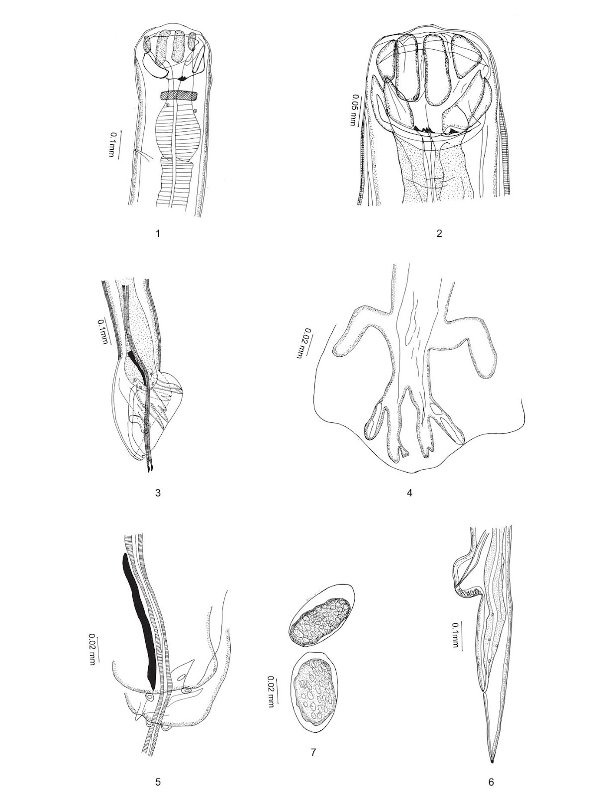
Figures: Anterior region of female (lateral view, 1), Anterior region of female (lateral view) enlarged (2), Posterior region of male (lateral view, 3), Dorsal bursal rays, enlarged (4), Cloacal region of male, enlarged (5), Posterior region of female (lateral view, 6), and Eggs, enlarged (7).

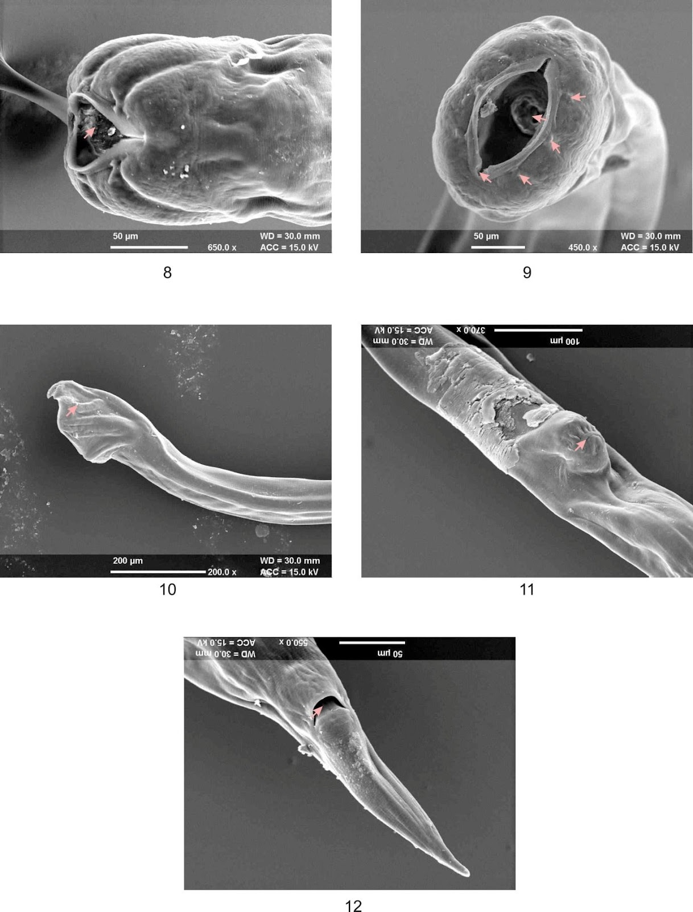
Figures: SEM Photographs of Anterior region, ventral view (8), Enface view (9), Posterior region of male, lateral view (10), Vulvar region, ventral view (11) and Posterior region of female, ventral view (12).

DISCUSSION AND CONCLUSION
Head directed anteriorly; oesophagus stout and short; cervical papillae small; dorsal ray bifurcates and each branch further trifurcates distally; genital cone small with two pairs of papillae; gubernaculum lamina shaped; spicules thin, long almost three quarter of total length of the body; tips of spicules spatula shaped; tail of female short and pointed; the present species has been assigned as Kalicephalus, Molin, 1861.
Schad (1962) revised the genus Kalicephalus, and arranged the species of this genus into six groups. Litchenfels (1980) divided this genus into six subgenera. However, Baker (1987) noticed that the subgeneric name, Kalicephalus (Kalicephalus), was not used in the classification of Litchenfels (1980) which is required by the International Code of Zoological Nomenclature. In the key to subgenera given by Litchenfels (1980), the type of species of this genus Kalicephalus, K. costatus, belongs to the new subgenus Kalicephalus (Schadius). Therefore, Baker (1987) regarded Kalicephalus (Schadius) Litchenfels, 1980 as synonym of Kalicephalus (Kalicephalus) Molin, 1861.
This species has vulva closer to anus than to mid-body in mature worms; uteri prodelphic; spicules equal and thin and species belong to subgenus Kalicephalus (Schadius) Litchenfels, 1980 (Syn Kalicephalus (Kalicephalus) Molin, 1861).
The present species is similar to Kalicephalus (Kalicephalus) schadi Ogden, 1966 and Kalicephalus (Kalicephalus) schadi fotedari Kalia and Nayital, 1989, spicules long, thin, almost three quarters of length 7.75-8.60 long; genital cone with two digitiform papillae and Kalicephalus (Schadius) guangdongenesis Zhang et al. 2011, spicules extremely long (longer than the body length); genital cone rounded with two digitiform papillae dorsal to cloacal opening. This species differs from the above said species having oesophagus claviform with three oesophageal teeth; genital cone with two pairs of papillae and spicules 6.44-6.92 long, thin, alate, tips of spicules spatula shaped; gubernaculum lamina shaped 0.114-0.124 long and presence of telemon which is absent in above said species. It was concluded from the study that the present species is new to science and named after the locality of the host.
COMPETING INTERESTS: The authors declare that they have no conflict of interest.
ACKNOWLEDGEMENT The authors extend their gratitude to the Department of Biosciences, Himachal Pradesh University, Shimla, Himachal Pradesh for providing lab facilities to carry out the research work.
Ethical Approval
Animal Ethic committee approval has been collected and preserved by the author(s)
Disclaimer (Artificial intelligence)
Option 1:
Author(s) hereby declare that NO generative AI technologies such as Large Language Models (ChatGPT, COPILOT, etc.) and text-to-image generators have been used during the writing or editing of this manuscript.
Option 2:
Author(s) hereby declare that generative AI technologies such as Large Language Models, etc. have been used during the writing or editing of manuscripts. This explanation will include the name, version, model, and source of the generative AI technology and as well as all input prompts provided to the generative AI technology
Details of the AI usage are given below:
1.
2.
3.
REFERENCES
Anderson RC. Nematode parasites of vertebrates: their development and transmission. City, Cabi; 2000.
Baker, M.R. 1987. Synopsis of the Nematoda parasitic in amphibians and reptiles. Memorial University of New-foundl and Occasional Paper in Biology, 11: 1-325.
Cieri, R. L. (2018). The axial anatomy of monitor lizards (Varanidae). Journal of Anatomy, 233(5), 636-643.
Daudin, F.M. 1802. Histoire naturelle, generale et particuliere des reptiles; Ouvrage faisant suite a l` Histoire naturelle generale et particuliere, et redigee par C.S. Sonnini, member de plusieurs societies savants. Tome troisieme. Pp 1-452, Pl. XXIX-XLIV Paris.
Doneley, B., Monks, D., Johnson, R., Carmel, B., & Wiley, J. (Eds.). (2018). Reptile medicine and surgery in clinical practice (pp. 425-439). Oxford, UK:: Wiley Blackwell.
Evans HE. Reptiles: introduction and anatomy, in Zoo and Wildlife Medicine, 2nd Ed. W.B. Saunders, Philadelphia. 1986:108-32.
Freedman, A. H., & Wayne, R. K. (2017). Deciphering the origin of dogs: from fossils to genomes. Annual review of animal biosciences, 5(1), 281-307.
Islam, M. K., Mussa, M. T., Talukder, S., Hossain, H., & Siddiqui, M. S. I. (2023). Investigation of the axial skeleton of Bengal monitor lizard (Varanus bengalensis): A macroanatomical study. DYSONA-Life Science, 4(1), 23-29.
Jaman, M. F., Ahmed, S., Hossain, S., & Rabbe, M. F. (2024). Activity budget of Bengal Monitor Varanus bengalensis: Effect of daytime, season, age and temperature. Heliyon, 10(7).
Junker, K., Lane, E. P., Dlamini, B., Kotze, A., & Boomker, J. (2009). Post mortem identification of Kalicephalus colubri colubri (Nematoda: Diaphanocephalidae) in a captive Mole snake (Pseudaspis cana) in South Africa: clinical communication. Journal of the South African Veterinary Association, 80(1), 54-56.
Kalia, D.C. and Nayital, A.K. 1989. A new subspecies record of Kalicephalus Molin, 1861 (Nematoda: Diaphanocephaloidea) from jackal; hitherto a cosmopolitan parasite of snakes. Indian journal of Parasitology, 13: 135-138.
Larki, S., Alborzi, A., Bahramnejad, K., & Asadi, Z. (2023). The occurrence of the strongylid nematodes, Kalicephalus viparae viparae (nematoda: Diaphanocephalidae), in viper snakes, Macrovipera lebetina (Reptilia: Viperidae), Southwestern Iran. Archives of Razi Institute, 78(2), 611.
Litchenfels, J.R. 1980. Key to genera of the Superfamilies Ancylostomatoidea and Diaphanocephaloidea. Pages 1-26 in R.C.Anderson and A.G.Chabaud, eds. CIH Keys to the Nematode Parasites of Vertebrates. Commonwealth Agricultural Bureaux, Farnham Royal, U.K.
Matt, C. L., Nagamori, Y., Stayton, E., & Brandão, J. (2020). Kalicephalus hookworm infection in four corn snakes (Pantherophis guttatus). Journal of Exotic Pet Medicine, 34, 62-66.
Matt, C. L., Nagamori, Y., Stayton, E., & Brandão, J. (2020). Kalicephalus hookworm infection in four corn snakes (Pantherophis guttatus). Journal of Exotic Pet Medicine, 34, 62-66.
Ogden, C.G. 1966. On some parasitic nematodes from reptiles, mainly from Ceylon. Journal of Helminthology, 40: 81-90.
Purwaningsih, E. (2011). New host and locality records of snake intestinal nematode Kalicephalus spp in Indonesia. Asian Pacific Journal of Tropical Biomedicine, 1(2), 121-123.
Schad, G.A. 1962. Studies on the genus Kalicephalus (Nematoda: Diaphanocephalidae). II. A taxonomic revision of the genus Kalicephalus Molin, 1861. Canadian Journal of Zoology, 40: 1035-1166.
Zhang, H., Zhang, S. and Zhang, L. 2011. Two species of the genus Kalicephalus Molin, 1861 (Nematoda: Diaphanocephaloidea) from the water monitor, Varanus salvator (Laurenti, 1768) in Guangdong Province, China. Acta Parasitologica, 56(1): 48-53.

