Short research Article

Molecular Validation of Catla catla and Labeo rohita among Morphologically Identified Fish Species in Narmada River of Madhya Pradesh, India

Abstract
Freshwater ecosystems are crucial for biodiversity, ecological balance, and livelihoods through aquaculture and fisheries. Precise identification of fish species is essential for understanding biodiversity, assessing ecosystem health and guiding conservation strategies. The Narmada River, a biodiversity-rich ecosystem in India, hosts ecologically and economically significant fish species. Morphological identification, though widely used, is often limited by phenotypic and environmental variations, leading to misidentifications. To address this, the study integrates molecular and traditional taxonomic techniques to validate species identification. A total of 20 fish specimens were collected from seven locations along the river. Morphological analysis identified several species, with Catla catla and Labeo rohita selected for molecular validation. DNA barcoding of the mitochondrial cytochrome c oxidase I (COI) gene confirmed their molecular identity, reinforcing the accuracy of morphological classification. This study emphasizes the value of DNA barcoding in uncovering cryptic biodiversity and enriching molecular databases. The findings offer critical insights into genetic diversity, species distribution, and conservation efforts, highlighting the ecological and economic importance of key species such as Catla catla and Labeo rohita. Moreover, the study provides a replicable framework for biodiversity assessments and sustainable aquaculture practices.

Keywords: Narmada River, COI Gene, Variation, DNA Barcoding, mitochondrial cytochrome c oxidase I (COI) gene, molecular validation, biodiversity assessments

Introduction

The accurate identification of fish species is fundamental to biodiversity conservation, sustainable fishery management, and advanced immunological studies. The Narmada River, one of the major rivers in central India, supports diverse aquatic ecosystems and provides a habitat for various economically and ecologically significant fish species. Among these, Catla catla (Indian major carp) and Labeo rohita (rohu) are of prime importance due to their pivotal role in aquaculture and their nutritional value in the human diet. Despite their significance, the morphological identification of fish species remains susceptible to inaccuracies caused by phenotypic plasticity, ontogenetic variations, and environmental influences (Ward et al., 2005; Ward et al., 2009).Advances in molecular biology have introduced robust genetic tools for species identification that complement traditional morphological approaches. DNA barcoding and other molecular techniques enable researchers to overcome the limitations of morphological identification by providing precise and reproducible results (Zafar et al.,2024;Eeman et al.,2024). Such methods involve analyzing genetic markers, such as mitochondrial DNA (cytochrome oxidase I gene), which exhibit sufficient interspecific divergence (Hebert et al., 2003). Molecular identification, therefore, serves as a powerful tool for resolving taxonomic ambiguities and confirming species identity with confidence.

In the context of immunological studies, accurate species identification is crucial as genetic variations between species can influence immune response mechanisms and pathogen susceptibility (Nguyen, 2024;Butt et al.,2023). The immunological attributes of C. catla and L. rohita have garnered significant attention due to their resilience against diseases and their potential as models for understanding fish immunity (Mohanty et al., 2019). A thorough molecular identification of these species will not only strengthen the reliability of immunological studies but also aid in the development of disease-resistant fish strains through selective breeding programs. The present study aims to perform the molecular identification of C. catla and L. rohita among the morphologically identified fish species in the Narmada River, Madhya Pradesh. By combining traditional morphological methods with molecular tools, this research seeks to enhance our understanding of the genetic diversity and immunological potential of these species, contributing to the broader goals of sustainable aquaculture and fishery management.

Materials and methods

Geographical Context of the Study: This study was conducted in the Narmada River, a vital freshwater ecosystem in central India known for its ecological diversity and economic importance. The research focused on multiple sites within the Narmadapuram District of Madhya Pradesh, an area characterized by diverse aquatic habitats that support a wide variety of fish species. Five sampling locations were carefully chosen to encompass different ecological zones and habitat types, ensuring thorough representation of the river's fish biodiversity.

Fish Collection and Sampling Techniques: Fish specimens were collected using a range of traditional fishing methods, including cast nets, gill nets, and hand nets. These techniques provided an efficient way to capture species of various sizes and ecological preferences. Seasonal sampling campaigns were conducted to account for temporal variations in fish diversity and abundance. Collected specimens were treated carefully to minimize stress and injury during the process. Initial identification was performed using standard morphological techniques and taxonomic keys (Jayaram, 1999).

Preservation and Transportation of Tissue Samples: To prepare specimens for molecular analysis, fin clips were excised from each morphologically identified fish. The tissue samples were promptly preserved in 95% ethanol to ensure the integrity of the DNA. After proper labeling, the samples were transported to the laboratory under controlled conditions to prevent degradation during transit.

DNA Extraction Protocol: DNA was extracted from the preserved tissue samples using the phenol-chloroform method as outlined by Sambrook and Russell (2001). This widely used protocol is effective for obtaining high-quality genomic DNA suitable for downstream applications. The extracted DNA was quantified using a spectrophotometer to ensure the concentration and purity of the samples was adequate for subsequent molecular procedures.

Molecular Target and PCR Optimization: The mitochondrial cytochrome c oxidase I (COI) gene, a reliable marker for DNA barcoding, was chosen for species identification. Polymerase chain reaction (PCR) amplification was carried out using universal primers (Vrijenhoek, 1994). Reaction parameters, such as annealing temperature and cycling conditions, were optimized to achieve high efficiency and specificity for the gene of interest. The amplified DNA fragments were visualized on an agarose gel to confirm their quality and expected size.

Purification and Sequencing of PCR Products: Successfully amplified PCR products were purified using a commercial PCR purification kit (Himedia). This step ensured the removal of contaminants that could interfere with sequencing. The purified products were then sequenced using the Sanger sequencing method, recognized for its accuracy in generating high-quality nucleotide sequences.

Data Analysis and Species Confirmation: The raw sequence data obtained through sequencing were edited and assembled using BioEdit software (Hall, 1999) to eliminate errors. These processed sequences were compared against reference databases, such as the Barcode of Life Data System (BOLD) and GenBank, using BLAST searches. This comparison confirmed the molecular identity of the species and validated the results obtained from morphological identification.

Results and Discussion

The morphological examination of the collected fish specimens identified multiple species belonging to the Cyprinidae family, as previously documented by Swain et al. (2012). Among these, Catla catla and Labeo rohita were prioritized for molecular validation due to their ecological relevance and central role in aquaculture systems. Taxonomic keys were employed for morphological classification; however, environmental influences and phenotypic variability posed limitations, making precise species identification challenging. These challenges emphasized the value of molecular approaches for accurate species confirmation (Lenka et al., 2024; Rahman, 2023).

To ensure reliable molecular identification, high-quality genomic DNA was extracted and subsequently amplified using primers specific to the cytochrome c oxidase I (COI) gene. The resulting DNA fragments, approximately 655 base pairs in size, were confirmed via gel electrophoresis (Figure 2), demonstrating both integrity and expected amplification. Sequence analysis of these fragments through databases such as GenBank and the Barcode of Life Data System (BOLD) revealed 100% alignment with reference sequences of Catla catla and Labeo rohita.
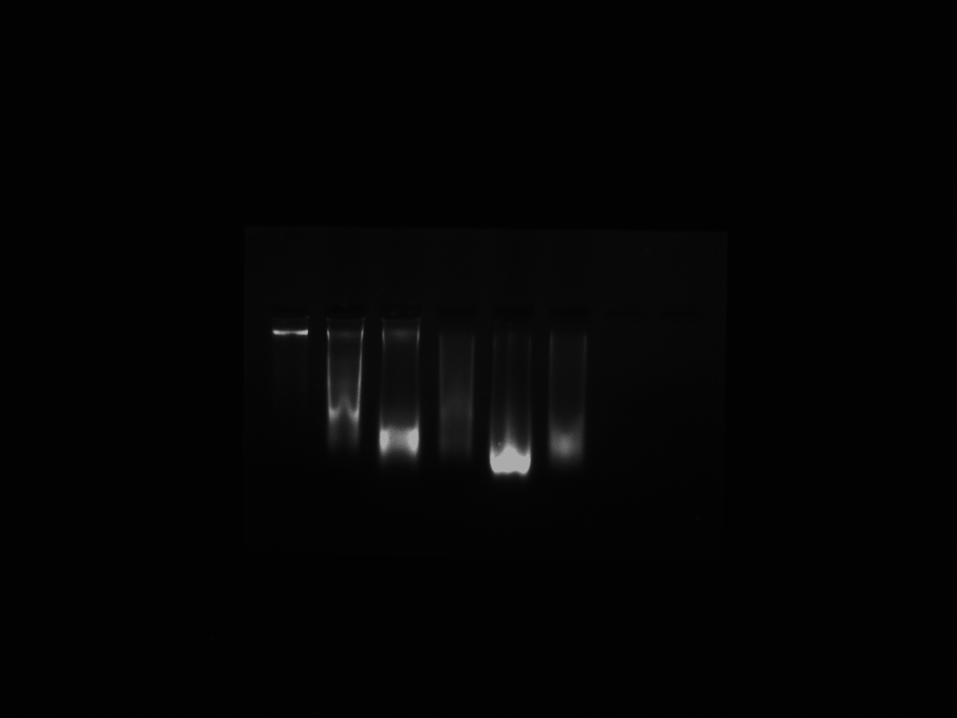

Figure 1 provides a visual reference of the genomic DNA extracted from fish specimens analyzed in this study, reflecting the consistent quality of the samples processed.
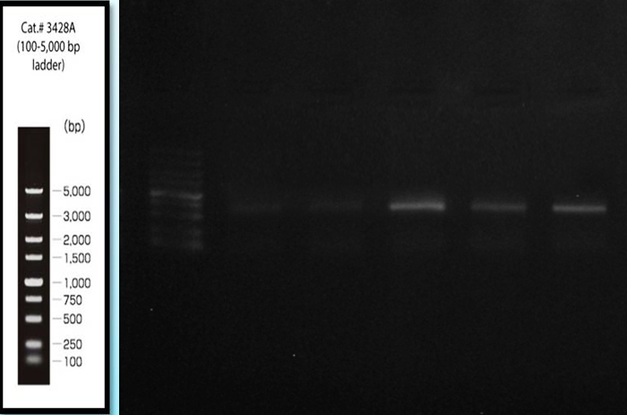

Figure 2: COI gene Desired gene fragment 655bp amplification.

Beyond confirming species identity, the study brought to light indications of potential cryptic species organisms that appear identical in external morphology but differ significantly at the genetic level. This finding is particularly relevant in freshwater ecosystems such as the Narmada River, where biodiversity is high and many species remain poorly documented. The presence of genetically distinct but morphologically similar fish suggests that traditional identification methods may overlook important components of biodiversity. This reinforces the need to incorporate molecular tools, such as DNA barcoding, into regular biodiversity assessments to improve the accuracy and resolution of species identification.

Recognizing cryptic species has important implications for conservation and resource management. It allows for a more precise understanding of species distributions and population structures, which is essential for developing effective conservation strategies. In ecosystems facing increasing anthropogenic pressures, such as pollution, habitat modification, and overfishing, the ability to detect and protect genetically unique populations becomes critical. The genetic data generated in this study not only support the initial morphological classifications but also contribute to India’s growing database of freshwater fish genomics, helping to fill gaps in national biodiversity records. In addition to its taxonomic contributions, the molecular characterization of Catla catla and Labeo rohita provides a valuable foundation for future research. These species are central to aquaculture in India, and understanding their genetic makeup can aid in studies related to immune function, disease resistance, and overall health. Such research is essential for improving aquaculture practices, especially in the face of challenges like disease outbreaks and environmental stress. Previous studies by Ahmad et al. (2022) and Ahmad et al. (2020) have emphasized the importance of genetic insights in enhancing fish resilience and productivity, and the present findings align with those efforts.

Finally, the ecological and economic importance of Catla catla and Labeo rohita cannot be overstated. As primary consumers in the Narmada River ecosystem, they play a vital role in maintaining ecological balance. At the same time, they are key species in local aquaculture, supporting the livelihoods of many communities. Ensuring their conservation through informed and targeted strategies is essential not only for sustaining biodiversity but also for securing food and income for populations that depend on inland fisheries.

Conclusion

This study demonstrates the effectiveness of combining traditional morphological techniques with modern molecular tools for the accurate identification of fish species in freshwater ecosystems. The integration of DNA barcoding with morphological taxonomy offers a robust framework for species validation, enriching our understanding of biodiversity while addressing challenges like cryptic diversity and taxonomic ambiguities.
Disclaimer (Artificial intelligence)
Author(s) hereby declare that NO generative AI technologies such as Large Language Models (ChatGPT, COPILOT, etc.) and text-to-image generators have been used during the writing or editing of this manuscript.
References
Ahmad, M., Zuberi, A., Ali, M., Sherzada, S., & Noorullah, M. (2022). Identification and determination of phylogenetic relationship among Labeo rohita, Labeo catla and their reciprocal hybrids by traditional and molecular tools. Aquaculture Research, 53(7), 2686-2696.
Ahmad, M., Zuberi, A., Ali, M., Syed, A., Khan, A., & Kamran, M. (2020).Effect of acclimated temperature on thermal tolerance, immune response and expression of HSP genes in Labeo rohita, Catla catla and their intergeneric hybrids. Journal of Thermal Biology, 89, 102570.
Butt, M., Perveen, S., Rasool, F., Ayub, A., Ali, K., Sajjad, A., ... & Magsi, A. S. (2023). Genetic variation between hybrid (Labeo rohita♂, Cirrhinus mrigala♀ and Labeo rohita) by RAPD marker. Brazilian Journal of Biology, 84, e268551.
Eeman, A., Naz, S., Chatha, A. M. M., & Iqbal, S. S. (2024). Morphological and Genetic Identification of Fish Species of River Ravi, Pakistan. Current Trends in OMICS, 4(2), 77-101.
Hall, T. A. (1999). BioEdit: A user-friendly biological sequence alignment editor and analysis program for Windows 95/98/NT. Nucleic Acids Symposium Series, 41, 95–98.
Hebert, P. D. N., Cywinska, A., Ball, S. L., & deWaard, J. R. (2003).Biological identifications through DNA barcodes.Proceedings of the Royal Society of London. Series B: Biological Sciences, 270(1512), 313–321.
Jayaram, K. C. (1999). The freshwater fishes of the Indian region.Narendra Publishing House.
Lenka, P., Singh, N., Ghosh, D., Mahadani, P., & Ghosh, S. (2024). Integrated morphometric and molecular approaches to screen hybrid from wild Labeo rohita and Labeo catla parent populations. Molecular Biology Reports, 51(1), 738.
Mohanty, B. P., Mahanty, A., Ganguly, S., Mitra, T., Karunakaran, D., &Anandan, R. (2019).Nutritional composition of food fishes and their importance in providing food and nutritional security.Food Chemistry, 293, 561-570.
Mushagalusa Mulega, A., Boom, A. F., Rahmouni, I., Bazairi, H., Benhoussa, A., Vanhove, M. P., & Van Steenberge, M. (2024). Catfishes from the North-Western Part of Lake Tanganyika: Contribution to a Reference Library of DNA Barcodes. Diversity, 17(1), 8.
Nguyen, N. H. (2024). Genetics and genomics of infectious diseases in key aquaculture species.Biology, 13(1), 29.
Rahman , M. H., Alam , M. A., Flura, Moniruzzaman , M., Sultana , S., & Das , B. C. (2023). Growth Performance and Muscle Composition of Carps (Labeo rohita, Catla catla, Cirrhinus cirrhosus and Hypophthalmichthys molitrix) at Different Protein Diets under Polyculture Farming. Asian Journal of Fisheries and Aquatic Research, 24(3), 35–43. https://doi.org/10.9734/ajfar/2023/v24i3635
Sambrook, J., & Russell, D. W. (2001). Detection of DNA in agarose gels. In Molecular Cloning, A Laboratory Manual (3rd ed.). Cold Spring Harbor Laboratory Press.
Swain, B., Samanta, M., Basu, M., Panda, P., Sahoo, B. R., Maiti, N. K.,& Eknath, A. E. (2012). Molecular characterization, inductive expression and mechanism of interleukin‐10 gene induction in the Indian major carp, catla (Catla catla). Aquaculture Research, 43(6), 897-907.
Vrijenhoek, R. (1994). DNA primers for amplification of mitochondrial cytochrome c oxidase subunit I from diverse metazoan invertebrates.Molecular Marine Biology and Biotechnology, 3(5), 294–299.
Vu, H.-T., & Le, L. (2019). Bioinformatics Analysis on DNA Barcode Sequences for Species Identification: A Review. Annual Research & Review in Biology, 34(1), 1–12. https://doi.org/10.9734/arrb/2019/v34i130142
Ward, R. D., Hanner, R., & Hebert, P. D. N. (2009).The campaign to DNA barcode all fishes, FISH-BOL.Journal of Fish Biology, 74(2), 329–356.
Ward, R. D., Zemlak, T. S., Innes, B. H., Last, P. R., & Hebert, P. D. N. (2005). DNA barcoding Australia's fish species.Philosophical Transactions of the Royal Society B: Biological Sciences, 360(1462), 1847-1857.
Zafar, S., Jabeen, F., Ali, M., & Sajjad, A. (2024). Assessment of genetic diversity of freshwater genus Labeo through DNA barcoding and phylogenetic analysis inhabited in the River Indus. Journal of King Saud University-Science, 36(4), 103123.

