LENGTH–WEIGHT RELATIONSHIP AND CONDITION FACTOR OF MUDSKIPPER, Periophthalamus barbarus (LINNEAUS 1766) FROM IKO RIVER ESTUARY,
NIGER DELTA REGION, NIGERIA

ABSTRACT
This study investigates the length-weight relationship and the condition factor of Periophthalamus barbarus from Iko estuary, situated in the Niger Delta Region of Nigeria. A total of 180 specimens were collected over a six-month period (December 2021 to May 2022) through monthly sampling using traditional fishing methods, including hand picking and locally constructed traps. The total length and body weight of male specimens ranged from 2.50 to 14.70 cm and 2.50 to 25.30g, respectively, while those of females ranged from 6.50 to 14.40cm and 2.10 to 23.60g. The length-weight relationship for males was best described by the equation W=0.0115L^{2.5655}, and for females by W=0.0245L^{2.642}, indicating a negative allometric growth pattern in both sexes (with b-values<3). The Fulton’s condition factor (K) ranged from 0.799 to 1.043 in males and 0.815 to 1.019 in females, suggesting relatively good health and favourable environmental conditions for growth and survival. The findings imply that P.barbarus in the Iko River Estuary exhibit moderate well-being and energy reserves, although the negative allometric growth may reflects adaptive strategies to the estuarine habitat. This study provides essential baseline data for ecological monitoring and fishery management of P.barbarus in the Niger Delta estuarine ecosystem.

Keywords: Gobiidae, ecological system, length-weight relationship, negative allometric

1.0 Introduction:
The family Oxudercidae and subfamily oxudercinae is that of the Periophthalamus barbarus, commonly called mudskipper (Bidawi, et al., 2017). It is an amphibious goby species that inhabits intertidal zones, estuaries, and mangrove ecosystem along the west African Coast, including the Niger Delta Region of Nigeria (Akinrotimi et al; 2013; Abiaobo et al; 2021). The presence of mangrove forest is most preferred by this species and occupies a dual position as primary and secondary consumers in the food chain in the coastal aquatic ecological system (Polgar and Lim, 2011; Elviania and Sunami 2018). Its ecological significance is underscored by its unique behavioural and physiological adaptations, including the ability to respire through both gills and cutaneous surfaces, as well as its capacity to survive in fluctuating salinity and hypoxic conditions typical of estuarine environment (Abiaobo et al; 2021). These characteristics make P. barbarus an important ecological indicator for monitoring environmental quality and anthropogenic impacts in coastal habitats.
The various importance of Mudskipper fish has been employed for various benefits, which include medical values (Ravi and Rajagopal, 2009); induce energy at consumption for expectant mothers (Purwaningsin et al., 2013), economic exchange and raw materials for animal and fish food (Muhtadi et al., 2016).
The benefits of Mudskipper at Iko estuary are very high, as different species were observed at the local fisher base, as it constitutes part of the local delicacy and its harvesting prompt food market value. However, there is dearth of information and research with respect to the growth patterns and condition factor of Mudskipper in Iko estuary, Niger Delta Region, Nigeria
The growth pattern and condition factor of fish is established through the measurement of its length and weight (Lanzoni et al., 2018, Philips, 2019 and Amin and Sabrah, 2019; Abiaobo and Udo, 2017). Study on the length-weight relationship of fish is of great essence in the design of fisheries stock assessment and its management. Therefore, this study is geared at examining the length-weight relationship and conditions factor of P. barbarus found in Iko estuary, Niger Delta Region Nigeria thereby contributing valuable information to understanding of its growth dynamics and ecological status.

2.0 MATERIALS AND METHODS
2.1 Study Area
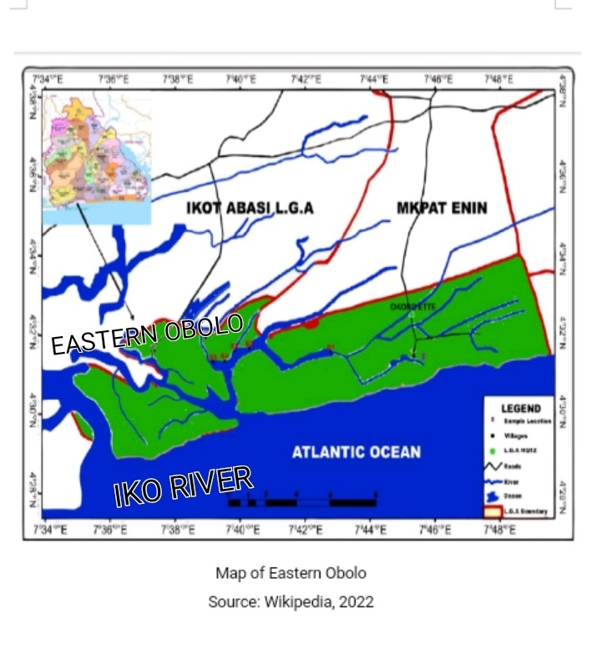
The Iko River Estuary is a tropical brackish-water ecosystem located in the Niger Delta, within Akwa Ibom State, Nigeria. Geographically, the estuary lies approximately between latitudes 4⁰32ʹ to 4⁰.36ʹN and longitude 7⁰44’ to 7⁰. 47ʹE (Fig. 1). It flows into the Atlantic Ocean through a network of creeks, mangroves and tidal channels. The Iko Estuary supports a wide range of aquatic biodiversity and serves as a critical habitat for estuarine and marine species. It is influenced by tide characterize by a mixture of freshwater and seawater resulting in variable salinity gradients and rich organic sediments. The estuarine substrate consists mainly of muddy and silty sediment, which support benthic life and vegetation growth. The estuary experiences two main seasons – wet (April to October) and dry (November to March) which strongly influenced its hydrology, nutrients load and biological productivity (Abiaobo et. al., 2021, George et. al., 2023a; b). The estuary is dominated by mangrove vegetation, especially species from the genera: Rhizophora Spp. (red mangroves), Avecennia Spp. (black mangroves) and Laguncularia racemosa (white mangroves). These mangroves forest serve as nursery grounds for juvenile fish and crustaceans, stabilize the shoreline, and act as natural filters for pollutants. The estuary also supports salt-tolerant grasses, algae and floating macrophytes such as Eichhornia crassipes (water hyacinth) especially in areas closer to freshwater flows. Human activities in the estuary include; Artisanal and small-scale fishing, mangrove wood harvesting, oil and gas exploration, sand mining, boat transportation, agricultural activities and waste dumping. Despite the ecological stressors the estuary is faced with emanating from human disturbances, the estuary supports numerous species such as mudskipper (Periophthalmus barbarus), crabs (Callinectes spp.), shrimps and various estuarine fishes (Abiaobo et. al., 2021, George et. al., 2023a; b).

Fig. 1: Map of Eastern Obolo showing Iko River Estuary

2.2 Collection of Specimens
The samples of P.barbarus species were collected for a period of six months from December, 2021 to May, 2022. Monthly sampling was carried out to ensure representation across both dry and early wet seasons. Fish were collected from selected sampling sites along the estuarine margin using non-destructive traditional fishing methods, including hand picking particularly during low tide when mudskippers are most active on mudflats, locally fabricated traps (basket traps), set along intertidal zones and creeks banks during ebb tides. A total of 180 specimens (both males and females) were captured throughout the sampling period. Specimens were then preserved on ice chest and transported to the laboratory for morphometric measurements.

Plate 1: Specimens of P. barbarus from Iko River Estuary
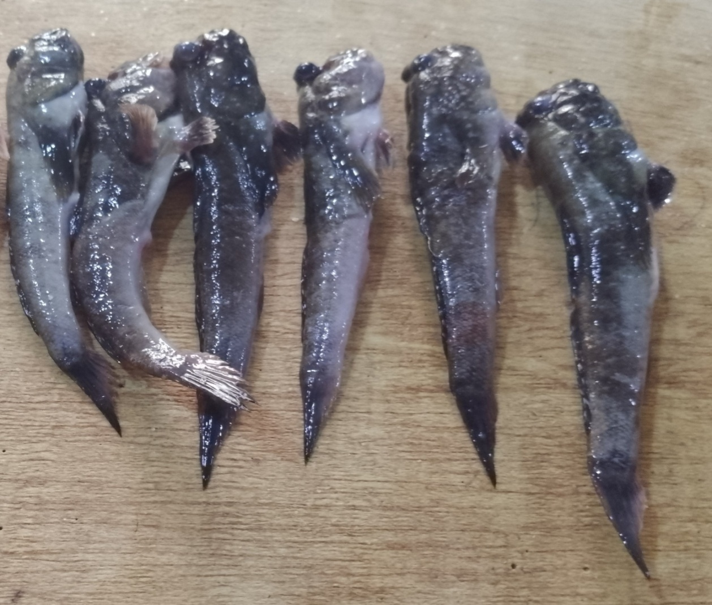

2.3 Measurement of Specimens
In the laboratory, each specimen was identified and sorted by sex, based on external morphological features such as body coloration, size and genital papillae. The following morphometric parameters were recorded:

2.3.1 Measurement of Total Length
Total length (TL) was measured from the tip of the snout to the end of the caudal fin using a digital measuring board to the nearest 0.01cm.

2.3.2 Measurement of Body Weight
Body weight (BW) was determined using a digital electronic balance to the nearest 0.01g.

2.3.3 Lenth-Weight Relationship (LWR)
Lenth-weight relationship (LWR) was estimated using the power function formular:
W=aL^{b} ……………………… (1)
Where L = total length (TL) of fish in (cm)
W= body weight of fish in (g)
a = constant (intercept)
b = growth exponent (allometric coefficient)
To linearize the equation, data were log-transformed and analyzed using linear regression:
Log W =log a + b log L ………… (2)
The coefficient of determination (R²) was used to assess the goodness-of-fit of the regression models. The value of b was interpreted to determine the type of growth: Isometric growth if b = 3; positive allometric growth if b>3; negative allometric growth b<3 (Andem et.al., 2013).

2.3.4 Condition Factor (K)
The Fulton’s condition factor (K) was calculated to assess the health and well-being of the fish using the formular; (Okgerman, 2005)

K = WX100/ L³ ……………………… (3)
Where;
K = condition factor
W = Weight (g)
L = Total length (cm)
3 = Coefficient.
One of the main features of fish growth pattern is the Fulton (k) condition factor. This shows the State of physical capacity for fish survival and reproduction (Effendie, 2002).

2.4 Data Analysis
All statistical analyses were conducted using Microsoft Excel and SPSS version 25.0, with significance tested at p<0.05. Results were presented using descriptive statistics, including ranges, means and standards deviations for both length and weight across sexes.

3.0 Results and Discussion
3.1 Length-weight Relationship of P. barbarus
A total of 180 specimens of P. barbarus were examined, comprising of 104 males and 76 females. The fish total length size of males P. barbarus ranged from 2.5-14. 70cm and females ranged from 6.50-14.20cm. The fish total weight size of males of P. barbarus ranged from 2. 50-25.30g and females ranged from 2.10-23.60g (Table 1). The males exhibited a broader length distribution, including smaller individuals compared to females, indicating a more diverse size composition in the male population. The monthly size distribution of P. barbarus is shown in (Fig.2). The observed differences in the morphometric characteristics such as length and weight between male and females P. barbarus captured from Iko River Estuary are natural and biologically expected. These variations can be attributed to a combination of biological, ecological and environmental factors including; sexual dimorphism, seasonal variation and period of sampling, reproductive status feeding intensity and exposure to predation (Akpan, 2013, George and Akpan, 2011; George et.al., 2011).

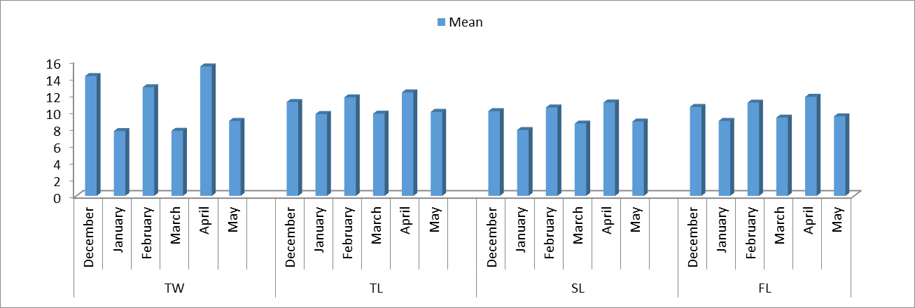
Fig. 2: Monthly size distribution of P. barbarus in the study area

Table I: Fish total length, fish weight and length - weight relationship parameter of P. barbarus in Iko Estuary
Sex | No. of fish | Total Length | (cm) | Weight (g) |  | Length  a | Weight  b | Relationship R²
Sex | No. of fish | Min | Max | Min | Max | Length  a | Weight  b | Relationship R²
Male | 104 | 2.50 | 14.70 | 2.50 | 25.3 | 0.0115 | 2.5655 (A-) | 0.9585
Female | 76 | 6.50 | 14.20 | 2.10 | 23.60 | 0.0245 | 2.642 (A-) | 0.9204
Combined sex | 180 |  |  |  |  | 0.0119 | 2.597 (A-) | 0.9143
The regression analysis of length-weight relationship for both sexes showed strong correlation between length and weight. The LWR equation for males P. barbarus was W=0.0115L^{2.5055} (Fig.3). The value of the allometric coefficient b (2.5655) indicates a negative allometric growth pattern (b<3), meaning that weight increased at a slower rate than length. The coefficient of determination (R²) was 0.9585, suggesting a very strong correlation between length and weight in males. The LWR for females P. barbarus was W = 0.0245L^{2.642} (Fig.4). Similarly, the b value of 2.642 also denotes negative allometric growth. The R2 value for the females was 0.9204, indicating a strong correlation, although slightly lower than that observed in males.
The length-weight relationship in fish is very essential in fishery assessment and management (Obasohan et al., 2012, Sunarmi et al., 2019, Abowei et al., 2019).
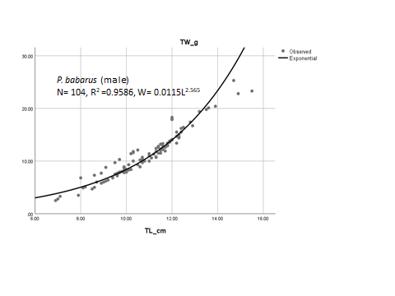
Fig. 3: Length-Weight Relationship of male P. barbarous in Iko Estuary
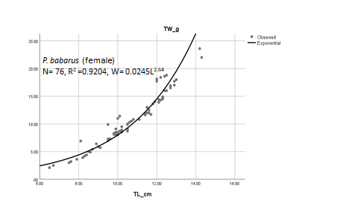
Fig 4: Length-Weight Relationship of female P. barbarus in Iko Estuary
The study revealed that combined sexes of P. barbarus examined exhibited negative allometric growth pattern with regression analyses exponent b value less than 3, indicating a high degree of positive correlation (Fig.5). The correlation coefficients (R²) of the fishes ranged between 0.9204 – 0.9586 indicating a high degree of positive correlation between their total lengths and body weights (Table 1). The results showed that the body weights of fishes were observed to increase with increase in body length, however the rate of increase in weight was less compared to increase in length.
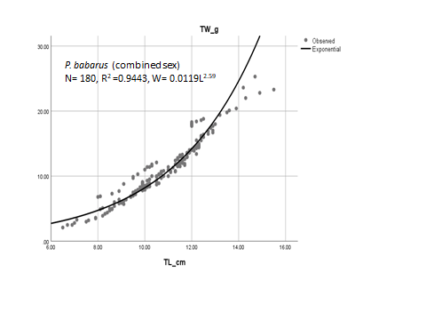
Fig. 5: Length-Weight Relationship of combined sex for P. barbarus in Iko Estuary
With reference to the study of Adeyemi et al., 2009, negative allometric growth pattern in fish implied that the weight increases at a lesser rate than the cube of the body length. Similar report of negative allometric growth pattern in many fishes have been reported (Bidawi et al., 2017, Mahadevan et al., 2017, Dewiyanti et al., 2022).
The body length and weight of fish throughout its life cycle are very impactful on the growth value of fish species, such that the factors affecting the duo (length and weight) could positively or negatively affect its growth pattern (Abiaobo and Udo, 2017). Various factors affect fish growth, which include natural factors and anthropogenic factors (King, 1996). The variation in feeding and biosynthetic processes in the aquatic habitat could result in changes in the weight of fish (Merestsky et al., 2000).

3.2 The Condition Factor of P. Barbarus
The Fulton’s condition factor (K) values showed that P. barbarus individuals were generally in good physiological condition across both sexes. Males had K values ranging from 0.799 to 1.043 while the females had K values ranging from 0.815 to 1.019 (Table 2). These values suggest that the fish were relatively healthy and adapted to prevailing environmental conditions of the estuary. Slight variation in K between sexes may be attributed to reproductive status, energy allocation and food availability during the study period. Condition factors are tailored to assess the general wellbeing of fish (Blackwell et al., 2000, Abowei 2009, Obasohan et al., 2012). The reflection of morphological parameters of the body fat content and growth rate are embodied in the condition factor (Froese 2006, Stevenson and woods, 2006).

Table 2: Condition factor of P. barbarus
Sex | No. of fish | Condition Factor (k) |  | Mean
 |  | Min | Max
Male | 104 | 0.799 | 1.043 | 0.853
Female | 76 | 0.815 | 1.019 | 0.842

The condition factor is an important tool for the assessment of fish biology, mainly when the species lies at the base by the higher food web. (Diaz et al., 2000). The greater the value of condition factor, the greater the match between the fish species and the aquatic environment. However, this result indicates that the male mean condition factor of P. barbarus was greater than that of female P. barbarus. This result agrees favourably with the findings of (Rahardjo and Simanjuntak, 2008). The observed variation in the condition factor could be attributed to the release of eggs and reproduction process in the females, hence the low values of condition factors recorded during the study. Similar results of males having higher condition factor than females were earlier reported by (Sunarni et al., 2019). The low values of condition factors recorded in the females was noted to be relatively higher when the gonads are filled and attain their peak before spawning takes place. However, condition factor may differ due to season and location of capture, gender, gonadal maturity level and mostly preponderance of nutritional materials and physico-chemical conditions of the aquatic habitat (King, 1995; George et.al., 2013; George and Atakpa, 2015; Udo, 2002). The presence and density of predators are also likely factors that may impact on condition factors (Murphy et al., 1991 and Blackwell et al., 2000).

4.0 Conclusion
The study on the length-weight relationship and condition factor of Periophthalmus barbarus from the Iko River Estuary, Niger Delta, provides valuable baseline data on the growth patterns and health status of this ecologically important mudskipper species. The findings revealed that both male and female individuals exhibited negative allometric growth (with b values of 2.5655 and 2.642, respectively), indicating that increases in weight were proportionally less than increases in length. This growth pattern suggests that P. barbarus in the estuary may prioritize elongation over mass accumulation, possibly as an adaptive response to environmental conditions such as habitat structure, feeding strategies, or reproductive investment. The high coefficient of determination (R²) values for both sexes (0.9585 for males and 0.9204 for females) demonstrate a strong positive correlation between length and weight, affirming the reliability of the length-weight models derived for this population. Furthermore, the Fulton’s condition factor (K), which ranged from 0.799 to 1.043 in males and 0.815 to 1.019 in females, indicates that the sampled population of P. barbarus was in relatively good physiological condition, with minimal evidence of environmental or nutritional stress during the study period. In conclusion, the Iko River Estuary provides a moderately supportive habitat for P. barbarus, as reflected by the condition factor and consistent morphometric relationships. However, the observed negative allometric growth emphasizes the need for continued ecological monitoring to evaluate long-term trends and potential stressors—particularly in the light of increasing anthropogenic activities such as oil exploration, deforestation, and artisanal fishing. These findings contribute to the growing body of knowledge required for the conservation, management, and sustainable utilization of estuarine fish resources in the Niger Delta ecosystem.

Disclaimer (Artificial intelligence)
Option 1:
Author(s) hereby declare that NO generative AI technologies such as Large Language Models (ChatGPT, COPILOT, etc.) and text-to-image generators have been used during the writing or editing of this manuscript.
Option 2:
Author(s) hereby declare that generative AI technologies such as Large Language Models, etc. have been used during the writing or editing of manuscripts. This explanation will include the name, version, model, and source of the generative AI technology and as well as all input prompts provided to the generative AI technology
Details of the AI usage are given below:
1.
2.
3.

5.0 References
Abiaobo, N. O. and Udo, M. T. (2017). The population Dynamics of the Mudskipper, Penohthalamus barbarus (LINNEAUS 1766, TELEOSTEI, GOBIIDAE) and the Implication for conservation and management in the mangrove swamp of Iko River Estuary. Southeastern Nigeria. Journal of Applied Life Sciences International; 14(4):1-19.
Abiaobo, N. O; Asuquo, I. E; Ejogu, I. N. and James, E. J. (2021). Aspects of the Biology of Periophthalamus barbarous (Mudskipper), from Jaja Creek, Niger Delta, Nigeria. Ecology and Evolutinary Biology 6(1):15-22.
Abowei, J. F. N. Davies O. A. and Eli A. A. (2009). Study of the length –weight relationship and condition factor of five fish species from Nkoro River, Niger Delta, Nigeria. Current research Journal of Biological Sciences; 1(3). 94-98.
Adeyemi, S. O., Bankole, N. O. and Adikwu, I. A. (2009). Length-weight Relationship and condition factor of Protopterus Annectens. Continental J. fisheries and Aquatic Science 3.8-11.
Akinrotimi, O. A., Edun, O. M., Uka, U. and Owhonda, K. N. (2013): Public Perception of Mudskipper Consumption in some Fishing Communities of River State Nigeria. Journal of Fisheries and Aquatic Science 8(1): 208-212.
Akpan, I. I. (2013). Species composition and Abundance in Uta Ewa Creek, Niger Delta Region, Nigeria. Journal of Agriculture and Veterinary Science; 3(3):56-60.
Amin, A. M. and Sabrah, M. M. (2019). Basic parameters for assessment and management of the short-finned squid Ilex coindeti (Verany, 1839) (cephalopoda, Ommastrephidae) from the deep water of Egyptian Mediterranean Sea. Egyptian Journal of Aquatic Biology and Fisheries 23(1): 13-26.
Andem, A. B., Idung, J. U., Eni, G. E. and George, U. U. (2013). Length –weight Relationship and Fulton’s Condition Factor of Brackish River Prawn (Macrobrachium macrobrachion, Herklots, 1851) from Great Kwa River, Obufa Esuk Beach, Cross River State, Nigeria. European Journal of Experimental Biology, 3(3):722-730.
Bidawi B. Y., Destrita, Yunasfi (2017). Length-weight relationships and condition factor of mudskipper (family: Gobiidae) at the Mangrove ecosystem of the Sembilan Island village of Langkat Regency, North Sumatera. Depik, 6 (3):228-234.
Blackwell B. G.; Brown, M. L.; Willis D. W. (2000). Relative weight (Wr) status and current use in fisheries assessment and management. Review in fisheries science 8(1):1-44.
Dewivanti I, Melanie, K., Almuniro, S., Damora, A., Nufadillah, N. and Batubara, A. S. (2022). Growth patterns and condition factor of the mudskipper (Periophthalmus gracilis) in mangrove ecosystem rehabilitation areas in Banda Aceh and Aceh Besar, Indonesia. Fisheries and Aquatic Life, 30:85-94.
Diaz L. S.; Roa, A., Garcia C. B.; Acero, A.; Navas G; (2000). Length relationship of demersal fishes from the upper continental slope off Columbia. NAGA, 23(3):23-25
Effendie M. I. (2002). Biologi Perkanan(Edisi Revisi). Yayasan Pustaka Nusatara, Yogyakarta, 163.
Elviania S; Sunarmi (2018). The composition and abundance of Mudskipper species relationship with organic materials in estuary aquatic Merauke Districts. Journal Agribisnis Perikanan, 11(12):38-43.
Froese R. (2006). Cube law, condition factor and weight-length relationship: history, meta-analysis and recommendations. Journal of Applied Ichthyology; 22: 241-253
George, U. U. and Akpan, E. R. (2011). Diet Composition and Condition Factor of Ilisha africana in the Cross-River Estuary. African Journal of Environmental Pollution and Health, 9(2):24-32.
George, U. U., Atakpa, E. O. (2015). Food and Feeding Ecology of Chrysichthys nigrodigitatus in the Cross-River Estuary, South Eastern Nigeria. New York Science Journal, 8(11): 83-90.
George, U. U., Ekanem, A. P., and George, E. (2011). Food and Feeding Habits of Ophiocephalus obscura (African Snakehead in the Cross-River Estuary, Cross River State, Nigeria. International Journal of Fisheries & Aquaculture, 3(13):231-238.
George, U. U., Idung, J. U., Andem, A. B., Okorafor, K. A. and Mowang, D. (2013). Diet Composition and condition Factor of Ethmalosa fimbriata in the Cross-River Estuary. Greener Journal of Biological Science, 3(6):244-252.
King, R. P. (1996). Population Dynamics of the Mudskipper Periophthalmus barbarous (Gobiidae) in the estuarine swamps of Cross River. Nigeria. Journal of Aquatic Sci; 2: 31-34.
King. M. (1995). Fisheries Biology: Assessment and Management. Blackwell Science Ltd., London, Pp341.
Lanzoni, M., Aschonitis, V., Milardi, M., Castaldelli, G., Fano, E. A. (2018). A method to identify bimodal weight-length relations. Possibleontogenic diet and/or metabolism shift effects in anguilla (Actinopterygii; Anguilliformes; Anguillidae) Acta Icthyologica et Piscatoria; 48(2): 163-171.
Mahadevan, G. Ravi, V.; Murugesan, P. (2017). Length-weight relationship of two mudskippers (Gobiidae; Oxudercinae) Oxuderces dentatus (Eydoux&Souleyet, 1850) and Scatelaoshistophorus (Valenciennes, 1837) from Dhamara estuary, Odhisia, India. Journal of Applied IchthyologyI; 33(6): 1258-1260.
Merestsky, V. J., Valdes, R. A.; Douglas, M. E., Brouder, M. J., Gorman, O. T., Marsh, P. C. (2000). Spatiotemporal variation in length-weight relationship of endangered humpback chub: Implication for Conservation and Management. Transaction of the America Fisheries Society; 129:419-428.
Muhtadi, A., Ramadhani, S. F., Yunasfi (2016). Identification and habitat type of mudskipper (Family Gobidae) at the Bali Beach District of Batu Bara, North Sumatra province, Biospecies; 9(2):1-6 (in Indonesia).
Murphy, B. R., Brown, M. L., Spinger, T. A. (1991). The relative weight (Wr) index management, status and needs. Fisheries, 16(2):30-38.
Obasohan, E. E.; Obasohan, E. E., Imasuen, J. A, and Isidahome, C. E. (2012). Preliminary studies of the length-weight relationships and condition factor of five fish species from Ibiekuma Stream, Ekpoma Edo State, Nigeria. Journal of Agriculture research and developmentI; 2(3):61-69.
Okgerman, H. (2005): Seasonal variation of the length-weight and condition factor of Rudd (Scardinus erythrophthalmus) in Spanca Lake. International Journal of Zoological Research 1(1): 6-10.
Philips, A. E. (2019). Fisheries Biology of Terapon puta (Cuvier, 1829) from east Egyptian Mediterranean waters. Egyptian Journal of Aquatic Biology and Fisheries 22(1): 197-203.
Polgar, G., Lim, R. (2011). Mudskipper: Human use, ecotoxicology and biomonitoring of mangrove and other soft bottom intertidal ecosystem. In: Mangrove,Ecology, Biology and Taxonomy.Publisher: Nova Science publishers. Pp 51-86
Purwaningsin, S., Salamah, E., Riviani (2013). The changing of chemical composition amino acids and taurine content at glodok fish (Periophthalmodon Schlosseri). Journal Pengolahan Hasi Perikanan, Indonesia; 16(1): 12-21.
Rahardjo, M. F. and Simanjuntak, C. P. H. (2008). Length weight relationship and condition factor of belanger’s croaker, Johnius belangerii (Pisces: Sciaenidae) in Mayangan coastal waters, West Java. Journal Ilmu-ilmu Perairan dan perikanan, Indonesia, 15(2): 135-140.
Stevenson R. D. and Woods W. A. (2006). Condition indices for conservation: new uses for evolving tools. In: Integrative and comparative Biology, 46: 1169-1190
Sunarmi, Edy, H. P. Melmamlsessy, Norce Mote, Rahmatia, Baigo Hamucena (2019). Length-Weight Relationship and condition factor of mudskipper Baleophthalmus pectinirostris from Maro Estuary Merauke Regency Papua, Journal of Ecological Engineering; 20(8): 199-204.
Udo, M. T. (2002). Morphometric Relationships and Reproductive Maturation of the Mudskipper, Periphthalmus barbarous from subsistence catches in the Mangrove Swamps of Imo estuary. Nigeria. J. Environ. Sci. 14: 221-226.

