In Silico Network Pharmacology and Molecular Docking Analysis of Phytochemicals from Orthosiphon aristatus Leaves against Chronic Kidney Disease

Abstract
Chronic Kidney Disease (CKD) is characterized by progressive loss of kidney function, often leading to the need for renal replacement therapy, such as dialysis or transplantation. It is represented by the presence of kidney damage or an estimated glomerular filtration rate (eGFR) of less than 60 mL/min/1.73 m², persisting for 3 months or more. The herbal plant Orthosiphon aristatus commonly known as Poonaimeesai belongs to the family Lamiaceae and has been documented as an anti-proliferative, antioxidant, analgesic, anti-inflammatory, antimicrobial, and diuretic properties. Preliminary molecular docking study through computational analysis was done with the Auto Dock tool (Version 1.5.7) to study the efficacy of the plant constituents against renal failure. The phytoconstituents present in Orthosiphon aristatus were identified and retrieved through literature survey. The potential action of Orthosiphon aristatus against various targets involved in renal function was compared with allopathic standard drug Pentoxifylline for its action of reducing proteinurea and maintaining eGFR. From the Study, phytoconstituents present in Orthosiphon aristatus shows effective binding action ranging from -3 to -9 against various targets (ATP- binding Cassette, P53, CYP1B1, ADORA1, ADORA2A) involved in pathogenesis of Chronic renal failure. The constituents present in the herb Orthosiphon aristatus (Sinensetin, Rosmarinic acid, Eupatorin, Ladanein and Salvigenin) has inherent action on renal function by binding with various targets has been concluded by the present study.
Keywords: Siddha, Chronic Kidney Disease, Orthosiphon aristatus, Poonaimeesai, Renal failure.
Type of the Article: Orginal research article

- Introduction
Chronic Kidney Disease (CKD) is a multifactorial disease characterized by progressive decline of kidney function resulting in defective excretion of uremic toxins, leading to the need for renal replacement therapy, such as dialysis or transplantation. CKD is denoted by the presence of kidney damage or an estimated glomerular filtration rate (eGFR) of less than 60 mL/min/1.73 m², persisting for 3 months or more^{[1]}. CKD is more prevalent in low-income and middle-income than in high-income countries^{[2]}. From 1990 to 2017, the global prevalence and mortality rates of CKD has rises by 29.3% and 41.5%, respectively. In India, the proportion of deaths due to kidney failure has increased by 38% between 2001–2003 and 2010–2013^{[3]}.
CKD is categorised into 6 stages known as G1: (Glomerular filtration rate) GFR 90 mL/min/1.73 m2 and above with evidence of kidney disease, such as haematuria or proteinuria; G2: GFR 60 to 89 mL/min/1.73 m2; G3a: GFR 45 to 59 mL/min/1.73 m2; G3b: GFR 30 to 44 mL/min/1.73 m2; G4: GFR 15 to 29 mL/min/1.73 m2 and G5: GFR less than 15 mL/min/1.73 m2 or treatment by dialysis^{[4]}
The 3 levels of albuminuria include an ACR (Albumin-to-Creatinine ratio) A1: ACR less than 30 mg/g (<3.4 mg/mmol); A2: ACR 30 to 299 mg/g (3.4-34 mg/mmol) and A3: ACR greater than 300 mg/g (>34 mg/mmol)
Inspite of various challenges in management of CKD, there is an urgent need to explore safe and effective alternative therapies that can reduce the need for dialysis and delay the need for renal transplantation. For this, a herb Orthosiphon aristatus belonging to the family- Lamiaceae which was previously known as Clerodendranthus spicatus is selected based on the properties related to renal functions such as Anti-inflammatory, Diuretic, Anti-lithiatic, Anti-hypertensive, Anti-oxidant, Anti-angiogenic, Anti-cancer, Anti-microbial, Analgesic, Anti-pyretic, Hepatoprotective and Hypo-glycemicactivity^{[5]}. It is primarily distributed in tropical or subtropical areas from Southeast Asia to North Australia. It is also called as Poonaimeesai, Cat`s Whiskers, Java tea etc., in various languages.
Molecular modelling is the most important method for the investigation and reorganization of receptor protein and compound structure, potentially without giving more investment in research work and time. This Study aims to develop a herbal-based management of CKD at an affordable cost. Developing such interventions could alleviate the economic burden and improve the quality of life for patients with CKD.

- Materials and Methods:
Structure prediction of the target and the ligand is important for their interaction studies.
2.1 Preparation of Ligand:
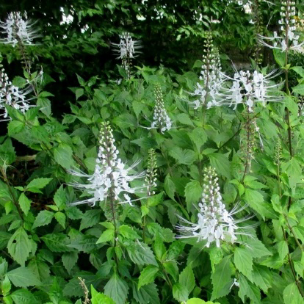

Fig 1: Orthosiphon aristatus(Poonaimeesai)

The active compounds present in the Orthosiphon aristatus like Sinensetin, Rosmarinic acid, Eupatorin, Ladanein and Salvigenin were identified^{[6]}. The Standard allopathic drug Pentoxifylline was selected based on its action of reducing proteinurea and maintaining eGFR ^{[7]}. The phytochemicals identified with its Molecular weight, Molecular formula, H-bond donor, H-bond acceptor, Rotatable bonds were listed in table 1.
Table1: Chemical properties of constituents of Orthosiphon aristatus (Ligands)
Compound | Molecular Weight g/mol | Molecular formula | H- bond donar | H- bond acceptor | Rotatable bonds
Sinensetin | 372.4 | C₂₀H₂₀O₇ | 0 | 7 | 6
Rosmarinic acid | 360.3 | C₁₈H₁₆O₈ | 5 | 8 | 7
Eupatorin | 344.3 | C₁₈H₁₆O₇ | 2 | 7 | 4
Ladanein | 314.29 | C₁₇H₁₄O₅ | 2 | 6 | 3
Salvigenin | 328.3 | C₁₈H₁₆O₆ | 1 | 6 | 4
Pentoxifylline | 278.3 | C₁₃H₁₈N₄O₃ | 0 | 4 | 5
Each selected phytochemical was prepared for docking by obtaining its 2D and 3D structures from Pubchem database (https://pubchem.ncbi.nlm.nih.gov/) in SDF format and converted to PDB format, followed by energy minimization to ensure stable conformations and reduced steric hindrance. Each ligand was then parameterized with appropriate partial charges and rotatable bonds to enable flexible interactions with the target protein. The structure of ligands are shown in Table 2
Table 2: 2D and 3D structure of the selected Ligands
Compound | 2D Structure | 3D structure
Sinensetin | 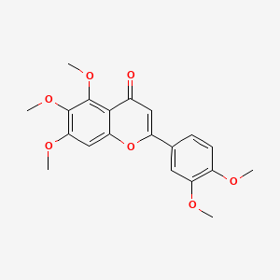 | 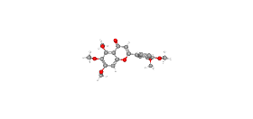
Rosmarinic acid | 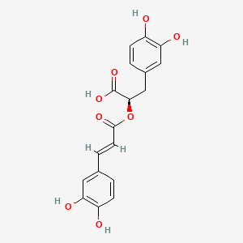 | 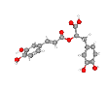
Eupatorin | 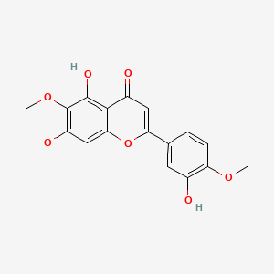 | 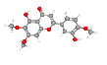
Ladanein | 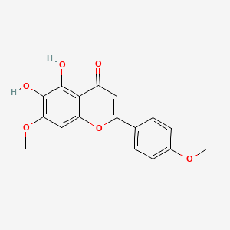 | 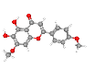
Salvigenin | 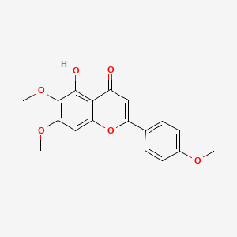 | 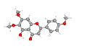
Pentoxifylline | 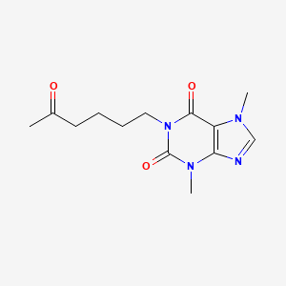 | 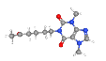

  - Preparation of Target:
The targeted proteins were selected based on Swiss target prediction software (http://www.swisstargetprediction.ch/index.php) with higher probability. The predicted targets were downloaded from RCSB PDB database (https://www.rcsb.org/) . The x-ray diffraction structure of the different target proteins under study having resolution not less than 2A⁰ were used for the study(Table 3). The additional combined Co-factors, Ligand, Water molecules, etc., were removed and converted into PDB format.
Table 3: Selected targets and their action in Kidney
Target protein | PDB ID | Structure | Role in CKD
ATP Binding Cassette (ABCG2) | 1Q12 | 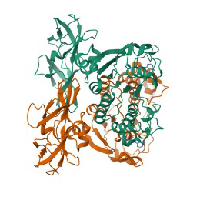 | - ABCG2 as a physiological exporter of Uremic toxin- Indoxyl sulfate^{[8]}  - ABCG2 plays a physiologically important role in uric acid excretion^{[8]}  - ABCG2 dysfunction is a risk factor for mortality in hemodialysis patients^{[9]}.
Cytochrome P450 1B1(CYP1B1) | 3PMO | 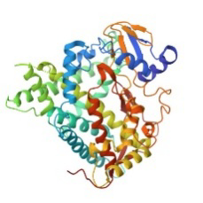 | - Novel target for developing therapeutic agents for treating renal disease associated with angiotensin 2 induced hypertension^{[10]}.
Adenosine A1 receptor (ADORA1) | 6D9H | 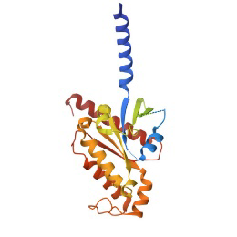 | - Altered adenosine levels and signalling through ADORA1 may contribute to the development of renal fibrosis^{[11]}.  - Controlling Glomerular filtration and renin release^{[12]}.  - Reduces renal blood flow and regulates fluid balance^{[13]}.
Adenosine A2a receptor (ADORA2A) | 8UGW | 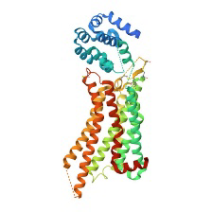 | - ADORA2A agonists can reduce tubulointerstitial fibrosis by suppressing macrophage infiltration and associated profibrotic factors like TGF-β^{[14]}.  - Activation of A2ARs suppresses the expression of the Mφ-linked glomerular damage mediators, transforming growth factor-β, osteopontin-1, thrombospondin-1, and tissue inhibitor of metalloproteinase-1^{[15]}.

  - Molecular Docking Strategy
Docking simulations were conducted using MGL Auto Dock tools to evaluate the binding interactions between the target protein and each ligand. Molecular interaction analysis was done by using Auto Dock 1.5.7 Morris et al.(2009)^{[23]} through the following steps: Gasteiger partial charges were added to the ligand atoms. Nonpolar hydrogen atoms were merged, and rotatable bonds were defined. A grid box was centered on key active site residues to confine docking to relevant regions. Parameters, including binding affinity (ΔG), inhibition constant (Ki) and interaction surface were calculated for each ligand. Docking was repeated using Swiss dock vina page^{[16,17]}.

- Results and Discussion
In this study, network pharmacology and molecular docking techniques were used to identify the key pharmacodynamic components and key targets for treatment of chronic renal failure. From the plant Orthosiphon aristatus, five major bioactive compounds (Sinensetin, Rosmarinic acid, Eupatorin, Ladanein and Salvigenin) ^{[24]} and an allopathic drug (Pentoxifylline) were selected.
Renal injury leads to changes in renal structure and function, resulting in abnormal excretion of certain electrolytes, retention and loss of electrolyte ions, increase or decrease of serum electrolyte content and can cause serious complications such as renal anaemia, renal rickets and disorders of excretory function^{[18]}. The progression of CKD starts initially with increased pressure in glomerular capillaries (glomerular hypertension) with protein leakage (albuminuria) resulting in scaring (glomerularsclerosis). Many overlapping targets were found with different mechanisms in evolution of CKD. The target related to Renal functions (ATP- binding CassetteG2, P53, CYP1B1, ADORA1, ADORA2A) were selected. In these targets, ABCG2 serves as a “gatekeeper cell” for the excretion of uric acid produced throughout the body metabolism. It also protects various other organs by “Remote Sensing and Signalling Hypothesis”^{[19]}. CYP1B1 regulation helps in preventing Angiotensin 2 induced hypertension, preventing endothelial dysfunction, increasing superoxide production, preventing ROS production and finally preventing renal damage and inflammation caused by angiotensin 2^{[20]}. ADORA1 receptor activation inhibits Inflammation, necrosis and apoptosis caused as a result of renal injury. ADORA1 plays a vital role as a mediator of tubuloglomerular feedback (TGF), a mechanism that coordinates GFR with tubular transport. It is also involved in inhibiting renin secretion, a hormone that regulates blood pressure^{[21]}. ADORA2A plays a potential role in preventing renal damage mainly through its anti- inflammatory and anti- fibrotic properties. It also reduces the infiltration of inflammatory cells, including macrophages, into the kidney thus mitigating inflammation and associated tissue damage, suppression of profibrotic mediators like TGF-β1 and ROCK1^{[22]}. By complex role of various targets involved in CKD, it prevents the function of the kidneys and also prevents various other vital organ damage caused due the eliminated toxins of CKD.
From the results of the docking analysis, All the ligand posses interactions around 10-20 sites in the targets. The highest binding energies from the interactions obtained were listed in the Table 4. From the table, the highest binding energies range between -3 to -9 which denotes the higher affinity of Target drug interaction. The smaller the free binding energy, the greater the affinity between the receptor and the ligand. Similarly, the binding energies obtained from the phytochemical of Orthosiphon aristatus is similar to the values obtained from the allopathic drug Pentoxifylline. All the compounds exhibit higher binding energy against ABCG2 and ADORA1 when compared to CYP1B1 and ADORA2A. Indoxyl- sulphate is a degraded product in bacterial degradation of tryptophan in gut and excreted via kidneys. But in CKD, excretion of Indoxyl- sulphate is altered by binding with albumin and difficult to eliminate even by haemodialysis. Accumulation of Indoxyl sulphate leads to Tubulointerstitial injury in kidneys, increases risk of cardiovascular diseases, inhibit osteoblast activity in bones leading to osteodystrophy and induce endothelial dysfunction by promoting oxidative stress and inflammation. By regulation of ABCG2, the excretion of uremic toxin- Indoxyl sulphate is increased and decreases the vital organ damage in Haemodialysis patient. By regulating ADORA1, the GFR is maintained as result of decreasing the blood pressure, thus in turn reducing the renal blood flow. The 3D Docking poses of various compounds were tabulated in the Table 5.
Table 4: Highest Binding free energy of Compounds on Targets
S. No | Compounds | Highest Binding Free  energy Kcal/ mol (ABCG2) | Highest Binding Free  energy Kcal/ mol  (CYP1B1) | Highest Binding Free  energy Kcal/ mol  (ADORA1) | Highest Binding Free  energy Kcal/ mol  (ADORA2A)
1 | Sinensetin | -6.843 | -9.714 | -6.736 | -8.203
2 | Rosmarinic acid | -7.308 | -9.312 | -6.897 | -8.279
3 | Eupatorin | -6.796 | -7.529 | -6.697 | -8.592
4 | Ladanein | -6.844 | -9.101 | -6.844 | -8.294
5 | Salvigenin | -6.877 | -7.629 | -6.513 | -8.406
6 | Pentoxifylline | -3.835 | -8.531 | -5.429 | -6.490

Table 5: 3D Docking structure of various compounds

Compounds | Docking interaction with ABCG2 | Docking interaction with CYP1B1 | Docking interaction with ADORA1 | Docking interaction with ADORA2A
Sinensetin | 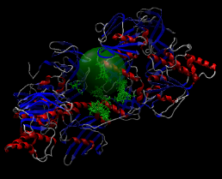 | 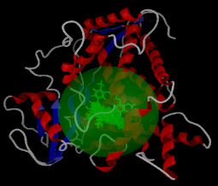 | 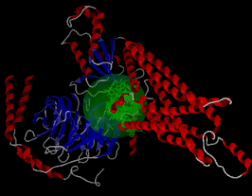 | 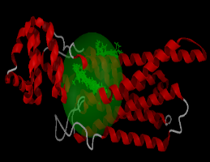
Rosmarinic acid | 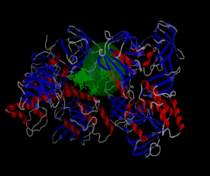 |  | 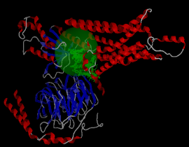 | 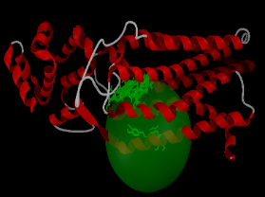
Eupatorin | 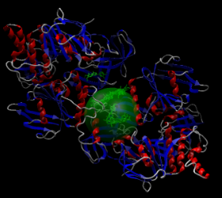 | 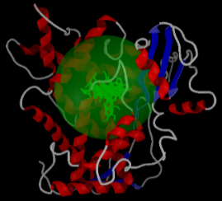 |  | 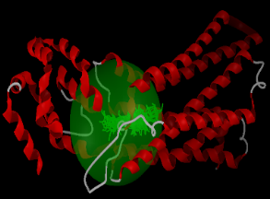
Ladanein | 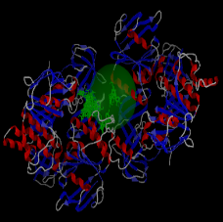 | 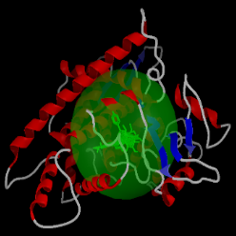 |  | 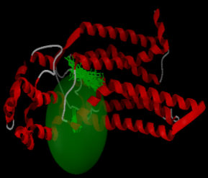
Salvigenin | 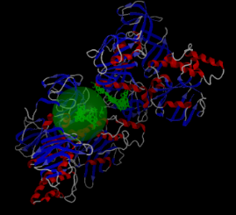 | 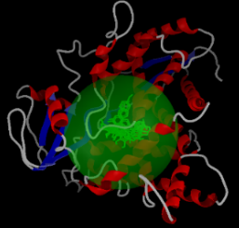 |  | 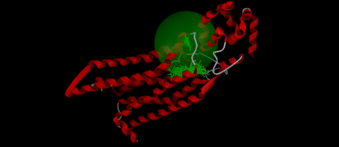
Pentoxifylline | 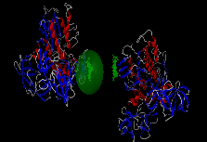 | 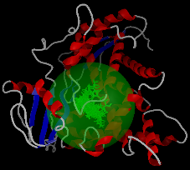 | 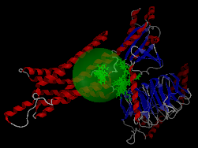 | 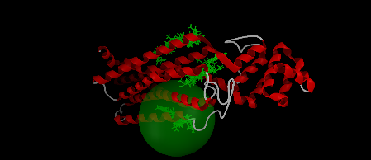

- Conclusion
A timely diagnosis of chronic kidney damage is important for slowing down the progression and treating additional complications that develop in parallel with chronic kidney damage. Based on the outcomes of the computational analysis, the phytochemicals present in the herb Orthosiphon aristatus like Sinensetin, Rosmarinic acid, Eupatorin, Ladanein and Salvigenin prevents renal damage by regulating various targets with high affinity which is more relevant to the allopathic drug Pentoxifylline. It also concludes that it not only regulates the renal function and but also prevents other vital organ damage caused by toxins like Indoxyl- sulphate resulting from CKD. Thus, the herb Orthosiphon aristatuscan be used in the management of Chronic Kidney Disease (CKD) with minimal cost without further renal damage.

- Disclaimer (Artificial intelligence)
Author(s) hereby declare that no generative AI technologies such as Large Language Models (ChatGPT, manuscript.

- References
- Vaidya SR, Aeddula NR. Chronic Kidney Disease. [Updated 2024 Jul 31]. In: StatPearls [Internet]. Treasure Island (FL): StatPearls Publishing; 2025 Jan-. Available from: https://www.ncbi.nlm.nih.gov/books/NBK535404/
- Jha V, Garcia-Garcia G, Iseki K, et al. Chronic kidney disease: global dimension and perspectives. Lancet. 2013;382(9888):260–272. doi: 10.1016/S0140-6736(13)60687-X [DOI] [PubMed] [Google Scholar]
- Dare AJ, Fu SH, Patra J et al. ; Million Death Study Collaborators. Renal failure deaths and their risk factors in India 2001–13: nationally representative estimates from the Million Death Study. Lancet Glob Health 2017; 5: e89–e95
- Vaidya SR, Aeddula NR. Chronic Kidney Disease. [Updated 2024 Jul 31]. In: StatPearls [Internet]. Treasure Island (FL): StatPearls Publishing; 2025 Jan-. Available from: https://www.ncbi.nlm.nih.gov/books/NBK535404/
- Chai, Tsun-Thai & Wong, Fai-Chu & Abd Manan, Fazilah&Kengfei, Ooh &Mohd Ismail, Nor Ismaliza. (2014). Orthosiphon aristatus: A review of traditional uses, phytochemical profile, and pharmacological properties.
- Chua LS, Lau CH, Chew CY, Ismail NIM, Soontorngun N. Phytochemical profile of Orthosiphon aristatus extracts after storage: Rosmarinic acid and other caffeic acid derivatives. Phytomedicine. 2018 Jan 15;39:49-55. doi: 10.1016/j.phymed.2017.12.015. Epub 2017 Dec 18. PMID: 29433683.
- Donate-Correa J, Tagua VG, Ferri C, Martín-Núñez E, Hernández-Carballo C, Ureña-Torres P, Ruiz-Ortega M, Ortiz A, Mora-Fernández C, Navarro-González JF. Pentoxifylline for Renal Protection in Diabetic Kidney Disease. A Model of Old Drugs for New Horizons. J Clin Med. 2019 Feb 27;8(3):287. doi: 10.3390/jcm8030287. PMID: 30818852; PMCID: PMC6463074.
- Takada T, Yamamoto T, Matsuo H, Tan JK, Ooyama K, Sakiyama M, Miyata H, Yamanashi Y, Toyoda Y, Higashino T, Nakayama A, Nakashima A, Shinomiya N, Ichida K, Ooyama H, Fujimori S, Suzuki H. Identification of ABCG2 as an Exporter of Uremic Toxin Indoxyl Sulfate in Mice and as a Crucial Factor Influencing CKD Progression. Sci Rep. 2018 Jul 24;8(1):11147. doi: 10.1038/s41598-018-29208-w. PMID: 30042379; PMCID: PMC6057959.
- Nakashima A, Ichida K, Ohkido I, Yokoyama K, Matsuo H, Ohashi Y, Takada T, Nakayama A, Suzuki H, Shinomiya N, Urashima M, Yokoo T. Dysfunctional ABCG2 gene polymorphisms are associated with serum uric acid levels and all-cause mortality in hemodialysis patients. Hum Cell. 2020 Jul;33(3):559-568. doi: 10.1007/s13577-020-00342-w. Epub 2020 Mar 16. PMID: 32180207; PMCID: PMC7324430.
- Jennings BL, Anderson LJ, Estes AM, Yaghini FA, Fang XR, Porter J, Gonzalez FJ, Campbell WB, Malik KU. Cytochrome P450 1B1 contributes to renal dysfunction and damage caused by angiotensin II in mice. Hypertension. 2012 Feb;59(2):348-54. doi: 10.1161/HYPERTENSIONAHA.111.183301. Epub 2011 Dec 19. PMID: 22184325; PMCID: PMC3268066.
- Berthold Hocher, Adenosine A1 receptor antagonists in clinical research and development, Kidney International, Volume 78, Issue 5, 2010, Pages 438-445, ISSN 0085-2538, https://doi.org/10.1038/ki.2010.204. (https://www.sciencedirect.com/science/article/pii/S0085253815545730)
- Oyarzún C, Garrido W, Alarcón S, Yáñez A, Sobrevia L, Quezada C, San Martín R. Adenosine contribution to normal renal physiology and chronic kidney disease. Mol Aspects Med. 2017 Jun;55:75-89. doi: 10.1016/j.mam.2017.01.004. Epub 2017 Jan 18. PMID: 28109856.
- Wei He, Kaixin Pan, Chenggen Xiao, Activation ADORA1 protects against sepsis-associated acute kidney injury by inhibiting pyroptosis, Tissue and Cell, Volume 95, 2025, 102849, ISSN 0040-8166, https://doi.org/10.1016/j.tice.2025.102849. (https://www.sciencedirect.com/science/article/pii/S0040816625001296)
- Garcia GE, Truong LD, Li P, Zhang P, Du J, Chen JF, Feng L. Adenosine A2A receptor activation and macrophage-mediated experimental glomerulonephritis. FASEB J. 2008 Feb;22(2):445-54. doi: 10.1096/fj.07-8430com. Epub 2007 Sep 26. PMID: 17898087; PMCID: PMC2864119.
- Gabriela E. Garcia, Luan D. Truong, Jiang-Fan Chen, Richard J. Johnson, Lili Feng, Adenosine A2A receptor activation prevents progressive kidney fibrosis in a model of immune-associated chronic inflammation, Kidney International, Volume 80, Issue 4, 2011, Pages 378-388, ISSN 0085-2538,https://doi.org/10.1038/ki.2011.101. (https://www.sciencedirect.com/science/article/pii/S008525381555045X)
- Bugnon M, Röhrig UF, Goullieux M, Perez MAS, Daina A, Michielin O, Zoete V. SwissDock 2024: major enhancements for small-molecule docking with Attracting Cavities and AutoDock Vina. Nucleic Acids Res. 2024
- Eberhardt J, Santos-Martins D, Tillack AF, Forli S..AutoDock Vina 1.2.0: New Docking Methods, Expanded Force Field, and Python Bindings. J. Chem. Inf. Model., 2021
- Zhou L, Wang X, Sun Z, Bao X, Xue L, et al. (2023) Study on the mechanism of Shenkang injection in the treatment of chronic renal failure based on the strategy of "Network pharmacology—Molecular docking—Key target validation". PLOS ONE 18(10): e0291621.
- Cleophas MC, Joosten LA, Stamp LK, Dalbeth N, Woodward OM, Merriman TR. ABCG2 polymorphisms in gout: insights into disease susceptibility and treatment approaches. PharmgenomicsPers Med. 2017 Apr 20;10:129-142. doi: 10.2147/PGPM.S105854. PMID: 28461764; PMCID: PMC5404803.
- Jennings BL, Anderson LJ, Estes AM, Fang XR, Song CY, Campbell WB, Malik KU. Involvement of cytochrome P-450 1B1 in renal dysfunction, injury, and inflammation associated with angiotensin II-induced hypertension in rats. Am J Physiol Renal Physiol. 2012 Feb 15;302(4):F408-20. doi: 10.1152/ajprenal.00542.2011. Epub 2011 Nov 16. PMID: 22088434; PMCID: PMC3289420.
- Lee HT, Gallos G, Nasr SH, Emala CW. A1 adenosine receptor activation inhibits inflammation, necrosis, and apoptosis after renal ischemia-reperfusion injury in mice. J Am Soc Nephrol 15: 102–111, 2004. [DOI] [PubMed] [Google Scholar]
- Garcia GE, Truong LD, Li P, Zhang P, Du J, Chen JF, Feng L. Adenosine A2A receptor activation and macrophage-mediated experimental glomerulonephritis. FASEB J. 2008 Feb;22(2):445-54. doi: 10.1096/fj.07-8430com. Epub 2007 Sep 26. PMID: 17898087; PMCID: PMC2864119.
- Morris GM, Huey R, Lindstrom W, Sanner MF, Belew RK, Goodsell DS, Olson AJ. AutoDock4 and AutoDockTools4: Automated docking with selective receptor flexibility. J Comput Chem. 2009 Dec;30(16):2785-91. doi: 10.1002/jcc.21256. PMID: 19399780; PMCID: PMC2760638.
- Divakar Samidurai, Ashok Kumar Pandurangan, Senthil Kumar Krishnamoorthi, Madan Kumar Perumal, Raaman Nanjian, Sinensetin isolated from Orthosiphon aristatus inhibits cell proliferation and induces apoptosis in hepatocellular carcinoma cells,Process Biochemistry,Volume 88, 2020, Pages 213-221, ISSN 1359-5113,https://doi.org/10.1016/j.procbio.2019.09.031.

