Original Research Article
Occurrence of two phoretic mites of suborder Uropodina (Acari: Mesostigmata) on Holotrichia consanguinea (Scarabaeidae: Coleoptera) from Ahilyanagar, Maharashtra, India.

Abstract:
Mites inhabiting different habitats are important bio-controlling agents of various pests such as fungi, nematodes, harmful insects. Faunistic surveys were undertaken to collect beetles associated mites from the study area. The survey revealed the presence of phoretic deutonymphs of two mite species - Uroobovella marginata and Uropoda orbicularis (order Uropodina) on Holotrichia consanguinea beetle. Deutonymph is the larval stage of mite which disperse through phoresy on several insects and attach to insect cuticle by their anal pedicel. A brief diagnosis of these species is provided along with their locality records. Remarkably, these species are reported for the first time from Maharashtra, specifically from Sangamner Tehsil, Ahilyanagar district.
KeyWords: Uropodina, Phoresy, Biocontrol, dispersal, anal pedicel.

Introduction:

Members of the superfamily Uropodoidea are called tortoise mites because of their appearance (Knee et al., 2012). These mites generally inhabit organic substrates such as decaying wood, soil, leaf litter, dung, nests of birds, burrows of mammals, and deutonymphs can be phoretic on insects (Bal, 2006; Krantz & Walter, 2009; Wiśniewski & Hirschmann, 1993). Some mites of the family Urodinychidae and Trematuridae are fungivorous (Faasch, 1967). Mites such as U. marginata, U. vegetans, U. phoenicis, and U. pyriformes are reported to feed on fly larvae, nematodes, and some other mites (Athias-Binche & Habersaat, 1988; Hughes, 1976; Jalil & Rodriguez, 1970). Hence, they are involved in the biocontrol of pests. Developing deutonymphs disperse through phoresy on several insects and attach to insect cuticle by using their anal pedicel. The placement of mite group Uropodina is not stable (Halliday, 2016). The taxonomic studies on the superorder Uropodina are very poor, approximately 2200 species are present worldwide. Only 10 species have been described from India in the last 30 years (Kontschán, 2024). Approximately 25 species are present in India (Kontschán, 2012; Wiśniewski & Hirschmann, 1993), which is relatively few compared to other taxa. Recently, a new species of Uroobovella tripophinae was reported on Trilophidia turpis grasshopper from Tamil Nadu (Vaithiyanathan, 2024). Maharashtra State has shared the Western Ghats but none of the species is reported yet from this large suborder, Uropodina from Maharashtra. Holotrichia consanguinea is one of the phytophagous pests in groundnut, maize, sugarcane, guava and grapes. Several methods of controlling this phytophagous pest are employed as they are causing heavy losses (Singh et al., 2024) Studying the interactions between insects and mites can yield insights into how mites utilize their hosts and reveal lesser-known microhabitats, as well as their societal implications. Hence an attempt is made to study on insect-associated mites from study area.
Material and Methods:
During the collection of insect-associated mites, 3 Holotrichia beetles were collected in a light trap near vermicompost, cattle manure sites and groundnut agricultural fields. The insects were observed under a DewinterTM stereo binocular microscope. The mites were detached from the insect body by using a minute pin, and both the insect and the mites were stored in 95% ethanol. The mites were cleared by using lactic acid for 24 hrs in cavity blocks at 50 °C on the hot plate. Permanent slides were made by using a PVA medium (Krantz & Walter, 2009) and coverslips are sealed by using red insulating paint (MG Chemicals, USA), and slides were put into the heat incubator at 50 °C for a week. Mites were observed under a Labomed LX500 compound microscope and photographed using an Amscope 5MP camera. Identification of mites is done by using key provided by (Mašán, 2001).
Results and Discussion:
Systematic Account:
Phylum: Arthropoda
Class: Arachnida
Order: Mesostigmata
Suborder: Uropodina
Superfamily: Uropodoidea
Family: Urodinychidae
Genus: Uroobovella
Species: marginata (C. L. Koch, 1839)
Diagnosis: (Fig. 1 a & b) Deutonymph (n=5): The dorsal shield is oval, punctate-reticulated with small pit-like round depressions. Length of idiosoma is 830 µm long and 585 µm wide. There are 54 pairs of setae of which 35 pairs are long, 19 pairs of small, and 2 unpaired setae are present at the anterior podonotal area. All dorsal setae are smooth heteromorphic, mostly long and needle-like. The sternal shield is vase-shaped, reticulated with a small dotted appearance, 420 µm long and 190 µm wide at coxa II. The sternum is partially merged onto the ventrianal shield and bears 8 pairs of simple st1-st8 setae. One pair of prominent gland-like pores on the sternum are present between coxae III and IV. The ventrianal shield is bowl-shaped, anteriorly concave with numerous dots, 220 µm long and 440 µm wide, and possesses 6 pairs of preanal acicular setae (Fig.5 a). The anus is round and is located at posterior end of ventrianal shield and bearing 2 pairs of adanal setae. The peritrematal shield is well developed, stigmata located close to leg III, peritreme is U-shaped medially and bent anteriorly (Fig. 4 a.). The tritosternum elongated, base is vase shaped, located close to flat coxae I, two tooth-like projections distally, and pilose lacinia are divided anteriorly into 3 branches, of which the middle is longer than the remaining two. (Fig.3 a.) Chelicerae are not observed.
Material examined: 5 deutonymph; alt 549 meters asl. Sukewadi, 19.5930º N, 74.2267º S, Tal-Sangamner, 22 May 2023 collected by V.S. Bhand and V.V. Bhavare, ex. Holotrichia consanguinea.
Distribution- Poland, Czech Republic, Austria, Madagascar, Kazakhstan, India, Iran, England, Holland, Germany, Italy, Turkey.
Phylum: Arthropoda
Class: Arachnida
Order: Mesostigmata
Suborder: Uropodina
Superfamily: Uropodoidea
Family: Uropodidae
Genus: Uropoda
Species: orbicularis (O. F. Müller, 1776)
Diagnosis: (Fig.2 a & b) Deutonymph (n=6) The dorsal shield is oval to dome shaped and reticulated with small round pits. Length of idiosoma is 540 µm long and 430 µm wide. 41 pairs of small acicular setae are present on dorsum. The glands are located alongside the setae. Epistome is narrow, serrated and divided into 2 pilose branches. Sternal shield punctate with small pits and measured 290 µm long and 150 µm wide at the level of coxae II. The posterior width of sternal shield is 250 µm which reaches to boundary of ventrianal shield. There are 5 pairs of small needle-shaped setae (st1-st5) along with 2 pairs of glands are present. The ventrianal shield is bowl shape, wider than long (115 µm long and 230 µm wide) and 5 pairs of small acicular setae are present. 2 pairs of adanal setae are present. On lateral side 20 pairs of microsetae are present on the small platelets. The stigmata are located between coxae II and III and peritreme is slightly twisted at near to coxa II. Coxa I is large, flat and tritosternum is located between coxae. A well-developed serrated setae is present on palp coxa (Fig.3 b.). The tritosternum base is vase shaped, lacinia is divided into five branches and middle branch is longest than other.
Material examined: 6 deutonymph; alt 493 meters asl. Kolapewadi, 19.9292° N, 74.3617° E, Tal-Kopargaon, 10 June 2024 collected by V.S. Bhand and V.V. Bhavare, ex. Holotrichia consanguinea.

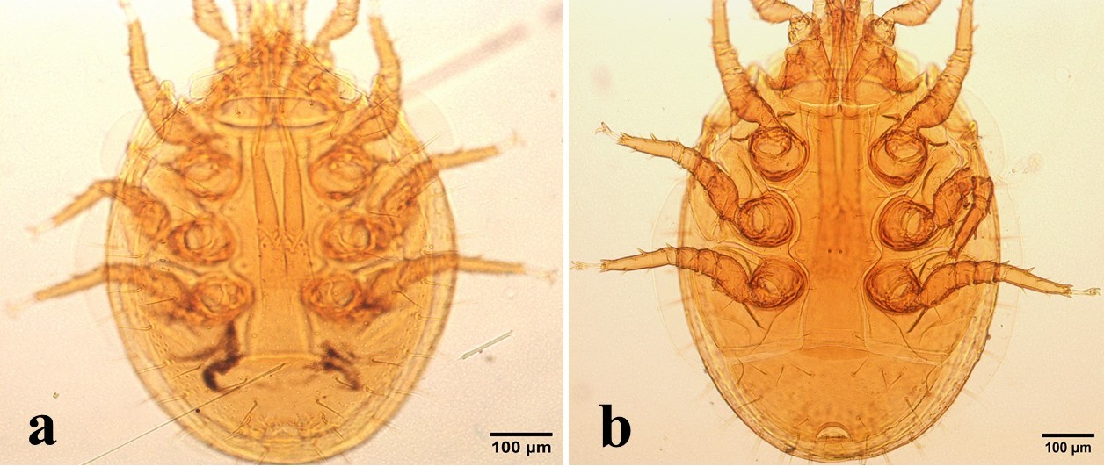
Figure 1. Uroobovella marginata a. Dorsal view b. Ventral view.
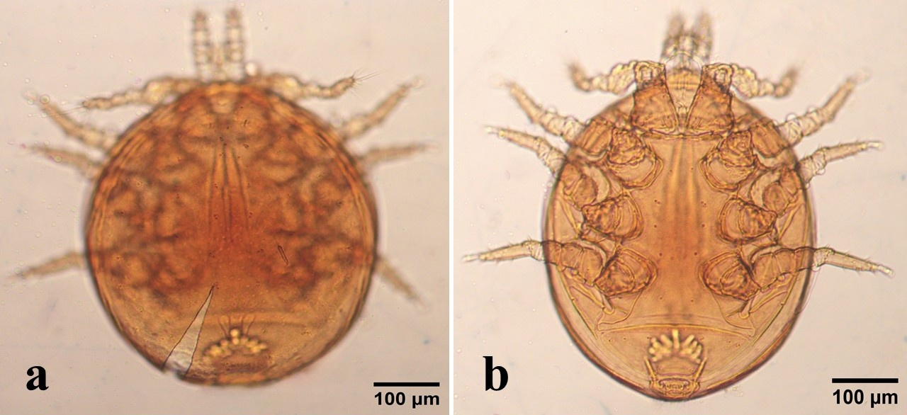
Figure 2. Uropoda orbicularis a. Dorsal view b. Ventral view.
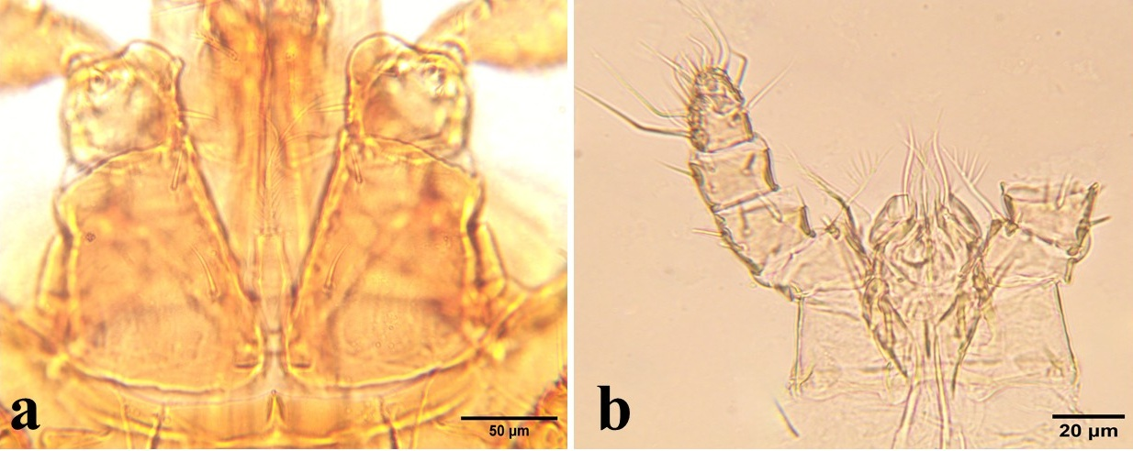
Figure 3. a. Flat coxae and tritosternum of U. marginata b. Gnathosoma showing serrated palp coxal setae of U. orbicularis.
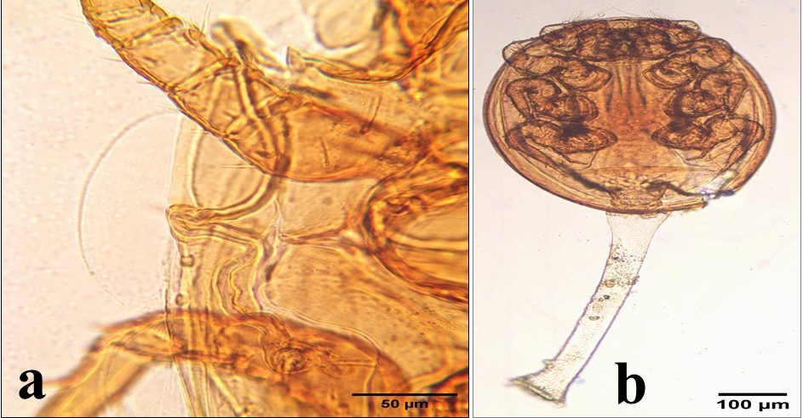
Figure 4. a. Peritrematal shield of U. marginata showing medially bent peritreme b. Anal pedicel of U. orbicularis.
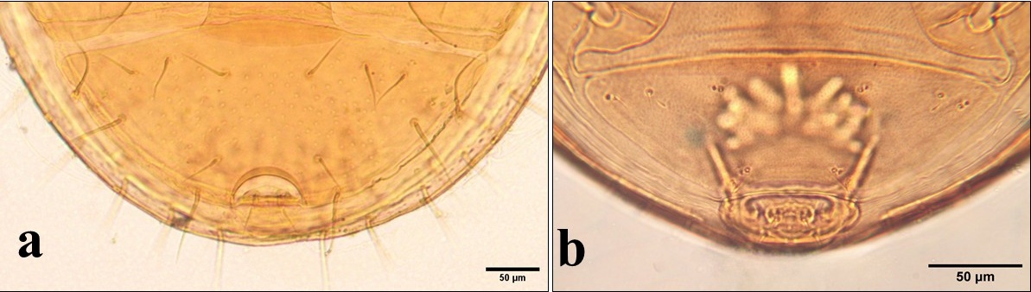
Figure 5. Ventrianal shields a. Uroobovella marginata b. Uropoda orbicularis.
Material Examined -
Distribution- Austria, Czech Republic, Hungary, Iran. First country record for India, first record for the Indian Subcontinent.
Discussion:
Both the reported mite species are generally predators and their deutonymph stage is phoretic on different coleopteran beetles, primarily dung beetles. Uroobovella marginata is one of the well-studied and non host-specific mites and it has been reported from flies, dung beetles, reptiles, mammals, and generally observed in various manure habitats (Bajerlein, 2011; Bajerlein et al., 2024); it is frequently observed as a deutonymph on the Rhynchophorus ferrugineus (Faasch, 1967; Farahani et al., 2016; Farahi et al., 2022). Studies have demonstrated that U. marginata might be effective against the harmful agricultural pest Laevicaulis alte (Raut & Panigrahi, 1991). In the development cycle of U. marginata, some deutonymphs are phoretic while some are free living and both these forms are slightly differed at anal region (Bajerlein et al., 2024) whereas all deutonymphs can be phoretic in U. orbicularis (Evans, 1992). U. orbicularis is tested for its biological control against invasive pest R. ferrugineus and it has been shown that it significantly reduces the longevity and fecundity of beetle (Ali et al., 2025). Further studies are required to understand the relationship between mite and H. consanguinea.
References:
Ali, M. A., Al-Farga, A., & Hussein, H. S. (2025). Potential impact of the parasitising mite, Uropoda orbicularis, as a biological control agent for the red palm weevil, Rhynchophorus ferrugineus. African Zoology, 0(0), 1–8. https://doi.org/10.1080/15627020.2024.2440452
Athias-Binche, F., & Habersaat, U. (1988). An ecological study of Janetiella pyriformis (Berlese,1920). A phoretic Uropodina from decomposing organic matter (Acari: Anactinotrichida). Mitt. Schweiz. Entomol. Gesell., 61, 377-90 [DINYCHIDAE].
Bajerlein, D. (2011). Seasonal abundance and infestation of deutonymphs of Uropoda orbicularis (Müller, 1776) (Acari: Mesostigmata) phoretic on coprophilous beetles (Scarabaeidae, Geotrupidae, Aphodiidae, Hydrophilidae, Histeridae). International Journal of Acarology, 37(3), 216–227. https://doi.org/10.1080/01647954.2010.505579
Bajerlein, D., Błoszyk, J., Halliday, B., & Konwerski, S. (2024). Hitchhiking through life: A review of phoresy in Uropodina mites (Parasitiformes: Mesostigmata). The European Zoological Journal, 91(1), 31–63. https://doi.org/10.1080/24750263.2023.2288847
Bal, D. A. (2006). New species of mites in the genera Uropoda, Crinitodiscus and Uroobovella from Turkey (Acari: Mesostigmata: Uropodidae, Urodinychidae). Zootaxa, 1368(1). https://doi.org/10.11646/zootaxa.1368.1.2
Evans, G. O. (1992). The principles of acarology. CAB International, Wellingford.
Faasch, H. (1967). Beitrag zur Biologie der einheimischen Uropodiden Uroobovella marginata (C. L. Koch 1839) und Uropoda orbicularis (O. F. Müller 1776) und experimentelle Analyse ihres Phoresieverhaltens. Zoologische Jahrbücher, Abteilung Für Systematik, 94, 521–608.
Farahani, V. R., Ahadiyat, A., Mašán, P., & Dehvari, M. A. (2016). Phoretic uropodine mites (Acari: Mesostigmata) associated with the red palm weevil, Rhynchophorus ferrugineus (Coleoptera: Curculionidae) in Iran. Journal of Entomological and Acarological Research, 48(3), 317. https://doi.org/10.4081/jear.2016.5853
Farahi, S., Shishehbor, P., Nemati, A., & Perotti, M. A. (2022). Mesostigmata diversity by manure type: A reference study and new datasets from southwestern Iran. Experimental and Applied Acarology, 86(4), 517–534. https://doi.org/10.1007/s10493-022-00710-1
Halliday, R. B. (2016). Catalogue of families and their type genera in the mite suborder Uropodina (Acari: Mesostigmata). Zootaxa, 4061(4), Article 4. https://doi.org/10.11646/zootaxa.4061.4.2
Hughes, A. M. (1976). The mites of stored food and houses (2nd ed.). Min. Agr.. Fish. Food Tech. Bull. 9. London: H. M. Stationery Office.
Jalil, M., & Rodriguez, J. G. (1970). Biology of and Odor Perception by Fuscuropoda vegetans (Acarina: Uropodidae), a Predator of the House Fly. Annals of the Entomological Society of America, 63(4), 935–938. https://doi.org/10.1093/aesa/63.4.935
Knee, W., Beaulieu, F., Skevington, J. H., Kelso, S., Cognato, A. I., & Forbes, M. R. (2012). Species Boundaries and Host Range of Tortoise Mites (Uropodoidea) Phoretic on Bark Beetles (Scolytinae), Using Morphometric and Molecular Markers. PLoS ONE, 7(10), e47243. https://doi.org/10.1371/journal.pone.0047243
Kontschán, J. (2012). New Uropodina mites from India (Acari: Mesostigmata). Zootaxa, 3518(1). https://doi.org/10.11646/zootaxa.3518.1.2
Kontschán, J. (2024). Catalogue of the Uropodina species (Acari: Mesostigmata) described between 1993 and 2023. Acta Phytopathologica et Entomologica Hungarica, 59(1), 29–62. https://doi.org/10.1556/038.2024.00216
Krantz, G. W., & Walter, D. E. (Eds.). (2009). A manual of acarology (3. ed). Texas Tech Univ. Press.
Mašán, P. (2001). Mites of the cohort Uropodina (Acarina, Mesostigmata) in Slovakia. Annot. Zool. Bot., 223, 1-320. (In Slovak).
Raut, S., & Panigrahi, a. (1991). The mite Fuscuropoda marginata (C. L. Koch) for the control of pest slugs Laevicaulis alte (Ferussac).In: Dusbábek F, Bukva V, editors. In Modern Acarology (Vol. 2, pp. 683–687). The Hague: Academia, Prague and SPB Academic Publishing bv.
Singh, S., Sandhu, R. K., Shera, P. S., Sharma, R., Kaur, J., & Sreedevi, K. (2024). Integrated Pest Management of White Grub Holotrichia Consanguinea Blanchard in Guava and Grapes. Indian Journal of Entomology, 1–4. https://doi.org/10.55446/ije.2024.1563
Vaithiyanathan, R. (2024). Description of Uroobovella tripophinae Sp. Nov. (Acarina: Uropodidae) Phoretic association with grasshopper Trilophidia turpis Walker (Acrididae: Orthoptera) from Tamil Nadu, India. Pakistan Journal of Zoology. https://doi.org/10.17582/journal.pjz/20240307080135
Wiśniewski, J., & Hirschmann, W. (1993). Gangsystematik der Parasitiformes. Teil 548. Katalog der Ganggattungen, Untergattungen, Gruppen und Arten der Uropodiden der Erde (Taxonomie, Literatur, Grösse, Verbreitung, Vorkommen). Acarologie Schriftenreihe Für Vergleichende Milbenkunde, 40, 1–220.

