Monocled Cobra, Naja kaouthia Lesson, 1931 (Squamata: Elapidae) Breeding Biology in Dibrugarh City, Assam (India): Notes on 100 percent hatching success in a semi-natural condition and colouration with markings in juveniles.

.
ABSTRACT

Observation on breeding microenvironment of Monocled Cobra, Naja kaouthia Lesson, 1931, one of the four species of the genus Naja found in India was done in Bongalgaon, Dibrugarh City, Assam (India). An egg cluster with 24 numbers of empty egg shells showing 100 percent hatching was recovered from a network of rat holes under a cemented earthen floor of a room used as living room by a family. Measurements of the empty shells were done in terms of length, breadth and ratio of the average values. Seven hatchlings were recorded, four of which were rescued, photographed and released into their natural habitat with the help of personnel from the Government Forest Department of Assam. Body colouration and markings of 4 juveniles were noted. The case study is communicated with a review of the related aspects of breeding biology of this species in natural and captive conditions.

Keywords: Naja kaouthia, breeding, microenvironment, Dibrugarh, egg-cluster, juvenile, colouration

1. INTRODUCTION

Monocled Cobra, Naja kaouthia Lesson, 1931 (Order- Squamata: Family-Elapidae) is one of the four species of the genus Naja found in Indian limits. The other three species are Naja naja (Linnaeus, 1758), Naja oxiana (Eichwald, 1831) and Naja sagittifera Wall, 1913 [1]. Naja kaouthia is among the medically important venomous snakes of Southeastern Asia and is distributed in the countries of India, Nepal, Bhutan, Bangladesh, Myanmar, South and SW China, Thailand, North and West Malaysia, Cambodia, S. Laos and Vietnam [2,3]. This species is distributed in North and Eastern India in the plains of Ganga and Brahmaputra in the states of Arunachal Pradesh, Assam, Bihar, Haryana, Manipur, Meghalaya, Mizoram, Nagaland, Orissa, Sikkim, Tripura, Uttar Pradesh, and West Bengal [3, 4, 5] (Fig.1.). Naja kaouthia is found in certain areas of its distribution in India, where it occurs sympatrically with its sister species Naja naja (Linnaeus, 1758). Monocled Cobra is a terrestrial species that prefers damp areas and is sometimes found near water bodies. A mostly nocturnal snake showing activities in dusk and dawn feeding on fish, small snakes, frogs and rats [4]. Individuals of Naja kaouthia handled by the present author during rescue in Dibrugarh City and nearby areas exhibited venom spitting behavior that supports similar findings of earlier workers in this region of India [6].

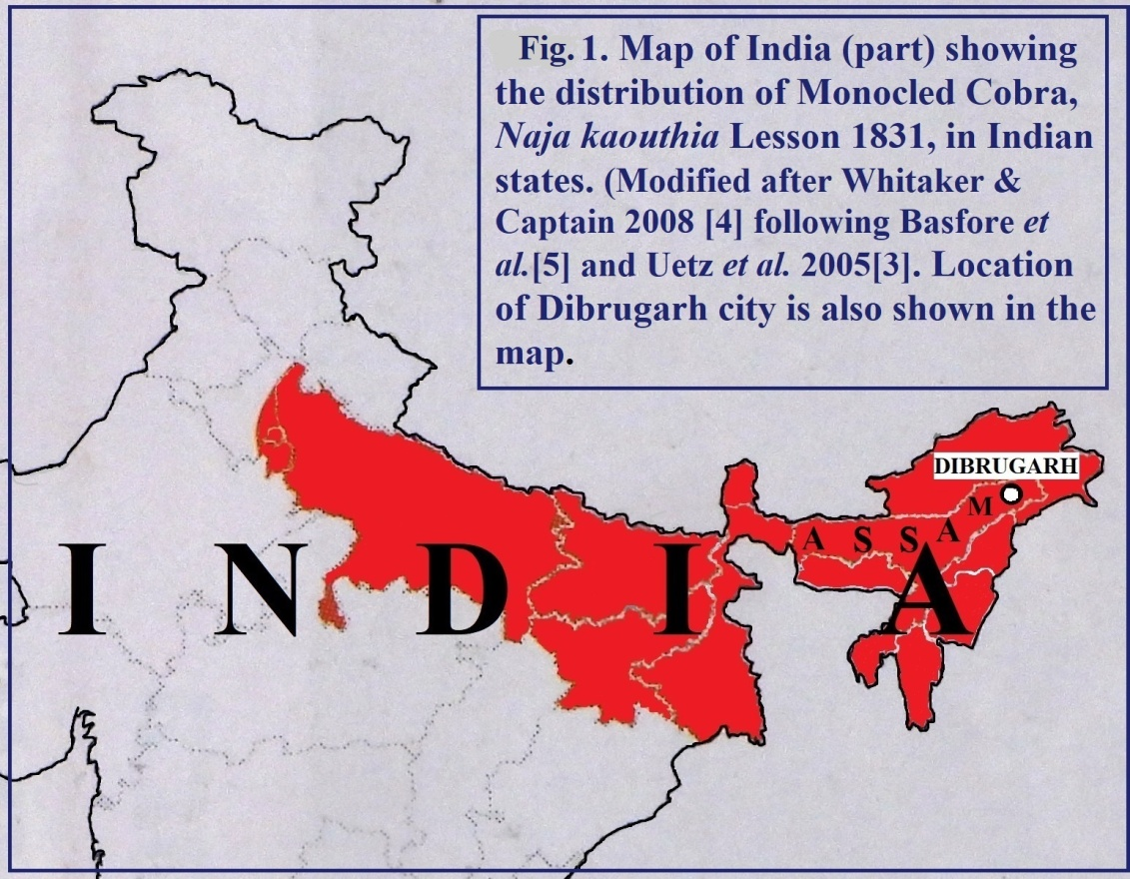

Fig.1. Map of India (part) showing the distribution of Monocled Cobra, Naja kaouthia Lesson 1831, in Indian states and location of Dibrugarh city, Assam.

Naja kaouthia assumed to be capable in reproducing most of the year depending upon geographical area. It exhibits dissociated type of reproductive pattern in which males mate at a time when their gonads are quiescent and the level of sex steroids are low in blood [7]. Mating of this oviparous species takes place during winter to summer months [8,13]. Southern population normally has a reproductive period from January to March and in some cases up to the month of July [9,10]. Mating in captive Naja kaouthia observed in Poland from late autumn to early winter (11th October to 29th December). Periods of egg deposition vary [12]. Females lay clusters of eggs from October to March [2,9,10,14,20,21,22,23]. Egg laying in Plock Zoo took place after the last day of mating in December to 19th March [11]. The time period from mating to egg laying was recorded as 76 (61-111) days [11].
Naja kaouthia oviposits in sheltered microhabitats such as root holes, rodent burrows, dry mounds and caves . [9,13,14]. A female laid eggs in a ‘nest’ measuring 20 cm diameter, 55 cm circumference and 62 cm depth formed in a decaying root hole [15]. However it is also noted that eggs may be laid anywhere [19].
Number of eggs in a clutch of this species may be eight to 43 [9,10,11,13,14, 15,16,18,19]. However the number of eggs laid by a female in one brood is up to 45 in Indian Cobra (Naja naja), the sympatric sister species of Monocled Cobra [17]. There is also a record of seven clutches in 7/8 years from the first year of egg laying by Naja kaouthia with an average number of 30 eggs per clutch [11].
Measurements of nine eggs from a single cluctch of Naja kaouthia had an average length of 47.45 mm (range: 42.74-51.27 mm; n=9) and an average width of 24.86 mm (range: 20.80-28.30 mm; n=9) [15]. These measurements correspond to a length-to-breath ratio of 1.90 based on the average values.
Females of Monocled Cobra generally remain with and guard their eggs until hatching occurs [4,9,10,21,22,23,24]. One report documented a female guarding a nest inside a hole in a decaying root [15]. Captive females were also seen to remain with the clutch [11]. However, male-female collaboration has been reported in hybrids of Naja naja and Naja kaouthia [20]. In natural conditions, snakes are generally reported to abandon the nest before the eggs hatch[9].
In the Monocled Cobra, incubation periods have been reported to range from 50 to 73 days [10,16, 22,25]. At 28⁰C, the incubation period of captive N. kaouthia was recorded as 61-69 days [18], while incubation periods of 51-69 days have been reported at approximately 33⁰C [26,27]. In captivity, hatchings occurred in 50-60 days when eggs were kept at 84-86⁰C with 70-80% humidity, and in some cases, it took 4-5 day for an entire clutch to hatch [19]. New born snakes are seen from summer through most of the monsoon season [13].In Assam, hatchlings were observed in August [20] and in one case in Mizoram, on 3rd September [15]. Another case recorded where young found hatched after an average incubation of 51 days (48 – 54 days) with a hatching success rate of 39.5% (n= 476) [11]. Furthermore, there were instances of 57% hatching success for N. kaouthia eggs in captivity under monitored environmental condition [25].
Naja kaouthia has comparatively thin and fragile egg membranes. In captivity, damage to the outer covering of eggs has been reported to be caused by cockroaches [11]. Fungal infection are also commonly seen in captivity. Hatching percentage may also be reduced by unfertilized eggs or damage of eggs by fungal infection [15].
The length of newborn Naja kaouthia were measured from 20 to 35 cm.[13]. Both dark-coloured and bright-coloured hatchlings were seen to hatch [11].Cannibalistic behavior is also reported in juveniles of N. kaouthia [11,15].
There are records of four observations by the author similar to the case presented in this communication on breeding biology of Monocled Cobra, all related to breeding microhabitat, clusters of eggs, juveniles and two concerned adults in Dibrugarh City and nearby areas. Of these four cases the first occurred at Maijan Road (‘Rail line’) Paltanbazar area of the City on 2 Aug. 2017, the second was from Bongalmora area of the city, in late October 2023 which is reported in the present communication, the third was from Bonpitha of Mohmari, south of the city, on 30 July 2024; and the fourth was from Lekai, a nearby area of Dibrugarh City.
Measurements of an egg from the cluster in the fourth case were approximately: length 4.64 cm, breadth, 2.66 cm, length- to-breadth ratio 1.74, and weight 22 g (unpublished). This was an egg detached during collection of the cluster andmeasured with care, with minimal handling and movement. No attempt was made to clean sand or soil particles attached to the egg to avoid any probable adverse effects on the developing embryo. Observations in all four cases were made possible by calls for rescue of the snakes found in rat-hole networks within the earthen floors of resident’s houses. The present communication concerns the second observation, from the Bongalgaon area of Dibrugarh city in late October 2023. It is expected that these findings will contribute to a better understanding of the breeding biology of the Monocled Cobra in Assam.

2. material and methods

2.1. Dibrugarh City: Dibrugarh City, the headquarters of the administrative district of Dibrugarh, Assam, in the northeastern region of India, is located on the south bank of the Brahmaputra river[28]. The geographical coordinates of at Chowkidingi Chariali, a central point of the city, are 27⁰28’ N latitude and 95⁰30’E longitude. The city liedat an elevation of 104.24 meters above mean sea level (MSL).The master plan area of Dibrugarh city is 66.14 km², witha population of 186214 in 2014 [29]. However, according to the 2011 census, the land area and total population of the city were 15.5 km² and 146,122, respectively [31].
Dibrugarh city experiences a subtropical monsoon climate with mild winters, warm and humid summers and high rainfall. The average rainfall and number of rainy days over a 30-year period (1981-2010) were 260.9 mm and 128.5 days, respectively. The average annual minimum and maximum temperatures for the same period were 18.8⁰C and 28.1⁰C, respectively[30a]. Temperature data for 2023 recorded at Dibrugarh Airport are presented in Figure 2.[30b].

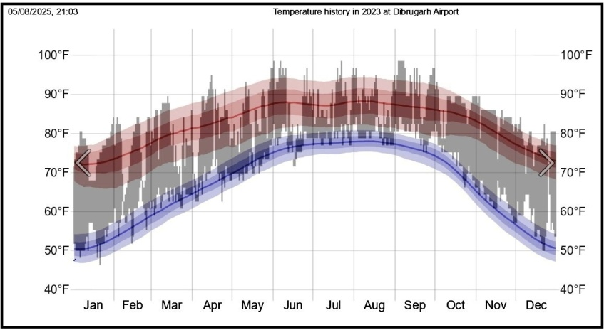

Figure 2. Temperature history in 2023 at Dibrugarh Airport (Source: Indian Meteorology Department [30b]).

Relative humidity during the rainy season is about 88%. The climatie of Dibrugarh City can be divided into four seasons, namely winter, pre-monsoon, monsoon and retreating monsoon [31]. The humid subtropical climate of Dibrugarh city with extremely wet summers and relatively dry winters, is classified as Cwa under the Koppen climate classification system [32]. The city and district as a whole are situated on the alluvial flood plains of the Brahmaputra river. Residential areas, including vegetation inl gardens and along road sides, areinterspersed with small forest patches, tea garden vegetation, bamboo plantations, and a few vanishing wetlands. The peripheral regions of the city are dominated by human habitation, forested areas, tea gardens and some riverside low land vegetation. Jokai Reserve Forest covering approximately 800 hectares, is located 10.2 km to the south of Dibrugarh city.

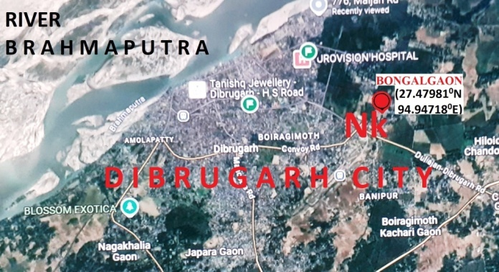

Fig.3 Google Map of Dibrugarh city (part), Assam, showing the location of the site of Naja kaouthia (Nk) at Bongalgaon.

2.2. Monocled Cobra in Dibrugarh City :
Dibrugarh city and its nearby places can be called the home of Monocled Cobra (Naja kaouthia). There are nearly 50 records of this species in this area, representing more than 45 localities. The records are based on personal observations, rescue reports and photographic evidences, as well as, snakes rescued by personnel from the Forest Range Office and other individuals in the city and surrounding districts.
The present author recorded clusters of empty egg shells and hatchlings of Naja kaouthia on 22nd and 23rd August 2023 at the residence of Mr. Rajib Jaiswal (27.47981⁰N, 94.94718⁰E) in the Bongalgaon area of Dibrugarh City, District Dibrugarh, Assam, India). The microhabitat consisted of a network of rat holes beneath a cemented earthen floor in two rooms of the house with bamboo walls used by the family as living room. (Fig.3.4). The surroundings of the house included grass covered low land in the North, half-constructed RCC. house and an open area to the south, a road and a residential house to the East and a forest pocket with bamboo plants to the west.

2.3. Field Observation:
On 6th October 2023, the present author was informed that a cobra snake had been seen at the residence of Mr. Jaiswal, entering and exiting through an opening in the living room floor. On 2nd October, hatchlings were observed and the adult cobra spat venom onto the hand of the housewife. Later that afternoon, a family member captured one hatchling. Upon request, the present author visited the site for snake rescue and observed several openings of rat holes in the damaged floor, which were being used by the adult snake to move in and out. A second hatchling was rescued during the visit. Shed skin from an adult cobra was also found in one corner of the room. On the morning of the 23rd October 2023, the present author was informed that three additional Cobra hatchlings (3rd, 4th and 5th) had escaped into the surroundings. The family decided to break the cemented earthen floor to expose the rat holes, rescue any remaining snakes, and hatchlings (if any) and to repair the floor for safety. The present author advised the family to contact Forest Range Office, Dibrugarh, Assam for assistance.

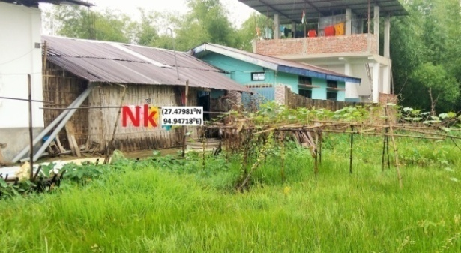

Fig.4. Picture showing the location of the site (house) of Monocled Cobra, Naja kaouthia (Nk) and its environment at Bongalgaon in Dibrugarh city, Assam.

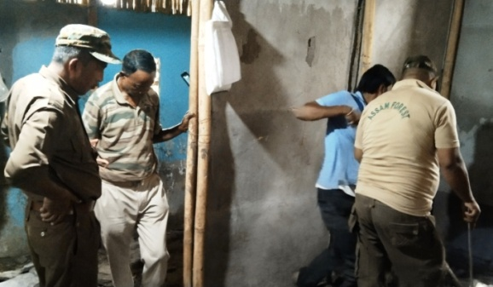

Fig. 5. Picture showing persons from the State Forest Department and the owner of the house at the time of breaking the floor to expose the network of rat holes - the shelter of Monocled Cobra (Naja kaouthia) in the house (Nk) at Bongalgaon.

On the 25th Oct.’23 the cemented earthen floor of one room was broken and all the interconnected rat holes were exposed in presence of the Forest Department personnel, namely Mr. Jitu Hazarika, Ms. Minati Deori, Mr. Ranjan Kumar Gogoi, Ms. Lipika Das and Mr. Sunil Sonowal (Fig. 5).

2.4. Egg shells and Juveniles :
A cluster of 24 empty eggshells was recovered (Fig. 6). In the afternoon of the same day two more cobra hatchlings (6th and 7th) were rescued. The floor of the second room was also broken on 26th October, but neither the adult nor juvenile cobras could be rescued, and no more egg shell cluster recovered. Altogether seven hatchlings were recorded, of which three escaped into the surroundings and four were rescued and released through the Forest Department. The linear measurements and weights of the 24 egg shells were recorded (Fig. 7).
The four Monocled Cobra juveniles were photographed, and colouration and markings of the head and neck were noted before release. The juveniles were released into the wild under the supervision of authorized personnel from the Forest Range Office, Dibrugarh (State Forest Department, Government of Assam) in the Jokai Reserved Forest at a point (27.3918, 94.9322) adjacent of the Jokai Forest Beat Office.

3. results and discussion
3.1 Egg Shells:
All 24 egg shells attached in the cluster were examined. The egg shells were empty, with similar and characteristic openings, indicating 100% hatching of eggs. They were irregularly inflated. The length and breadths of all irregularly inflated egg shells were measured using vernier calipers. Although the measurements cannot be considered the actual size of the eggs, the values and their ratios can provide an idea of the relative size of the eggs in the cluster. The average values of the lengths and breadths, as well as their ratio for the 24 irregularly inflated eggs, are given in Table 1.

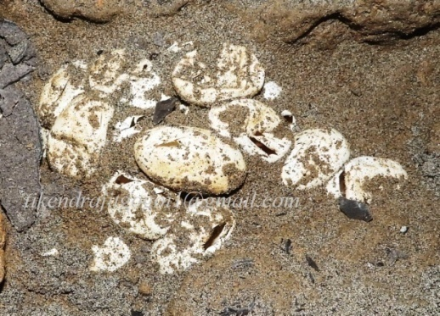

Fig. 6.Cluster of empty egg shells of Monocled Cobra (Naja kaouthia) in soil within a rat-hole network under the floor of a house at Bongalgaon, Dibrugarh City, Assam.

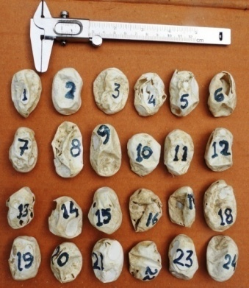
Fig. 7. Twenty-four empty egg shells of the Monocled Cobra (Naja kaouthia) recovered from the rat-hole network.

The average measurements of the 24 irregularly inflated eggs were:mean length 4.21 cm (range 3.60 to 5.15), mean width 2.84 cm (range: 2.22 to 3.30 cm), and mean average 0.58 g. This gives a length-to- breadth ratio of 1.48 (Table 1). These measurements can be compared with those of nine eggs from a clutch of N. kaouthia, with an average length of 4.74 cm (range: 4.27 cm to 5.12 cm), mean width 2.48 cm (range 2.08 cm to 2.83 cm), and a length-to- breadth ratio of 1.90, as reported by Lalmuansanga et al., 2020 [15]. A recent unpublished observation by the present author recorded anegg length of 4.64 cm, width of 2.66 cm, length-to-breadth ratio of 1.74, and weight of 22 g (Chapter 1.2).

Table.1.
Length and breadth of 24 empty, open and deformed egg shells of Naja kaouthia recovered from a rat-hole in the earthen floor of a house in Bongalgaon, Dibrugarh City, Assam,India.

N. | L. | B. | N. | L. | B. | N. | L. | B. | N. | L. | B. | A.L. | A.B. | L.B. ratio | A.W.
1 | 4.45 | 2.70 | 7 | 4.10 | 2.50 | 13 | 4.10 | 2.50 | 19 | 4.20 | 2.60 | 04.21 | 02.84 | 1.48 | 0.58
2 | 4.25 | 2.80 | 8 | 5.15 | 2.75 | 14 | 3.75 | 3.15 | 20 | 3.90 | 2.80
3 | 4.20 | 3.30 | 9 | 4.85 | 2.85 | 15 | 4.25 | 3.20 | 21 | 4.05 | 3.00
4 | 4.10 | 3.00 | 10 | 4.00 | 3.00 | 16 | 4.05 | 3.10 | 22 | 3.60 | 3.20
5 | 4.45 | 2.80 | 11 | 4.20 | 2.40 | 17 | 3.90 | 2.90 | 23 | 4.35 | 2.70
6 | 4.00 | 2.70 | 12 | 4.20 | 2.22 | 18 | 4.75 | 3.20 | 24 | 4.20 | 2.90

(Notes : L=.Length (cm), B= Breadth (cm.), W=Weight (gm.), A=Average, N =Serial Number. (n= 24).

3.2. Juvenile colouration and markings: The four juveniles observed displayed bright colouration with characterstic hood and throat markings. The 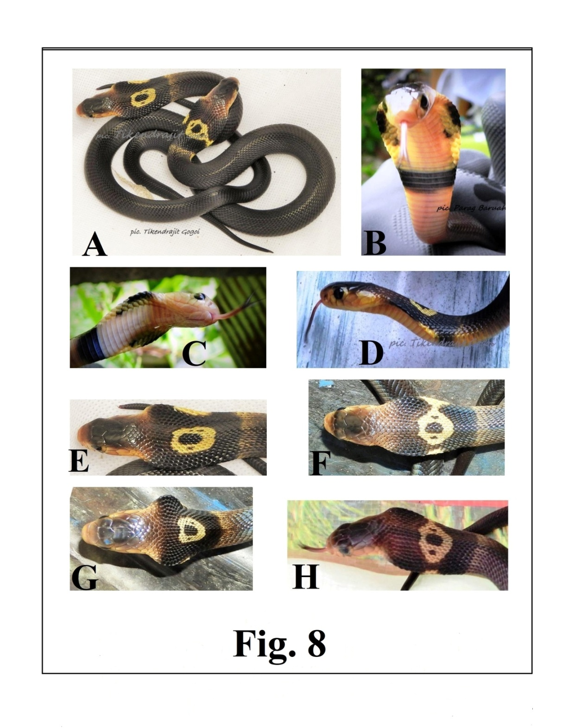
Fig. 8 (A, B, C, D, E, F, G, H) Pictures of the juveniles of Monocled Cobra, Naja kaouthia showing colouration and markings.

The dorsum of all juveniles was uniformly black (Fig. 8A). Juvenile colouration was noticeably brighter that that of adults, consisten with previous observations by the author.Adult Monocled cobras observed earlier in Assam by the present author typically had yellowish, brownish, olivaceous, grey or black dorsal surfaces sometimes with ragged bands.
Common distinct markings in the head and neck region of the juveniles include (a) typical central hood marking on the neck, (b) lateral yellow marks on both sides of the hood mark, (c) a transverse light band on the neck behind the hood mark, (d) a black ventral band in the neck region, and (d) black paired spots in the ventral side of the neck (hood).
The central hood mark a yellow periphery, a black central area, and two black spots- one on each side of the black area – within the yellow region. These black spots were sometimes split into two smaller spots (Plat 1A, E). The lateral yellow marks on bothsides of the hood mark may be merged with the central yellow area. (Fig. 8A, F). The ventral side of the hood was pinkish-white with yellow on on both sides (Fig. 8B, C). At the widest part of the hood, there were elongated black marginal areas on both sides(Fig. 8B, C). Within these lateral black regions, two smaller black spots were present on each side (Fig. 8B, C). A black ventral band was present on the throat at the lower part of the hood (Fig. 8B, C).
The yellow periphery of the hood mark extend anteroposteriorly from the 8th-10th to the 17th- 21st transverse rows of dorsal scales and transversely covered 12- 20 longitudinal rows. The central black mark, almost oval and anteroposteriorly elongated, extended from 11th to 16th transverse rows, covering 4= 6 longitudinal rows. The lateral yellow area on both sides of the hood mark covered up to 7 transverse rows of dorsal scales, corresponding to the 11th- 13th longitudinal dorsal rows. The faint transverse band behind the hood mark extended from the 21st-23rd transverse rows of dorsal scales. The black ventral band in the neck region covered 16th-19th ventral scales, corresponding to the 23rd to 25th transverse dorsal rows.

4. CONCLUSION

The breeding microhabitat of the Monocled cobra observed in this study can be described as a semi-wild condition, where the snake bred naturally in rat holes beneath a human dwelling. This was the second of four similar cases of egg-laying by Naja kaouthia in Dibrugarh City and nearby areas documented by the present author. Adverse biotic and abiotic conditions including microbial infections, predation, desiccation, submergence were absent in this microhabitat. Under these semi natural environmental conditions, and in absence of egg spoilage during development, a 100% hatching success of the 24 eggs was observed. All four normal juveniles displayed bright colouration, and typical head and neck marking. Selection of such a microenvironment for breeding may have adaptive value for the species in rural environments.

DISCLAIMER

The author hereby declares that no any kind of assistance of AI technique was used during the preparation of this manuscript.

ETHICAL ISSUE

No experiment was conducted on the animals. To avoid the risk of physical injury and to minimize their stress no attempts were made to handle the rescued juveniles for measurements, scale count and sex determination. The four Monocled Cobra juveniles were rescued, photographed and released into the wild under the supervision of the authorized personnel of Forest Range office, Dibrugarh. The shells of 24 empty eggs were deposited to the State Forest Department, the custodian of wildlife resources.

REFERENCES

1.Mohapatra,P.P., Ray, S., Sarkar, S., Deuti, K., Palot, M.J., Sethy, P.G.S. & Bahuguna, A. (2024).
Fauna of India Checklist Chordata : Reptilia, Online Version 1.0. Zoological Survey of India,
1-41.

https://zsi.gov.in › english › 119_REPTILIA /04/08/25.
2.Wallach, V., Williams, K.L. & Boundy, J. (2017). Snakes of the World A Catalogue of Living and
Extinct Species (1st ed.). CRC Press.
3.Uetz, P., Hallermann, J. & Hosek, J. (2025). The Reptile Database.
https://reptile- database.reptarium.cz/species?genus=Naja&species=kaouthia
/03/8/25.
4.Whitaker, R. & Captain, A. (2008). Snakes of India The Field Guide (1st ed.). Draco Books,
Chennai.
5.Basfore, B. Kalita, M. J., Sharma, N. & Boro, A. R. (2024). An updated checklist of snakes
(Reptlia: Squamata) in northeastern India derived from a review of recent literature. Journal
of Threatened Taxa 16(11), 26131–26149.
6.Shi, S.-Chao, Vogel, G., Ding L., Rao, D.-Qi, Liu, S, Zhang, L. et al. ( 2022). Description of a
New Cobra (Naja Laurenti, 1768;Squamata, Elapidae) from China with Designation of a
Neotype for Naja Atra. Animals 12(3481),1-31.
7.Tumkiratiwong, P., Meesuk, W, Chanhome, L. & Aowphol, A.(2012). Reproductive Patterns of
Captive Male and Female Monocled Cobra, Naja kaouthia (Lesson, 1831). Zoological
Studies 51(5), 692-700.
8.Csurhes, S. & Fisher, P.(2016). Cobra (all species) Invasive animal risk assessment. Queensland
Government, Australia. chrome-extension://efaidnbmnnnibpcajpcglclefindmkaj/https://www.daf.qld.gov.au/__data/assets/pdf_file/0003/51996/IPA-Cobra-Risk-Assessment.pdf /03/8/25
9.Ratnarathorn, N.( 2019). Regional Variation of the Monocled Cobra Naja kaouthia Lesson, 1831
(Squamata:Elapidae), in Thailand: Development, Temperature Effects, Environment, and
Phylogeny. Final Ph.D.Thesis. University College London. https://www.researchgate.net/publication/331430490_Regional_Variation_of_the_Monocled_Cobra_Naja_kaouthia_Lesson_1831_Squamata_Elapidae_ in_Thailand_Development_Temperature_Effects_Environment_and_Phylog
eny /03/8/25)
10.Anonymous 1.(2025). Monocled Cobra, Mating Habits. Online Animal Encyclopedia. https://animalia.bio/monocled-cobra#google_vignette/3/8/25.
11.Kopczynski, J.( 1993). Breeding and exhibiting the Monocellate cobra Naja kaouthia at Plock
Zoo. International Zoo Yearbook 32(1),197 – 204. DOI:10.1111/j.1748-1090.1993.tb03535.x
/3/8/25).
12.Das, S. & Biswas, A.(2017). Notes on the breeding ecology of monocled
cobras (Naja kaouthia) from areas adjacent to Sundarban, India. The
Herpetological Bulletin 140, 33-34.
13. Purkayastha, Jayaditya (2025). India Biodiversity Portal Naja kaouthia Lesson, 1831, Species.https://indiabiodiversity.org/species/show/227801 /03/08/25.
14. Cox, M. J. (1991). The Snakes of Thailand and Their Husbandry.(1st.ed) Krieger Public Company
Limited. Florida, U.S.A.
15. Lalmuansanga, Lalbiaкzuala, Lalrinsanga, Vanlalchhuana M., Hmar G.Z., Vanlalhrima,
Romalsawma et al.( 2020). Naja kaouthia (Monocled Cobra) Diet and Reproduction.
Herpetological Review.Natural History Notes 356.
https://www.researchgate.net/profile/Ht-Lalremsanga/publication/341987210_Naja_kaouthia-_Diet_and_Reproduction/links/5edc8e32299bf1c67d4ad849/Naja-kaouthia-Diet-and-Reproduction./03/08/25.
16.Das, I. & Das, A. (2025). A Naturalist’s Guide to the Reptiles of India, Bangladesh, Bhutan,
Nepal, Pakistan and Sri Lanka, Prakash Books India Pvt.Ltd. New Delhi, India.
17.Palot, M. J. and Santhosh, K. (2021). Record Clutch Size for an Indian Cobra, Naja naja (Linnaeus
1758). Reptiles and Amphibians, 28(3),494.
18.Strimple, P. (1992). Incubation and Hatching of Monocled Cobra Eggs. Litteratura Serpentium 12
(4).100 chrome-extension://efaidnbmnnnibpcajpcglclefindmkaj/https://www.snakesociety.nl/jaargangen/1992e/Litteratura%20Serpentium%2012-4%20100%20Strimple,%20Incubation%20and%20hatching%20of%20Naja%20naja%20kaouthia%20eggs.pdf/03/8/25.
19. Beard,W.(2011). Captive Care and Breeding of the Monocle Cobra Naja naja kaouthia. 1-5.
www.venomous reptiles.org/articles/449. /03/8/25.
20.Wüster, W. (1998). The Cobras of the Genus Naja in India. Hamadryad. 23 (1), 15-32.
21.Ahmed, M.F., Das, A. & Dutta, S. K.(2009). Amphibians and Reptiles of
Northeast India A Photographic Guide. (1st ed.) Aaranyak, Guwahati, India.
22.Das, I.(2008). A Photographic Guide to Snakes and other Reptiles of India (2nd
ed.) New Holland Publishers (U.K.) Ltd.
23.Whitaker, R.(2010). Common Indian Snakes A Field Guide (2nd ed.). Macmillan Publishers India. 24. Mattison, C.(2007). The New Encyclopedia of Snakes. Princeton, N.J : Princeton University
Press New York, United States of America.
25. Chanhome, L., Jintakune, P., Wilde, H. & Cox, M.J.( 2001). Venomous snake husbandry in
Thailand. Wilderness and Environmental Medicine,12,17-23. 26.Jackson, K.( 2002). Post-
ovipositional development of the monocled cobra, Naja kaouthia (Serpentes: Elapidae). Zoology, 105, 203-214. https://www.researchgate.net/publication/7417855_Post-
ovipositional_development_of_the_Monocled_cobra_Naja_kaouthia_Serpen
tes_Elapidae. /03/8/25.
27.Jitakune, P. (2004). งูพิษในประเทศไทย 2 (Venomous Snakes in Thailand 2).Bangkok, Thailand:
Matichon Book Publishing. (in Thai).
28.Das, S., Mili,U. & Bora, P. (2020). An overview of Urban Flooding in
Dibrugarh Town, Assam. PJAEE, 17(9), 7825-7836.
29. Anonymous (2025). Dibrugarh University. https://dibru.ac.in/about- dibrugarh /04/8/25.
30a. Anonymous (2025). Indian Metrological Department. "Dibrugarh Climatological Table 1971– 2000". https://city.imd.gov.in/citywx/extreme/JAN/dibrugarh2.htm
30b. Anonymous (2025). Indian Metrological Department https://weatherspark.com/h/y/149049/2023/Historical-Weather-during- 2023-at-Dibrugarh-Airport-Assam-India#Figures-Temperature
31.Anonymous (2025). City Disaster Management Plan (Dibrugarh), District Disaster Information &
Response Center, D.C’s.Office, Dibrugarh. https://www.asdma.gov.in>pdf>Dibrugarh
City/04/8/25.
31. Peel, M. C., Finlayson, B. L. & McMahon, T. A. (2007). Updated World map of Koppen-Geiger
climate classification. Hydrology and Earth System Sciences. 11 (5), 1633-1644)
.DOI:10.5194/hess-11-1633-2007/04/8/25.

