Waterquality should add Water quality Analysis of Coastal Lakeof Kalamboli, NaviMumbai, India modify the heading

Abstract:

Coastal lakes act as sedimentation basins and reduce the flow of pollutants from the catchment area to the marine environment. Due to anthropogenic activities, the coastal lakes are gradually overloaded with nutrients, leading to the eutrophication and posing a threat to biodiversity and human health. In this study, water quality parameters such as pH, Temperature, Turbidity, Total solids (TS), Total dissolved solids (TDS), Total suspended solids (TSS), Dissolved oxygen (DO), Biochemical oxygen demand (BOD), Carbon dioxide (CO₂), Chemical oxygen demand (COD), Salinity, Orthophosphate (O-PO₄), Ammonia- nitrogen (NH₃–N), Nitrate–nitrogen (NO₃–N), and Silicates were assessed at coastal lake of Kalamboli, Navi Mumbai, monthly from January 2024 to December 2024. Results of the study reveal that overall, water quality of coastal lake of Kalamboli experiences seasonal variations. pH, temperature and salinity exhibit negative correlation with monsoonal precipitation whereas turbidity, dissolved oxygen, and nutrients reveals strong positive correlation. Excess quantity of municipal wastes and sewage along with effluents into the lake are acting as the anthropogenic stressors of lake pollution. Pollution of the lake by organic pollutants was confirmed by lower level of dissolved oxygen and high values of biological oxygen demand. Results of the study can be taken as a baseline for assessment of anthropogenic impact on coastal lakes of Navi Mumbai.

Keywords:
Waterquality;coastal lakes;eutrophication;sewage; naturalresource; pollution

Introduction
Coastal lakes occur in topographic basins and are separated from the sea by narrow barriers of land [1]. They are shallow basins, often elongated, run parallel to the shore, and form secondary coastlines behind the main ocean coastline [2]. Coastal lakes are often formed by ocean sand washed ashore that blocks a stream discharging into the sea. This sand plug creates a lake behind it that can last for many years [3]. Lentic systems, including lakes, reservoirs, wetlands, and ponds, are critical resources that play a major role in global hydrologic and biogeochemical cycles [4].
Most of the coastal lakes act as sedimentation basins and reduces the flow of pollutants deriving from the catchment area [5]. But due to overloading with nutrients and eutrophication, the biological diversity of the coastal lakes is depleting. Lakes are crucial for the country's economy and play diverse roles in supporting industrial, agricultural, and ecological processes [6, 7]. They are the ecological indicators since they help regulate the micro-climate and thereby influence adjacent life forms [8].
Water of coastal lakes is the source for generation of electricity, irrigation of crops, industrial production, fisheries, mariculture, transportation, and recreation [9]. Coastal lakes provide ecosystem services such as: provisioning services (such as water extraction), regulating services (sediment and nutrient retention), supporting services (breeding/nursery habitatforwaterbirdsandfish,sourceofwaterforwildlife),andculturalservices(indigenous cultural values and sites, tourism and recreation) [10, 11].
Nordin et al [12] noted that; coastal lakes serve as habitat for both resident and anadromous fish. Further, activities such as logging and agriculture change the water quality in these lakes [13]. Knowledge of the water quality of coastal lakes could be useful in directing community efforts towards their preservation and sustainable exploitation of these resources[14].Sustainabilityofhealthyecologicalsystemincoastallakeensuresbetter

beneficial uses and socio-economic well-being in served watershed [15]. River discharges, industrial effluents, dredging, waste dumping, sewage disposal, population growth, climate change and variability, and changing land use practices all contribute to the stress of coastal water quality [16]. Coastal lakes are more vulnerable to pollution due to their comparatively lower self-regulating capacity than lotic systems [17].
Coastal lakes are critically important ecosystems, because they provide habitat and breeding locations for a great number of aquatic species [18]. Effective and long-term management of coastal lakes requires identification of both natural and anthropogenic influences and contaminant sources, for the planning, mitigation and clean-up processes [19]. Good water quality is essential to sustain the ecological health of coastal lakes and nearby people [20]. Write brief introduction covering the main topic and lake
Rasal et al [21] reported that; coastal pollution has damaged the water quality of most lakes in India; which affects the ecosystem services of the lakes and also the human health [22,23].Globallyabout21%ofthecoastallakesaremostdisturbedwiththehighestlevelsof chlorophyll-a, nutrients, algae and plants [24, 25]. Pollution due to developmental activities, oil and gas exploration, population growth, industrialization, and urbanization has drastically affected the lake ecosystem [26, 27]. Coastal lakes and wetlands are susceptible to water quality impairments driven by runoff from the landscape due to their location along the shoreline [28, 29].
Prasad et al [30] reported that; the quality of lake water affects the aquaculture activities, the fish productivity levels and the species composition of avifauna [31, 32]. Nowadays, the coastal water quality is deteriorating due to disposal of partially treated sewage, open drains water and industrial wastewater [33, 34]. Water quality is a critical issue in coastal regions, where increasing populations create serious environmental problems [35, 36]. Therefore, managing and protecting the quality of lake water for coastal people shouldbe a central concern of both citizens and public officials [37, 38].
According to Patil et al [39] and Muhtadi et al [40]; study of water quality is the essential step to understand the ecological health of coastal lakes [41]. Monitoring and assessment of water quality of coastal lakes act as the integral components in themanagement of lake ecosystems and are essential to provide current status of aquatic ecosystems [42, 43]. Due to anthropogenic activities going on in the coastal region, it is important to assess the water quality of coastal lakes on a regular basis and providemitigation measures for coastal pollution [44]. Remove these come under review
Coastal lake of Kalamboli, Navi Mumbai is critical to the lake ecosystem due to its fishery resources and a natural habitat for many coastal birds. Nowadays, the growing population and anthropogenic activities exacerbates the problem of environmental degradation and water pollution of coastal lakes. As a result, it is necessary to evaluate water quality to establish the most appropriate policy for the use and management of these lakes. Therefore, water quality monitoring is critical for the coastal lake of Kalamboli for its sustainability. The aim of the study was to determine the level of pollution in the waters of Kalamboli Lake based on its water quality parameters. Reduce reptetion in this introduction rewrite the introduction

Materialsand Methods
StudyArea
Navi Mumbai (19° 1' 58.8'' N, 73° 1' 46.92'' E) is basically a satellite township on the west shore of Maharashtra. It was made in 1971 to be another urban township of Mumbai by Government of Maharashtra. Navi Mumbai is located in the Konkan division of the western Maharashtra in Thane district and is a part of the Mumbai Metropolitan Area. Navi Mumbai covers an area of 344 km2with an elevation of 14m and has total population 1,618,000. Temperature range of Navi Mumbai varies from 22°C to 36°C. In winter, temperature is between17°Cto20°Cwhilesummertemperaturerangesfrom36°Cto41°C.Averageannual

rainfall is 2000-2500 mm and humidity is 61-86 %. Out of total rainfall, 80% rainfall is experienced during June to October.
Kalamboli (19° 2' 0.24'' N, 73° 6' 8.64'' E) is a nodal city of Navi Mumbai located in the Raigad District. It is strategically positioned near the Mumbai-Pune Expressway, making it a key transit point for goods and travel. It covers an area of 7.83 km2with an elevation of 14.935 m and has total population 177,154. It is a transportation hub, and is among the biggest iron and steel delivery centers in India. The township is divided into sectors, which are further divided into plots.

Study Location
Kalamboli is surrounded by natural features that add to its geography. The Kharghar Hills lie to its east, offering a green backdrop and acting as a natural boundary. To the west, the Kalundre River flows, supporting local water needs and enhancing the area’s ecology. Several small lakes, like the Panvel Lake nearby, add to the region’s scenic beauty and help maintain its water table.
Kalamboli is located in the vicinity of the Taloja creek, a tributary of Panvel creek or Ulve creek. The 7 km long creek passes through Taloja, Panvel and Ulve, before entering the seaatBelapur,andfinallyopensupintotheThaneCreek.Nayak[45]statedthat;dumpingof construction debris and garbage along the vast embankment of the Kalamboli holding pond adjoining Sion-Panvel Highway is drying up mangroves on the stretch. Further, illegal shops and shanties are destroying the mangrove cover due to encroachment.
The coastal lake is located in the vicinity of the educational complex of Karnatak Lingayat Education Society at Sector 3, Kalamboli, Navi Mumbai, very near to the service road near Mumbai-Pune Express way. It is a natural lake, which covers an area of approximately 1 sq km with depth of about 7 to 100 feet. The lake is flushed regularly with high tide and low tide water from the Kamothe creek. Along the lake, the sampling stations were carefully selected keeping in view of discharge points, on-going construction activities and other anthropogenic activities. For present investigations, three study sites, namely Site I (Mangrovemudflats:southwestsideofthelake(19°1'36.138''N73°5'43.836''E),SiteII
(HanumanMandirRoad:southeastside(19°1'34.6404''N73°5'45.582''E)andSiteIII
(Northside)(19°1'40.098''N73°5'46.4424''E)separatedapproximatelybyhalfkmwere
selected(Fig. 1 and 2). Write briefly cover only important info
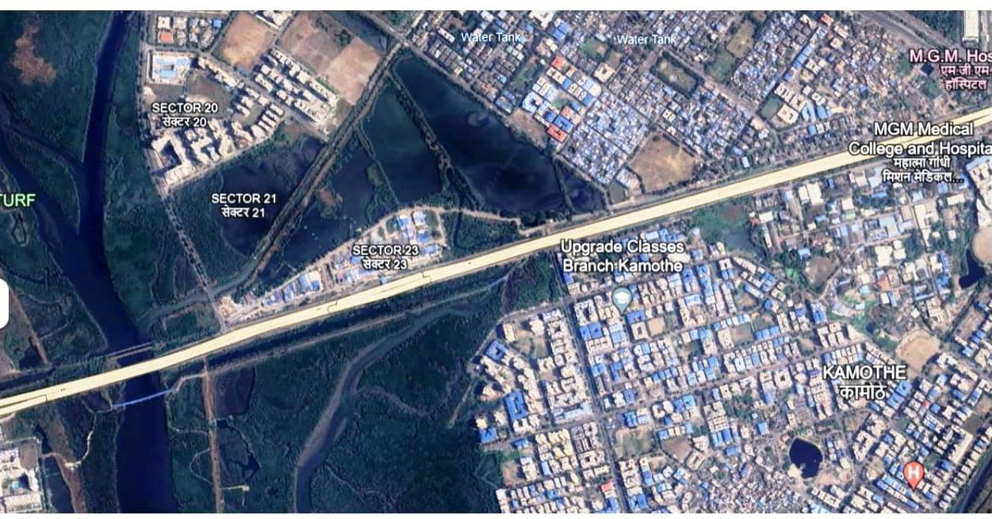

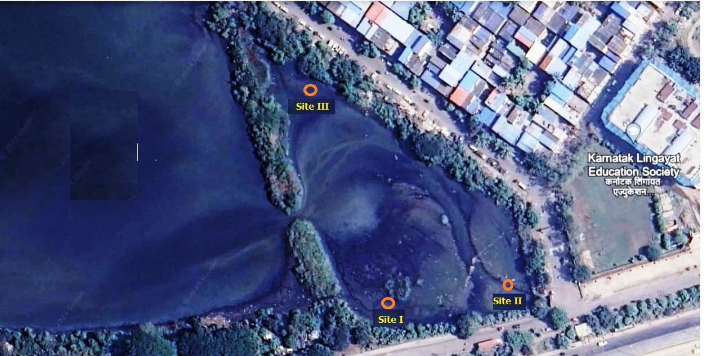
Fig.1Satelliteimageofstudyareawithsamplingstations(Source:Google Map)

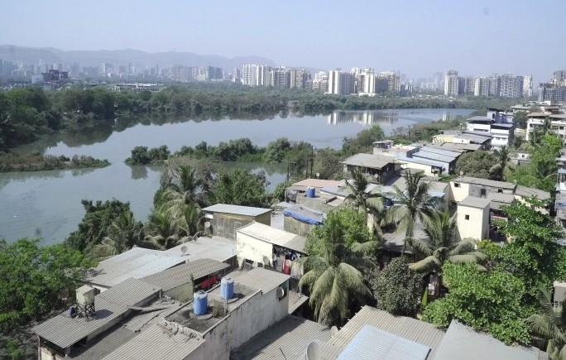
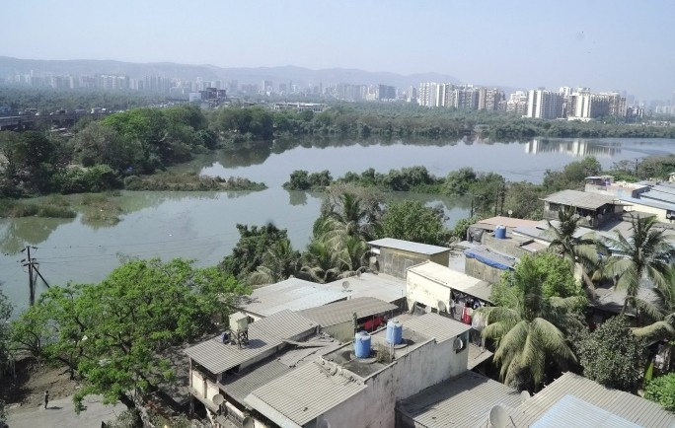
CoastalLake of Kalamboli

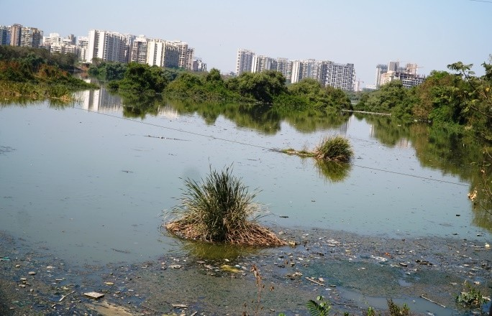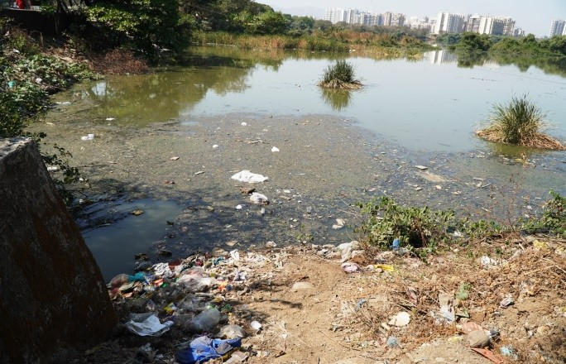
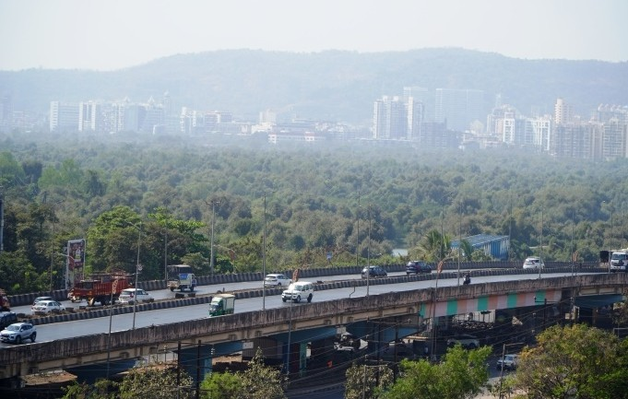
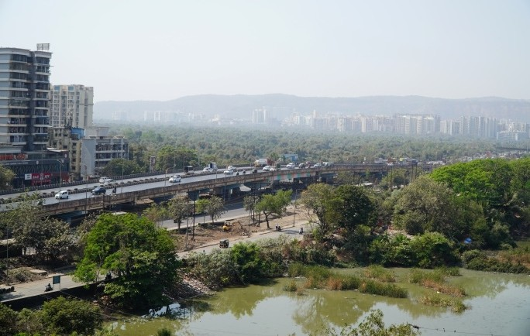
Suspendedandsettleddebrisinthelake
Mangrove vegetation Mumbai-PuneExpresswayandServiceRoad
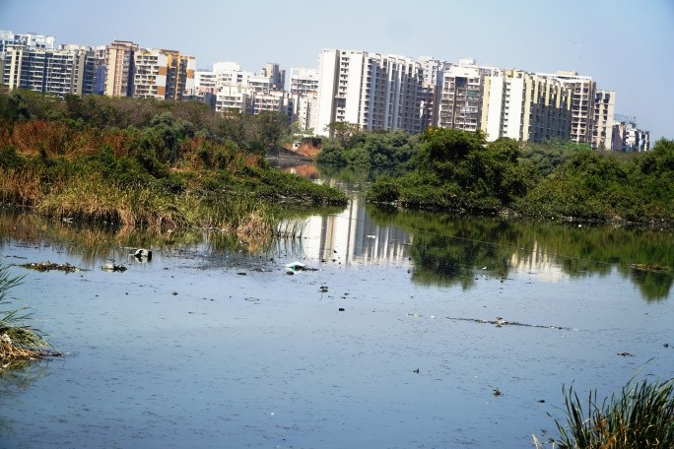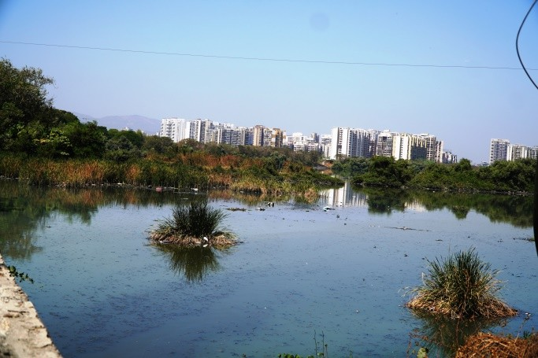
Construction of Residential colonies in the vicinity of the lake Fig.2CurrentstatusofthecoastallakeofKalamboli,NaviMumbai

Methods
Surface water samples were collected from substations along the coastal lake of Kalamboli, Navi Mumbai. Water samples were collected monthly from January 2024 to December 2024 and were analyzed for pH, Temperature, Turbidity, Total solids (TS), Total dissolved solids (TDS), Total suspended solids (TSS), Dissolved oxygen (DO), Biochemical oxygen demand (BOD), Carbon dioxide (CO₂), Chemical oxygen demand (COD), Salinity, Orthophosphate (O-PO₄), Ammonia-nitrogen (NH₃–N), Nitrate–nitrogen (NO₃–N), and Silicates following standard protocols of coastal water quality analysis [46, 47] (Table 1). All colorimetric measurements were done on ERMA INC (AE 11D) colorimeter.
Table1:Standard methodsadoptedfor waterquality assessment
Sr. No. | Water quality variable | Standardmethodadopted
1 | pH | PortablePhilipspHmeter

2 | Temperature | Centigradethermometer
3 | Turbidity | Nephelometricmethod
4 | Totalsolids(TS) | Gravimetricmethod
5 | TotalDissolvedsolids(TDS) | Gravimetricmethod
6 | Totalsuspendedsolids(TSS) | Subtractingvalueof TDSfrom TS
7 | Salinity | Argentometricmethod
8 | Dissolved oxygen (DO) | Winkler’sIodometric method
9 | Biochemicaloxygendemand (BOD) | Titrimetricmethod
10 | Carbondioxide (CO₂) | Titrimetricmethod
11 | Chemicaloxygendemand (COD) | Open reflux method
12 | Orthophosphate(O-PO₄) | Ascorbicacid method
13 | Ammonia-nitrogen(NH₃–N) | Nesslerizationmethod
14 | Nitrate–nitrogen(NO₃–N) | Cadmiumreduction method
15 | Silicates(SiO₄-Si) | Molybdo-silicatemethod

Results&Discussion
The average values and seasonal variations of water quality variables at coastal lakeof Kalamboli for the period of 12 months (January 2024 to December 2024) are presented in Table 2. Graphical representation of water quality parameters are presented in Figure 2a and 2b.
Table2:Seasonal variationsof waterqualityvariablesatcoastallakeof Kalamboli
Water quality variable | Pre-monsoon | Monsoon | Post-monsoon
pH | 6.89±0.02 | 6.85±0.03 | 7.56±0.21
Temperature(°C) | 29.86±0.12 | 28.02±0.55 | 28.97±0.16
Turbidity(NTU) | 52.34±11.34 | 52.68±8.08 | 56.27±11.92
Totalsolids(mg/l) | 1.59±0.04 | 1.72±0.09 | 1.53±0.06
TotalDissolvedsolids(mg/l) | 0.96±0.04 | 1.09±0.08 | 0.96±0.09
Totalsuspendedsolids(mg/l) | 0.59±0.03 | 0.54±0.06 | 0.48±0.02
Salinity(ppt) | 21.15±4.76 | 15.06±2.81 | 22.44±0.76
Dissolved oxygen (ml/l) | 1.26±0.17 | 1.26±0.07 | 1.43±0.17
Biochemicaloxygendemand (ml/l) | 0.96±0.05 | 1.15±0.19 | 0.94±0.09
Carbondioxide (mg/l) | 50.60±14.42 | 34.53±2.72 | 43.49±2.78
Chemicaloxygendemand (mg/l) | 80.49±19.69 | 63.58±13.45 | 87.39±11.66
Orthophosphate (µg/l) | 0.64±0.08 | 0.81±0.22 | 0.77±0.23
Ammonia-nitrogen(µg/l) | 54.21±25.62 | 29.81±7.73 | 49.67±5.90
Nitrate–nitrogen(µg/l) | 15.73±0.50 | 25.73±0.41 | 22.69±1.84
Silicates(µg/l) | 81.52±23.78 | 63.33±5.24 | 68.50±3.58

pH
In present study, an acidic pH (6.85 to 6.89) was observed in pre-monsoon and monsoon, which becomes slightly alkaline (7.29 to 7.24) during post-monsoon. Thedecreased pH is attributable to the decomposition of organic wastes; influence of freshwater influx, dilution of saline water, reduction of salinity and temperature [19]. pH significantly affects the chemical and biological interactions in the aquatic environment [46]. Slightly higher alkaline observed during post-monsoon may be due to high anthropogenic activities, photosynthesis process, and intrusion of seawater [48].

Temperature
Temperature in the range of 27.29–28.54 °C was observed during the monsoon season,whereasmoderatelyhightemperature(29.95°C)wasnotedduringthepre-monsoon.

During post-monsoon, the noted range of temperature is 28.13–29.31°C) at all study sites. In present study, the surface water temperature varies from 27.29 to 29.95°C, with maximum during summer and minimum during monsoon. Higher temperature observed during summer is correlated to the high solar radiation, increased evaporation, and low water level. Lower temperature during monsoon could be due to precipitation and freshwater influx [33].

Turbidity
In present study, high turbidity in the range of 39.61–66.73 NTU was recorded during pre- and post-monsoon, whereas during monsoon, the noted turbidity range was 43.62-62.37 NTU. Turbidity of water played a key role in controlling the light penetration and regulating rate of photosynthesis by plants in water [21]. Higher values of turbidity during monsoon are attributed to the rainwater runoff, and the waste discharge. Similar results on turbidity were earlier reported by Lee et al [35] in a coastal region of Sea Dike Construction in Korea and Muhtadi et al [40] in Lake Siombak, a tropical coastal lake of Indonesia.

TotalSolids(TS)
Moderately higher level of TS in the range of 1.48 to 1.79 mg/l was recorded in the surface waters of Kalamboli lake. As compared to mean TS levels during Pre- and post- monsoon (1.53-1.59 mg/l), significantly higher values (1.59-1.79 mg/l) of TS were recorded duringmonsoon.TSrefertoanymattereithersuspendedordissolvedinwater.ResultsonTS are in agreement with the work of North American Lake Management Society [3] on Nitinat Lake, a British Columbia Tidal Lake and Cleawox Lake, Oregon: The Coastal Sands of Cultural Omission.

TotalDissolvedSolids(TDS)
Exceptionally higher values (1.01- 1.16 mg/l) of TDS were recorded during monsoon as compared to pre- and post-monsoon (0.96±0.04 -0.96±0.09 mg/l) during present study. TDS includes materials such as, bicarbonate, sulphate, phosphate, nitrate, calcium, magnesium, sodium, organic ions, and other ions dissolved in the water. Higher TDS levels during monsoon were correlated to the urban run-off, wastewater, septic effluent, and decaying plants and animals, and geological features in the area [48]. Similar results on TDS levels were earlier reported by North American Lake Management Society [3] in Florida’s Coastal Dune Lakes and Tenmile Lake on the Oregon Coast.

TotalSuspendedSolids(TSS)
In present study, except lower level of TSS (0.48±0.02 mg/l) during post-monsoon, during remaining period, TSS was not significantly varied, i. e. 0.54±0.06 mg/l during monsoon and 0.59±0.03 mg/l during pre-monsoon. Higher concentration of TSS may be due to release of wastes from local drainages, anthropogenic activities, and wastewater effluents. Findings of the present study are in the agreement with the results of Queensland Wetlands Program [10] on the water quality of coastal and sub-coastal non-floodplain soil lakes of Queensland, Australia; and Singh and Jadhav [27] on the water quality in Rabale waterbody, Navi-Mumbai, India.

Salinity
Higher salinity such as 21.15±4.76 ppt and 22.44±0.76 ppt was recorded during pre- monsoon and post-monsoon respectively. A distinct low level of salinity (15.06±2.81 ppt)was observed during monsoon at all sampling sites. Present study exhibits a remarkable seasonal variation in salinity ranging from 12.46 to 23.99 ppt. Lower salinity noted during monsoon was due to monsoonal runoff and freshwater influx; whereas high salinity during pre-andpost-monsoonseasonisattributedtothehighdegreeofevaporationofsurfacewater. Similar results on salinity were observed by Bhateria and Jain [32], Sapkale et al [41], Ahamad et al [17], and Shen et al [4].

Dissolvedoxygen(DO)

Except a slightly higher level of DO (1.43±0.17 ml/l) recorded during post-monsoon, moderate levels of DO in the range of 1.05–1.44 ml/l during pre-monsoon and 1.17-1.21 ml/l during monsoon were observed. Higher values of DO recorded during post-monsoon are attributed to the photosynthetic activity by aquatic plants and algae and to the lower temperature and salinity [28].
Lower DO recorded during pre-monsoon and monsoon is due to release of large amountsofindustrialeffluentsanddomesticsewagewithhighloadoforganicwastesintothe lake water. Results on DO were in agreement with the findings of Patil et al [39] on water quality of inland water bodies of Mumbai, and Prasad et al [30] on water quality dynamics in the coastal waters of Kollam, Kerala.

Biochemicaloxygendemand (BOD)
Significantly lower BOD values in the range of 0.94±0.09- 0.96±0.05 ml/l were observed during pre- and post-monsoon; whereas slightly higher values of BOD (1.15±0.19 ml/l) were recorded during monsoon. Low BOD values were due to low organic pollution, and distribution of domestic sewage into the lake. High BOD values were attributed to the high oxygen demanding substances disposed to the lake water by surface runoff and utilization of oxygen for its oxidative biodegradation [7, 40, 49].

Carbondioxide(CO₂)
In present study, significantly high values of free CO₂ were reported during all seasons. Except the slightly lower values observed during monsoon (34.53±2.72 mg/l), exceptionally higher values were recorded both during pre-monsoon (50.60±14.42 mg/l) and post-monsoon (43.49±2.78 mg/l). High values of free CO₂ during pre-monsoon and post- monsoon was attributed to the pollution of lake water with surface runoff with nutrients, domestic waste and sewage, and biological breakdown of organic matter [31, 33].

ChemicalOxygenDemand(COD)
Very high values of COD in the range of 52.92- 97.36 mg/l were reported during present investigation. Except the slightly lower values noted in monsoon (63.58±13.45 mg/l), significantly high values of COD were observed during pre-monsoon (80.49±19.69 mg/l) and post-monsoon (87.39±11.66 mg/l). Higher values of COD recorded during pre-monsoon and post-monsoon could be due to decrease in freshwater inflow and domestic sewage [46]. Low COD recorded during the monsoon is correlated to the freshwater influx by the monsoonal runoff [34, 35].

Orthophosphate(O-PO₄)
Moderate values of O-PO₄ in the range of 0.44 – 1.02 μg/l were reported during present study. As compared to pre-monsoon (0.64±0.08 μg/l) and post-monsoon (0.77±0.23 μg/l), slightly higher values of O-PO₄ (0.81±0.22 μg/l) were observed during monsoon. Higher content of O-PO₄ recorded during monsoon was may be due to domestic detergents, industrial sewage effluents, and surface runoff. Moderate O-PO₄ noted during pre-monsoon and post-monsoon was correlated to the high salinity and utilization of phosphate by phytoplankton. Similar findings were reported earlier by Strombeck [13] in water quality and optical properties of Swedish Lakes and coastal waters, and Pradhan et al [44] in coastal waters off Chennai, East Coast of India.

Ammonia-nitrogen(NH₃-N)
Except lower values of NH₃-N (29.81±7.73 μg/l) recorded during monsoon, significantly higher values were noted during pre-monsoon (54.21±25.62 μg/l) and post- monsoon (49.67±5.90 μg/l). Higher concentration of NH₃-N during pre-monsoon and post- monsoon might be due to discharge of chemical effluents and NH₃ released from decompositionoforganicmatter.LowNH₃-Ninmonsooniscorrelatedtothemicrobial
assimilationandincreasedconversiontoNH+toNOandNO.Resultsofthestudyarein
4 2 3
parallelwiththefindingsofSheelaetal[19]onpollutionstatusoftheAkkulam-VeliLake,

Thiruvananthapuram, India, and Nair et al [24] on water quality of different water bodies in and around Mumbai.

Nitrate–nitrogen(NO₃-N)
Higher NO₃–N was recorded in surface water during monsoon (25.73±0.41 μg/l) and post-monsoon (22.69±1.84 μg/l), whereas comparatively lower values of NO₃–N were noted during pre-monsoon (15.73±0.50 μg/l). Higher values of NO₃–N concentration recorded during monsoon and post-monsoon is attributed to the freshwater inflow, terrestrial runoff, and land drainage. Findings of the study are in line with the results of Mitter [22] in surface water of Powai Lake, Mumbai, India; and Shaftel et al [26] in coastal lakes in the Arctic Coastal Plain of Alaska.

Silicates(SiO₄-Si)
Exceptionally higher silicates in the range of 49.28-105.21 μg/l were recorded during pre-monsoon as compared to the monsoon (58.29-70.26 μg/l) and post-monsoon (63.93- 72.66 μg/l). Higher silicate concentration recorded during pre-monsoon might be due to land drainage, and silicates leached out from rocks [11, 27]. Relatively lower silicates reported during monsoon and post-monsoon were due to biological removal/uptake of silicates by phytoplankton [12, 42, 48].

Months
MeanvaluesofpH

7.8
7.6
7.4pH7.2
7
6.8
6.6

30.5
30
29.5
°C29
28.5
28
27.5
27
Months
MeanvaluesofTemperature(°C)
Months
Months
mg1/.l6
MeanvaluesofTotalSolids(TS)
NTU50
MeanvaluesofTurbidity (NTU)
70
65
60
55
1.9
1.8
1.7
45
40
35
30
1.5
1.4
1.3
Months
Months
MeanvaluesofTotalDissolvedSolids(TDS)
MeanvaluesofTotalSuspendedSolids(TSS)
1.2
1.15
0.65
0.6
1.1
1.05
mg/1l
0.95
0.9
0.55
mg/l0.5

0.45
0.85
0.8
0.4

Fig.2a:Graphicalrepresentation ofmeanvaluesofwaterquality parameters
Months
Months
ppt
MeanvaluesofSalinity (ppt)
MeanvaluesofDissolvedoxygen(DO)
26
24
22
20
18
16
14
12
10
1.6
1.5
1.4
1.3
ml/l
1.2
1.1
1

Months
mg/4l5
MeanvaluesofCarbondioxide (CO2)
Months
ml/l
MeanvaluesofBiochemicalOxygenDemand(BOD)
1.4
1.3
1.2
1.1
65
60
55
50
1
0.9
0.8
0.7
40
35
30
25
Months
MeanvaluesofOrthophosphate(O-PO4)
Months
MeanvaluesofChemicalOxygenDemand(COD)
μg0/.l7
110
1.1
100
1
90 0.9
0.8
80
mg/l70
0.6
60
0.5
50
0.4
40
0.3
Months
Months
μg4/l0
MeanvaluesofAmmonia-nitrogen(NH3–N)
μg/l1
MeanvaluesofNitrate–nitrogen(NO3–N)
80
27
70
25
60
23
50
21

9
30
17
20
15
10
13

Fig.2b: Graphical representation of mean values ofwater qualityparameters
Months
μg/l
MeanvaluesofSilicates(SiO4-Si)
110

100

90

80

70

60

50

40
Jan-24Feb-24Mar-24Apr-24May-24Jun-24Jul-24Aug-24Sep-24Oct-24Nov-24Dec-24

Conclusion
Results of the study reveal that overall, water quality of coastal lake of Kalamboli experiences distinct seasonal variations. Parameters such as pH, temperature and salinity exhibit negative correlation with monsoonal precipitation whereas turbidity, dissolved oxygen, and nutrients exhibit strong positive correlation. Report of excess quantity of municipalwastesandsewagealongwitheffluentsfromthenearbyindustriesareactingasthe anthropogenic stressors of lake pollution. As the coastal lakes can be the sites for monitoring the migration of water pollution towards the sea, it is an urgent need of frequent monitoring the water quality of coastal lakes at regular intervals. This study marks the first attempt to assess water quality of the coastal lakes of Navi Mumbai; findings of the study can guide appropriate actions to safeguard the lake resources. Check refrences and this whole paper needs changes

References
- Oertel G F. Coastal Lakes and Lagoons. In: Schwartz, M.L. (eds) Encyclopedia of Coastal Science. Encyclopedia of Earth Science Series. Springer, Dordrecht. 2005; pp 263–266. https://doi.org/10.1007/1-4020-3880-1_81.
- Akshay Anand. Linking Urban Lakes: Assessment of Water Quality and its Environmental Impacts. Thesis submitted to the Faculty of Geo-InformationScience and Earth Observation of the University of Twente in partial fulfilment of the requirements for the degree of Master of Science in Geo-Information Science and Earth Observation. 2014; pp. 76.
- NALMS (North American Lake Management Society). Coastal Lakes. LakeLine, Winter2013,NorthAmericanLakeManagementSociety,4510RegentStreet,Suite 2A Madison, WI 537052013; 2014; 3(4): 1-56. ISSN 0734-7978.
- Shen Wangzheng, Liang Zhang, Emily A Ury, Sisi Li, Biqing Xia, Nandita B Basu. Restoring small water bodies to improve lake and river water quality in China. Nature Communications, 2025; 16:294. https://doi.org/10.1038/s41467-024-55714-
9.
- Szymaska–Walkiewicz Monika, Mikołaj Matela, Krystian Obolewski. Patterns of effects of land-use structure on lake water quality in coastal lake catchments of the southern Baltic Sea. Ecohydrology & Hydrobiology, 2024; 24: 449–460. https://doi.org/10.1016/j.ecohyd.2023.07.004.
- Kapani Kavitha, Nagabhushan V Charantimath, Pavan Chikkanarayanaswamy, Uday Jayaramaiah. Assessing the water quality of Vatadahosahalli Lake in Chikkaballapura district, Karnataka, India. HydroResearch, 2024; 7: 326–336. https://doi.org/10.1016/j.hydres.2024.06.001.
- Djitli Yasmina, Dani Boix, Amel Milla, Faiza Marniche, Irene Tornero, David Cunillera-Montcusi, Jordi Sala, Stéphanie Gascón, Xavier D Quintana, Samia Daoudi-Hacini. Annual cycle of water quality and macroinvertebrate compositionin Algerian wetlands: a case study of Lake Réghaïa (Algeria). Limnetica, 2021; 40(2): 399-415. DOI: 10.23818/limn.40.27.
- Ujjania N C, Monika Dubey. Water quality index of estuarine environment. Current Science, 2015; 108(8): 1430-1433.
- Montano M, D Robadue. Coastal Water Quality Monitoring and Management. In Robadue, D., editor and translator, Eight Years in Ecuador: The Road to Integrated Coastal Management. Narragansett, RI: Coastal Resources Center, University of Rhode Island. 2006; pp. 24.
- QWP (Queensland Wetlands Program). Coastal and Sub-Coastal Floodplain Lakes and Non-Floodplain Soil Lakes. Wetland Management Profile. Communications Manager, Queensland Wetlands Program, Publishing job no: QWP 2010/11, 2010; 29113, pp. 28. xxxxxx@derm.qld.gov.au.

- WHO (World Health Organization). Guidelines on recreational water quality. Volume 1: coastal and fresh waters. Geneva: World Health Organization; Licence: CC BY-NC-SA 3.0 IGO. 2021; pp. 164.
- Nordin Rick, John-Mark Davies, Asit Mazumder. Coastal Lakes in British Columbia. LakeLine Winter 2003/04, 2004; pp. 17-19.
- Strombeck Niklas. Water Quality and Optical Properties of Swedish Lakes and Coastal Waters in Relation to Remote Sensing. Dissertation for the Degree of Doctor of Philosophy in Limnology presented at Uppsala University in 2001. Comprehensive Summaries of Uppsala Dissertations from the Faculty of Science and Technology 633. Acta Universitatis Upsaliensis Uppsala, 2001; pp. 27.
- Pedrozo Catarina da Silva, Odete Rocha. Environmental Quality Evaluation of Lakes in the Rio Grande do Sul Coastal Plain. Brazilian Archives of Biology and Technology, 2007; 50(4): 673-685.
- Hala Abayazid, Ibrahim Al-Shinnawy. Coastal Lake Sustainability: Threats and Opportunities with Climate Change. IOSR Journal of Mechanical and Civil Engineering (IOSRJMCE), 2012; 1(5): 33-41.
- Vijay Prakash K, Geetha Vimala ChS, Preethi Latha T, Jayaram C, Nagamani P V, Laxmi ChNV. Assessment of Water Quality Along the Southeast Coast of India During COVID-19 Lockdown. Front. Mar. Sci., 2021; 8:659686. doi: 10.3389/fmars.2021.659686.
- Ahamad F, Sharma A K, Tyagi S K. A Study on Comparative Assessment of Water Quality of Dal and Nigeen Lakes of Jammu and Kashmir, India.AgroEnvironmental Sustainability, 2023; 1(1): 48-56.
https://doi.org/10.59983/s2023010107.
- IOSS (Integrated Ocean Observing system). Monitoring Estuarine Water Quality. Completed by Amy Dean. 2ndedition. 2016; pp. 47.
- Sheela A M, J Letha, S Joseph, M Chacko, S P Sanal kumar, J Thomas. Water quality assessment of a tropical coastal lake system using multivariate cluster, principal component and factor analysis. Lakes & Reservoirs: Research and Management, 2012; 17: 143–159. Doi: 10.1111/j.1440-1770.2012.00506.x.
- NODE (NOAA Ocean Data Education). Data in the Classroom Monitoring Estuarine Water Quality. National Environmental Satellite, Data, and Information Service (NESDIS), National Estuarine Research Reserve System, National OceanographicDataCenterandtheOfficeofNationalMarineSanctuaries.2018;
pp. 42.
- RasalVishal,UjwalaPatil,MeetaBhot.AssessmentofWaterQualityofTenUrban Lakes in Mumbai. Journal of Aquatic Biology & Fisheries, 2019; 7: 110 – 114.
- Mitter Chhaya. Assessment of Water Quality of Powai Lake, Mumbai, India. International Journal of Science and Research (IJSR), 2018; 7(1): 1138-1139. Paper ID: ART20179586 DOI: 10.21275/ART20179586.
- Tiwari Vijayta, Ramesh C Sharma. Water Quality Assessment of Sacred Lake Nachiketa Tal, Garhwal Himalaya, India. J. Himalayan Ecol. Sustain. Dev., 2017; 12: 1-15.
- Nair Anjali P, Ganga Sankaranarayanan, Ritika R Kumbhar, Ranjitsing Bayas, Seema Shinde. Assessment of water quality of different water bodies in and around Mumbai. International Journal for Research Trends and Innovation, 2022; 7(5):387-393.
- USEPA (U. S. Environmental Protection Agency). National Water Quality Inventory: Report to Congress. EPA 841-R-16-011, 2017; pp. 1-22.

- Shaftel Rebecca, Dan Bogan, Dustin Merrigan, Leslie Jones. Condition of lakes in the Arctic Coastal Plain of Alaska: water quality, physical habitat, and biological communities. Alaska Center for Conservation Science, University of Alaska Anchorage, 3211 Providence Dr., Anchorage, AK, 99508. 2018; pp. 26.
- Singh Pooja, Jadhav Anita S. Assessment of quality index of water by using different physico-chemical parameters in Rabale waterbody, Navi-Mumbai, Maharashtra, India. Intern. J. Zool. Invest. 2021; 7(2): 369-375. https://doi.org/10.33745/ijzi.2021.v07i02.007.
- Harrison Anna M, Alexander J Reisinger, Matthew J Cooper, Valerie J Brady, Jan J H Ciborowski, Katherine E O’Reilly, Carl R Ruetz III, Douglas A Wilcox, Donald G Uzarski. A Basin-Wide Survey of Coastal Wetlands of the Laurentian Great Lakes: Development and Comparison of Water Quality Indices. Wetlands, 2020; 40:465–477. https://doi.org/10.1007/s13157-019-01198-z.
- Desai Pooja. Water Quality Assessment of Lakes in Vashi, Navi Mumbai, Maharashtra, India. International Journal of Scientific Engineering and Research (IJSER), 2015; 3(7): 66-69. Paper ID: IJSER15327.
- Prasad Anagha, P Rama Chandra Prasad, N Srinivasa Rao. Assessing the water quality dynamics in the coastal waters of Kollam (Kerala, India) using Sentinel images.AnthropoceneCoasts,2024;7:10https://doi.org/10.1007/s44218-024-
00042-0.
- Bhat Salim Aijaz, Ashok K Pandit. Surface Water Quality Assessment of Wular Lake, A Ramsar Site in Kashmir Himalaya, Using Discriminant Analysis and WQI. Hindawi Publishing Corporation Journal of Ecosystems, 2014; Article ID 724728, 18 pages. http://dx.doi.org/10.1155/2014/724728.
- Bhateria Rachna, Disha Jain. Water quality assessment of lake water: a review. Sustain. Water Resour. Manag., 2016; 2:161–173. DOI 10.1007/s40899-015-0014- 7.
- Jose Dinu Maria, Venkata Ravibabu Mandla, Saladi S V Subbarao, N SrinivasaRao, Sheela A Moses. Assessment of Coastal Water Quality along South West Coast of India Using Multile Regression Analysis On Satellite Data. Journal of Rural Development, 2018; 37(2): 269-284. NIRD&PR, Hyderabad. DOI: 10.25175/jrd/2018/v37/i2/129673.
- Kamble Swapnil R, Ritesh Vijay, R A Sohony. Water Quality Assessment ofCreeks and Coast in Mumbai, India: A Spatial and Temporal Analysis. 11th ESRI India User Conference 2010. ESRI India, 2010; pp. 1-6.
- Lee Y W, Oh Y H, Lee S H, Kim D, Joung D. Assessment of Water Quality in a Coastal Region of Sea Dike Construction in Korea and the Impact of LowDissolved Oxygen Concentrations on pH Changes. J. Mar. Sci. Eng., 2023; 11: 1247. https://doi.org/10.3390/jmse11061247.
- RatheeshKumarR,PurushothamanCS,SreekanthGB,ManjuLekshmiN,Renjith V, Sandeep K P, Pandey P K. State of Water Quality of Two Tropical Urban Lakes Located at Mumbai Megacity. International Journal of Science and Research(IJSR), 2015, 4(5): 1991-1998. Paper ID: SUB154650.
- Sheela A M, Letha J, Joseph S, Ramachandran K K, Justus J. Assessment of Pollution Status of a Coastal Lake System using Satellite Imagery. J Geophys Remote Sensing; 2013; 2: 110. doi:10.4172/2169-0049.1000110.
- Stanescu Madalina, Constantin Buta, Geanina Mihai. Assessment of Water Quality from Coastal Lakes for Use in Irrigation. Ovidius University Annals Series: Civil Engineering. Sciendo, 2021; pp. 200-207. DOI: 10.2478/ouacsce-2021-0022.

- Patil G K, Sachin Bhere, Twinkle Gaikwad, Kunal Joshi, Saurabh Sawant, Rohit Rathod. Water Quality of Inland Water Bodies of Mumbai using Hyperspectral Remote Sensing Hyperion EO1. Roorkee Water Conclave, Indian Institute of Technology Roorkee and National Institute of Hydrology, Roorkee during February 26-28, 2020; pp. 1-10.
- Muhtadi A, Yulianda F, Boer M, Krisanti M, Riani E, Leidonald R, Hasani Q, Cordova M R. Assessment of pollution status of tropical coastal lakes using modified Water Quality Index (WQI) based on physio-chemical parameters. AACL Bioflux, 2023; 16(1):356-370.
- Sapkale Pravin H, Neelam Saharan, Sanath Kumar, Vidya Shree Bharati, Kundan Kumar. Assessment of Water Quality Along the Mahim Creek in Mumbai using Water Quality Index Method. Environment and Ecology, 2019; 37(1): 16-21.
- Abhijna U G. Monitoring and assessment of a eutrophicated coastal lake using multivariate approaches. Global J. Environ. Sci. Manage. 2016; 2(3): 275-288.DOI: 10.7508/gjesm.2016.03.007.
- Dey J, R Vijay. Geospatial assessment of seasonal water quality of Malad creek, Mumbai, India: An impact of sewage discharge. Indian J Geo-Mar Sci, 2022; 51(10): 811-821. DOI: 10.56042/ijms.v51i10.2930.
- Pradhan U, Panda U S, Naik S, Mishra P, Kumar D S, Begum M, Murthy M V R. Coupled hydrodynamic and water quality modeling in the coastal waters off Chennai, East Coast of India. Front. Mar. Sci., 2022; 9:987067. doi: 10.3389/fmars.2022.987067.
- NayakBB.'DebriskillinggreencoveratKalamboli'|MumbaiNewsTimesof India Dec 9, 2018; http://timesofindia.indiatimes.com/articleshow/67004361.cms?utm_source=contentofinterest&utm_medium=text&utm_campaign=cppst.
- Hand Joe. Typical Water Quality Values for Florida’s Lakes, Streams, and Estuaries. Watershed Assessment Section, Bureau of Watershed Management, Florida Department of Environmental Protection, 2600 Blair Stone Road, Tallahassee, FL 32399. 2004; pp. 101.
- Strickland J D H, and Parsons T R. A practical handbook of seawater analysis, 1972; 167: 1977. (Fisheries Research Board of Canada, Ottawa).
- Pawar Prabhakar R. Impact of Jawaharlal Nehru Port (JNP) and port related establishments on seawater quality of the Uran coast, Navi Mumbai. Advances in Environmental Biology, 2017; 11(10): 9-31.
- Abayazid H O, El-Adawy A. Assessment of a Non-Optical Water Quality Property Using Space-Based Imagery in Egyptian Coastal Lake. Journal of Water Resource and Protection, 2019; 11: 713-727. https://doi.org/10.4236/jwarp.2019.116042.

