Original Research Article
Butterflies of Chhattisgarh: Updated Checklist with 19 Additions to the State Fauna.

ABSTRACT

The Conservation and Research of Wilderness (C.R.O.W.) Foundation conducted a comprehensive field survey, encompassing all 33 districts of Chhattisgarh state, from 2019 to 2024 to update the checklist of butterflies in the state. Along with overview of previous studies, we reported a total of 201 butterfly species which updated the state's butterfly fauna by incorporating 19 species that had not been previously documented in Chhattisgarh. Lycaenidae led with 67 species from 43 genera, followed by Nymphalidae with 60 species from 28 genera, Hesperiidae with 42 species of 30 genera, Pieridae included 20 species of 10 genera, Papilionidae presented 10 species of three genera, and Riodinidae with two species of one genus. Current report also confirmed the presence of one species, Tarucus nara which were reported by Chandra et al., 2014.

Keywords: Biodiversity, New Record, Lepidoptera, Rhopalocera, Insect fauna, Conservation, Butterflies fauna of Central India.

1. INTRODUCTION

Heppner (1998) put the number of butterfly species in the world at roughly 19,238; however. With 1,641 species of butterflies, India is unique in the world, holding 9.50% of all species (Varshney 2006). Prior to Chandra et al. (2007), scientists including Forsayeth (1884), Swinhoe (1886), De Niceville (1890), Betham (1890), and Witt (1909) carried out a limited amount of historical documentation of butterflies in Chhattisgarh region. In Madhya Pradesh and Chhattisgarh during the 19th century, numerous academics made important advancements in butterfly studies (D'Abreau, 1920; Evans, 1932; Talbot, 1947; Wynter-Blyth, 1957; Singh, 1977; Gupta & Shukla, 1987; Pandharipande, 1990; Chaudhury, 1995). Following its proclamation as a separate state in 2000, Chhattisgarh, research on butterflies was undertaken by multiple researchers, including Chandra (2006), Varshney (2006), Siddiqui and Singh (2004), and Singh and Chandra (2006).
The butterfly fauna of Chhattisgarh, India, is examined in detail in this report, covering the period from the first area specific checklist of state created by Chandra et al. in 2007 to more recent additions made by different researchers. Starting with a baseline of 174 species, the study concentrated on Madhya Pradesh and Chhattisgarh, of which 113 are unique to the Chhattisgarh state. Subsequent investigations, such as those by Sharma & Chandra (2009), Chandra et al. (2014), Dubey et al. (2015), Sisodia, 2019, Tandan et al. (2020, 2021a, 2021b), Nihlani et al. (2021), Chand et al. (2022), Jangde (2023), and Singh et al (2023) have broadened and enhanced our understanding of Chhattisgarh's butterfly diversity. So far, 182 species of butterflies have been documented in the state of Chhattisgarh (Tandan et al., 2024a, b, c; Tandan & Visvanathan, 2024).

2. material and methods

For this survey, binoculars were used for field observations, and butterflies were photographed using digital cameras, with occasional use of mobile phone cameras. Identification was primarily made with Smetacek (2016) and Kehimkar (2016), and confirmed based on the works of Evans (1932), Wynter-Blyth (1957), and Haribal (1992).

2.1 Study area
After breaking away from Madhya Pradesh on November 1, 2000, Chhattisgarh was founded as a new state and initially consisted of 16 districts. Nevertheless, it presently has 33 revenue districts in total (Figure – 1). At 135,192 square kilometers, Chhattisgarh is the ninth-largest state in India. The region is renowned for having a significant quantity of forest cover, with over 44% of its entire area covered by woodlands. These forests are categorized as Reserve forests (43.13%), protected forests (40.21%), and Un-classed forests (16.65%), and they hold three National Parks and eleven Wildlife Sanctuaries. Chhattisgarh has a variety of forest types, including evergreen, dry-deciduous, grasslands, and bamboo (Chandra et al., 2014).
Geographically, Chhattisgarh features a diverse terrain, with hilly landscapes in the north & south, while the central Chhattisgarh characterized by plains. Biogeographically, the region is considered a part of the Deccan Plateau (Rodgers et al., 2000). From a geological perspective, the state is situated within the Central Indian Plateau, which is part of the Gondwana Plate (Mohanty, S. P., 2020). Between the Eastern and Western Ghats, the study area particularly in the districts of the Bastar division serves as an essential habitat with significant biodiversity, which makes it of great ecological value. With a northeastern elongation, the central locations of Chhattisgarh are between 17°46' and 24°8' N latitude and 80°15' to 84°24' E longitude. Because it is so close to the Tropic of Cancer, the state has a tropical climate, which is marked by high temperatures and high humidity. We see extremes in temperature, with summers reaching as high as 46 °C (115 °F) and winters falling below 5 °C (41 °F). In Chhattisgarh, there is approximately 1,292 millimeters (50.9 in) of rainfall on average per year. Water resources are abundant in the state since so many rivers flow through it. This is one of its unique features. These rivers, which are essential to the area's biological balance and water availability, include the Mahanadi, Shivnath, Arpa, Indravati, Sabari, Leelagar, Hasdeo, Pairi, and Sondur.

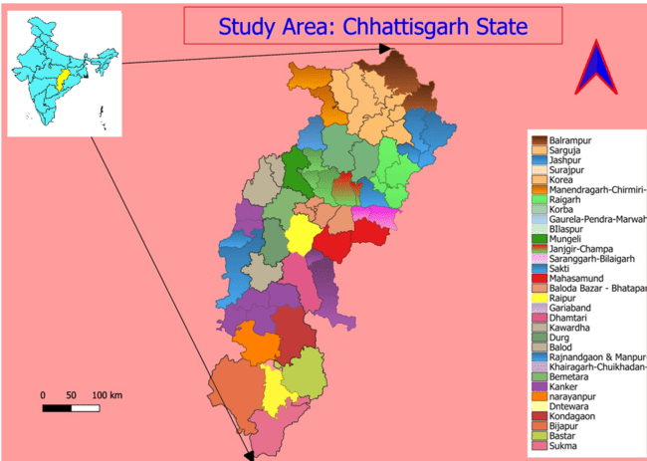

Figure 1: Map showing collection localities all 33 districts of State Chhattisgarh.

3. RESULTS AND DISCUSSION

We conducted photographic documentation and prepared a checklist comprising 201 butterfly species (Table- 02). Our study documented nineteen species of butterflies in Chhattisgarh that were notably not documented in previous records, which are as follows:
We photographed the12 species of butterflies that were first time recorded for the Chhattisgarh states, which belonging to family Hesperiidae, of which two are the new records for Central India.
2.2.1 Family: Hesperiidae,
Sub family: Coeliadinae

Bibasis sena (Moore, [1866]) - Orange-tailed Awlet (Image 01)

Distribution in India: Maharashtra to Madhya Pradesh and south to Kerala, Himachal Pradesh to N.E. India; Andaman & Nicobar Is. (Varshney & Smetacek, 2015).
Remarks: It was photographed by Ravi Naidu from Bastar on 28.xii.2020. This species was reported from Central India (Madhya Pradesh) by Chandra et al. (2007) and it was observed first time in Chhattisgarh by present report. Only one sub-species Bibasis sena sena under Bibasis sena was reported in India (Varshney & Smetacek, 2015).

Burara harisa (Moore, [1866]) - Orange Striped Awlet (Image 02)

Distribution in India: Sikkim to N.E. India. (Varshney & Smetacek 2015).
Remarks: The species was photographed from KVNP, Bastar by Ravi Naidu on 28.x.2021. Two subspecies Burara harisa harisa (Moore, [1866]) and Burara harisa andamana Chiba & Tsukiyama, 2009, are recorded in India (Varshney & Smetacek 2015). Added here as new record for Chhattisgarh State.

Burara vasutana (Moore, [1866]) – Green Awlet (Image 03)

Known Distribution in India: Uttarakhand to N.E. India (Varshney & Smetacek 2015).
Remarks: This species was photographed from KVNP, Bastar by Ravi Naidu on 24.x.2020. No subspecies under this species. An individual of the species was observed feeding on bird droppings on the ground in KVNP Bastar, and added here as new to the Chhattisgarh State.

Burara gomata (Moore, [1866]) – Pale Green Awlet (Image 04)

Known Distribution in India: Sikkim to N.E. India. & Goa to Kerala. (Varshney & Smetacek 2015).
Remarks: This species was photographed from KVNP, Bastar by Ravi Naidu on 03.ix.2021. Two subspecies are recorded in India, Burara gomata gomata (Moore, [1866]) shows distribution in Sikkim to N.E. India, and Burara gomata kanara (Evans, 1926), has distribution in Goa to Kerala (Varshney & Smetacek 2015). Added here as new record for the Chhattisgarh State.

Sub family: Hesperiinae

Ampittia dioscorides (Fabricius, 1793) - Bush Hopper (Image 05)

Known Distribution in India: Maharashtra east to West Bengal and south to Kerala; Himachal Pradesh to N.E. India. (Varshney & Smetacek, 2015).
Remarks: The species was observed for the first time in Central India and reported hereby a first record for butterfly fauna of central India. It was observed and photographed by Saurabh & Ravi at Jashpur (18.x.2018), Gulab & Ramanand at Gariaband (18.xi.2018). This species has been reported as one subspecies Ampittia dioscorides dioscorides (Fabricius, 1793) in India. (Varshney & Smetacek, 2015).

Halpe porus (Mabille, [1877]) - Moore’s Ace (Image 06)
Known Distribution: Maharashtra to West Bengal and southward to Kerala; Uttarakhand to N.E. India; Andaman & Nicobar Is.. (Varshney & Smetacek, 2015).
Remarks: The species is also known as the Moore's Ace. (Varshney & Smetacek, 2015; Saji, K. & Prashanth S. N., 2021) and no subspecies are documented for this particular species in India. Ravi Naidu recorded from Bastar on 17.ix.2020 and H. N. Tandan recorded from Tatamari Eco-Center, Keshkal in Kondagon district on 20.x.2020. This species is a new addition to the butterfly fauna of the Chhattisgarh.

Pelopidas agna (Moore, [1866]) - Obscure Branded Swift (Image 07)

Known Distribution in India: Andaman & Nicobar Islands; Jammu & Kashmir; Kerala to Gujarat and W. Bengal. (Varshney & Smetacek, 2015).
Remarks: The specimen was frequently observed in Chhattisgarh by Ravi Naidu, Avinash Bhoi & Saurabh Singh at Dongargarh, Rajnandgaon27.ix.2020, Gulab Chand & H. N. Tandan at Kurud, Dhamtari 19.vii.2020, 19.viii.2020, 05.ix.2020, Gulshan Kumar at Nagari, Dhamtari on 28.ix.2020, 28.ix.2021,17.x.2021, H. N. Tandan at Kasdol, Baloda-Bazar District on 14.x.2020. The species Pelopedas agna has only one sub species (Varshney & Smetacek, 2015) is Pelopidas agna agna (Moore, [1866]) – Bengal Obscure Branded Swift also known as the Dark Branded Swift. This species is a new addition to the butterfly fauna of the Central India.

Pelopidas assamensis (de Niceville, 1882) - Great Swift (Image 08)

Known Distribution in India: Himachal Pradesh to N.E. India; Gujarat; Madhya Pradesh; Odisha (Varshney & Smetacek 2015).
Remarks: The species were observed by Ravi Naidu at KVNP, Bastar on 10.iv.2021. No subspecies under this species recorded in India. This species is added here as new record for the Chhattisgarh Sate here with the present report.

Parnara guttatus (Bremer & Grey, [1852]) – Straight Swift (Image 09)

Known Distribution in India: Jammu & Kashmir to N.E. India. (Varshney & Smetacek 2015).
Remarks: Observed by Ravi Naidu at Rajnandgaon on 27.ix.2020, and Gulab Chand at Dhamtari on 19.x.2017. The species has no subspecies. This species has distribution in N.E. India and first time observed in Chhattisgarh while added as new record for the state.

Oriens goloides (Moore, [1881]) - Ceylon Dartlet (Image 10)

Known Distribution in India: Maharashtra to Kerala; Sikkim to N.E. India (Varshney & Smetacek 2015).
Remarks: This species was first photographed by Ravi Naidu at KVNP, District Bastar on17.x.2021. No subspecies in India. This species was included in this report as a new record for Chhattisgarh State.

Sub Family: Pyrginae

Gerosis bhagava (Moore, [1866]) - Common Yellow-breast Flat (Image 11)

Known Distribution: Goa to Jharkhand and south to Kerala; Sikkim to N.E. India (Varshney & Smetacek, 2015).
Remarks: The specimen was sighted by Ravi Naidu in KVNP, Bastar district on 17.ix.2020. This species has two listed subspecies: Gerosis bhagawa andamanica by Wood Mason & de Niceville, 1881, and Gerosis bhagawa bhagava by Moore, [1866] as cited in Varshney & Smetacek, 2015. While the species was previously reported in Hoshangabad, Madhya Pradesh by Betham (1890-91) and in Central India by Chandra et al. (2000b) as mentioned in Chandra et al., 2007, this marks its first observation in Chhattisgarh, adding a new species to the state's butterfly fauna.

Sarangesa purendra Moore, 1882 - Spotted Small Flat (Image 12)

Known Distribution in India: Karnataka; Tamil Nadu, Kerala to Rajasthan, Himachal Pradesh to Uttarakhand, Gujarat. (Varshney & Smetacek, 2015).
Remarks: Ravi Naidu photographed the species at INP on 19.vii.2020. Subspecies listed under this species are Sarangesa purendra purendra Moore, 1882 – West Himalayan Spotted Small Flat, mostly observed from Himalayan range, Sarangesa purendra pandra Evans, 1949 – Hill Spotted Small Flat and Sarangesa purendra hopkinsi Evans, 1921 – Dakhan Spotted Small Flat, shows more distribution in Western Ghats and Central India, but Sarangesa purendra sati de Nicéville, 1891 – Desert Spotted Small Flat, shows less distribution limited to Western Ghats. Chaudhary and Khan (2002) documented this species in Umaria, Madhya Pradesh, Central India, as referenced by Chandra et al., 2007. However, this study marks its first observation in Chhattisgarh, reporting it as a new addition to the state's butterfly fauna.

We photographed 03 new species from the Lycaenidae family, adding to the butterfly fauna of Chhattisgarh state are as:

2.2.2 Family: Lycaenidae
Sub family:Theclinae

Spindasis syama (Horsfield, [1829]) - Club Silverline (Image 13)

Known Distribution in India: Odisha; Jharkhand; Sikkim to N.E. India (Varshney & Smetacek 2015).
Remarks: Documented by Ravi Naidu at KVNP Bastar on 30.ix.2021. Only one subspecies recorded in India is Spindasis syama peguanus Moore, 1884.
Spindasis lohita (Horsfield, [1829]) - Long-banded Silverline (Image 14)

Known Distribution in India: Uttarakhand to Arunachal Pradesh; Maharashtra to Kerala; Andaman & Nicobar Is. (Andamans). (Varshney & Smetacek 2015).
Remarks: Photographed by Saurabh Singh at Jashpur on 13.ix.2020 and Ravi Naidu recorded it from KVNP, Bastar on 23.x.2017. There are three sub species in India recorded as Spindasis lohita himalayanus (Moore, 1884), shows the distribution in Uttarakhand to Arunachal Pradesh, Spindasis lohita lazularia (Moore, [1881]) shows its distribution in India as Maharashtra to Kerala and Spindasis lohita zoilus (Moore, 1877) distributed in Andaman & Nicobar Is. (Andamans).

Surendra quercetorum (Moore, [1858]) - Common Acacia Blue (Image 15)

Known Distribution: Uttarakhand to N.E. India (Varshney & Smetacek, 2015),
Remarks: This species was photographed by Gulshan Kumar at Nagri, Dhamtari on 05.xii.2020. Letter on it was observed in KVNP by Ravi Naidu on 22.x.2022. No subspecies recorded in this species. This species was not documented in earlier reports from the Chhattisgarh and reported here as a new record for the state fauna of Chhattisgarh.

We photographed 01 species of family Nymphalidae, adding to the butterfly fauna of Chhattisgarh state as:

2.2.3 Family Nymphalidae

Ypthima baldus (Fabricius, 1775) - Common Fivering (Image 16)

Known Distribution in India: Himachal Pradesh to N.E. India; Gujarat to Kerala; Madhya Pradesh and Chhattisgarh (Varshney & Smetacek 2015).
Remarks: Ravi Naidu photographed this species at KVNP on September on 26.ix.2020 and 27.ix.2020. Ypthima baldus has three subspecies in India: Ypthima baldus baldus from Himachal Pradesh to N.E. India, Ypthima baldus madrasa from Gujarat to Kerala, and Ypthima baldus satpura from central India, including Madhya Pradesh and Chhattisgarh, previously undocumented in Chhattisgarh. This report adds it to Chhattisgarh's butterfly fauna.

We photographed 03 species within the Pieridae family, adding to the butterfly fauna of Chhattisgarh state are as:

2.2.4 Family Pieridae

Eurema blanda (Boisduval, 1836) - Three-spot Grass Yellow (Image 17)

Known Distribution in India: Uttarakhand to N.E. India, Northern & Central Nicobar Is., Southern Nicobar Is., Gujarat to Kerala, and Andaman Is. (Varshney & Smetacek 2015).
Remarks: This species has subspecies as Eurema blanda silhetana (Wallace, 1867) distributed within Uttarakhand to N.E. India, Eurema blanda moorei (Butler, 1886) distributed in Northern & Central Nicobar Is., Eurema blanda grisea (Evans, 1932) distributed in Southern Nicobar Eurema blanda davidsoni Moore, 1906, distributed in Gujarat to Kerala, and Eurema blanda roepstorffi Moore, 1907 has limited distribution to Andaman Is. This species was first time documented here by Ravi Naidu at KVNP Bastar on 17.ix.2020.

Eurema andersoni Moore, 1886 One-spot Grass Yellow (Image 18)

Known Distribution in India: Southern Andaman Is., Uttarakhand to N.E. India; Tripura; West Bengal, Karnataka; Kerala; Tamil Nadu (Varshney & Smetacek 2015).
Remarks: Three subspecies in India as Eurema andersoni evansi Corbet & Pendlebury, 1932 distributed in Southern Andaman Is. Eurema anderson jordani Corbet & Pendlebury, 1932 distributed in Uttarakhand to N.E. India; Tripura; West Bengal, and Eurema andersoni shimai Yata & Gaonkar, 1999 distributed to Karnataka; Kerala; Tamil Nadu. This species has been documented in Chhattisgarh by Ravi Naidu at KVNP Bastar on 17.ix.2020 and reported here as new addition to state fauna of butterfly.

Colotis amata (Fabricius, 1775) - Small Salmon Arab (Images 19)

Known Distribution in India: Delhi; Gujarat; Haryana; Maharashtra; Punjab; Rajasthan; Uttar Pradesh; Andhra Pradesh; Karnataka; Kerala; Odisha; Tamil Nadu; W. Bengal (Varshney & Smetacek 2015).
Remarks: Two subspecies in India as Colotis amata amata (Fabricius, 1775) distributed in Delhi; Gujarat; Haryana; Maharashtra; Punjab; Rajasthan; Uttar Pradesh, and Colotis amata modestus (Butler, 1876) distributed in Andhra Pradesh; Karnataka; Kerala; Odisha; Tamil Nadu; W. Bengal (Varshney & Smetacek 2015). Ravi Naidu documented this species first time in Chhattisgarh at Bastar on 11.vii.2022. This is the first record in Central India.

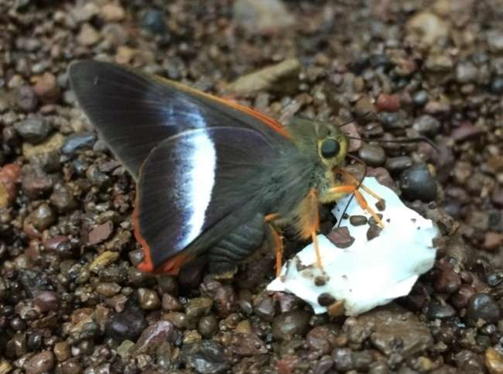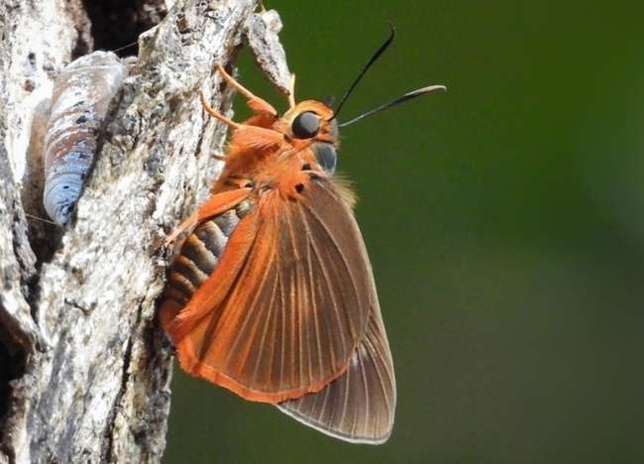
Image 1: Bibasis sena ©Ravi Naidu Image 02: Bibasis harisa ©Ravi Naidu
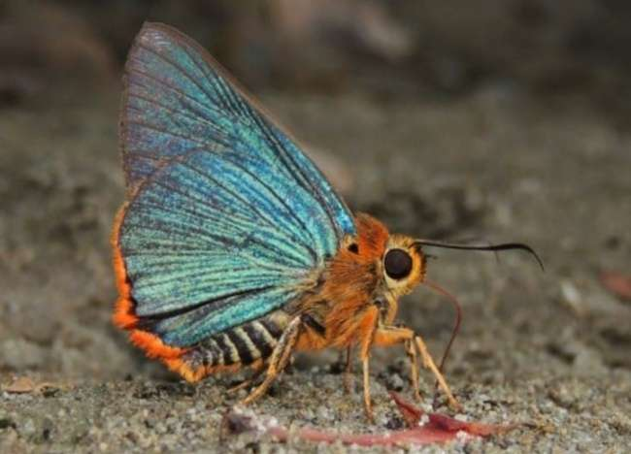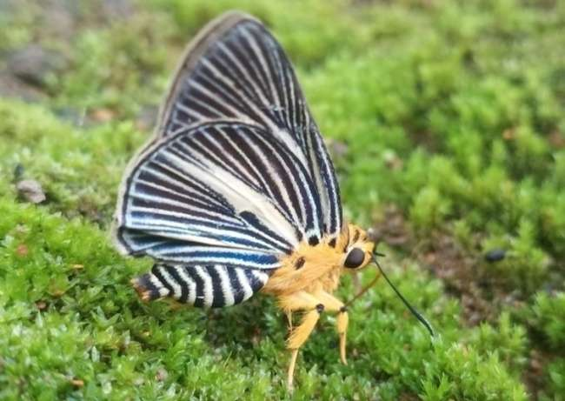
Image 3: Burara vasutana ©Ravi Naidu Image 4: Burara gomata ©Ravi Naidu
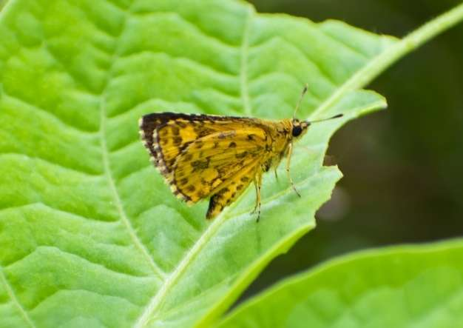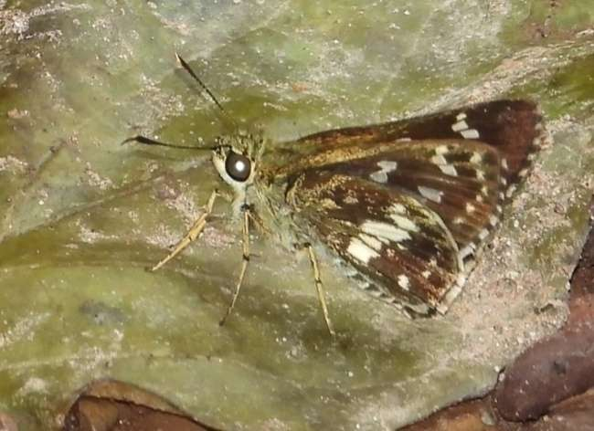
Image 5: Ampittia dioscorides ©Ravi Naidu Image 6: Halpe porus ©Ravi Naidu
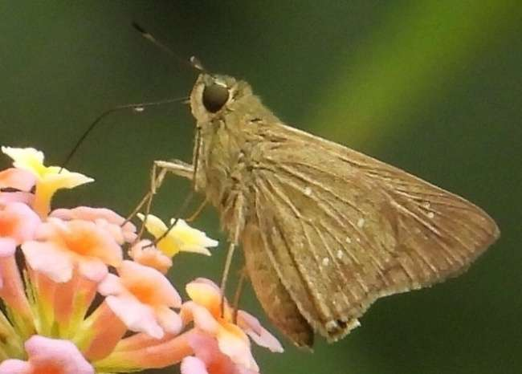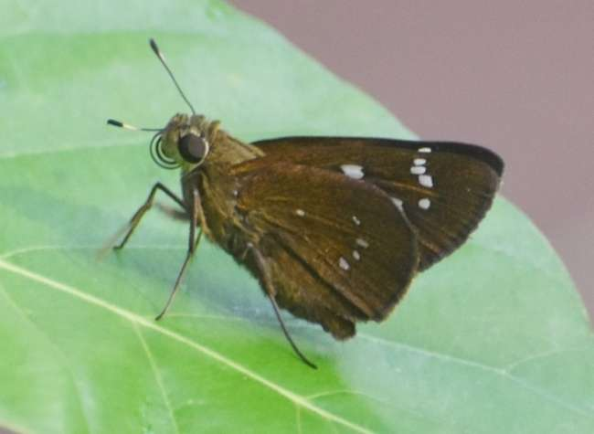
Image 7: Pelopidas agna ©Ravi Naidu Image 8: Pelopidas assamensis ©Ravi Naidu

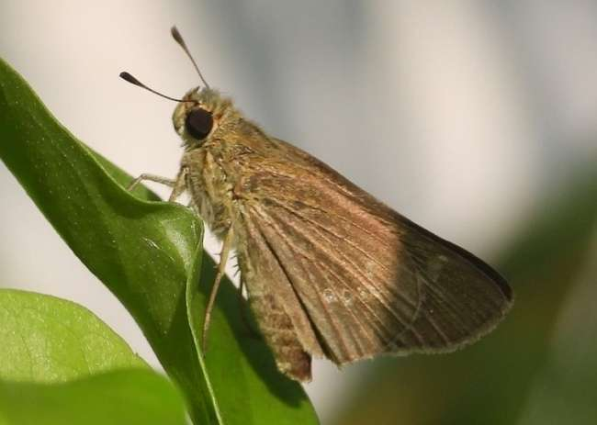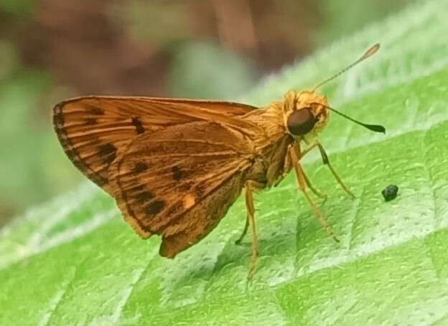
Image 09: Parnara guttata ©Ravi Naidu Image 10: Oriens goloides ©Ravi Naidu
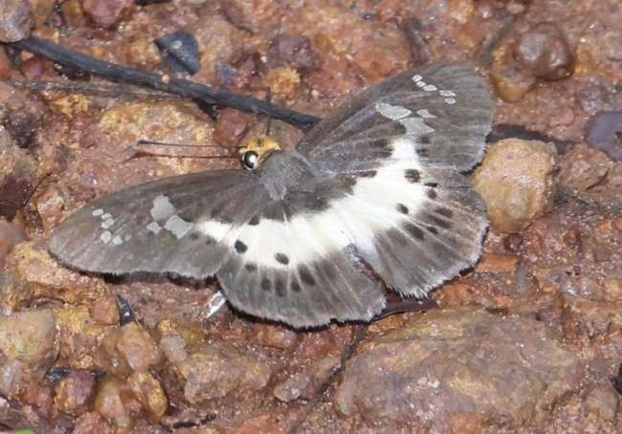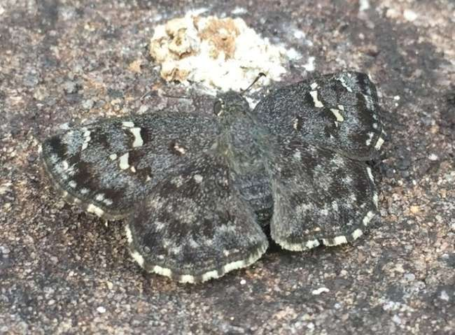
Image 11: Gerosis bhagava ©Ravi Naidu Image 12: Sarangesa purendra ©Ravi Naidu
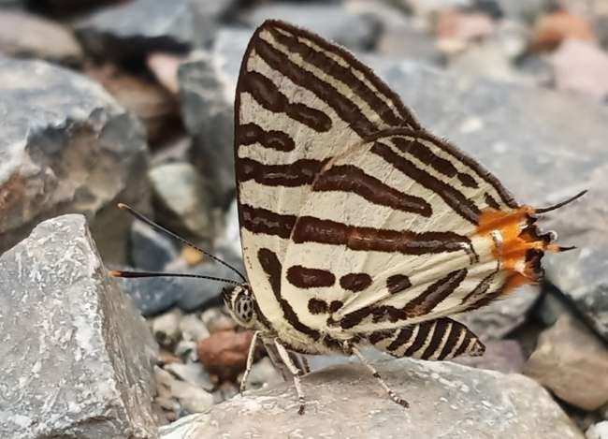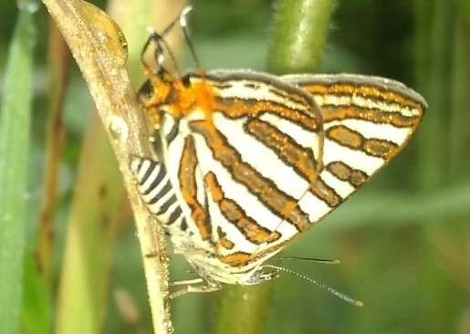
Image 13: Spindasis syama ©Ravi Naidu Image 14: Spindasis lohita ©Ravi Naidu
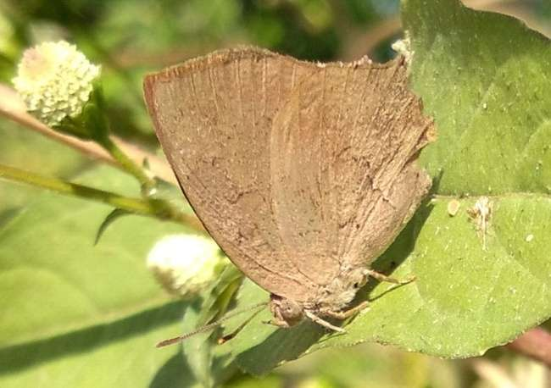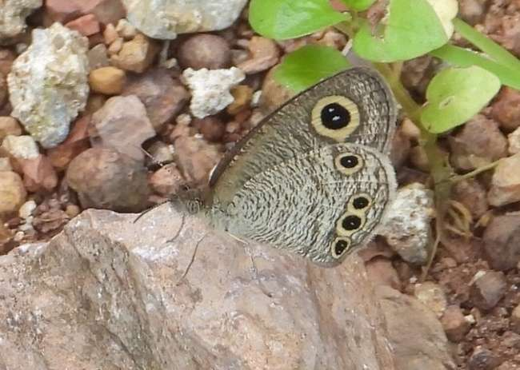
Image 15: Surendra quercetorum ©Ravi Naidu Image 16: Ypthima baldus ©Ravi Naidu
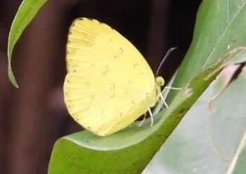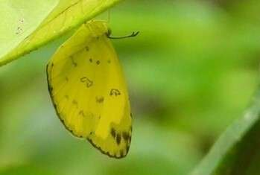
Image 17: Eurema blanda ©Ravi Naidu Image 18: Eurema andersoni ©Ravi Naidu
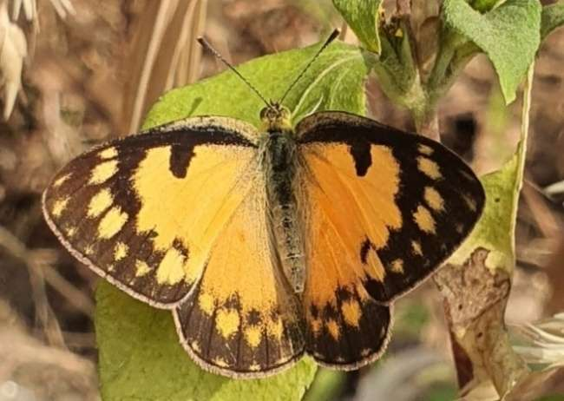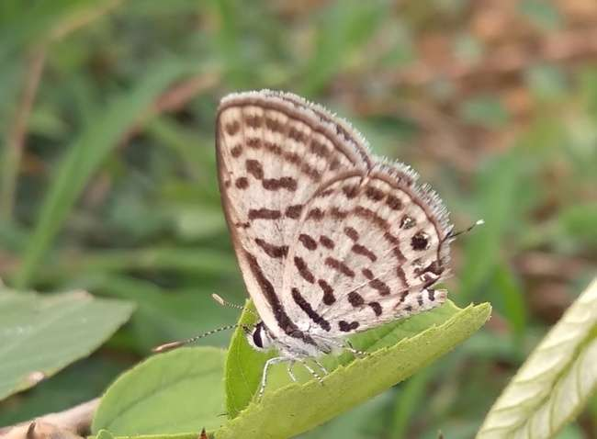
Image 19: Colotis amata ©Ravi Naidu Image 20: Tarucus Nara ©Gulshan Kumar

An impressive count of 201 butterfly species was observed and documented, along with a compilation of previous research contributions and systematically placed into six families. Lycaenidae dominated with 67 species from 43 genera, closely followed by Nymphalidae with 60 species from 28 genera, showcasing remarkable diversity in the study area. The Hesperiidae family also exhibited significant diversity, comprising 42 species from 30 genera. However, the families Pieridae with 20 species from 10 genera, Papilionidae with 10 species from three genera, and Riodinidae with two species from one genus contributed one species (Table-2). The study enriched the state's butterfly checklist with 19 newly documented species and also confirms the presence of one species Tarucus nara (Kollar, 1848) from seven butterfly species previously listed tentatively by Sisodia, 2019 in his compiled checklist of butterflies in annexure-3, and recommended further studies to validate their existence. These seven species were initially reported in Chandra et al. (2014) but were not included in the catalogue of butterflies of India from Chhattisgarh by Varshney & Smetacek (2015). In the current study, out of these seven species, one species were documented from various parts of Chhattisgarh, effectively confirming their existence in the region (Table - 03). Reviewing the Chhattisgarh butterfly fauna, Sisodia 2019 eliminated two species from the Chandra et al. 2014 list due to misidentification, bringing the adjusted total count to 159 species. Several new butterfly species were added to Chhattisgarh's fauna by various researchers from 2020 to 2024 and added 23 species (Sisodia and Kshirsagar, 2020; Tandan et al. 2020; Nihalani et al., 2021; Tandan et al., 2021a & b; Chand et al., 2022; Jangde et al., 2023; Nihalani et al., 2022; Singh et al, 2023; Tandan et al., 2024a,b,c; Tandan & Visvanathan 2024). At the finding of present observation, we updated the checklist of butterflies with 201 species with the addition of 19 new records documented during field surveys.

Table 1. NEW ADDITIONS TO THE STATE FAUNA OF BUTTERFLIES OF CHHATTISGARH.

S.N. | Scientific Name | Common Name | Recorded from  District of Chhattisgarh | Date of observation
Family: Hesperiidae
Sub family: Coeliadnae
1. | Bibasis sena (Moore, [1866]) | Indian Orange-tailed Awl | Bastar | 23.xii.2020
2. | Burara harisa (Moore, [1866]) | Orange Striped Awl | Bastar | 28.x.2021
3. | Burara vasutana (Moore, [1866]) | Green Awlet | Bastar | 24.x.2020
4. | Burara gomata (Moore, [1866]) | Pale Green Awlet | Bastar | 3.ix.2021
Sub family: Hesperiinae
5. | Ampittia dioscorides (Fabricius, 1793) | Bush Hopper | Jashpur, Gariaband | 18.x.2019, 18.xi.2018
6. | Halpe porus (Mabille, [1877]) | Moore’s Ace | Bastar, Kanker | 17.ix.2020
7. | Pelopidas agna (Moore, [1866]) | Obscure Branded Swift | Dhamtari, Bastar, Gariaband, Sarguja, B.Bazar, Dongargarh, | 14.x.2020, 19.vii.2020, 5.ix.2020, 17.x.2021, 29.x.2021, 27.ix.2020, 28.ix.2020, 5.x.2021
8. | Pelopidas assamensis (de Nicéville, 1882) | Great Swift | Bastar | 10.iv.2021
9. | Parnara guttatus (Bremer & Grey, [1852]) | Straight Swift | Rajnandgaon, Dhamtari | 27.xi.2020, 19.x.2017
10. | Oriens goloides (Moore, [1881]) | Ceylon Dartlet | Bastar | 17.x.2021
Sub family: Pyrginae
11. | Gerosis bhagava (Moore, [1866]) | Common Yellow-breasted Flat | Bastar | 17.ix.2020
12. | Sarangesa purendra Moore, 1882 | Spotted Small Flat | Bijapur | 19.vii.2020
Family: Lycaenidae
Sub Family: Theclinae
13. | Spindasis syama (Horsfield, [1829]) | Club Silverline | Bastar | 30.ix.2021
14. | Spindasis lohita (Horsfield, [1829]) | Long-banded Silverline | Jashpur, | 13.ix.2020, 23.x.2017
15. | Surendra quercetorum (Moore, [1858]) | Common Acasia Blue | Bastar | 11.vii.2022
Family: Nymphalidae
Sub Family: Satyrinae
16. | Ypthima baldus (Fabricius, 1775) | Common Fivering | Bastar | 26.ix.2020, 27.ix.2020
Family: Pieridae
Sub Family: Coliadinae
17. | Eurema blanda (Boisduval, 1836) | Three-spot Grass Yellow | Bastar | 17.ix.2020
18. | Eurema andersonii (Moore, 1886) | One-spot Grass Yellow | Bastar | 17.ix.2020
Sub family: Pierinae
19. | Colotis amata (Fabricius, 1775) | Small Salmon Arab | Bastar | 11.vii.2022

Table - 2: UPDATED CHECKLIST – BUTTERFLIES OF CHHATTISGARH

S. N. | Scientific Name | Common Name | Recorded from (Districts of C.G.) | Source/ Recorded by
Order: Papilionoidea
Family: Hesperiidae
Sub-Family: Coeliadinae
 | Badamia exclamationis (Fabricius, 1775) | Brown Awl | Bilaspur, Korea , Bastar, Raigarh, Jashpur | Chandra et al., 2007
- * | Bibasis sena (Moore, [1866]) | Indian Orange-tailed Awl | Bastar | Present Survey
- * | Burara harisa (Moore, [1866]) | Orange Striped Awlet | Bastar | Present Survey
- * | Burara vasutana (Moore, [1866]) | Green Awlet | Bastar | Present Survey
- * | Burara gomata (Moore, [1866]) | Pale Green Awlet | Bastar | Present Survey
 | Burara jaina (Moore, [1866]) | Common Orange Awlet | Bastar | Dubey et al., 2015
 | Hasora chromus (Cramer, [1780]) | Common Banded Awl | Bastar, Korea, Raipur, Raigarh, Jashpur Throughout C.G. | Chandra et al., 2007
 | Hasora vitta (Butler, 1870) | Plain Banded Awl | Bastar, Jashpur | Dubey et al., 2015
Sub-Family: Hesperiinae
- * | Ampittia dioscorides (Fabricius, 1793) | Bush Hopper | Bastar, Jashpur | Present Survey
 | Baoris farri (Moore, 1878) | Paint-brush Swift | Bilaspur | Chandra et al., 2007
 | Borbo bevani (Moore, 1878) | Bevan’s Swift/Lesser Rice Swift | Bastar | Chandra et al., 2007
 | Borbo cinnara (Wallace, 1866) | Rice Swift | Bastar, Jashpur, Dhamtari, Gariaband, Raipur, Baloda-Bazar, Janjgir-Champa, | Chandra et al., 2014
 | Caltoris kumara (Moore, 1878) | Blank Swift | Bastar, Bilaspur | Chandra et al., 2007
 | Cupitha purreea (Moore, 1877) | Wax Dart | Bastar, Dhamtari, Gariaband, | Dubey et al., 2015
 | Gangara thyrsis (Fabricius, 1775) | Giant Redeye | Jashpur, Kanker, Jashpur, Gariaband, Dhamtari, Janjgir-Champa | Sisodia & Kshirsagar, 2020
- * | Halpe porus (Mabille, [1877]) | Bispot Banded Ace | Bijapur, Bastar | Present Survey
 | Iambrix salsala (Moore, [1866]) | Chestnut Bob | Bastar, Jashpur, Korea, Korba, Bilaspur | Dubey et al., 2015
 | Matapa aria (Moore, [1866]) | Common Branded Redeye | Narayanpur, Bastar, Gariaband, Janjgir-Champa | Jangde et al., 2023
 | Erionota torus Evans, 1941 | Rounded Palm-redeye | Gariaband, Dhamtari, Kondagaon, Bastar | Tandan et al., 2024
 | Erionota thrax (Linnaeus, 1767) | Palm Redeye | Gariaband | Tandan & Visvanathan, 2024
 | Notocrypta curvifascia (C. & R. Felder, 1862) | Restricted Demon | Bastar, Jashpur, Gariaband, Mahasamund, Dhamtari | Chandra et al., 2014
- * | Parnara guttatus (Bremer & Grey, [1852]) | Straight Swift | Bastar, Jashpur | Present Survey
- * | Pelopidas agna (Moore, [1866]) | Obscure Branded Swift | Bastar, Narayanpur, Dhamtari, Gariaband, Sarguja, Baloda-Bazar, Rajnandgaon | Present Survey
 | Pelopidas mathias (Fabricius, 1798) | Small Branded Swift | Bastar, Sarguja, Dhamtari | Chandra et al., 2007
- * | Pelopidas assamensis (de Nicéville, 1882) | Great Swift | Bastar | Present Survey
 | Suastus gremius (Fabricius, 1798) | Oriental Palm Bob | Bilaspur, Sarguja, Dhamtari, Bastar | Chandra et al., 2007
 | Telicota bambusae (Moore, 1878) | Dark Palm-Dart | Bastar, Gariaband, Dhamtari | Chandra et al., 2007
 | Telicota colon (Fabricius, 1775) | Pale Palm-Dart | Sarguja, Gariaband, Dhamtari | Chandra et al., 2014
 | Udaspes folus (Cramer, [1775]) | Grass Demon | Bastar, Bilaspur, Jashpur, Gariaband, Mahasamund | Chandra et al., 2007
- * | Oriens goloides (Moore, [1881]) | Smaller Dartlet | Bastar | Present Survey
 | Hyarotis adrastus (Stoll, [1780]) | Tree Flitter | Gariaband | Tandan et al., 2024
Sub-Family: Pyrginae
 | Caprona ransonnettii (R. Felder, 1868) | Golden Angle | Bilaspur, Bastar, Gariaband, Dhamtari, Rajnandgaon | Chandra et al., 2007
 | Caprona agama (Moore, 1858) | Spotted Angle | Kabirdham, Gariaband, Mahasamund, Dhamtari | Nihlani et al. 2021
 | Odontoptilum angulata (C. Felder, 1862) | Chestnut Angle | Bastar | Dubey et al., 2015
 | Celaenorrhinus ambareesa (Moore, [1866]) | Malabar Spotted Flat | Kabirdham, Bastar, Bilaspur | Chandra et al., 2014
 | Celaenorrhinus leucocera (Kollar, [1844]) | Common Spotted Flat | Bastar, Jashpur | Chandra et al., 2007
 | Coladenia indrani (Moore, [1866]) | Tricolour Pied Flat | Sarguja, Bastar | Chandra et al., 2014
- * | Gerosis bhagava (Moore, [1866]) | Common Yellow-breasted Flat | Bastar | Present Survey
- * | Sarangesa purendra Moore, 1882 | Spotted Small Flat | Bijapur | Present Survey
 | Spialia galba (Fabricius, 1793) | Indian Grizzled Skipper | Bastar, Bilaspur, Kanker, Sarguja, Throughout C.G. | Chandra et al., 2007
 | Tagiades japetus (Stoll, [1781]) | Common Snow Flat | Bastar, Jashpur | Chandra et al., 2014
 | Tagiades litigiosa Möschler, 1878 | Water Snow Flat | Jashpur, Bastar | Sisodia & Kshirsagar, 2020
Family: Lycaenidae
Sub-Family: Curetinae
 | Curetis acuta Moore, 1877 | Acute Sunbeam | Jashpur, Bastar | Sisodia, 2019
 | Curetis bulis (Westwood, [1851]) | Bright Sunbeam | Bastar | Chandra et al., 2007
 | Curetis thetis (Drury, [1773]) | Indian Sunbeam | Jashpur, Bastar, Dhamtari, Gariaband | Sisodia, 2019
Sub-Family: Miletinae
 | Spalgis epius (Westwood, [1851]) | Apefly | Jashpur,Korea, Dhamtari, Gariaband, | Sisodia, 2019
Sub-Family: Polyommatinae
 | Acytolepis puspa (Horsfield, [1828]) | Common Hedge Blue | Bastar, Raipur, Jashpur, Dhamtari, Gariaband, Korea, | Chandra et al., 2014
 | Anthene emolus (Godart, [1824]) | Common Ciliate Blue | Korba, Dhamtari, Gariaband | Chandra et al., 2014
 | Anthene lycaenina (R. Felder, 1868) | Pointed Ciliate Blue | Bastar, Jashpur, Rajnandgaon, Dhamtari, Gariaband | Tandan et al., 2020
 | Azanus ubaldus (Stoll, [1782]) | Bright Babul Blue | Raigarh | Sisodia, 2019
 | Caleta decidia (Hewitson, 1876) | Angled Pierrot | Bastar, Dantewara, Jashpur, Dhamtari, Gariaband | Chandra et al., 2007
 | Castalius rosimon (Fabricius, 1775) | Common Pierrot | Bastar, Bilaspur, Dantewara, Kanker, Sarguja, Raigarh, Raipur, Janjgir-Champa, Jashpur, Throughout C.G. | Chandra et al., 2007
 | Catochrysops strabo (Fabricius, 1793) | Forget-me-not | Bastar, Bilaspur, Dantewara, Kabirdham, Korba, Raipur, Janjgir-Champa, Jashpur, Throughout C.G. | Chandra et al., 2007
 | Chilades lajus (Stoll, [1780]) | Lime Blue | Raipur, Raigarh, Bilaspur, Jashpur, Throughout C.G. | Sisodia, 2019
 | Chilades pandava (Horsfield, [1829]) | Plains Cupid | Bastar, Kabirdham, Jashpur, Korea, Raipur, Dhamtari, Gariaband | Chandra et al., 2007
 | Chilades parrhasius (Fabricius, 1793) | Small Cupid | Jashpur, Bastar, Dhamtari, Gariaband | Sisodia, 2019
 | Euchrysops cnejus (Fabricius, 1798) | Gram Blue | Bastar, Dantewara, Kanker, Sarguja, Bilaspur, Raipur, Jashpur, Throughout C.G. | Chandra et al., 2007
 | Everes lacturnus (Godart, [1824]) | Indian Cupid | Jashpur. Dhamtari, | Chandra et al., 2014
 | Freyeria putli (Kollar, [1844]) | Black-spotted Grass Jewel | Throughout C.G. | Tandan et al., 2021a
 | Freyeria trochylus (Freyer, 1845) | Orange-spotted Grass Jewel | Sarguja, Kabirdham | Chandra et al., 2014
 | Jamides alecto (C. Felder, 1860) | Metallic Cerulean | Bastar, Jashpur | Chandra et al., 2007
 | Jamides bochus (Stoll, [1782]) | Dark Cerulean | Bastar, Jashpur, Dhamtari, Gariaband | Tandan et al. (2020)
 | Jamides celeno (Cramer, [1775]) | Common Cerulean | Bastar, Dantewara Jashpur, Raigarh, Raipur, Bilaspur Dhamtari, Gariaband | Chandra et al., 2007
 | Lampides boeticus (Linnaeus, 1767) | Pea Blue | Bastar, Bilaspur, Dantewara, Kanker, Bilaspur, Dhamtari, Gariaband | Chandra et al., 2007
 | Leptotes plinius (Fabricius, 1793) | Zebra Blue | Bastar, Dantewara, Kabirdham, Raipur, Bilaspur, Raigarh, Jashpur Throughout C.G. | Chandra et al., 2007
 | Megisba malaya (Horsfield, [1828]) | Malayan | Bastar | Sisodia, 2019
 | Neopithecops zalmora (Butler, [1870]) | Common Quaker | Bastar | Sisodia, 2019
 | Pithecops corvus Fruhstorfer, 1919 | Forest Quaker | Bastar | Chandra et al., 2007
 | Tarucus theophrastus  (Fabricius, 1793) | Pointed Pierrot | Bastar | Chandra et al., 2014
 | Petrelaea dana (de Nicéville, [1884]) | Dingy Lineblue | Bastar, Jashpur, Dhamtari, Gariaband | Chandra et al., 2014 & Sisodia, 2019
 | Prosotas dubiosa (Semper, [1879]) | Tailless Lineblue | Bastar, Durg, Raigarh, Raipur, Bilaspur, Jashpur, Throughout C.G. | Chandra et al., 2014
 | Prosotas nora (C. Felder, 1860) | Common Lineblue | Raipur, Raigarh, Bilaspur, Jashpur, Dhamtari, Gariaband | Sisodia, 2019
 | Prosotas noreia (R. Felder, 1868) | White-tipped Lineblue | Bijapur, Gariaband | Tandan et al., 2023
 | Pseudozizeeria maha (Kollar, [1844]) | Pale Grass Blue | Dantewara, Raipur, Raigarh, Bilaspur, Jashpur, Dhamtari, Gariaband | Chandra et al., 2007
 | Tarucus balkanica (Freyer, 1844) | Little Tiger Pierrot | Dhamtari, Gariaband | Chand et al. 2022
 | Tarucus callinara Butler, 1886 | Spotted Pierrot | Bastar, Dantewara | Chandra et al., 2007
 | Tarucus nara (Kollar, 1848) | Striped Pierrot | Dhamtari, Gariaband | Chandra et al., 2007  And Resighted in Present Survey
 | Talicada nyseus (Guérin-Méneville, 1843) | Red Pierrot | Jashpur, Bastar | Singh et al., 2023
 | Zizeeria karsandra (Moore, 1865) | Dark Grass Blue | Bastar, Dantewara, Kanker, Raipur, Sarguja, Jashpur, Throughout C.G. | Chandra et al., 2007
 | Zizina otis (Fabricius, 1787) | Lesser Grass Blue | Bastar, Dantewara, Kanker, Throughout C.G. | Chandra et al., 2007
 | Zizula hylax (Fabricius, 1775) | Tiny Grass Blue | Bastar, Dantewara, Kanker, Jashpur, Dhamtari, Gariaband | Chandra et al., 2007
Sub-Family: Poritiinae
 | Poritia hewitsoni Moore, [1866] | Common Gem | Bastar | Sisodia & Naidu, 2019
Sub-Family: Theclinae
 | Amblypodia anita Hewitson, 1862 | Purple Leaf Blue | Bastar, Janjgir-Champa, Raipur, Rajnandgaon, Dhamtari, Gariaband Mahasamund | Chandra et al. 2014
 | Ancema blanka (de Nicéville, 1894) | Silver Royal | Kondagaon, Bastar, Dhamtari, Gariaband, | Tandan et al., 2021b
 | Arhopala amantes (Hewitson, 1862) | Large Oakblue | Bastar, Bilaspur, Korba, Jashpur, Korea, | Chandra et al., 2007
 | Arhopala atrax (Hewitson, 1862) | Indian Oakblue | Bilaspur, Korba, Jashpur, Sarguja, Raipur, Dhamtari, Gariaband | Chandra et al., 2007
 | Arhopala centaurus (Fabricius, 1775) | Centaur Oakblue | Bastar, Jashpur | Chandra et al., 2007
 | Horaga onyx (Moore, [1858]) | Common Onyx | Jashpur | Sisodia, 2019
 | Horaga viola Moore, 1882 | Brown Onyx | Jashpur | Sisodia & Kshirsagar, 2020
 | Hypolycaena othona Hewitson, [1865] | Orchid Tit | Bastar, Korea, Raipur, Jashpur, Korba, Gariaband | Chandra et al., 2007
 | Iraota timoleon (Stoll, [1790]) | Silverstreak Blue | Bastar, Jashpur | Chandra et al., 2007
 | Loxura atymnus (Stoll, 1780) | Yamfly | Bastar, Bilaspur, Korea, Jashpur, Gariaband | Chandra et al., 2007
 | Rapala iarbus (Fabricius, 1787) | Common Red Flash | Bastar, Bilaspur, Jashpur, Dhamtari, Gariaband | Chandra et al., 2007
 | Rapala manea (Hewitson, 1863) | Slate Flash | Bastar, Jashpur, Gariaband | Chandra et al., 2007
 | Rapala pheretima (Hewitson, [1863]) | Copper Flash | Jashpur, Bastar, Dhamtari, Gariaband | Chandra et al., 2014
 | Rapala varuna (Horsfield, [1829]) | Indigo Flash | Jashpur | Sisodia, 2019
 | Rathinda amor (Fabricius, 1775) | Monkey Puzzle | Throughout C.G. | Tandan et al., 2024
 | Spindasis ictis (Hewitson, 1865) | Common Shot Silverline | Bastar, Jashpur, Dhamtari, Gariaband | Tandan et al., 2021a
 | Spindasis vulcanus (Fabricius, 1775) | Common Silverline | Bastar, Korba, Korea, Sarguja, Jashpur, Gariaband, Dhamtari, | Chandra et al., 2007
- * | Spindasis syama (Horsfield, [1829]) | Club Silverline | Bastar | Present Survey
- * | Spindasis lohita (Horsfield, [1829]) | Long-banded Silverline | Jashpur, Bastar | Present Survey
 | Tajuria cippus (Fabricius, 1798) | Peacock Royal | Bastar, Bilaspur, Jashpur | Chandra et al., 2007
 | Tajuria jehana Moore, [1884] | Plains Blue Royal | Bastar | Chandra et al., 2007
 | Virachola isocrates (Fabricius, 1793) | Common Guava Blue | Bastar, Dhamtari | Chandra et al. 2014
- * | Surendra quercetorum (Moore, [1858]) | Common Acasia Blue | Bastar | Present Survey
 | Zeltus amasa (Hewitson, [1865]) | Fluffy Tit | Bastar, Jashpur | Sisodia, 2019
 | Zesius chrysomallus Hübner, [1819] | Redspot | Korba, Jashpur, | Chandra et al. 2014
 | Deudorix epijarbas (Moore, [1858]) | Cornelian | Baloda-Bazar, Bastar, Bijapur | Nihlani et al., 2022
 | Catapaecilma major Druce, 1895 | Common Tinsel | Bastar | Tandan et al., 2024
Family: Nymphalidae
Sub-Family: Apaturinae
 | Euripus consimilis (Westwood, [1851]) | Painted Courtesan | Bastar | Sharma & Chandra, 2009
Sub-Family: Biblidinae
 | Ariadne ariadne (Linnaeus, 1763) | Angled Castor | Bastar, Dhamtari, Gariaband, Mahasamund, | Chandra et al., 2014
 | Ariadne merione (Cramer, [1777]) | Common Castor | Bastar Throughout C.G. | Chandra et al., 2007
Sub-Family: Charaxinae
 | Charaxes agrarius Swinhoe, [1887] | Anomalous Nawab | Janjgir-Champa, Raipur, Jashpur, Bastar | Sisodia, 2019
 | Polyura athamas (Drury) | Common Nawab | Bastar | Chandra et al., 2007
 | Charaxes bernardus (Fabricius, 1793) | Tawny Rajah | Bastar, Raipur, Jashpur, Gariaband, | Chandra et al., 2007
 | Charaxes psaphon Westwood, 1847 | Plain Tawny Rajah | Raigarh, Bastar | Sisodia, 2019
 | Charaxes solon (Fabricius, 1793) | Black Rajah | Bastar, Bilaspur, Raipur, Jashpur, Kondagaon | Chandra et al., 2007
Sub-Family: Cyrestinae
 | Cyrestis thyodamas Doyère, [1840] | Common Map | Jashpur, Bastar, GPM, Kondagaon, Gariaband | Chandra et al., 2014
Sub-Family: Danainae
 | Danaus chrysippus (Linnaeus, 1758) | Plain Tiger | Bastar, Bilaspur, Korba, Korea, Durg, Dantewara, Jashpur, Raigarh, Sarguja, Raipur Through C.G. | Chandra et al., 2007
 | Danaus genutia (Cramer, [1779]) | Striped Tiger | Bastar, Bilaspur, Kabirdham, Korba, Korea, Raigarh, Raipur, Sarguja, Jashpur Dhamtari, Gariaband, Mahasamund, Baloda-Bazar, Janjgir-Champa, Bilaigarh. | Chandra et al., 2007
 | Euploea core (Cramer, [1780]) | Common Crow | Bastar, Bilaspur, Dantewara, Durg, Jashpur Kabirdham, Raigarh, Raipur  Throughout C.G. | Chandra et al., 2007
 | Euploea klugii Moore, [1858] | King Crow | Bastar, Gariaband | Tandan et al., 2021a
 | Euploea mulciber (Cramer, [1777]) | Striped Blue Crow | Bastar | Chandra et al., 2007
 | Euploea sylvester (Fabricius, 1793) | Double-branded Crow | Raipur, Jashpur, Bastar | Sisodia, 2019
 | Parantica aglea (Stoll, [1782]) | Glassy Tiger | Bastar, Jashpur, Rajnandgaon, Sarguja, Bilaspur Dhamtari, Gariaband, | Chandra et al., 2014
 | Tirumala limniace (Cramer, [1775]) | Blue Tiger | Bastar, Dantewara Raigarh, Raipur, Sarguja, Jashpur Through out C.G. | Chandra et al., 2007
 | Tirumala septentrionis (Butler, 1874) | Dark Blue Tiger | Bastar | Chandra et al., 2014
Sub-Family: Heliconiinae
 | Acraea terpsicore (Linnaeus, 1758) | Tawny Coster | Bastar, Bilaspur, Dantewara, Korea, Raipur, Raigarh, Through C.G. | Chandra et al., 2007
 | Phalanta alcippe (Stoll, [1782]) | Small Leopard | Bastar | Chandra et al., 2007
 | Phalanta phalantha (Drury, [1773]) | Common Leopard | Bastar, Bilaspur, Dantewara, Kabirdham, Kanker, Korea, Raipur, Janjgir-Champa, Jashpur Through C.G. | Chandra et al., 2007
 | Vagrans egista (Cramer, [1780]) | Vagrant | Bastar | Sisodia & Naidu, 2019
Sub-Family: Limenitidinae
 | Athyma inara Westwood, 1850 | Colour Sergeant | Bastar, Jashpur, Korea | Chandra et al., 2007
 | Athyma perius (Linnaeus, 1758) | Common Sergeant | Bastar, Bilaspur, Dantewara, Kabirdham, Korea, Jashpur Through C.G. | Chandra et al., 2007
 | Athyma ranga Moore, [1858] | Blackvein Sergeant | Bastar, Dantewara | Chandra et al., 2007
 | Athyma selenophora (Kollar, [1844]) | Staff Sergeant | Bastar, Bilaspur, Dantewara, Kabirdham, Jashpur Gariaband, Dhamtari | Chandra et al., 2007
 | Euthalia aconthea (Cramer, [1777]) | Common Baron | Bastar, Sarguja, Kabirdham, Raipur, Jashpur Through C.G. | Chandra et al., 2007
 | Euthalia lubentina (Cramer, [1777]) | Gaudy Baron | Bastar, Jashpur Korea, Gariaband | Chandra et al., 2007
 | Moduza procris (Cramer, [1777]) | Commander | Bastar, Bilaspur, Kabirdham, Jashpur, Raipur, Raigarh Through C.G. | Chandra et al., 2007
 | Neptis hylas (Linnaeus, 1758) | Common Sailer | Bastar, Bilaspur, Dantewara, Kanker, Raigarh, Raipur, Jashpur Through C.G. | Chandra et al., 2007
 | Neptis jumbah Moore, [1858] | Chestnut-streaked Sailer | Bastar, Bilaspur, Jashpur, Gariaband | Chandra et al., 2007
 | Pantoporia hordonia (Stoll, [1790]) | Common Lascar | Bastar, Dantewara, Jashpur, Gariaband | Chandra et al., 2007
 | Phaedyma columella (Cramer, [1780]) | Short-banded Sailer | Bilaspur, Korea, Raigarh, Jashpur | Chandra et al., 2007
 | Symphaedra nais (Forster, 1771) | Baronet | Bastar, Dantewara, Korba, Sarguja, Korea, Janjgir-Champa, Raigarh, Raipur, Jashpur Through C.G. | Chandra et al., 2007
 | Tanaecia lepidea (Butler, 1868) | Grey Count | Bastar, Bilaspur, Dantewara, Korba, Korea, Jashpur, Sarguja, Dhamtari, Gariaband | Chandra et al., 2007
Sub-Family: Nymphalinae
 | Hypolimnas bolina (Linnaeus, 1758) | Great Eggfly | Bastar, Bilaspur, Durg, Kabirdham, Korea, Raipur, Sarguja, Raigarh, Janjgir-Champa, Jashpur Through C.G. | Chandra et al., 2007
 | Hypolimnas misippus (Linnaeus, 1764) | Danaid Eggfly | Bastar, Bilaspur, Dantewara, Jashpur, Sarguja, Raigarh, Raipur, Jashpur Through C.G. | Chandra et al., 2007
 | Junonia almana (Linnaeus, 1758) | Peacock Pansy | Bastar, Bilaspur, Dantewara, Kabirdham, Kanker Koryia, Sarguja, Raipur, Raigarh, Jashpur Through C.G. | Chandra et al., 2007
 | Junonia atlites (Linnaeus, 1763) | Grey Pansy | Bastar, Kabirdham, Korba, Korea, Bilaspur, Dantewara, Kanker, Raigarh, Raipur, Jashpur Through C.G. | Chandra et al., 2007
 | Junonia hierta (Fabricius, 1798) | Yellow Pansy | Bastar, Bilaspur, Durg, Kabirdham, Korba, Korea, Sarguja, Raigarh, Raipur, Jashpur Through C.G. | Chandra et al., 2007
 | Junonia iphita (Cramer, [1779]) | Chocolate Pansy | Bastar, Kabirdham, Bilaspur, Dantewara, Kanker, Sarguja, Korea, Raipur, Raigarh, Jashpur Through C.G. | Chandra et al., 2007
 | Junonia lemonias (Linnaeus, 1758) | Lemon Pansy | Bastar, Bilaspur, Dantewara, Kabirdham, Kanker, Korea, Raipur, Raigarh, Jashpur Through C.G. | Chandra et al., 2007
 | Junonia orithya (Linnaeus, 1758) | Blue Pansy | Bastar, Bilaspur, Dantewara, Kabirdham, Kanker, Korea, Raipur, Raigarh, Jashpur Through C.G. | Chandra et al., 2007
 | Kallima inachus (Doyère, [1840]) | Orange Oakleaf | Bastar, Kabirdham, Jashpur, Korba | Chandra et al., 2007
 | Vanessa cardui (Linnaeus, 1758) | Painted Lady | Bastar, Bilaspur Korea, Raipur, Jashpur, | Chandra et al., 2007
Sub-Family: Satyrinae
 | Elymnias hypermnestra (Linnaeus, 1763) | Common Palmfly | Bastar, Dantewara, Raipur, Raigarh, Jashpur Through C.G. | Chandra et al., 2007
 | Lethe drypetis (Hewitson, 1863) | Tamil Tree brown/two eyed tree brown | Bastar, Bilaspur | Chandra et al., 2007
 | Lethe europa (Fabricius, 1775) | Bamboo Treebrown | Bastar, Raipur, Jashpur, Gariaband, Dhamtari | Chandra et al., 2014
 | Lethe rohria (Fabricius, 1787) | Common Treebrown | Bastar, Kabirdham | Chandra et al., 2007
 | Melanitis leda (Linnaeus, 1758) | Common Evening Brown | Bastar, Bilaspur, Dantewara, Kanker, Korea, Raipur, Sarguja, Jashpur Through C.G. | Chandra et al., 2007
 | Melanitis zitenius (Herbst, 1796) | Great Evening Brown | Bastar, Dantewara | Chandra et al., 2007
 | Mycalesis mineus (Linnaeus, 1758) | Dark-branded Bushbrown | Bilaspur, Kabirdham Dhamtari, Gariaband | Chandra et al., 2007
 | Mycalesis perseus (Fabricius, 1775) | Common Bushbrown | Bastar, Dantewara, Kabirdham, Kanker, Raipur, Sarguja Through C.G. | Chandra et al., 2007
 | Mycalesis visala Moore, [1858] | Long-branded Bushbrown | Bastar, Dantewara, Kanker | Chandra et al., 2007
 | Orsotriaena medus (Fabricius, 1775) | Nigger | Bastar, Dantewara | Chandra et al., 2007
 | Telinga lepcha (Moore, 1880) | Lepcha Bushbrown | Bilaspur | Chandra et al., 2007
- * | Ypthima baldus (Fabricius, 1775) | Common Fivering | Bastar | Present Survey
 | Ypthima asterope (Klug, 1832) | Common Threering | Jashpur | Sisodia, 2019
 | Ypthima ceylonica Hewitson, [1865] | White Four-ring | Bastar, Dantewara, | Chandra et al., 2007
 | Ypthima huebneri Kirby, 1871 | Common Four-ring | Bastar, Dantewara, Sarguja, Raipur, Jashpur Mahasamund, Dhamtari, Gariaband | Chandra et al., 2007
Family: Papilionidae
Sub-Family: Papilioninae
 | Graphium agamemnon (Linnaeus, 1758) | Tailed Jay | Bastar, Raipur, Jashpur Through C.G. | Chandra et al. 2007
 | Graphium doson (C. & R. Felder, 1864) | Common Jay | Bastar, Raipur, Bilaspur, Jashpur Through C.G. | Chandra et al. 2014
 | Graphium nomius (Esper, 1799) | Spot Swordtail | Bastar, Korba, Jashpur, Korea, Mungeli, Jashpur Gariaband | Chandra et al., 2007
 | Pachliopta aristolochiae (Fabricius, 1775) | Common Rose | Bastar, Kabirdham, Raipur, Raigarh, Mahasmund, Gariaband | Chandra et al., 2007
 | Pachliopta hector (Linnaeus, 1758) | Crimson Rose | Bastar, Jashpur, Kondagaon, Bilaspur, Mahasamund | Chandra et al., 2007
 | Papilio clytia Linnaeus, 1758 | Common Mime | Bastar, Bilaspur, Jashpur, Korea, Kondagaon, Gariaband | Chandra et al., 2007
 | Papilio crino Fabricius, 1793 | Common Banded Peacock | Bastar, Kabirdham, Korea, Jashpur Kondagaon, Gariaband | Chandra et al., 2007
 | Papilio demoleus Linnaeus, 1758 | Lime Swallowtail | Bastar, Dantewara, Kanker, Korea, Raigarh, Raipur, Sarguja, Janjgir-Champa, Bilaspur, Mungeli, Jashpur  Throughout C.G. | Chandra et al., 2007
 | Papilio polymnestor Cramer, 1775 | Blue Mormon | Bastar, Dantewara, Kabirdham, Sarguja, Raipur, Raigarh, Bilaspur, Jashpur Kondagaon, Korea, Gariaband, Mahasamund | Chandra et al., 2007
 | Papilio polytes Linnaeus, 1758 | Common Mormon | Bastar, Dantewara, Durg, Kabirdham, Korea, Sarguja, Raipur, Raigarh, Jashpur Throughout C.G. | Chandra et al., 2007
Family: Pieriidae
Sub-Family: Coliadinae
 | Catopsilia pomona (Fabricius, 1775) | Lemon Emigrant | Bastar, Bilaspur, Durg, Jashpur, Kanker, Kabirdham, Korba, Raigarh, Raipur, Sarguja Throughout C.G. | Chandra et al., 2007
 | Catopsilia pyranthe (Linnaeus, 1758) | Mottled Emigrant | Bastar, Bilaspur, Durg, Kabirdham, Kanker, Koria, Raigarh, Raipur, Sarguja Throughout C.G. | Chandra et al., 2007
- * | Eurema blanda (Boisduval, 1836) | Three-spot Grass Yellow | Bastar | Present Survey
 | Eurema brigitta (Stoll, [1780]) | Small Grass Yellow | Bastar, Dantewara, Kanker, Raigarh Gariaband, Dhamtari | Chandra et al., 2007
 | Eurema hecabe (Linnaeus, 1758) | Common Grass Yellow | Bastar, Dantewara, Durg, Raipur, Raigarh, Jashpur, Kabirdham, Kanker, Sarguja Throughout C.G. | Chandra et al., 2007
 | Eurema laeta (Boisduval, 1836) | Spotless Grass Yellow | Bastar, Bilaspur, Dantewara, Kanker, Raigarh, Raipur Gariaband, Dhamtari | Chandra et al., 2007
- * | Eurema andersonii (Moore, 1886) | One-spot Grass Yellow | Jashpur, Bastar | Present Survey
Sub-Family: Pierinae
 | Appias lyncida (Cramer, [1777]) | Chocolate Albatross | Bastar, Dantewara | Chandra et al., 2007
 | Belenois aurota (Fabricius, 1793) | Pioneer | Bilaspur, Sarguja, Jashpur, Baloda-Bazar, Gariaband, Dhamtari, Mahasamund | Chandra et al., 2007
 | Cepora nerissa (Fabricius, 1775) | Common Gull | Bastar, Dantewara, Kanker, Raipur, Sarguja, Bilaspur, Jashpur, Mahasamund | Chandra et al., 2007
 | Colotis aurora (Cramer, [1780]) | Plain Orange-tip | Bastar | Chandra et al., 2007  (Colotis eucharis Boisduval)
- * | Colotis amata (Fabricius, 1775) | Small Salmon Arab | Bastar | Present Survey
 | Colotis fausta (Olivier, 1804) | Large Salmon Arab | Bastar | Chandra et al., 2007
 | Delias eucharis (Drury, 1773) | Indian Jezebel | Bastar, Dantewara, Korea, Raigarh, Raipur, Sarguja, Jashpur | Chandra et al., 2007
 | Delias hyparete (Linnaeus, 1758) | Painted Jezebel | Bastar, Dantewara, Mahasamund, Dhamtari, Gariaband, | Chandra et al., 2007
 | Leptosia nina (Fabricius, 1793) | Psyche | Bastar, Raigarh, Bilaspur, Jashpur, Sarguja, Korea, Gariaband,Dhamtari | Chandra et al., 2007
 | Pareronia hippia (Fabricius, 1787) | Indian Wanderer | Bastar, Dantewara, Kabirdham, Kanker, Jashpur, Raipur, Bilaspur  Throughout C.G. | Chandra et al., 2007
 | Pareronia ceylanica (C. & R. Felder, 1865) | Dark Wanderer | Gariaband, Baloda-Bazar | Tandan et al., 2024
 | Gandaca harina (Horsfield,1829) | Tree Yellow | Bastar | Sharma & Chandra, 2009
 | Pieris canidia (Linnaeus, 1768) | Asian Cabbage White /Indian Cabbage White | Bastar, Bilaspur, Sarguja | Chandra et al., 2007
Family: Riodinidae
Sub-Family: Nemeobiinae
 | Abisara bifasciata Moore, 1877 | Double-banded Judy | Throughout C.G. | Tandan et al., 2023
 | Abisara echerius (Stoll, [1790]) | Plum Judy | Bastar, Dantewara, Sarguja, Korea, Raipur, Raigarh, Jashpur | Chandra et al., 2007

Table 03: CONFIRMS THE PRESENCE OF ONE SPECIES FROM THE SEVEN BUTTERFLY SPECIES THAT WERE TENTATIVELY LISTED BY SISODIA (2019).

S.N. | Scientific Name | Common Name | Recorded from District of C.G. | Recorded on
 | Family: Lycaenidae
 | Sub Family: Polyommatinae
1. | Tarucus nara (Kollar, 1848) | Striped Pierrot | Gariaband, Dhamtari | 10.vii.2020, 25.08.2020, 26.vi.2021, 11.vii.2021, 30.xi.2021

4. Conclusion

This comprehensive field survey conducted across all 33 districts of Chhattisgarh from 2019 to 2024 has led to a significant update of the state's butterfly checklist. The revised checklist now includes 201 species, incorporating 19 new records. Notably, the majority of these new records belong to the family Hesperiidae (12 species), followed by Lycaenidae (3 species), Pieridae (3 species), and Nymphalidae. Additionally, the present study confirms the occurrence of Tarucus nara, a species first recorded in Chhattisgarh by Chandra et al. (2014) and placed in tentative list by Sisodia (2019).

Consent (where ever applicable)

NA

Ethical approval (where ever applicable)

NA

Definitions, Acronyms, Abbreviations

Abbreviations used: KVNP-Kanger Valley National Park; INP-Indravati National Park, SWLS-Sitanadi Wildlife Sanctuary, UWLS-Udanti Wildlife Sanctuary, USTR – Udanti-Sitanadi Tiger Reserve, GGNP-Guru Ghasidas National Park; BWS-Badalkhol Wildlife Sanctuary; JDP- Jagdalpur Range; IFB-IFoundButterflies (Butterflies of India Website).

COMPETING INTERESTS DISCLAIMER:
Authors have declared that they have no known competing financial interests OR non-financial interests OR personal relationships that could have appeared to influence the work reported in this paper.

References

- Chandra K., Raha A., Majumder A., Gupta R. (2014). New records and updated list of butterflies (Lepidoptera: Rhopalocera) from Chhattisgarh, Central India. Records of the Zoological Survey of India, 114: 233–250.
- Heppner J.B. (1998). Classification of Lepidoptera. In: Holarctic Lepidoptera, 5(Suppl. 1): 1–148.
- Varshney R.K. (2006). An estimate of the numbers of butterfly species in the Indian Region. Bionotes, 8(3): 61–63.
- Chandra K., Sharma R.M., Singh A., Singh R.K. (2007). A checklist of butterflies of Madhya Pradesh and Chhattisgarh states, India. Zoos’ Print Journal, 22(8): 2790–2798.
- Forsayeth R.W. (1884). Life history of sixty species of Lepidoptera observed in Mhow, Central India. Transactions of the Entomological Society of London, 3: 377–419.
- Swinhoe C. (1885). On the Lepidoptera of Bombay and the Deccan. Part I–IV. Proceedings of the Zoological Society of London, 1885: 124–148.
- de Nicéville L. (1890). The Butterflies of India, Burma and Ceylon, Vol. III (Lycaenidae). Calcutta: The Calcutta Central Press Co. Ltd., 503 pp.
- Betham J.A. (1890). The butterflies of the Central Provinces. Journal of the Bombay Natural History Society, 5: 19–28; 151–161; 279–286.
- Witt D.O. (1909). The butterflies (Rhopalocera) of the Nimar district, Central Provinces. Journal of the Bombay Natural History Society, 19(3): 564–571.
- d'Abreu E.A. (1920). Some insect prey of birds in the Central Provinces.
- Evans W.H. (1932). The Identification of Indian Butterflies. 2nd ed. Bombay Natural History Society, Bombay; 455 pp., 32 plates.
- Talbot G. (1947). The Fauna of British India, Including Ceylon and Burma. Butterflies, Vol. II. London: Taylor and Francis Ltd.
- Wynter-Blyth M.A. (1957). Butterflies of the Indian Region. Bombay Natural History Society, Bombay.
- Singh R.K. (1977). On a collection of butterflies (Insecta) from Bastar district, Madhya Pradesh, India. Newsletter of the Zoological Survey of India, 3(5): 323–326.
- Gupta I.J., Shukla J.P.N. (1987). Butterflies from Bastar District, Madhya Pradesh, India.
- Pandharipande T.N. (1990). Butterflies from Nagpur City, Central India (Lepidoptera: Rhopalocera).
- Chaudhury M. (1995). Insecta: Lepidoptera. In: Fauna of Conservation Area: Fauna of Indravati Tiger Reserve, Zoological Survey of India, 6: 45–52.
- Chandra K. (2006). The butterflies (Lepidoptera: Rhopalocera) of Kangerghati National Park (Chhattisgarh). Advancement in Indian Entomology: Productivity and Health, 11: 83–88.
- Siddiqui A., Singh S.P. (2004). A checklist of the butterfly diversity of Panna Forest (M.P.). National Journal of Life Sciences, 1(2): 403–406.
- Chandra K. (2006). The butterflies (Lepidoptera: Rhopalocera) of Kangerghati National Park (Chhattisgarh). Advancement in Indian Entomology: Productivity and Health, 2: 83–88.
- Chandra K., Sharma R.M., Singh A., Singh R.K. (2007). A checklist of butterflies of Madhya Pradesh and Chhattisgarh states, India. Zoos’ Print Journal, 22(8): 2790–2798.
- Sharma R.M., Chandra K. (2009). First report of the occurrence of some rare butterflies (Lepidoptera: Rhopalocera) from Chhattisgarh, Central India. Records of the Zoological Survey of India: 33–36.
- Dubey S., Agarwal R.K., Mondal S. (2015). New records of butterflies (Lepidoptera: Hesperiidae) in Bastar District (C.G.), India. Biolife, 3(2): 528–532.
- Sisodia A. (2019). Butterflies (Lepidoptera: Papilionoidea) of Chhattisgarh, India. Bionotes, 21(4): 116–141.
- Tandan H.N., Chand G., Naidu R., Tandan S. (2020). Butterflies of government nursery, Bhatagaon, Chhattisgarh with two additions to the state fauna. Bionotes, 22(3): 195–201.
- Tandan H.N. et al. (2021a). Checklist of butterflies (Insecta: Lepidoptera) from four districts of Chhattisgarh, India with three additions to the state fauna. Bionotes, 23(2 & 3): 98–108.
- Tandan H.N. et al. (2021b). Butterflies of Tatamari Eco Centre, Chhattisgarh, India. Bugs R All #204, Zoo’s Print, 36(9): 1–6.
- Nihlani G., Bux F., Bharos A.M.K. (2021). First record of Spotted Angle butterfly Caprona agama agama (Moore, 1858) from Bhoramdev Wildlife Sanctuary, Chhattisgarh, India. Revista Chilena de Entomología, 47: 259–264. https://doi.org/10.35249/rche.47.2.21.13
- Chand G., Tandan H.N., Naidu R. (2022). Black-spotted Pierrot, addition to the butterfly fauna of Chhattisgarh, India. Bugs R All #235, Zoo’s Print, 37(3): 33–36.
- Jangde K.K. et al. (2023). Biodiversity of butterflies (Lepidoptera) in Janjgir-Champa, with one addition to the state fauna of Chhattisgarh. Journal of Experimental Zoology India, 26: 1279–1284. https://doi.org/10.51470/jez.2023.26.1.1279
- Tandan H.N. et al. (2024a). Butterfly species diversity in Udanti Wildlife Sanctuary, Gariaband: additions of two species to the state faunal records of Chhattisgarh, India. Ambient Science, 11(1): 10–19.
- Tandan H.N. et al. (2024b). Common Tinsel (Catapaecilma major Druce, 1895): a new record for butterflies in Chhattisgarh, India. Annual Research & Review in Biology, 39(9): 178–183. https://doi.org/10.9734/arrb/2024/v39i92132
- Tandan H.N. et al. (2024c). Diversity of butterfly habitats in and around Udanti-Sitanadi Tiger Reserve, Chhattisgarh, India. Journal of Threatened Taxa, 16(8): 25748–25757. https://doi.org/10.11609/jott.8348.16.8.25748-25757
- Tandan H.N., Vishwanathan P. (2024). Addition of Erionota thrax (Linnaeus, 1767) to the butterfly fauna of Chhattisgarh State. African Journal of Biological Sciences, 6(14): 8042–8049. https://doi.org/10.48047/AFJBS.6.14.2024.8042-8049
- Varshney R.K., Smetacek P. (2015). A Synoptic Catalogue of the Butterflies of India. Butterfly Research Centre, Bhimtal and Indinov Publishing, New Delhi.
- Kehimkar I.D. (2016). Butterflies of India. Bombay Natural History Society, Mumbai & Oxford University Press, Delhi; xii + 528 pp.
- Haribal M. (1992). The Butterflies of the Sikkim Himalaya and Their Natural History. Sikkim Nature Conservation Foundation, Gangtok; 217 pp.
- Rodgers W.A. (2000). Wildlife protected area network in India: A review executive summary.
- Sisodia A., Naidu R. (2019). Extension of the known distribution of the Vagrant butterfly Vagrans egista (Cramer, [1780]) to Bastar, Chhattisgarh. Bionotes, 21(1): 12–13.
- Mohanty S.P. (2020). Evolution of the “Central Indian Tectonic Zone”: A critique based on the study of the Sausar belt. In: Structural Geometry of Mobile Belts of the Indian Subcontinent, Springer, Cham, pp. 57–89.
- Kollar V. (1848). Aufzählung und Beschreibung der von Freiherr C.V. Hügel auf seiner Reise durch Kaschmir und das Himalaya-Gebirge gesammelten Insekten. Hügel, Kaschmir und das Reich der Siek, Hallenberger’sche Verlagshandlung, Stuttgart, 4(2): 471.
- Sisodia A., Kshirsagar N. (2020). Further additions to the butterfly fauna of Chhattisgarh, India. Bionotes, 22(2): 38–40.
- Singh A.P. (2017). Butterflies of eastern Assam, India. Journal of Threatened Taxa, 9(7): 10396–10420.
- Nihlani G., Bux F., Bharos A.M.K. (2022). Confirming the presence of Cornelian butterfly Deudorix epijarbas (Moore, 1857) from Chhattisgarh, India. Bionotes, 24(1 & 2): 204–206.

