EPIDEMIOLOGICAL INSIGHTS INTO THE INCIDENCE OF ENTEROTOXAEMIA IN THE CAUVERY DELTA REGION OF TAMILNADU, INDIA
Abstract
The present investigation provides a comprehensive epidemiological assessment of enterotoxaemia in goats in the Cauvery Delta region, a major livestock-rearing zone in Tamil Nadu. The disease, caused by Clostridium perfringens type D and its potent epsilon toxin, leads to sudden death and severe neurological symptoms. Among 550 goats with neurological disorders examined between December 2023 and May 2025, 23 (11.68%) were confirmed with enterotoxaemia. Disease occurrence was more common in non-descript breeds and in kids below 6 months of age. Seasonal distribution showed higher incidence at the onset of monsoon, emphasizing environmental and dietary triggers. Common clinical signs included abnormal gait, muscle tremors, and head pressing, correlating with typical CNS lesions. Diagnostic confirmation involved lateral flow detection of epsilon toxin and characteristic histopathological changes in the brain. The study underscores the importance of prompt diagnosis, vaccination, and husbandry practices to mitigate economic losses from this fatal disease.

Keywords: Caprine, Enterotoxaemia, Clostridium perfringens Type D, Epsilon toxin, Focal symmetrical encephalomalacia, Tamil Nadu
1. INTRODUCTION
Enterotoxaemia is an acute, highly fatal disease primarily affecting young and adult goats. It is caused by Clostridium perfringens type D, a Gram-positive, spore-forming anaerobe found in the intestinal tract of healthy animals. Under stress, dietary shifts (e.g., high-carbohydrate diets), or parasitic infestation, the organism proliferates rapidly and produces epsilon toxin, leading to systemic toxemia. The disease presents as sudden death or neurological manifestations like ataxia, convulsions, and opisthotonus.
Caprine enterotoxaemia poses a substantial economic threat to farmers due to high mortality, particularly in fast-growing kids and high-yielding lactating does. Previous studies have documented that the condition is under-reported in goats compared to sheep, due to subtle clinical signs and rapid progression. Moreover, vaccine efficacy in goats remains variable, requiring better regional surveillance and immunization strategies.
This study was undertaken to explore the breed-wise, age-wise, and seasonal prevalence of enterotoxaemia in goats with neurological disorders in the Cauvery Delta, a region characterized by intensive goat farming and frequent dietary transitions due to paddy harvesting and waterlogging during monsoon.
2. MATERIALS AND METHODS
2.1. Study area:
Thanjavur district is geographically located at a latitude of approximately 10.7867° N and a longitude of 79.1378° E in the state of Tamil Nadu, India. It supports extensive small ruminant farming under semi-intensive systems along with a tropical climate and seasonal rainfall. These conditions create a fertile ground for enterotoxaemia outbreaks, especially during periods of nutritional transition.
2.2 Study Design:
In the present study, the incidence of neurological disorders in goats was studied based on age, breed, sex and season. A total of 11735 goats were presented to the Small Ruminants Medicine Outpatient Unit, Veterinary Clinical Complex (VCC), Veterinary College and Research Institute (VCRI), Orathanadu during the study period (December 2023 to May 2025). Out of which, 754 goats (6.42%) were suspected for various neurological diseases. Following detailed clinical, laboratory and diagnostic investigations, 550 cases (4.68%) were confirmed as neurological disorders in goats. 23 (11.68%) were diagnosed with enterotoxaemia among infectious neurological diseases. The disease contributed significantly to caprine mortality in the study population. Among that Detailed clinical, demographic, and epidemiological data were recorded.
2.3 Laboratory Diagnostics
Epsilon Toxin Detection:
Epsilon toxin (ETX) detection was carried out to confirm the involvement of Clostridium perfringens type D in suspected cases of enterotoxaemia. Rapid identification of the toxin was performed using a lateral flow immunoassay (Dipfit, BIO K 388, Bio-X Diagnostics, Belgium). This assay is a qualitative, chromatographic test designed for the detection of epsilon toxin in fecal homogenates.
Fresh fecal samples (approximately 5 grams) were collected directly from the rectum of clinically affected or recently deceased goats. Each sample was homogenized in phosphate-buffered saline (PBS) in a ratio of 1:10 (w/v) to prepare a uniform suspension. The mixture was vortexed thoroughly and centrifuged at 3000 rpm for 10 minutes to clarify the sample. The supernatant was then used for testing. According to the manufacturer’s instructions, 3–4 drops of the supernatant were added to the sample well of the lateral flow cassette. The test was allowed to develop at room temperature (20–25°C) for approximately 10–15 minutes. The appearance of a visible test line along with a control line indicated a positive result for epsilon toxin (Fig.1), while the presence of only a control line was interpreted as negative.
Fig.1. DIPFIT lateral flow immunoassay for Epsilon Toxin
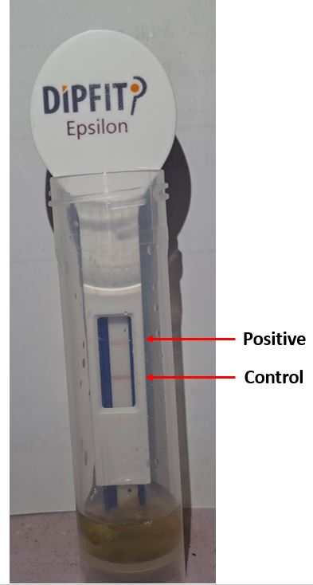
The assay's sensitivity and specificity, as reported by the manufacturer, are approximately 92.5% and 96.3%, respectively. In this study, the test served as a rapid field-level diagnostic aid and was used in conjunction with clinical history, gross lesions, and histopathological findings to confirm a diagnosis of enterotoxaemia.
2.4 Data Analysis
Descriptive statistics were employed to calculate the prevalence and distribution patterns. Age, breed, sex, and seasonal factors were analyzed to identify risk groups.
3. RESULTS
The present investigation recorded a total of 23 confirmed cases of enterotoxaemia in goats from the Cauvery Delta region. Clinical signs consistently observed included abnormal gait in all affected animals (100%), followed by reduced mentation in 95.65% of cases, muscle tremors in 91.3%, seizures in 86.96%, loss of balance in 82.61%, and head pressing in 34.78% of the goats (Fig.2). Age-wise distribution revealed the highest number of cases (39.13%) in kids aged 0–6 months, followed by adults over 2 years (34.78%), kids aged 7–12 months (21.74%), and the lowest incidence in young goats aged 1–2 years (4.35%).
Fig.2. Neurological signs in Enterotoxemic goats
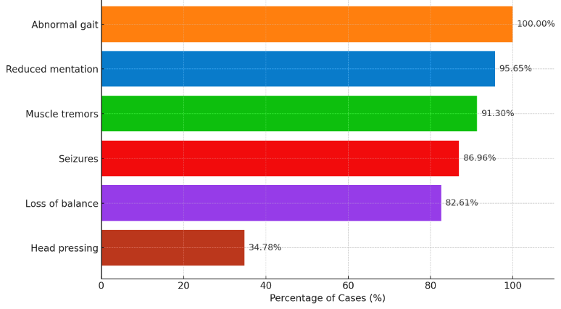
Enterotoxaemia was recorded in 11 non-descript goats (5.58%), 5 Thanjavur Black goats (2.53%), 4 Kanni Adu goats (2.03%), and 3 Kodi Adu goats (1.52%). A total of 9 cases (4.57%) of enterotoxaemia were observed in male goats, while 14 cases (7.11%) were recorded in females, suggesting a higher susceptibility among female animals.
Out of the total 23 cases of enterotoxemia recorded, the highest number of cases occurred during the Pre-monsoon season with 8 cases (34.78%), followed by Monsoon with 6 cases (26.09%). During Winter, 5 cases (21.74%) were observed, all in the year 2024, while Summer recorded 4 cases (17.39%) equally distributed between 2024 and 2025 (Fig.3). w
Fig.3: Seasonal Distribution of Enterotoxaemic cases in goats
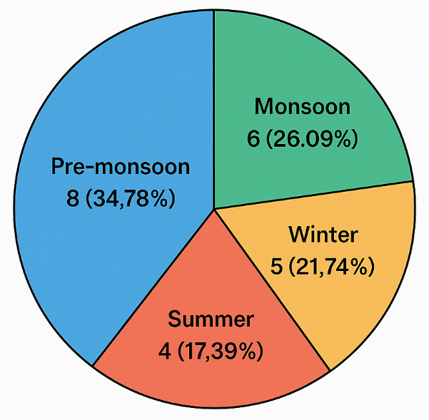
Rapid detection of epsilon toxin using the Dipfit lateral flow immunoassay yielded positive results in fecal samples, suggesting its utility as an effective pen-side diagnostic tool. These findings confirm the involvement of Clostridium perfringens type D epsilon toxin in the etiology of the disease and underline the importance of early diagnosis and preventive strategies in susceptible goat populations.
4. DISCUSSION:
The present study recorded 23 confirmed cases of enterotoxaemia in goats from the Cauvery Delta region, underscoring the disease’s significance in this agro-climatic zone. Enterotoxaemia, caused primarily by Clostridium perfringens type D epsilon toxin, is a well-known cause of sudden death and neurological disturbances in small ruminants globally (Uzal et al., 2014). The clinical signs observed in affected goats abnormal gait (100%), reduced mentation (95.65%), muscle tremors (91.3%), seizures (86.96%), loss of balance (82.61%), and head pressing (34.78%)—align closely with classical descriptions of enterotoxaemia’s neurotoxic impact on the central nervous system (Mancini et al., 2019). These signs reflect the pathological mechanism whereby epsilon toxin disrupts vascular integrity and causes neuronal damage, particularly in the brainstem and cerebral cortex. Uzal et al. (2002) also described the cerebral involvement and are consistent with the neurotoxic effects of epsilon toxin. Further, this study highlights the continuing relevance of enterotoxaemia as a major cause of neurological illness and mortality in goats in Tamil Nadu. The findings resonate with those of Finnie and Uzal (2022), who described the role of ETX in disrupting the blood-brain barrier and inducing vasogenic brain edema.
Age-wise distribution showed kids aged 0–6 months constituted the largest proportion of cases (39.13%), followed by adults over 2 years (34.78%). This susceptibility pattern concurs with previous findings that young animals are more prone to enterotoxaemia due to an immature immune system and dietary changes during weaning that favor bacterial overgrowth (Songer, 1996; Radostits et al., 2007). The notable incidence in older adults suggests that other predisposing factors such as nutritional stress or concurrent diseases may contribute to disease development (Radostits et al., 2007).
Breed distribution showed that non-descript goats were most affected (5.58%), followed by Thanjavur Black (2.53%), Kanni Adu (2.03%), and Kodi Adu (1.52%) breeds. Variations in breed susceptibility to enterotoxaemia have been documented and may relate to genetic factors or differences in management and environmental exposure (Patel et al., 2015). The higher number of cases in female goats (7.11%) compared to males (4.57%) suggests increased vulnerability potentially linked to physiological stresses during pregnancy and lactation, which can suppress immunity (Radostits et al., 2007).
Seasonally, the highest incidence was during the Pre-monsoon (34.78%) and Monsoon (26.09%) periods, collectively accounting for more than 60% of cases. Climatic factors such as increased humidity, temperature variation, and changes in pasture quality during these seasons can promote C. perfringens proliferation and toxin production (Cheong et al., 2020). Similar seasonal trends have been reported in other tropical regions, indicating a strong environmental influence on disease epidemiology (Kumar et al., 2017).
The use of the Dipfit lateral flow immunoassay for rapid detection of epsilon toxin in fecal samples demonstrated high utility as a pen-side diagnostic tool, facilitating early confirmation of enterotoxaemia in field conditions. Rapid immunodiagnostic methods have been advocated in recent studies to improve case detection and timely treatment initiation, especially in resource-limited settings (Kumar et al., 2017; Uzal et al., 2014). In agreement with Pawaiya et al. (2020), the diagnosis based solely on clinical signs is challenging. Our use of lateral flow assays and brain histopathology ensured specific and timely identification.
Overall, these findings highlight the critical need for implementing effective preventive strategies against enterotoxaemia in goats of the Cauvery Delta region of Tamilnadu, India. Vaccination protocols targeting susceptible age groups before the high-risk Pre-monsoon and Monsoon seasons should be prioritized. Additionally, educating farmers on early clinical signs and promoting good nutritional and management practices can reduce disease incidence. Further molecular epidemiological studies are warranted to characterize circulating C. perfringens strains and evaluate vaccine efficacy in this region.
Despite vaccination, disease occurrence persists, implying potential vaccine failure or incomplete coverage. As reported by Veschi et al. (2006), goats often require optimized immunization protocols different from those of sheep. The lack of visible enteric lesions and the predominance of neurological signs further emphasize the need for awareness among field veterinarians. Field-level diagnostic kits for toxin detection have shown promise in enabling rapid response and treatment.
5. CONCLUSION
This study highlights enterotoxaemia as a significant neurological and economic concern in goats of the Cauvery Delta region, particularly affecting kids below 6 months, non-descript breeds, and female goats, with a seasonal peak during Pre-monsoon and Monsoon. The findings emphasize the critical need for timely vaccination, early diagnosis using rapid field tests like the lateral flow assay, and improved management practices. Persistent cases despite vaccination suggest the need for goat-specific immunization protocols and continued farmer awareness to reduce mortality and economic losses in this region.
REFERENCES
- Uzal, F.A., Songer, J.G., Prescott, J.F., and Popoff, M.R. (2014). Clostridial Diseases of Animals. Wiley-Blackwell, Hoboken, NJ, USA, pp. 123–142.
- Mancini, S., Menchetti, L., Guelfi, G., Fatone, G., and De Lucia, M. (2019). Pathological and immunohistochemical features of epsilon toxin–associated brain lesions in goats. Research in Veterinary Science, 124: 425–430.
- Uzal, F.A., Kelly, W.R., and Thomas, R. (2002). Experimental reproduction of focal symmetrical encephalomalacia in goats. Veterinary Pathology, 39(1): 58–65.
- Finnie, J.W. and Uzal, F.A. (2022). The neurotoxic effects of Clostridium perfringens epsilon toxin. Toxins, 14(1): 46.
- Songer, J.G. (1996). Clostridial enteric diseases of domestic animals. Clinical Microbiology Reviews, 9(2): 216–234.
- Radostits, O.M., Gay, C.C., Hinchcliff, K.W., and Constable, P.D. (2007). Veterinary Medicine: A Textbook of the Diseases of Cattle, Horses, Sheep, Pigs and Goats. 10th ed. Saunders Elsevier, London, pp. 822–825.
- Patel, A.M., Patel, K.B., Patel, P.B., and Jani, R.G. (2015). Study on incidence and pathology of enterotoxemia in goats. Veterinary World, 8(1): 50–53.
- Cheong, Y.L., Leitão, P.J., Lakes, T., and Jatzko, A. (2020). Climate variability and outbreaks of Clostridial diseases in small ruminants: A review. Tropical Animal Health and Production, 52(3): 919–930.
- Kumar, A., Singh, A.K., and Sahu, D. (2017). Rapid immunodiagnostic assay for field detection of epsilon toxin of Clostridium perfringens type D. Indian Journal of Animal Research, 51(6): 1024–1028.
- Pawaiya, R.V.S., Dhama, K., Mahendran, M., and Singh, S.D. (2020). Clostridial infections in animals: A review with special emphasis on enterotoxemia. Journal of Experimental Biology and Agricultural Sciences, 8(1): 1–15.
- Veschi, J.L.A., Vasconcelos, A.C., Salgado, B.S., and Ribeiro, M.G. (2006). Evaluation of the immune response to enterotoxemia vaccines in goats. Pesquisa Veterinária Brasileira, 26(2): 97–101.

