Ultra-structural alterations in scales and kidney of common carp after exposure to synthetic pyrethoid insecticide deltamethrin

Abstract
Deltamethrin (DLM), a type II synthetic pyrethroid is one of the most commonly used insecticide worldwide. It contaminates aquatic ecosystems via airborne dispersal, runoff, or groundwater percolation. This insecticide poses a significant threat to aquatic organisms, particularly fish. In present study, effects of synthetic pyrethroid DLM on common carp fish was studied by scanning electron microscopy (SEM) of scales and transmission electron microscopy (TEM) of kidney after treatment with different sub lethal concentrations for 28 days period. Sub lethal concentrations were selected on the basis of 96hrs LC₅₀ value of pesticide. SEM analysis of changes in surface ultra-structure of scales of common carp revealed damaged lepidonts, circuli, radii and focus irregular and broken circuli, widening of interspace between circuli after treatment of different sub lethal concentrations of DLM. TEM study revealed that DLM exposure led to changes like fragmented endoplasmic reticulum, dilated and swollen mitochondria, nuclei with condensed chromatin, deformed nucleus, degenerated nuclear membrane and severe vacuolization in kidney of common carp. The extent of damage noted in fish scales and kidney correlated directly with the toxicant's concentration and the duration of exposure. Higher pesticide concentrations and longer exposure periods were consistently associated with more severe scale and kidney damage.
Keywords: pyethroid, deltamethrin, common cap, scales, kidney, electron microscopy
Introduction
Pesticides, chemical compounds designed to control crop-damaging and disease-transmitting pests, are widely used globally to boost agricultural productivity (Damalas and Eleftherohorinos, 2011). The global pollution of freshwater environments with chemical such as toxic metals and pesticides is a significant worry. Residual pesticides can infiltrate surface water, posing a considerable threat to aquatic life. These pesticides are implicated in biodiversity attrition, specifically through adverse effects on non-target organisms such as beneficial insects, avian populations, and aquatic organisms. Consequently, this leads to disruptions in ecosystem functionality, notably through perturbations in trophic interactions (predator-prey dynamics) and the impairment of essential ecosystem services like pollination (Khoshnood, 2024).
Driven by the environmental threats posed by persistent organochlorine and organophosphate pesticides, the 1970s saw the emergence of pyrethroid pesticides, whose use has steadily increased as organochlorine and organophosphate applications have declined (Yang et al., 2020). They've emerged as effective alternatives to conventional pesticides primarily because of their potent insecticidal action, broad spectrum of activity, rapid biodegradability and lower mammalian toxicity (Guardiola et al., 2014; Tian et al., 2019). Overuse of these pesticides is contaminating the environment and water resources, directly imperiling aquatic life and indirectly posing a risk to human health (Fırat et al., 2011). Pyrethroids can accumulate in fish due to their lipophilicity, readily entering the fish body through the gills in aquatic environments (Clasen et al., 2018). Once absorbed, they're transported via blood circulation to various tissues, leading to toxicity.
Deltamethrin (DLM), a type-II pyrethroid, characterized by the presence of a cyano group is in extensively used in farming and aquaculture for its broad-spectrum control of pests and diseases (Zhang et al., 2019; Zhou et al., 2021). DLM rapidly affects insect nervous systems causing quick knockdown, and is also associated with sustained opening of voltage gated sodium channels, leading to neuron depolarization, repetitive discharges, synaptic disorders, and impaired exchange of chloride and calcium ions (Chrustek et al., 2018). DLM is also exceptionally effective in combating malaria vectors, suggesting its efficiency for manufacturing mosquito evictor nets (Kumar et al., 2011). Given its widespread use, DM can enter lakes and rivers via surface water runoff and household wastewater, posing a threat to the well being of non target aquatic species especially fish. Due to its significant toxicity and persistence in the environment, the harmful impact of DM on aquatic species has become a major concern (Wu et al., 2020; Kong et al., 2021).
Fish are effective bio-indicators, offering quantitative insights into the ecological integrity and health of aquatic environments (Stalin et al., 2019). Common carp (Cyprinus carpio) is an economically significant and nutritionally valuable fish. Because of its robustness, adaptability to diverse environmental conditions, and broad temperature tolerance, the common carp serve as an effective test organism for contaminants (Nazir et al., 2022). Fish scales are vital tissues, not only providing protection from harmful agents but also containing minerals and type I collagen fibrils. This composition makes them valuable biomarkers for assessing toxicity in fish. Fish scale morphometric analysis via SEM is effective for environmental impact assessment, as toxicant-induced damage to lepidonts, circuli, and other surface structures can be monitored and utilized as biomarkers (Babu et al., 2014; Devi and Gupta, 2024). Fish kidneys are essential for upholding internal stability through their critical involvement in osmoregulation (balancing electrolytes and water), waste product removal, and the detoxification of foreign substances (Sharma et al., 2021). In addition to its other physiological roles, the kidney is a principal organ for erythropoiesis. However, given its reception of the largest proportion of post-branchial blood, it exhibits a heightened vulnerability to toxicant-induced lesions (Samanta et al., 2016).
In present investigation, alterations in the ultrastructure of scales and kidney of common carp following exposure to different sub lethal concentrations of synthetic pyrethroid insecticide DLM (11% EC) was studied by the use of electron microscopy.
Materials and methods
Collection of animal and maintenance
Fresh water fish common carp was used as an experimental animal in present study. These fish were procured from the Deoli fish farm in Ghaghus, Bilaspur, Himachal Pradesh, and subsequently transferred to the Himachal Pradesh University laboratory. Transportation occurred in well-oxygenated polythene bags. A 15-day acclimatization period in an aquarium preceded the experiment. To mitigate potential infections or injuries, fish received a prophylactic 2-4 minute bath in a 0.2% potassium permanganate solution. The 28-days experimental procedure took place in the laboratory within approximately 180-liter aquariums, which contained de-chlorinated and pollutant-free water.
Test Chemical
The pesticide utilized in the current investigation was synthetic pyrethroid insecticide deltamethrin in 11% EC formulation.
96hrs LC₅₀ value estimation
The acute toxicity of DLM 11% EC for the freshwater fish Cyprinus carpio was determined by measuring the LC₅₀ value of pesticide using probit analysis (Finney, 1971). It involved two exploratory (range finding) tests and one definitive test. Based on range finding, fish were exposed to varying concentrations of DLM (11% EC) for a period of 96 hours. Fish mortality was recorded every 24 hours. By establishing a dose response relationship between the percentage of death and the concentrations of the toxicant, the LC₅₀ values were calculated using the concentrations from the definitive test. The concentrations acquired from the final test were transformed into log concentrations to compute the LC₅₀ using probit analysis. 96hrs LC₅₀ value of DLM (11% EC) for common carp was found to be 0.114 µl/l.
Physicochemical properties of water
Water was analyzed during current investigation to note down its physicochemical parameters (APHA, 2005). The water parameters maintained throughout the study were as follows: Temperature (25±1.5 ⁰C), pH (7.23±0.51), Total hardness (135±2.72 mg/L), Alkalinity (108±2.97 mg/L), Dissolved Oxygen (7.86±0.26 mg/L) and Total Dissolved Solutes (215±22 ppm). Physicochemical analysis of water was performed during the experiment to make sure that the alterations observed during the experiment were solely due to pesticide.
Experimental Setup
To assess DLM (11% EC) toxicity, fish were exposed for 28 days to sub-lethal concentrations (0.005, 0.011, and 0.022 µl/l), which were based on 1/20th, 1/10th, and 1/5th of its 96-hour LC₅₀ value. For the experiment, fish were divided into four groups. Group 1 was the control group and was not exposed to any pesticide. Group 2 received the lowest sub-lethal concentration (0.005 µl/l) of Deltamethrin for 28 days. Group 3 received the middle concentration (0.011 µl/l) for the same duration, while Group 4 was treated with the highest sub-lethal concentration (0.022 µl/l) of Deltamethrin over 28 days. Throughout the experiment, fish were continuously maintained in their respective concentrations. To assess the progressive effects of exposure, fish from each group were sacrificed at day 14 and day 28 of the experiment.

Results
SEM of scales
Scanning electron micrograph of scales of control fish depicted unique centre called focus, surrounded by concentric rings known as circuli. Lepidonts, radii and lateral field were also seen. SEM analysis of changes in surface ultra-structure of scales of common carp was done after the treatment of 0.005µl/l, 0.011µl/l and 0.022µl/l concentrations of DLM at time intervals of 14 and 28 days. Changes like damaged lepidonts, circuli, irregular and broken circuli were observed. Widening of interspace between circuli, damaged radii and focus were seen after treatment of different concentration of DLM.
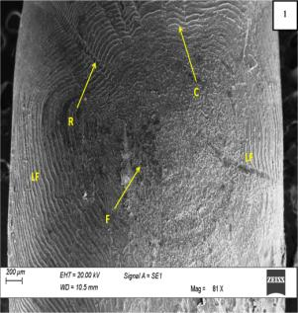
Figure 1: Scanning electron micrograph (SEM) of scales of control fish depicting 1: circuli (C), radii (R), focus (F) and lateral field (LF).
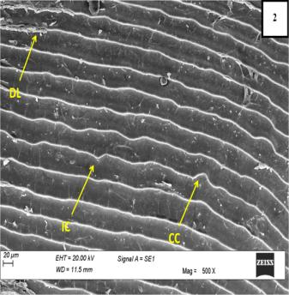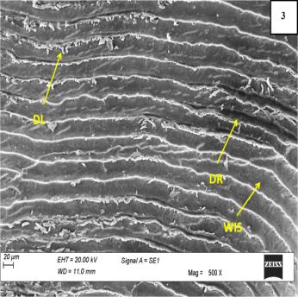
Figure 2: SEM of DLM (0.005µl/l) treated fish scales after 14 days exhibiting 2: damaged lepidonts (DL), irregular circuli (IC), curling of circuli (CC) 3: damaged lepidonts (DL), damaged radii (DR) and widening of interspace between circuli (WIS) after 28 days.
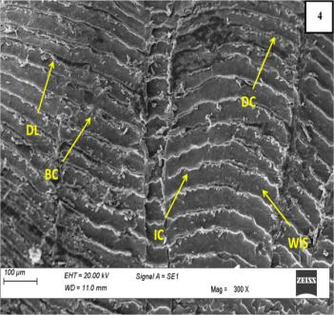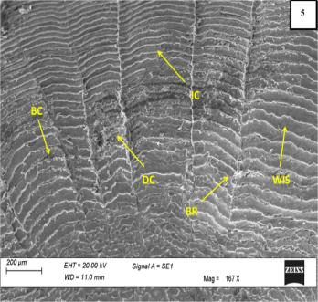
Figure 3: SEM of scales of DLM (0.011µl/l) treated fish showing 4: damaged lepidonts (DL), damaged circuli (DC), broken circuli (BC), irregular circuli (IC) and widening of interspace between circuli (WIS) after 14 days 5: irregular circuli (IC), damaged circuli (DC), broken circuli (BC), broken radii (BR) and widening of interspace between circuli (WIS) after 28 days.
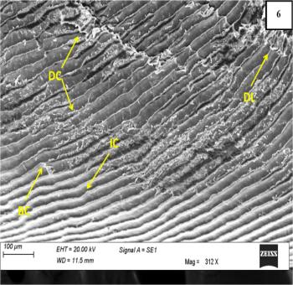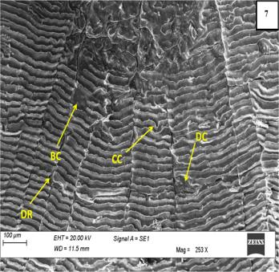
Figure 4: SEM of scales of fish treated with 0.022µl/l concentration of DLM depicting 6: damaged lepidonts (DL), irregular circuli (IC), damaged circuli (DC) and broken circuli (BC) after 14 days 7: curling of circuli (CC), damaged radii (DR), damaged circuli (DC) and broken circuli (BC) after 28 days.
TEM of kidney
Transmission electron microscopy of control kidney revealed nucleus with uniform distribution of chromatin, and network of mitochondria and endoplasmic reticulum. After the exposure to different sub lethal concentrations of DLM electron micrograph of kidney of common carp revealed different alterations like fragmentation of endoplasmic reticulum, dilated and swollen mitochondria, nucleus with condensed chromatin, deformed nucleus, degenerated nuclear membrane and severe vacuolization.
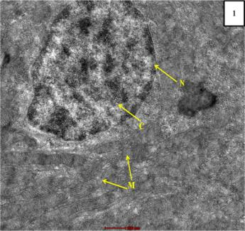
Figure 5: Transmission electron micrograph (TEM) of a control fish kidney revealing 1: nucleus (N) with uniformly distributed chromatin (C) and normal mitochondria (M).
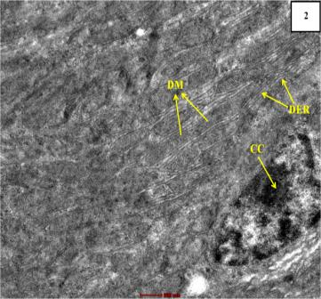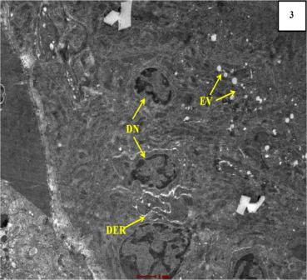
Figure 6: Transmission electron micrograph of kidney treated with 0.005µl/l DLM concentration depicting 2: dilated mitochondria (DM), dilated endoplasmic reticulum (DER) and nucleus with condensed chromatin (CC) at 14 days. 3: deformed nuclei (DN), dilated endoplasmic reticulum (DER) and vacuolation (EV) at 28 days.
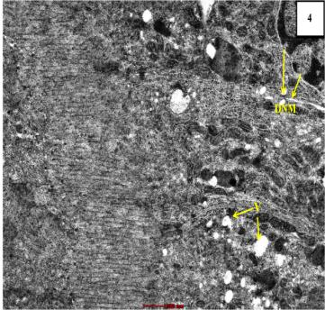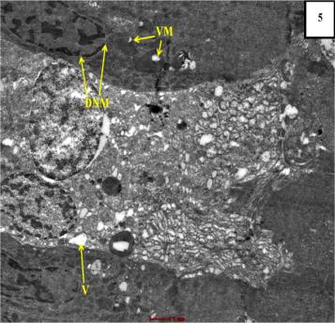
Figure 7: Transmission electron micrograph of kidney treated with 0.011µl/l DLM concentration revealing 4: degenerated nuclear membrane (DNM) and vacuolation (V) at 14 days. 5: vacuolated mitochondria (VM), degenerated nuclear membrane (DNM) and cellular vacuolation (V) at 28 days.
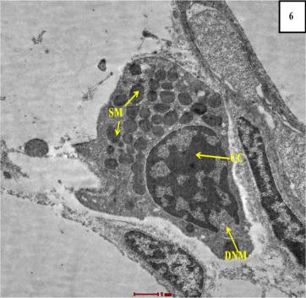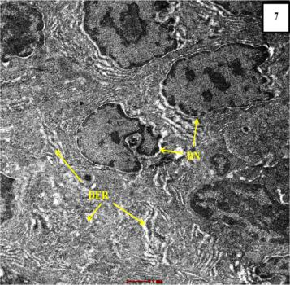
Figure 8: Transmission electron micrograph of kidney treated with 0.022µl/l DLM concentration exhibiting 6: degenerated nuclear membrane (DNM), nucleus with condensed chromatin (CC) and swollen mitochondria (SM) at 14 days. 7: deformed nuclei (DN) and degenerated endoplasmic reticulum (DER) at 28 days.
Discussion
Electron microscopy is the premier method for identifying cellular intoxication symptoms. Scanning electron microscopy (SEM) is an effective method for evaluating how environmental stressors impact the vital structures of fish, which are crucial for their overall fitness and survival (Velmurugan et al., 2015). TEM's ability to produce two-dimensional images reveals minute surface and internal alterations, like changes in organelle numbers, nuclear degeneration, or loss of cytoplasmic integrity, which are undetectable by light microscopy (Nazir et al., 2022). The potential of fish scales as bio-indicators of pollution has largely been overlooked, even though they are directly exposed to toxicants and show alterations in circuli shape and elemental deposition when the environment changes. Kidney is particularly susceptible to pesticide-induced detrimental changes making transmission electron microscopy essential for detailed cellular examination. The cellular damage caused by DLM toxicity in the fish kidney likely impaired its osmoregulatory function, given that the kidney serves as both an excretory and osmoregulatory organ. The teleost kidney is particularly vulnerable, often being among the initial organs impacted by toxicants in water (Massar et al., 2014).
In the current investigation changes in the ultra-structure of scales and kidney of common carp fish were investigated after being exposed to sub lethal concentrations of DLM for a period of 28 days. Present study observed significant morphological damage to the scales of DLM exposed fish. This included damaged circuli and distorted lepidonts which ultimately caused scales to loosen and shed. Consequently, the fish's sensitive skin came into contact with contaminated water, facilitating the absorption of heavy metals or pesticides into their bodies (Kaur et al., 2016). Widening of interspace between circuli, damaged radii and focus were also seen after treatment of different sub lethal concentrations of DLM. The findings of current investigation have been compared with the previous observations by other researchers regarding the toxicological impacts of diverse toxicants on various fish species.
Exposure to sub-lethal concentrations of chlorpyrifos resulted in notable structural changes in the scales of freshwater Ctenopharyngodon idellus, including damage to the radii, focus, circuli, and severe harm to the lepidonts (Jindal and Kaur, 2015). Similar changes were also seen by Velmurugan et al. (2015) in the scales of Anabas testudineus after the exposure of chlorpyrifos. SEM of fenvalerate treated Ctenopharyngodon idella also showed significant morphological changes like distorted focus, dislodged surface structures, perforations, and loss of mineral content to the ultrastructure of scales (Batoye et al., 2021). Damage to lepidonts structures of scales of Anabas testudineus was also noticed by Babu et al. (2014) after the treatment with synthetic pyrethroid cypermethrin. Devi and Gupta (2024) similarly utilized SEM technique to investigate the ultrastructural toxicity of sub-lethal deltamethrin and permethrin concentrations on Anabas testudineus scales. Fish exposed to these pesticides showed significant deformation and fusion of circuli, disrupting normal radii patterns, distorted circuli and loss of lepidonts. These results were consistent with the current findings.
TEM study demonstrated that the sub lethal exposure of DLM resulted in different alterations in ultrastructure of kidney like fragmentation of endoplasmic reticulum, dilated and swollen mitochondria, nucleus with condensed chromatin, deformed nucleus, degenerated nuclear membrane and cytoplasmic vacuolization. Similar to present findings exposure of glyphosate herbicide led to degeneration in mitochondria, vesiculation, dilation and fragmentation of rough endoplasmic reticulum and severe vacuolation in kidney of Oreochromis niloticus (Samanta et al., 2018). Samanta et al. (2016) observed dilation and fragmentation of rough endoplasmic reticulum, degeneration in mitochondria and marked vacuolation in kidney of Heteropneustes fossilis after the exposure of glyphosate based herbicide. Common carp renal cells exposed to phorate and dimethoate developed various ultrastructural abnormalities like deformed glomerulus, vacuolization, degenerated nuclei and mitochondria (Nazir et al., 2022). Consistent with our current observations these abnormalities became more pronounced with increased insecticide concentrations and longer exposure periods.
Conclusion
It was concluded that DLM is highly toxic to Cyprinus carpio, as evidenced by significant ultrastructural alterations to the fish's scales and kidneys, even at sub-lethal concentrations. Present investigation showed that the duration and concentration of pesticide exposure correlate with the ultra-structural changes observed in scales and kidney of common carp. Our findings demonstrated that electron microscopy highly effective method for identifying the initial impacts of toxins on living beings. This study also highlighted a simple and cost-effective method for environmental assessment using fish scales, eliminating the need to sacrifice the fish. We suggest that scales can serve as a reliable bio-monitoring tool for pesticide pollution.
References
Babu, V., Mariadoss, S., Ipek, C. E., Serbest, B., & Ali, S. (2014). Surface structures of gill, scale and erythrocyte of Anabas testudineus exposed to sublethal concentration of cypermethrin. Environmental Toxicology and Pharmacology, 37(3), 1109-1115.
Batoye, S., Jindal, R., & Verma, S. (2021). Ameliorating effect of ascorbic acid on fenvalerate induced ultrastructural changes in scales, erythrocytes and gills of Ctenopharyngodon idella (Valenciennes, 1844). Environmental Science and Pollution Research, 28, 36472-36492.
Chrustek, A., Hołyńska-Iwan, I., Dziembowska, I., Bogusiewicz, J., Wróblewski, M., Cwynar, A., & Olszewska-Słonina, D. (2018). Current research on the safety of pyrethroids used as insecticides. Medicina, 54(4), 61.
Clasen, B., Loro, V. L., Murussi, C. R., Tiecher, T. L., Moraes, B., & Zanella, R. (2018). Bioaccumulation and oxidative stress caused by pesticides in Cyprinus carpio reared in a rice-fish system. Science of the total environment, 626, 737-743.
Damalas, C. A., & Eleftherohorinos, I. G. (2011). Pesticide exposure, safety issues, and risk assessment indicators. International journal of environmental research and public health, 8(5), 1402-1419.
Devi, M. S., & Gupta, A. (2024). Sub-lethal effects of deltamethrin and permethrin resulted in ultrastructural alterations in scales and oxygen uptake changes of Anabas testudineus (Bloch, 1792). Aquatic Toxicology, 272, 106939.
Finney, D. J. (1971). Probit analysis, Cambridge University Press. Cambridge, UK.
Fırat, Ö., Cogun, H. Y., Yüzereroğlu, T. A., Gök, G., Fırat, Ö., Kargin, F., & Kötemen, Y. (2011). A comparative study on the effects of a pesticide (cypermethrin) and two metals (copper, lead) to serum biochemistry of Nile tilapia, Oreochromis niloticus. Fish Physiology and Biochemistry, 37, 657-666.
Guardiola, F. A., Gónzalez-Párraga, P., Meseguer, J., Cuesta, A., & Esteban, M. A. (2014). Modulatory effects of deltamethrin-exposure on the immune status, metabolism and oxidative stress in gilthead seabream (Sparus aurata L.). Fish & Shellfish Immunology, 36(1), 120-129.
Jindal, R., & Kaur, M. (2015). Ultrastructural alterations in scales of Ctenopharyngodon idellus (Cuvier & Valenciennes) induced by chlorpyrifos: a promising tool as bioindicator of pesticide pollution. International Journal of Fisheries and Aquatic Studies, 2(3), 58-62.
Kaur, K., Kaur, R., & Kaur, A. (2016). Surface microstructural features of scales in relation to toxic stress of Basic Violet-1. Environmental Science and Pollution Research, 23, 1173-1182.
Khoshnood, Z. (2024). A review on toxic effects of pesticides in Zebrafish, Danio rerio and common carp, Cyprinus carpio, emphasising Atrazine herbicide. Toxicology Reports, 101694.
Kong, Y., Li, M., Shan, X., Wang, G., & Han, G. (2021). Effects of deltamethrin subacute exposure in snakehead fish, Channa argus: Biochemicals, antioxidants and immune responses. Ecotoxicology and environmental safety, 209, 111821.
Kumar, S., Thomas, A., & Pillai, M. K. K. (2011). Deltamethrin: Promising mosquito control agent against adult stage of Aedes aegypti L. Asian Pacific Journal of Tropical Medicine, 4(6), 430-435.
Massar, B., Dey, S., & Dutta, K. (2014). Structural changes in kidneys of common carp (Cyprinus carpio L.) inhabiting a polluted reservoir, Umiam in Meghalaya, India. J. Adv. Microsc. Res, 9(2), 105-109.
Nazir, S., Ali, M.N., Tantray, J.A., Baba, I.A., Jan, A., Popescu, S.M., Paray, B.A. & Gulnaz, A. (2022). Study of ultrastructural abnormalities in the renal cells of Cyprinus carpio induced by toxicants. Toxics, 10(4), 177.
Samanta, P., Kumari, P., Pal, S., Mukherjee, A. K., & Ghosh, A. R. (2018). Histopathological and ultrastructural alterations in some organs of Oreochromis niloticus exposed to glyphosate-based herbicide, Excel Mera 71. Journal of microscopy and ultrastructure, 6(1), 35-43.
Samanta, P., Mukherjee, A. K., Pal, S., Kole, D., & Ghosh, A. R. (2016). Toxic effects of glyphosate-based herbicide, Excel Mera 71 on gill, liver, and kidney of Heteropneustes fossilis under laboratory and field conditions. Journal of Microscopy and Ultrastructure, 4(3), 147-155.
Samanta, P., Pa, S., Mukherjee, A. K., Senapati, T., & Ghosh, A. R. (2016). Cytopathological effects of Almix herbicide on gill, liver and kidney of Oreochromis niloticus under field and laboratory conditions. Toxicol Open Access, 2(112), 2.
Sharma, R., Jindal, R., & Faggio, C. (2021). Impact of cypermethrin in nephrocytes of freshwater fish Catla catla. Environmental Toxicology and Pharmacology, 88, 103739.
Stalin, A., Suganthi, P., Mathivani, S., Paray, B. A., Al-Sadoon, M. K., Gokula, V., & Musthafa, M. S. (2019). Impact of chlorpyrifos on behavior and histopathological indices in different tissues of freshwater fish Channa punctatus (Bloch). Environmental Science and Pollution Research, 26, 17623-17631.
Tian, L., Kong, C., Fang, C., Lou, X., Han, F., Shi, Y., & Cai, Y. (2019). Research of detection and quantitative method of cypermethrin, fenvalerate and deltamethrin residues in sediment by gas chromatography. In IOP Conference Series: Earth and Environmental Science (Vol. 233, No. 4, p. 042012). IOP Publishing.
Velmurugan, B., Selvanayagam, M., Cengiz, E. I., & Ugurlu, P. (2015). Scanning electron microscopy study of the gills, scales and erythrocytes of Anabas testudineus upon exposure to chlorpyrifos. Toxicological & Environmental Chemistry, 97(2), 208-220.
Wu, Y., Li, W., Yuan, M., & Liu, X. (2020). The synthetic pyrethroid deltamethrin impairs zebrafish (Danio rerio) swim bladder development. Science of the Total Environment, 701, 134870.
Yang, C., Lim, W., & Song, G. (2020). Mediation of oxidative stress toxicity induced by pyrethroid pesticides in fish. Comparative Biochemistry and Physiology Part C: Toxicology & Pharmacology, 234, 108758.
Zhang, C., Zhang, Q., Pang, Y., Song, X., Zhou, N., Wang, J., He, L., Lv, J., Song, Y., Cheng, Y. & Yang, X. (2019). The protective effects of melatonin on oxidative damage and the immune system of the Chinese mitten crab (Eriocheir sinensis) exposed to deltamethrin. Science of the Total Environment, 653, 1426-1434.
Zhou, S., Dong, J., Liu, Y., Yang, Q., Xu, N., Yang, Y., & Ai, X. (2021). Effects of acute deltamethrin exposure on kidney transcriptome and intestinal microbiota in goldfish (Carassius auratus). Ecotoxicology and Environmental Safety, 225, 112716.

