Molecular Validation of Catla catla and Labeo rohita among Morphologically Identified Fish Species in Narmada River of Madhya Pradesh

Abstract
Freshwater ecosystems are crucial for biodiversity, ecological balance, and livelihoods through aquaculture and fisheries. Precise identification of fish species is essential for understanding biodiversity, assessing ecosystem health and guiding conservation strategies. The Narmada River, a biodiversity-rich ecosystem in India, hosts ecologically and economically significant fish species. Morphological identification, though widely used, is often limited by phenotypic and environmental variations, leading to misidentifications. To address this, the study integrates molecular and traditional taxonomic techniques to validate species identification. A total of 20 fish specimens were collected from seven locations along the river. Morphological analysis identified several species, with Catla catla and Labeo rohita selected for molecular validation. DNA barcoding of the mitochondrial cytochrome c oxidase I (COI) gene confirmed their molecular identity, reinforcing the accuracy of morphological classification. This study emphasizes the value of DNA barcoding in uncovering cryptic biodiversity and enriching molecular databases. The findings offer critical insights into genetic diversity, species distribution, and conservation efforts, highlighting the ecological and economic importance of key species such as Catla catla and Labeo rohita. Moreover, the study provides a replicable framework for biodiversity assessments and sustainable aquaculture practices.

Keywords: Narmada River, COI Gene, Variation, DNA Barcoding, mitochondrial cytochrome c oxidase I (COI) gene, molecular validation, biodiversity assessments

Introduction

The accurate identification of fish species is fundamental to biodiversity conservation, sustainable fishery management, and advanced immunological studies. The Narmada River, one of the major rivers in central India, supports diverse aquatic ecosystems and provides a habitat for various economically and ecologically significant fish species. Among these, Catla catla (Indian major carp) and Labeo rohita (rohu) are of prime importance due to their pivotal role in aquaculture and their nutritional value in the human diet. Despite their significance, the morphological identification of fish species remains susceptible to inaccuracies caused by phenotypic plasticity, ontogenetic variations, and environmental influences (Ward et al., 2005; Ward et al., 2009).Advances in molecular biology have introduced robust genetic tools for species identification that complement traditional morphological approaches. DNA barcoding and other molecular techniques enable researchers to overcome the limitations of morphological identification by providing precise and reproducible results. Such methods involve analyzing genetic markers, such as mitochondrial DNA (cytochrome oxidase I gene), which exhibit sufficient interspecific divergence (Hebert et al., 2003). Molecular identification, therefore, serves as a powerful tool for resolving taxonomic ambiguities and confirming species identity with confidence.

In the context of immunological studies, accurate species identification is crucial as genetic variations between species can influence immune response mechanisms and pathogen susceptibility (Nguyen, 2024). The immunological attributes of C. catla and L. rohita have garnered significant attention due to their resilience against diseases and their potential as models for understanding fish immunity (Mohanty et al., 2019). A thorough molecular identification of these species will not only strengthen the reliability of immunological studies but also aid in the development of disease-resistant fish strains through selective breeding programs.

The present study aims to perform the molecular identification of C. catla and L. rohita among the morphologically identified fish species in the Narmada River, Madhya Pradesh. By combining traditional morphological methods with molecular tools, this research seeks to enhance our understanding of the genetic diversity and immunological potential of these species, contributing to the broader goals of sustainable aquaculture and fishery management.

Materials and methods

Geographical Context of the Study: This study was conducted in the Narmada River, a vital freshwater ecosystem in central India known for its ecological diversity and economic importance. The research focused on multiple sites within the Narmadapuram District of Madhya Pradesh, an area characterized by diverse aquatic habitats that support a wide variety of fish species. Five sampling locations were carefully chosen to encompass different ecological zones and habitat types, ensuring thorough representation of the river's fish biodiversity.

Fish Collection and Sampling Techniques: Fish specimens were collected using a range of traditional fishing methods, including cast nets, gill nets, and hand nets. These techniques provided an efficient way to capture species of various sizes and ecological preferences. Seasonal sampling campaigns were conducted to account for temporal variations in fish diversity and abundance. Collected specimens were treated carefully to minimize stress and injury during the process. Initial identification was performed using standard morphological techniques and taxonomic keys (Jayaram, 1999).

Preservation and Transportation of Tissue Samples: To prepare specimens for molecular analysis, fin clips were excised from each morphologically identified fish. The tissue samples were promptly preserved in 95% ethanol to ensure the integrity of the DNA. After proper labeling, the samples were transported to the laboratory under controlled conditions to prevent degradation during transit.

DNA Extraction Protocol: DNA was extracted from the preserved tissue samples using the phenol-chloroform method as outlined by Sambrook and Russell (2001). This widely used protocol is effective for obtaining high-quality genomic DNA suitable for downstream applications. The extracted DNA was quantified using a spectrophotometer to ensure the concentration and purity of the samples was adequate for subsequent molecular procedures.

Molecular Target and PCR Optimization: The mitochondrial cytochrome c oxidase I (COI) gene, a reliable marker for DNA barcoding, was chosen for species identification. Polymerase chain reaction (PCR) amplification was carried out using universal primers (Vrijenhoek, 1994). Reaction parameters, such as annealing temperature and cycling conditions, were optimized to achieve high efficiency and specificity for the gene of interest. The amplified DNA fragments were visualized on an agarose gel to confirm their quality and expected size.

Purification and Sequencing of PCR Products: Successfully amplified PCR products were purified using a commercial PCR purification kit (Himedia). This step ensured the removal of contaminants that could interfere with sequencing. The purified products were then sequenced using the Sanger sequencing method, recognized for its accuracy in generating high-quality nucleotide sequences.

Data Analysis and Species Confirmation: The raw sequence data obtained through sequencing were edited and assembled using BioEdit software (Hall, 1999) to eliminate errors. These processed sequences were compared against reference databases, such as the Barcode of Life Data System (BOLD) and GenBank, using BLAST searches. This comparison confirmed the molecular identity of the species and validated the results obtained from morphological identification.

Results and Discussion

The morphological identification of the collected fish specimens revealed several species from the Cyprinidae family (Swain et al., 2012). Among these, Catla catla and Labeo rohita were selected for molecular validation due to their ecological importance and contribution to aquaculture. Morphological analysis was carried out using established taxonomic keys, which, although helpful in the preliminary classification, were found to be limited by environmental and phenotypic variations. These limitations highlighted the necessity of molecular techniques to confirm species identity with precision (Neekhra et al., 2014).

Molecular analyses involved the extraction of high-quality genomic DNA, followed by the successful amplification of the cytochrome c oxidase I (COI) gene. The amplified DNA fragments, measuring approximately 655 base pairs as shown in Figure 2, were verified through gel electrophoresis to confirm their integrity and expected size. The sequences obtained were then compared with reference databases, including GenBank and the Barcode of Life Data System (BOLD), which confirmed a perfect match with the genetic profiles of Catla catla and Labeo rohita.

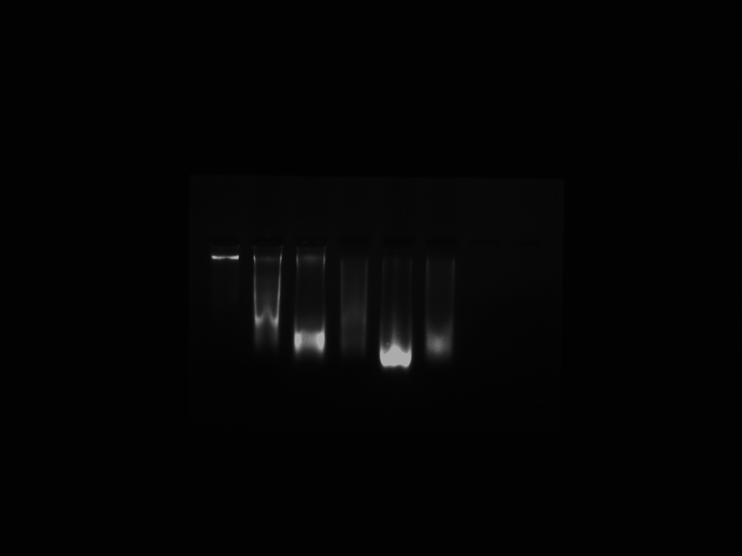

Figure 1: Present figure showing the genome of Fish during present study.

This step provided strong molecular evidence supporting the morphological identifications and emphasized the robustness of DNA barcoding as a tool for accurate species classification (Mushagalusa et al., 2024).

Additionally, Figure 1 illustrates the genome obtained during the molecular analysis, offering a visual representation of the high-quality DNA used for downstream processes. The clarity and accuracy of the genomic data underscore the effectiveness of the laboratory protocols followed in this study. Insights into Biodiversity and Conservation This study also brought to light the potential presence of cryptic species, which might have gone unnoticed through morphological identification alone. Such findings underline the importance of integrating molecular methods to uncover hidden biodiversity within freshwater ecosystems like the Narmada River. Cryptic diversity can have profound implications for ecosystem dynamics, influencing everything from species interactions to population management.

Figure 2: COI gene Desired gene fragment 655bp amplification.

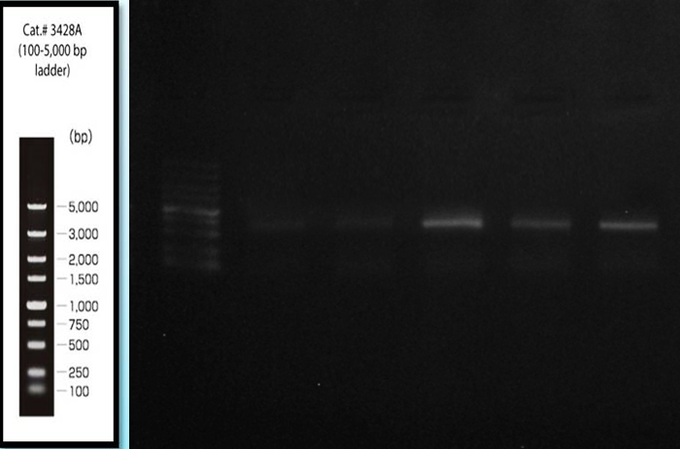

The molecular profiles generated in this research significantly enrich the existing genetic database for freshwater fish in India. These data not only validate morphological identifications but also provide a foundation for future ecological and immunological studies. The genetic characterization of Catla catla and Labeo rohita opens new avenues for studying their immune mechanisms and resistance to pathogens, which are critical for improving aquaculture practices and ensuring the sustainability of fish populations (Ahmad et al.,2020).The findings reinforce the ecological significance of Catla catla and Labeo rohita as key species in the Narmada River ecosystem. These species play vital roles as primary consumers within the food web and are integral to the livelihoods of local communities engaged in aquaculture. Conservation efforts aimed at preserving their populations are essential not only for maintaining ecological balance but also for ensuring economic stability in regions dependent on fisheries.

Conclusion

This study demonstrates the effectiveness of combining traditional morphological techniques with modern molecular tools for the accurate identification of fish species in freshwater ecosystems. The integration of DNA barcoding with morphological taxonomy offers a robust framework for species validation, enriching our understanding of biodiversity while addressing challenges like cryptic diversity and taxonomic ambiguities.

References
Ahmad, M., Zuberi, A., Ali, M., Syed, A., Khan, A., & Kamran, M. (2020).Effect of acclimated temperature on thermal tolerance, immune response and expression of HSP genes in Labeo rohita, Catla catla and their intergeneric hybrids. Journal of Thermal Biology, 89, 102570.
Hall, T. A. (1999). BioEdit: A user-friendly biological sequence alignment editor and analysis program for Windows 95/98/NT. Nucleic Acids Symposium Series, 41, 95–98.
Hebert, P. D. N., Cywinska, A., Ball, S. L., & deWaard, J. R. (2003).Biological identifications through DNA barcodes.Proceedings of the Royal Society of London. Series B: Biological Sciences, 270(1512), 313–321.
Jayaram, K. C. (1999). The freshwater fishes of the Indian region.Narendra Publishing House.
Mohanty, B. P., Mahanty, A., Ganguly, S., Mitra, T., Karunakaran, D., &Anandan, R. (2019).Nutritional composition of food fishes and their importance in providing food and nutritional security.Food Chemistry, 293, 561-570.
Mushagalusa Mulega, A., Boom, A. F., Rahmouni, I., Bazairi, H., Benhoussa, A., Vanhove, M. P., & Van Steenberge, M. (2024). Catfishes from the North-Western Part of Lake Tanganyika: Contribution to a Reference Library of DNA Barcodes. Diversity, 17(1), 8.
Neekhra, B., Mansoori, A. A., Verma, S., Koiri, R. K., & Jain, S. K. (2014). RAPD-PCR based biomarker study in fish species (Family: Cyprinidae) of Madhya Pradesh, India. Austin Journal of Molecular & Cellular Biology, 1(1), 1003.
Nguyen, N. H. (2024). Genetics and genomics of infectious diseases in key aquaculture species.Biology, 13(1), 29.
Sambrook, J., & Russell, D. W. (2001). Detection of DNA in agarose gels. In Molecular Cloning, A Laboratory Manual (3rd ed.). Cold Spring Harbor Laboratory Press.
Swain, B., Samanta, M., Basu, M., Panda, P., Sahoo, B. R., Maiti, N. K.,& Eknath, A. E. (2012). Molecular characterization, inductive expression and mechanism of interleukin‐10 gene induction in the Indian major carp, catla (Catla catla). Aquaculture Research, 43(6), 897-907.
Vrijenhoek, R. (1994). DNA primers for amplification of mitochondrial cytochrome c oxidase subunit I from diverse metazoan invertebrates.Molecular Marine Biology and Biotechnology, 3(5), 294–299.
Ward, R. D., Hanner, R., & Hebert, P. D. N. (2009).The campaign to DNA barcode all fishes, FISH-BOL.Journal of Fish Biology, 74(2), 329–356.
Ward, R. D., Zemlak, T. S., Innes, B. H., Last, P. R., & Hebert, P. D. N. (2005). DNA barcoding Australia's fish species.Philosophical Transactions of the Royal Society B: Biological Sciences, 360(1462), 1847-1857.

