Original Research Article

Diagnostic Role of Triphasic Computed Tomography in Characterization of Focal Liver Lesions: A Prospective Observational Study

.
ABSTRACT

Aims: To evaluate the diagnostic role of the enhancement pattern of focal liver lesions on triphasic CT in the arterial, portal venous, and delayed phases at our tertiary care centre.

Study design: Prospective observational study.

Place and Duration of Study: Department of Radiodiagnosis at our tertiary care centre.

Methodology: 50 patients (Age range: 41-60years) presenting with suspected liver disease referred for triphasic CT scan. A dynamic assessment of all reconstructed CT images was conducted. Initially, the unenhanced, hepatic arterial phase (HAP), and portal venous phase (PVP) images were evaluated to identify any focal liver lesions. Following this, each lesion's appearance across different phases (unenhanced, HAP, PVP, and delayed) was analyzed based on its enhancement characteristics and attenuation in comparison to the surrounding liver tissue in each phase. Lesions were broadly categorized as either hypervascular or hypovascular relative to the liver parenchyma. Each imaging phase was first assessed independently, followed by a combined interpretation of all phases.

Results: The top three ranked focal lesions of liver appeared in triphasic CT were found to be hydatid cyst (22%), hemangioma (20%), and hepatocellular carcinoma (18%). Contrast triphasic CT scan diagnostic work-ups showed appearance of enhanced and non-enhanced focal lesions of liver in 32 and 18 patients respectively. Majorly arterial/venous/delayed-hypo/hypo/hypo pattern constitutes lesions of simple cysts, hydatid cysts, and metastases in 4, 11, and 3 patients respectively. Majorly, the homogenous enhancement patterns were appeared on triphasic CT scan, and which are diagnosed with hepatocellular carcinoma, metastasis, and haemangioma in 3, 4, and 3 patients respectively.

Conclusion: multidetector triphasic CT allows highly precise imaging during the arterial, venous, and delayed phases of hepatic enhancement. Optimal acquisition timing in combination with thinner collimation permits improved lesion detection and will also show improved characterization of lesions.

Keywords: Triphasic CT; liver; metastasis; hepatocellular carcinoma; haemangioma.

1. INTRODUCTION

The liver plays a critical role within the digestive system. Owing to its dual blood supply and essential metabolic activities, it is susceptible to a broad spectrum of disorders, from simple benign cysts to malignancies like hepatocellular carcinoma and metastases (Ahirwar et al., 2016). Among the diverse hepatic conditions, liver masses hold particular clinical importance. Evidence suggests that liver lesions generally remain undetectable on standard radiographs unless calcification occurs (Rani & Tripathi, 2018). Focal liver lesions, which may be benign or malignant, show considerable variation in prevalence based on geographic and ethnic differences (Mendez-Sanchez et al., 2005). Many such lesions are non-malignant and can be monitored through imaging, particularly in patients without a known history of malignancy or chronic liver disease (Schwartz et al., 1999). Benign hepatic tumors have been observed in up to 52% of the general population, yet identifying and accurately characterizing focal liver lesions continues to pose a diagnostic challenge (Mittal & Kumbhar, 2024).
Focal liver lesions represent localized abnormalities within the liver parenchyma and are increasingly detected due to the widespread application of modern imaging techniques (Sadler, 2018). Accurate classification of these lesions is vital for guiding therapeutic strategies. The diagnostic spectrum includes both malignant and benign entities, and the presence of common benign lesions such as cysts, hemangiomas, and focal nodular hyperplasia necessitates precise identification and evaluation. Often, clinicians are unaware of the specific liver lesion present when patients are referred for CT imaging (Moore & Anne, 2007). Therefore, an ideal imaging modality should provide high sensitivity and specificity for lesion detection and characterization, distinguishing those that require further intervention from those that do not (Reznik et al., 2004).
Ultrasonography is frequently utilized as a first-line imaging tool, but its specificity is limited. Magnetic resonance imaging, although highly effective in lesion characterization is typically reserved for complex or uncertain cases due to limited accessibility (Van Leeuwen et al., 1996). Triple-phase computed tomography (CT), which captures arterial, portal venous, and delayed phases has emerged as the preferred imaging method. This approach highlights specific enhancement patterns useful in distinguishing various lesions; for example, hypervascular tumors like hepatocellular carcinoma (HCC) demonstrate arterial phase enhancement followed by rapid washout, whereas benign hemangiomas often show peripheral nodular enhancement (Mishra et al., 2009; Oliver et al., 1996). Triple-phase CT is particularly valuable in differentiating benign from malignant liver lesions, thus helping to avoid invasive procedures when unnecessary, such as in cases of hemangiomas (Oliver et al., 1996).
Most primary and metastatic hepatic tumors derive their blood supply from the hepatic artery, altering the normal hepatic circulation in which approximately 70% of the blood comes from the portal vein, with the hepatic artery contributing the rest (Sinnatamby, 1999). This alteration in vascular pattern underpins the principle of the triple-phase liver CT scan. The technique has significantly enhanced understanding of the radiologic features of both primary and metastatic liver tumors (Foley et al., 2000).
There are scarce of data on role of triphasic CT in characterization of focal liver lesions in our study setting. With this scenario, present study was conducted with the main objective to evaluate the diagnostic role of triphasic CT in detection of the enhancement pattern of focal liver lesions in the arterial, portal venous, and delayed phases at our tertiary care centre.

2. material and methods

2.1 Study design and patients
This is a prospective observational study conducted with total of 50 patients presenting with suspected liver disease referred for triphasic CT scan to Department of Radiodiagnosis at S. S. Institute of Medical Science and Research Centre (SSIMRC) Davangere, Karnataka. A written informed consent was taken from all the patients enrolled in to the study.
2.2 Inclusion criteria
Patients presenting with:
- Clinical suspicion of focal liver lesions
- Previous imaging studies depicted focal liver lesions
- Altered liver function tests

2.2 Exclusion criteria
Patients with:
- History of trauma
- Allergic to contrast agents
- Chronic kidney disease
- Pregnant women
- Claustrophobic patients
- Age: <19years

2.3 Triphasic CT imaging of liver
Patients are kept nil orally 4 hours before triphasic CT scan to avoid complications while administrating contrast medium. Risks of contrast administration were explained to the patient, and consent was obtained prior to the contrast study. Triple-phase helical CT images of the liver were obtained with General Electrical (GE) Bright Speed Elite 16 slices MDCT machine with 5mm collimation, 1.25m reconstruction interval, the gantry rotation speed of 0.98 seconds, the pitch of 1.675:1, 120 kV, and 220 mA. Once unenhanced helical CT was performed through the entire abdomen, 80 to 100 mL of Iohexol (Omnipaque 300) was injected intravenously through a 20gauge cannula at a rate of 3ml/sec with an automated power injector. For the arterial dominant phase, the delay between the start of contrast material administration and helical scanning was 20 seconds. The portal-dominant phase was obtained after 70 seconds and the delayed phase after 180 seconds.

2.4 Interpretations
A dynamic assessment of all reconstructed CT images was conducted. Initially, the unenhanced, hepatic arterial phase (HAP), and portal venous phase (PVP) images were evaluated to identify any focal liver lesions. Following this, each lesion's appearance across different phases (unenhanced, HAP, PVP, and delayed) was analyzed based on its enhancement characteristics and attenuation in comparison to the surrounding liver tissue in each phase. Lesions were broadly categorized as either hypervascular or hypovascular relative to the liver parenchyma. Each imaging phase was first assessed independently, followed by a combined interpretation of all phases.
Lesion confirmation was done through biopsy, surgery, ultrasound (USG), or follow-up imaging depending on clinical need. In patients presenting with multiple lesions, biopsy was typically performed on up to two lesions, and others displaying similar CT characteristics were assumed to be of the same nature. If a lesion demonstrated no change in size over at least six months, it was considered benign.
For cases with more than ten lesions, a representative analysis was carried out on the ten most characteristic lesions using all imaging phases. Both the size and visibility (conspicuity) of lesions in each phase were recorded. Lesion conspicuity was rated on a scale as follows: 0 – Not Visualized, 1 – Visualized, and if visualized, further classified as 2 – Good or 3 – Excellent. Each lesion's appearance in a given phase was described based on its attenuation and homogeneity in comparison with the surrounding liver parenchyma, and categorized into one of five predefined states.

- Area of water attenuation, homogenous: hypo (cyst)
- Area of soft tissue attenuation, slightly in homogenous: hypo
- Area of mixed attenuation but hypo attenuation than the arterial system: mixed
- Area of hyper attenuation but less than the arterial system: hyper
- Isoattenuating compared to the arterial system: arterial or A

The pattern of enhancement is a three-pattern name that includes appearance of lesion in each phase (e.g.; hypo/hypo/hypo). Additional patterns of subtype enhancement in arterial phase like peripheral puddles, variegated, continuous hyper attenuating rim, incomplete rim and cleft were also considered.

2.4 Statistical analysis
Data were entered in Microsoft Excel 2021 and statistical analysis was done using IBM Statistical Software for Social Sciences (SPSS) version 22. Categorical variables were represented in the form of frequency, and percentage. Continuous variables were presented as descriptive statistics (Mean and Standard deviation).

3. results

Major proportion of study subjects were belonged to age group of 41-50 years and 51-60 years (28%) with male predominance (68%) as compared to females (Table 1).

Table 1: Demographic characteristics
Variables | Frequency | Percentage
Age (Years)
19-30 | 8 | 16.0
31-40 | 8 | 16.0
41-50 | 14 | 28.0
51-60 | 14 | 28.0
61-70 | 5 | 10.0
71-80 | 1 | 2.0
Gender
Male | 34 | 68.0
Female | 16 | 32.0

The top three ranked focal lesions of liver appeared in Triphasic CT were found to be hydatid cyst (22%), hemangioma (20%), and hepatocellular carcinoma (18%). The other focal lesions of liver diagnosed using triphasic CT were listed in Table 2.

Table 2: Diagnosis of focal liver lesions using Triphasic CT technique
Variables | Frequency | Percentage
Hydatid Cyst | 11 | 22.0
Hemangioma | 10 | 20.0
Hepatocellular carcinoma | 9 | 18.0
Abscess | 7 | 14.0
Metastasis | 6 | 12.0
Simple cyst | 4 | 8.0
Indeterminate* | 2 | 4.0
Intrahepatic cholangio Ca | 1 | 2.0
*Biopsy proved Metastasis (1) and Gain hemangioma (1)
Contrast triphasic CT scan diagnostic work-ups showed appearance of enhanced focal lesions of liver in 32 patients. Whereas, non-enhanced focal lesions of liver appeared in 18 patients (Fig. 1).

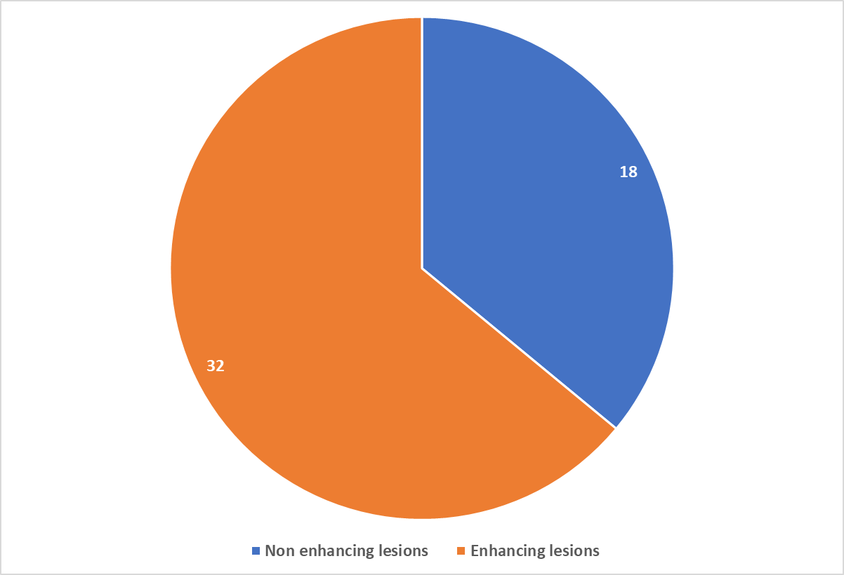
Fig. 1. Post contrast appearance on triphasic CT scan

The enhancement pattern of focal lesions of liver appeared on triphasic CT scan were represented in Table 3. Results depicted that majorly arterial/Venous/Delayed-hypo/hypo/hypo pattern constitutes lesions of simple cysts, hydatid cysts, and metastases in 4, 11, and 3 patients respectively.

Table 3: Enhancement pattern of focal lesions of liver on triphasic CT scan
Arterial/Venous/Delayed | Lesion | No. of Patients
Hypo/hypo/hypo | Simple cysts | 4
Hypo/hypo/hypo | Hydatid cysts | 11
Hypo/hypo/hypo | Metastases | 3
Hypo/hypo/hypo | Total | 18
Hyper/hypo/hypo | Hepatocellular carcinoma | 5
Hyper/Hyper/hypo | Metastases | 4
Hyper/iso/hypo | Hepatocellular carcinoma | 3
Iso/hyper/iso | Hepatocellular carcinoma | 1
Hyper(rim)/hyper(rim)/hyper(rim) | Abscess | 7
Hyper/hyper/hyper | Typical haemangioma | 8
Iso/hyper/hyper | Atypical haemangioma | 2
Nodular hyper(rim)/Nodular hyper(rim)/Nodular hyper (rim) | Atypical haemangioma | 1
Iso/hyper(rim)/hyper(rim) | Intra hepatic cholangio  carcinoma | 1
The enhancement patterns and respective diagnosis appeared on triphasic CT scan were listed in Table 4 and illustrated Fig. 2. Majorly homogenous enhancement patterns were appeared on triphasic CT scan, and which are diagnosed with hepatocellular carcinoma, metastasis, and haemangioma in 3, 4, and 3 patients respectively.

Table 4: Arterial phase enhancement pattern appeared on triphasic CT scan
Enhancement pattern | Diagnosis | No. of Patients
Homogenous | HCC | 3
Homogenous | Metastasis | 4
Homogenous | Haemangioma | 3
Abnormal internal vessels or variegated | HCC | 6
Complete ring | Abscess | 7
Peripheral nodular | Haemangioma | 6
No enhancement | Simple cysts | 4
 | Metastasis | 3
 | Hydatid cyst | 11
 | Haemangioma | 2
 | Intrahepatic cholangio  carcinoma | 1
HCC, Hepatocellular carcinoma
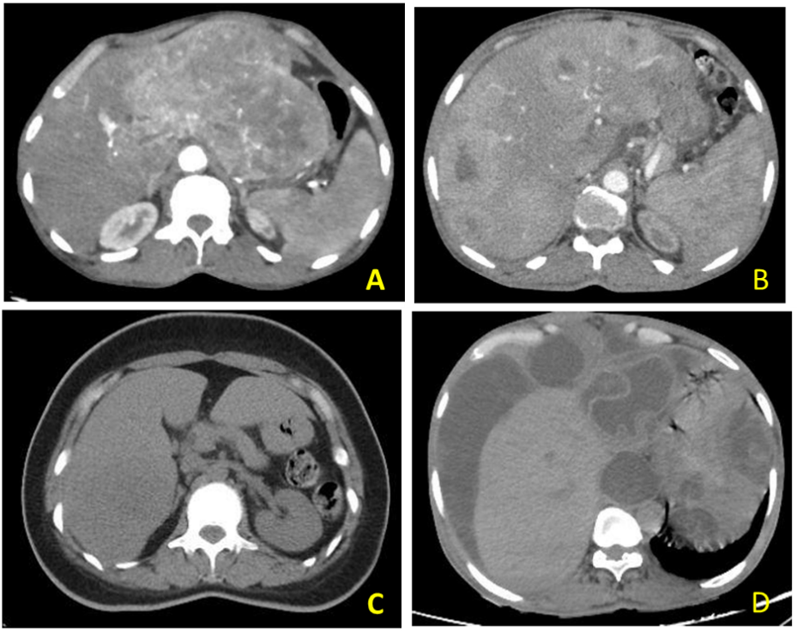
Figure 2. Arterial phase enhancement pattern appeared on triphasic CT scan
Hepatocellular carcinoma (A); Metastasis (B); Hemangioma (C); Hydatid cyst (D)
4. discussion

Liver is prone to various diseases including benign and malignant because of its major function of digestion, detoxification and rich blood supply by hepatic artery and portal vein (Ahirwar et al., 2016). The diagnostic evaluation of liver lesions is critical for accurate clinical management, and imaging plays a pivotal role in this process (Adhikari et al., 2024). Hence, the current prospective observational study involving 50 patients was conducted with the main purpose to assess the diagnostic role of the enhancement pattern of focal liver lesions on triphasic CT in the arterial, portal venous, and delayed phases at our tertiary care centre.
In our study majority of the patients i.e., 28% belonged to age group of 41-50 years and 51-60 years with male predominance (68%). These findings were comparable with literature studies reported by various other research investigators. Ahirwar et al., in a hospital based prospective study of 100 cases reported a major proportion of patients (30%) were belonged to age group of 40-50 years with male predominance (54%). These findings were similar to our study findings (Ahirwar et al., 2016). These findings were further supported by Jain et al., wherein authors reported 21.4% of patients in the age group of 41.50 years with male predominance (52.4%) (Jain et al., 2019).
The top three ranked focal lesions of liver appeared in triphasic CT in our study were found to be hydatid cyst (22%), hemangioma (20%), and hepatocellular carcinoma (18%). These findings were comparable with the previous studies reported by various other researchers. Ahirwar et al., reported largest group i.e., 36% was formed by liver metastases. Second largest group was of hemangioma (23%). Furthermore, Ahirwar et al., reported the most common primary benign and malignant hepatic masses were hemangioma in 23% and HCC in 13% respectively (Ahirwar et al., 2016). Kaushal et al., also reported liver metastasis in 36% of cases, hemangioma in 23% of cases (Kaushal et al., 2016).
In our study maximum number of cases showed arterial phase enhancement in 88.8% of our cases that correlated with Cho et. al., study (Cho et al., 1996). Furthermore, portal vein involvement was noted in 44.4% of cases in our study that correlates with a study carried out by Karahan et al., wherein authors have reported 50% of portal vein involvement (Karahan et al., 2003). In our study, two atypical hemangiomas showed no enhancement in the arterial phase and started enhancing in portal phase with progressive filling in delayed phase which correlated with observations of Van Leeuwen et al., (1996).
In our study, 6 patients with metastasis could be characterized by triple-phase CT alone. One patient with metastasis from mesothelioma is diagnosed as multiple abscesses with differential being metastases which necessitated histopathological confirmation. Soyer et al., in a study of triple-phase helical CT of the liver, demonstrated that the portal-dominant phase imaging, depicted significantly more hypovascular hepatic metastases than unenhanced or arterial-dominant phase imaging (Soyer et al., 2004).
In our study, there were 14% cases of abscesses, all of which showed peripheral rim enhancement and a cent percent PPV for the complete ring enhancement pattern. Confirmation was made by aspiration of pus from the abscesses and pus culture. Mortele and Ros, in their study of focal cystic lesions of the liver, have described abscesses as usually thick-walled lesions with homogeneous low attenuation at CT. In addition to the enhancing abscess wall, contrast-enhanced CT typically shows increased peripheral rim enhancement, which is secondary to increased capillary permeability in the surrounding liver parenchyma (Mortele & Ross, 2001).
In our study, there were eleven cases of intrahepatic hydatid cyst, which did not enhance on any phase of triple-phase CT; 8 cases showing wall calcification, and in two cases, there was a rupture of the cyst revealing membranous folds representing the peri cyst probably. Daughter cysts are identified in 7 patients. Concurrently, Mortele and Ros have described intrahepatic hydatid cyst at CT as a well-defined hypoattenuating lesion with a distinguishable wall. Coarse calcifications of the wall are present in 50% of cases, and daughter cysts are identified in 75% of cases.21 In the present study, 72% of hydatid cysts showed peripheral wall calcifications, which correlated with a study by Mortele and Ros.
CT is a sensitive technique in detecting wall calcification. Hepatic cysts are common and are presumed to be present in 2.5% of the population.21 The incidence of simple cysts in the present study is 8% that correlated with a study by Jain et al., wherein researchers have reported 11.9% incidences of simple cysts. The cysts are regular in margin and did not show enhancement in any of the phases on triphasic CT.16

5. Conclusion

Triphasic spiral liver CT is a standardized CT procedure which enables the detection and characterization of a large variety of liver lesions. Multidetector triphasic CT allows highly precise imaging during the arterial, venous, and delayed phases of hepatic enhancement. Optimal acquisition timing in combination with thinner collimation permits improved lesion detection and will also show improved characterization of lesions.

Consent and ethical approval

A written informed consent was taken from all the subjects participating in the study.

Ethical approval (where ever applicable)

The ethical approval was obtained from the Institutional Scientific Committee and the Institutional Ethics Committee of SSIMS & RC., Davangere. All authors hereby declare that all experiments have been performed in accordance with the ethical standards laid down in the 1964 Declaration of Helsinki

References

Adhikari, K., Bhattarai, M., Raman, R. K., Bhattarai, S., Khadka, H., Adhikari, B. B., Dahal,
S., & Dahal, S. (2024). Triple phase CT scan in focal liver lesion with histopathology correlation. SSR Institute International Journal of Life Science, 10(6), 6417–6421.
Ahirwar, C. P., Patil, A., & Soni, N. (2016). Role of triple-phase computed tomography
findings for evaluation of hepatic lesions. International Journal of Research in Medical Sciences, 4(8), 3576–3581.
Cho, J. S., Kwag, J. G., Oh, Y. R., & Song, C. J. (1996). Detection and characterization of
hepatocellular carcinoma: Value of dynamic CT during the arterial dominant phase with uniphasic contrast medium injection. Journal of Computer Assisted Tomography, 20, 128–134.
Foley, W. D., Mallisee, T. A., Hohenwalter, M. D., Wilson, C. R., Quiroz, F. A., & Taylor, A. J.
(2000). Multiphase hepatic CT with a multirow detector CT scanner. AJR American Journal of Roentgenology, 175, 679–685.
Jain, S., Khanduri, S., Shah, J. K., Yadav, P., & Krishnam, A. (2019). Role of MDCT in
detection and characterisation of focal liver lesions. Journal of Clinical and Diagnostic Research, 13(5).
Karahan, O. I., Yikilmaz, A., Isin, S., & Orhan, S. (2003). Characterization of hepatocellular
carcinomas with triphasic CT and correlation with histopathologic findings. Acta Radiologica, 44(6), 566–571.
Kaushal, L., Verma, V. K., & Soni, N. (2016). Comparison of triple phase CT and
ultrasonography findings for evaluation of hepatic lesions. International Journal of Medical Research Review, 4(8), 1456–1465.
Méndez-Sánchez, N., Villa, A. R., Chávez-Tapia, N. C., Ponciano-Rodriguez, G., Almeda-
Valdés, P., González, D., & Uribe, M. (2005). Trends in liver disease prevalence in Mexico from 2005 to 2050 through mortality data. Annals of Hepatology, 4(1), 52–55.
Mishra, A. K., Shrestha, P., Bista, N. R., Bhurtel, P., Bhattarai, S., Thakali, K., & Pathak, S.
R. (2009). Pattern of liver diseases. Journal of Nepal Health Research Council, 7(1), 14–18.
Mittal, A., & Kumbhar, R. R. (2024). Evaluation of focal liver lesions using triple phase
contrast computed tomography among Indian patients. Bioinformation, 20(10), 1429.
Moore, K. L., & Dalley, A. F. (2007). Essential clinical anatomy (3rd ed.). Lippincott Williams
& Wilkins.
Mortele, K. J., & Ros, P. R. (2001). Cystic focal liver lesions in the adult: Differential CT and
MR imaging features. Radiographics, 21(4), 895–910.
Oliva, M. R., & Saini, S. (2004). Liver cancer imaging: Role of CT, MRI, US and PET. Cancer
Imaging, 4(Special No. A), S42–S46.
Oliver, J. H., Baron, R. L., Federle, M. P., & Rockette, H. E. Jr. (1996). Detecting
hepatocellular carcinoma: Value of unenhanced or arterial phase CT imaging or both used in conjunction with conventional portal venous phase contrast-enhanced CT imaging. AJR American Journal of Roentgenology, 167(1), 71–77.
Rani, S., & Tripathi, P. (2018). Imaging characteristics of focal liver lesions on contrast-
enhanced helical computed tomography. International Journal of Scientific Study, 6(3), 53–56.
Reznik, Y., Dao, T., Coutant, R., Chiche, L., Jeannot, E., Clauin, S., Rousselot, P., Fabre,
M., Oberti, F., Fatome, A., Zucman-Rossi, J., & Bellanne-Chantelot, C. (2004). Hepatocyte nuclear factor-1 alpha gene inactivation: Cosegregation between liver adenomatosis and diabetes phenotypes in two maturity-onset diabetes of the young (MODY)3 families. Journal of Clinical Endocrinology and Metabolism, 89(3), 1476–1480.
Sadler, T. W. (2018). Langman's medical embryology. Lippincott Williams & Wilkins.
Schwartz, L. H., Gandras, E. J., Colangelo, S. M., Ercolani, M. C., & Panicek, D. M. (1999).
Prevalence and importance of small hepatic lesions found at CT in patients with cancer. Radiology, 210, 71–74.
Sinnatamby, C. S. (1999). Last’s anatomy: Regional and applied (10th ed.). Churchill
Livingstone.
Soyer, P., Poccard, M., Boudiaf, M., Abitbol, M., Hamzi, L., Panis, Y., Valleur, P., & Rymer,
R. (2004). Detection of hypovascular hepatic metastases at triple-phase helical CT: Sensitivity of phases and comparison with surgical and histopathologic findings. Radiology, 231(2), 413–420.
Van Leeuwen, M. S., Noordzij, J., Feldberg, M. A., Hennipman, A. H., & Doornewaard, H.
(1996). Focal liver lesions: Characterization with triphasic spiral CT. Radiology, 201(2), 327–336.

