DIAGNOSTIC AND THERAPEUTIC MANAGEMENT OF NASAL SCHOSTOSOMIASIS IN CATTLE-A RESTROSPECTIVE STUDY

ABSTRACT
BACKGROUND: Nasal schistosomosis caused by the blood fluke, Schistosoma nasale, is a snail-borne disease which is prevalent among the bovine populations of many Indian states. In cattle, this disease is characterised by severe respiratory distress due to granulomatous growth obstructing the nasal meatus.
AIM: The present study was undertaken to identify the actual status of nasal schistosomiasis among the white and Non-Descript (ND) cattle within the age group of 3 to 8 years.
METHODS: A total of 12 cattle were presented at Veterinary clinical complex, Rajendranagar, during the period of 2 yrs (2022-2024), with distinct clinical signs of rhinitis, snoring, granuloma around and inside the nostrils, bilateral purulent nasal discharges, difficulty in breathing and anorexia. Each cattle with similar symptoms were subjected to thorough physical and clinical examinations, with fecal examination and nasal smears to assess the infection with accuracy.
FINDINGS: Physical examination revealed cauliflower-like granulomatous growth in and around the nasal cavity was observed, with distinct inspiratory dyspnoea and snoring sounds. Parasitic eggs of Schistosoma nasale were recorded on nasal smear examination, confirming the presence of the disease.
CONCLUSION: Therapeutic management was initiated with lithium antimony tartarate and Oxyclozanide antihelminthic drug, proven to be a safe and result-yielding drug of choice for the treatment of nasal schistosomiasis. Among the 12 affected cattle, 2 succumbed to its deteriorating respiratory issues, while the others showed slow and gradual recovery, with complete recovery after 2 weeks of rigorous treatment.

KEY WORDS: Nasal schistosomiasis, white cattle, miliary granuloma, nasal smear.

- INTRODUCTION
Nasal schistosomosis (NS), commonly known as the ‘snoring disease’ is a snail-borne trematode infection caused by the blood fluke Schistosoma nasale, characterized by rhinitis, bilateral muco-purulent nasal discharges, cauliflower like nasal granuloma in nasal cavity, distinct snoring sounds and extreme respiratory distress in cattle. The discomfort due to dyspnoea causes morbidity, reduction in milk yield and impaired growth, resulting in heavy economic losses in production cattle. Schistosomiasis ranks second after malaria in high morbidity and mortality among parasitic infections (Karunamoorthi et al., 2018). Eggs of the fluke Schistosoma nasale, act as the main pathogenic agent that causes abscess formation in the nasal cavity, that further ruptures and occludes the nasal passage with purulent discharges, leading to dyspnoea. Adult flukes cause ‘Snoring disease’ in cattle but remains mostly asymptomatic in buffaloes while shedding parasitic eggs through the nasal discharges. The zoonotic importance is considerable in view of the scope for dermatitis in man likely to be provoked by the cercaria of S. nasale in common water sources (Anantaraman, 1981). The freshwater snail Indoplanorbis exustus acts as intermediate host, widely prevalent over the Indian sub-continent.

- MATERIALS AND METHODS
2.1. Collection of materials
The present work consists of 12 clinical cases presented at the Veterinary Clinical Complex and Department of Veterinary Clinical Medicine, Rajendranagar. White cattle and ND breeds ranging from 3 to 8 years of age, were studied over a period of 2 years, from 2022 to 2024, on the basis of chief complaint of anorexia, snoring sounds while breathing, bilateral muco-purulent nasal discharges and dyspnoea.
  - Examinations conducted:
The cases were subjected to detailed physical and clinical examinations. Fecal examination to determine the severity of the infection based on the parasitic egg count, nasal smears and hematobiochemical analysis. Fecal examination was done by collecting fecal samples in polythene containers and subjecting them to direct smear and sedimentation methods of analysis.
Nasal scrapings or discharges were collected and subjected to microscopic examination.
  - Chemicals:
Nasal scrapings and discharges were collected in 2% normal saline for immediate screening. 5 ml of 10% potassium hydroxide was added to the sample in a test tube and boiled over a flame for 5 minutes to induce mucolysis. It was then allowed to cool down and centrifuged at 2000 rpm for 3-5 minutes. The supernatant obtained was then discarded and the sediment was examined under low power of microscope.

- RESULTS
Clinical examination of the cows revealed unilateral or bilateral miliary/cauliflower-like granulomatous growth in and around the nasal cavity, inspiratory dyspnoea and snoring sounds. Nasal hyperemia and mucopurulent bilateral nasal discharges were also common findings, with moderate to severe varying degrees of respiratory distress. No parasitic eggs were detected on fecal examination but the direct microscopic examination of nasal discharges and scrapings revealed boomerang/palanquin shaped eggs of S.nasale with fully developed miracidium and a distinct terminal spine, confirming the disease as nasal schistosomiasis.
TABLE.1: Various clinical signs observed among the 12 cattle presented at the clinic are categorised in the table below

CLINICAL SIGNS | Snoring sounds and inspiratory dyspnoea | Anorexia | Granulomatous growth inside the nasal cavity | Granulomatous growth around the nasal cavity | Mucopurulent nasal discharges | Fall in milk yield

White cattle
1. | Present | Absent | Present | Indistinct | Bilateral | Present
2. | Present | Present | Present | Present | Bilateral | Present
3. | Present | Present | Present | Absent | Bilateral | - *
4. | Present | Present | Present | Present | Bilateral | Present
5. | Discontinuous | Absent | Present | Present | Unilateral | - *
6. | Present | Present | Present | Present | Bilateral | - *
7. | Mild | Absent | Indistinct | Present | Unilateral | Present
ND cattle
1. | Present | Present | Present | Absent | Unilateral | Present
2. | Present | Absent | Indistinct | Present | Bilateral | - *
3. | Mild | Absent | Present | Present | Unilateral | Absent
4. | Present | Present | Present | Present | Bilateral | Present
5. | Present | Present | Present | Indistinct | Bilateral | - *

*Male Cattle.

Given below are the recorded images of both physical and microscopical examination of the affected subjects.
Figure 1 depicts the nasal erythema, mucosal wall thickening and miliary granulomatous growth in the nasal cavity.
Figure 2 depicts the presence of Napolean hat/ Boomerang shaped egg of Schistosoma nasale, with a distinct terminal spine and a developing miracidium observed in the microscopic examination of the nasal scrapings/nasal discharge.
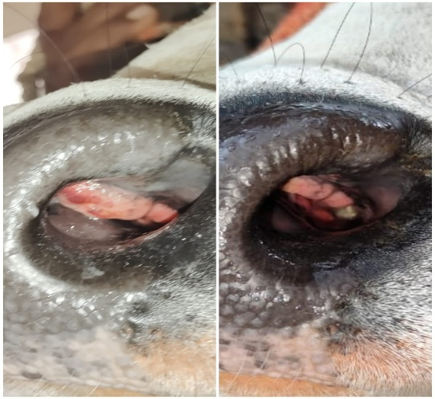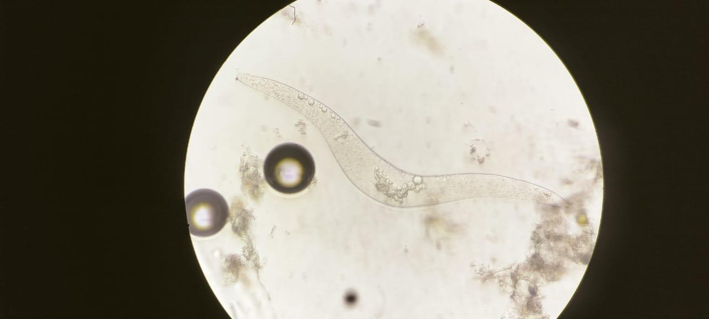
Fig.2: Microscopic examination of the nasal scrapings revealed Napolean hat/ Boomerang shaped egg of Schistosoma nasale, with a distinct terminal spine and a developing miracidium.

Fig.1: Nasal erythema, mucosal wall thickening and miliary granulomatous growth observed inside the nasal cavity.

Therapeutic management was initiated with Injection Lithium antimony tartarate @ 20ml intramuscularly, supportive with Injection Chlorpheniramine maleate (0.5 mg / kg bwt i/m) administered weekly for 4 weeks. Suspension oxyclozanide @ 15 mg/kg b.wt was given orally to all the animals. Among the 12 affected cattle, 2 succumbed to its deteriorating respiratory health and complications, while the others showed slow and gradual recovery, with reduction in snoring sound and improvement in breathing. Reduction in the size of nasal granuloma and recovery was recorded after 2 weeks of continuous treatment and monitoring.

- DISCUSSION
Nasal schistosomiasis, caused by the blood fluke Schistosoma nasale, is a snail borne trematode infection of cattle and buffaloes. It causes nasal granulomas and snoring disease among cattle, but only a subclinical infection among buffaloes. The main molluscan vectors, Lymnaea luteola and Indoplanorbis exustus, carry the larval form, Cercariae indicae (Singh, 2003). Schistosomiasis is recognized as a tropical disease of considerable public health importance. Muraleedharan et al.(1975a) and Koshy et al. (1975) exposed miracidia of S. nasale of cattle and buffalo origin and found that the developmental period for cercariae in snails varied from 23-84 days post-infection. Adult flukes are found in the blood vessels of the nasal mucosa, but the main pathogenic agent are the eggs of the parasite. Transmission of infection occurs by percutaneous penetration of cercaria of S. nasale from the intermediate host Indoplanorbis exustus snail. The animals should be avoided from grazing near water bodies in which infected snails are noticed (Soulsby, 1982).
On field diagnosis of nasal schistosomiasis is done mainly based on the clinical symptoms and physical examination. Most commonly observed clinical signs include sneezing, bilateral thick muco-purulent nasal discharge, congestion of nasal mucosa (nasal erythema) Mukund (2012), persistent dyspnoea and anorexia in some protracted cases in accordance with previous reports where snoring was observed in animals (Soulsby, 1982). Formation of polyps and cauliflower-like granulomatous growth are observed in chronic cases of the disease, resulting in Snoring, henceforth giving the name ‘snoring disease’ (You et al., 2018). Unilateral or bilateral miliary/cauliflower-like nasal granuloma in cattle was observed by Ottalwar et al. (2004), Kishor (2008) and Qadri and Ganguly (2016). Symptoms like anorexia in few cases may be due to irritation caused in the nasal mucosa and rhinitis. Subclinical schistosomiasis in live animals is difficult to diagnose by physical examination due to lack of any clinical signs, mostly prevalent in Buffaloes (Rajamohanan and Peter (1975)). On microscopic examination of nasal washings/scrapings, eggs of S.nasale are identified as per the standard taxonomical keys (Soulsby, 1982). The presence of boomerang shaped eggs with terminal spine in nasal scrapings of cattle is also in accordance with the reports of Banerjee and Agrawal, (1992) and Sumanth et al., 2004.
Therapeutic management is done with Lithium antimony tartarate as the antimony attaches itself to sulphur atoms in trypanothione reductase which is used by the Schistosoma nasale to complete its life cycle in the host. Hence, the administration of Lithium antimony tartarate might be the choice of the treatment (Ponnuswamy et al.,2016) along with antihelminthic Oxyclozanide which acts by uncoupling oxidative phosphorylation (Walley JK, 1966).
The only natural host responsible for the transmission of S. indicum, S. spindale and S. nasale is Indoplanorbis exustus (Kumar and de Burbure, 1986), widely prevalent in the states Andhra Pradesh, Tamil Nadu, West Bengal, Assam, Bihar, Orissa and Maharashtra, based on the studies of S. Yogeshpriya et al.,2021.

- CONCLUSION
In conclusion, nasal schistosomiasis should be taken into consideration as one of the major limiting factors in cattle productivity as mass morbidity leads to economic losses. Owners should be advised to not allow the cattle to graze near water shores and follow regular deworming every six months of interval. To maintain public safety and awareness, both animals and humans should be screened for Schistosomiasis in water logging areas. Different control measures advocated for snail eradication, including Indoplanorbis exustus, have to be carried out and integrated for their effective implementation in the prevalent areas and initiate immediate treatment of the affected herd to prevent further deterioration

REFERENCES
- Anantaraman M. The epizootiology of nasal schistosomiasis in animals. Proc Indian Acad Sci (Anim Sci) 1981; 90: 659-63.
- Banerjee PS, Agrawal MC. Epizootiological studies in bovines on fluke infections with special reference to schistosomiasis. Indian Vet J 1992; 69: 215-20.
- De Bont J, Van Akin D, Vercruysse J, Fransen JM, Southgate VR, Rollinson D. The preva lence and pathology of Schistosoma nasale Rao,1933 in cattle in Sri Lanka. Parasitology 1989; 98: 197-202.
- Karunamoorthi K, Almalki MJ, Ghailan KY.Schistosomiasis: A neglected tropical disease of poverty: A call for intersectoral mitigation strategies for better health. J Health Res Rev. 2018;5:1-12.
- Koshy TJ, Achuthan HN and Alwar VS (1975). Cross transmissibility of Schistosoma nasale (Rao, 1933) infection between cattle and buffaloes. Indian Veterinary Journal 52 216-218.
- Kumar V, de Burbure G. Schistosomes of animals and man in Asia. Helminthol Abst 588 (Ser A) 1986; 55: 469-80.
- Muraleedharan K, Kumar SP, Hegde KS and Alwar VS (1975a). Experimental infection of Indoplanorbis exustus (Deshayes) with miracidia of Schistosoma nasale Rao, 1933. Current Research 4 116-117.
- Ponnuswamy, K.K.,Sivaraman, S., and Venkatesakumar, E., Sivaseelan, S. and Vijayakumar, G.(2016). Rhinoscopic diagnosis of nasal schistosomiasis and its medical management in a cow. Indian Veterinary Journal. 93. 33-35.
- Rajamohanan K, Peter CT. Pathology of nasal schistosomosis in buffaloes. Kerala J Vet Sci 1975; 6: 94-100.
- Singh KS. Veterinary helminthology. New Delhi: Indian Council of Agricultural Re search, 2003: 113-5. Singh KS. Veterinary helminthology. New Delhi: Indian Council of Agricultural Re search, 2003: 113-5.
- Soulsby EJL. Helminths, Arthropods and Protozoa of Domesticated Animals. 7th Ed. English Language Book Society and Baillere Tindall, London 1982, 763-772.
- Sumanth S, D’Souza PE, Jagannath M S. Study of the nasal and visceral schistosomosis in cattle slaughtered at an abattoir in Bangalore, South India. Rev Sci Tech 2004; 23: 937-42.
- Walley JK. Oxyclozanide (3,3′,5,5′,6-pentachloro-2,2′-dihydroxybenzanilide--6Zanil″) in the treatment of the liver fluke Fasciola hepatica in sheep and cattle. Vet Rec. 1966;78:267–276. doi: 10.1136/vr.78.8.267.
- Yogeshpriya, S., P. Selvaraj, M. Saravanan, P. K. Ramkumar and Asmitha, S. 2021. Conventional Borescope in the Evaluation and Management of Nasal Schistosomiasis in a Bullock. Int.J.Curr.Microbiol.App.Sci. 10(01): 3024-3027.
- You, H., Cai, P., Tebeje, B. M., Li, Y., & McManus, D. P. (2018). Schistosome Vaccines for Tropical Domestic Animals. medicine disease, and 3(2), infectious 68.

