New Distributional record of snapping shrimp Alpheus bisincisus De Haan, 1844 (Decapoda: Alpheidae) from the Southeast Coast of India, Bay of Bengal

ABSTRACT
This study explains a detailed morphological character of Alpheus bisincisus de Haan, 1844 (Decapoda: Alpheidae), as bycatch from Mudasalodai, southeast coast of India. The morphometric and morphological observation revealed key diagnostic features, including a distinct rostrum, specialized chelipeds, and characteristic body proportions, which were compared with existing descriptions. Notable morphological differences from the closely related A. chiragricus, particularly in claw structure and rostral shape, are documented. This study marks the first record of A. bisincisus from Tamil Nadu, expanding its known home range along the Indian coastline. These findings may contribute an additional information to the growing baseline data on the distribution and morphological variation of snapping shrimp in Indian coastal waters.
Keywords: Alpheus bisincisus, Morphometric analysis, Crustacean taxonomy, Marine biodiversity, Morphological variation.
1. INTRODUCTION
The snapping shrimp, or pistol shrimp, belong to the Alpheidae family, which includes the genus Alpheus. They are found in a wide range of marine environments, from shallow coastal waters to deep-sea habitats (Chace, 1988). However, their distribution is not uniform, and different species of alpheus shrimp show preferences for specific habitats. This diversity is influenced by factors such as substrate availability, environmental conditions, and the presence of symbiotic partners (Dworschak et al., 2000). The distribution patterns of these shrimp can also be affected by ocean currents and regional climatic conditions, with some species inhabiting shallow coastal waters and others residing in deeper offshore environments (Anderson, 2010).
Alpheus shrimp play crucial roles in maintaining the health and community dynamics in marine ecosystems (Pérez-Botello et al., 2021). Their populations are highly influenced or closely tied to environmental conditions such as changes in water temperature, salinity, and habitat quality can impact their abundance and distribution (Jean et al., 2022). They have various ecological interactions with other organisms, including symbiotic relationships with marine sponges, corals, fishes and other on benthic communities. Among fish, gobies are small fish that inhabit burrows alongside alpheus shrimp. This symbiotic relationship provides protection for the gobies, while the shrimp benefits from receiving warning signals about potential predators (Karplus,1987). In sponges, shrimp find refuge, gaining protection and a secure breeding environment. In return, the shrimp's activities enhance the sponge's health by preventing overgrowth and improving water circulating (Dufft et al., 2000). In coral, shrimp seek shelter among coral branches or sea urchin spines without harming their hosts. This symbiotic arrangement provides protection for the shrimp using existing structures, while the host organism remains largely unaffected (Bruce, 1976).
Their distinctive snapping behavior, characterized by an oversized claw can able to produce high-velocity water jet, this behaviour sets them apart from other crustaceans (Versluis et al., 2000). Detailed descriptions of the morphological features such as carapace, chelae, antennae, and specialized structures like the snapping claw are essential for understanding their adaptations and ecological roles (Anker et al., 2006). The unique snapping behavior of Alpheus shrimp is explored for its purposes in communication, predation, and territorial defense, reveals insights into the intricate social structures and interactions of Alpheus shrimp (Anker et al., 2006).
In India, Alpheus spp can be found in a variety of marine environments, ranging from shallow coastal waters to deeper offshore regions of the Arabian Sea (Jha et al., 2019) and the Bay of Bengal (Thomas, 1976). They are able to thrive in diverse environments such as coral reefs, mangroves, seagrass beds, and sandy or rocky substrates. The first report of alpheus shrimp species in India dates back to Thomas (1976), who identified four species. A study conducted by Radhakrishnan et al. (2012) identified 16 species of Alpheus within a larger review of 23 species in the alpheidae family. Ramachandran et al. (2019) were reported a species of A. bisincisus from the southwest coast of India. Recently two specimens of flathead snapping shrimp, Alpheus bisincisus were collected from the Mudasalodai landing centre, revealing a new distributional record of this species in southeast coast of India.
2. MATERIALS METHOD
Two specimens of the Alpheus bisincisus were collected as bycatch at the Mudasalodai landing site during July 2023. Morphological measurements were taken using a Mitutoyo CD-6” ASX digital caliper, recorded to the nearest 0.1 millimeter (mm) by following the standard protocol from McClure and Wicksten (1997). The term Cl used as carapace length from the tip of the rostrum to the posterior dorsal border of the carapace, Al used as abdomen length from the posterior margin of the carapace to posterior of the telson, Tl used as Telson length from the anterior base of the telson to its posterior tip.

c
b
a
Figure 1. Mudasalodai landing centre, located on the southeast coast of India, represents (a) the state of Tamil Nadu within India, (b) the Cuddalore district within Tamil Nadu, and (c) the Mudasalodai region within Cuddalore.
Characters
Total length (mm) | 28.54
Proportions
Carapace Length (%TL) | 40.15
Abdominal Length (%TL) | 59.85
Ocular Width (%AL) | 21.49
First antennular segment (%ASL) | 26.68
Second antennular segment (%ASL) | 38.52
Third antennular segment (%ASL) | 22.27
Telson length (%AL) | 24.65
Telson width Proximal (%TIL) | 67.70
Telson width Distal (%TIL) | 44.89
Major chela dactyl length (%MpL) | 38.56
Major chela propodus height (%MpL) | 19.79
Major hand Height (%MdL) | 53.38
Table 1. Morphometric data of A. bisincisus specimen

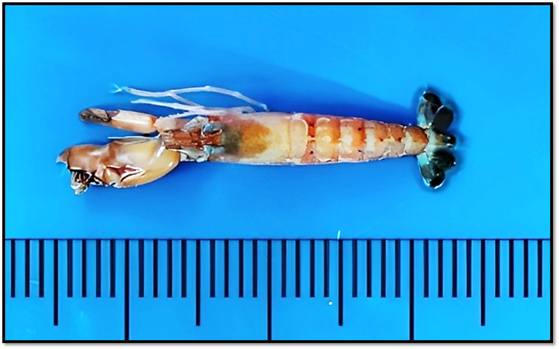
Figure 2. Alpheus bisincisus de Haan, 1844; Dorsal view.

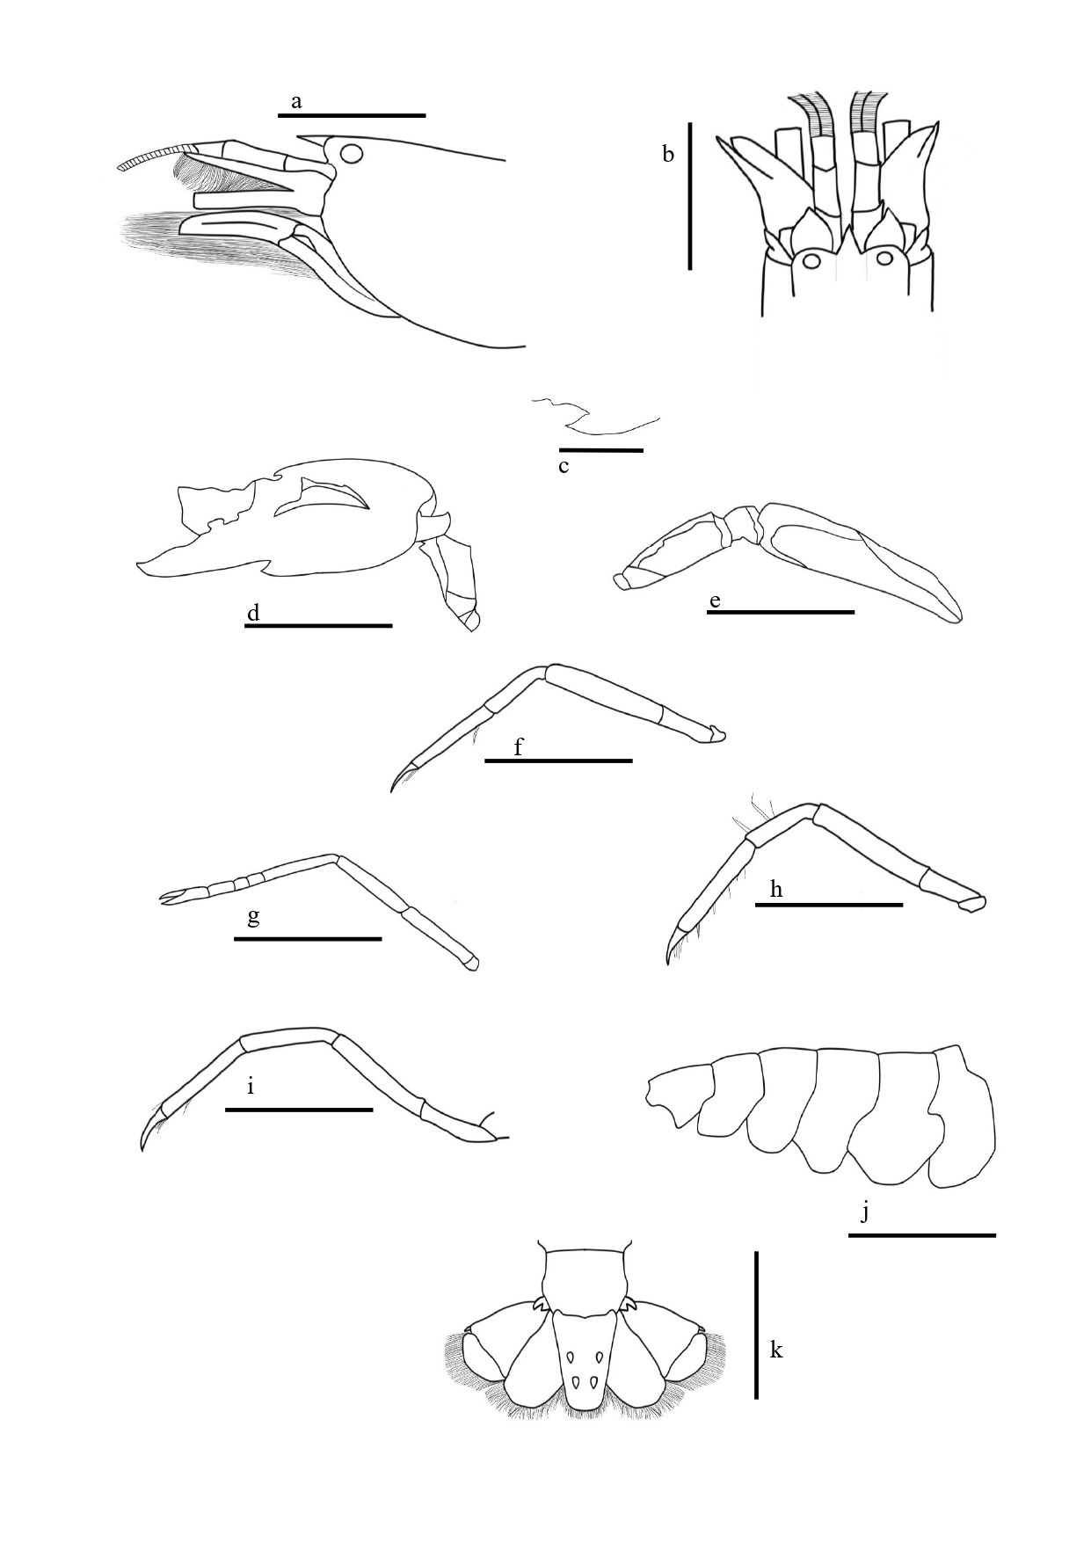

Figure 3. Alpheus bisincisus, male paratype, cl 11.46 mm from Parangipettai, India: a, anterior region, lateral view; b, same, dorsal view; c, carina below right first antennular segments; d, major first pereopod; e, minor first pereopod; f, right second pereopod; g, right third pereopod; h, right fourth pereopod; i, right fifth pereopod; j, abdomen; k, telson and uropods. (Scale 10 mm: a, b, d, e, f, g, h, i, j ; scale 5 mm: c, and k)

3. RESULT
3.1 Scientific position
Class: Malacostraca
Order: Decapoda
Family: Alpheidae
Genus: Alpheus Fabricus,1798
Species: Alpheus bisincisus de Haan, 1844.
3.2 Types:
3.2.1 Holotype: Japan, Collector De Man, 1844, Voucher RMNH D5545 (Ramachandran et al., 2019).
3.2.2 Paratype: Maldives island, Countiere, 1905 (Ramachandran et al., 2019).
3.3 Distribution: Indo-Pacific Ocean.
3.4 Ecology:
Marine, mixed rocky-sandy shores and coral reef flats, under rocks and coral rubble; intertidal zone. In India, the species was reported at a depth of 33 meters (Ramachandran et al., (2019).
3.5 Type locality:
Mudasalodai landing centre, Tamil Nadu, India.

3.6 Size:
The largest specimen can grow up to 2-7cm (Banner and Banner, 1980). In east-coast of India its shows 8 mm of Cl; 29.5mm of TL (Ramachandran et al., 2019). In our study it is 11.46mm of CL; 28.54mm of TL.
3.7 Taxonomic account:
See Banner and Banner (1980); see also Coutiere and Gardiner, J. S. (1906) for additional illustrations Ramachandran et al. (2019).
3.8 Restricted synonyms:
Alpheus avarus De Haan, 1844
Alpheus bis-incisus var. malensis Coutiere, 1905
Alpheus bis-incisus var. stylirostris Coutiere, 1905
Alpheus bis-incisus var. variabilis Coutiere, 1905
Alpheus bisincisus Kim, 1981
3.9 Description:
Body smooth, stout and not unusually compressed. Rostrum acute, narrowly triangle, flattened, longer than broad, about 2.1 times as long as broad at base, sharp distally, reaching to middle area of first article of antennular peduncle with absence of teeth. Rostral carina strong compressed, acute, long and narrow extending posteriorly of carapace and elongated triangle passing far behind posterior end of eye. Carina is reaching to 1st distal margin of antennular segment. Orbital hoods inflated, round, separated from mid dorsal carina by shallow groove and reach proximal margin of stylocerite. Carapace is smooth, compressed, and narrow with small groove near to ocular width. Pterygostomial angle rounded with no spines. They have a tiny carina, almost merely angle runs along the anterior surface towards the antennule’s articulation. Further carapace without median tooth or tubercle on gastric region, flattened teeth overhanging posterior ends of adrostral furrows, anterior margin between rostrum and orbital hood unarmed, concave near rostrum.
Ocular hood is developed anteriorly and dorsally above the levels of the rostrum, and it is separated by a relatively deep orbito-rostral groove, noticeable depression. Ocular hood anterior edge is slightly concave near to the rostrum. Eyes with antero-medial lobe extending beyond anterior margins of orbital hoods. Carapace with pterygostomian margin produced anteriorly below base of basicerite.
Abdomen smooth, pleura of 2nd somites is round in shape, 3rd and 4th somites somewhat U in structure and 5th somites sub-triangular in shape slightly elongate posterior ventral margin. Ocular hood totally encloses the eye. First antennular segment with carina extending from ventral inner margin, ventral portion spined with directing anterior. Antennule with stylocerite carrying a acute, sharp edge in distolateral end and almost reaching the distal margin of first antennular article. Second antennular article twice as long as broad, 1.4 times as long as first article, about 1.7 times as long as third. Blunt end of basicerite with moderate development not as long as stylocerite. The lateral spine of scaphocerite has a tip is almost reach the distal end of antennular peduncle and is longer than the flattened part. Carpocerite little longer than scaphocerite.
Tooth of the stylocerite was directed outward. Scaphocerite 2.6 times as long as broad. Scaphocerite distal spine overreaching distal end of antennular article, inner blade, and the distal end of carpocerite. Inner blade narrow distal and reaching the antennular article distal end. Cleft between the distal spine and inner blade and its reach half of the distal end of scaphocerite. Carpocerite overreaching the distal end of the third antennular peduncle segment. Basicerite small with dull end, no longer than the rostrum and the stylocerite.
The third maxilliped are slender and extended straight well towards the end of carpocerite; mandible with bi-segmented Palp. Tip compressed, unarmed distally with very long setae on distal margin, scale on inner surface dense. Ultimate segment about 4.3 times as long as broad at distal end, with very long, stiff setae on inferior distal margin; setae overreaching distal end of proximal segment. Penultimate segment rather short, broad about 2.2 times as long as broad near distal end. Exopod not overreaching the penultimate segment. Short and dense of tufts setae on inner margin
Major cheliped noticeably not compressed laterally with immoveable fingers occupying numerous setae in distal and overreaching distal end of carpocerite. The hand is very large, compressed dorsally, absence of granules. In front of both superior margin and inferior margin has transverse U-shaped blunt groove, in superior which is behind the dactylar articulation and distance between them are depression depth. The hands are smooth and soft texture. A well-defined superior saddle exhibits subacute proximal shoulder, which is overhanging on the transverse groove. Inferior shoulder robust, distal margin with subacute tooth projecting towards the outer face on inferior shoulder. Palmar broad, bearing humps and bumps. Lateral palmar shallow deep, quadrangular, reaching the linea impressa. Mesial palmar shallow depression with triangular. A mobile claw carrying a sturdy plunger, while an immovable claw features a robust socket with sharp edge. Carpus with tooth like projection on superior distal margin. Merus about 2.5 times as long as broad with inferior margin smooth, no spines and spiky edges in the distal end.
Minor chela of first pereopods is sexually dimorphic, male has balaeniceps crest of hairs on dactylus, about 3.9 times as long as broad with fingers 2.6 times as long as palm. Fingers not gaping and tip crossed when they closed, series of sweeping hairs from propodus to ductylus. Hand concave, soft texture with very long hairs, and dentate near dactylus. Presence of small transverse groove behind the dactylar articulation and lateral palmar portion has tooth like projection near to ductylus. Moveable fingers narrow, balaeniceps. Both dactylus and pollex bearing dense long setae on crest of each of both lateral faces. Cup shaped carpus bearing a sharp edge. Merus about 2.5 times as long as broad, carrying spiky edges, ventral side of merus smooth in texture with absence of spine.
Going beyond the proximal of the second carpus segment to the distal end of the carpocerite with the second pereopod. Fingers of chela slightly less than 4 times as long as palm. First segment of carpus about 1.8 times as long as second: second segment 1.7 times as long as third; third segment equal to fourth; fifth segment about 1.8 times as long as fourth
Merus of third pereopod 5 times as long as wide, with long setae, ischium bearing a moveable spine. Carpus bearing inermous and several long setae on superior margin, projecting as tooth-like process on superior distal margin. Propodus little longer than carpus, presence of 10 spines (Fig: 4) on inferior margin, series of setae on the distal end. Dactylus simple, conical about 2.3 length of the propodus, ventral surface slightly excavates.
Fourth pereopod almost as same as third pereopod, which includes ischium bearing a moveable spine.
Fifth pereopods are considerably narrower than third pereopods. Absence of moveable spine. There are several lengthy setae in the corpus and propodus. Propodus is two times smaller than Dactylus.
Telson long, symmetrical, anterior 1.5 time as long as wider than the anterior, armed with two sets of dorsal spines and with no longitudinal depression the dorsal surface. Lateral margin almost straight. Posterior margin regularly convex, bearing series of seta-like spines and armed with pair of rather weak spines at each lateral end. Dorsal pairs situated approximately at positions dividing telson into three roughly equal parts.
Uropodal endopod with distinct inner depression at anterior half, protopod bearing two subacute teeth. The distal margin of a uropodal exopod bears a numerous of thick long seta. The lateral margin ends in an acute, immovable lobe that is internally flanked by rounded lobes with distolateral tooth. The transverse suture creates two lobes that are extremely convex. Presence of exopodal diaeresis.
3.10 Colour pattern
The carapace displays a predominant brownish-orange shade adorned with white band. Distal end of the carapace bearing falu red line over the rostrum and post-orbital. The abdomen region displays an orange tone featuring with sequence of linear white patches extending from the 2nd to 6th segment. The initial segments bear four small black dots on the dorsal side, while the third segment carries two black dots on the dorsal side. The fourth and fifth segments each have two black dots on the ventral side and one on the dorsal side. The pleura’s exhibit a glassy texture with a light orange hue, adorned with translucent white markings. At the distal end of the carpocerite, a caramel hue emerges. The rostrum takes on a brick red shade, and its orbital hoods possess a translucent white quality. Both the antennal and antennular peduncles are adorned with caramel shading and scaphocerite with inner blade adorned with single layer of translucent with rust colour. The primary chela finger boasts a rust with pale orange colour, with fingertips displaying ginger colour situated in distal end of ductulus. The telson is characterized by a lower region is black-orange coloration, while the uropod the endopod bearing dark blue hue. In exopod bearing black hue surrounded by grey colour.
4. DISCUSSION
In the current investigation, the rostrum exhibits a length-to-breadth ratio of 2.2, Banner and Banner (1982) reported ratios between 1.8 and 3. In contrast, Yang et al. (2007) found a ratio of 2 in length, and a more recent observation by Ramachandran et al. (2019) determined the rostrum to be 2.2 times as long as broad.
Banner and Banner in 1982 indicated that the merus is 1.6 times as long as it is broad, featuring a robust distal tooth on the inferno internal margin. In contrast, Yang et al. (2007) illustrated a merus length-to-breadth ratio of 2.4 from Korean waters. A more recent investigation by Ramachandran et al. (2019) revealed a merus that is 2.6 times longer than its width. In our present study, we observe a merus ratio of approximately 2.5, characterized by spiky edges at the distal end.
The sexual dimorphism in the minor chela of the first pereopods is evident, particularly in males, who possess a distinctive balaeniceps crest of hairs on the dactylus. In this study, the male minor chela exhibits a length-to-breadth ratio of about 3.9, with fingers that are 2.6 times as long as the palm. Comparable findings in the minor chela from the Arabian Sea yield a ratio of 4.0, aligning closely with the observations made by Ramachandran et al. (2019). However, Yang et al. (2007) reports a slightly different ratio, noting a length-to-width proportion of 3.6. Banner and Banner (1982) contribute valuable insights by emphasizing the variability in ratios, ranging from 2.3 to 4, across the different locations. This underscores the importance of considering geographical variations in understanding the sexual dimorphism of the minor chela. When comparing the merus, both Banner and Banner (1982) and this study reveal a length-to-breadth ratio of 2.4 and 2.5, showcasing a notable similarity.
Examining the distal aspects of the second pereopod in our present study reveals that the first carpal segment is approximately 1.8 times longer than the second, the second segment is 1.7 times longer than the third. Notably, the fifth segment is approximately 1.8 times longer than the fourth. In the context of banner and banner (1982) research establishes a ratio of 10:7:2:2:3. Looking at Ramachandran et al. (2019) findings, the carpus surpasses the second segment by 1.4 times, with the second segment measuring 2.3 times longer than the third segment, while the fifth segment extends to 0.42 times the length of the first segment. In contrast, Yang et al. (2007) present divergent metrics, indicating that the first segment surpasses the second by 1.9 times, with the second segment being twice the length of the third, and the fifth segment measuring 0.4 times that of the first. The third and fourth segments equal in all the studies.
Analyzing the merus of the third pereopod, it is noteworthy that it carries a movable spine and exhibits a length-to-width ratio of 5, consistent with the observations of Banner and Banner in 1982. However, Yang et al. (2007) and Ramachandran et al. (2019) diverge from this pattern, indicating a ratio of 6.1. Examining the dactylus, its length is reported as 0.3 times that of the propodus, aligning with Yang's et al. (2007) observations, yet exhibiting slight variations in the observations of Banner and Banner (1982), where the ratio is noted as 0.4.
Further exploration into the propodus introduces additional variation. According to Banner and Banner (1982), the propodus bears 7 spines, whereas Yang's et al. (2007) observations indicate 8 spines. In our study, the propodus features 10 spines (Fig: 4). This divergence in spine count among different studies prompts a critical assessment of potential factors influencing.
This comprehensive comparative analysis emphasizes the variability in proportional lengths across different studies, providing valuable insights into the intricacies of the species morphology.
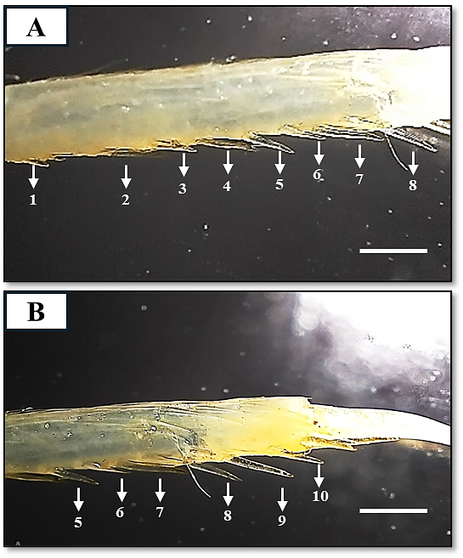
Figure 4. Merus of third pereopod (A) showing 1 to 8 spines and (B) showing 5 to 10 spines

5. REMARKS
Alpheus bisincisus and Alpheus chiragricus share a close phylogenetic relationship, as noted by Banner and Banner (1982). Their claw morphology and colour patterns closely resemble those of A. chiragrius, with nearly identical features, except for a subtle difference a u-shaped modification in the major claw. Notably, both the superior and inferior regions of the major claw exhibit a transverse groove contributing to the striking similarity in these closely related species.
Another significant deviation lies in the flattened rostrum of Alpheus bisincisus, which extends over the grooves, presenting a distinct feature not observed in A. chiragricus. Unlike the latter, where the rostrum may not exhibit the same flattened overhanging structure, the pronounced morphology of A. bisincisus involves a rostrum that is distinctly flattened and extends beyond the grooves. This specific characteristic adds to the suite of distinguishing features between these closely related species, providing valuable insights into their morphological diversity.
ETHICAL APPROVAL
Ethical approval was not required for this study
REFERENCES
Anderson, L.C. (2010). Predictive habitat model for the snapping shrimp genus Alpheus in the coastal southeastern United States. Master Thesis, University of Southern Mississippi, United States. University Press 391pp.
Anker, A., S.T. Ahyong, P.Y. Noel & A.R. Palmer. (2006). Morphological phylogeny of alpheid shrimps: parallel preadaptation & the origin of a key morphological innovation, the snapping claw. Evolution 60: 2507-2528.
Banner, A.H. & D.M. Banner. (1980). Some small collections of alpheid shrimp from the Indian Ocean, including two new species of the genus Synalpheus. Pacific Science 33: 25-35.
Banner, D.M. & A.H. Banner. (1982). The alpheid shrimp of Australia Part III: The remaining alpheids, principally the genus Alpheus, and the family Ogyrididae. Rec. Australian Mus. 34: 1-357.
Bruce, A.J. (1976). Shrimps and prawns of coral reefs, with special reference to commensalism. Biology and geology of coral reefs 3: 37-94.
Chace, F.A. (1988). The caridean shrimps (Crustacea: Decapoda) of the Albatross Philippine expedition, 1907-1910, part 5: family Alpheidae. Smiths. Contr. Zool. 466: vi+99.
Coutiere, H. (1905). Les Alpheidae. In: The fauna and geography of the Maldive and Laccadive Archipelagoes. Vol. 2 (ed. J.S. Gardiner), pp. 852-921. University Press, Cambridge, England.
Duffy, J.E., C.L. Morrison & R.N. Rios. (2000). Multiple origins of eusociality among sponge-dwelling shrimps (Synalpheus). Evolution 54: 503-516.
Dworschak, P.C., A. Anker and D. Abed-Navandi. (2000). A new genus and three new species of alpheids (Decapoda: Caridea) associated with thalassinids. Annalen des Naturhistorischen Museums in Wien. Serie B für Botanik und Zoologie, 301-320.
Jean, L., A. Lugo, L. Ramo, M.D. Rabia & S. Rabia. (2022). Salinity and temperature tolerance of snapping shrimps (Alpheus sp.). International Journal of Biosciences 20: 378-382.
Jha, P.N., P. Purushothaman, S. Chinnadurai, R.K. Renjith, M.P. Remesan, M.V. Baiju et al., (2019). Occurrence of Alpheus euphrosyne de Man, 1897 (Crustacea: Decapoda: Alpheidae) from the south-eastern Arabian Sea, India. Indian Journal of Geo Marine Science 48: 1695-1698
Karplus, I. (1987). The association between gobiid fishes and burrowing alpheid shrimps. Oceanography and Marine Biology 25: 507-562.
Pérez-Botello, A.M., M. Mascaró & N. Simões. (2021). The importance of home cleaning: sediment transport by alpheid shrimps provides a competitive advantage to their host anemones. Frontiers in Marine Science 8: 677024.
Radhakrishnan, E.V., V.D. Deshmukh, G. Maheswarudu, J. Josileen, A.P. Dineshbabu, K.K. Philipose et al., (2012). Prawn fauna (Crustacea: Decapoda) of India—an annotated checklist of the Penaeoid, Sergestoid, Stenopodid and Caridean prawns. Journal of the Marine Biological Association of India 54: 50-72.
Ramachandran, S., S.P. Varghese, N. Unnikrishnan, D.K. Gulati, A.E. Ayoob and L. Ramalingam. (2019). New record of Alpheus bisincisus De Haan, 1844 (Caridea: Alpheidae) from the west coast of India. Journal of the Marine Biological Association of India 61: 95-99.
Thomas, M.M. (1976). New records of four alpheid shrimps from Indian waters. Journal of the Marine Biological Association of India 18: 667-669.
Versluis, M., B. Schmitz, A. Von der Heydt & D. Lohse. (2000). How snapping shrimp snap: through cavitating bubbles. Science 289: 2114-2117.
Wicksten, M.K. & M.R. McClure. (1997). Morphological variation of species of the edwardsii group of Alpheus in the northern Gulf of Mexico and northwestern Atlantic (Decapoda: Caridea: Alpheidae). Journal of Crustacean Biology 17: 480-487.
Yang, H.J., H.S. Ko & W. Kim. (2007). Redescription of Alpheus bisincisus De Haan (Decapoda: Alpheidae) from Korea. Fisheries and Aquatic Sciences 10: 37-42.

