Pathological and Immunophenotypic Assessment of Canine Splenic Lymphoma in Biopsy and Necropsy cases

Abstract

Aim: This study aimed to characterize canine splenic lymphoma through a comprehensive evaluation of gross, cytological, histopathological, and immunophenotypic features in both biopsy and necropsy specimens, and to distinguish primary splenic lymphomas from splenic involvement in multicentric disease.
Study Design: An observational, descriptive investigation was undertaken on confirmed cases of canine splenic lymphoma submitted for routine diagnostic evaluation.
Place and Duration of Study: The study was conducted in the Department of Veterinary Pathology, Madras Veterinary College, Chennai - 07, for one year (June 2011 to June 2012].
Methodology:
Eight canine cases were diagnosed as splenic lymphoma, comprising six multicentric diffuse large B-cell lymphomas (DLBCL) and two primary splenic B-cell lymphoblastic lymphomas (B-LBL). Specimens were obtained from surgically excised splenic biopsies and post-mortem examinations. Grossly, all spleens exhibited marked splenomegaly, with weights ranging from 120 to 560 g. Patient data revealed a mean age of 8.56 years, with no sex predilection and representation from multiple breeds. Cytological and histopathological classification was performed according to the updated Kiel and World Health Organization (WHO) criteria. Immunohistochemical analysis employed a Pan T-cell marker (CD3) and a B-cell marker (CD79a) to determine lineage.
Results:
All cases demonstrated a CD3-negative/CD79a-positive immunophenotype, consistent with high-grade B-cell lymphoma. Six cases represented splenic involvement in multicentric lymphoma, whereas two were classified as primary splenic lymphomas. Histomorphological features corresponded to their cytological classification, and gross lesions were characterized by diffuse enlargement and loss of normal splenic architecture.
Conclusion:
The integration of gross pathology, cytology, histopathology, and immunohistochemistry enables accurate subtyping of canine splenic lymphoma, with CD3 and CD79a serving as reliable markers for lineage determination. In this series, high-grade B-cell lymphoma was the predominant subtype, underscoring its clinical relevance and the value of immunophenotyping in routine diagnostic practice.

Keywords: Canine splenic lymphoma, DLBCL, B-cell lymphoblastic lymphoma, Cytology, Histopathology, Immunophenotyping

1.Introduction
Lymphoma constitutes third most common malignant neoplasm accounts for approximately 7-24% of all canine neoplasms and 83% of all canine hematopoietic malignancies (Vail and Young, 2007). Multicentric form is the most common presentation which involves all the peripheral lymphnode and internal organs spleen, liver, bonemarrow and extranodal sites (Vail et al., 2013). In USA, the incidence was about 107 cases per 100,000 (Chiu and Hou, 2015) and in UK, it was about 63 cases per 100,000 dogs (Pittaway et al., 2019). The etiology of canine lymphoma (cL) is multifactorial and environmental factors play a pivotal role (Valli et al., 2013). Canine lymphoma can affect any breed with no gender predilection and at any age group, but more predominantly affects middle to aged dogs with mean age .vary from 6.3 to 7.7 years (Zandvliet, 2016).
The cytological and histological aspects of canie splenic diseases were correlated by Christensen et al. (2009), who discovered intermediate to large cell lymphoma in the affected spleen. According to the updated Kiel classification, the six subtypes like diffuse large B cell lymphoma, marginal zone lymphoma, peripheral T cell lymphoma not otherwise specified, nodal T zone lymphoma, T lymphoblastic lymphoma and follicular lymphoma were the common entities (Valli et al., 2011). The histologic appearance of splenic marginal zone and mantle zone lymphoma is irregular and coalescing follicular structures with loss of T cells between merging follicles (Sabattini et al. 2018). Fracácio et al. (2018) annotated the histopathological and immunophenotypical study of the canine splenic lymphoma and performed IHC by using the CD3 antibody for T-cell and CD79a for B-cell identification.

2. Methodology
Cases included in this study consisted of six splenic tissues from the necropsy examination of dogs with multicentric lymphoma and two surgically splenectomised tissues suspected for splenic neoplasm. The impression smears from the necropsied and excised spleen tissues for cytological study and stained with Leishman stain. The tissues were then fixed in 10% neutral buffered formalin and routinely processed and sectioned at 4 µm and stained with haematoxylin-eosin stain. Immunophenotyping in all cases were labeled with CD3 (Epsilon, Ref.No:AM477-5M, Rabbit polyclonal antibody) and CD79a (Clone 11E3, Ref.No. AM 414-5M, Mouse monoclonal antibody) for T-cell and B-cell at a dilution of 1:100, then processed with the superenhancer and immunoreactions chromogen kit (Biogenex Laboratories, USA). The IHC slides were counter stained with Mayer’s haematoxylin and examined for immunostaining of the sections.

3. Results and discussion
The clinical presentation of the multicentric lymphoma cases were non-specific and vague such as dullness, anorexia and generalized peripheral lymphadenopathy and in the splenectomised cases anorexia, abdominal enlargement with palpable mass in physical examination and hyperechoic mass in ultrasound imaging (Sabattini et al., 2018). The demographic details like age, sex and breed, classification and immunophenotype subtypes are given in the Table 1.

Table. 1: Demographic information of lymphoma-affected dogs, their classification and immunophenotype characterization
S.No | Breeds | Age | Sex | Classification | Sample obtained | Immunophenotype subtypes  (CD3-/CD 79a+)
1 | Non- Descript | 7 | Female | Multicentric lymphoma | Necropsy | B- cell
2 | Labrador Retriever | 7 | Male | Multicentric lymphoma | Necropsy | B- cell
3 | Non- Descript | 12 | Female | Multicentric lymphoma | Necropsy | B- cell
4 | Labrador Retriever | 3.5 | Male | Multicentric lymphoma | Necropsy | B- cell
5 | German Shepherd | 10 | Male | Multicentric lymphoma | Necropsy | B- cell
6 | Boxer | 7 | Male | Multicentric lymphoma | Necropsy | B- cell
7 | Spitz | 11 | Female | Extranodal form | Splenectomy | B- cell
8 | Dachshund | 11 | Female | Extranodal form | Splenectomy | B- cell

The age recorded in our study ranges from 3.5 to 12 years with mean of 8.2 years and found equal distribution of sex. Kimura et al. (2011) reported that the incidence of canine lymphoma was higher between 5 and 9 years (45%), followed by 10 to 13 years (34%); 17 per cent had an age below 4 years and 5 per cent had an age above 13 years. The mean age was 8.7 years with a range of 5 months to 15 years. The two each case observed in Non-descript and Labrador retriever scored, followed by one each in German shepherd, Boxer, Spitz and Dachshund (Wilkerson et al., 2005). Comazzi et al. (2018) observed in their studies that the breeds like Labrador retriever, boxer, German shepherd and Rottweiler were overrepresented The breed prevalence will vary depends on the different geographical area and its local canine population.
Among the eight cases, six were multicentric lymphomas from the necropsy and two were primary splenic lymphoblastic lymphoma obtained from splenectomy. The weight of the spleen ranges from 120g to 560g, Mallinckrodt and Gottfried (2011) reported that dog’s normal spleen weight is about 0.2% to 0.7% of the body weight. He further suggested that the splenic weight as a percentage of body weight might be useful in differentiating between malignant and benign lesions in dogs with splenic masses. Grossly, in multicentric lymphoma, all the lymph nodes were enlarged which was very prominent in a seven-year-old male Labrador (Fig.1). Cut section of enlarged lymph nodes were grey-white (Fig.2). The spleen was mild to moderately enlarged and diffuse in nature, pale red (Fig.3) to grey brown. Cut section of spleen showed multifocal pale white, mild to prominent raised foci about 0.2 to 0.4mm (Fig.4).
Fry and McGavin (2012) reported that in all canine lymphomas, multicentric lymphomas were 80-85 per cent and the majority of these were intermediate to high grade tumours (80%). Necropsy findings included enlarged lymph nodes that bulged and on gray white cut section. Splenic and hepatic involvement was common and infiltration of tumour cells could result in diffuse enlargement or nodule formation. Lymphoma is the third most commonly occurring splenic neoplasm reported by da Silva et al. (2016) and Figueiredo et al. (2019) followed by haemangiosarcoma and haemangioma.

Christopher et al. (2012) and Cardona et al. (2020) reported the normal splenic aspirate cytology which was highly cellular with a mild increase in the number of medium and large lymphocytes and plasma cells. Cytologically, all six cases showed large round monomorphic population of lymphoid neoplastic cell (Fig.5). The cells contained uniformly round nucleus, multiple prominent nucleoli with thin rim of basophilic cytoplasm and numerous mitotic figures (Cienava et al., 2004 and Cardona et al., 2020). Fry et al. (2003) observed the same histopathological changes as like our study, splenic capsule was irregularly thinned out due to compression of neoplastic cells and was characterised by presence of large multiple nodules of lymphoid proliferation (Fig.6). The follicular patterns were extensive and bigger than germinal centre. Lymphoid depletion around PALS and infiltration of neoplastic cells in the red and white pulp giving ‘starry sky pattern’ (Fig.7) with disruption of follicular structure, occasional necrosis of germinal centre, multifocal haemosiderin deposits and presence of numerous mitotic figures suggestive of diffuse large B cell lymphoma. DLBCL was recorded upto 5% in splenic parenchyma among the high frequency of about total 40% incidence (Valli et al., 2011 and Martini et al., 2021).

Two cases of primary splenic B-lymphoblastic lymphoma (B-LBL) obtained from the splenectomy, One in an 11-year-old female Spitz and its gross morphology showed a large red brown subcapsular nodule measuring 4.14 x 4.58 x 5.37 cm (Fig.9) on the body of the spleen. Cut section was grey white distinct interspersed with dark red irregular haemorrhagic areas (Fig.9 Inset). The other in Dachshund breed specimen revealed diffuse splenomegaly (Holm et al., 2018). Cytology of these two cases revealed more number of blast cells (Fig.10) with large amount of basophilic cytoplasm and prominent nuclei were noticed. Large binucleated cells and a few mitotic figures (Fig.10 Inset) were present (Sapierzyński et al., 2010). Histopathologically, the capsule was irregularly thickened, with heavily infiltrated neoplastic lymphoid cells (Fig.11). The white and red pulps were completely substituted by B-LBL neoplastic cells (Holm et al., 2018). Cells showed anisokaryosis, prominent nuclei, chromatin margination. Neoplastic cell showing nuclear indentation with large single prominent nucleolus were also found. In addition, areas of infarct, lacy fibrin, neutrophilic infiltration were observed. Megakaryocytes with multilobulated nucleus were present in the midst of neoplastic cells. Valli, 2006 and Martini et al. (2021) described B-lymphoblastic lymphoma affects spleen in a focal or multifocal manner that resulted in a symmetrical splenomegaly and irregular masses which distended the capsule. Histopathologically, the neoplastic proliferation started from PALS with large round cells with large prominent nucleoi and the underlying lymphoid tissue was pale or dark and haemorrhagic.

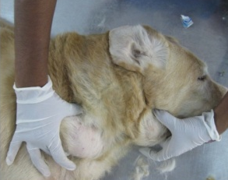 | 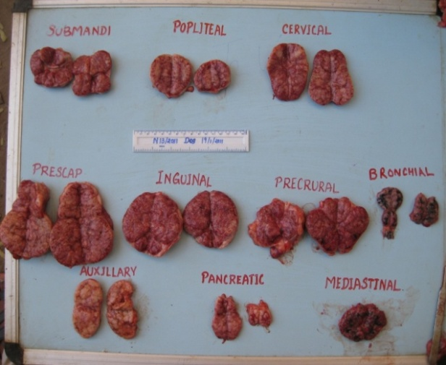
Fig.1: Dog - Multicentric lymphoma - Sub mandibular and prescapular lymphnode enlargement | Fig.2: Multicentric lymphoma - Cut Section – affected lymphnodes – grey white to pale dirty pink
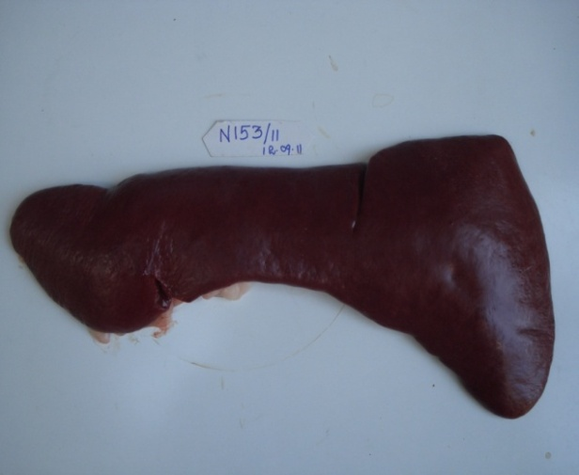 | 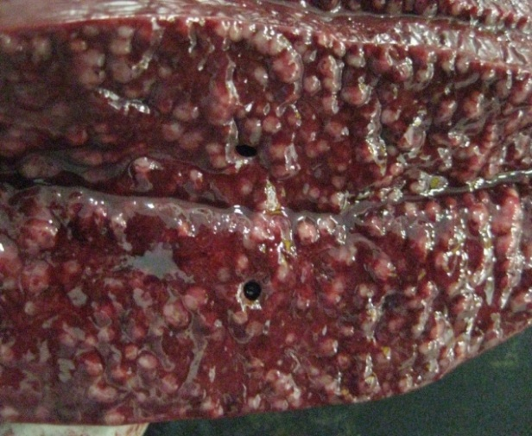
Fig.3: Multicentric lymphoma – Diffuse splenomegaly | Fig.4: Multicentric lymphoma – Spleen – Cut section - prominent multifocal pale white raised foci
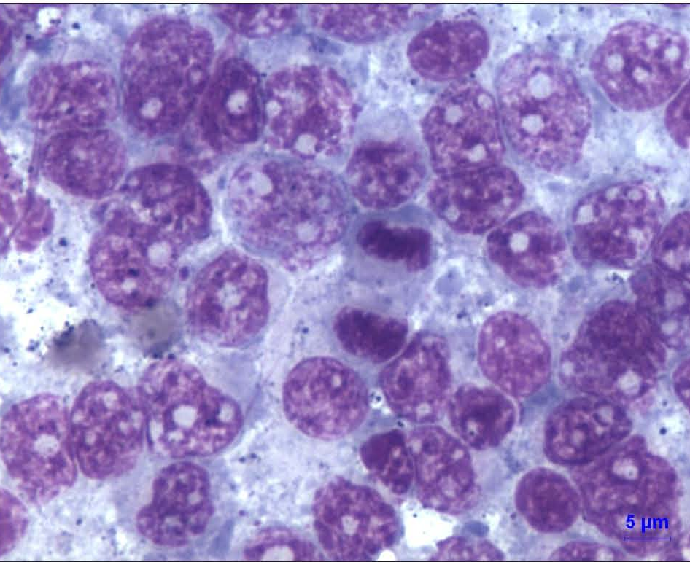 | 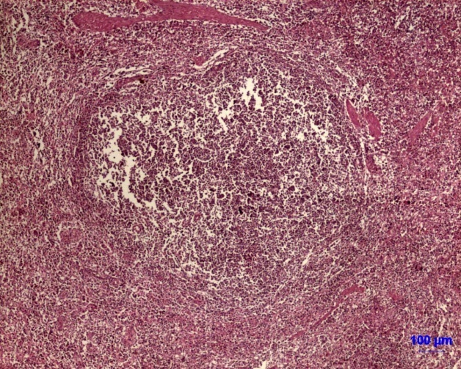
Fig.5: DLBCL – Cytology - Monomorphic large round cell, round nuclei with, multiple prominent nucleoli and thin rim of basophilic cytoplasm. Mitotic figure at the centre, LG bar, 5 µm | Fig.6: DLBCL - Large nodules of lymphoid proliferation with lymphoid depletion in white pulp, H&E bar = 100 µm
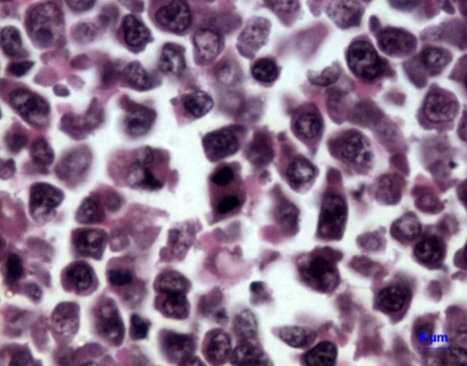 | 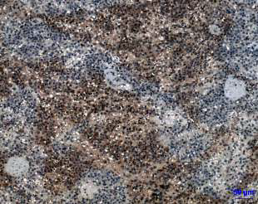
Fig.7: DLBCL – Large neoplastic cells with multiple mitotic figure, H& E = 5µm | Fig.8: DLBCL – IHC: CD79a (DAB Brown) - Positive signals in cytoplasm of neoplastic cells near PALS, 50 µm
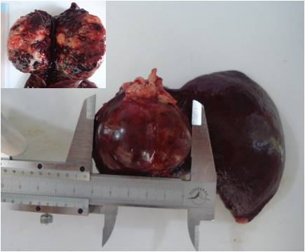 | 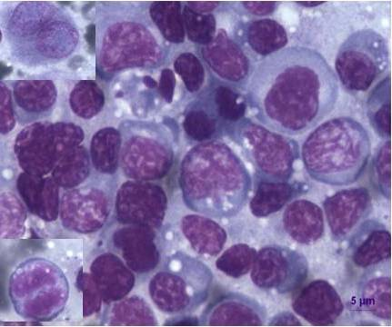
Fig.9: B-Lymphoblastic Lymphoma – Red mixed white, firm, big solitary nodule. Inset: Cut section- grey white interspersed with dark red areas | Fig.10: B-LBL – Cytology- Large blast cells with marked basophilic cytoplasm, Inset Top: Binucleated cell, Bottom: Mitotic figure, LG bar,  5 µm
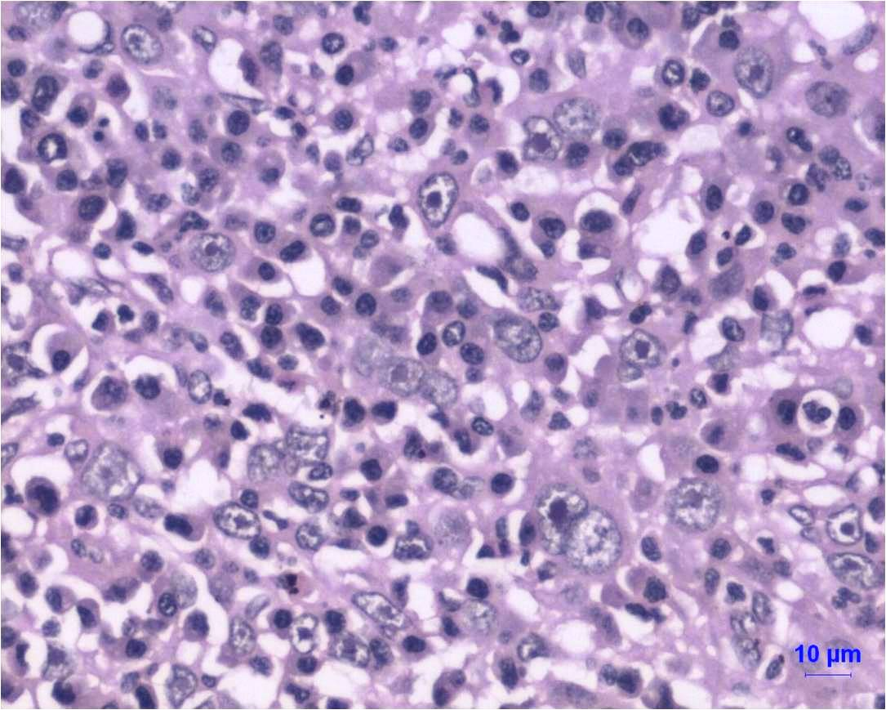 | 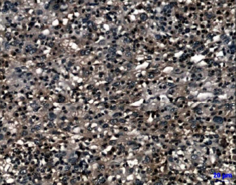
Fig.11: B-LBL – Neoplastic cells showing nuclear indentation with large single prominent nucleoli, H& E = 10 µm | Fig.12: B-LBL - IHC – CD79a+ (DAB Brown) – Positive signals in cytoplasm of lymphoblasts, 10 µm

Immunohistochemistry was performed in all the eight spleen tissues. In our study, all the splenic tissues showed high immunostaining with CD79a+/ CD3- antibodies in the cell cytoplasm (Fig.8, DLBCL and Fig.12, B-LBL), suggested that neoplastic lymphoid cells are of B-cell origin. Stein et al. (2019) evaluated the expression of series of antibodies and found strong immunoreactivity with CD20 and PAX 5 in eight splenic follicular derived B-cell lymphoma. Ponce et al. (2010) and Fracácio et al. (2018) assessed the histopathogical and immununophenotyping in canine splenic lymphoma the most prevalent histological type was marginal zone B-cell lymphoma (60.7%) followed by diffuse large B-cell lymphoma (12.1%) and lymphoblastic T-cell lymphoma (12.1%). This study was in concordance with our findings except the T-cell lymphoma. Due to the non-availability of different panel of leucocyte antibodies like CD4, CD5, CD8, CD4, CD20, CD21, PAX 5 and flow cytometry in our study much detailed subtyping and lineage assessment was not done during the study period.
4. Conclusion
Most of the authors reported and reviewed the high prevalence of high grade B cell lymphoma. The fundamental aid in diagnosing lymphoma is cytopathology, thus it can be used as initial screening test. Then the histopathological criteria can be used to predict the grade as high or low and further to assess the immunophenotypic characterization, other ancillary test like immunocytochemistry or immunohistochemistry can be employed. Flow cytometry helps to check the involvement of lymphoid lineage. The Polymerase chain reaction antigen receptor reaarangement (PARR) can support in clonality assessment and early diagnosis. The IHC and FC correlation gives significant sensitivity and specificity in predicting the prognosis and the overall survival time of the dogs. Canine lymphoma is treatable neoplasm with single agent or multiple agent chemotherapy; thus, the early diagnosis ensures the longer survivability with appropriate therapy.

References
- Cardona, J. C., Johnsrude, J. D., McManus, P. M and MacWilliams, P. S. (2020). The Spleen. In, Cowell and Tyler's Diagnostic Cytology and Hematology of the Dog and Cat. Mosby. (5th Edn), Elsevier Health Sciences
- Cienava, E. A., Barnhart, K. F., Brown, R., Mansell, J., Dunstan, R., & Credille, K. (2004). Morphologic, immunohistochemical, and molecular characterization of hepatosplenic T‐cell lymphoma in a dog. Veterinary clinical pathology, 33(2), 105-110.
- Chiu, B. C. H., & Hou, N. (2015). Epidemiology and etiology of non-hodgkin lymphoma. Non-Hodgkin lymphoma: pathology, imaging, and current therapy, 1-25.
- Christensen, N. I., Canfield, P. J., Martin, P. A., Krockenberger, M. B., Spielman, D. S., & Bosward, K. L. (2009). Cytopathological and histopathological diagnosis of canine splenic disorders. Australian veterinary journal, 87(5), 175-181.
- Christopher, M. M. (2003). Cytology of the spleen. Veterinary Clinics: Small Animal Practice, 33(1), 135-152.
- Comazzi, S., Marelli, S., Cozzi, M., Rizzi, R., Finotello, R., Henriques, J., ... & Teske, E. (2018). Breed-associated risks for developing canine lymphoma differ among countries: an European canine lymphoma network study. BMC veterinary research, 14(1), 232.
- Figueiredo, R. S., Muramoto, C., Fontes, T. N., Meneses, I. D., Cardoso, P. G., Vieira Filho, C. H., ... & Peixoto, T. C. (2019). Lesions in 224 spleens of splenectomized dogs and evalution of alternative techniques for previous microscopic diagnosis. Pesquisa Veterinária Brasileira, 39(08), 622-629.
- Fracácio, C. P., Sueiro, F. A., Anai, L. A., Pucci, M. B., Senhorello, I. L., Barata, J. S., & Jark, P. C. (2018). Histopathological and immunophenotypical assessment of canine primary splenic lymphoma according to the World Health Organization. Pesquisa Veterinária Brasileira, 38, 2129-2132.
- Fry, M. M., Vernau, W., Pesavento, P. A., Brömel, C., & Moore, P. F. (2003). Hepatosplenic lymphoma in a dog. Veterinary pathology, 40(5), 556-562.
- Fry, M. M., & McGavin, M. D. (2012). System lymphatic, bone marrow, blood cells, and the lymphatic system. Pathologic Basis of Veterinary Disease. 5th ed. Elsevier, St Louis, 734-770.
- Holm, F., Hardon, T., Clasen‐Linde, E., Mikkelsen, L. H., & Heegaard, S. (2018). B‐cell lymphoblastic lymphoma of the nictitating membrane as the first presenting sign in a 2‐year‐old Springer Spaniel. Clinical Case Reports, 6(11), 2246.
- Kimura, K. C., Zanini, D. A., Nishiya, A. T., Dias, R. A., & Dagli, M. L. (2011). Morphology and immunophenotypes of canine lymphomas: a survey from the service of animal pathology, School of Veterinary Medicine and Animal Science, University of São Paulo, Brazil. Brazilian Journal of Veterinary Pathology, 4(3), 199-206.
- Martini, V., Marano, G., Aresu, L., Bonfanti, U., Boracchi, P., Caniatti, M., ... & Comazzi, S. (2022). Performance of lymph node cytopathology in diagnosis and characterization of lymphoma in dogs. Journal of veterinary internal medicine, 36(1), 204-214.
- Pittaway, C., Schofield, I., Dobson, J., O'Neill, D. G., & Brodbelt, D. C. (2019). Incidence and risk factors for the diagnosis of lymphoma in dogs in UK primary‐care practice. Journal of Small Animal Practice, 60(10), 581-588.
- Ponce, F., Marchal, T., Magnol, J. P., Turinelli, V., Ledieu, D., Bonnefont, C., ... & Fournel-Fleury, C. (2010). A morphological study of 608 cases of canine malignant lymphoma in France with a focus on comparative similarities between canine and human lymphoma morphology. Veterinary pathology, 47(3), 414-433.
- Sabattini, S., Lopparelli, R. M., Rigillo, A., Giantin, M., Renzi, A., Matteo, C., ... & Bettini, G. (2018). Canine splenic nodular lymphoid lesions: immunophenotyping, proliferative activity, and clonality assessment. Veterinary pathology, 55(5), 645-653.
- da Silva, E. O., Di Santis, G. W., Headley, S. A., & Bracarence, A. P. F. R. L. (2016). Splenic lesions observed in 71 splenectomized dogs: a retrospective study. Semina: Ciências Agrárias, 37(5), 3181-3188.
- Stein, L., Bacmeister, C., Ylaya, K., Fetsch, P., Wang, Z., Hewitt, S. M., & Kiupel, M. (2019).Immunophenotypic characterization of canine splenic follicular-derived B-cell lymphoma. Veterinary pathology, 56(3), 350-357.
- Vail, D. M, and Young, K. M. (2007). Hematopoietic tumours, In: Withrow S.J. & Vail D.M. (Eds), Small Animal Clinical Oncology. 4th edn. Saunders Elsevier, Saint Louis. pp.699-733.
- Vail, D. M, Pinkerton, M.E and Young, K. M. (2013). Withrow and MacEwen’s Small Animal Clinical Oncology. 5th Edn. W.B. Saunders, Missouri. Pp. 768.
- Valli, V. E., Vernau, W., de Lorimier, L. P., Graham, P. S., & Moore, P. F. (2006). Canine indolent nodular lymphoma. Veterinary Pathology, 43(3), 241-256.
- Valli, V. E., Myint, M. S., Barthel, A., Bienzle, D., Caswell, J., Colbatzky, F., ... & Vernau, W. (2011). Classification of canine malignant lymphomas according to the World Health Organization criteria. Veterinary pathology, 48(1), 198-211.
- Valli V E, Kass P H, Myint M S and Scott F. (2013). Canine Lymphomas. Association of classification type, disease stage, tumor subtype, mitotic rate, and treatment with survival. Veterinary Pathology 50(5): 738–748.
- Wilkerson, M. J., Dolce, K., Koopman, T., Shuman, W., Chun, R., Garrett, L., ... & Avery, A. (2005). Lineage differentiation of canine lymphoma/leukemias and aberrant expression of CD molecules. Veterinary immunology and immunopathology, 106(3-4), 179-196.
- Zandvliet, M. (2016). Canine lymphoma: a review. Veterinary Quarterly, 36(2), 76-104.

