Influence of temperature and humidity stress on growth and development of various breeds of Bombyx mori L.

Abstract:
Heat stress is a significant environmental factor that affects the growth and productivity of Bombyx mori, a key species in sericulture. This study identifies the thermotolerant silkworm breeds. Also, the study evaluated the impact of elevated temperature on fecundity, survival rate, cocoon weight, shell ratio, and filament length across bivoltine silkworm breeds under controlled and high-temperature (HT) conditions. Results show the significant inter-breed variation in thermal response. While breeds like APDR105, APS45, and AC9 maintained better performance under HT stress, APS9 showed severe sensitivity, with reduced survival and complete cocoon failure. Statistical analysis confirmed significant differences, as indicated by high F values and low CD at the 1% level, across most traits, particularly in filament length and cocoon weight. The coefficient of variation (CV%) increased under HT, indicating greater phenotypic variability among breeds under stress. These results suggest that certain silkworm breeds possess internal thermotolerant capacities, making them ideal for breeding programs aimed at improving climate resistance. This study offers critical insights for sustainable sericulture in high-temperature regions.
Keywords: Bombyx mori, thermal stress, fecundity, survival rate, cocoon weight, filament length
Introduction:
Lepidoptera experienced significant evolution throughout the Palaeozoic era, spanning 200 million years, with extensive radiations unparalleled by any other living form. These are highly successful organisms that serve an important purpose as pollinators, biological controllers, recyclers, and components of the food chain within the environment (Grimaldi and Engel, 2005). Various insect species are used as food in many South Asian nations. Many lepidopteran orders possess the ability to produce specialised products that are highly beneficial to human life. It includes silk, honey, wax, pheromones, shellac, and cochineal colour. Among these products, silk is a premium material that cannot be artificially replicated; therefore, it maintains our dependence on silkworms. Lepidoptera serve as significant model systems for studying aspects of genetics, physiology, development, ecology, and evolutionary biology (Mitter et al., 2017). All silk-producing lepidopterans are limited to the families Saturniidae and Bombycidae. All wild silkworms have been placed within the family Saturniidae, whereas the mulberry silkworm, Bombyx mori L., belongs inside the family Bombycidae (Schmidt et al., 2023). The domestic silkmoth, Bombyx mori, is an ideal animal for genetic research, including scientific studies, sericulture, and biotechnology. It is the insect that is fully domesticated, relying totally on humans for both survival and reproduction (Goldsmith et al., 2005). Bombyx mori has been used for silk production for almost 5,000 years. As an entirely domesticated insect, its existence and reproduction are reliant upon humans (The International Silkworm Genome Consortium, 2008).
In evolutionary studies, during the Palaeozoic Era, especially in the Devonian to Carboniferous periods, approximately 300 million years ago, insect species emerged. Approximately 200 million years ago, during the Permian period, Lepidopterans evolved, alongside the emergence of the wild silkworm Bombyx mori, not Bombyx mandarina. Domestication of silkworms commenced in approximately 4000 BC in China, coinciding with the evolution of Bombyx mori and other silkworm species (Banno et al., 2010).
Sericulture involves raising silkworms for the production of silk. Many types of silkworms exist, but Bombyx mori (the larva of the domesticated moth) is the most commonly used and studied. Silkworm larvae eat mulberry leaves, and when they reach the fourth instar stage, they climb a nearby mulberry branch to spin their silk cocoons. Silk is a continuous fibre made of fibroin protein, which is released by salivary glands. A specific protein, sericin, holds the fibroin filament together. Silkworm larvae are highly susceptible to environmental factors, particularly temperature fluctuations. The life cycle of the silkworm is significantly affected by changes in temperature, and even voltinism (the number of generations per year) can be altered by a one-degree increase in temperature. Temperature also plays a significant role in cocoon quality and silk yield during larval spinning. In tropical regions, high temperatures are a key factor that disrupts and influences the silkworms' lifecycle. Sericulturists in tropical countries, such as India, mainly rely on climate conditions to determine their silk output.
Material and Methods
Breed selection and thermal challenging experimentation
Breed selection and thermal challenge experiments, based on silk production traits, involved 14 top-performing bivoltine breeds (APS12, APS50, APS8, APJ1, AP72, APS45, APS27, AC9, APDR105, AP71, APS9, HTO5, HTO2, HT) chosen from the germplasm available at Andhra Pradesh State Silk Research and Development Institute (APSSRDI), Hindupuram, Andhra Pradesh, India. An initial screening was conducted by rearing the breeds at high temperature (34°C ± 1°C) and low humidity conditions (50% ± 5% RH), following the Standard Rearing Procedure (Datta et al., 2002). All breeds were reared for nine generations in two groups: one maintained as a control, reared at 26°C and 85% relative humidity, and the other subjected to the thermal challenge. During this screening, only eight breeds (APS50, APS45, APS27, AC9, APDR105, APS9, HTO2, HTP5) showed better performance.
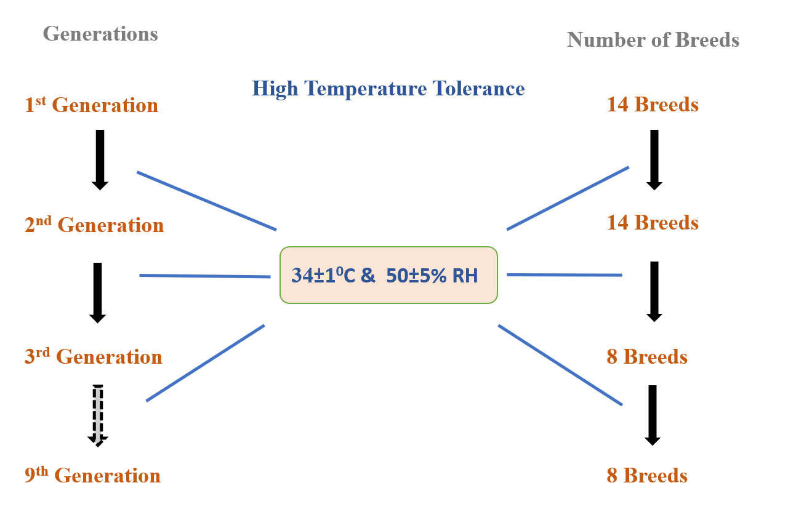
Image 1. Heat and humidity stress treatment for silkworm strains
These breeds were evaluated for thermal tolerance for all life stages. An experimental set up having an arrangement to increase temperature from with an incremental interval of 0.5 degree Celsius for every six hour and stabilize at 34 degrees Celsius for six hours followed by lowering temperature in a decreasing interval of 0.5 degree Celsius per hour till reaching room temperature. The experimental temperature cycling is presented in Graph 1.
Each treatment group consisted of five replications with 100 larvae per replication. The experimental setup was designed to record key quantitative traits, including fecundity, survival rate, cocoon weight, shell ratio, and filament length. In the rearing conditions hygiene were maintained uniformly throughout the rearing period.
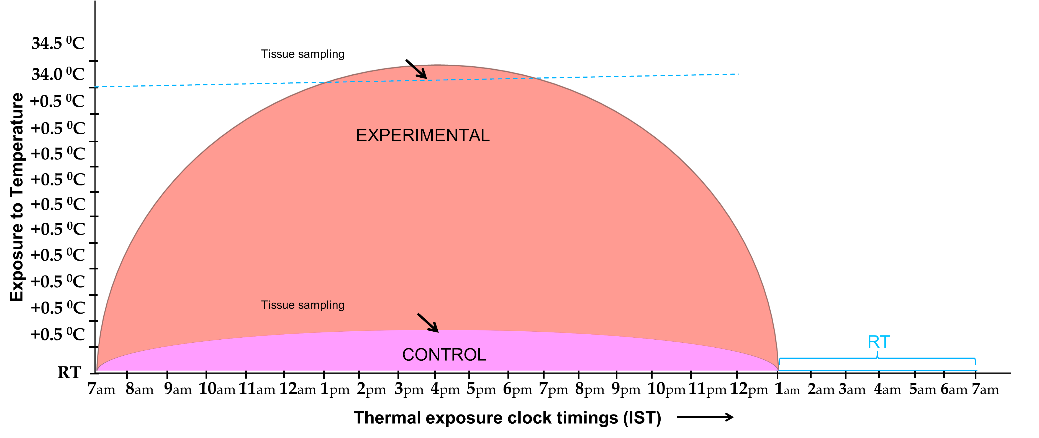
Graph 1 Experimental design for thermal treatment to a rearing population
Trait Evaluation
Fecundity
Fecundity defines the reproductive capacity of female silkworm moths, evaluated by the total number of eggs discharged by each female. After the emergence of the moths from their cocoons, male and female moths were permitted to copulate. During mating, each female moth was individually positioned on an oviposition card within an appropriate chamber, and the quantity of eggs deposited was recorded. The count was averaged across all females from each replication. This measure serves as a vital indicator of the breed's reproductive viability under both stress and controlled situations (Eltayb, M. and Magid, T., 2013).
Survival Rate
Survival rate is the percentage of larvae that successfully develop into the spinning stage and form cocoons out of the total number of hatched larvae. It was calculated by tracking the number of larvae that reached the cocoon formation stage in each replicate and dividing it by the total number of larvae initially reared. This parameter provides insights into breed robustness, tolerance to environmental conditions, and disease resistance (Tassoni et al., 2024).
$$Survival Rate (\%)=\frac{Total number of larvae reared}{Number of larvae forming cocoons​}×100$$
Cocoon Weight
Cocoon weight refers to the gross weight of the cocoon, including both the shell and the pupa inside (Jyothi et al., 2010). For each replicate, ten healthy and well-formed cocoons were randomly selected, and their individual weights were recorded using a digital balance. The average cocoon weight was then calculated for each breed. This parameter reflects the productivity potential of a breed in terms of silk output and biomass accumulation under both normal and high-temperature conditions.
Shell Ratio
The shell ratio is the weight of the silk shell divided by the weight of the whole cocoon, shown as a percentage. It is an important economic feature that shows how much silk that a cocoon can make (Chanda et al., 2013). After carefully taking out the pupa and drying the shell, the weight of the shell was calculated using the following formula:
$$Shell Ratio \%=\frac{Shell Weight}{Cocoon Weight}×100$$
A higher shell ratio signifies greater silk content and is preferred in commercial silk production.
Filament Length
Filament length describes the total length of silk thread reeled from a single cocoon. For each breed, control and treatment, ten randomly selected cocoons were boiled and reeled using a conventional multi-end reeling machine. The silk filament was reeled until it broke, and its length was measured using a meter counter. The average of these readings was recorded as the filament length per cocoon for each replicate. Filament length is a direct indicator of the reelability and quality of silk produced and is crucial for assessing the commercial potential of silkworm breeds (Kumar et al., 2025).

Result
Comparative Rearing Performance of Silkworm Breeds under High Temperature and Control Conditions
Breeds | Fecundity (No.) |  | Survival rate (%) |  | Cocoon Wt. (g) |  | Shell Ratio (%) |  | Filament length (m)
Breeds | HT | Control | HT | Control | HT | Control | HT | Control | HT | Control
APS50 | 462 | 510 | 81.0 | 92.7 | 1.54 | 1.66 | 20.48 | 21.41 | 704.00 | 750.00
APS45 | 437 | 515 | 85.0 | 91.8 | 1.44 | 1.56 | 20.25 | 21.34 | 835.00 | 841.00
APS27 | 476 | 513 | 83.0 | 92.0 | 1.39 | 1.47 | 19.72 | 21.28 | 888.00 | 828.00
AC9 | 470 | 564 | 75.0 | 91.0 | 1.49 | 1.59 | 20.00 | 21.10 | 830.00 | 974.00
APDR105 | 467 | 550 | 86.0 | 91.4 | 1.43 | 1.54 | 20.10 | 21.00 | 942.00 | 957.00
APS9 | 400 | 524 | 47.0 | 85.8 | 0.00 | 1.52 | 0.00 | 19.20 | 00.00 | 00.00
HTO2 | 518 | 513 | 81.0 | 89.0 | 1.37 | 1.54 | 19.90 | 20.80 | 810.00 | 908.00
HTP5 | 467 | 509 | 67.0 | 78.0 | 1.24 | 1.39 | 19.30 | 20.20 | 821.00 | 711.00
Average | 462 | 525 | 75.6 | 88.9 | 1.40 | 1.54 | 19.96 | 20.79 | 833.00 | 853.00
S.D | 12.53 | 9.65 | 1.78 | 1.64 | 0.06 | 0.03 | 0.18 | 0.131 | 49.80 | 72.40
CV% | 4.2 | 2.96 | 3.92 | 2.99 | 1.73 | 2.63 | 1.47 | 0.99 | 5.84 | 8.02
F value | 61.58 | 27.54 | 130.8 | 49.53 | 707.2 | 48.40 | 759.00 | 116.49 | 6.73 | 136.63
CD @ 1% | 24.68 | 19.01 | 3.505 | 3.22 | 0.029 | 0.05 | 0.36 | 0.257 | 84.67 | 23.60
Table 1 Comparative rearing performance of silkworm breeds at high temperature and control conditions (Mean of 5 replications)
We evaluated the rearing efficiency of eight bivoltine Bombyx mori breeds—APS50, APS45, APS27, AC9, APDR105, APS9, HTO2, and HTP5—under high temperature (HT) stress (35 ± 1°C) and control (25 ± 1°C) conditions. There were significant variations (p < 0.01) in all evaluated variables between breeds and between treatments.
1. Fecundity
The average fecundity decreased under high temperature conditions from 525 eggs (control) to 462 eggs. The highest fecundity under HT was recorded in HTO2 (518), while APS9 showed the lowest (400). All breeds exhibited reduced egg-laying under HT, indicating a stress-induced decline in reproductive efficiency.

Graph.2 Fecundity Number of various breeds of silkworm
2. Survival Rate
Survival rate was significantly affected by high temperature. The average survival dropped from 88.9% (control) to 75.6% (HT). APDR105 (86%) and APS45 (85%) recorded the highest survival under HT, while APS9 showed drastic reduction (47%), indicating poor thermal tolerance.

Graph 3 Survival rate of various breeds of silkworm
3. Cocoon Weight
The cocoon weight also declined under heat stress. The overall average dropped from 1.54 g (control) to 1.40 g (HT). APS50 (1.54 g) and AC9 (1.49 g) maintained relatively better cocoon weights under HT, whereas APS9 produced no cocoons at all, confirming its heat sensitivity.

Graph 4 Cocoon weight of various breeds of silkworm
4. Shell Ratio
The shell ratio was less affected, showing a minor reduction from 20.79% (control) to 19.96% (HT). APS50 (20.48%), APS45 (20.25%), and APDR105 (20.10%) maintained higher shell ratios under HT, reflecting good silk accumulation capacity despite thermal stress. APS9 produced no cocoons.

Graph 5 Shell Ratio of various breeds of silkworm
5. Filament Length
Filament length exhibited high variability under thermal stress. The average length reduced from 853.0 m to 833.0 m. APDR105 (942 m), APS27 (888 m), and AC9 (830 m) showed long filaments even under HT, suggesting stability in silk gland activity. APS9 failed to yield any filament under HT, absence of its performance.

Graph 6 Filament length of various breeds of silkworm
Statistical Significance
ANOVA results showed highly significant differences (p < 0.01) among treatments and breeds for all traits. The highest F value was observed for shell ratio (759.00), indicating large variability in this trait among breeds. The coefficient of variation was highest for filament length (8.02% under control), and the critical difference (CD at 1%) was particularly high for filament length under HT (84.67 m), indicating substantial differences in breed performance.
Discussion
The present study investigated the impact of elevated temperature on the economic and biological traits of eight Bombyx mori breeds, comparing their performance under normal and heat-stress conditions. The traits analysed included fecundity, survival rate, cocoon weight, shell ratio, and filament length. The statistical parameters such as standard deviation (S.D), coefficient of variation (CV%), F value, and critical difference (CD at 1%), further validated the variability and significance of the observed differences. Fecundity increased in all breeds under HT conditions, indicating a helpful physiological response to thermal stress. The highest increase was recorded in AC9 (from 470 to 564 eggs), while APS9, although improving from 400 to 524 eggs, showed relatively poor thermal changes in other traits. The F value for fecundity under HT (61.58) was statistically significant, and the CD at 1% (24.68) shows that these variations were not due to random chance. Survival rate showed a clear difference among breeds under thermal stress. While APDR105 (86.0%) and APS45 (85.0%) maintained a high survival rate, APS9 showed the lowest (47.0%), reflecting less heat tolerance. The average survival rate decreased from 88.9% to 75.6%, indicating that high-temperature stress had a substantial impact on larval viability. The F-value (130.8) and CD at 1% (3.505) indicate significant differences among the breeds. Cocoon weight and shell ratio were considerably affected by heat stress. APS9 completely failed to produce cocoons under HT, which suggests a highly physiological disruption. Among the successful breeds, APS50 and APDR105 showed marginal reductions, indicating their resilience. The cocoon weight dropped on average from 1.54 g to 1.40 g, while the shell ratio declined from 20.79% to 19.96%. The high F values (707.2 and 759.00) for these parameters highlight significant inter-breed variation under stress. The filament length reduction was observed in most breeds under HT. APS9, again, produced no filament under heat stress, whereas APDR105 maintained the most extended filament length (942 m), followed by AC9 and APS27. The average filament length decreased from 853 m to 833 m, and the high F value (136.63) and CD at 1% (23.60) confirmed the statistical significance of these differences. Among the breeds, APDR105, APS45, and AC9 show better thermotolerance, as evidenced by minimal losses across all parameters.
In contrast, APS9 performed poorly under stress, particularly in terms of survival rate, cocoon formation, and filament production. The higher values of standard deviation and CV% under HT treatment for traits such as filament length and fecundity indicate increased phenotypic variability under stress, suggesting that heat exposure amplifies genetic differences among breeds. This finding aligns with earlier studies by Ardehjani et al. (2023) that demonstrate the role of genetic background in thermotolerance in Bombyx mori.
Conclusion
The current study clearly states that increased temperature has a significant impact on the biological and economic traits of Bombyx mori across different breeds. At the same time, all breeds showed some level of stress response. APDR105, APS45, and AC9 exhibit comparatively better thermotolerance, as evidenced by maintaining higher survival rates, stable cocoon weights, and superior filament lengths under heat treatment. In contrast, APS9 exhibited drastic reductions in survival and failed to form cocoons under stress, indicating poor heat adaptability. The significant F values and low critical difference (CD @ 1%) across most traits confirm that the observed differences are statistically reliable. These findings highlight the importance of breed selection in sericulture under changing or adverse climate conditions. The study provides a baseline for identifying thermotolerant breeds for future breeding programs. Further, it supports the need for integrating physiological traits with molecular markers for sustainable silkworm cultivation in the face of rising global temperatures.

References
- Eltayb, M. and Magid, T. (2013). Relation Between Female Cocoons (pupae) Measurements and the Number of Eggs Laid (fecundity) by the Wild Silk Moth Epiphora bauhiniae (Gurinmeneville) Lepidopetera: Saturniidae. International Journal of Advance Industrial Engineering, 1(01).
- Tassoni, L., Belluco, S., Marzoli, F., Contiero, B., Cremasco, S., Saviane, A., S. Cappellozza and Dalle Zotte, A. (2024). Microbiological safety assessment of silkworm farms: a case study. animal, 18(8), 101221.
- Jyothi, P. N., Suneetha, Y., Nagalakshmamma, K., and Prasad, S. S. (2010). Studies on economic parameters of the cocoon the silkworm, Bombyx mori under the influence of ultrasound treatment., Journal of Experimental Zoology, India, 2010, Vol. 13, No. 2, 383-387 ref. 10
- Chanda, S., Saha, L. M., Das, N. K., Kar, N. B., and Bindroo, B. B. (2013). Correlation among shell percent, cocoon yield and reeling parameters of Multi X Bivoltine cocoons under different agro-climatic conditions of West Bengal, India. International Journal of Industrial Entomology and Biomaterials, 26(2), 74-80.
- Ardehjani, A. A., Moghaddam, S. H. H., Rabiei, B., Zarbafi, S. S., Mirhoseini, S. Z., and Nematollahian, S. (2023). The effect of temperature on combining ability and genetic parameters of parental silkworm Lines (Bombyx mori L.). Ecological Genetics and Genomics, 26, 100161.
- Kumar, Arun, Nishant Singhal, Neha Hore, and Abhishek Tripathi (2025). Impact of Seasonal Variations on Filament Length and Non-Broken Filament Length in Relation to Silk Reeling Performance, Uttar Pradesh Journal of Zoology, 46 (8):15-25. DOI-https://doi.org/10.56557/upjoz/2025/v46i84890
- Schmidt, T., Puchalla, N., Schendzielorz, M., and Kramell, A. E. (2023). Degumming and characterization of Bombyx mori and non-mulberry silks from Saturniidae silkworms. Scientific Reports, 13(1), 19504.
- Manjunatha, H. B., Rajesh, R. K., and Aparna, H. S. (2010). Silkworm thermal biology: A review of heat shock response, heat shock proteins and heat acclimation in the domesticated silkworm, Bombyx mori. Journal of Insect Science, 10(1), 204.
- Guo, H., Ling, M., Yang, R., Gui, T., Li, G., Zhao, G., and Qian, H. (2024). Effects of high temperature on the growth performance and midgut autophagy of thermotolerant and thermosensitive silkworm strains. Archives of Insect Biochemistry and Physiology, 116(4), e22128.
- Sun, Z., Kumar, D., Cao, G., Zhu, L., Liu, B., Zhu, M., and Gong, C. (2017). Effects of transient high temperature treatment on the intestinal flora of the silkworm Bombyx mori. Scientific Reports, 7(1), 3349.

